NOTICE OF AVAILABILITY/NOTICE OF INTENT
TO ADOPT A NEGATIVE DECLARATION REGARDING THE ENVIRONMENTAL IMPACT OF THE MID-TOWN AREA/SPECIFIC PLAN

Project Title: Mid-Town Area/Specific Plan Initial Study/Initial Environmental Checklist/Negative Declaration
Project Location: Citywide
Lead Agency: City of South Lake Tahoe
Project Description:
The City of South Lake Tahoe (City) is seeking public comments on a proposed Mid-Town Area/Specific Plan (MTAP). The City of South Lake Tahoe proposes that the MTAP implement numerous changes to development and design standards.
- The Area Plan proposes site and building design standards to maximize functionality, accessibility, aesthetics, and sustainability.
- The Mid-Town Area Plan expands allowed uses in both commercial and residential categories throughout the area; however, tourist accommodations remain only where they were allowed under previous planning documents.
- All uses may implement an optional 30% reduction in the number of required parking spaces. The entirety of commercial and residential parcels within the plan area are within ½ mile of a transit stop.
- The Area Plan includes changes necessary to implement the Tahoe Regional Planning Agency (TRPA) Phase 2 Affordable and Workforce Housing Code Amendments adopted in December 2023 for the areas within and outside of the Town Center.
- The MTAP proposes to significantly expand the TRPA Town Center overlay by 339 acres. Parcels within this area will be allowed additional height, up to 70% coverage, and higher density.
- One alternative coverage system is proposed that applies only to public service uses on parcels or project areas greater than one-third acre. The alternative system complies with the provisions of TRPA Code 13.5.3B.1.
- To reduce barriers to establishing outdoor dining, 20 outdoor dining seats will be allowed for eating and drinking uses without the need to obtain additional commercial floor area (CFA).
- The Mid-Town Area Plan includes an implementation chapter as a jumping-off point for future incentives and strategies to revitalize the region. Implementation of such strategies would be part of a unique action taken by the City Council, including feasibility analyses, policy development, approval action, and environmental review.
The MTAP will serve as a mutual plan for the City of South Lake Tahoe and TRPA, providing direction on how the area shall be regulated to achieve regional environmental and land-use objectives. The development standards and the specific policies referenced in the MTAP are the land-use standards intended to administer and regulate development within the 780-acre boundary of the MTAP.
Review Period:
The City has prepared an Initial Study/Negative Declaration (IS/ND) for the proposed Area Plan in compliance with the California Environmental Quality Act (CEQA, Public Resources Code Section 21000 et seq.), the CEQA Guidelines. The IS/ND is being circulated for public review and comment pursuant to Section 15073 (a) of the CEQA Guidelines. The 30-day comment period begins on July 21, 2026, and ends on August 19, 2026. Comments should be submitted to Anna Kashuba at:

Email: | akashuba@cityofslt.gov
Mail: | Anna Kashuba, Senior Planner  City of South Lake Tahoe Planning Division  1052 Tata Lane  South Lake Tahoe, CA 96150

Public Meeting:
The City of South Lake Tahoe Planning Commission will hold a public hearing on the proposed Mid-Town Area/Specific Plan at its regularly scheduled meeting on August 20, 2026, at 3:00 p.m. to consider a recommendation to City Council regarding adoption of the Area Plan and associated Initial Study/Negative Declaration. The Planning Commission agenda packet for this item will be available at least three days prior to the hearing at www.cityofslt.gov/84/Watch-City-CouncilCommission-Meetings . The hearing will be held in the City Council Chambers at 1901 Lisa Maloff Way, South Lake Tahoe, CA.

Documents Available for Review:
The IS/IEC/ND and the proposed Mid-Town Area Plan may be viewed and downloaded at the Planning Division web page: https://www.cityofslt.gov/2454/Current-Projects. If you require additional information, please contact Anna Kashuba at (530) 542-7405. A hard copy of the IS/IEC/ND is also available for public review at 1052 Tata Lane and 1901 Lisa Maloff Way in South Lake Tahoe, California.

Written public comments received 72 hours prior to the meeting will be distributed to the Planning Commission. Any writings or documents provided to a majority of the Planning Commission regarding any open session item will be made available for public inspection within the agenda posted on the City’s Website.

Every reasonable effort will be made to accommodate any person needing special assistance to participate in Planning Commission meetings. Contact the City Clerk at (530) 542-6005 in advance of the meeting for assistance [28 CFR 35.102.35.104 ADA Title II and Brown Act Government Code Sections 54953.2, 54954.1, 54954.2, and 54957.5].
Notice Date: July 21, 2026
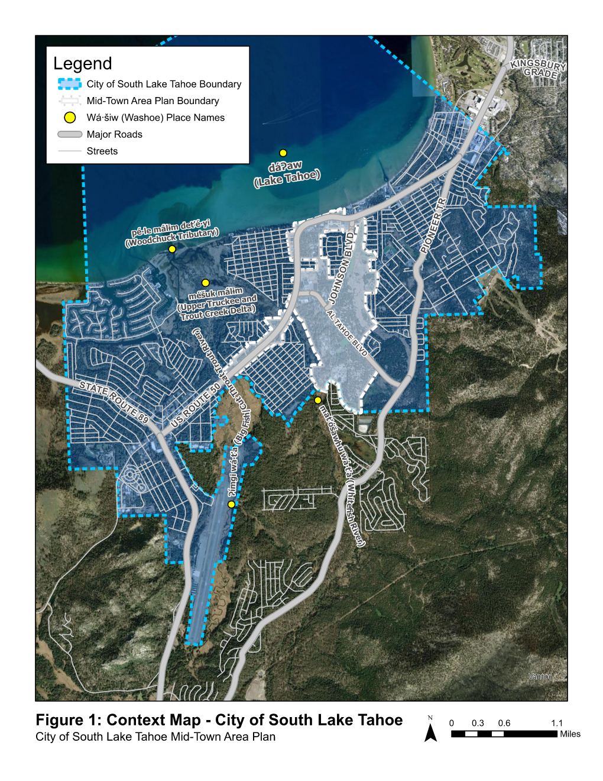
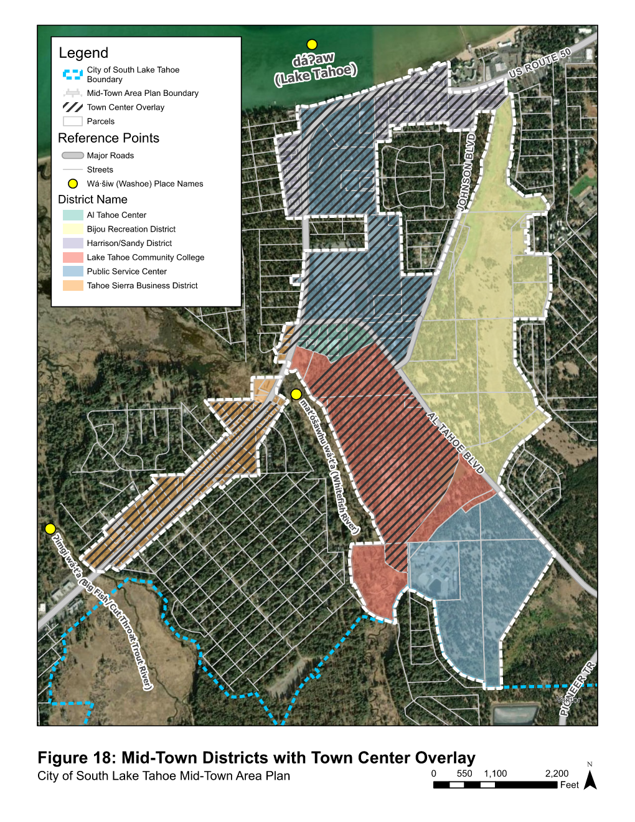
Figure 2: Mid-Town Area Plan Districts and Town Center Overlay

