 | CITY OF BRAWLEY | Development Services Department  205 S. Imperial Avenue  Brawley, CA 92227  Building Division  Phone: (760) 344-8622  Fax: (760) 351-2656  Housing Division  Phone: (760) 351-1905  Fax: (760) 351-2656  Planning Division  Phone: (760) 344-8822  Fax: (760) 351-2656
August 14, 2025

RE: Initial Outreach Proposed Specific Plan Amendment, GP Amendment, Zone Change, Tentative Tract Map (APN: 048-440-001)
To whom it may concern,
The City of Brawley Planning Department received Specific Plan Amendment, GP Amendment, Zone Change, and Tentative Tract Map for a parcel located in the Gateway Specific Plan Area.

- Site Location/Vicinity:
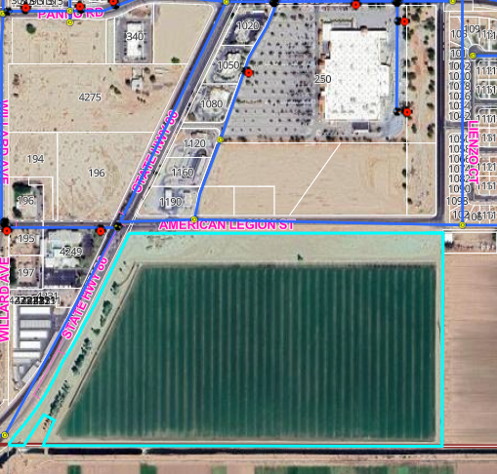

WAL-MART

ARCO
Church/Hospital

Project Parcel

- Proposed Project:

The proposed project would require City approval of an amendment to the Brawley Gateway Specific Plan and a tentative tract map for future commercial and multi-family residential uses; refer to Exhibit 1, Conceptual Site Plan. As currently proposed, the western portion of the property (approximately 37 acres) would be subdivided for future commercial development, including strip retail plaza and larger retail shopping center uses. The conceptual Site Plan would include 65,500 SF of commercial space (Pads 1 to 8); the square footage of the retail shopping center uses is proposed to be 243,000 SF (Pads 10 and 11). A hotel of approximately 150 rooms (Pad 9). Proposed access to the commercial use area would still be from (future) Legion Road to the north, with secondary access occurring from the south continuation of Mead Road. Currently the Rockwood Canal runs along the southern property boundary and would require to be undergrounded. The eastern portion of the property (approximately 29 acres) would be subdivided to allow for the future development of 408 multi-family residential units and associated community amenities, with an estimated 836 parking spaces. Total square footage of the residential uses would be 273,288 SF. Proposed primary and secondary access to the residential would remain from (future) Legion Road to the north (to be improved to centerline of roadway); secondary access would be via a future road along the eastern boundary through the continuation of Western Avenue.

- Current Zoning Designation: The subject property is located within a C-2 (Medium Commercial), M-1 (Light Manufacturing); and C-P (Service Professional) zones. The project would require a zone change to accommodate R-2 (Medium Density Residential), additional Commercial Zone, and eliminate the M-1 zone.

- Adjacent Property Zoning Designations:

North: | C-2 (Medium Commercial)/  Wal-Mart/ARCO/Strip Shopping Center | East: | R-1 (Single Family Residential)
South: | Proposed Planned Development (Rancho Los Lagos) | West: | C-2/C-P (Medium Commercial/Service Professional) Hospital, Church, and Pharmacy

Please consider this letter and preliminary project information as formal notification of a proposed project. Please respond in writing within 30 days if you wish to request consultation regarding possible significant effects that the proposed project may have on tribal cultural resources.
Please provide a designated lead contact person if you have not already provided such information. If you or any of your tribal members have any questions or concerns regarding the proposed project, please contact don’t hesitate to contact me: planning@brawley-ca.gov.

Sincerely,

Cynthia Mancha

