Notice of Exemption

Appendix E

To:

Office of Planning and Research
P.O. Box 3044, Room 113
Sacramento, CA 95812-3044
County Clerk
County of: Mendocino
501 Low Gap Road
Ukiah, CA 95482

From: (Public Agency):
Mendocino County Resource Conservation District
115 East Smith Street
Ukiah, CA 95482
(Address)

Project Title: Ukiah West Hills Gateway Trail Fire-Hardening
Project Applicant: Mendocino County Resource Conservation District
Project Location - Specific: T15N R12W Sec 30 (APNs: 00-319-017-00, 00-319-011-00, 00-319-008-00, 00-350-019-00, 00-350-014-00, and 00-326-001-00)
Project Location - City: Ukiah Project Location - County: Mendocino
Description of Nature, Purpose and Beneficiaries of Project:
The project involves manual vegetation treatment along approximately 27.7 acres of the existing Gateway Trail corridor in the City of Ukiah. Activities include the use of hand tools to thin small-diameter understory vegetation, lop-and-scatter of cut material, hand-piling, and prescribed pile burning. No ground disturbance, grading, or use of heavy mechanized equipment is proposed. The purpose of the project is to reduce hazardous fuel loading and vertical fuel continuity within the wildland-urban interface, thereby reducing wildfire risk and improving defensible space along the trail corridor. The primary beneficiaries of the project include nearby residents, recreational trail users, and the broader Ukiah community through reduced wildfire risk, improved public safety, and enhanced forest health and resilience.
Name of Public Agency Approving Project: Mendocino County Resource Conservation District
Name of Person or Agency Carrying Out Project: Mendocino County Resource Conservation District
Exempt Status: (check one):
Ministerial (Sec. 21080(b)(1); 15268);
Declared Emergency (Sec. 21080(b)(3); 15269(a));
Emergency Project (Sec. 21080(b)(4); 15269(b)(c));
Categorical Exemption. State type and section number: Class 4 – Minor Alterations to Land (Section 15304)
Statutory Exemptions, State code number:
Reasons why project is exempt:
The project qualifies for a Class 4 Categorical Exemption (Section 15304) because it consists of minor alterations to land involving vegetation management using hand tools, with no ground disturbance, grading, or expansion of existing use. Activities are limited to thinning of small-diameter vegetation, lop-and-scatter, hand-piling, and prescribed pile burning within an existing trail corridor. The project will not result in significant impacts to environmental resources, as it avoids sensitive habitats, does not involve removal of mature trees, and will not cause substantial soil disturbance, erosion, or slope instability. All work will occur using non-mechanized methods, and prescribed burning will be conducted under the supervision of the Ukiah Valley Fire Authority in accordance with applicable permitting requirements. The project is located in an area that is not environmentally sensitive and will not result in a cumulative impact or unusual circumstances that would cause a significant effect on the environment. Therefore, none of the exceptions to the use of categorical exemptions identified in CEQA Guidelines Section 15300.2 apply.
Lead Agency
Contact Person: Doug Turk Area Code/Telephone/Extension: 707-462-3664/107
If filed by applicant:
1. Attach certified document of exemption finding.
2. Has a Notice of Exemption been filed by the public agency approving the project? Yes No
Doug Turk
Signature: Date: Title:
Forestry Program Manager
3/23/2026
Signed by Lead Agency Signed by Applicant
Authority cited: Sections 21083 and 21110, Public Resources Code. Date Received for filing at OPR: Reference: Sections 21108, 21152, and 21152.1, Public Resources Code.

Revised 2011

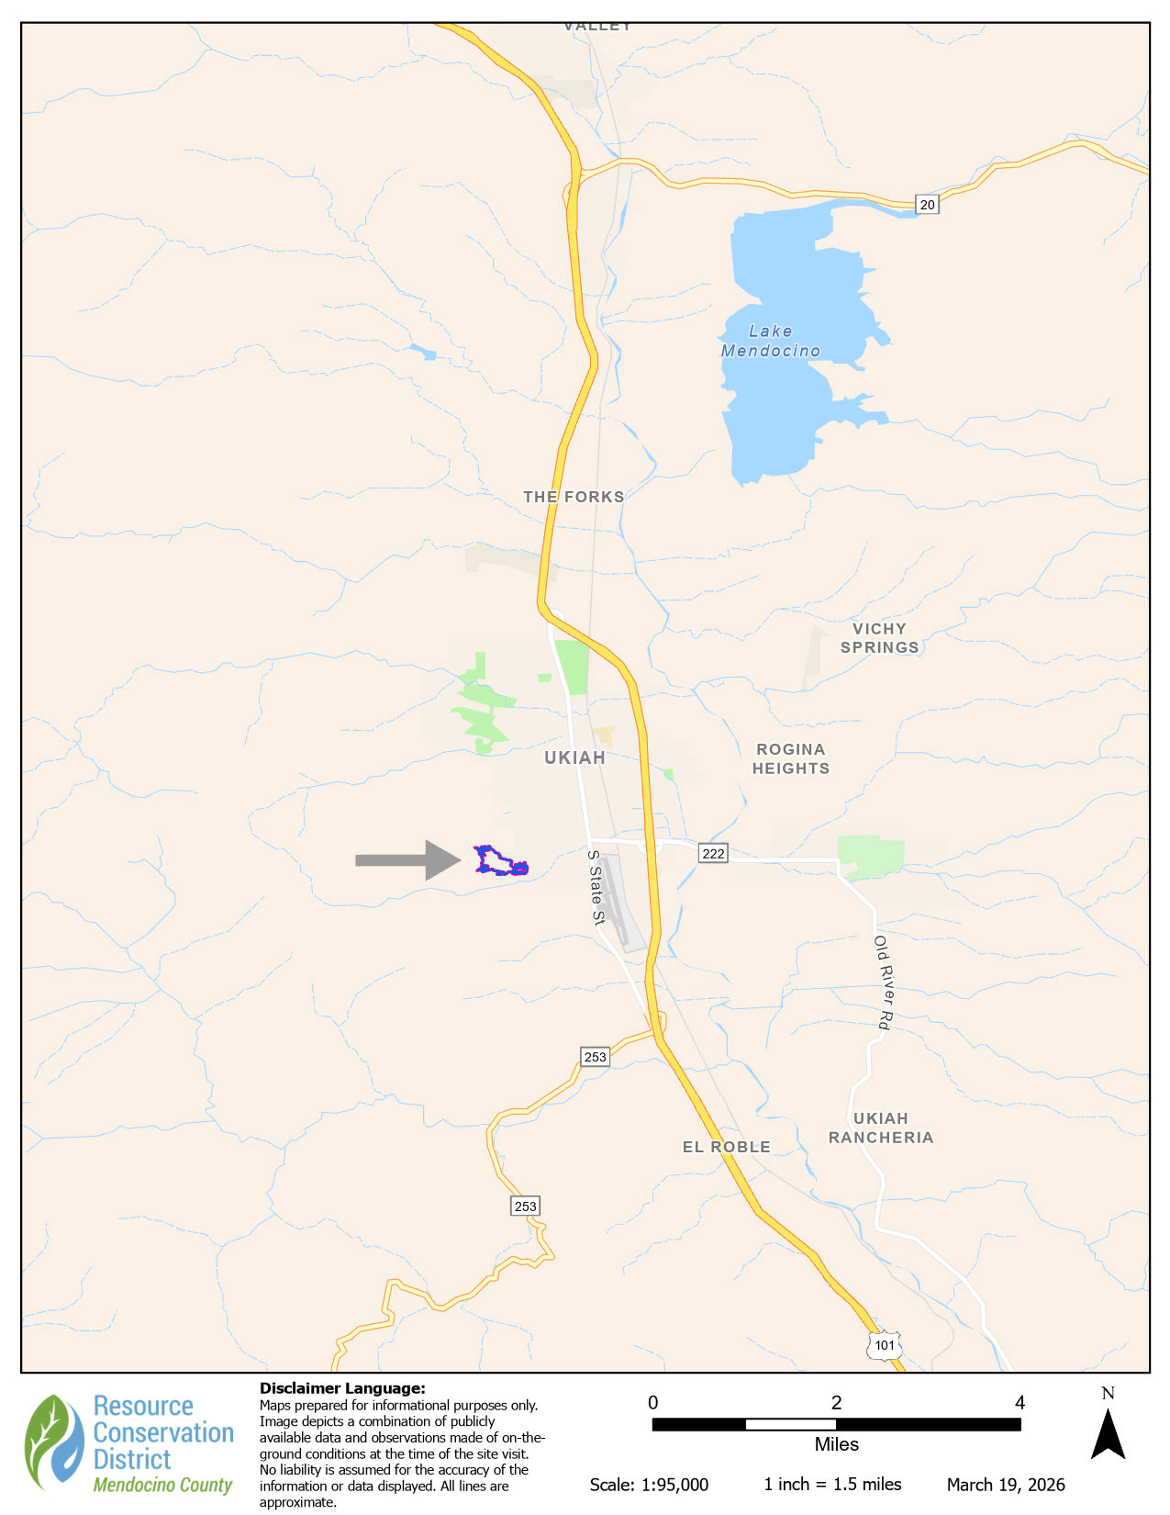

Project Area

