Sloughhouse RCD – CalSIP Stream Gage Installation Project
Prepared For: | Sloughhouse Resource Conservation District / Groundwater Sustainability Agency
Prepared By: | Aidan Kelleher, Ari Frink
Date: | 06/12/2026

Project Description

Purpose and Need
The Sloughhouse Resource Conservation District and Groundwater Sustainability Agency (SRCD) seeks to enhance the management of regional water resources by expanding the network of reliable, real-time monitoring infrastructure within our watersheds. Through funding from the Department of Water Resources’ Stream Gage Improvement Program (“CalSIP”), SRCD will upgrade, reactivate, and install up to seven new surface water gaging stations to address critical data gaps.

This infrastructure is essential for fostering collaborative, science-based management of surface and groundwater systems. By providing high-resolution data, the Project delivers a net benefit to the watershed, supporting informed instream flow management and the long-term protection of sensitive aquatic and riparian resources. While construction may result in minor and temporary localized impacts, these effects will be strictly minimized through avoidance and minimization measures. Ultimately, this improved data stream will facilitate adaptive management strategies that balance the needs of agricultural productivity with the biological requirements of local fish and wildlife populations.

Project Elements
Seven stream gage locations will be selected from the potential stream gage locations and new gages will be installed. Each station will include sensors (pressure transducers or radar for stage measurement), a data logger, power supply and a telemetry system that transmits data to the California Data Exchange Center (CDEC).

2.1 Typical Stream Gage
To support the collection of continuous, real-time hydrologic data, SRCD will install a stream gage system utilizing a bubbler-style water level measurement device consistent with DWR Stream Gage Improvement Program recommendations. The bubbler system measures stream stage by monitoring the air pressure required to force air bubbles through an orifice line submerged in the stream. This approach provides accurate and reliable measurements without the need for in-water electronic sensors.

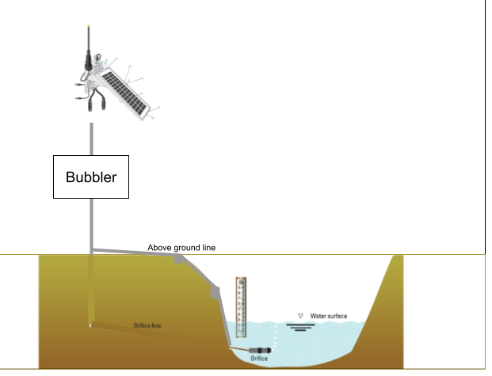
Figure 1: Typical Stream Gage

A typical stream gage installation consists of the following components:
- Stage sensor: a pressure transducer in a stilling well or a radar/sonic sensor mounted on a bridge or pole. Pressure transducers, in the form of bubbler units, are recommended at the SRCD sites because there are limited locations to mount radar and a submerged sensor reduces vandalism risk.
- Stilling well or pipe: protects the pressure transducer, provides stable water levels and can be anchored to a bank, abutment or pile. Some sites may use existing stilling wells from historic gages or new PVC pipes.
- Staff gage: a graduated staff mounted near the sensor for manual stage readings and calibration.
- Data logger and telemetry: housed in a weatherproof enclosure above flood levels. It records stage data, stores site metadata and transmits readings via cellular or satellite telemetry to CDEC.
- Power supply: solar panel with battery to power sensors, logger and transmitter.
- Secured housing and fencing: to deter vandalism and protect equipment from livestock or debris.
Each gage station will include a bubbler unit housed in a weatherproof enclosure mounted above ground, typically on a pole equipped with solar panels for power and telemetry components for data transmission. The bubbler unit connects to an orifice line that runs from the gage housing to a fixed point within the stream channel. The orifice line includes two components: (1) an airline for the bubbler system, and (2) a line for an oxygen sensor that will measure dissolved oxygen at the monitoring site. The bubbler unit, pressure transducer, gage housing, and supporting pole will be located above the ordinary high water mark (OHWM); these above-OHWM components are outside U.S. Army Corps of Engineers jurisdiction and may involve minor ground disturbance or concrete as needed.

To minimize impact, the orifice line will be installed above ground in coordination with MBK Engineering’s stream gage construction. The orifice line will be routed above ground and secured with small u-bolt anchors to maintain stability and protect the line from disturbance. MBK Engineering will install staff gages on t-posts that are securely driven into the streambed or bank. Each staff gage plate will be mounted to the post using corrosion-resistant hardware, such as U-bolts. No concrete, cement, or footing will be used for staff gage installation. Staff gages located within the stream channel or between the water’s edge and the ordinary high water mark (OHWM) will consist of driven t-posts only, with no excavation, cut, or fill, consistent with the U.S. Army Corps of Engineers No Permit Required determination (SPK-2026-00077, dated April 28, 2026).
Where necessary, a trench may be dug to bury and secure the orifice line. The buried configuration would extend from the gage housing to the stream channel, with the terminal orifice anchored at a known elevation within the channel bed. Any such trenching will be confined to areas above the OHWM; the terminal orifice fitting will be placed within the channel without excavation, cut, or fill.

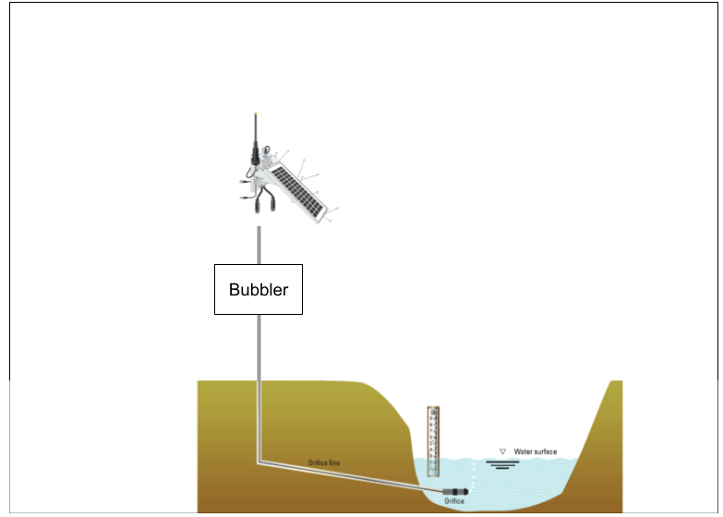
Figure 2. Alternative Subsurface Line Stream Gage Installation

No in-channel structures, footings, or foundations are proposed beyond the staff gage, the small, submerged orifice fitting, and associated line. The installation footprint will be limited to the immediate area surrounding the gage housing and the narrow trench or surface alignment of the orifice line. Ground disturbance, if any, would be minimal and localized.

Construction Methods, Duration, and Sequencing
Construction activities will be conducted by a small crew (two to three personnel) using light-duty vehicles and handheld equipment. When the orifice line is installed below ground, minor trenching (approximately 4 to 6 inches wide and up to 2 feet deep) will be required between the gage housing and the streambank. Where above-ground routing is necessary, the orifice line will be laid on the surface and secured with small concrete anchors. All trenching and concrete anchors will be located above the OHWM. Staff gages and any other installations at or below the OHWM will be driven t-posts only, with no excavation, cut, fill, or concrete.

All work will occur during dry or low-flow conditions to avoid impacts to aquatic habitat. No construction activities will require dewatering. In-water work will be avoided to the extent practicable, with only installation of some of the staff gages and placement of the orifice line potentially requiring in-water work. Temporary disturbance will be confined to previously disturbed or unvegetated areas to the extent practicable. Following installation, all work areas will be restored to pre-project conditions.Any in-water or below-OHWM staff gage installation will be limited to driven t-posts with no excavation, cut, or fill.

3.1 Installation Sequencing
Installing a stream gage typically involves the following steps:
- Site preparation and access: confirm landowner permissions, flag access routes and clear a small area for installation. Installation must conform with real-property rights and regulatory permits.
- Mounting stage sensor and stilling well: for pressure transducers, a PVC pipe (stilling well) is anchored to a bank, pier, bridge pile or boulder. Locations were identified where pressure transducers are preferred because suitable radar mounting points are lacking.
- Installing staff gage: mount a metal staff gage near the sensor for manual stage observations and calibration.
- Setting up data logger, power and telemetry: install a weatherproof enclosure with data logger, solar panel and battery on a pole or platform above flood level. Connect sensors, configure the logger and program telemetry to send data to CDEC.
- Calibration and flow measurements: perform initial flow measurements and develop rating curves to relate stage to discharge; adjust sensor calibration accordingly.
- Documentation: record equipment specifications, telemetry configuration and installation details for each site. Maintain a log of equipment purchased and installed.

Operation, Maintenance, and Completion of Use

Per CalSIP guidelines, SRCD must maintain operation and maintenance of the stream gages until at least June 30, 2027.

4.1 Operation and Maintenance
Following installation, each stream gage will require periodic operation and maintenance activities to ensure continued data collection and equipment integrity throughout the monitoring period. Routine maintenance will be conducted by a small crew (one to two personnel) accessing each site via existing access routes on foot. Maintenance activities may include: inspection and cleaning of the orifice line and bubbler components; removal of debris or sediment that may accumulate around the staff gage or orifice fitting; replacement or repair of minor hardware components (e.g., u-bolt anchors, staff gage plates, solar panels, telemetry equipment); and vegetation management within the immediate equipment footprint as needed to maintain site access and equipment function. Any in-channel work associated with maintenance will be limited to the previously disturbed installation footprint and will be conducted during dry or low-flow conditions to the extent practicable. No new ground disturbance beyond the original installation footprint is anticipated.

4.2 Completion of Use and Removal of Stream Gage Installations
Upon completion of data collection activities or the end of the monitoring program, each stream gage will be removed to the maximum extent practicable in accordance with regulatory requirements. This includes all components of the gage system: the stage sensor (pressure transducer or radar/sonic unit), stilling well or PVC pipe, staff gage, data logger and telemetry enclosure, power supply (solar panel and battery), and any associated lines or anchors.

For bubbler-type systems, the bubbler unit, housing, and orifice line (including airline and dissolved oxygen line) will be disconnected and removed. Where the orifice line was installed above ground, all small concrete or u-bolt anchors will be detached and retrieved. Where lines were buried, excavation will be limited to the previously disturbed trench alignment, and the trench will be backfilled with native material and contoured to match pre-construction grades.

All t-posts used for staff gages will be extracted to the extent practicable. The stilling well or PVC pipe, if installed, will be detached from its anchor point (e.g., bank, abutment, or pile) and removed. Any weatherproof enclosures, poles, solar panels, or fencing used to protect the installation will also be removed from the site.

Following equipment removal, the disturbed area will be restored to pre-construction elevations and contours. Disturbed soils will be stabilized as necessary to prevent erosion and sediment discharge. No permanent in-channel structures, footings, or foundations will remain.

All materials and equipment will be transported off-site for proper disposal or recycling at an approved facility. These actions will ensure the site is returned, to the extent practicable, to pre-project conditions consistent with regulatory requirements and any impact minimization measures described for installation.

Locations
SRCD, in consultation with MBK Engineering and Wildeye, have identified multiple suitable locations for seven stream gage sites. The proposed stream gage network encompasses six watersheds within the greater SRCD area, spanning portions of Sacramento and Amador Counties. Site selection focused on locations that balance hydrologic representativeness, accessibility, and long-term maintenance feasibility while minimizing permitting and landowner constraints. Each proposed location reflects coordination with DWR and evaluation by MBK Engineering. FlowWest, and Wildeye during September 2025 field visits. The following table (Table 1) summarizes recommended and alternative sites for each stream reach, including notes on existing infrastructure, land ownership, and suitability for the DWR-approved bubbler system. The final section of this document includes site location photographs.
Table 1: Potential Stream Gage Location Information
Site ID | Location (Approx. coordinates) | Parcel APN | Ownership (indicate Federal or not) | On a bridge? Y/N | Installation Notes (11/7/25) | Preferred Gage Location Notes
2019-01 | Deer Creek near Sloughhouse (38.551477°, -121.110026°)  https://www.google.com/maps/place/38.55146,-121.11000/ | 073-0050-041-0000 | Private (Granite property); no bridge | N | Our tower will be 12ft west of a historical gauge house and 13.5ft from water  From the edge of the water it's 40ft to the middle of the stream.  Tower to middle is 53.5 ft | Install on the historic Granite property gage. Pressure transducer recommended because there is no good radar mounting spot and vandalism has been an issue. Alternate options include Meiss Road bridge (county approval required) and a private creek crossing at the confluence with Carson Creek; Jackson Road, Keifer Road and Latrobe Road bridges are not recommended.
2842-01 | Laguna Creek west of Folsom South Canal (38.333955°, –-121.189171°)  https://www.google.com/maps/place/38.33272,-121.19054/ | 138-0060-053-0000 | Private (Silva property); off-bridge | N | Our tower will be 70ft from the middle of the stream.  About 20ft of that is the downhill bank. | Adjust coordinates slightly downstream of USBR property on the Silva property to avoid coordination with USBR. A pressure transducer is preferred due to limited radar mounting opportunities. McKenzie Road and Clay Station Road bridges are not recommended.
2009-01 | Dry Creek near Ione (38.299117°, –121.062524°)  https://www.google.com/maps/place/38.29941,-121.06384/ | 154-0120-013-0000 | Private (Bleecher property) | N | Our tower will be 80ft from the middle of the stream. About 20ft of that is the downhill bank. | Install at the Bleecher property, a historic gage site with easier access and less vegetation. Pressure transducer recommended to reduce vandalism risk.
2005-01 | Dry Creek above Sutter Creek near Ione (38.415055°, –120.906367°)  https://www.google.com/maps/place/38.41485,-120.90553/ | 008-240-053-0000 | Private (Ilich and Strachan properties) | N | Our tower will be 3ft west from historical gauge house  30 ft from tower to middle of stream | Use the historic gage on the Ilich property; coordinate with co-owner Jennifer Strachan for access. Pressure transducer recommended; radar mounting points are limited. An alternate site at Willow Creek Road bridge would require county approval.
2803-01 | Hadselville Creek, Silva Property (38.33458°, –121.17136°) | 138-0060-064-0000 | Private (Silva property); near a bridge | N |  | Install at Hadselville Creek on the Silva property. A pressure transducer is preferred to avoid vandalism and because there is no good radar mounting location along the busy road. The Kenefick property near the bridge is not recommended due to wide, vegetated channel.
2007-01 | Sutter Creek at Ione Footbridge (38.352533, -120.935318) | 004-141-004-0000 | County bridge (footbridge) | Y |  | New gage options include the Ione Foot Bridge and the Sutter Creek Foot Bridge; both require county/city approval. Private landowner bridges downstream of Locust Lane may also be suitable with landowner approval; the Glavenich property and Sutter Creek Road bridge are not recommended due to vandalism and lack of agreements.
2011-01 | Jackson Creek off Buena Vista Road  https://tinyurl.com/Site7JacksonCreek  (38.287960, -120.913105) | 012-070-009-0000 | Amador County Land | No |  | Site is owned by Amador County and used as a corp yard to park equipment and materials.

Site Photographs and Overviews

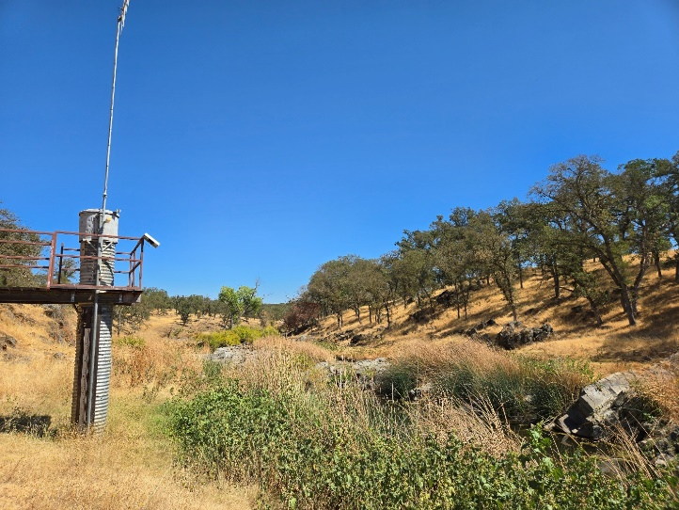
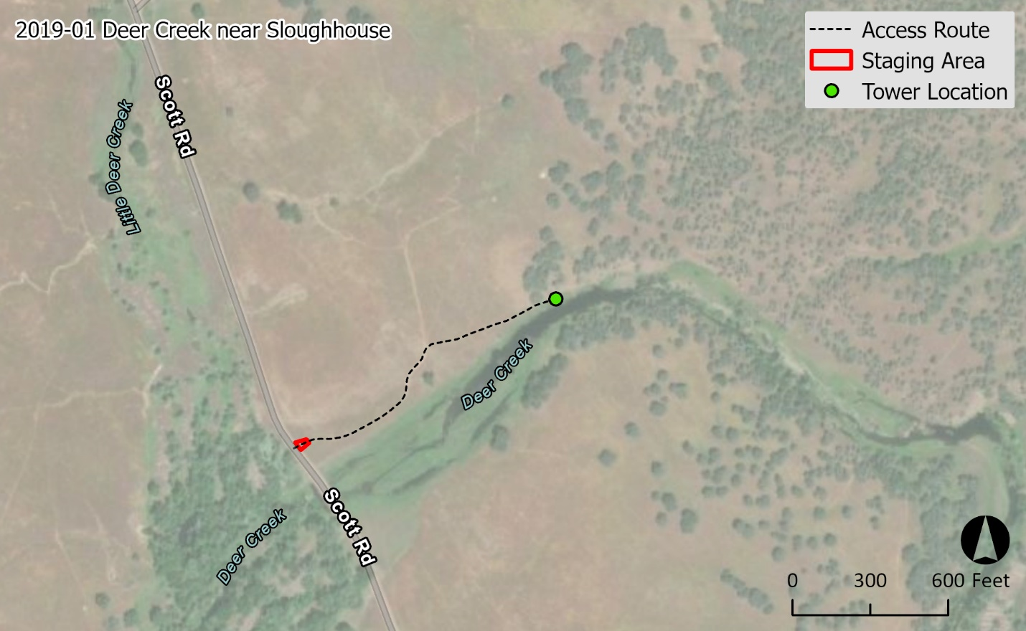
Site 1: 2019-01 DEER Creek

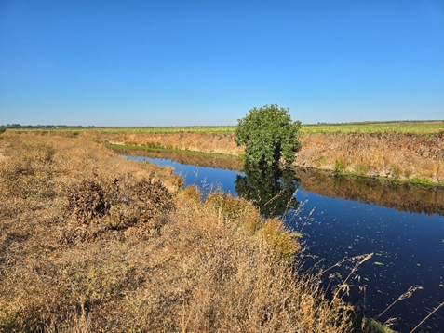
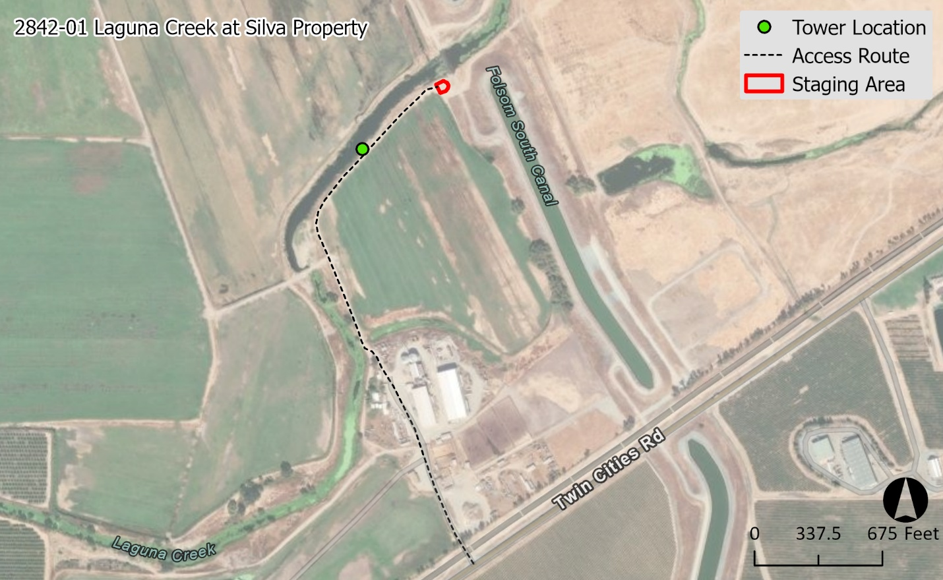
Site 2: 2842-01 Silva Property

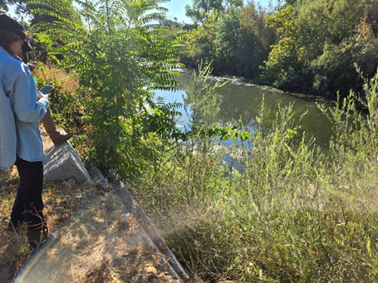
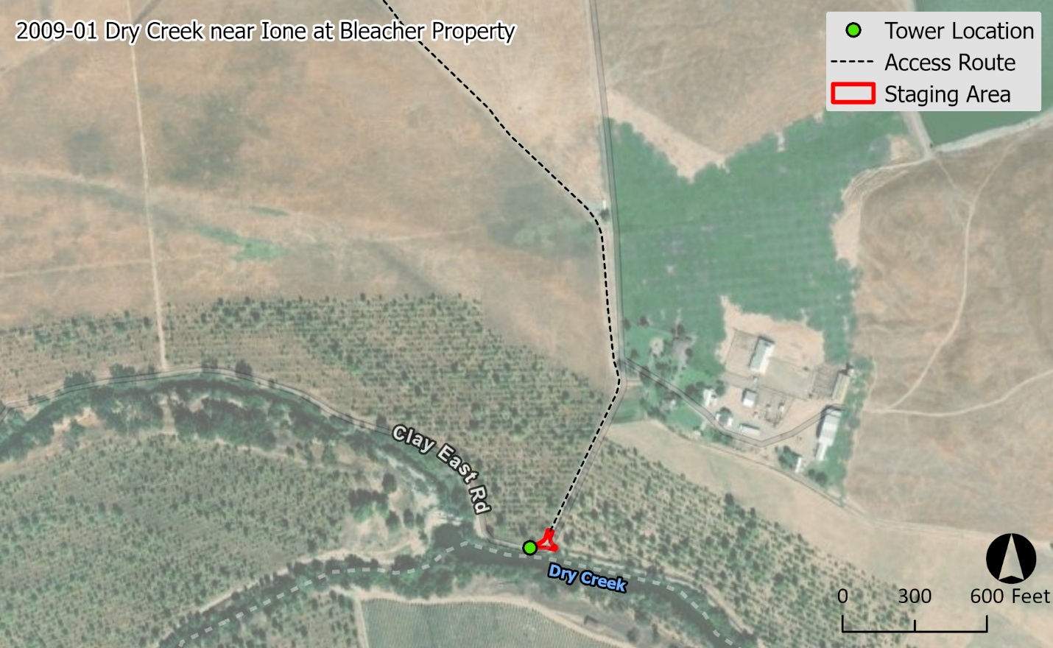
Site 3: 2009-01 Dry Creek Nr Ione CA

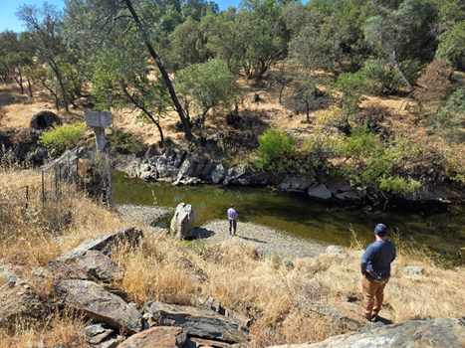
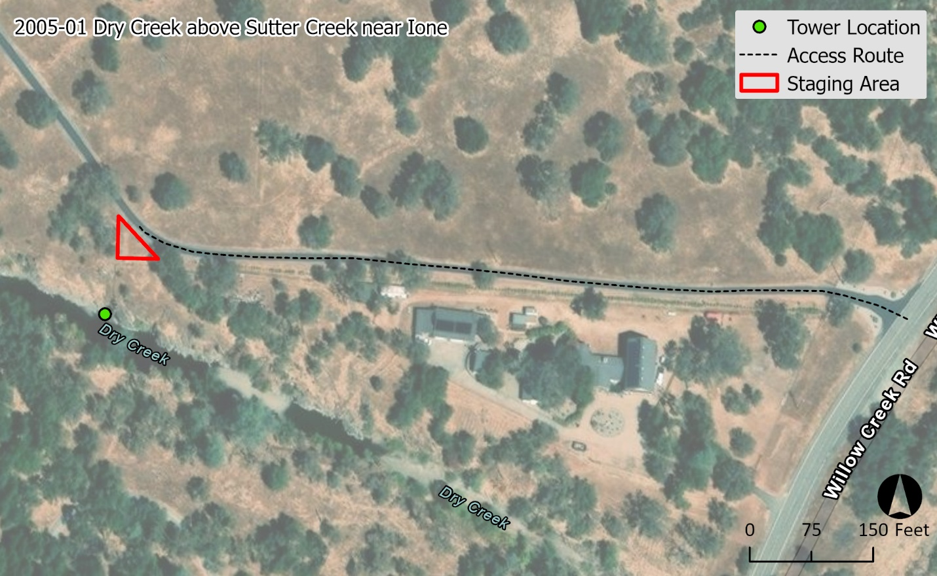Site 4: 2005-01 Dry Creek on Ilich Property

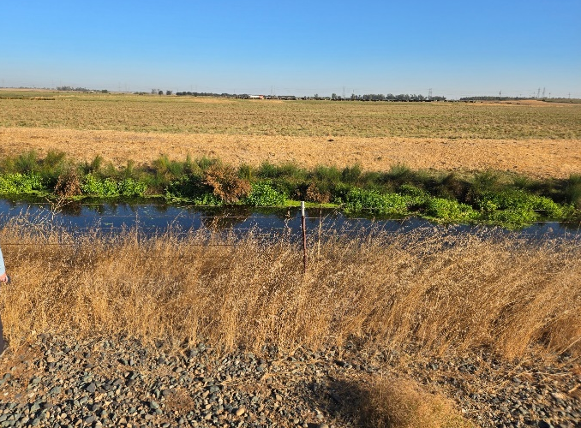
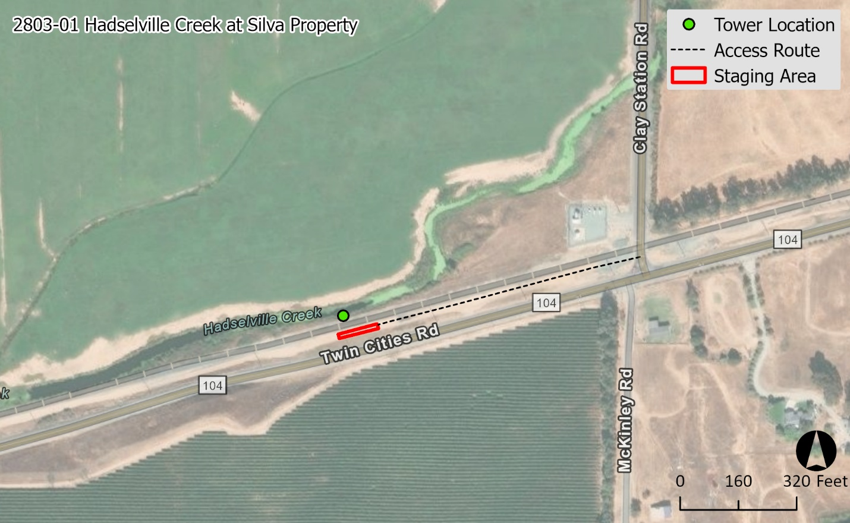Site 5: 2803-01 Hadselville Creek at Silva Property

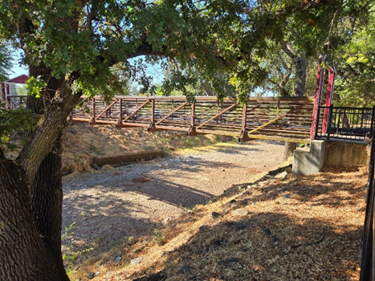
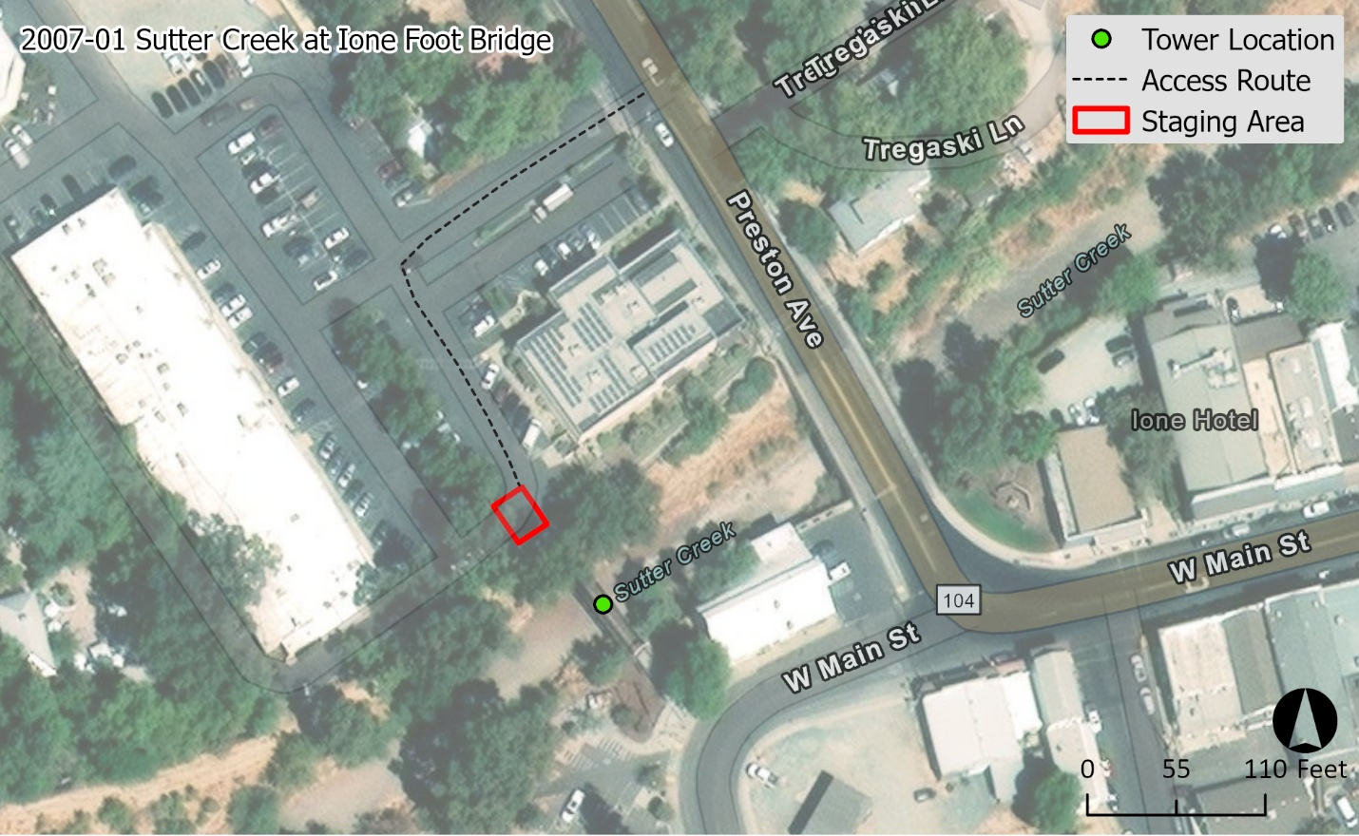Site 6: 2007-01 Sutter Creek at Ione Foot Bridge
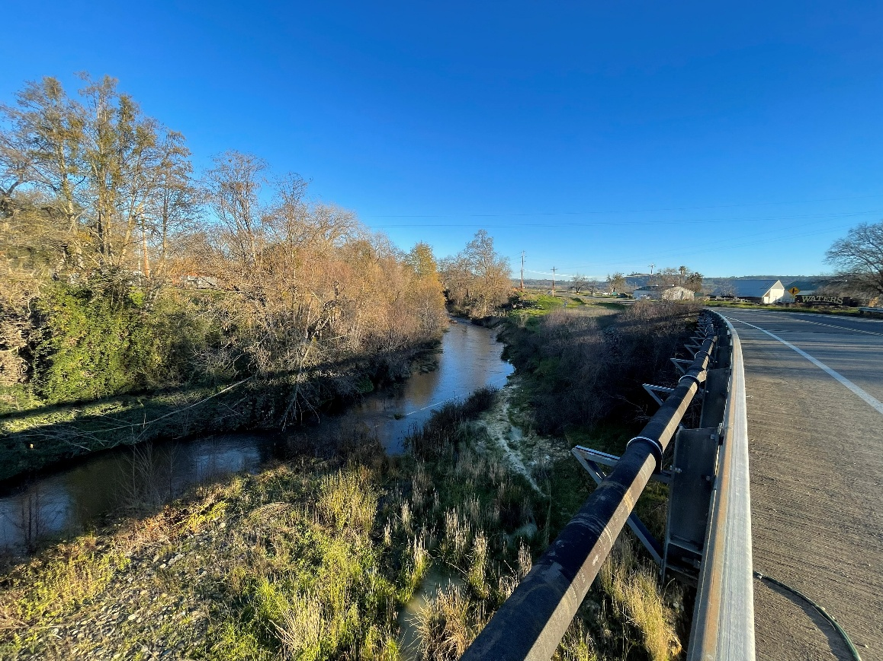
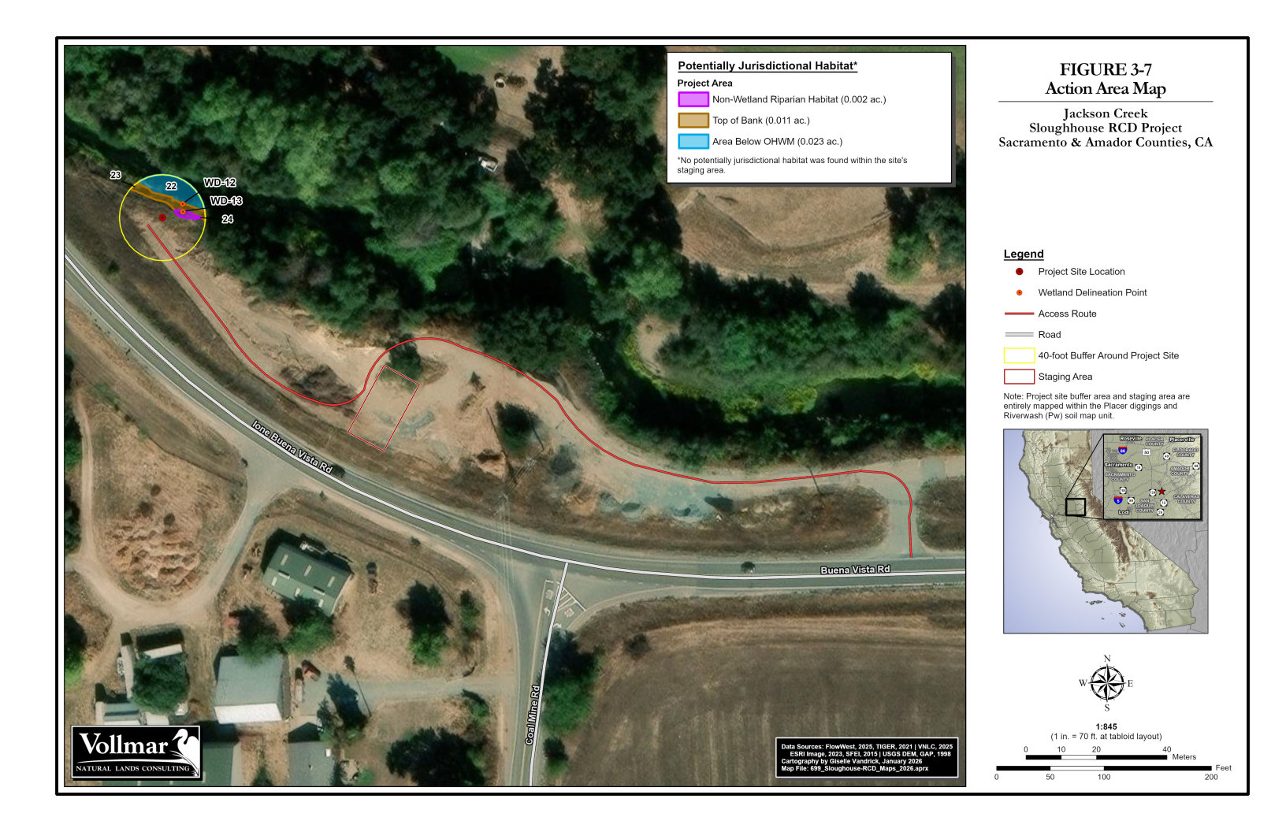Site 7: XXXX-XX Jackson Creek at Buena Vista Road

