Notice of Exemption Appendix E

To: Office of Planning and Research
P.O. Box 3044, Room 113
Sacramento, CA 95812-3044
From: (Public Agency):

City of Mission Viejo, Mission Viejo, CA 92691

County Clerk

County of:
Orange

601 N. Ross Street, Santa Ana, CA 92701

Project Title: Planned Development Permit P-PDP2024-0008

Project Applicant: Simon Property Group, LLC; 555 The Shops at Mission Viejo, Mission Viejo, CA 92692

Project Location - Specific:

555 The Shops at Mission Viejo, Mission Viejo, CA 92692 - APNs 740-121-29 and 740-121-18

Project Location - City:

Mission Viejo
Project Location - County:

Orange County

Description of Nature, Purpose and Beneficiaries of Project:
The project includes the construction of four (4) new retail buildings, totaling 47,812 square feet, situated along a ½-acre open-air promenade located at 555 The Shops at Mission Viejo in the CR (Commercial Regional) zone. The approval, Planned Development Permit P-PDP2024-0008, allows for the development of a 2.5-acre portion of mall by the applicant, Simon Property Group, LLC.

Name of Public Agency Approving Project: City of Mission Viejo

Name of Person or Agency Carrying Out Project: City of Mission Viejo

Exempt Status: (check one):
Ministerial (Sec. 21080(b)(1); 15268);
Declared Emergency (Sec. 21080(b)(3); 15269(a)); Emergency Project (Sec. 21080(b)(4); 15269(b)(c));
X Categorical Exemption. State type and section number: In Fill Development Projects, 15332

Statutory Exemptions. State code number: Reasons why project is exempt:
A Class 32 Exemption applies because the project is: consistent with the applicable general plan and zoning
designation, and all applicable general plan policies; is less than five (5) acres; has no value as habitat for endangered species; and can be adequately served by all required utilities and public services. The approval of the project would not result in any significant effects relating to traffic, noise, air quality, or water quality.

Lead Agency

Larry Longenecker (949) 470-3009

Contact Person: Area Code/Telephone/Extension:
If filed by applicant:
- Attach certified document of exemption finding.
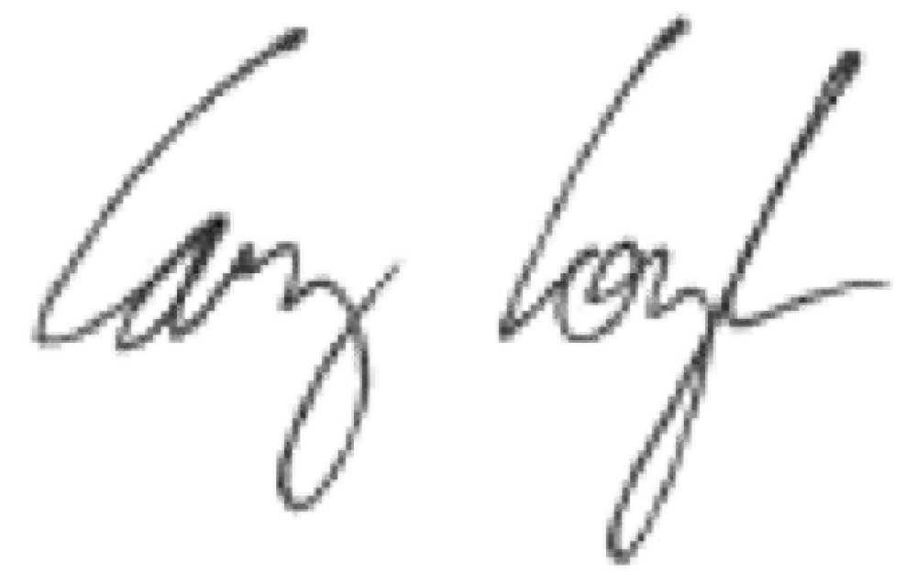
- Has a Notice of Exemption been filed by the public agency approving the project? Yes No

Signature: Date:

06/10/2025

Title:

Director of Community Development

  - Signed by Lead Agency Signed by Applicant

Authority cited: Sections 21083 and 21110, Public Resources Code. Date Received for filing at OPR: Reference: Sections 21108, 21152, and 21152.1, Public Resources Code.

