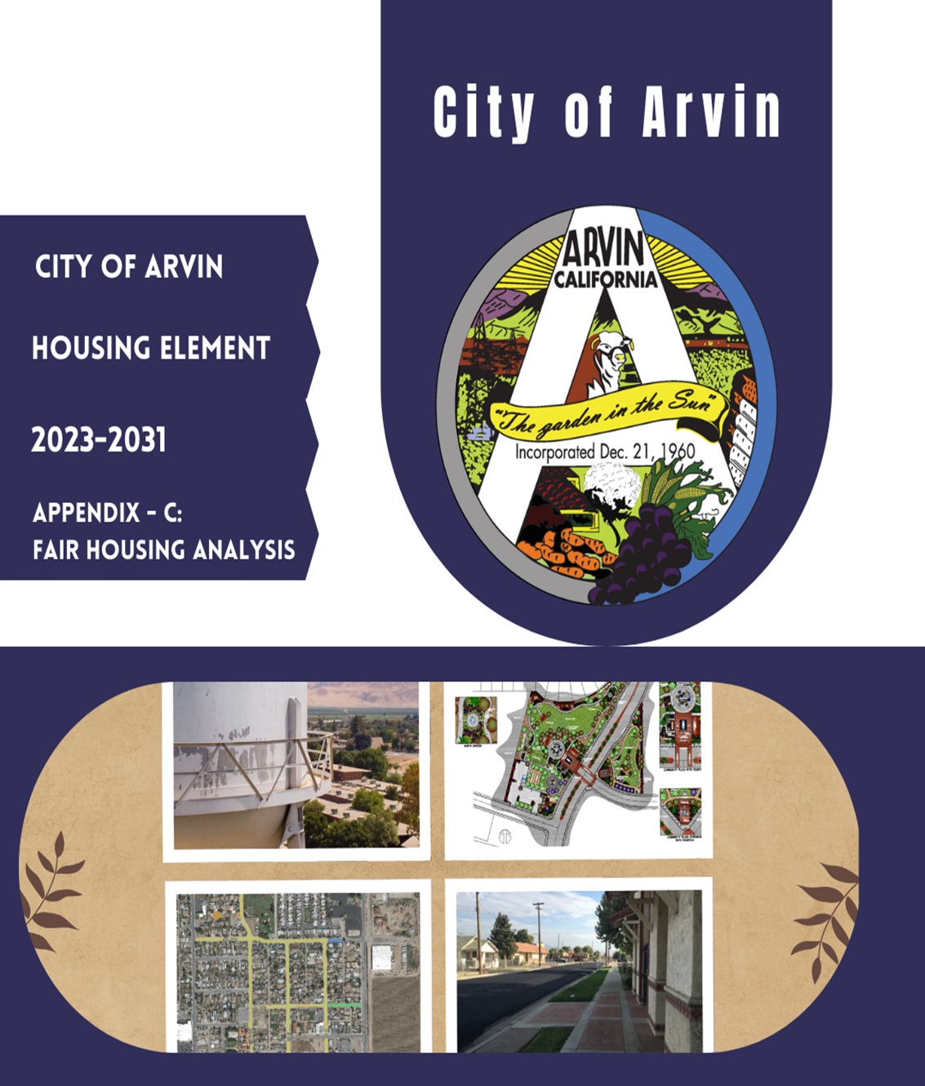

Prepared by: Realty Planners Group, Inc. 3258 Alta Vista Drive, Fallbrook, CA 92028

City of Arvin
2023-2031 HOUSING ELEMENT
APPENDIX – C: FAIR Housing Analysis
Resolution No. 2025-04
JANUARY 28, 2025

Adopted by the City Council on: January 28, 2025- Resolution No. 2025-04

Table of Contents

OUTREACH AND PUBLIC PARTICIPATION…………………………………………….…...1
- ARVIN HOUSING ADVISORY COMMITTEE……………………………………………………….….….2
- CITY OF ARVIN WEBSITE…………………………………………………………………………………….….2
- GENERAL MULTI-LINGUAL ADVERTISEMENTS………………………………………………..…..…3
- CITY COUNCIL/PLANNING COMMISSION WORKSHOP…………………………………….….….3
- COMMUNITY WORKSHOPS………………………………………………………………………………..….3
- STAKEHOLDER INPUT……………………………………………………………………………….…….….….4
- OUTREACH AND PUBLIC PARTICIPATION - MOVING FORWARD …………………..….……4
- ASSESSMENT OF FAIR HOUSING ISSUES……………………………………………………….….…4
- KEY DATA AND BACKGROUND INFORMATION……………………………………………….……..4
- FAIR HOUSING ENFORCEMENT AND OUTREACH CAPACITY…………………………….…….5
- INTEGRATION AND SEGREGATION PATTERNS AND TRENDS………………………………..10
- RACIALLY OR ETHNICALLY CONCENTRATED AREAS OF POVERTY (RECAP)……………31
- RACIALLY CONCENTRATED AREAS OF AFFLUENCE (RCAA)……………………………………32
- DISPARITIES IN ACCESS TO OPPORTUNITIES………………………………………………………..32
- DISPROPORTIONATE HOUSING NEEDS AND DISPLACEMENT……………………………….47
- DISPLACEMENT RISK……………………………………………………………………………………………60

SITES INVENTORY……………………………………………………………………………………….….……66
- FUTURE HOUSING NEEDS INCLUDING SEGREGATION/INTEGRATION………..………..67
- R/ECAPS and CAAs……………………………………………………………………………….……………..68
- ACCESS TO OPPORTUNITY……………………………………………………………………………………69
- DISPROPORTIONATE HOUSING NEEDS……………………………………………………………..…70
- SITES INVENTORY FINDINGS…………………………………………………………………………..……70

IDENTIFICATION OF CONTRIBUTING FACTORS AND FAIR HOUSING

PRIORITIES AND GOALS………………………………………………………………………………….……75

LOCALIZED PERSPECTIVE AND OVERALL SUMMARY OF TRENDS AND

PATTERNS……………………………………………………………………………………………………………78
APPENDIX 1 - OUTREACH

List of Tables
Table 1 Compliance with Fair Housing Laws 6
Table 2A Population by Race by Hispanic Origin Over Time 11
Table 2B Population by Race by Hispanic Origin 11
Table 3 Racial Dissimilarity Index Values for Kern County 19
Table 4 Disability by Type for the Population with a Disability (Detailed) 20
Table 5 Households by Size 24
Table 6 Households by Type 25
Table 7 Kern County – Farm Labor (2017) 26
Table 8 Senior Households by Tenure 27
Table 9 Income by Household Types 28
Table 10 Households in Poverty over Time 28
Table 11 Poverty Status of Families by Family Type and Marital Status 29
Table 12 Age Distribution and Dependent Population – Year 2020 29
Table 13 Median Household Income by Race or Hispanic Origin 32
Table 14 Domains and List of Indicators by Factors 36
Table 15 Opportunity Resource Levels by Census Tract 37
Table 16 Industry in which the Civilian Employed Population 16 Years and Over is
Employed 40
Table 17 Employment by Occupation 41
Table 18 Arvin Households Overpaying for Housing by Income Level – 2018 42
Table 19 Kern County Office of Education Student Performance by
Ethnicity2021-22………………………………………………………………………….……..43
Table 20 Overcrowded Households in Arvin - 2020 47
Table 21 Overcrowded Households in Arvin by Tenure – 2010-2020 48
Table 22 Privately Owned Farm Worker Housing Kern County 51
Table 23 Publicly Owned Farm Worker Housing Kern County 52
Table 24 Arvin Households with Housing Problems - 2019 53
Table 25 Arvin Households Overpaying for Housing by Income Level - 2018 54
Table 26 Overcrowded Households in Arvin - 2020 55
Table 27 Overcrowded Households in Arvin by Tenure – 2010-2020 …… ………..... 55
Table 28 Housing Units by Year Built 56
Table 29 Housing Authority Facilities 58
Table 30 Facilities for Special Needs 58
Table 31 Arvin’s RHNA 2023-2031 By Income Level 67
Table 32 AFFH Census Tracts Analysis Summary 71
Table 33 Potential Housing Units 2023-2031 74
Table 34 Fair Housing Issues and Contributing Factors 75
List of Figures

Figure 1 City of Arvin Annexation & Sphere of influence 12
Figure 2 Census Tract Boundaries 14
Figure 3 Housing Choice Vouchers by Census Tract and Subsidized Housing 15
Figure 4 Public Housing Building, LIHTC And Multifamily Properties 16
Figure 5 Linguistic Isolation Percentile 17
Figure 6 2018 Diversity Index 18
Figure 7 Predominant Population by Census Tracts 21
Figure 8 Racially Concentrated Areas of Affluence/Poverty 22
Figure 9 Percent of Population with A Disability 23
Figure 10 Percent of Population Over 18 Living with Spouse 34
Figure 11 Median Income and Percent of Children in Married Couple…………………….
Households 34
Figure 12 Median Income by Census Block Group 35
Figure 13 Percent of Population Below Poverty Level 35
Figure 14 TCAC/HCD – High Segregation and Poverty 2023 39
Figure 15 Vacant Residential Lots 50
Figure 16 TCAC/HCD Opportunity Area Map for Arvin 62
Figure 17 Percent of Children in Female Householder 62
Figure 18 SB 535 Disadvantaged Communities 63
Figure 19 Housing Burden Percentile 63
Figure 20 Unemployment Percentile 64
Figure 21 Education Percentile 64
Figure 22 Cumulative Impacts 65
Figure 23 Pollution Burden Percentile 65
Figure 24 Arvin Census Tracts 72
AFFIRMATIVELY FURTHERING FAIR HOUSING ANALYSIS

California State Law AB 686 created new requirements for all housing elements revised on or after January 1, 2021 to contain an Affirmatively Furthering Fair Housing (AFFH) analysis consistent with the core elements of the analysis required by the federal Affirmatively Further Fair Housing Final Rule of July 16, 2015. These requirements ensure that the obligation to affirmatively further fair housing is a part of a jurisdiction’s planning process and guiding documents for community development. The Housing Element analysis of AFH must include an analysis of Racially Concentrated Areas of Affluence, and patterns and trends at both a local and regional scale.
Under State law, affirmatively further fair housing means “taking meaningful actions, in addition to combatting discrimination, to facilitate deliberate actions to explicitly address, combat, and relieve disparities resulting from past patterns of segregation to foster more inclusive communities free from barriers that restrict access to opportunity based on protected characteristics”. These characteristics can include, but are not limited to, race, religion, sex, marital status, ancestry, national origin, color, familial status, or disability.
The AFFH analysis must contain the following:
  - Outreach
  - Assessment of Fair Housing
- Key Data and Background Information
- Fair Housing Enforcement and Outreach Capacity
- Integration and Segregation Patterns and Trends
- Racially or Ethnically Concentrated Areas of Poverty
- Racially Concentrated Areas of Affluence
- Disparities in Access to Opportunity
- Disproportionate Housing Needs in the Jurisdiction
- Displacement Risk
  - Sites Inventory
  - Identification of Contributing Factors, Goals and Actions
While this section provides a focused analysis of fair housing issues in Arvin, several other sections of the Housing Element address these issues and are included in this section by reference.

OUTREACH AND PUBLIC PARTICIPATION
The City of Arvin deeply values the role of public participation in the planning process and inclusively engages with all members of the Arvin community.
Section 65583(c)(9) of the Government Code requires local governments make a diligent effort to achieve public participation of all segments of the community in the development of the Housing Program, and the Program shall describe this effort. Meaningful community participation is also required in connection with the
City’s Assessment of Fair Housing (AFH). Residents, businesses, and interest groups were provided the opportunity to participate in the Housing Program (that includes the fair housing assessment), update process and were an important component of the overall program. Details regarding opportunities for
public involvement during the preparation and adoption of this Housing Program are provided in Appendix 1 – Outreach.
As part of the 6th Cycle Housing Program Update, a public outreach plan was developed to inform the community of the intent to Update the Housing Program as well as the proposed Affirmatively Furthering Fair Housing Analysis, Appendix C. The Public Outreach Plan included various forms of outreach and notification efforts
including physical notification such as posting at businesses, pamphlets, brochures, newspapers articles, workshops and the City’s website. The electronic notification utilizes various automated platforms such as the City’s website, the City’s Planning Department phone line.
Several public outreach participation methods were used (i.e., public workshops, public comment periods) to discuss the Arvin Housing Program and Fair Housing Update and solicit input from the community. Copies of the draft Housing Program and Fair Housing Analysis were disseminated for review throughout the community at locations including City Hall, Arvin Public Library, and the City’s website.
Following the public workshops, the Planning Commission hearing, and City Council meeting, the draft Housing Program was submitted to the California Department of Housing and Community Development (HCD) for review. The Housing Program was revised to address comments received by HCD. The Housing Program updates are to be scheduled at a public hearing held by the City Council. All public hearings will be duly noticed, posted in the local newspaper. For further information regarding the public participation program as well as to view pamphlets distributed, and tools used for engagement and obtaining feedback, please see Appendix A of the Housing Element and Appendix 1 of the Fair Housing Analysis.
The City of Arvin remains committed to providing a diversity of housing options for all income levels, encouraging development throughout the community to help overcome patterns of segregation and foster inclusive communities free from barriers that restrict access to opportunity based on protected characteristics. The vast majority of the City’s Housing Programs designed to address fair housing will be implemented on an ongoing basis, with annual progress reports and programs evaluations to ensure they are achieving the City’s objectives.

ARVIN HOUSING ADVISORY COMMITTEE
The City has made multiple attempts during the 5th cycle Housing Element to establish the Arvin Housing Element Advisory Committee. It has been difficult to get commitment from special needs groups and community-based organizations to join the committee. The City will continue to work towards having an Arvin Housing Element Advisory Committee that will include stakeholders and community-based organizations (i.e., California Coalition of Rural Housing, California Rural Legal Assistance, Leadership Counsel for Justice and Accountability, Lideres Campesinas, Committee for a Better Arvin, and the Arvin Navigation Center (ANC). etc.) to advise the city on various Housing Element programs. The Housing Element Advisory Committee will actively participate in the city’s efforts to prioritize and implement various housing opportunities including for special needs groups. The Arvin Planning Commission duties may be expanded to function as the AHEAC. The AHEAC make up may consist of the five (5) members of the Planning Commission and appoints of stakeholders including the Arvin Navigation Center that may wish to participate. A new program will be added to reflect this City commitment.
As part of the public outreach effort, the city has taken the following actions:

CITY OF ARVIN WEBSITE
City of Arvin website (https://www.arvin.org/166/City-Planning) serves as the main conduit of information for individuals who can access material online. The website is regularly updated to reflect ongoing community input opportunities, advertise draft housing element, and answer commonly asked questions. The website includes the following information:

    - Upcoming meeting information
    - Housing Element Workshops (Spanish and English)
    - Notices of Public Hearing
    - Links to Housing Element and other planning documents

GENERAL MULTI-LINGUAL ADVERTISEMENTS
The city utilized a variety of methods to advertise the project, engage the community, and solicit input on the Housing Element (including fair housing analysis). These efforts are summarized herein to demonstrate the City’s meaningful commitment to community collaboration. The city has prepared workshop flyers (in English and Spanish), and sent emails to stakeholders requesting involvement and providing flyers and outreach information in English and Spanish.

CITY COUNCIL/PLANNING COMMISSION WORKSHOP
In June 2023, a public workshop was held with the City Council and Planning Commission to provide an overview of the Housing Element Update, invite input on housing-related needs and priorities, and to give the community another opportunity to identify housing-related concerns.

COMMUNITY WORKSHOPS
As part of the public outreach effort, the city has conducted two community workshops on the Housing Element. The first virtual stakeholder workshop was held on July 28, 2022 and the second public workshop was conducted on October 18, 2022, as part of the Planning Commission meeting at Arvin City Hall, 200 Campus Drive, Arvin. The community workshop discussed housing issues facing the city and received input for the development of the Housing Element.
The City Staff prepared a workshop flyer and distributed the flyer to local merchants, churches, Arvin Library, and schools advertising the upcoming workshop. The workshop flyer was posted at the City Hall, Planning, Police Department, and City Council Chambers. No responses and recommendations were received by the city – See Revised Appendix A – Workshop Flyer English and Spanish and Distribution List by City Staff.
Notices for the community workshops/meetings were published in the Bakersfield Californian. All workshop notices were posted at City Hall and the library. The city also notified local organizations of the community workshops. The community workshop notices were sent out (English and Spanish), and in compliance with the Americans with Disabilities Act (ADA), any resident in need of special assistance to participate in these workshops could contact the Office of the city Clerk by phone or email. Additionally, to involve as many participants as possible at the community workshops, a Spanish interpreter was available for the presentation and public comments.
Discussions included housing element, and fair and accessible housing. The attendees, except for one person, at the first workshop, July 28, 2022, did not speak to nor provided any comments or recommendations to be incorporated in the proposed housing element. The one person that spoke at the workshop, in summary “appreciated the city moving forward with any programs that will make housing more accessible.” With the AFFH analysis, no additional modifications or revisions were required.
The City has experienced a general lack of participation and interest from members of the community (both businesses and members of the public) in spite of outreach through flyers, notices and direct approach to businesses and passersby on the streets. The City has not found any correlation of this lack of participation to a particular economic segment, race, marital status, age, education or other social characteristics.

STAKEHOLDER INPUT
City staff sought input from community stakeholders on housing issues in Arvin and to discuss the proposed housing programs. The stakeholders consulted included representatives from:
- Delores Huerta Foundation
- Committee for a Better Arvin
- Lideres Campesinas to discuss and clarify the proposed housing programs

OUTREACH AND PUBLIC PARTICIPATION - MOVING FORWARD
Expand the membership of the Arvin Housing Advisory Committee to include representatives of lower-income and special needs households in future public outreach efforts, Arvin Navigation Center. Arvin Navigation Center goals include programs to provide 24/7 access for persons experiencing homelessness in Arvin and Lamont.

ASSESSMENT OF FAIR HOUSING ISSUES
This section provides an overview of available federal, state, and local data to analyze fair housing issues in Arvin. This data is supplemented with local knowledge of existing conditions in the community to present a more accurate depiction of fair housing issues in Arvin, and a more informed perspective from which to base goals, policies, and programs to affirmatively further fair housing. The following issues are addressed:
- Key Data and Background Information
- Fair Housing Enforcement and Outreach Capacity
- Integration and Segregation Patterns and Trends
- Racially or Ethnically Concentrated Areas of Poverty
- Racially Concentrated Areas of Affluence
- Disparities in Access to Opportunity
- Disproportionate Housing Needs in the Jurisdiction
- Displacement Risk

KEY DATA AND BACKGROUND INFORMATION
Arvin is a participating city with Kern County and is served by the Housing Authority of Kern County (HACK) which provides low-income residents of Kern County with wide-ranging programs for safe and affordable housing, and with community and economic development programs for self-sufficiency and home ownership.
The city supports the recommendations of the 2014 San Joaquin Valley Fair Housing and Equity Assessment (FHEA) that was prepared by the California Coalition for Rural Housing. The FHEA analyzes patterns in racial and economic segregation, discusses how segregation impacts individuals’ and families’ ability to access housing opportunity, and proposes strategies and recommendations to create more equitable and integrated communities. Some of the recommendations include:
Use the data and findings in the FHEA document to guide local Consolidated Planning Processes, ongoing CDBG and HOME funding allocations, Housing Elements Processes, and other city planning documents.
- Actively seek funding for marginalized or distressed communities, such as Transit Oriented Development Funds, Strategic Growth Council grants, HCD's Housing-Related Parks Program, Safe Routes to School, and Brownfield funding.
- Develop and implement a proactive code enforcement program that holds property owners accountable and proactively plans for resident relocation when necessary.
- Consider new technologies and/or products such as modular housing construction to reduce costs and increase access to housing.
- Prioritize basic infrastructure improvements like water, sewer, and street lights.
- Support acquisition and rehabilitation programs to combat vacant or blighted properties.
- Use the FHEA data and the opportunity indices to help guide site selection of affordable housing developments.
- Use design tools to seamlessly integrate affordable housing development into larger mixed-income developments.
- Develop a program to educate and encourage landlords to accept Housing Choice Vouchers.
The city is also committed to providing information on fair housing services through printed material to be available at City Hall and on the city’s website. The city makes provisions for Spanish translation of print materials and provides interpreters at community workshops.

FAIR HOUSING ENFORCEMENT AND OUTREACH CAPACITY
The City’s fair housing services are provided by the Housing Authority of the County of Kern (HACK). HACK provides fair housing education and empowerment services to all residents of Kern County. HACK provides comprehensive fair housing enforcement, education, and outreach services, including:

- Pre-Purchase Home buying Counseling – one-on-one or group counseling sessions on mortgage readiness, fair housing education, budgeting for a mortgage payment, credit education, money management, and identifying and avoiding predatory lending. Participants who complete 8 – 12 hours of counseling may receive a Homebuyers Certificate of Completion.
- Rental Assistance – counsel and assist clients with obtaining the information needed to find rent subsidies, access to affordable housing, budgeting for rent payments, education on client and landlords rights, and explanation of the eviction process.
- Financial Literacy –counsel and assist clients in understanding and utilizing credit, asset building, debt management, budgeting, and understanding basic financial services.
- Non-Delinquency Post Purchase Education –assist clients in keeping the home they purchased by teaching them to make wise decisions when it comes to budgeting and understanding the new homeowner responsibilities, including taxes and insurance, renovations, managing repairs and being a good neighbor.
- Services for the Homeless – We assist clients in obtaining information and referrals to an emergency shelter and /or transitional housing.
The City of Arvin’s compliance with fair housing laws and regulations is explained in Table 1 below. The City is unaware of any findings, lawsuits, enforcement actions, settlements, or judgments related to fair housing or civil rights within its boundaries.

Table 1
Compliance with Fair Housing Laws
Law | Description | Compliance
California Fair Employment and Housing Act (FEHA) | The Fair Employment and Housing Act (FEHA) applies to public and private employers, labor organizations and employment agencies and prohibits discrimination in housing and employment on the basis of protected characteristics.  The FEHA prohibits those engaged in the housing business – landlords, real estate agents, home sellers, builders, mortgage lenders, among others – from discriminating against tenants or homeowners on the basis of protected characteristics.  It is also illegal for cities, counties, or other local government agencies to make zoning or land-use decisions, or have policies, that discriminate against individuals based on those traits. | The city complies with employment requirements through strict enforcement of hiring practices and regular training of hiring managers and human resources staff.  All development projects with City funding are required to comply with FEHA.  Under the Community Development Block Grant Program, the County of Kern operates a Fair Housing Program under Title VIII of the Civil Rights Act of 1968 aimed at combating illegal discrimination in housing. The City refers all parties with concerns regarding housing discrimination or believe they have been unfairly treated in housing matters to Kern County’s Information Line - (661) 862-5299, both in English and Spanish.  Also, the City’s policies and land use decisions do not discriminate against individuals based on protected characteristics
Government Code Section 65008 | Covers actions of a city, county, city and county, or other local government agency, and makes those actions null and void if the action denies an individual or group of individuals the enjoyment of residence, landownership, tenancy, or other land use in the state because of membership in a protected class, the method of financing, and/or the intended occupancy.  For example, a violation under Government Code section 65008 may occur if a jurisdiction applied more scrutiny to reviewing and approving an affordable development as compared to market-rate developments, or multifamily housing as compared to single family homes. | Compliance is achieved by uniform application of the City’s codes, regulations, policies and practices, including development standards, design guidelines, application submittal requirements, fees and approval findings.  Arvin supports the recommendations of the San  Joaquin Valley Fair Housing and Equity Assessment and cooperates with the State in the development of the  Assessment of Fair Housing
Government Code Section 8899.50 | Requires all public agencies to administer programs and activities relating to housing and community development in a manner to affirmatively further fair housing and avoid any action that is materially inconsistent with its obligation to affirmatively further fair housing. | Compliance is achieved through consultations with community stakeholders and support agencies as part of program evaluation and funding decisions.
Government Code Section 11135 et seq. | Requires full and equal access to all programs and activities operated, administered, or funded with financial assistance from the state, regardless of one’s membership or perceived membership in a protected class. | Compliance is achieved through promotion/availability of activities and programs to all persons of all backgrounds to participate equally in community programs and activities.
Density Bonus Law (Gov. Code, § 65915.) | Density bonus law is intended to support the construction of affordable housing by offering developers the ability to construct additional housing units above an agency’s otherwise applicable density range, in exchange for offering to build or donate land for affordable or senior units. Density Bonus Law also provides for incentives intended to help make the development of affordable and senior housing economically feasible. | Compliance is achieved by City of Arvin Ordinance No. 2019-456. The city Council adopted Ordinance No. 2019-456 amending the Municipal Code, including the Density Bonus Ordinance to comply with State law. As part of the 6th Cycle amendments, the density bonus ordinance will be updated to reflect current density bonus laws, as explained in Chapter VI. C. Housing Element Programs.
Housing Accountability Act (Gov. Code, § 65589.5.) | Provides that a local agency shall not disapprove a housing development project, for very low, low-, or moderate-income households, or an emergency shelter, or condition approval in a manner that renders the housing development project infeasible for development for the use of very low, low-, or moderate-income households, or an emergency shelter, including through the use of design review standards, unless it makes certain written findings, based upon a preponderance of the evidence in the record. | Compliance is achieved through the development review process consistent with the Housing Accountability Act. Additionally, the city continually reviews its development standards and tensure they facilitate an objective and equitable review of applicable projects. These are supported by Housing Programs 4, 8, 11, 13 including the density bonus ordinance, 17, 22 and 23
No-Net-Loss Law (Gov. Code, § 65863) | Ensures development opportunities remain available throughout the planning period to accommodate a jurisdiction’s RHNA allocation, especially for lower- and moderate- income households. | The City’s draft Housing Element identifies a surplus of sites with a capacity to accommodate the City’s RHNA allocation. The city proposes to Update and Amend the General Plan and Zoning Ordinance to accommodate the RHNA allocation in the Housing Element. The city reviews all General Plan and zoning amendment applications to ensure there is no net loss in density or adequate sites to accommodate its housing needs.
Least Cost Zoning Law (Gov. Code, § 65913.1) | Provides that, in exercising its authority to zone for land uses and in revising its housing element, a city, county, or city and county shall designate and zone sufficient vacant land for residential use with appropriate standards, in relation to zoning for nonresidential use, and in relation to growth projections of the general plan to meet housing needs for all income categories as identified in the housing element of the general plan. | Compliance is achieved through the proposed amendment and implementation of the City’s General Plan & Zoning Ordinance and the implementation of Housing Element Housing Plan Programs which commit the city to ensure adequate sites to accommodate the City’s RHNA at densities and intensities consistent with those discussed in the Inventory of Residential Sites section.
Excessive Subdivision Standards (Gov. Code, § 65913.2.) | Provides that, in exercising its authority to regulate subdivisions a city, county, or city and county shall:  Refrain from imposing criteria for design, as defined in Section 66418, or improvements, as defined in Section 66419, for the purpose of rendering infeasible the development of housing for any and all economic segments of the community. However, nothing in this section shall be construed to enlarge or diminish the authority of a city, county, or city and county under other provisions of law to permit a developer to construct such housing.  Consider the effect of ordinances adopted and actions taken by it with respect to the housing needs of the region in which the local jurisdiction is situated.  Refrain from imposing standards and criteria for public  improvements including, but not limited to, streets, sewers, fire stations, schools, or parks, which exceed the standards and criteria being applied by the city, county, or city and county at that time to its publicly financed improvements located in similarly zoned districts within that city, county, or city and county. | Compliance is achieved through the implementation of a fair and equitable development review process which is administrated consistent with the Excessive Subdivision Standards Act.
Limits on Growth Controls (Gov. Code, § 65302.8.) | Provides that, if a county or city, including a charter city, adopts or amends a mandatory general plan element which operates to limit the number of housing units which may be constructed on an annual basis, such adoption or amendment shall contain findings which justify reducing the housing opportunities of the region. The findings shall include all of the following:  A description of the city’s or county’s appropriate share of the regional need for housing.  A description of the specific housing programs and activities being undertaken by the local jurisdiction to fulfill the requirements of subdivision (c) of Section 65302.  A description of how the public health, safety, and welfare would be promoted by such adoption or amendment.  The fiscal and environmental resources available to the local jurisdiction | The City’s draft Housing Element and the elements in the City’s adopted General Plan do not include any provisions which further limits (relative to the current Housing Element and prior General Plan) the development of housing, except such provisions as may be required by state or federal laws.
Housing Element Law (Gov. Code, § 65583, esp. subds. (c)(5), (c)(10).) | Section 65583 stipulates that the housing element shall consist of an identification and analysis of existing and projected housing needs and a statement of goals, policies, quantified objectives, financial resources, and scheduled programs for the preservation, improvement, and development of housing. The housing element shall identify adequate sites for housing, including rental housing, factory-built housing, mobile homes, and emergency shelters, and shall make adequate provision for the existing and projected needs of all economic segments of the community.  Subdivision (c)(5) provides that, in order to make adequate provision for the housing needs of all economic segments of the community, the program shall promote and affirmatively further fair housing opportunities and promote housing throughout the community or communities for all persons regardless of race, religion, sex, marital status, ancestry, national origin, color, familial status, or disability, and other characteristics protected by the California Fair Employment and Housing Act (Part 2.8 (commencing with Section 12900) of Division 3 of Title 2), Section 65008, and any other state and federal fair housing and planning law. | Compliance is achieved through preparation and adoption of a Housing Element found to be in substantial compliance with State Housing Element law by the California Department of Housing and Community Development.

- INTEGRATION AND SEGREGATION PATTERNS AND TRENDS
To inform priorities, policies, and actions, an analysis of integration and segregation, including patterns and trends, related to people with protected characteristics. Segregation generally means a condition in which there is a high concentration of persons of a particular race, color, religion, sex, familial status, national origin, or having a disability or a particular type of disability when compared to a broader geographic area. Conversely, integration refers to a condition in which there is a not a high concentration of persons of a particular race, color, religion, sex, familial status, national origin, or having a disability or a particular type of disability when compared to a broader geographic area. The following analysis will analyze levels of segregation and integration for race and ethnicity, persons with disabilities, familial status, age, and income to identify the groups in Arvin that experience the highest levels of segregation. Minorities are often concentrated in impoverished areas and lack access to resources such as jobs, educational opportunities, life services and face other disadvantages.
The majority of subsidized and supported housing (Subsidized housing, LIHTC assisted housing developments, assisted multifamily development, rural housing developments and public housing) are located in the central-west area of the city, mostly south of E-Bear Mountain Boulevard and West of South Darby Street. 94% of Arvin residents are of Hispanic or Latino and there is a very high linguistic isolation as shown in Figure 5.
Figure 2 shows that areas south of East Bear Mountain Boulevard and North of Sycamore Road are areas of high segregation and poverty in the City of Arvin.
Diversity Index
Tracking the diversity of cities and counties throughout California is crucial to understanding the shifting demographics of race and ethnicity in California and the United States. ESRI, a provider of geographic information system (GIS) software, locational intelligence, and mapping, has developed a Diversity Index, which captures the racial and ethnic diversity of a geographic area in a single number, from 0 to 100. Scores less than 55 represent lower diversity in the jurisdiction while scores of greater than 85 represent higher diversity. Additionally, scores between 40-55 represent low diversity, 55-70 represent moderate diversity, and 70-85 represent high diversity.
Table 2A (Housing Element Table No.5) depicts the demographic trends of different racial/ethnic categories within Arvin between 2000 and 2020. During this period, the total population of Arvin grew by 50.47 percent, however, growth in the last decade between 2010 and 2020 was a mere 0.99 percent.
Arvin’s Hispanic population was 87.5 percent of the total population in the year 2000. By 2020, the Hispanic/Latino population was 94 percent of the population compared to .54% in Kern County and 39% in California (Table 2B). The changing ethnic characteristics of a community, coupled with shifting in age composition, lead to changes in household composition and ensuing housing needs. The percentage of population that are White residents decreased from 9.8% in 2000 to 3.8% in 2020. The overall non-Hispanic population decreased from 12.5% in 2000 to 6% in 2020.
Figure 6 shows that Arvin in general has a lower diversity index with several pockets of very high non-white population (>80%). There are some pockets of moderate diversity index scores but mostly these are vacant parcels to the south, northwest and east of the city.

Table 2A
Population by Race by Hispanic Origin Over Time
 | 2000 | Percent | 2010 | Percent | 2020 | Percent
Total: | 12,956 |  | 19,304 |  | 21,220
Hispanic or Latino | 11,341 | 87.50% | 17,892 | 92.70% | 19,952 | 94.00%
Not Hispanic or Latino | 1,615 | 12.50% | 1,412 | 7.30% | 1,268 | 6.00%
White Alone | 1,276 | 9.80% | 985 | 5.10% | 803 | 3.80%
Black Or African American Alone | 68 | 0.50% | 102 | 0.50% | 126 | 0.60%
American Indian and Alaska Native Alone | 33 | 0.30% | 41 | 0.20% | 9 | 0.00%
Asian Alone | 132 | 1.00% | 135 | 0.70% | 305 | 1.40%
Native Hawaiian and Other Pacific Islander Alone | 2 | 0.00% | 2 | 0.00% | 0 | 0.00%
Some Other Race Alone | 16 | 0.10% | 30 | 0.20% | 0 | 0.00%
Two Or More Races: | 88 | 0.70% | 117 | 0.60% | 25 | 0.10%
Two Races Including Some Other Race |  |  |  |  | 0 | 0.00%
Two Races Excluding Some Other Race, And Three Or More Races |  |  |  |  | 25 | 0.10%
Source: 1990 US Census; 2000 US Census; 2010 US Census, 2016-2020 ACS

Table 2B

Population by Race by Hispanic Origin

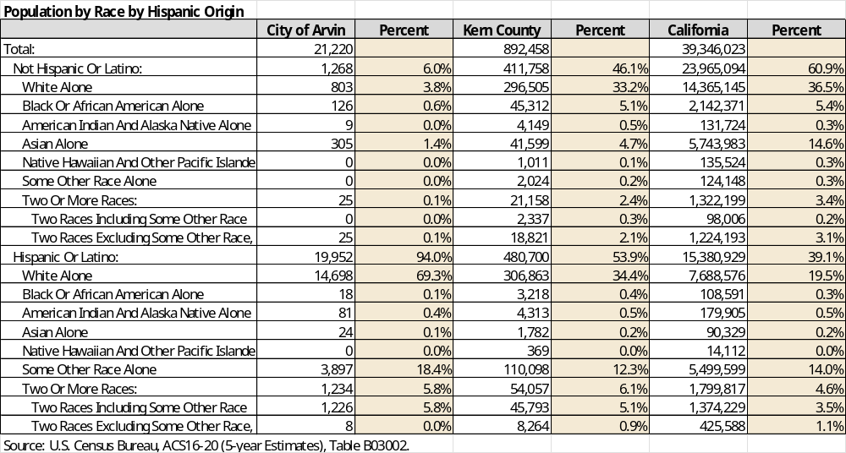

GINI Index
The GINI index is a measure of the extent to which the distribution of income among families/households within a community deviate from a perfect equal distribution. The scale is from 0 to 1, with 0 representing perfect equality and 1 representing the highest possible level of inequality. Gini coefficient for California is 0.487. City of Arvin’s Gini index is 0.371. City of Delano in Kern County has an index of 0.434, whilst the community of Lamont within the unincorporated area D of Kern County has a Gini index of 0.403 (source: California Open Data Portal – Income Inequality). The lower Gini index in Arvin is reflective of the low median income levels as shown in Figure 12.
Disparities in Access to Opportunities
The condition of housing in Arvin varies from excellent to poor, generally based on the age of the housing. Approximately 40% of the housing stock is 40 to 50 years and are in need of structural renovation and maintenance. Overall, the condition of the neighborhoods is fair with all neighborhoods connected to water and sewer and with much of the city developed with curb, gutter, and sidewalks. The city has been proactive in seeking grant funding to create safe routes to school, has applied for and received grant from Cal Trans which developed a Safe Routes to School. Where new development is approved, the city requires the installation of curbs, gutter and sidewalks.
The city is isolated from other unincorporated communities of Kern County and located approximately 12 miles for the City of Bakersfield. The Arvin Transit provides express service to the Tejon Ranch for Arvin’s residents. The City of Arvin Transportation Department is known for providing safe and reliable transportation for residents and visitors alike. With convenient schedules that run from 4 am to 4:30 pm, the Transportation Department also provides round trip bus service to Lamont, Tejon Ranch, and Bakersfield. As the City of Arvin grows, the Transportation Department is keeping pace, researching key areas and studying possible new bus routes as riders' needs expand. Their modern fleet is equipped with lifts and bike racks and provides comfortable transport for a wide range of patrons. As is the case throughout the City, the residents of these areas have access to Arvin Transit and Dial-A-Ride programs for public transportation. The city currently has 18 local stops. There are a number of Arvin’s residents employed at the Kern County’s Tejon Ranch commercial center.
Figure 1
City of Arvin Annexation & Sphere of influence
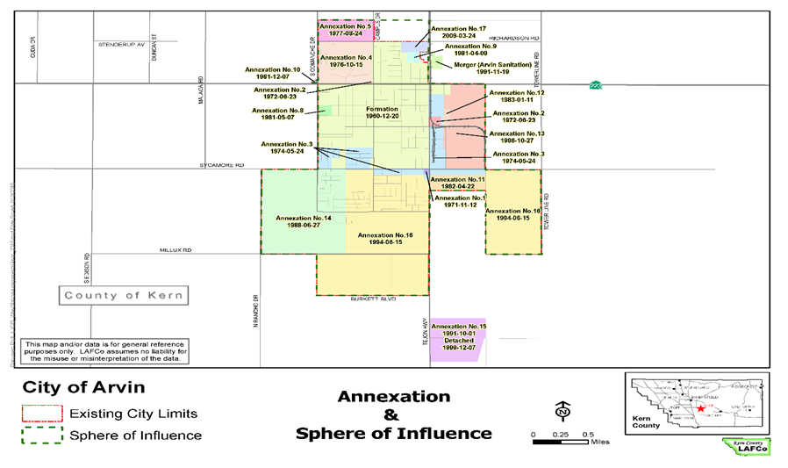

Figure1 shows the City’s annexation and sphere of influence. The condition of housing in the area varies from excellent to poor, generally based on the age of the housing. Some 24% of the housing is built before 1970. Overall, the condition of the neighborhoods is fair with all neighborhoods connected to water and sewer and with much of the city developed with curb, gutter, and sidewalks. The city has applied for and received grant from Cal Trans which developed a Safe Routes to School. The city is being proactive in seeking grants to create safe routes to schools. Where new development is approved, the city requires the installation of curbs, gutters and sidewalks.
The Arvin Transit provides express service to the Tejon Ranch for Arvin’s residents. The City of Arvin Transportation Department is known for providing safe and reliable transportation for residents and visitors alike. With convenient schedules that run from 4 am to 4:30 pm, the Transportation Department also provides round trip bus service to Lamont, Tejon Ranch, and Bakersfield. As the City of Arvin grows, the Transportation Department is keeping pace, researching key areas and studying possible new bus routes as riders' needs expand. Their modern fleet is equipped with lifts and bike racks and provides comfortable transport for a wide range of patrons. As is the case throughout the City, the residents of these areas have access to Arvin Transit and Dial-A-Ride programs for public transportation. The city currently has 18 local stops. There are a number of Arvin’s residents employed at the Kern County’s Tejon Ranch commercial center.
The City has considered trends and patterns related to integration and segregation based on racial and ethnic factors, disability, family status, seniors, and median household income. City of Arvin faces some unique challenges compared to Kern County as a whole, as a significantly higher proportion of Arvin’s households are under the poverty line (29.6%). 94% of the city’s population are Hispanic/Latino compared to 54% in Kern County and 39% in California. As a result, there is very high linguistic isolation that needs to be addressed.
Arvin has a very low percentage of people with disabilities <5%), compared to 11% in Kern County and California. 92.9% of the households in Arvin are Family Households, which is much greater than 73.8% in Kern County and 68.6% in the State. Arvin also has a very high proportion of married couple households (64.6%) compared to 50.5% in the County and 49.6% Statewide. 18% of the households in Arvin are female headed households which is much lower than the 24.5% Countywide and 26.2% Statewide. However, 60.8% of female headed households in Arvin are below the poverty line. There are some patterns of isolation or segregation apparent especially with female headed households. Segregated areas with higher poverty levels are to the south of East Bear Mountain Boulevard and north of Sycamore Road.
Some 37.6% of the households in Arvin are large family households with 5 or more persons compared to 17.9% Countywide and 13.6% Statewide. 61.9% of the households have 4 persons or more compared to 35% in the County and 28.4% in the State. This demonstrates the need for large housing units in the City. The city also has a significant need for dependent care and support systems for young children and youth, as 11.8% of the population are under 5 years old and 27% of the population are between the ages of 5 and 17. This is significantly higher than 7.7% and 21.2% of the population respectively in the County.
Only 11.4% of the households in Arvin are senior households compared to 21.2% in the County and 24.4% in the State. Arvin will continue to participate in the implementation of Kern County housing programs and the Housing Plan. The city will continue to consider these findings in relation to program funding and resources to further reduce poverty levels, any patterns of isolation and segregation and work collaboratively with the County and State to increase access to housing, particularly for female headed households and large family units.

.

FIGURE 2 CENSUS TRACT BOUNDARIES
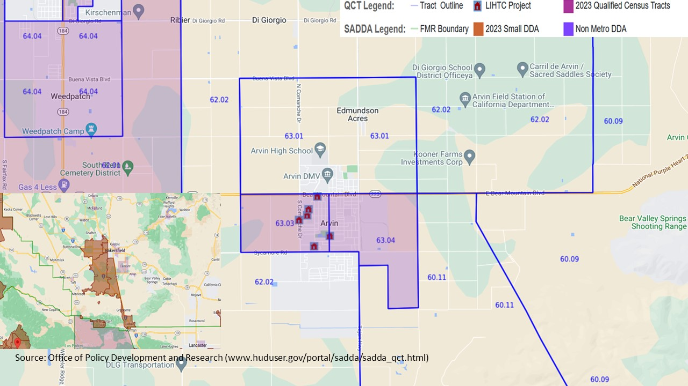

FIGURE 3: HOUSING CHOICE VOUCHERS BY CENSUS TRACT AND SUBSIDIZED HOUSING
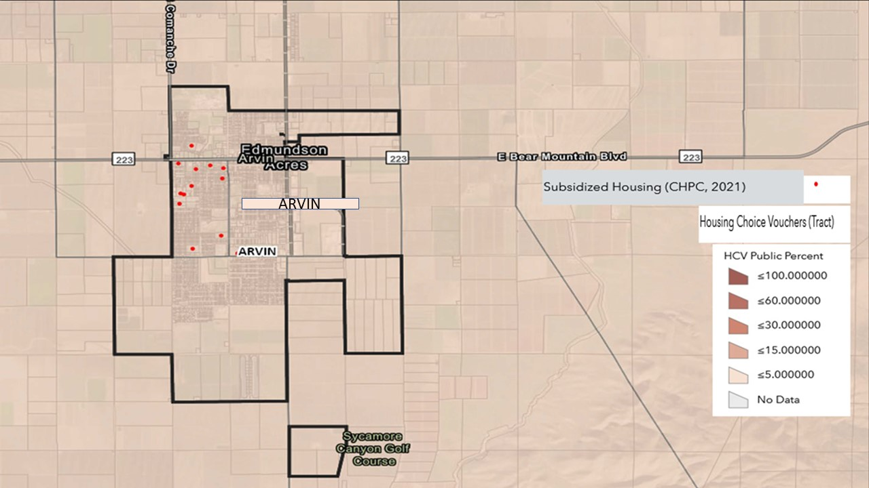

Sources: Kern Council of Governments Housing Needs Mapping Tool/ AFFH HCD 2.0

FIGURE 4: PUBLIC HOUSING BUILDING, LIHTC AND MULTIFAMILY PROPERTIES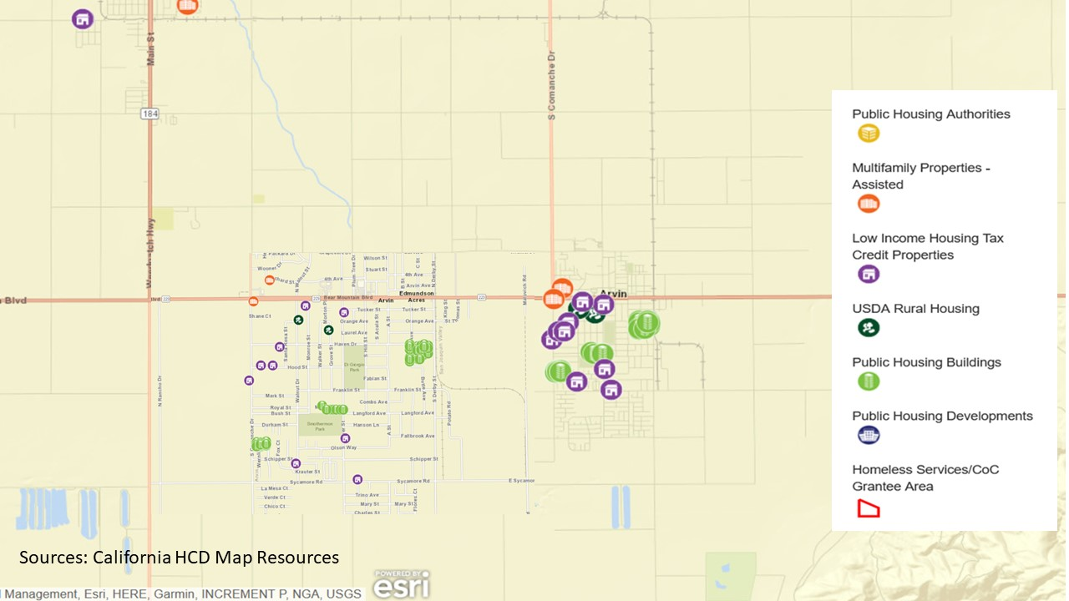

FIGURE 5: LINGUISTIC ISOLATION PERCENTILE
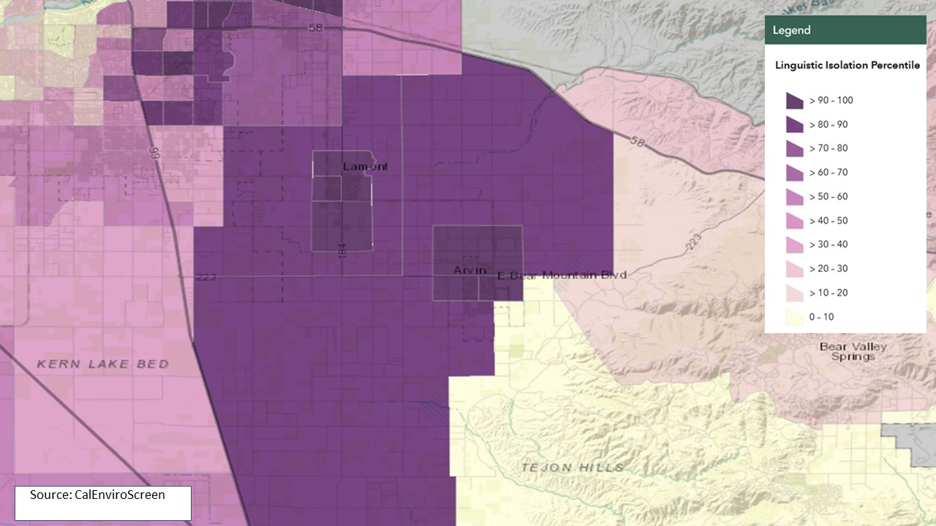

FIGURE 6: 2018 DIVERSITY INDEX
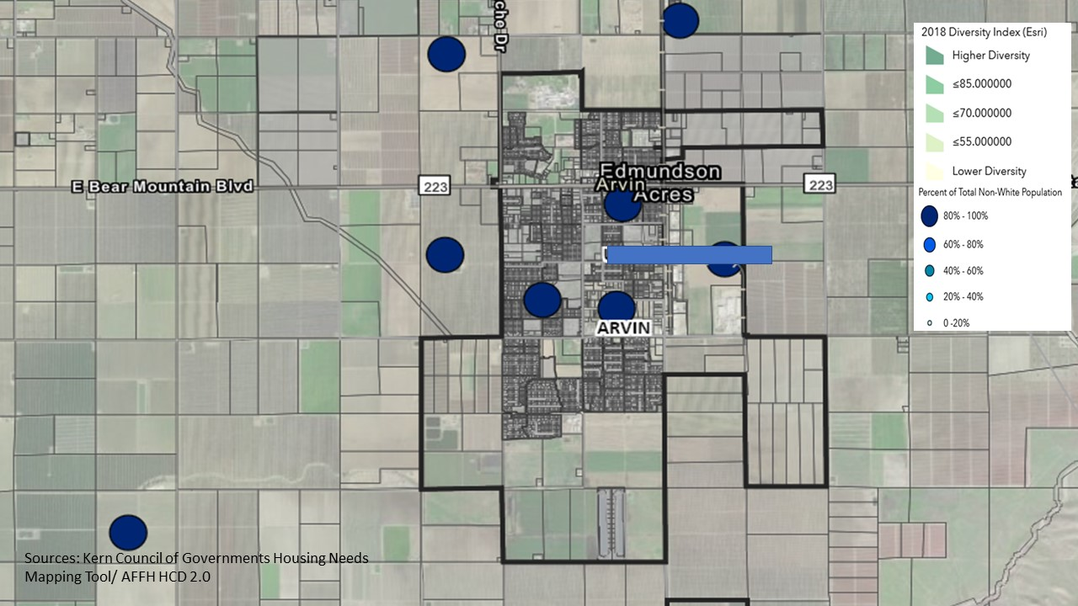

Dissimilarity Index
Another way to measure segregation is by using a dissimilarity index. This index measures how evenly any two groups are distributed across neighborhoods relative to their representation in a city overall. The dissimilarity index at the jurisdiction level can be interpreted as the share of one group that would have to move neighborhoods to create perfect integration for these two groups.
The dissimilarity index ranges from 0 to 1. Higher values indicate that groups are more unevenly distributed (e.g., they tend to live in different neighborhoods).
Table 3 below provides the dissimilarity index values indicating the level of segregation in Kern County between White residents and non-White residents across four time periods (2010, 2018, 2020, and 2021).

Table 3
Racial Dissimilarity Index Values for Kern County
Race | 2010 | 2018 | 2020 | 2021
White to Non-White Racial Dissimilarity | 0.49 | 0.487 | 0.507 | 0.50

Source: FRED Economic Data (fred.stlouisfed.org)

The high dissimilarity index reflects the increase in non-white population in Kern County. Considering the population distribution in Arvin of 94% Hispanic/Latino, Arvin will also have a high dissimilarity index.
Mapped Patterns of Integration and Segregation
Patterns of integration and segregation are considered for people with disabilities, familial status, and income groups. Relying primarily on data available from the US Census, it is possible to map and consider existing patterns which may indicate historical influences and future trends by census tract and census block groups.
Predominant Racial/Ethnic Population
The predominant race/ethnic population by census tract for Kern County is 56.1% Hispanic or Latino; 31.1% White alone, not Hispanic or Latino; 6% Black or African American; 5.6% Asian; and 2.8% American Indian and Alaska Native. Kern County overall is more diverse than City of Arvin (source: US Census).
Figure 7 shows the predominant racial/ethnic population by census tract for Arvin and surrounds. The predominant population in City of Arvin in 2020 is a Hispanic majority of 94% and 6% non-Hispanic population. Arvin’s Hispanic population was 87.5 percent of the total population in the year 2000. The percentage of population that are White residents decreased from 9.8% in 2000 to 3.8% in 2020.
Concentrations of Race and Ethnicity
Figure 8 provides another look at concentration of race in Arvin by affluence or poverty. It doesn’t show demarcation based on race; however, it does show pockets of poverty south of East Bear Mountain Boulevard. As outlined in Table 2 B, out of the 94% of the population that are Hispanic/Latino, 69.3% are White Alone, 18.4% are Some Other Race Alone and 5.8% are Two or More Races. As shown in Figure 7, the central and northern areas of the city have pockets of non-white population of greater than 80%. Out of the 6% Non-Hispanic population, 3.8% are White Alone, 1.4% are Asian and 0.6% are Black or African American Alone.
Figure 6 depicts the diversity index in 2018. There is more diversity around Kovacevich Park, areas north of East Bear Mountain Boulevard and areas south of East Bean Mountain Boulevard and west of N Derby St, and mostly these areas have a higher number of vacant land parcels.

Population with a Disability
As shown in Figure 9, the city of Arvin mostly has a disability rate of <10% with the south east portion of the city having a rate of 10-20%. Approximately 5% of the population in Arvin has a disability compared to approximately 11% of the population in Kern County and the state of California. As per the 2020 American Community Survey, among Arvin’s population between the ages of 18 and 64, 5.6 percent were classified as having a disability. About 4.7 percent of the total population were aged 65 and older, of which about 33 percent were found to have one or more forms of disability. Table 4 (Table 26 of Housing Element) shows that of the five percent of the total population with a disability, the most prevalent disability was ambulatory difficulties (53.8%). The mobility limitation does not necessarily indicate a need for special need/supportive housing and statistics on the total number of disabled persons needing supportive housing in the city is not available. Using the national standard of one to three percent of the total disabled population needing supportive housing, it can be estimated that the city has approximately 15 to 45 disabled individuals in need of supportive housing.
Table 4:
Disability by Type for the Population with a Disability (Detailed)

 | City of Arvin | Percent | Kern County | Percent | California | Percent
With One or More Types of Disability | 1,067 | 5% | 98,426 | 11.4% | 4,146,951 | 10.7%
Hearing Difficulty | 211 | 19.8% | 23,470 | 23.8% | 1,147,500 | 27.7%
Vision Difficulty | 115 | 10.8% | 19,029 | 19.3% | 778,145 | 18.8%
Cognitive Difficulty | 392 | 36.7% | 36,914 | 37.5% | 1,585,969 | 38.2%
Ambulatory Difficulty | 574 | 53.8% | 51,480 | 52.3% | 2,118,765 | 51.1%
Self-Care Difficulty | 361 | 33.8% | 21,131 | 21.5% | 964,579 | 23.3%
Independent Living Difficulty | 292 | 27.4% | 35,762 | 36.3% | 1,654,210 | 39.9%
Source: U.S. Census Bureau, ACS16-20 (5-year Estimates), Table B18102 - B18107.

To assist disabled individuals in providing adequate housing to meet their needs, the State of California, in 1984, mandated Title 24, of the Uniform Building Code. Title 24 provides regulations for adaptability and accessibility of apartment units to provide for the safety and welfare of physically disabled inhabitants and visitors. An adaptable apartment is one that is accessible for entry and circulation and that can at any future point, be adapted to meet the specific needs of a person with disabilities. These improvements would include the installation of wider doors, grab bars, lower cabinets, lower light switches and sidewalk-to-front door ramps.
For persons with mental illness, the Mental Health Services Department provides a full range of services throughout the County. Services include initial assessment, crisis services, ongoing case coordination, case management, and counseling services, among others. Hospitalization and inpatient treatment and placement programs may be contracted for the Department with private providers.
Several County programs assist persons with physical disabilities. The Community Development Program Department operates the Home Access Program, providing grants for home accessibility improvements. In addition, HACK has made five percent of the affordable public housing stock accessible to persons with physical disabilities (45 units), and two percent of units adaptable to the sensory impaired (18 units).
FIGURE 7: PREDOMINANT POPULATION BY CENSUS TRACTS
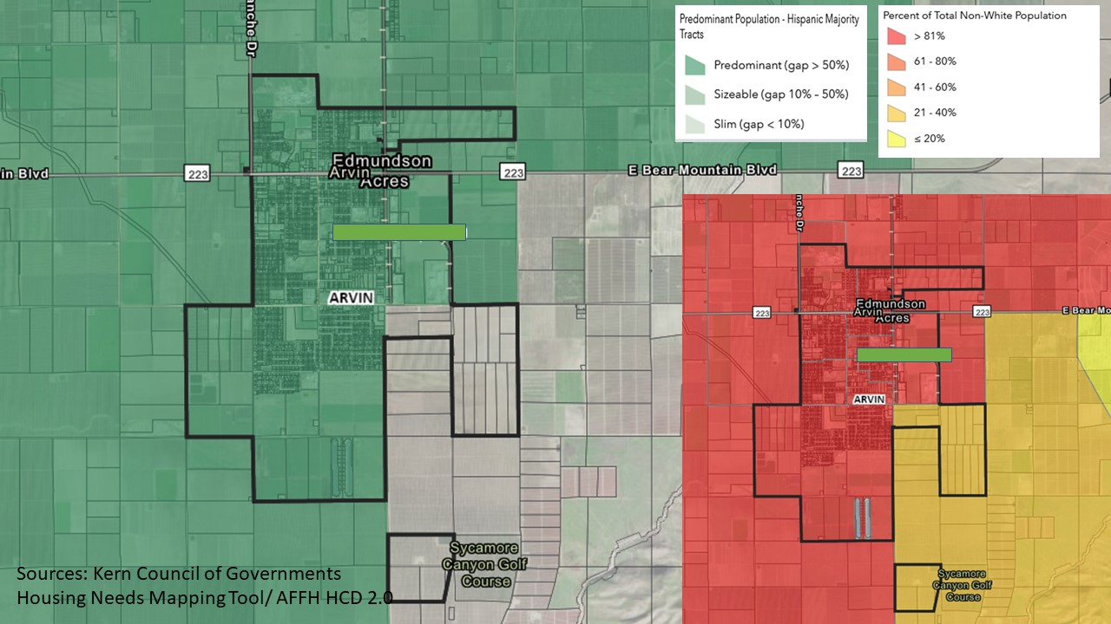

City of Arvin, 2023-2031 Housing Element | AFFHA 21

FIGURE 8: RACIALLY CONCENTRATED AREAS OF AFFLUENCE/POVERTY

FIGURE 9: PERCENT OF POPULATION WITH A DISABILITY

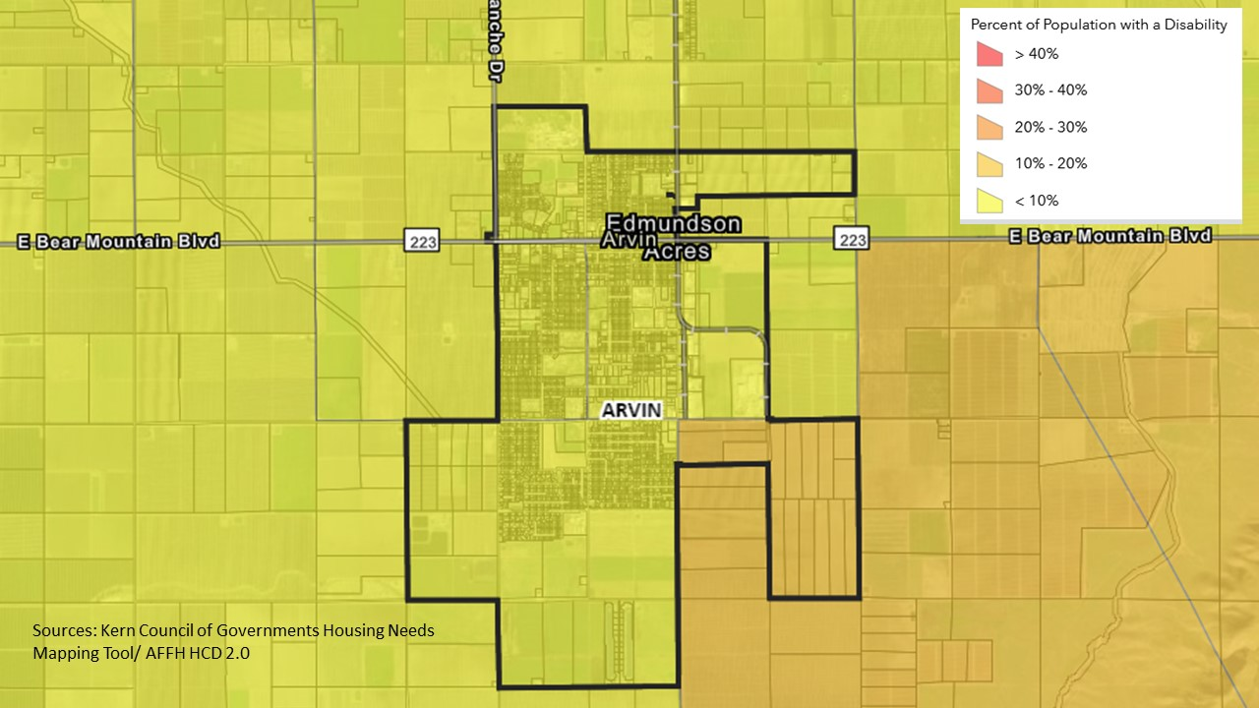

Percent of Population 18 Years and Over in Households Living with Spouse
Figure 10 identifies the percent of population over the age of 18 years and over in households living with spouse in Arvin. As shown in Table 5 (Table 31 in Housing Element), 92.9% of households in Arvin are family households, which is significantly greater than the averages for Kern County and California. Arvin also has larger households with more 3,4,5,6 and 7 person households compared to Kern County and the State.
Table 6 shows that 64.6% of total households in Arvin are married couple households, and an additional 9.9% households are cohabiting couple households. This is significantly greater than the average of approximately 50 percentage of households in Kern County and State of California.

Table 5
Households by Size
 | City of Arvin | Percent | Kern County | Percent | California | Percent
Total: | 4,711 |  | 273,556 |  | 13,103,114
Family Households: | 4,377 | 92.9% | 201,939 | 73.8% | 8,986,666 | 68.6%
2-Person Household | 613 | 13.0% | 63,848 | 23.3% | 3,209,170 | 24.5%
3-Person Household | 849 | 18.0% | 42,009 | 15.4% | 2,054,635 | 15.7%
4-Person Household | 1,145 | 24.3% | 46,904 | 17.1% | 1,945,127 | 14.8%
5-Person Household | 731 | 15.5% | 27,461 | 10.0% | 1,006,126 | 7.7%
6-Person Household | 596 | 12.7% | 12,948 | 4.7% | 433,324 | 3.3%
7-Or-More Person Household | 443 | 9.4% | 8,769 | 3.2% | 338,284 | 2.6%

Percent of Children in Married Households
As shown in Figure 11, the percentage of children in married couple households vary across different areas of Arvin. Greater than 60% of households north of East B Mountain Boulevard and South of Sycamore Road have children in married households. Households south of East B Mountain Boulevard and North of Sycamore Road have more single parent female headed households.
Female-headed Households
Figure 12 identifies the percent of population in female-headed households. 18% of total households in Arvin are Female Headed Households compared to 24.5% in Kern County and 26.2% in the State of California. Arvin has a higher number of female-headed households south of East Bear Mountain Boulevard and North of Sycamore Road. These are also vulnerable sensitive households with higher levels of poverty. As shown in Table 5 (Table 31 in Housing Element), of the 4,711 total households in Arvin, female householders with no spouse or partner present accounted for 848 households or 18 percent. 60.8% of female headed households with children are below the poverty line. 11.8% of households have their own children under 18 and 4.4% of households living with children under the age of 18 who are not their own.

Families with female heads of household typically display a need for housing assistance due to the demand for day care services and lower wages earned and is therefore identified as a special needs group. Among married couple households, only 20.08 percent were below the poverty line, whereas among households with no spouse present, 60.8 percent were below the poverty line.
Single individuals with dependent children face a variety of housing problems. Single parent renters often have difficulty finding suitable housing due to the high cost of rent compared to income, as well as discriminatory housing practices. These problems are of particular concern for family households with a single female householder. Though the majority of female households were in the labor force, this segment of the community generally represents one of the lowest categories of wage earners as compared to other householders.

Table 6
HOUSEHOLDS BY TYPE

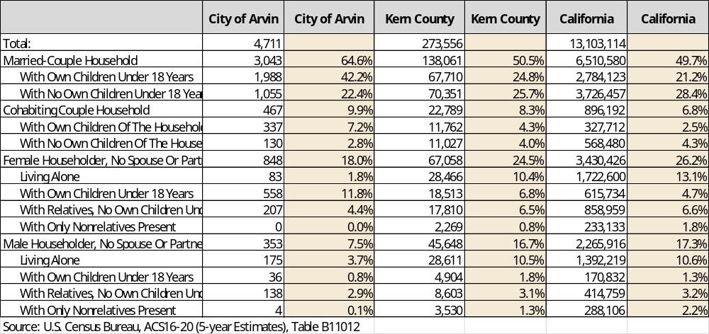

Large Families
Large families are defined as households with five or more members. Many large families are forced to occupy inadequately sized units because housing units that meet their needs are either unavailable or beyond their ability to pay. Table 5 shows that 37.6% percent of family households and zero percent of the non-family households in Arvin were composed of five or more persons, which by the State Department of Housing and Community Development (HCD) definition is considered “large households”. This is significantly more than the countywide proportion of large households of 17.9%, and State of California’s proportion of 13.6% large households. Also, 61.9% of households in Arvin have 4 or more persons compared to 35% in Kern County and 28.4% in the State of California. This indicates a need for larger units for large households in the city. To address overcrowding, communities can provide incentives to facilitate the development of affordable apartments with three or more bedrooms to meet the needs of large households.
The shortage of large rental units can be alleviated through the provision of affordable ownership housing opportunities, such as homeownership assistance and self-help housing (through Habitat for Humanity and other organizations). In addition, Section 8 rental assistance provided by HACK can enable large families to rent units they otherwise cannot afford. HACK currently operates 941 public housing units, of which 123 are single-family units that can accommodate larger families. The County has also contributed CDBG and HOME funds to assist in the development of housing for large families.

Farmworkers
Agriculture is a key economic industry in Kern County, and particularly in Arvin. Agriculture plays a major role in the lives of Arvin’s residents. Classified in terms of industry, 3,565 individuals were employed in agriculture, forestry, fishing and hunting, and mining positions, representing 47.5 percent of the total civilian employed population ages 16 and older of 7,511. In comparison, the Kern County average for these economic sectors was 14.7 percent. Almost all of those Arvin residents employed in this sector were in agriculture.
There were 1,731 farms located in Kern County according to the USDA 2017 Census of Agriculture. Some 22 percent of the farms employed only a single farm worker; some 46 percent employed between two and nine workers, and some 32 percent were larger farms employing ten or more workers. Table 7 (Table 28 of Housing Element) also indicates that migrant workers totaled 6,062, representing approximately 30 percent of total farm workers. Farmworkers are generally considered to have special housing needs because of their limited income and their seasonal and migratory nature of their work.

Table 7
Kern County – Farm Labor (2017)

Category | Farms | Percent | Workers | Percent
Farms with 1 worker | 186 | 22.01 | 186 | 0.91
Farms with 2 workers | 130 | 15.38 | 260 | 1.27
Farms with 3-4 workers | 125 | 14.79 | 429 | 2.10
Farms with 5-9 workers | 135 | 15.98 | 860 | 4.20
Farms with 10 or more | 269 | 31.84 | 18734 | 91.52
Total farms and workers | 845 | 100 | 20469 | 100
Migrant workers/ hired | 84 | 85.71 | 5779 | 95.33
Migrant workers/contract | 14 | 14.29 | 283 | 4.67
Total migrant workers | 98 | 100 | 6062 | 100
Source: USDA 2017 Census of Agriculture
https://www.nass.usda.gov/Publications/AgCensus/2017/Full_Report/Volume_1,_Chapter_2_County_Level/California/

In response to the need for farmworker housing and to comply with State Housing law, the City of Arvin adopted Ordinance No. 241 in July 2015, which amended the Zoning Ordinance to permit by-right housing reserved for person employed in various industries – though agriculture is the industry most often used in this category. Since agriculture is a key industry in Arvin, this is especially importance for farmworker housing. This ordinance permits by right up to six unrelated individuals to legally live in the same residential unit. Owners of employee housing are required to obtain a permit from the State Department of Housing and Community Development.
Housing options that are currently available to farm workers include privately- and publicly- owned farm worker housing. The 48-unit Sun Garden Village located at 701 Meyer Street is the only farmworker housing currently in Arvin. The Arvin Farm Labor Center #26 is located approximately five miles west of Arvin and has 88 units available for migrant farm workers.

Persons 65 Years of Age or Older
11.4% of households in Arvin have householders 65 years of age or older which is significantly lower compared to 21.2% in Kern County and 24.4% in the State of California. In 2012, 796 residents in Arvin were reported as 65 years or older, comprising 4.4 percent of the total population. As shown in Table 8 (Table 27 of Housing Element), there were 563 elderly households in the city in 2020 and about two-thirds (67.2%) live in owner-occupied units compared to 76.4% in Kern County and 73.4% in the State of California. There are high levels of home ownership in 65 years or older age group in comparison to 50.3 percent of the total households in the city residing in owner occupied units. 27.5% of the 65 years of age or older households have an income of less than $15,000 per annum. It is also important to note that about 33 percent of the elderly in Arvin are identified as disabled.
There are many programs to accommodate the special needs of seniors, including but not limited to congregate care, supportive services, rental subsidies, shared housing, and housing rehabilitation assistance. For the elderly, or those with disabilities, housing with functional design features that accommodate disabilities can help ensure continued independent living. Elderly with mobility/self-care limitations also benefit from transportation alternatives. Senior housing with supportive services can be provided for those who require assistance with daily living.
The Senior Citizens Information and Referral Service provides seniors with information on available services in the County, including Social Security, Medicare, Medi-Cal, nutrition sites, discount cards, and transportation information, among other things. The Office on Aging also operates 27 senior nutrition sites at senior and community centers throughout the County. Home delivered meals are also available upon request. In Arvin, the senior nutrition site is located at the Arvin Senior Center located at 800 Walnut Drive.

TABLE 8
Senior Households by Tenure

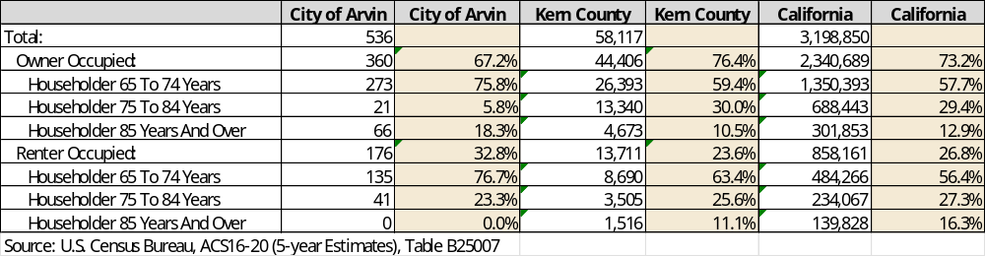

Median Household Income
The median household income of the city is $39,750, which is only 72.5% of the median income made by a household in Kern County and 50.5% of the median household income in the Sate of California. Median and mean incomes by household types in Arvin are shown in Table 9 (Table 12 of Housing Element). Non-families have the lowest median household income of $20,208 and married families have the highest median household income of $45,413. These income levels are significantly lower than Kern County and the State of California.

Table 9
Income by Household Types

Type | Median ($) | Mean ($)
Households | 39,750 | 49,056
Families | 40,459 | 48,841
Married Families | 45,413 | -
Non-Families | 20,208 | 27,272
Source: US Census 2020 ACS 5-Year Survey (Table S1901)

The median income by census tract is also low (<$55,000) in Arvin with some areas to the east and northeast having a median income of <$30,000 as shown in Figure 12. According to the U.S. Census Bureau, the estimated poverty threshold for a four-person household was approximately $26,496 in 2020. For two-person households, the threshold was $15,659 if the householder was age 65 or older, and $17,413 for householders under 65 years. Approximately one-third (29.6%) of the households (2020 census data) in Arvin were below the poverty level, while 16.7 percent of the County’s households and 9% of the State of California’s households were below the poverty level. As outlined in Table 10 (Table 13 of Housing Element), there are no changes to poverty levels over time in Arvin. Figures 8 and 13 also show the segregated areas with higher poverty levels, south of East Bear Mountain Boulevard and North of Sycamore Road in Census tracts 6029006303 and 6029006304, which are identified as Low-Income Community Opportunity Zones. Median household income, median household value, education (percentage of population with high school diploma), median age is all significantly lower compared to California.

Table 10
Households in Poverty over Time
 |  | 2010 | 2020
Households with Income in the Past 12 Months below Poverty Level |  | 1,045 | 1,294
Total Households |  | 3,497 | 4,377
Percent of Households in Poverty |  | 29.9% | 29.6%
Percent Change of Households in Poverty |  |  | 0.0%
Source: U.S. Census Bureau, ACS16-20 (5-year Estimates), Table B17019. HCD Data Packet

For senior citizen households (ages 65 years and over) the percentage of those below the poverty rate was 22 percent and for children under 18 the poverty rate is 40% in Arvin. 18 percent of households in Arvin are female headed households with children. 60.8% of these households are below the poverty line as shown in Table 11. Patterns of segregated economic wealth, albeit lower income levels, do exist in Arvin as illustrated in Figure 13. Poverty levels are greater than 40% for areas south of East Bear Mountain Boulevard and North of Sycamore Road. This coincides with areas that have a high percentage of female headed households with low median income in line with the higher levels of poverty amongst this group.
The dependency ratio as outlined in Table 12 (Table 3 of the Housing Element), which is the ratio of the population under 18 and over 65 years of age to the population 18 to 64, is an indicator of the reliance of children and senior citizens on the working age population. The lower the dependency ratio, the lesser the “burden” is on a community’s working age residents. Table 12 shows that on average, a working age
individual in the City of Arvin must support more dependents (0.77) than a working age resident in Kern County (0.66), which again indicates the need for dependent care and support systems for young children and youth.
Table 11
Poverty Status of Families by Family Type and Marital Status

Poverty | Married-couple |  | With no spouse present
Below Poverty Line | 611 | 20.08% | 594 | 60.8%
Above Poverty Line | 2432 | 79.92% | 383 | 39.2%
Total | 3043 | 100% | 977 | 100%
Source: U.S. Census Bureau, ACS16-20 (5-year Estimates), Table B17010
Note: The Census Bureau uses a federally defined poverty threshold that remains constant throughout the country and does not correspond to Area Median Income.

Table 12
Age Distribution and Dependent Population – Year 2020

Age Group | Arvin | Kern County
Under 5 | 11.8% | 7.7%
5-17 | 27.0% | 21.2%
18-34 | 26.1% | 25.7%
35-64 | 30.2% | 34.4%
65+ | 5.0% | 10.9%
Median Age | 24.7 | 31.9
Age Dependency Ratio | 77.8 | 66.4
Child Dependency Ratio | 69.0 | 48.1
Old-Age Dependency Ratio | 8.8 | 18.2
Source: 2020 ACS 5-Yr Est. Table S0101

As described in the Housing Element, City of Arvin is committed to supporting the development of fair and affordable housing for lower income households in locations throughout the city. Sites are identified for future growth and development that are designed to promote a more balanced and integrated pattern of household incomes.
Findings
The City has considered trends and patterns related to integration and segregation based on racial and ethnic factors, disability, family status, seniors, and median household income. City of Arvin faces some unique challenges compared to Kern County as a whole, as a significantly higher proportion of Arvin’s households are under the poverty line (29.6%). 94% of the city’s population are Hispanic/Latino compared to 54% in Kern County and 39% in California. As a result, there is very high linguistic isolation that needs to be addressed.
Arvin has a very low percentage of people with disability (<5%), compared to 11% in Kern County and California. 92.9% of the households in Arvin are Family Households, which is much greater than 73.8% in Kern County and 68.6% in the State. Arvin also has a very high proportion of married couple households (64.6%) compared to 50.5% in the County and 49.6% Statewide. 18% of the households in Arvin are female headed households which is much lower than the 24.5% Countywide and 26.2% Statewide. However, 60.8% of female headed households in Arvin are below the poverty line. There are some patterns of isolation or segregation apparent especially with female headed households. Segregated areas with higher poverty levels are to the south of East Bear Mountain Boulevard and north of Sycamore Road.
37.6% of the households in Arvin are large family households with 5 or more persons compared to 17.9% Countywide and 13.6% Statewide. 61.9% of the households have 4 persons or more compared to 35% in the County and 28.4% in the State. This demonstrates the need for large housing units in the City. The city also has a significant need for dependent care and support systems for young children and youth, as 11.8% of the population are under 5 years old and 27% of the population are between the ages of 5 and 17. This is significantly higher than 7.7% and 21.2% of the population respectively in the County.
Only 11.4% of the households in Arvin are senior households compared to 21.2% in the County and 24.4% in the State. Arvin will continue to participate in the implementation of Kern County housing programs and the Housing Plan. The city will continue to consider these findings in relation to program funding and resources to further reduce poverty levels, any patterns of isolation and segregation and work collaboratively with the County and State to increase access to housing, particularly for female headed households and large family units.

- RACIALLY OR ETHNICALLY CONCENTRATED AREAS OF POVERTY (R/ECAP)
HUD has developed a census tract-based definition of R/ECAPs to assist communities in identifying racially/ethnically concentrated areas of poverty (R/ECAPs), R/ECAP is defined as a racial/ethnic concentration threshold and a poverty test. The racial/ethnic concentration threshold is straightforward: R/ECAPs must have a non-white population of 50 percent or more. Regarding the poverty threshold, Wilson (1980) defines neighborhoods of extreme poverty as census tracts with 40 percent or more of individuals living at or below the poverty line. Because overall poverty levels are substantially lower in many parts of the country, HUD supplements this with an alternate criterion. Thus, a neighborhood can be a R/ECAPs if it has a poverty rate that exceeds 40% or is three or more times the average tract poverty rate for the metropolitan/micropolitan area, whichever threshold is lower.
According to the HCD AFFH Dataset, there is no R/ECAP in the City of Arvin as shown in Figure 8. There are no racial or ethnic segregation in Arvin. 94% of the population is Hispanic/Latino. Figure 8 shows segregated areas of poverty but these areas have no correlation to race. ethnicity. The segregated areas of poverty (shown in red in Figure 8) to the south of East Bear Mountain Boulevard and north of Sycamore Road. Comparing Figures 12 and 7 on Household Income and Diversity (Predominant Population by Census Tract), no correlation was found between lower incomes and low diversity. There are no issues found in relation to segregation and integration, lack of access to opportunities or disproportionate impacts as a result of race, ethnicity, or special needs of the population. The City, has two areas of segregation due to poverty within the City boundary (Figure 8 – Racially Concentrated Areas of Affluence Poverty). The two areas are south of West Bear Mountain Boulevard. The Housing Plan includes programs to encourage diversity and support housing needs in the city. Figure 13 also shows that there is income segregation (>40% poverty) in this area.
The 2020 US Census data defines Hispanic or Latin populations as persons of Cuban, Mexican, Puerto Rican, South or Central American, or other Spanish culture or origin regardless of race and defines the White Alone populations as persons having origins in any of the original peoples of Europe, the Middle East, or North Africa, such as persons of Irish, German, Italian, Lebanese, Arab, Moroccan, or Caucasian descent.
According to 2020 Census data, the largest minority population represented in Kern County and the City of Arvin is Hispanic or Latino, which make up 56.1% of the population in Kern County and 94% in the City of Arvin. The City of Arvin has no areas within the city limits that are considered less than 60% non-white.
To counter potential impacts of furthering socioeconomic segregation, and to promote neighborhood equity, stabilization, and housing mobility, the city will implement various programs, including, but not limited to, the following:
These programs will allow for the continued development of affordable housing, greater housing opportunities, utilize renter assistance programs, and community engagement strategies to support better integration and neighborhood equity throughout the City.
- RACIALLY/CONCENTRATED AREAS OF AFFLUENCE (RCAA)
“Segregation is a continuum, with polarity between race, poverty, and affluence, which can be a direct product of the same policies and practices” in accordance with the Guidance Memo issued by the Housing and Community Development AFFH. While HCD does not have a standard definition for RCAAs, looking at the percentage of the White population and median household income can provide a good indicator for areas of affluence.
In addition to RECAPs utilized by HUD, scholars at the University of Minnesota Humphrey School of Public Affairs created the Racially Concentrated Areas of Affluence (RCAAs) metric to tell the story of segregation more fully in the United States5. RCAAs are defined as census tracts where 1) 80 percent or more of the population is White, and 2) the median household income is $125,000 or greater (slightly more than double the national median household income in 2016).
Table 13 (Housing Element Table No. 4) on Median Household Income by Race or Hispanic Origin in City of Arvin, the median household incomes of White, non-Hispanic residents in City of Arvin are not greater than other races. However, this is not the case for County as whole. There is no census block in the city with a median household income of $125,000 and a population that is 80 percent or more White. As such, there are no census tracts in Arvin that fit these criteria, and it can be concluded that the City has no RCAAs.

Table 13
Median Household Income by Race or Hispanic Origin
 | City of Arvin | Kern County | California
White Alone Non-Hispanic | $37,969 | $66,163 | $90,496
Black or African American Alone Non-Hispanic | $47,059 | $39,422 | $54,976
American Indian And Alaska Native Alone Non-Hispanic |  | $49,412 | $60,182
Asian Alone Non-Hispanic |  | $74,021 | $101,380
Native Hawaiian And other Pacific Islander Alone Non-Hispanic |  | $73,750 | $81,682
Some Other Race Alone Non-Hispanic | $43,442 | $49,168 | $59,287
Two Or More Races Non-Hispanic | $31,588 | $49,484 | $76,733
Hispanic Or Latino of Any Race | $39,469 | $47,095 | $62,330
Source: U.S. Census Bureau, ACS16-20 (5-year Estimates), Table B19013.

- DISPARITIES IN ACCESS TO OPPORTUNITIES
The Department of Housing and Community Development (HCD) together with the California Tax Credit Allocation Committee (TCAC) established the California Fair Housing Task Force to provide research, evidence-based policy recommendations, and other strategic recommendations to HCD and other related state agencies/departments to further the fair housing goals (as defined by HCD).
The TCAC/HCD Opportunity Map was developed showing that the characteristics of neighborhoods – such as poverty rates and the quality of local public schools – substantially impact long-term outcomes for low-income families and children. The TCAC/HCD Opportunity Map identifies areas in every region of the state whose characteristics are most strongly associated with positive economic, educational, and health outcomes for low-income families – particularly long-term outcomes for children – when compared to other neighborhoods in the same region. The map also identifies areas in California that are both high-poverty and racially segregated.
In 2017, the California TCAC adopted the TCAC/HCD Opportunity Map and associated policies into the Low-Income Housing Tax Credit (LIHTC) program. Since then, the number of affordable housing developments funded in higher resource neighborhoods has increased.
The opportunity maps are made from composite scores of three different domains made up of a set of indicators. The Task Force analyzed three domains (Economic, Environmental, Education) to establish the resource category for each block group. The Economic Domain analyzes poverty, level of adult education, employment rates, job proximity, and median home value in each block group, while the Education Domain analyzes math/reading proficiency, high school graduation rates, and the student poverty rate. The Environmental Domain looks at the Cal Enviro Screen 4.0 Pollution indicators (Exposures and Environmental Effect indicators) and processed values. Figure 15 shows the locations of proposed vacant sites to accommodate the 6th Cycle RHNA. Table 14 shows the full list of indicators.

FIGURE 10: PERCENT OF POPULATION OVER 18 LIVING WITH SPOUSE

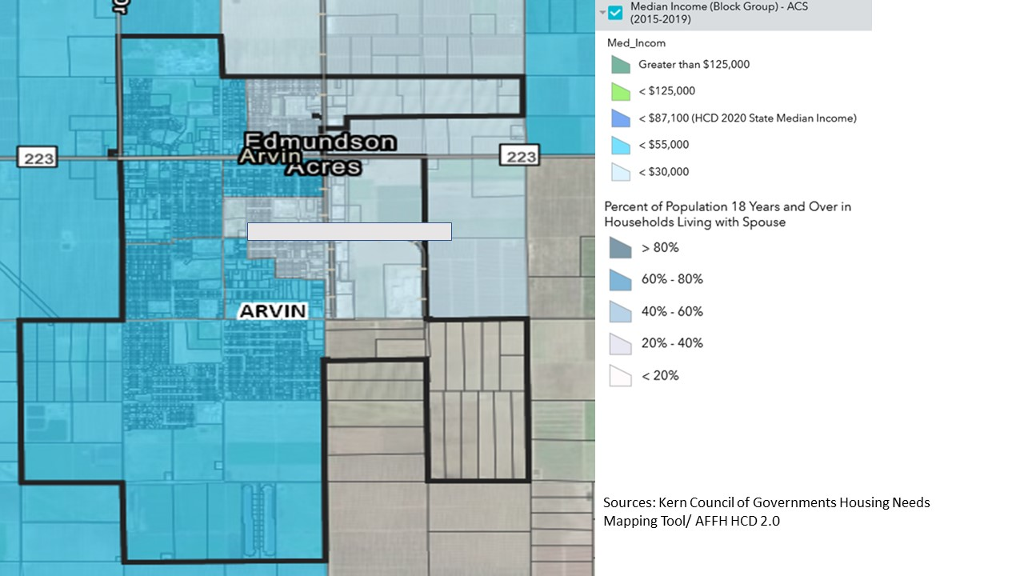
FIGURE 11: MEDIAN INCOME AND PERCENT OF CHILDREN IN MARRIED COUPLE HOUSEHOLDS

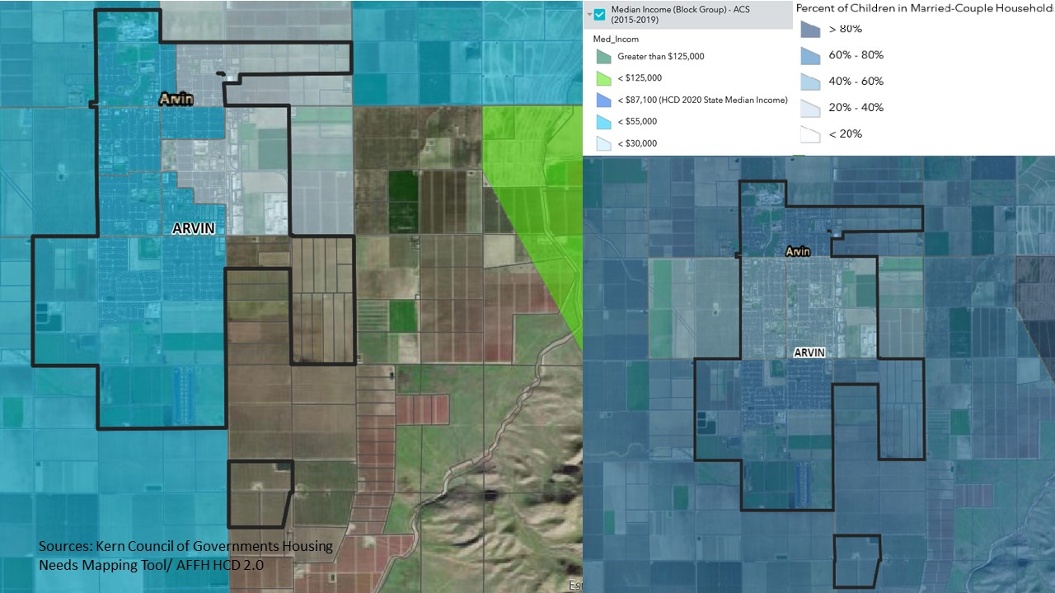

FIGURE 12: MEDIAN INCOME BY CENSUS BLOCK GROUP

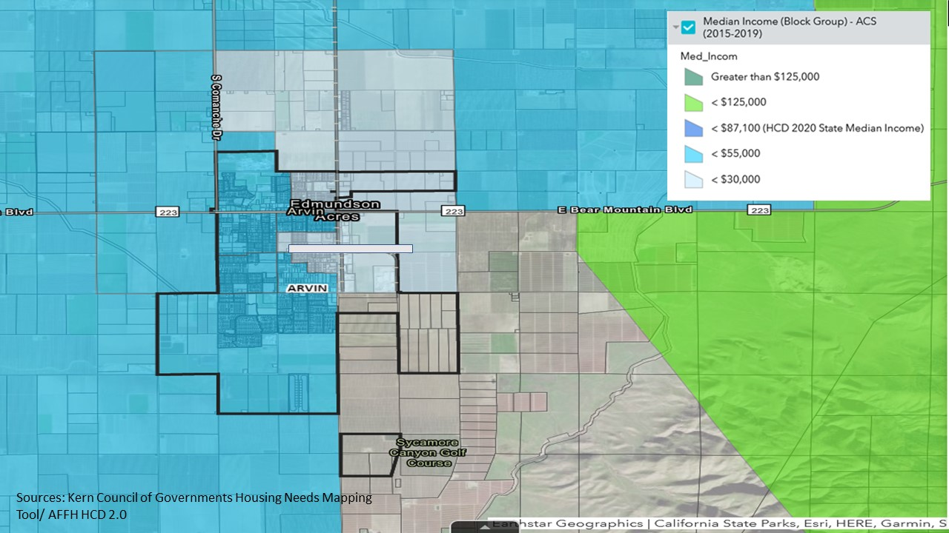
FIGURE 13: PERCENT OF POPULATION BELOW POVERTY LEVEL
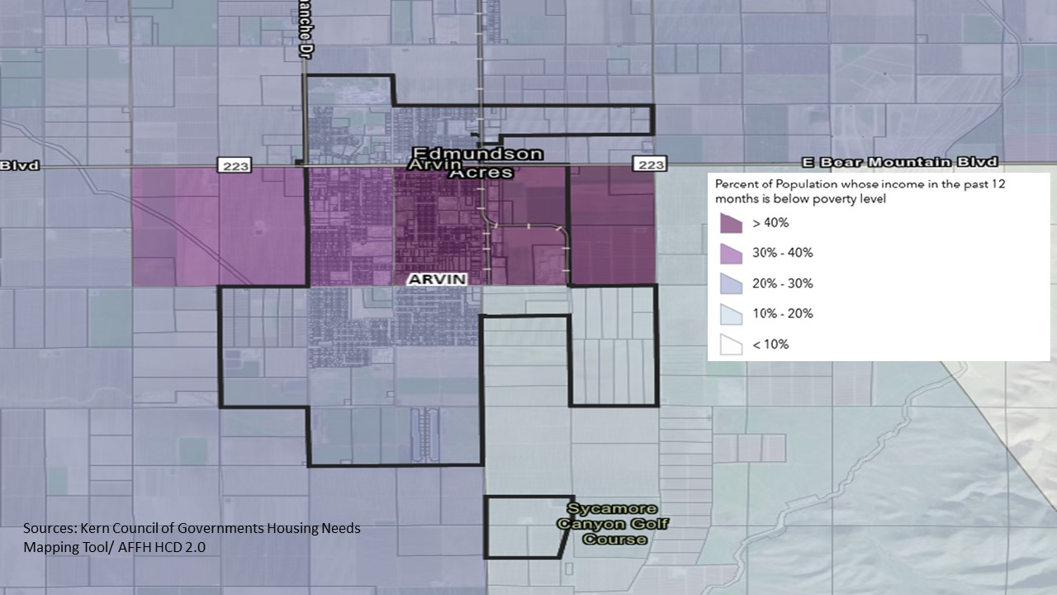

Table 14:
Domains and List of Indicators by Factors
Domain | Indicator
Economic | - Poverty  - Adult education  - Employment  - Job proximity  - Median home value
Education | - Math proficiency  - Reading proficiency  - High school graduation rates  - Student poverty rates
Environmental | - CalEnviroScreen values | 4.0 | pollution  indicator
Source: California Fair Housing Task Force, Methodology for TCAC/HCD Opportunity Maps, December 2020.

Based on the domain scores, census tracts are categorized as Highest Resource, High Resource, Moderate Resource, Moderate Resource (Rapidly Changing), Low Resource, or areas of High Segregation and Poverty. According to the Task Force’s methodology, the tool allocates the 20% of the tracts in each region with the highest relative index scores to the “Highest Resource” designation and the next 20% to the “High Resource” designation. Each region then ends up with 40% of its total tracts as “Highest” or “High” resource. These 2 categories are intended to help State decision-makers identify tracts within each region that the research suggests low-income families are most likely to thrive, and where they typically do not have the option to live—but might, if given the choice. The remaining tracts are then evenly divided into “Low Resources” and “Moderate Resource”.
Figure 16 identifies the final resource categories of each census block group, as identified on the TCAC/HCD Opportunity Map. No census block groups of the city have the highest levels of opportunity with a small block showing moderate levels of opportunity. City of Arvin is mostly identified has high segregation and poverty.
Table 15 identifies the opportunity resources levels by census block group and the corresponding scores for economic, educational, and environmental indicators.

Table 15
Opportunity Resource Levels by Census Tract
Census Tract | Block Group | Resource Level | Economic Score | Environmental Score | Education Score
6029006301 | 1 | Low Resource | 0.477 | 0.084 | 0.224
6029006301 | 2 | Low Resource | 0.57 | 0.084 | 0.196
6029006303 | 1 | High Segregation and Poverty | 0.421 | 0.103 | 0.224
6029006303 | 2 | High Segregation and Poverty | 0.29 | 0.103 | 0.327
6029006304 | 1 | High Segregation and Poverty | 0.243 | 0.252 | 0.224
6029006304 | 2 | High Segregation and Poverty | 0.393 | 0.252 | 0.224
6029006304 | 3 | High Segregation and Poverty | 0.654 | 0.252 | 0.327
6029006202 | 1 | Moderate Resource | 0.589 | 0.047 | 0.393
Source: California Department of Housing and Development, Affirmatively Furthering Fair Housing Data and Mapping Resources, accessed May 24, 2023

The City of Arvin has one census block group designated as moderate resource area on the TCAC/HCD Opportunity Map. A large portion of the city is designated as high segregation and poverty, and low resource area as shown in Figure 16. Figure 17 shows percentage of children in Female Householder and this area coincides with the high segregation and poverty areas shown in Figure 14.
Sites to accommodate the City’s lower-income 6th Cycle RHNA are generally located in low resource, and high segregation and poverty opportunity tracts. Given that the city does not have any high or highest resource areas, the City has no choice but to look at areas with lower levels of resources in order to accommodate new development. The City’s intent is to support new development by providing incentives to private investors through revised city ordinances and by committing to prioritize city investments in infrastructure (e.g., water supply and sewerage) to support these developments. Also, the City has distributed these units throughout the available resource levels to promote more equal and equitable patterns of opportunity.
The City of Arvin experienced a very small percentage of around 1% growth in population between 2010 and 2020. It has the highest percent of Hispanic or Latino population,94%, compared to Kern County and State of California. Excerpts from the Environmental Justice Element identify the City of Arvin as a Low-Income Community (EJ Element-2023). The City of Arvin is identified as a “disadvantaged community” as per Senate Bill 1000 (2016), it is considered a low-income community as per AB 1550). To facilitate good planning practices and to comply with applicable law, the City added the Environmental Justice Element to its General Plan. The Element will be used by the Arvin City Council, other boards, commissions and agencies, developers and the general public in planning for the physical and socio-economic development of the City.
The City of Arvin residents are in close proximity to schools, parks, and services. The City has parks within walking distance of the existing residential developments and as new developments occur, amenities such as schools and parks will be enhanced. Arvin currently has a park land-to-resident ratio of 2.7 acres per 1,000 residents. Although the state does not have any set park ratio standards, the Statewide Park Development and Community Revitalization Act of 2008 (AB 31) considers communities with less than three acres per 1,000 residents as a "critically underserved community". Four parks exist in the Arvin area on a total of approximately 43 acres. These parks include Di Giorgio Park, Kovacevich Park, Di Giorgio Park, Smotherman Park, and another recently open City park that has not yet been named. Figure CO-3 illustrates, Excerpt from the Conservation and Open Space Element, the location of these parks in the context of the City boundaries and other public services.
As outlined in the Housing Element, City of Arvin is committed to facilitating equal and fair housing opportunities by taking meaningful actions to affirmatively further fair housing and address impediments identified in this AFFH analysis. In summary, the city faces challenges in promoting and providing a range of housing types and prices suitable for lower income households. Providing a range of affordable housing can help foster more inclusive communities and increase access to opportunities for persons of color, persons with disabilities, and other protected classes.
In addition, the city intends to monitor the AFFH actions on an annual basis in conjunction with the preparation of the Annual Progress Report (APR) to ensure the goals are being met. If any action items are not being achieved, the city will adjust its metrics, timeframes, and commitments as necessary to ensure it meets its AFFH goals. There are a range of housing programs identified in the housing element that addresses the unmet needs of the community and achieves quantified objectives. These range from preserving the existing affordable housing stock, ensuring adequate availability of vacant land for development to removing governmental constraints with regard to development of ADUs, residential care facilities, employee housing etc.

Figure 14
TCAC/HCD – HIGH SEGREGATION AND POVERTY 2023
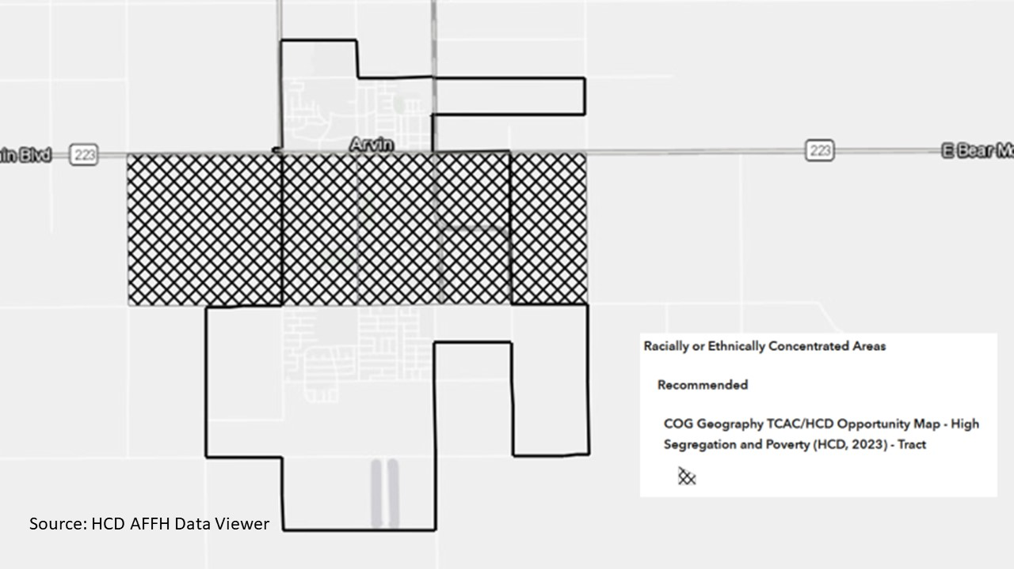

Economic Opportunity
The largest industries in Arvin in 2020 were Agriculture, Forestry, Fishing, Hunting, and Mining with 47.5% of total employment in this sector. This was followed by Educational Services, And Health Care and Social Assistance at 12.3%; Retail Trade at 9.7%; Transportation, Warehousing and Utilities at 6.1%; Construction at 5.2% and Manufacturing at 4.8%. As described above, the Fair Housing Task Force calculates economic scores based on poverty, adult education, employment, job proximity, and median home values. As shown in Table 15 above, the overall economic scores in Arvin range from 0.24 to 0.654. The economic scores vary significantly in the city, with block groups 1 and 2 of census tract 6303, block groups 1 and 2 of census tract of 6304, and block group 1 of census tract 6301 having relatively lower economic scores, which are between 0.24 and 0.477. Three block groups have economic scores ranging from 0.57 and 0.654. Although the predominant racial and ethnic group concentration is similar throughout the city, as shown in Figure 7, census block groups with lower economic scores are also census block groups with a lower median household income. The concentration of low economic opportunity census tracts also shows strong correlations with female headed households.
As shown in Table 16, 54.5 percent of Arvin’s population aged 16 and over were employed in 2020, with no residents employed in the armed forces. In Kern County, 51.2 percent of the working age population were employed in the civilian sector and one-half percentage point were in the armed forces. The unemployment rate within the civilian labor force was higher in Arvin than within the County, 9.3 percent, and 7.7 percent, respectively. In total, Arvin had a higher work force participation rate than Kern County; 36.2 percent of the working age population of Arvin was not in the labor force compared to the countywide rate of 40.6 percent.

Table 16:
Industry in which the Civilian Employed Population 16 Years and Over is Employed

 | 2010 | Percent | 2015 | Percent | 2020 | Percent
Total: | 6,457 | 100.0% | 7,689 | 100.0% | 7,511 | 100.0%
Agriculture, Forestry, Fishing and Hunting, and Mining | 3,027 | 46.9% | 4,210 | 54.8% | 3,565 | 47.5%
Construction | 451 | 7.0% | 310 | 4.0% | 393 | 5.2%
Manufacturing | 184 | 2.8% | 251 | 3.3% | 363 | 4.8%
Wholesale Trade | 205 | 3.2% | 287 | 3.7% | 262 | 3.5%
Retail Trade | 591 | 9.2% | 519 | 6.7% | 726 | 9.7%
Transportation and Warehousing, And Utilities | 417 | 6.5% | 212 | 2.8% | 459 | 6.1%
Information | 36 | 0.6% | 15 | 0.2% | 7 | 0.1%
Finance and Insurance, And Real Estate, and Rental and Leasing | 71 | 1.1% | 77 | 1.0% | 26 | 0.3%
Professional, Scientific, And Management, and Administrative, And Waste Management Services | 148 | 2.3% | 287 | 3.7% | 195 | 2.6%
Educational Services, And Health Care and Social Assistance | 912 | 14.1% | 825 | 10.7% | 924 | 12.3%
Arts, Entertainment, And Recreation, And Accommodation and Food Services | 241 | 3.7% | 417 | 5.4% | 155 | 2.1%
Other Services, Except Public Administration | 117 | 1.8% | 147 | 1.9% | 309 | 4.1%
Public Administration | 57 | 0.9% | 132 | 1.7% | 127 | 1.7%
Source: U.S. Census Bureau, ACS16-20 (5-year Estimates), Table C24050.

Agriculture plays a major role in the lives of Arvin’s residents. Classified in terms of industry, 3,565 individuals were employed in agriculture, forestry, fishing and hunting, and mining positions, representing 47.5 percent of the total civilian employed population ages 16 and older of 7,511. In comparison, the Kern County average for these economic sectors was 14.7 percent. Table 17 shows the occupational distribution of the residents of Arvin in 2020. Almost half (47.7%) of the employed individuals were occupied in the Natural Resources, Construction, and Maintenance Sector, compared to less than twenty percent for Kern County as a whole. At the same time, the proportions of Arvin workers in the Management, Business, Science, and Arts categories were less than a third of the Countywide average.

Table 17:
Employment by Occupation

 |  | Percent |  | Percent |  | Percent
 | City of Arvin | City of Arvin | Kern County | Kern County | California | California
Total: | 7,511 |  | 346,787 |  | 18,646,894
Management, Business, Science, And Arts Occupations: | 723 | 9.6% | 97,672 | 28.2% | 7,517,770 | 40.3%
Service Occupations: | 794 | 10.6% | 65,082 | 18.8% | 3,376,613 | 18.1%
Sales And Office Occupations: | 762 | 10.1% | 66,376 | 19.1% | 3,903,884 | 20.9%
Natural Resources, Construction, And Maintenance Occupations: | 3,762 | 50.1% | 67,998 | 19.6% | 1,638,447 | 8.8%
Production, Transportation, And Material Moving Occupations: | 1,470 | 19.6% | 49,659 | 14.3% | 2,210,180 | 11.9%
Source: U.S. Census Bureau, ACS16-20 (5-year Estimates), Table 24050.

Greater than 50% of total employment for City of Arvin residents are in Natural Resources, Construction and Maintenance compared to 19.6% in Kern County and 8.8% in California. Only 9.6% of employment is in Management, Business, Science and Arts compared to 28.2% in Kern County and 40.3% in the State.
Figure 4 shows census tracts 6303 and 6304 qualify for Low Income Housing Tax Credit (LIHTC), which is a tax incentive intended to increase the availability of low-income housing. Section 42 provides an income tax credit to owners of newly constructed or substantially rehabilitated low-income rental housing projects.
Table 18 (Table 43 of Housing Element) depicts overpayment conditions among Arvin households in 2018, detailed by tenure and income level. Out of the estimated 4,865 households, 2170 households (44.6%) were overpaying for housing at a cost burden over 30 percent, while 950 households (19.5 percent) had cost burdens greater than 50 percent MFI (Median Family Income). Median family income is calculated based on the income of the householder and all other individuals 15 years old and over in the household who are related. A household could just have the householder, while a family household will have more than one person (the householder and all other individuals 15 years old and over in the household who are related). Figure 19 shows the housing burden percentile in Arvin.

Table 18
ARVIN HOUSEHOLDS OVERPAYING FOR HOUSING BY INCOME LEVEL - 2018
Household Income | Owner |  | Renter |  | Total
Household Income | Number | % | Number | % | Number | %

Less than 30% MFI | 170 |  | 725 |  | 895
Cost Burden >30% | 150 | 88.2% | 610 | 84.1% | 760 | 84.9%
Cost Burden >50% | 130 | 76.5% | 435 | 60.0% | 565 | 63.1%
30-50% MFI | 440 |  | 835 |  | 1275
Cost Burden >30% | 325 | 73.9% | 555 | 66.5% | 790 | 62.0%
Cost Burden >50% | 155 | 35.2% | 185 | 22.2% | 340 | 27.0%
50-80% MFI | 805 |  | 605 |  | 1410
Cost Burden >30% | 355 | 44.0% | 230 | 38.0% | 585 | 41.5%
Cost Burden >50% | 30 | 3.7% | 15 | 2.5% | 45 | 3.2%
80-100% MFI | 270 |  | 110 |  | 380
Cost Burden >30% | 35 | 13.0% | 0 | 0.0% | 35 | 9.2%
Cost Burden >50% | 0 | 0.0% | 0 | 0.0% | 0 | 0.0%
More than 100% MFI | 695 |  | 210 |  | 905
Cost Burden >30% | 10 | 1.4% | 0 | 0.0% | 10 | 1.1%
Cost Burden >50% | 0 | 0.0% | 0 | 0.0% | 0 | 0.0%
Total | 2380 |  | 2485 |  | 4865
Cost Burden >30% | 875 | 36.8% | 1395 | 56.1% | 2170 | 44.6%
Cost Burden >50% | 315 | 13.2% | 635 | 25.6% | 950 | 19.5%
Source: HUDuser website, CHAS Data Query Tool (2015-2019).

Educational Opportunity
TCAC’s education score is based on math proficiency, reading proficiency, high school graduation rates, and the student poverty rate. As shown in Table 15 earlier, the overall education opportunity scores in Arvin range from 0.196 to 0.393. City of Arvin has similar scores to the surrounding region, except for the area outside of the city to the southeast. Figure 21 shows the Education Percentile scores for Arvin which are between 70 and 90 percentiles.
The Arvin Union School District enrolls 2993 students (2021-22 Ed Data Education Data Partnership) from kindergarten through 8th grade (Bear Mountain Elementary school, 1501 Hood Street, Arvin; Sierra Vista Elementary School, 300 Franklin St, Arvin; Haven Drive Middle School, 341 Haven Drive, Arvin; El Camo). The Kern High School District enrolls students from 9th through 12th grade (Kern Workforce Academy with a 10th grade to 12th grade enrolment of 412 students (2021-22) and Arvin High School, 900 Varsity Road, Arvin with an enrolment of 2893 students (2021-22).
The Kern County Office of Education has an enrolment of 5,490 students (census day) and cumulative enrolment of 7,543 students with an Ethnic Diversity Index of 26. Fluent English Proficiency is 19.96%, Free/Reduced Meals uptake is 73.3%. Chronic absenteeism is reported at 35.3%, Suspension rate of 4.7% and Staff to Student Ratio is not available. The overall CAASPP-Math Standard performance is 17.69% and CAASPP-ELA Standard performance of 32.03%. The Total General Fund Revenue in the school district is $247 million with expenditure reported at $231 million. Regarding college readiness, Cohort Graduates is 94.1% and Cohort Graduates by Socio-Economic Disadvantage is 95.1%. Table 19 summarizes overall Student Performance by ethnicity:

Table 19
Kern County Office of Education Student Performance by Ethnicity 2021-22
Ethnicity | Enrolment (%) | Math Standard (%) | ELA Standard (%) | CAASP Science (%) | Cohort Graduates (%) | Cohort Dropouts (%)
Asian | 1.1 | 40 | 40
Black or African American | 2.7 | 1.92 | 7.69
Hispanic or Latino | 75.1 | 9.87 | 23.58 |  | 97.6 | 52.7
Two or More Races | 1.3 | 27.91 | 40.91
White | 17.5 | 24.53 | 40.91 |  | 80 | 59.6
Overall |  | 32.03 | 17.69
District |  | 34 | 22 | 6.35
California |  | 47 | 33 | 29.47
Source: Ed Data Education Data Partnership – Fiscal, Demographic and Performance Data on California’s K-12 Schools, Date Accessed 28 May 2023

The ethnic/racial make-up was: 75.1% Hispanic, 1.1% Asian, 17.5% White, 2.7% African American, 0.4% Native American, 1% Filipino, and 1.3% two or more races.
Arvin Union contains 4 schools and 3,024 students. The district’s minority enrolment is 100%. Also, 94.5% of students are economically disadvantaged.
(Source: https://www.usnews.com/education/k12/california/districts/arvin-union-114749 ).
Students in the City generally have access to only lower-scoring schools. In Arvin Union School District (AUSD), 96 percent of AUSD’s student population is of Hispanic/Latino decent. Sixty-six percent of its student population is English Learners, with Spanish being the primary language of 97 percent of these students. Nine percent of AUSD’s student population receives special education services, primarily to assist with speech or language impairments and specific learning disabilities. (Source: City of Arvin Economic Development Strategy, 2016).
Grow Academy Arvin is a K-8 charter school that embraces a unique blended learning environment for education with a mission to close the achievement gap for students in the rural areas of Kern County by creating an environment for student excellence and wellbeing. The curriculum is tailored to reflect individual student achievement and involvement. The enrolment was 762 students in 2021-22 school year (www.gaarvin.org). 40.55% of students are English Learner, 33.6% of students are socio-economically disadvantaged, 10.10% of students have a disability and 95.14% of students are Hispanic/Latino. 48.8% of students are female, 4.59% of students are migrants. 2.76% of students are White and 1.18% of students are Black or African American. School achieved an ELA standard of 35% and Math standard of 20%.
Kern Community College District
The Kern Community College District (KCCD) was established in 1968 and is comprised of three community colleges (Bakersfield College, Cerro Coso Community College, and Porterville College) and three satellite campuses in Bishop, Delano, Edwards AFB, Lake Isabella and Mammoth Lakes. It serves more than 30,000 students and the City of Arvin lies within KCCD catchment area. Bakersfield College is 22 miles from the City of Arvin and is the nearest of the KCCD community colleges or satellite campuses. Many AHS students enroll in the over 100 associate degrees and certificate programs and short-term career training programs offered by Bakersfield College.
California State University, Bakersfield
Twenty-five miles from the City of Arvin, California State University, Bakersfield (CSUB) is the nearest 4-year university. Established in 1965, CSUB serves an estimated 10,500 students (estimated 8800 undergraduate students). Many AHS students enroll at CSUB to take advantage of the university’s 57 undergraduate programs across four schools – Arts and Humanities; Business and Public Administration; Natural Sciences, Mathematics and Engineering; and Social Sciences and Education. 64% of students are Hispanic/Latino, 14% are White, 7% are Asian, 4% are Black, 4% are International and 2% are Two or More Races. 61% of students are Pell grant recipients. 66% of students are Female, 41% of students come from households with an annual income of less than $30,000, and 68% of students are from households of less than $48,000 in annual income.
17.6% of the county population age 25 years or over has a Bachelor’s or higher-level degree compared 35.3% statewide. 75.95% of the county population age 25 years is a High School graduate compared to 84.2 % statewide. (Source: census data estimate 2022).
Environmental Opportunity
Environmental health scores are determined by the Fair Housing Task Force based on CalEnviroScreen 4.0 pollution indicators and values. CalEnviroScreen analyzes data on environmental, public health and socioeconomic conditions in California’s 8,000 census tracts to provide a clear picture of cumulative pollution burdens and vulnerabilities in communities throughout the state. The California Office of Environmental Health Hazard Assessment (OEHHA) compiles these scores to help identify California communities disproportionately burdened by multiple sources of pollution. In addition to environmental factors (pollutant exposure, groundwater threats, toxic sites, and hazardous materials exposure) and sensitive receptors (seniors, children, persons with asthma, and low birth weight infants), CalEnviroScreen also takes into consideration socioeconomic factors. These factors include educational attainment, linguistic isolation, poverty, and unemployment. The tool has helped CalEPA and other local, state and federal agencies ensure their activities address these pollution burdens and protect those communities from additional ones. CalEPA uses CalEnviroScreen to prioritize enforcement and outreach in vulnerable communities.
As shown in Table 15 earlier, the overall environmental scores in Arvin range from 0.087 to 0.252 making it a vulnerable or disadvantaged community, as the entire community has a relatively low environmental score. CalEnviroScreen 4 percentiles in City of Arvin range from 73 to 87, with high exposures to ozone pollution, pesticides, and poor drinking water quality. Census tract ending in 6304 has exposures to lead from housing and to hazardous waste. The community also has a high cardiovascular disease burden along with challenging socioeconomic factors such as low-income households, education, linguistic isolation, poverty, and unemployment. Most of these factors are interrelated, for example impoverished populations are likely to experience adverse health outcomes, a high degree of linguistic isolation among members of the community, which in turn impacts access to health information and public services and effective engagement with the regulatory processes. Figure 18 shows Arvin is also a SB535 Disadvantaged Community.
A review of predominant racial populations, neighborhood diversity, household types, median income, persons with a disability, and seniors does not indicate that these areas correspond with any concentration of these protected classes in areas with lower environmental scores versus higher scores. As shown in Figures 22 and 23, most of Alvin city have high cumulative impacts and high pollution burden percentiles across the census tracts. Comparing the City’s environmental scores to the distribution of protected classes, there are no discernible patterns of concentration of protected classes in the City’s areas with less positive environmental outcomes.
A disadvantaged community or environmental justice community (“EJ Community”) is identified by the California Environmental Protection Agency (“CalEPA”) as “areas that is disproportionately affected by environmental pollution and other hazards that can lead to negative health effects, exposure, or environmental degradation,” and may or may not have a concentration of low-income households, high unemployment rates, low homeownership rates, overpayment for housing, or other indicators of disproportionate housing need. In February 2021, the California Office for Environmental Health Hazard Assessment (COEHHA) released the fourth version of CalEnviroScreen, a tool that uses environmental, health, and socioeconomic indicators to map and compare community’s environmental scores. In the CalEnviroScreen tool, communities that have a cumulative score in the 75th percentile or above (25 percent highest score census tracts) are those that have been designated disadvantaged communities under SB 535. Communities that are identified as an EJ Community based on their cumulative pollution exposure score are targeted for investment through the State cap-and-trade program. However, the condition of these communities poses fair housing concerns due to disproportionate exposure to unhealthy living conditions. As shown in CalEPA’s Disadvantaged Communities Map 2022 (Figure 18), City of Arvin is an EJ Community. The exception is census tract ending 6303.
City of Arvin is an area disproportionately burdened by and vulnerable to multiple sources of environmental pollution. Its air quality, for example, places it among communities in California that consistently exceed the State’s 8-hour ozone concentration levels of 0.070 parts per million. The condition of drinking water in the City of Arvin places it among the communities in California that have concentrations of multiple contaminants in their drinking water supplies.
Environment and social justice seek to remedy a history of unfair treatment of communities, predominantly communities of low-income residents and people of color. It is recognized that these communities experience disproportionate impacts from one or more environmental hazards, socio-economic burdens, or both. It is also recognized that these residents have been excluded from policy setting and decision-making processes and were not afforded the benefits that other communities received.
Kern Council of Governments’ Regional Transportation Plan 2022 includes the Sustainable Community Strategy designed to help reduce emissions from passenger vehicle travel. The Kern Climate Change Task Force was formed in 2009 to assist Kern COG and its member agencies to meet the goals and objectives of Senate Bill No. 375 (SB 375) that was introduced as a result of AB 32, California climate change legislation. The City takes a multitude of actions to improve the environment and address sustainability. One of the key goals in City of Arvin’s Strategic Plan is to ‘Enhance the quality of life providing educational and recreational opportunities, and by being good environmental stewards. Through this goal, the City commits to establishing a focus on environmental sustainability and have committed to the following actions:

Engage/partner with San Joaquin Valley Air Pollution Control District (SJVAPCD)
Develop and adopt a Climate Action Plan
Implement Climate Action Plan
Develop an Air Quality Improvement Plan for Arvin
Transportation
Availability of efficient, affordable transportation can be used to measure fair housing and access to opportunities. The City of Arvin Transportation Department provides transportation for residents and visitors. The City is served by Four Arvin Transit routes – Arvin Local, Arvin to Lamont, Arvin to Tejon and Arvin to Bakersfield. The Arvin local route runs every 30 minutes. The service is free for Americans with Disabilities (ADA) Attendant and Children under 5 (travelling with fare paying adult). ADA certified passenger and Seniors (60 and above) are charged $0.75, and General Public is charged $1. There are 6 round trips a day between Arvin and Lamont, 2 round trips a day between Arvin and Tejon Industrial Complex, and 2 round trips a day between Arvin and Bakersfield.
The city is also undertaking a Clean Mobility Program whereby the community transportation needs are being assessed including barriers to mobility and community preferences on public transit. Arvin transit is conducting a community survey which is available in English and Spanish. This program will enable the City of Arvin to keep pace with City’s future transportation needs, better understand customer preferences and studying possible new bus routes as riders' needs expand. Their modern fleet is equipped with lifts and bike racks and provides comfortable transport for people with disabilities, the elderly, parents with prams etc. The fleet also includes no emissions buses. Most buses are low-floor design and use a ramp to provide access to passengers using wheelchairs.
The Dial-A-Ride Program (transit on demand) is a service that picks up seniors (age 60 and older) and Americans with Disabilities (ADA) through a reservation-based service. It’s offered on weekdays from 8am to 3.30pm, and a trip can be scheduled by calling Arvin Transit at 661-854-3139. The pick-ups and drop-offs are from/to locations requested by the patrons.
All Transit is a data tool that measures access to transit, connectivity, and service availability. The tool analyzes the transit frequency, routes, and access to determine an overall transit score at the city, county, and regional levels. According to All Transit, the City of Arvin has a transit performance score of 0.7, with an average household having access to 25 trips per week within 0.5 mile. Nearby cities of Lamont and Bakersfield have transit performance scores of 2.4 and 4.4 respectively.
The low score transit score in Arvin is attributed to ‘very low combination of trips per week and number of jobs accessible enabling negligible number of people to take transit to work’. There is no discernible connection between access to transit and location and areas with any predominant population by race or ethnicity or with concentrations of seniors and female-headed households with children.
Findings
Overall, it appears that residents of Arvin have low levels of access to opportunities– Low Resource, High Segregation and Poverty. One block has access to Medium Resource. The economic, educational and environmental opportunity scores are generally low across all census tracts in the City, and they vary across census tracts. Greater than 50% of total employment for City of Arvin residents are in Natural Resources, Construction and Maintenance compared to 19.6% in Kern County and 8.8% in California. Only 9.6% of employment is in Management, Business, Science and Arts compared to 28.2% in Kern County and 40.3% in the State.
Although the predominant racial and ethnic group concentration is similar throughout the city, as shown in Figure 7, census block groups with lower economic scores are also census block groups with a lower median household income. The concentration of low economic opportunity census tracts also shows strong correlations with female headed households. Census tracts 6303 and 6304 qualify for Low Income Housing Tax Credit (LIHTC), which is a tax incentive intended to increase the availability of low-income housing. 44.6% of households are overpaying for housing at a cost burden over 30 percent, while 19.5% of the households have cost burdens greater than 50 percent MFI (Median Family Income).
The city is generally served by lower performing schools and has less access to educational opportunity. City of Arvin is also an area disproportionately burdened by and vulnerable to multiple sources of environmental pollution. Sites to accommodate the City’s 6th Cycle RHNA, including its lower-income units, are distributed primarily in low resource areas.
g. DISPROPORTIONATE HOUSING NEEDS AND DISPLACEMENT
US Census defines an overcrowded unit as one occupied by 1.01 persons or more per room (excluding bathrooms and kitchens). Units with more than 1.5 persons per room are considered severely overcrowded. Overcrowding can take a variety of forms. Many overcrowded households may include three generations or extended families. More than two families may share the same units, or a family may be renting living space to non-family members. Overcrowding results directly from lack of affordability, as large households find that they are unable to afford units of sufficient size to meet their needs and are forced to economize beyond modern acceptable standards.
Table 20 (Table 44 of Housing Element) shows that in 2020, 1218 households in Arvin were living in overcrowded and severely overcrowded conditions. These households represented 26.4 percent of the total 4711 households in the city. Table 21 (Table 45 of Housing Element) shows that renters comprised 35.9 percent of the overcrowded and severely overcrowded households within the city’s total occupied housing stock. With the high percentage of overcrowding and severe overcrowding and the high number of households in low and extremely low-income household, there is a need to provide assistance in to develop programs to address affordability and overcrowding.
A household is considered cost burdened if the household pays more than 30% of its total gross income for housing costs. For renters, housing costs include rent paid by the tenant plus utilities. For homeowners, housing costs include mortgage payment, taxes, insurance, and utilities. 44.6% of households are overpaying for housing at a cost burden over 30 percent, while 19.5% of the households have cost burdens greater than 50 percent MFI (Median Family Income).
Table 20
OVERCROWDED HOUSEHOLDS IN ARVIN - 2020

 | City of Arvin | City of Arvin | Kern County | Kern County | California | California
Total | 4,711 |  | 273,556 |  | 13,103,114
0.50 or Less | 1,025 | 21.8% | 146,558 | 53.6% | 7,507,254 | 57.3%
0.51 to 1.00 | 2,410 | 51.2% | 101,834 | 37.2% | 4,520,122 | 34.5%
1.01 to 1.50 | 971 | 20.6% | 17,723 | 6.5% | 680,753 | 5.2%
1.51 to 2.00 | 247 | 5.2% | 5,432 | 2.0% | 287,225 | 2.2%
2.01 or More | 58 | 1.2% | 2,009 | 0.7% | 107,760 | 0.8%
Source: U.S. Census Bureau, ACS 16-20 (5-year Estimates), Table B25014
Table 21
Overcrowded Households in Arvin by Tenure – 2010-2020

 | 2010 | 2010 | 2015 | 2015 | 2020 | 2020
Total | 3,991 |  | 4,533 |  | 4,711
Owner Occupied | 2,069 | 51.8% | 2,085 | 46.0% | 2,370 | 50.3%
Owner - 0.50 or Less | 566 | 27.4% | 513 | 24.6% | 661 | 27.9%
Owner - 0.51 to 1.00 | 1,207 | 58.3% | 1,259 | 60.4% | 1,273 | 53.7%
Owner - 1.01 to 1.50 | 261 | 12.6% | 260 | 12.5% | 346 | 14.6%
Owner - 1.51 to 2.00 | 35 | 1.7% | 47 | 2.3% | 51 | 2.2%
Owner - 2.01 or More | 0 | 0.0% | 6 | 0.3% | 39 | 1.6%
Renter Occupied | 1,922 | 48.2% | 2,448 | 54.0% | 2,341 | 49.7%
Renter - 0.50 or Less | 394 | 19.0% | 412 | 16.8% | 364 | 15.5%
Renter - 0.51 to 1.00 | 732 | 35.4% | 1,286 | 52.5% | 1,137 | 48.6%
Renter - 1.01 to 1.50 | 651 | 31.5% | 632 | 25.8% | 625 | 26.7%
Renter - 1.51 to 2.00 | 103 | 5.0% | 118 | 4.8% | 196 | 8.4%
Renter - 2.01 or More | 42 | 2.0% | 0 | 0.0% | 19 | 0.8%
Source: U.S. Census Bureau, ACS 06-10, 11-15, 16-20 (5-year Estimates), Table B25014

To address displacement risks due to low income, overcrowding and overpayment, the city will implement a range of programs including access to information, clean up/fix up campaigns, and support to lower income residents with affordable home ownership and rental opportunities (Programs 1, 2,3,6,7,8, 9, 15, 17, 19, 22 and 24).
Future Growth Needs
The City’s future growth need is based on the RHNA, which allocates production of 17 extremely-low, 107 very-low, 79 low-income, and 971 moderate and above moderate units to the City for the 2023-2031 planning period. The Housing Element shows the City’s ability to meet its 2023-2031 RHNA need at all income levels and demonstrates the City’s ability to accommodate the anticipated future affordable housing needs of the community. Figure 15 shows that vacant lots for future growth are located mostly to the South-west and North of the City. Land occupied by deteriorated and/or dilapidated buildings in the South of Haven Drive and North of Hood Street has the potential to create a healthy, viable mix of housing for low-income groups and household sizes. It can involve the construction of new dwelling units in addition to those that are replaced, since parcels with blighted structures, for a variety of reasons, frequently have not been developed to their maximum potential density. Recycling, then, can have the dual benefit of both augmenting the city’s housing supply and improving the quality of dwelling units and neighborhoods.
Existing Needs
The City continues to review its zoning ordinances and actively liaises with affordable housing developers to help facilitate the development of housing for lower-income households. Arvin experienced approximately 49 percent population growth between 2000 and 2010 and about 0.99 percent population growth since then. The number of housing units increased 42% between 2000 and 2010 and 11.5% between 2010 and 2020. As shown in Table 5, more than 60 percent of the households in Arvin have 4 or more people living in it. 29.6% of households in Arvin are experiencing poverty. 49.7% of households in Arvin are renter occupied. Table 22 (Table 29 of Housing Element) identifies 18 privately owned camps, 12 of which are year-round camps and six of which are seasonal to provide housing for 474 farm workers. Table 23 (Table 30 of Housing Element) shows there are 10 (ten) publicly owned year-round farmworker housing developments with 729 units and two publicly owned seasonal housing developments with 172 units. Arvin has 114 rent-restricted assisted multifamily units across 3 facilities owned by The Housing Authority of the County of Kern (HACK). The City has 60 units for -seniors and the disabled and an additional 12 units for low-income families under HACK. The City also has 4 units constructed by Habitat for Humanity.

FIGURE 15: VACANT RESIDENTIAL LOTS
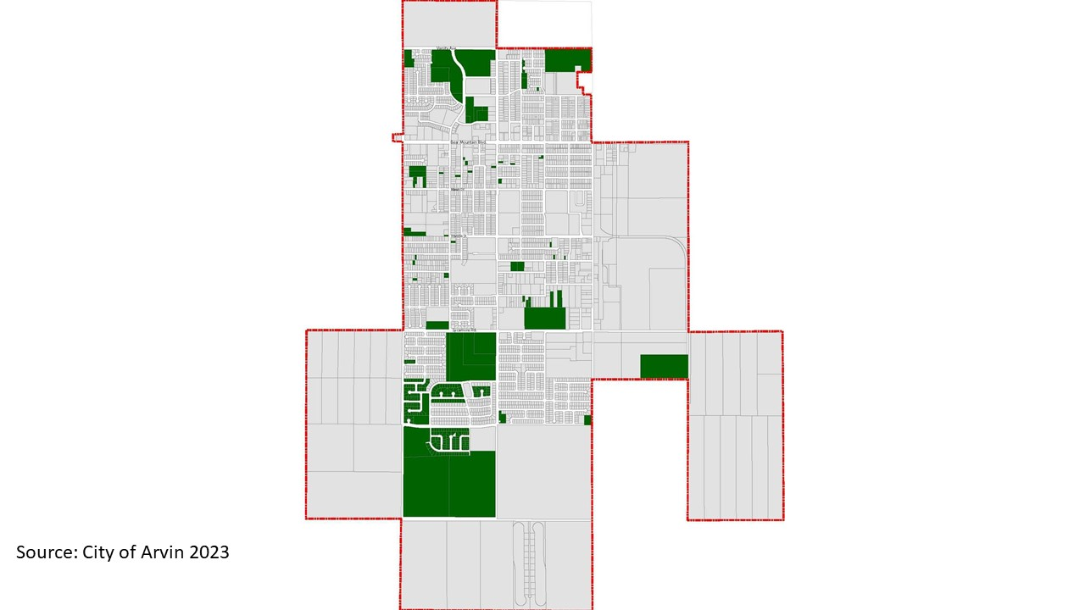

Table 22
PRIVATELY OWNED FARM WORKER HOUSING KERN COUNTY
Name | Number of Farm Workers | Months of Occupation/Year
Bonanza Farms | 16 | 12
Wheeler Highway 99 | 9 | 12
Wheeler Adobe | 7 | 12
Paramount 27 | 5 | 12
Paramount Belridge | 28 | 12
Opal Frye | 15 | 12
Westfarmers | 8 | 12
Cauzza | 7 | 12
Jimmie Icardo | 7 | 12
Spring Farms | 6 | 12
Belridge Drilling | 8 | 12
San Emigdio | 5 | 12
GVC 37 | 72 | 7-10
GVC 23B | 120 | 7-10
GVC 10A | 11 | 7-10
GVC 10B | 90 | 7-10
Kovacevich Clark | 15 | 6-8
Kovacevich Hildebrand | 45 | 6-8
Total | 474
Source: Kern County Regional Housing Allocation Plan, May 2001

Table 23
PUBLICLY OWNED FARM WORKER HOUSING KERN COUNTY
Name | Location | Number of Units
Year-Round Housing
Almond Village | Lost Hills | 81
Sun Garden Village | Arvin | 48
International Village | Delano | 50
Shafter | Shafter | 99
Beckes Street Apartments | Wasco | 57
Lamont H.R. Olson Homes | Lamont | 50
Ruben J. Blunt Village | Lamont/Weedpatch | 50
Casa del Valle | Delano | 35
Greenfield Homes | Bakersfield | 35
Rosaleda | Wasco | 224
Migrant Seasonal Housing
North Shafter Farm Labor Center #5 | Shafter | 84
Arvin Farm Labor Center #26 | Lamont/Weedpatch | 88
Source: https://kernha.org/farm-worker-housing-locations/

Cost Burden
A household is considered cost burdened if the household pays more than 30% of its total gross income for housing costs. For renters, housing costs include rent paid by the tenant plus utilities. For homeowners, housing costs include mortgage payment, taxes, insurance, and utilities. As discussed in the Background, as with most communities, the location of the home is one of the biggest factors regarding price.
Of an estimated total of 4865 households, 2900 households (59.6%) had housing problems. Based on tenure, 71.8 percent of renter households experienced housing problems, compared to 46.8 percent of owner households as shown in Table 24 (Table 42 of Housing Element). Among the extremely low-income households, 84.1 percent of the renter households experienced housing problems, compared to 94.1 percent of the owner households. As shown in Table 25 (Table 43 of Housing Element), out of the estimated 4,865 households, 2170 households (44.6%) were overpaying for housing at a cost burden over 30 percent, while 950 households (19.5 percent) had cost burdens greater than 50 percent MFI (Median Family Income). The ratio of overpaying households by tenure was approximately 36.8 percent owners to 51.6 percent renters. The extremely low income (less than 30% MFI) and low income (30 - 50% MFI) households pay the highest overpayments among all households by tenure and income levels.
The median sales price for a single-family home in Arvin was $176,400 in 2020, which requires an annual household income of over $43,000 and an average down payment of over $35,000.

Table 24
ARVIN HOUSEHOLDS WITH HOUSING PROBLEMS - 2019

Tenure | Extremely Low  <30% of MIF | Very Low  30-50% of MIF | Low  50-80% of MIF | Moderate  80-100% of MIF | Above Moderate  >100% of MIF | Total

Owner Households | 170 | 440 | 805 | 270 | 695 | 2380
w/ Hsg. Problem | 160 | 325 | 415 | 130 | 80 | 1115
Percent | 94.1% | 73.9% | 40.4% | 48.1% | 11.5% | 46.8%
Renter Households | 725 | 835 | 605 | 110 | 210 | 2485
w/ Hsg. Problem | 610 | 670 | 375 | 70 | 65 | 1785
Percent | 84.1% | 80.2% | 62.0% | 63.6% | 31.0% | 71.8%
Total Households | 895 | 1275 | 1410 | 380 | 905 | 4865
w/ Hsg. Problem | 770 | 995 | 790 | 200 | 145 | 2900
Percent | 86.0% | 78.0% | 56.0% | 52.6% | 16.0% | 59.6%
Source: HUDuser website, CHAS Data Query Tool (2015-2019).

Table 25
ARVIN HOUSEHOLDS OVERPAYING FOR HOUSING BY INCOME LEVEL - 2018
Household Income | Owner |  | Renter |  | Total
Household Income | Number | % | Number | % | Number | %

Less than 30% MFI | 170 |  | 725 |  | 895
Cost Burden >30% | 150 | 88.2% | 610 | 84.1% | 760 | 84.9%
Cost Burden >50% | 130 | 76.5% | 435 | 60.0% | 565 | 63.1%
30-50% MFI | 440 |  | 835 |  | 1275
Cost Burden >30% | 325 | 73.9% | 555 | 66.5% | 790 | 62.0%
Cost Burden >50% | 155 | 35.2% | 185 | 22.2% | 340 | 27.0%
50-80% MFI | 805 |  | 605 |  | 1410
Cost Burden >30% | 355 | 44.0% | 230 | 38.0% | 585 | 41.5%
Cost Burden >50% | 30 | 3.7% | 15 | 2.5% | 45 | 3.2%
80-100% MFI | 270 |  | 110 |  | 380
Cost Burden >30% | 35 | 13.0% | 0 | 0.0% | 35 | 9.2%
Cost Burden >50% | 0 | 0.0% | 0 | 0.0% | 0 | 0.0%
More than 100% MFI | 695 |  | 210 |  | 905
Cost Burden >30% | 10 | 1.4% | 0 | 0.0% | 10 | 1.1%
Cost Burden >50% | 0 | 0.0% | 0 | 0.0% | 0 | 0.0%
Total | 2380 |  | 2485 |  | 4865
Cost Burden >30% | 875 | 36.8% | 1395 | 56.1% | 2170 | 44.6%
Cost Burden >50% | 315 | 13.2% | 635 | 25.6% | 950 | 19.5%
Source: HUDuser website, CHAS Data Query Tool (2015-2019).

Overcrowding
The Census defines an overcrowded unit as one occupied by 1.01 persons or more per room (excluding bathrooms and kitchens). Units with more than 1.5 persons per room are considered severely overcrowded.
Table 5 shows that 15.5 percent of family households in Arvin had five or more persons, which by the State Department of Housing and Community Development (HCD) definition is considered “large households”. This is more than the countywide proportion of large households of 10 percent. Table 26 (Table 44 of Housing Element) shows that in 2020, 1218 households in Arvin were living in overcrowded and severely overcrowded conditions. These households represented 26.4 percent of the total 4711 households in the city. Table 27 (Table 45 of Housing Element) shows that renters comprised 35.9 percent of the overcrowded and severely overcrowded households within the city’s total occupied housing stock. With the high percentage of overcrowding and severe overcrowding and the high number of households in low and extremely low-income households, there is a significant need to provide assistance and to develop programs to address affordability and overcrowding.

Table 26
OVERCROWDED HOUSEHOLDS IN ARVIN - 2020
 | City of Arvin | City of Arvin | Kern County | Kern County | California | California
Total | 4,711 |  | 273,556 |  | 13,103,114
0.50 or Less | 1,025 | 21.8% | 146,558 | 53.6% | 7,507,254 | 57.3%
0.51 to 1.00 | 2,410 | 51.2% | 101,834 | 37.2% | 4,520,122 | 34.5%
1.01 to 1.50 | 971 | 20.6% | 17,723 | 6.5% | 680,753 | 5.2%
1.51 to 2.00 | 247 | 5.2% | 5,432 | 2.0% | 287,225 | 2.2%
2.01 or More | 58 | 1.2% | 2,009 | 0.7% | 107,760 | 0.8%
Source: U.S. Census Bureau, ACS 16-20 (5-year Estimates), Table B25014

Table 27
Overcrowded Households in Arvin by Tenure – 2010-2020
 | 2010 | 2010 | 2015 | 2015 | 2020 | 2020
Total | 3,991 |  | 4,533 |  | 4,711
Owner Occupied | 2,069 | 51.8% | 2,085 | 46.0% | 2,370 | 50.3%
Owner - 0.50 or Less | 566 | 27.4% | 513 | 24.6% | 661 | 27.9%
Owner - 0.51 to 1.00 | 1,207 | 58.3% | 1,259 | 60.4% | 1,273 | 53.7%
Owner - 1.01 to 1.50 | 261 | 12.6% | 260 | 12.5% | 346 | 14.6%
Owner - 1.51 to 2.00 | 35 | 1.7% | 47 | 2.3% | 51 | 2.2%
Owner - 2.01 or More | 0 | 0.0% | 6 | 0.3% | 39 | 1.6%
Renter Occupied | 1,922 | 48.2% | 2,448 | 54.0% | 2,341 | 49.7%
Renter - 0.50 or Less | 394 | 19.0% | 412 | 16.8% | 364 | 15.5%
Renter - 0.51 to 1.00 | 732 | 35.4% | 1,286 | 52.5% | 1,137 | 48.6%
Renter - 1.01 to 1.50 | 651 | 31.5% | 632 | 25.8% | 625 | 26.7%
Renter - 1.51 to 2.00 | 103 | 5.0% | 118 | 4.8% | 196 | 8.4%
Renter - 2.01 or More | 42 | 2.0% | 0 | 0.0% | 19 | 0.8%
Source: U.S. Census Bureau, ACS 06-10, 11-15, 16-20 (5-year Estimates), Table B25014

The Housing Element include several programs to address fair housing issues, especially Programs 1,2,4,6,7,8,9,10, 11, 13, 14, 15, 17, 18, 19, 20, 21, 22, 23, and 25. City of Arvin will develop and implement these programs and will review them to ensure the issue of overcrowding and housing affordability is addressed and will:

- encourage more affordable housing development;
- connect lower income residents with affordable homeownership and rental opportunities within the city; and
- respond to the housing needs of female headed households and households with children.

Substandard Housing
As discussed in the Housing Needs Assessment, the 2016-2020 ACS data indicates that 7.5% of the housing in the city is built before 1950 as outlined in Table 28 (Table 18 of Housing Element). 24.3% of the housing in the city is greater than 50 years old (i.e., built before 1970). Another 15.9% of units were built between 1970 and 1979. Building age is a significant factor in the deterioration and health and safety risks of structures. In general, homes built over 30 years ago are likely to require structural renovation and maintenance.
Table 28
Housing Units by Year Built
 | City of Arvin | Percent | Kern County | Percent | California | Percent
Total: | 4,711 |  | 273,556 |  | 13,103,114
2014 Or Later | 159 | 3.4% | 8,679 | 3.4% | 294,667 | 2.2%
2010 To 2013 | 199 | 4.2% | 6,244 | 4.2% | 234,646 | 1.8%
2000 To 2009 | 1,048 | 22.2% | 50,348 | 22.2% | 1,432,955 | 11.0%
1990 To 1999 | 899 | 19.1% | 40,394 | 19.1% | 1,448,367 | 11.1%
1980 To 1989 | 518 | 11.0% | 45,689 | 11.0% | 1,967,306 | 15.1%
1970 To 1979 | 748 | 15.9% | 43,060 | 15.9% | 2,290,081 | 17.5%
1960 To 1969 | 460 | 9.8% | 27,662 | 9.8% | 1,740,922 | 13.3%
1950 To 1959 | 352 | 7.5% | 28,089 | 7.5% | 1,767,353 | 13.5%

The CDBG survey undertaken in 2008 surveyed 3,400 residential parcels. Of these surveyed parcels, 2,158 parcels (63.5%) had housing that was in good condition, 195 parcels (16.8%) exhibit minor to moderate conditions and 308 parcels (9.1%) are in substantially deteriorated condition. There are also 360 (10.6%) vacant parcels.
In 2009, a housing conditions survey was conducted in Arvin and the results from the survey identified those parcels exhibiting conditions of physical blight, which indicated that they were candidates for recycling. Those blight parcels identified in the 2009 survey were revisited in 2015. The updated results indicated that eight of those parcels in two areas of the city that were zoned for multi-family units (R-2 and R-3) continued to exhibit condition of blight. Many of the existing structures on these sites exhibited signs of deterioration and substandard construction and/or were in violation of existing building code standards (see 2023-2031 Arvin Housing Element for details).
Homelessness
The 2022 Point in Time Count Report was released on April 27, 2022, and identified 1,603 unduplicated individuals in Kern County experiencing homelessness, as compared to 1,580 identified in the last in-person data collected in 2020. Countywide, 875 (55%) of individuals experiencing homelessness had shelter, as compared to 576 in 2020. While 728 (45%) were unsheltered, sleeping in parks, empty buildings, cars and other places not meant for human habitation, as compared to 1,004 in 2020 (Source: Bakersfield Kern Regional Homeless Collaborate).
In response to the needs of the homeless in Arvin and to comply with State law, the city adopted Ordinance No. 421 in July 2015, which amended the Zoning Ordinance to permit emergency shelters by-right in the M-2 zone. The ordinances states: Emergency Housing is intended for homeless persons, for a stay of up to six months in any given year. This type of housing will be permitted in the Light Industrial (M-2) zone, subject to certain development standards, including:

- The number of beds: It is recommended in the Housing Element that the maximum number of beds in an emergency housing facility be set at 20 beds.
- Parking: It is recommended that a parking standard be established so that an emergency housing facility provides one on-site parking space per employee on the maximum shift, plus one space per six beds. This standard recognizes that many homeless people do not own a vehicle and provide for the following:
    - An On-site Manager must be present at all times.
    - On-site security must be provided at all times.
    - Outdoor security lighting must be provided.
    - Occupancy is limited to a maximum of six months during any one-year period.
    - Storage space for resident’s belongings shall be provided at a rate of 10 square feet per bed.
    - An operational plan must be provided for City review and approval.
    - The facility must be licensed by the State of California
Though the City of Arvin does not have any homeless programs, the County does provide aid for the homeless. Formed in 1999, the Kern County Homeless Collaborative was formed to combat the problem of homelessness. Under the Collaborative, eight committees contribute to alleviating homelessness. The committees include needs assessment, resource assessment, evaluation, service integration, sustainability and development, advocacy/public relations, rural issues, and continuum of care. The chairs of each committee meet as a steering committee to exchange information and set direction for the collaborative, while the collaborative meets quarterly.
Three types of facilities provide shelter for homeless individuals and families: emergency shelters, transitional housing, and permanent housing as shown in Table 29 (Table 33 of Housing Element). Facilities for persons with special needs are shown in Table 30 (Table 34 of Housing Element).

Table 29
HOUSING AUTHORITY FACILITIES

Facilities | Address | Service Provided
Green Gardens | 2300 South Union Avenue, Bakersfield, CA 93307 | 104-unit single room occupancy facility that houses formerly homeless persons with disabilities referred to the site by the Kern Behavioral Health and Recovery Services.
Plymouth Rock | 100 Plymoth Avenue Bakersfield, CA 93308 | Eight (8) units providing temporary housing for homeless families returning from the Bakersfield Homeless Center.
Haven Cottages | 68 E. White Lane, Bakersfield, CA 93307 | 24 one-bedroom affordable rental homes for homeless individuals with mental illness.
Building Blocks Transitional Program | 1807 Belle Terrace,  Bakersfield, CA 93307 | 12-unit Transitional Housing Program for emancipated foster youth (ages 18-21) who are homeless or at immediate risk of becoming homeless.
Source: https://kernha.org/housing-for-homeless/

Table 30
FACILITIES FOR SPECIAL NEEDS
Facilities | Address | Service Provided
Bakersfield Homeless Center | 1600 E. Truxtun Avenue Bakersfield, CA 93305 | Healthcare, Counseling, Food, Shelter, Job placement, emergency services, child care, Home Assistance
Bakersfield Rescue Mission | 724 E. 21st Street Bakersfield, CA 93305 | Case management and referrals to community resources such as Human Services, Mental Health, Disabled Services, and Medical Services
Alliance Against Family Violence and Sexual Assault | 1921 19th Street  Bakersfield, CA 93301 | Shelter Service, Counseling, Education Services, Meal Services, Substance Abuse Counseling
Bethany Services’ Transitional Services Center | 1600 East Truxtun  Bakersfield, CA 93305 | Rent, Utilities, Referrals, Food, & Shelter for Women, Children & Families
Source: Kern County Housing Element

  - Emergency Shelter – A facility that provides overnight shelter and fulfills a client’s basic needs (i.e. food, clothing, medical care) either on-site or through off-site services. The permitted length of stay can vary from one day at a time to three months. The major providers of emergency shelter in the County are the Bakersfield Homeless Center (110 beds for men, 9 beds for women, 27 beds for families and an additional 25 beds for men or women depending on the need.) and the Bakersfield Rescue Mission (space for approximately 40 women and children, and 80 men, and has capacity for 138 persons per meal, and serves two meals per day.)
  - Transitional Housing – A residence that provides housing for up to two years. Residents of transitional housing usually include supportive services designed to assist the homeless in achieving greater economic independence and a permanent, stable living situation. Services may include mental and physical health care interventions, substance abuse treatment, job training and employment services, individual and group counseling and life skills training. Currently, HACK operates the only transitional housing facility in Kern County. The program includes seven units in the unincorporated area near Bakersfield. Other services exist throughout the County to assist individuals and families with making the transition from emergency shelter to permanent housing. Bethany Services’ Transitional Services Center provides support services for residents of supportive housing and homeless persons not in supportive housing. Recreation Community Project, Inc. (RCPI) provides transitional housing and support services targeted toward adult men and women with dependent children in inner-city neighborhoods. Also, some substance abuse programs offer limited transitional housing services in addition to treatment.
  - Permanent Housing – Service enriched permanent housing that is linked with on-going supportive services (on-site or off-site) and designed to allow formerly homeless clients to live at the facility on an indefinite basis. Units operated by HACK, as well as the Section 8 program provide some housing. However, the large demand may prevent many residents from gaining access to permanent housing. Other facilities in the County are geared toward homeless populations with special needs. Living Connections, Inc. operates two board and care homes for persons with mental illness, as well as 21-unit and 25-unit apartment complexes.
The Housing Authority of the County of Kern provides quality housing with supportive services to homeless individuals and emancipated foster youth who are at immediate risk of becoming homeless, partnering with local community organizations to provide housing, rental assistance, and supportive services to qualifying individuals. The agency operates a number of residential sites as well as rental assistance programs specially designed to serve the needs of local residents who are homeless, mentally ill, or disabled.
The Shelter Plus Care (S+C) program provides rental assistance to homeless disabled individuals and families who receive ongoing supportive services and case management from community organizations to help them remain in housing and increase their income. The Bakersfield Homeless Center, Flood Bakersfield Ministries, Independent Living Center, Clinica Sierra Vista and the California Veteran Assistance Foundation refer homeless persons to the Housing Authority to receive the S+C assistance.

h. DISPLACEMENT RISK
As previously discussed, there are no affordable units currently at-risk of converting to market-rate during 2023 – 2031 through termination of a subsidy contract, mortgage prepayment, or expiring use restrictions. The city analyzed the 4 possible affordable housing projects identified by California Housing Partnership (CHP) that are at risk of conversion to market rate in Arvin within the next ten years. The city also has several units which are affordable to lower-income families, specifically for protected classes, including persons with disabilities, female- headed households, seniors, and nonwhite residents. As described earlier in this Fair Housing Analysis, the city plans to accommodate its 2023-2031 RHNA allocation on parcels designated for single family, multifamily, and mixed-use development, with vacant sites representing most sites for new housing. Underdeveloped residential sites are also identified as helping to meet the City’s very low- income units and to provide additional opportunities for lower, moderate- and above-moderate income units. There is no significant displacement risk associated with the City’s current affordable housing stock as a result of new development.
The City recognizes that even though it has identified sufficient land to accommodate its RHNA allocation at all income levels, there is still the potential for economic displacement because of new development and investment. This “knock-on” effect can occur at any time, and it can be challenging for the city to predict market changes and development patterns which have the potential to impact rental rates and sales prices for housing available in the marketplace. To date, the city has no evidence that new development (affordable or market-rate) has resulted in economic displacement.
Research has also shown that low-income renter populations (49.7% of households in Arvin are renter occupied) are disproportionately exposed to environmental hazards and that housing tenure is a telling determinant of social vulnerability to disasters. Renters bear the brunt of the existing affordable housing shortage, and their adaptive capacity to cope and recover from the impacts of environmental hazards may be reduced due to systemic inequities and limited resources.
Environmental hazards affecting residential development in the city primarily include geologic and seismic hazards, flooding and inundation hazards, and hazardous materials release. Development within flood hazard areas is subject to the Municipal Code and Federal Emergency Management Agency (FEMA) standards. Seismic-related issues are addressed in the Municipal Code, which implements the California Building Standards Code (CBSC). Various State and federal regulations control the use, storage, and transportation of hazardous materials.
Overall, the city recognizes the need to reduce economic displacement risks and have incorporated a range of initiatives in the 24 Housing Element Programs.
Findings
The most disproportionate housing needs in Arvin include increasing the variety of housing types at affordable prices (including housing for low income and female headed households) and rehabilitating the existing housing stock. 44.6% of the households are overpaying for housing at a cost burden over 30 percent, while 19.5 percent of the households having cost burdens greater than 50 percent MFI. 49.7% of households in Arvin are renter occupied.
The City looks to implement Programs 3,4,10,11,13,14,15,16,17 to address the need for multifamily projects, addressing loans for rehabilitation of existing multifamily units, rental assistance, development of extremely low-income housing, facilitate large parcels to encourage affordable multi-family housing, and reasonable accommodations in rules, policies, practices and services. The Housing Element proposes 24 programs addressing these issues. The City will also consider programs such as having 50% of units receiving rehabilitation assistance be rented to eligible very low and low -income households upon completion of the project. The City’s Municipal Code allows for residential care facilities, emergency shelters, transitional and supportive housing, single-room occupancy (SRO), and employee/farmworker housing as a permitted use under various zones. Ordinance No. 421 outlines procedures for requests for reasonable accommodation with respect to zoning, building code compliance or permit processing.

FIGURE 16: TCAC/HCD OPPORTUNITY AREA MAP FOR ARVIN
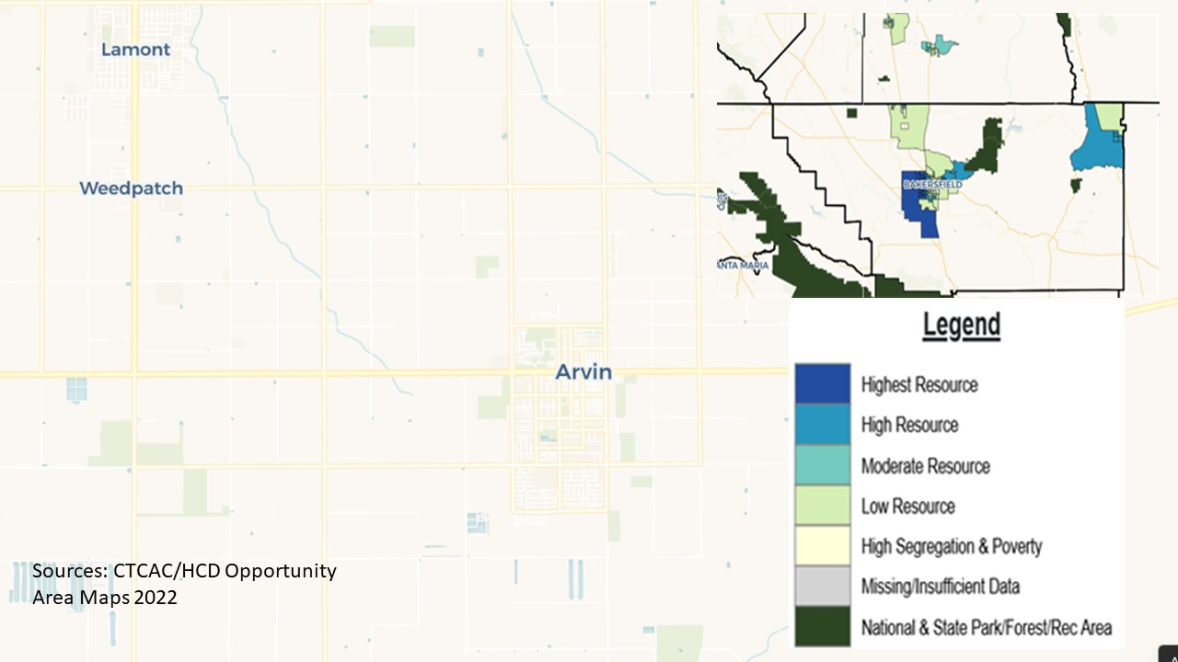
FIGURE 17: PERCENT OF CHILDREN IN FEMALE HOUSEHOLDER

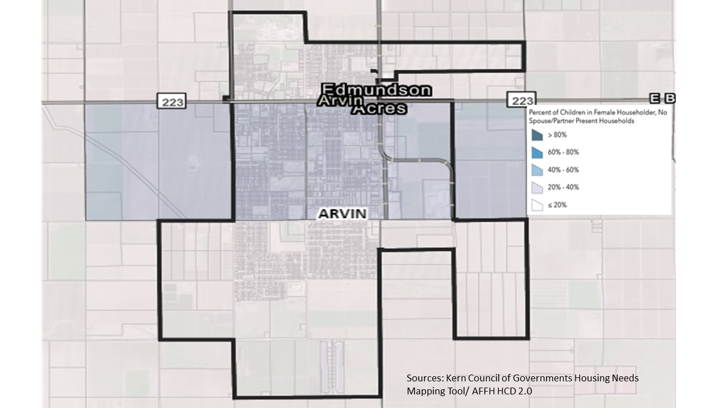

FIGURE 18: SB 535 DISADVANTAGED COMMUNITIES
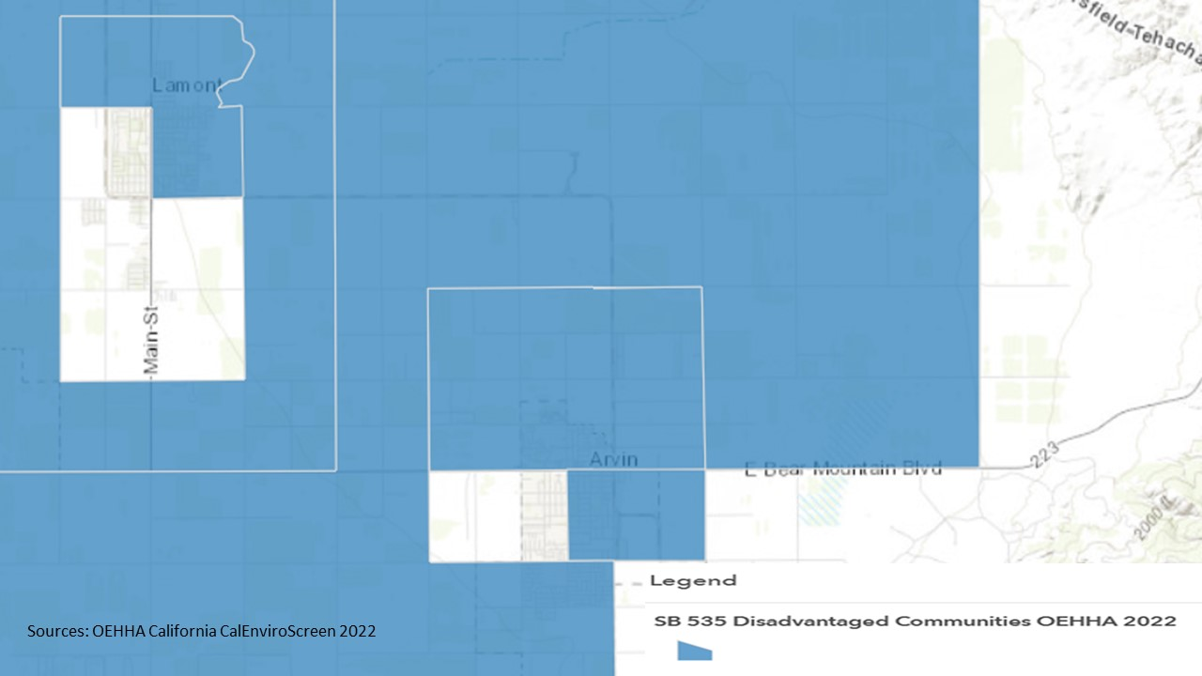
FIGURE 19: HOUSING BURDEN PERCENTILE
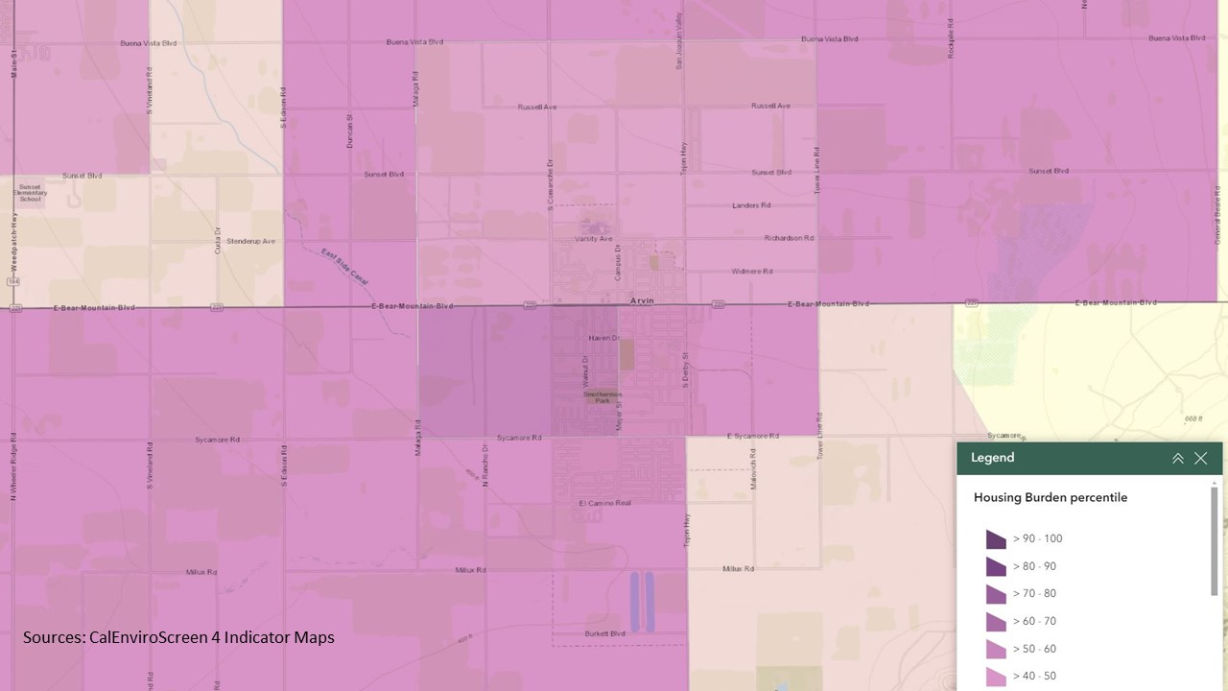

FIGURE 20: UNEMPLOYMENT PERCENTILE
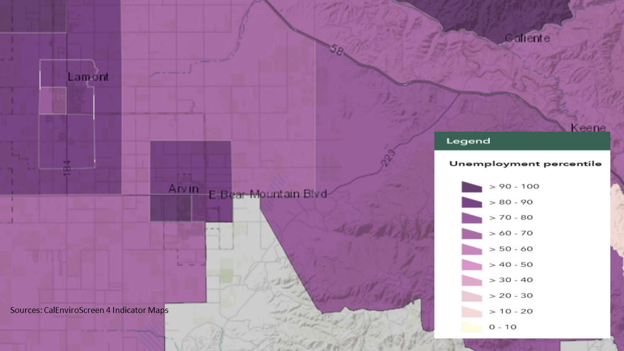
FIGURE 21: EDUCATION PERCENTILE
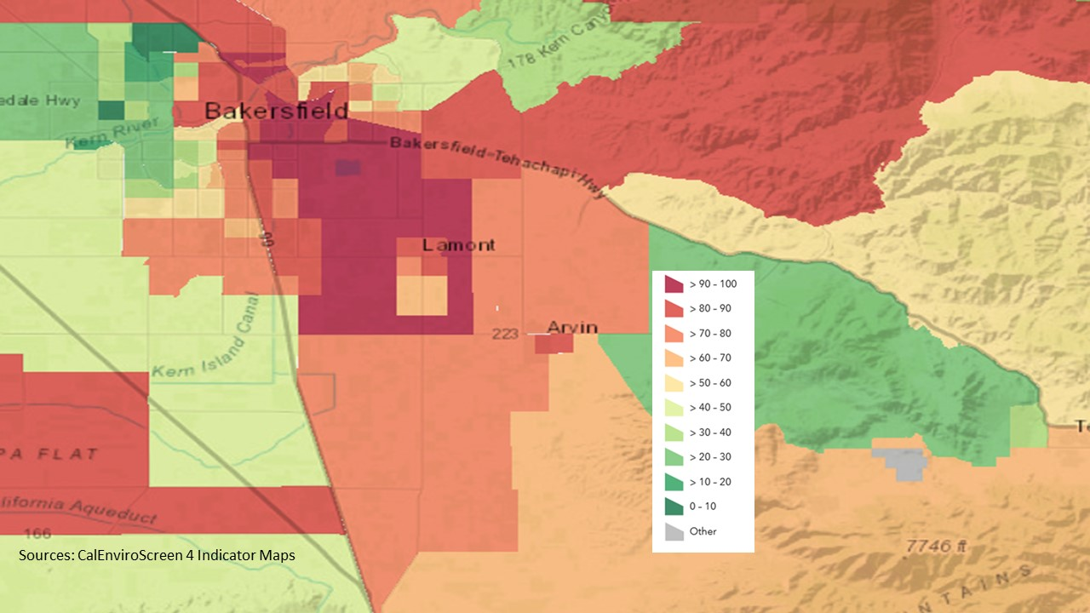

FIGURE 22: CUMULATIVE IMPACTS
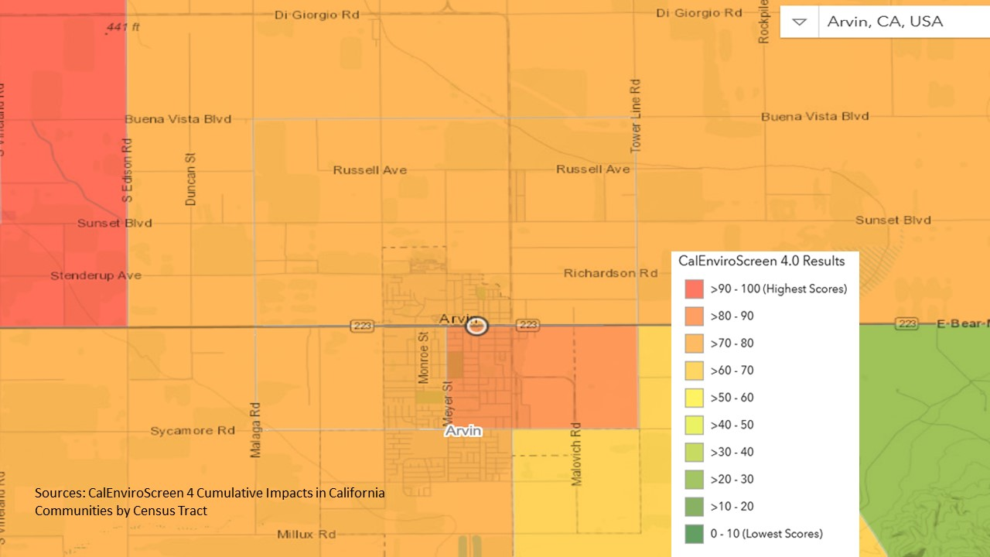
FIGURE 23 POLLUTION BURDEN PERCENTILE
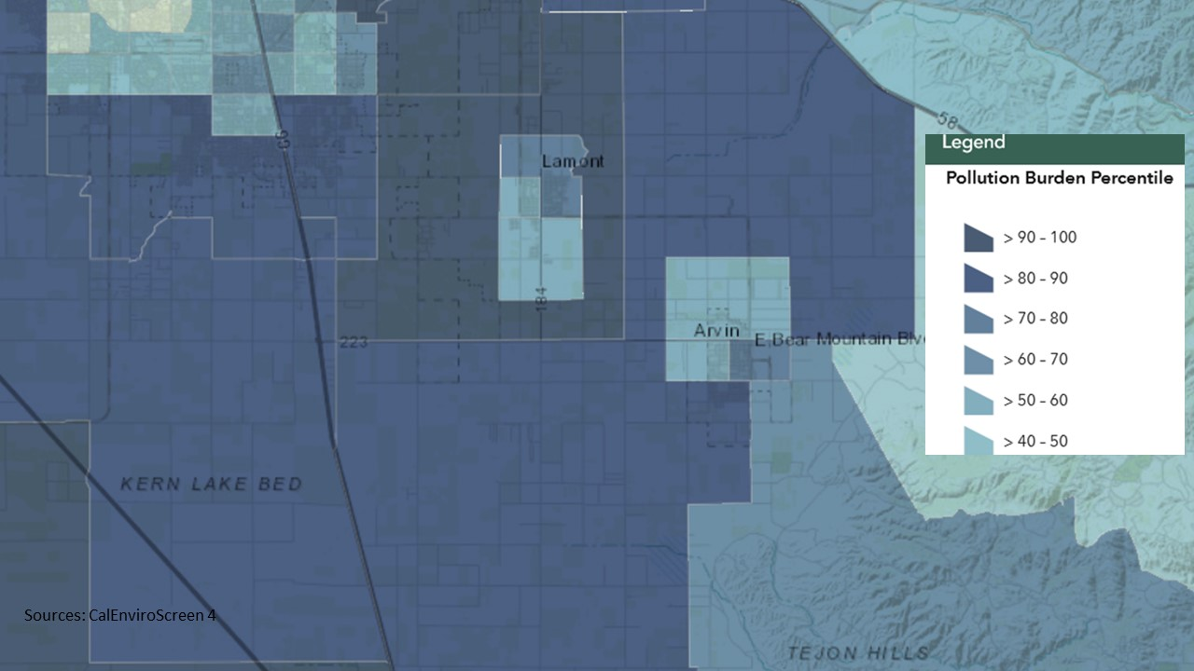

SITES INVENTORY

This section provides a review of available vacant and other sites in Arvin that would allow for and facilitate production of the city’s regional share of housing as required by State Law. This data is supplemented with local knowledge of existing conditions in the community to present a more accurate depiction of fair housing issues in Arvin. The following issues are addressed:
- Future Housing Needs Including Segregation/Integration
- R/ECAPs and RCAAs
- Access to Opportunity
- Disproportionate Housing Needs
- Sites Inventory Findings
To determine where the city has sufficient land to accommodate its share of regional housing needs for all income groups, the city must identify “adequate sites.” Under the State law (California Government Code section 65583[c][1], adequate sites are those with appropriate zoning in and development standards, with service and facilities, needed to facilitate and encourage the development of housing for all income levels.
Assembly Bill 686 (AB 686) has introduced a duty to affirmatively further fair housing into California state law. AB 686 requires that jurisdictions identify sites throughout the community in a manner that is consistent with its duty to affirmatively further fair housing. The site identification includes not only an analysis of site capacity to accommodate the RHNA (provided in this section), but also considers whether the identified sites serve the purpose of replacing segregated living patterns with truly integrated and balanced living patterns, transforming racially and ethnically concentrated areas of poverty into areas of opportunity. This section analyzes the role of all sites, regardless of income level, in assisting to affirmatively further fair housing and consider how the development of new affordable housing options can promote patterns of equality and inclusiveness.
The State Department of Housing and Community Development makes a periodic evaluation of statewide housing needs based on population trends, demographic changes, migration patterns, etc., and the Kern Council of Governments Regional Housing Needs Assessment (Kern COG RHNA) quantifies the housing needs for each jurisdiction between 2023 and 2031. The RHNA does not necessarily encourage or promote growth, but rather allows communities to anticipate in growth. The RHNA produces information on number of households and housing units, households paying over 30 percent of income for housing, and projections of future needs. All RHNA estimates are broken down into five income categories, with the County median as a baseline, and according to owner and renter occupancy.

- FUTURE HOUSING NEEDS INCLUDING SEGREGATION/INTEGRATION
Arvin’s future housing needs as projected in the Kern COG RHNA for the 2023-2031 planning period indicates a need for 1,174 units. As presented in Table 31 (Table 41 of Housing Element), the total housing needs include 62 units for extremely low-income (deemed 50% % of the RHNA Very Low-Income allocation, as determined by Kern COG), 124 units for very low-income, 79 units for low- income, 268 units for moderate-income, and 703 units for above moderate-income. Housing for lower-income households represents 37.5% of the above housing needs.
The need for housing will be 1,174 units by the year 2031.

Table 31
ARVIN’S RHNA 2023-2031 BY INCOME LEVEL

 | Extremely Low* | Very Low | Low | Moderate | Above Moderate | Total
Units | 62 | 124 | 79 | 268 | 703 | 1,174
Percent | * | 17.0% | 20.5% | 15.6% | 29.9% | 100.0%
Source: Kern COG RHNA, 2013-2023 Assessment
* Extremely Low Income is deemed 50% of Very Low Income (approx. 62 units) of the RHNA Very Low- Income allocation of 124 units, as determined by Kern COG RHNA. Source: https://www.Kern COG.org/wp-content/uploads/2022/07/ADOPTED-Kern-COG-RHNA-Plan_07-22-22.pdf

Table 2 (Table 5 of Housing Element) depicts the demographic trends of different racial/ethnic categories within Arvin between 2000 and 2020. During this period, the total population of Arvin grew by 50.47 percent, however, growth in the last decade between 2010 and 2020 was only 0.99 percent. Arvin’s Hispanic population was 87.5 percent of the total population in the year 2000. By 2020, the Hispanic population comprise of 94 percent of the population. The changing ethnic characteristics of a community, coupled with shifting in age composition, lead to changes in household composition and ensuing housing needs. The percentage of population that are White residents decreased from 9.8% in 2000 to 3.8% in 2020. The overall non-Hispanic population decreased from 12.5% in 2000 to 6% in 2020. Figure 6 shows that Arvin in general has a lower diversity index with several pockets of very high non-white population (>80%).
The City has considered trends and patterns related to integration and segregation based on racial and ethnic factors, disability, family status, seniors, and median household income. City of Arvin faces some unique challenges compared to Kern County as a whole, as a significantly higher proportion of Arvin’s households are under the poverty line (29.6%). There are some patterns of isolation or segregation apparent especially with female headed households. The city also has a significant need for dependent care and support systems for young children and youth, farm worker housing and housing appropriate for large families.

The City will continue to have an Arvin Housing Advisory Committee that will include stakeholders and community-based organizations (i.e., California Coalition of Rural Housing, California Rural Legal Assistance, Leadership Counsel for Justice and Accountability, Lideres Campesinas, Committee for a Better Arvin, etc.) to advise the city on developing and implementing various Housing Element programs. The Housing Element Advisory Committee will actively participate in the city’s efforts prioritize and implement the following strategies:
  - Research, identify, and apply for funds available through the CDBG and HOME Programs, Mobile home Park Rehabilitation and Resident Ownership Program (MPRROP), United States Department of Agriculture (USDA), Cap-and-Trade Program, and other funding sources that support affordable housing development and preservation, infrastructure investment, energy efficiency, homeownership, code enforcement, farmworker housing, etc.
  - Implement the following Housing Programs:
Program 5 - Code Enforcement Program, with a full-time building/code enforcement officer and a part-time code enforcement officer;
- Program 6 - Residential Unit Inspection and Maintenance Program;
- Program 7 - Single-Family Owner Occupied and Multi-Family Rehabilitation Loan/Grant Program;
- Program 8 - Inventory of “At-Risk” projects;
- Program 9 - Preserving Mobile home Parks;
- Program 18. Adequate Sites Monitoring Program
- Program 22. Equal Housing Opportunity Program to Affirmatively Furthering Fair Housing goals.
  - Foster partnerships with non-profit affordable housing developers and experts within the community-based organization’s membership.
  - Engage the community by “getting the word out” on key community planning meetings, informing the public on available housing programs, and translating affordable housing-related materials and interpreting at community workshop in Spanish and Mixtec. The city will arrange for provisions of Spanish translation materials and provide interpreters at community workshops.

- R/ECAPS and RCAAs
According to the HCD AFFH Dataset, there is no R/ECAP in the City of Arvin (Figures 12 and 6). No correlation was found between lower incomes and diversity. The Housing Plan includes programs to encourage diversity and support housing needs in the city.
Table 13 on Median Household Income by Race or Hispanic Origin in City of Arvin, the median household incomes of White, non-Hispanic residents in City of Arvin are not greater than other races. However, this is not the case for County as whole. There is no census tract in Arvin that fit the criteria of income of $125,000 and a population that is 80 percent or more White, and therefore the city has no RCAAs.
The distribution of RHNA sites throughout the city will therefore, not exacerbate racially/ethnically concentrated areas of poverty or racially concentrated areas of affluence. The majority of new dwelling units in Arvin will be added on land designated for LDR development in the southern portion of the city, while HDR development is anticipated to take place in the northwest portion. These vacant sites have potential to exceed the Kern COG RHNA projections.

- ACCESS TO OPPORTUNITY
City of Arvin does not have any high or highest resource areas. It largely consists of census tracts that are considered low resource areas (see Figure 16) and therefore the city must look to areas with lower to moderate levels of resources to accommodate new development. Figure 16, TCAC/HCD Opportunity Map provides areawide identification of Resource Opportunity areas. Comparing regional data for access to opportunity, the city of Arvin is in the “Low Resource” area, whereas, the City of Bakersfield, has Low and High Resource areas.
The city has distributed its RHNA sites throughout these areas. The new residential and mixed-use development in the identified areas will help to create more housing affordable to households at lower income levels, introduce new residents to the areas which can contribute to greater neighborhood stability, and expand opportunities for people to both live and work in Arvin. Taken together, new residential and mixed-use development in the identified areas will help to diversify the land use pattern and improve the conditions of these census tracts by providing greater housing choice and a broader range of goods and services, bringing new residential development closer to transit and jobs, and otherwise supporting community revitalization.
Table 26 shows that in 2020, 1218 households in Arvin were living in overcrowded and severely overcrowded conditions. These households represented 26.4 percent of the total 4711 households in the city.
Table 27 shows that renters comprised 35.9 percent of the overcrowded and severely overcrowded households within the city’s total occupied housing stock. With the high percentage of overcrowding and severe overcrowding and the high number of households in low and extremely low-income household, there is a need to provide assistance in to develop programs to address affordability and overcrowding.
The General Plan land use map and zoning ordinance identify those areas of the city that are to be developed with residential uses, and what standards apply to the different types of residential uses. Such standards are a necessary tool to promote and ensure a healthy, compatible, and high-quality living environment. Over 50 percent of the acreage in Arvin is designated for residential use. The Zoning Ordinance allows for a wide range of residential uses, with densities ranging from a maximum of 6 units per acre in lower density residential areas, up to 24 units per acre in the higher density multi-family and mixed-use overlay zones. Existing density bonus ordinance allows a developer to request a density bonus of up to 35 percent over the maximum density that is allowed by the zone in which the project is located if the developer agrees to reserve a certain percentage of the units as available to lower income households and/or senior citizens. A Program has been added to amend the Density Bonus Ordinance to be compatible with new changes in law, as applicable. The city is currently updating the Zoning Code effecting those changes.
In compliance with State Housing Law, the city will permit ADUs and JADUs within the City. Currently, the city is amending the Zoning Code to permit accessory dwelling units, ministerially, as stated in Housing element Program 13 (e). Since the 2018-2013 Housing Element, the city has adopted amendments to the Municipal Code to include residential care facilities, emergency shelters, transitional and supportive housing, single-room occupancy (SRO), and employee/farmworker housing as a permitted use under various zones. Since the 2013-2023 Housing Element, in compliance with the Surplus Lands Act, the city published in 2021 surplus lands available for possible low to moderate housing development.

The introduction of greater housing choice, a broader cross-section of households will have the opportunity to live in Arvin, which may ultimately have a positive impact on economic and education scores. A closer look at educational scores indicates that all elementary and middle schools serving the city have low standard scores and educational opportunities are consistent throughout the community. The city is served by a single High School.
- DISPROPORTIONATE HOUSING NEEDS
Most of the RHNA allocation sites are outside the high poverty area south of Easter Bean Mountain Boulevard and North of Sycamore Road. Figure 15 shows the vacant residential lots in Arvin. Available land can support 2474 housing units as shown in Table 33, which exceed the RHNA allocation requirements of 1174 units. There are 8 parcels in two areas of the city that are candidates for recycling and have potential for higher densities that will result in 90 additional home units for lower income levels. The Housing Element also identified the potential for the 5 existing mobile parks to be recycled to higher densities to further improve availability of affordable housing.
As per the Housing Inventory, the total number of units that could be accommodated in Arvin during 2023-31 planning period are 431 lower income housing units and 2333 moderate and above-moderate income housing units. The RHNA sites are split between sites located in census tracts with moderate and high levels of cost-burdened renter and homeowner households. Likewise, sites are split between census tracts with low and moderate levels of cost-burdened homeowner and renter households.
The intent of introducing new residential development in these areas is to add new housing to desirable areas and provide a range of housing choices at different prices to current and future residents. With a broader range of housing options, housing will become more affordable across the community, which should lessen the housing cost burden, particularly for renters in Arvin.
- SITES INVENTORY FINDINGS
AB 686 requires a jurisdiction’s site inventory to be consistent with its duty to affirmatively further fair housing. This section evaluates the City’s site inventory locations against various measures in the Assessment of Fair Housing that includes income level, racially and ethnically concentrated areas of poverty, access to opportunity, and environmental risk to determine any socio-economic patterns or implications.
Figure 24 shows all Census tracts within the City. Table 32 below provides a Census tract-level summary of all RHNA units relative to a variety of characteristics that impact fair housing.

Table 32
AFFH Census Tracts Analysis Summary

Census Tract | Existing  HH | RHNA Capacity⁽¹⁾ |  |  | AFFH Indicators
Census Tract | Existing  HH |  |  |  | Integration and Segregation |  |  |  | Access to Opportunity |  |  | Displacement Risk
Census Tract | Existing  HH | Lower | Mod | Above  Mod | Median HH Income | Poverty  Rate | Non- White Pop. | Disability  Rate | Resource Designation | Job Proximity Index ⁽²⁾ | CalEnviro Screen Score |  | Over-  crowding | Renter  Over-  payment | Homeowner Over-  payment
62.02 | 1,721 | 0 | 995 | 0 | $53,295 | 20.2% | 97.2% | 3.3% | High Segregation & Poverty | 86 | 79 |  | 17.1% | 47.8% | 47.3%
63.01 | 918 | 0 | 88 | 0 | $39,597 | 31.1% | 94.3% | 9.7% | Low Resource | 29, 38 | 75 |  | 24.3% | 56.0% | 39.0%
63.03 | 1,199 | 0 | 63 | 0 | $38,835 | 33.3% | 98.8% | 5.2% | High Segregation & Poverty | 18, 12 | 73 |  | 13.8% | 62.9% | 39.0%
63.04 | 961 | 431 | 870 | 0 | $34,960 | 32.3% | 96.1% | 6.5% | High Segregation & Poverty | 13, 13, 10 | 87 |  | 14.4% | 60.7% | 72.9%

Source: HCD AFFH 2.0 Data Viewer (ACS 2017-2021) and (TCAC 2023)
Note:
1. Based on Appendix B, Housing Element Site Inventory (Table A). Total units that can be accommodated by each parcel within Census Tracts
2. Job Proximity Index data available by Census Block Group. Census Tracts 63.01 and 63.03 include two Block Groups, and Census Tract 63.04 includes three Block Groups.

Figure 24
Arvin Census Tracts

CT 62.02
CT 63.03
CT 63.04
CT 63.01
City of Arvin
Census Tract No.

The distribution of RHNA sites across the community will help to improve the opportunities and outcomes throughout the City. Furthermore, the RHNA sites will allow for development at densities needed to stimulate affordable housing development. All residential zones in the city allow accommodation of low-income housing units, provided that the structures containing the units meet all development standards specified under the zoning ordinance. The Housing Element proposes to increase the maximum allowable densities in R3 and R4 zones to further support development of low-income housing units and improve financial feasibility.

Table 33
POTENTIAL HOUSING UNITS 2023-2031
(Quantified Objectives)
Housing/Type | Extremely Low Income | Very Low Income | Low Income | Moderate & Above Moderate Income | Total
RHNA 6th Cycle Allocation (New Constr.) | 62 | 62 | 79 | 971 | 1174
Additional New Construction | 0 | 50 | 50 | 0 | 1071
Rehabilitation | 1 | 2 | 2 | 0 | 5
Conservation/Preservation (MH Park) | 0 | 0 | 224 | 0 | 224
Total Housing Obligations | 63 | 114 | 355 | 971 | 2474
Source: RHNA Allocation – Kern Council of Governments; City of Arvin.
Notes:
- The “New Construction” objective (in the table above) refers to the number of new units that potentially could be constructed using public and/or private sources over the planning period, given the locality’s land resources, constraints, and proposed programs. RHNA Moderate & Above Moderate = (268 Moderate Units + 703 Above Moderate Units = 971).
- The “Rehabilitation” objective refers to the number of existing units expected to be rehabilitated during the planning period.
- The “Conservation/Preservation” objective refers to the preservation of the existing affordable housing stock throughout the planning period. To determine the number of units to be conserved, a locality could, for example, quantify the number of existing housing units that will be preserved through the provision of more stable zoning for mobile home parks or other affordable housing types.
- 50 percent of the regional housing need allocation (RHNA) for very low-income households (124 units) qualifies as 62 ELI units)
- Total Housing obligations include estimated number of units that could be facilitated above RHNA requirements.
Table 33 reflects that the sites identified to meet the City’s RHNA are at all income levels. The RHNA sites are generally accommodated throughout Arvin and are not concentrated in areas with high racial or ethnic populations, persons with disabilities, female-headed households, senior households, or LMI households. For these reasons, the city finds that the sites proposed to accommodate its RHNA allocation do not unduly burden existing areas of concentrated racial or ethnic homogeneity, poverty, or other characteristics. Moreover, the sites affirmatively further fair housing by helping to stimulate investment in areas where
additional opportunities are desired, and where new residential and/or mixed-use development can help to improve some of the opportunity level characteristics discussed earlier in this chapter.
Further, an emphasis on increasing access in primarily single-family neighborhoods through ADUs, SB 9 units, and alternative housing types as discussed in the Housing Plan will increase opportunities in areas where single family neighborhoods coincide with higher-than-average income levels, areas of opportunity, and lower diversity.

IDENTIFICATION OF CONTRIBUTING FACTORS AND FAIR HOUSING PRIORITIES AND GOALS
The December 2015 Affirmatively Furthering Fair Housing Rule Guidebook published by HUD identifies examples of contributing factors by each fair housing issue area: outreach, fair housing enforcement and outreach capacity, segregation and integration, racially and ethnically concentrated areas of poverty, disparities in access to opportunity, disparities in access to opportunities for persons with disabilities, disproportionate housing needs, including displacement risks, and sites inventory.
The city supports the recommendations of the 2014 San Joaquin Valley Fair Housing and Equity Assessment (FHEA) that was prepared by the California Coalition for Rural Housing. The FHEA analyzes patterns in racial and economic segregation, discusses how segregation impacts individuals’ and families’ ability to access housing opportunity, and proposes strategies and recommendations to create more equitable and integrated communities.
Based on the issues identified in this Fair Housing Analysis, the following are the top 5 issues to be addressed through the programs in the Housing Plan:
- Maintaining and preserving the existing affordable housing stock;
- Assisting in the provision of housing;
- Removing governmental constraints, as necessary;
- Providing adequate sites to achieve a variety and diversity of housing; and
- Promoting equal housing opportunity.
After considering these issues and FHEA recommendations, the City has identified in Table 34 potential contributing factors to fair housing issues in Arvin and outlines the meaningful actions to be taken. The meaningful actions listed in the Table relate to the actions identified in the Housing Plan.
Table 34: Fair Housing Issues and Contributing Factors
Fair Housing Issue | Contributing Factors | Priority | Meaningful Action
Limitations in local Consolidated Planning Processes, ongoing CDBG and HOME funding allocations, Housing Elements Processes, and other city planning documents. | - Existing low-density residential development under general plan and zoning code  - Gap between low density and medium density and high-density classifications | High | - Program 13 - Update and amend the General Plan and Zoning Ordinance to allow for a greater range of densities and to increase the potential to build additional housing on a per acre basis
Assist in the provision of housing by removing government constraints and promoting equal housing opportunity | - Limitations in zoning code and density classifications  - Permission of pre-approved design, and development standards | High | Programs 4 and 13  - Establish the Arvin Housing Advisory Committee with membership of Arvin Navigation Centre to facilitate housing programs including fair and accessible housing  - Add a new Medium-Low Density Land Use and Zoning classification  - Amend the Zoning Codes permitting ministerial approval of ADUs, preapproved designs and objective development standards  Amend the density bonus ordinance to comply with Status Density Bonus Law
Funding for marginalized or distressed communities, such as Transit Oriented Development Funds, Strategic Growth Council grants, HCD's Housing-Related Parks Program, Safe Routes to School, and Brownfield funding. | - Ensuring funding is available for marginalized and distressed community | High | - Research, identify, and apply for funds available through the CDBG and HOME Programs, Mobile home Park Rehabilitation and Resident Ownership Program (MPRROP), United States Department of Agriculture (USDA), Cap-and-Trade Program, and other funding sources that support affordable housing development and preservation, infrastructure investment, energy efficiency, homeownership, code enforcement, farmworker housing, etc.
Develop and implement a proactive code enforcement program that holds property owners accountable and proactively plans for resident relocation when necessary. | - Code enforcement | High | - Program 5 - Code Enforcement Program, with a full-time building/code enforcement officer and a part time code enforcement officer
Consider new technologies and/or products such as modular housing construction to reduce costs and increase access to housing. | - Permission of pre-approved design, and development standards | High | - Program 13 - Amend the Zoning Codes permitting ministerial approval of ADUs, preapproved designs and objective development standards
Prioritize basic infrastructure improvements like water, sewer, and street lights. | - Ensuring availability of basic infrastructure to proposed development of lower-income households | High | - Program 14 - Develop a Policy to provide basic infrastructure to affordable housing projects
Use the FHEA data and the opportunity indices to help guide site selection of affordable housing developments. | - Consideration of FHEA data in site selection and facilitation of affordable housing developments | High | Programs 1, 4, 8,9, 11,15, 16,17,18, 24
Use design tools to seamlessly integrate affordable housing development into larger mixed-income developments. | - Limitations in zoning code and density classifications  - Approval process | Medium | - Program 13 - Amend the Zoning Codes and density classifications  - Program 16 - Facilitate land divisions, lot-line adjustments, and specific plans to encourage affordable multiple family housing developments
Develop a program to educate and encourage landlords to accept Housing Choice Vouchers. | - Lack of readily available information regarding fair housing resources and assistance to persons in filing a complaint  - Lack of education of public and housing providers regarding rights and responsibilities under the AFH and FEHA | High | - Programs 1, 2, 21, 22 - Fair Housing Resources, including Enforcement and Outreach, and support community members with Housing Discrimination
Disproportionate Housing Needs, including Overpayment and Substandard Housing | - OOngoing need for need for affordable housing  - Need for assistance with monthly housing costs  - Lack of local information regarding available housing rehabilitation, emergency repair, and weatherization programs  - Need for targeted housing revitalization strategies | Medium | - Programs 1, 2, 3, 4, 5, 6, 10, 17, 20, 21, 22, 23, 24, 25, 26, 27, 30, 31
Displacement Risk | - Land use and zoning laws  - Displacement of residents due to economic pressures | Medium | - Programs 7, 10, 13, 15, 16, 17, 19, 20, 21, 23 and 24, 25, 26, 27

The City of Arvin remains committed to providing a diversity of housing options for all income levels, encouraging development throughout the community to help overcome patterns of segregation and foster inclusive communities free from barriers that restrict access to opportunity based on protected characteristics. The vast majority of the City’s Housing Programs designed to address fair housing will be implemented on an ongoing basis, with annual progress reports and programs evaluations to ensure they are achieving the City’s objectives. The following list summarizes those programs identified in this Housing Element which affirmatively further fair housing and implement the FHEA recommendations.
The City will continue to have an Arvin Housing Element Advisory Committee that will include stakeholders and community-based organizations (i.e., California Coalition of Rural Housing, California Rural Legal Assistance, Arvin Navigation Center, Leadership Counsel for Justice and Accountability, Lideres Campesinas, Committee for a Better Arvin, etc.) to advise the city on developing and implementing various Housing Element programs. The Housing Element Advisory Committee will actively participate in the city’s efforts to prioritize and implement the following strategies:
- Research, identify, and apply for funds available through the CDBG and HOME Programs, Mobile home Park Rehabilitation and Resident Ownership Program (MPRROP), United States Department of Agriculture (USDA), Cap-and-Trade Program, and other funding sources that support affordable housing development and preservation, infrastructure investment, energy efficiency, homeownership, code enforcement, farmworker housing, etc.
- The Arvin Housing Advisory Committee shall review and implement place-making strategies for conservation and preservation of neighborhoods. Examples of programs that could be added to housing programs in the city would include improving safety for pedestrians and quality of life by focusing sidewalk revitalization projects in low resource areas, expanding mobility by continuing to develop greenway facilities and new bike lanes in the city, etc.

- Implement the following Housing Programs:
    - Program 5 - Code Enforcement Program, with a full-time building/code enforcement officer and a part-time code enforcement officer;
    - Program 6 - Residential Unit Inspection and Maintenance Program;
    - Program 7 - Single-Family Owner Occupied and Multi-Family Rehabilitation Loan/Grant Program;
    - Program 8 - Inventory of “At-Risk” projects;
    - Program 9 - Preserving Mobile home Parks;
    - Program 15 – Facilitate Production of Affordable Housing
    - Program 16 – Facilitate Large Parcels
    - Program 18 - Adequate Site Monitoring Program;
    - Program 22 - Equal Housing Opportunity Program; and
    - Program 24 - Affirmatively Furthering Fair Housing.
    - Program 25 – Large Sites > 10 Acres
    - Foster partnerships with non-profit affordable housing developers and experts within the community-based organization’s membership.
    - Engage the community by “getting the word out” on key community planning meetings, informing the public on available housing programs, and translating affordable housing-related materials and interpreting at community workshop in Spanish and Mixtec (if needed). The city will arrange for provisions of Spanish translation materials and provide interpreters at community workshops.
V. LOCALIZED PERSPECTIVE AND OVERALL SUMMARY OF TRENDS AND PATTERNS
This section presents an overview of available federal, state, and local data to analyze fair housing issues in Arvin. These data sources are supplemented with local knowledge of existing conditions in the community to present a more realistic picture of fair housing concerns in Arvin and a more informed perspective from which to base goals, policies, and programs to affirmatively further fair housing. Figure 2 shows the 2023 Qualified Census Tracts (QCTs) and Difficult Development Areas (DDAs) in the region where City of Arvin is located.
The City of Arvin was incorporated in 1960 and approximately 40% of the housing stock is 40 to 50 years and would need structural renovation and maintenance. 24% of the housing stock was built before 1970. The last annexation of lands occurred in 1990 and was developed in 2010 through 2017. Homes built after 1970, which account for three-quarters (75.7%) of the city’s housing stock, should meet most of the existing building code standards. The City of Arvin is less than 5 square miles with a population of approximately 21,000, of which 94% of the population is Hispanic as defined by the 2020 Census. There were 4,711 occupied housing units, of which 50.3% were owner-occupied, and 49.7% were occupied by renters. The homeowner vacancy rate was 1.5%; the rental vacancy rate was 5.2%.
Ethnic Composition
Arvin’s Hispanic population was 87.5 percent of the total population in the year 2000. By 2020, the Hispanic population comprised of 94 percent of the population. The changing ethnic characteristics of a community, coupled with shifting in age composition, lead to changes in household composition and ensuing housing needs. The percentage of population that are White residents decreased from 9.8% in 2000 to 3.8% in 2020. The overall non-Hispanic population decreased from 12.5% in 2000 to 6% in 2020.

The majority of the members of Arvin City Council and Planning Commission are of Hispanic origin.

City Council Members: Planning Commission Members:

Olivia Calderon, Hispanic Joshlyn Horton, Caucasian
Donny Horton, Caucasian Fatima Arellano Gonzalez, Hispanic
Jaime Perez, Hispanic Anaiza Prado, Hispanic
Susana Reyes, Hispanic

Historical Land Use
Historically, city was a farming town which was incorporated in 1960 and has gown with approximately 21,000 population and approximately 4.7 square miles in area. It is laid out in a grid system of streets to form residential, commercial, and industrial developments. The city is not adjacent to other incorporated cities, except for farming and farm-based industrial operations such as storage and processing facilities of farm produce. Some of the housing stock is older and may need repair and maintenance. Several annexations have occurred and the last annexation was in 1990.
Affordable housing projects has been the sole source for multi-family projects in the city. A list of projects can be found in Tables 36 and 37 of the Housing Element. On July 26, 2023, the City Planner approved the 2-story, 4th Street Chavez Multi Family Development, with a total of 51 units (50 affordable and 1 manager’s unit) which comprised of 20% one-bedroom units, 55% two-bedroom units, and 25% three-bedroom units. Circulation is off 4th Street and provides for future extension to the west to accommodate future development. Off-street parking is provided through a combination of open-air parking and carports on the easterly and northly portions of the project site.
Fair Housing Complaints
No fair housing complaints were submitted from the City of Arvin during the previous housing cycle. While this can be considered a positive sign, it is also equally likely residents do not have adequate information or know their rights regarding fair housing to submit complaints. The Kern County Fair Housing Coordinator has information and a hotline for residents to access at any time.
The majority of subsidized and supported housing (Subsidized housing, LIHTC assisted housing developments, assisted multifamily development, rural housing developments and public housing) are located in the central-west area of the city, mostly south of West Bear Mountain Boulevard and West of South Derby Street.

Racially or Ethnically Concentrated Areas of Poverty (R/ECAP) - Localized Knowledge
Census Tract Analysis
Historical review of Census Tracts 63.01,63.02, 63.03 and 63.04.
Portions of Census Tract 63.01, 63.02 and 63.04 are portions of the 1960 City of Arvin incorporation, Formation December 20, 1960. The older residential developments occurred within the unincorporated limits of Kern County. The portions of Census Tract 63.03 and 63.04 prior to 1960 is generally bounded by Bear Mountain Boulevard to the north, Meyer Street to the west, South Derby (Tejon Hwy) to the east, and Franklin Street to the south.
Portions of Census Tract 63.04 were annexed in 1976, 1978, 1981, and 2009, resulting in new residential development.

Potential Reasons for lower incomes in Tracts 63.01, -03, and -04.
Census Tract 63.01 straddles the city and the county areas and is a small portion of the incorporated city limits, and reflects a lower average household income of $39,597, potentially due to lower income households within the county areas. The same is the case with Tract 63.04. Compared to Tract 63.01, 63.04 presents a lower household income of $34, 960.”
Another reason for the lower income is potentially due to the presence of lower-income households living in mobile homes and older, smaller housing stock. However, within the city limits, HCD data shows that Tract 63.01 has three mobile home parks consisting of 106 mobile home units; Census Tract 63.03 has one mobile home park consisting of 89 units; and Census Tract 63.04 has one mobile home park consisting of 33 units, demonstrating meeting the needs of lower income households.
Further, most commercial developments are within census tracts 63.03 and 63.04.
Parks and recreational facilities are predominantly within Census Tract 63-04; however, 63.03 also contains parks and open spaces that is beneficial to the community.
Place-based programs that will benefit the whole city, in general, and Census Tracts 63.01, 63.03 and 63.04 (all with poverty over 30%), in particular, have been added in the Housing Element (see Programs 13 e), 17, 24, 29, 30, 31, 33, and 34).
Table 32 shows that Census Tract 63.04 has the lowest median household income of $34,960 compared to Tract 62.02 with the highest income of $53,295. With regards to poverty, Tract 62.02 has the lowest poverty rate of 20.2%, while the highest is in Tract 63.03. Tract 62.02 has the lowest disability rate of 3.3%, while the highest disability is in Tract 63.01 consisting of 9.7%.
All tracts have poverty above 20%, non-white populations are approximately 94 to 99%, and all tracts have low to high segregation. The entire community is impacted by environmental impacts with a CalEnviro Score of 79 to 87% and deemed a disadvantaged community.
Due to the small size of the city, and with 94% Hispanic population, the fair housing analysis did not find a concentration of minorities in a geographic area, or a racially concentrated area of affluence (RCAA). However, with regards to R/ECAP, all four Census Tracts show high levels of poverty above 30%, with the exception of Census Tract 63.04 registering poverty above 40 percent (See Figs. 2 in FHA). Census Tract 63.04 lies in the downtown area containing older housing stocks, seniors and children accounting from lower income households and likely contributing to the higher levels of poverty in Census Tract 63.04. Most housing vouchers are issued for households within this census tract (Fig. 3 of FHA) and is indicative of higher levels of poverty compared to the rest of the city.
The newer housing stocks are in the northern and southern census tracts accounting for a lower level of poverty than Census Tract 63.04. The city-wide poverty is approximately 30%.
The infrastructure in Census Tracts 63.03 and 63.04 is similar. The streets are generally older in these Tracts which were annexed in 1960’s. Existing unimproved infrastructure in these tracts are associated with the existing undeveloped lots, which when developed, will install the required street upgrades as part of the development activity. With regards to recreational infrastructure and educational facilities, Census Tract No. 63.03 have the Smothermon community park and the Bear Mountain elementary school. Census Tract No. 63.04 have the DiGiorgio neighborhood park, Haven Middle School, and Sierra Vista Elementary School. The infrastructure in the city is sufficient to meet the RHNA housing production requirements (See Figure 11 A).
The City has been awarded a street improvement grant for Haven Drive and is in the process of finalizing NEPA clearances. The City is currently pursuing other grant opportunities for all four (4) Census Tracks including one for the renovation and improvement of Smothermon Park for adding a Resilience HUB; solar roofs, Solar EV Charging Station; installation of a 6-foot walkway, updated of irrigation, tree planting, sump renovation, bioswale renovation etc. See also HE, page 66.

To mitigate the effects of overall poverty in the city, the Housing Element Program includes the continuation of several programs from the 5th Cycle and the addition of newer place-based programs. A list of programs expected to mitigate the effects of overall poverty is listed under the Title, “Poverty, Homelessness and Extremely Low-Income Households”.
Place-based programs that will benefit the whole city, in general, and in Census Tracts 63.01, 63.03 and 63.04 (all with poverty over 30%), in particular, has been added in the Housing Element. For instance, see Programs 13 e), 17, 24, 29, 30, 31, 33, and 34.
Economic Opportunity - Localized Knowledge
A household is considered to be overpaying for housing (or cost burdened) if it spends more than 30 percent of its gross income on housing. Overpayment is due to inadequate income to meet housing costs. Severe housing cost burden occurs when a household pays more than 50 percent of its income on housing. The
reasons for overpayment vary significantly due to inadequate income, tenure, household type, and household size. The overall poverty rate in excess of 30 percent in the city is the major reason for this cost burden. Census Tract Census Tract 63.04 registered a poverty rate above 40 percent and it can be safely interpolated that Tract 63.04 has higher overpayment issues. The housing programs to facilitate additional affordable housing will ameliorate this condition.
Overcrowding – Localized Knowledge
Overcrowding in Arvin appears as a result of many factors such as historic population increase, inadequate income, poverty, multi child families, limited construction of housing, in general, and affordable housing, in particular, poorer schools, under-education, low paying jobs (Approximately, 47% or of the working-age population works in the agriculture and related sectors). With regards to tenure, there are no major differences in the overcrowding rate between owner-occupied (50.3%) and renter households (49.7%). Government intervention plays a large part in ameliorating the above situations, for example, providing financial and other incentives for affordable housing could alleviate overcrowding.
Substandard Housing – Localized Knowledge
The 2012 Housing Conditions Analysis conducted by Kern Council of Governments showed that housing conditions within the southern half of Arvin were noticeably better, with over three-fourths of residential units deemed standard conditions and the remainder deemed mostly in need of minor rehabilitation. The majority of the homes in the northwest portion of the city also had housing conditions that were standard or in need of minor rehabilitation. Housing condition issues were most prevalent in central and northeast parts of Arvin. Figure 6: Housing Condition Survey in the Housing Element shows that Census Tracts 63.04 and 62.04 in the central portion of town reveals the existence of substantially dilapidated houses`, also with higher levels of poverty.
To prevent displacement and improve the substandard housing, the city will continue to develop and implement the 24 programs as outlined in the Housing Element, including but not limited to Recycling and rehabilitation of substandard housing (Programs 2, 3, 6, 7, 9 of Housing Element), code enforcement (Program 5 of Housing Element). Further, the city will support and actively participate in the following regional programs:
- California Housing Finance Authority (CalHFA) financing the purchase or the refinancing of a home in need of repair;
- Habitat for Humanity building and rehabilitation programs of houses for families in need; and
- Kern County Housing Authority Programs.

Housing rehabilitation programs. All programs that the city establishes and/or funded by the county, state, or federal agencies would apply for all areas of the city. The city Building Official/Enforcement Officer responds to housing complaints relating to the health and safety factors. The 2023-2031 Housing Element Policies include Housing Rehabilitation Policies, Housing Preservation Policies and Fair Housing Policies and the Programs list twenty-five programs with program numbers 5 – Code Enforcement Program, and 7 – Funding Single-Family Owner-Occupied Rehabilitation and Multi-Family rehabilitation Programs.
Other Relevant Factors
The city works closely with County of Kern Council of Governments on the Fair Housing Program. It also works closely with the Housing Authority of the County of Kern which administers the Housing Choice Voucher Program. Eligible participants including very low-income families, the elderly, and the disabled are awarded vouchers enabling them to find housing in the private sector by paying the difference between 30% of an eligible household's income and the actual cost of renting a unit. Figure 3 shows housing choice vouchers and subsidized housing by census tract. As shown in Figure 4, there are 9 LIHTC-assisted housing developments, 2 assisted multifamily developments, 2 USDA rural housing developments and several public housing buildings located in Arvin.
The city in its pursuit of State and Federal Grants will prioritize, within Census Tracks 6.20 and 6.30 when possible, street renovations and other infrastructure projects as grant opportunities are provided by the State and Federal agencies.
The City has been awarded a street improvement grant for Haven Drive and is in the process of finalizing NEPA clearances.
The City is pursuing other grant opportunities for all four (4) Census Tracks that currently, (2024) , include:
- 2024 Renovation of and Improvement of Smothermon Park Open Space Area and Facilities: – The project consist of the following: (1) Resilience HUB; Community Center- Retrofit Rooftop and Solar EV Charging Station; (2) Add Smothermon CC Expansion Add HVAC, Filtration, Food Storage; (3) Installation 6’-0” walkway, updated of irrigation, tree planting, sump renovation, bioswale renovation of soccer field and retention basin.
- Meyer Street Class II Bike Lane Stripping from Bear Mountain Boulevard south to Oleson Street is approximately 12,300 lineal feet. The project consists of installation of bike lane stripping, installation of 14 bike lane signage, and installation of pavement markings.
- Plumtree Drive Street restoration and resurfacing beginning at Bear Mountain Boulevard intersection proceeding north crossing 4th Street intersection, Grapevine Drive intersection to Orchard Drive intersection (Approximately 4,700 lineal feet) will occur within the existing right-of-way and between existing curb lines. The project consists of the demolition of approximately 87,839 square feet of existing asphalt, installation of new aggregate base from Bear Mountain Boulevard to the intersection of Orchard Drive, replacement of three (3) existing commercial driveways, upgrade and replacement of existing sidewalks without change to the curb line, restriping of Plumtree Drive, installation of ADA Ramps, minor fence relocations, encroachment permits from the City Engineer and Cal Trans District No. 6.
- The installation and construction of a new transit stop with bicycle parking on 4th Street west of Walnut Avenue will provide additional transit facilities to the residents of Arvin.
- Urban Greening Phase II– Alderete Drive to Grapevine: Phase II expands a planned pocket park by extending a dual-purpose bike and pedestrian permeable 8’ wide tree-lined walkway/bikeway with solar lighting from Alderette Drive to Grapevine Drive (that parallels the east side Walnut Drive).

- 2024 EV Charging Facilities and Subsidy: The project includes the issuance of approximately 250 debit cards in the amount of $250.00 each per year (city wide); creation of charging stations, ARC BEAM Solar charges to be located at Kovacevich Park; and EV Buses for Local Route 3. Portable ARC Beam Solar Chargers for Kovacevich Park (2 Units) Level 2 chargers, portable trailer mounted unit. Benefits: portable; usable in emergency situations vehicles & how quickly can they be charged. Installation of EV charging stations will promote the use of electric vehicles.

- Urban Greening Phase I – North of 4th Street and Eastside of Walnut Street (Formerly “Pathways to A Greener Arvin – 2018) - Redesign by removing portion of the project from 4th Street and Expanding the planned pocket park on a portion of APN 190-260-06 and creating additional dual-purpose bike and pedestrian permeable 8’ wide tree-lined path with solar lighting east of Walnut Street.

6. Appendix 1 – OUTREACH
A – Workshop Flyer English and Spanish and Distribution List by City Staff.
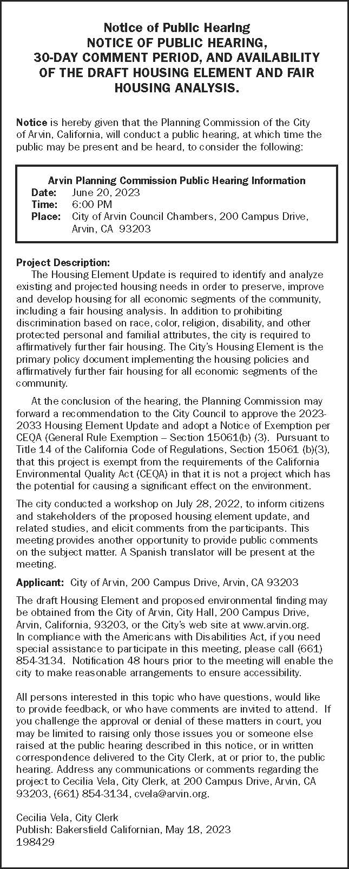

[External] Workshop Distribution – For October 18, 2022
Michael Brockman-Velazquez <mbrockman@civicspark.civicwell.org>
Thu 10/20/2022 2:48 PM
To: Jake Raper <jraper@arvin.org>

Flyers were distributed to the following businesses/locations:
Cricket Wireless
Vallarta
Little Caesars
Bear Mt. Pizza
La Fogota
Arvin Family Dental
La Mexicana Grocery Store
Bright Hope Baptist Church
Calvary Baptist Church
First Baptist Church
Iglesias de Oasis de Vida Arvin
St. John's Valley of Faith
Arvin Public Library
Arvin Union School District

Additionally I handed out flyers to individuals on the street.
--
Michael Brockman-Velazquez | he/him
CivicSpark Fellow, Central CA Region
mbrockman@civicspark.civicwell.org

Updated October 31, 2023

