PUBLIC NOTICE
Notice of Intent to Adopt a Mitigated Negative Declaration
Announcement of Opportunity for Public Hearing
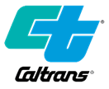
SR-138 Curve Correction near Hesperia, CA
Located in San Bernardino County
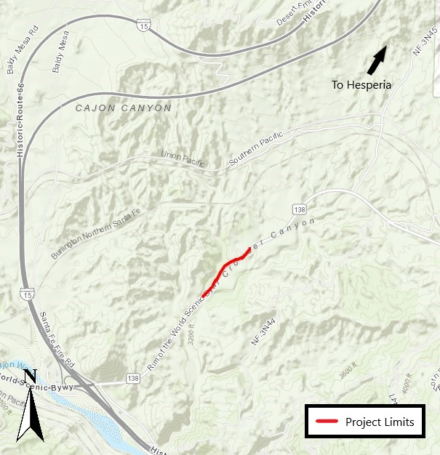
WHAT’S BEING PLANNED? | The California Department of Transportation (Caltrans) proposes to realign State Route 138 (SR-138) from Post Mile (PM) T16.2, 1.0 mile East of Wagon Train Road, to PM R17.4, at Hog Creek Bridge, near the City of Hesperia, in San Bernardino County. This project will improve the vertical and horizontal alignment within this segment to enhance safety and reduce the number of collisions.
WHY THIS NOTICE? | Caltrans has studied the effects this project may have on the environment. The studies show the project will not significantly affect the quality of the environment. The report which explains why is called an Initial Study with Proposed Mitigated Negative Declaration (ISMND). This notice is to tell you of the preparation of the ISMND, of its availability for you to read, and to offer the opportunity for a public hearing.
WHAT’S AVAILABLE? | The Proposed ISMND and other project information such as associated maps and technical studies are available for review and copying at the Caltrans District 8 Office (address below) on weekdays from 8am-5pm, or by email upon request to Gita.Tokhmafshan@dot.ca.gov.
WHERE YOU COME IN | Do you have any comments about processing the project with an ISMND or disagree with the findings of the study? Would you care to make any other comments on the project? Would you like a public hearing?  Please submit your comments or request for a public hearing in writing no later than March 20, 2025, to:  Gita Tokhmafshan, Senior Environmental Planner  California Department of Transportation  464 West Fourth Street, Mail Station 827  San Bernardino, CA 92401-1400  or via e-mail to: Gita.Tokhmafshan@dot.ca.gov  Please include “SR-138 Curve Realignment” in the subject line.  The date we will begin accepting comments is February 18, 2025. If there are no major comments or requests for a public hearing, Caltrans may proceed with the project’s design.
CONTACT | For more information about this study or any transportation matter, contact the Caltrans District 8 Office of Public Affairs at (909) 383-4631. For individuals with sensory disabilities, this document can be made available in Braille, in large print, on audiocassette, or on computer disk. To obtain a copy in one of these alternate formats, call or write to Gita Tokhmafshan, Senior Environmental Planner, 464 W. 4th Street, 6th Floor MS-827, San Bernardino, CA 92401; (909) 501-5742; or use the California Relay Service 1 (800) 735-2929 (TTY to Voice), 1 (800) 735-2922 (Voice to TTY), 1 (800) 854-7784 (Spanish and English Speech to Speech), or dial 711.

