TO: Arvin City Planning Commission

FROM: Jake Raper – Planning Consultant
Sam Lux – Consulting Engineer
Jeffrey Jones – City Manager/Finance Director

SUBJECT: Public Hearing – TPM 2024-WSR-01, Exhibit A, Minor land division subdividing Assessor Parcel Number 192-170-06 into two (2) parcels and one remainder located on the North side of West Sycamore Road and West of Stockton Avenue and East of Meyer Road subject to Conditions of Approval, Exhibit B, and Deferred Off-Site Improvement Agreement Exhibit C and Acceptance of CEQA Notice of Exemption Per Section 15305- Minor Alterations in Land Use Limitations.

RECOMMENDATION – PLANNING COMMISSION ACTION:

Staff, based upon the results of consultation with the various agencies, CEQA determination of a Notice of Exemption, is recommending that the Planning Commission adopt the following:

Adopt Resolution of the City Of Arvin Planning Commission Approving TPM 2024-WSR-01, Minor land division subdividing Assessor Parcel Number 192-170-06 into two (2) parcels and one remainder located on the North side of West Sycamore Road and West of Stockton Avenue and East of Meyer Road subject to Conditions of Approval, Exhibit B, and Deferred Off-Site Improvement Agreement Exhibit C and Acceptance of CEQA Notice of Exemption Per Section 15305- Minor Alterations in Land Use Limitations.

Agent: | Applicant | Property Owner:
A.J. Whitaker  Atlas Civil Design, Inc.  872 Higuera Street  San Luis Obispo, CA  93401  Emai: ajwhitaker@atlascivildesign.com | Jacob Soroudi, AMG & Associates  P.O. Box 260770  Encino, CA  91426  Email: jsoroudi@amgland.com | Paul Loeffel  Email: paloeffel@anthonyvineyards.com.
Project Address: | Not Assigned
Project Location: | North side of West Sycamore Road and West of Stockton Ave.  and East of Meyer Road
Assessor Parcel No. and Size: | APN 192-170-06, 17.94 Acres

Assessor Map, Aerial of Site, and Street Views
APN 192-170-06
North side of West Sycamore Road and West of Stockton Ave. and East of Meyer Road
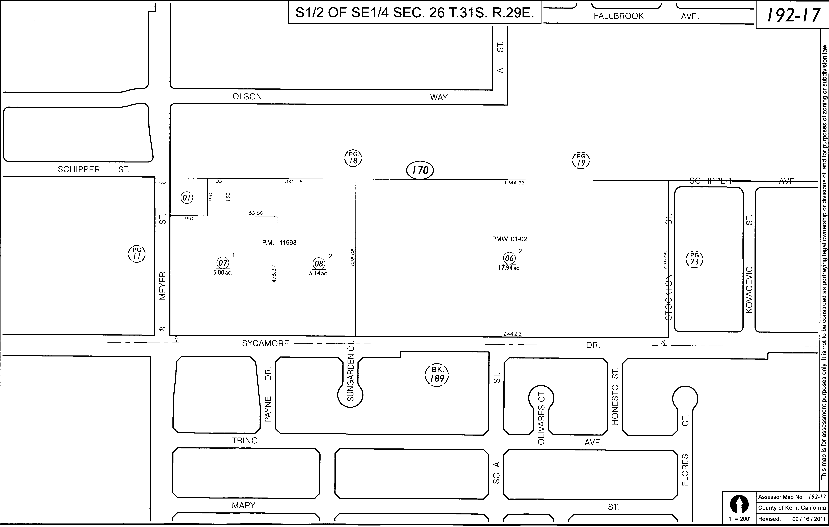 | 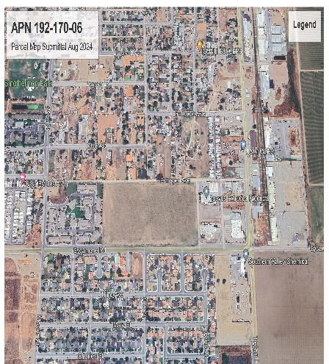
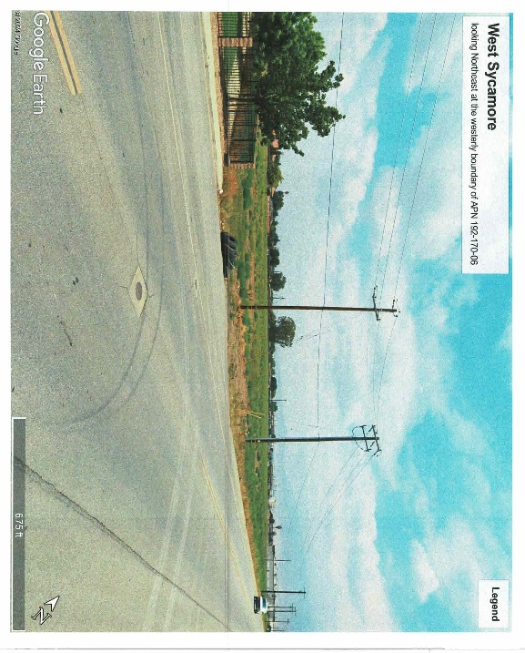 | 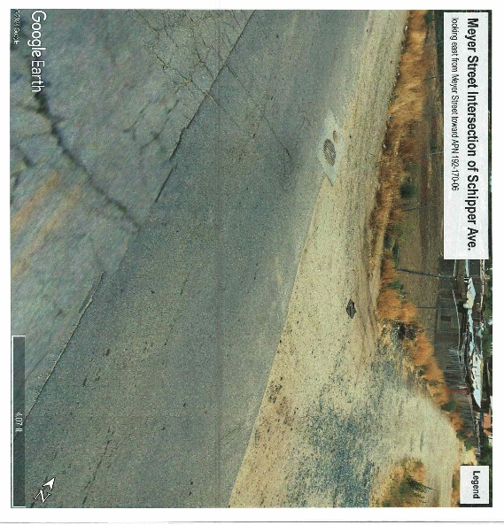
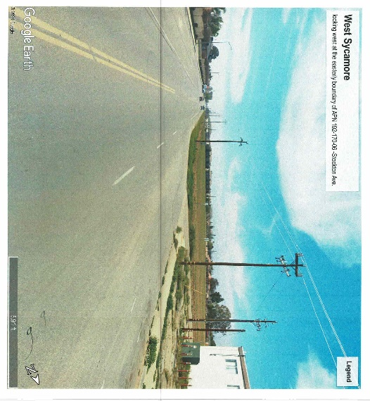 | 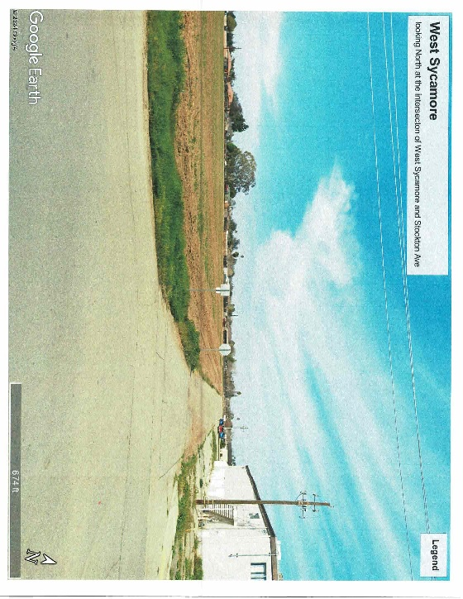
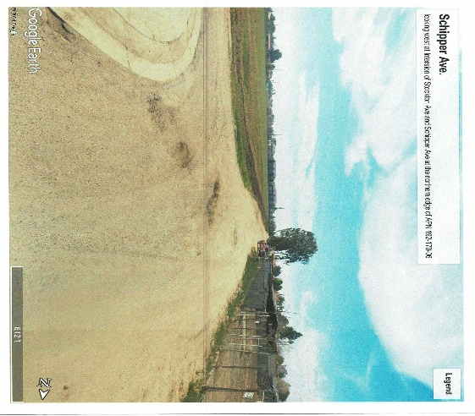

General Plan Land Use Designation: | MDR – Medium Density Residential - Density Range 16 to 24  Units per acre
Zoning: | R-3 Limited Family Dwelling Zone - Multiple Family Residential  development with a minimum development of sixteen (16) units per acre and  a maximum development of twenty-four (24) units per acre proposed  in compliance with Chapter 17.72 Multiple Family Residential Design  Review and shall be subject to Chapter 17.055 Multiple Family Residential  Design Review Ministerial Permit.
Zoning: R-3 Limited Family Dwelling Zone | General Plan Land Use Designation MDR – Medium Density Residential
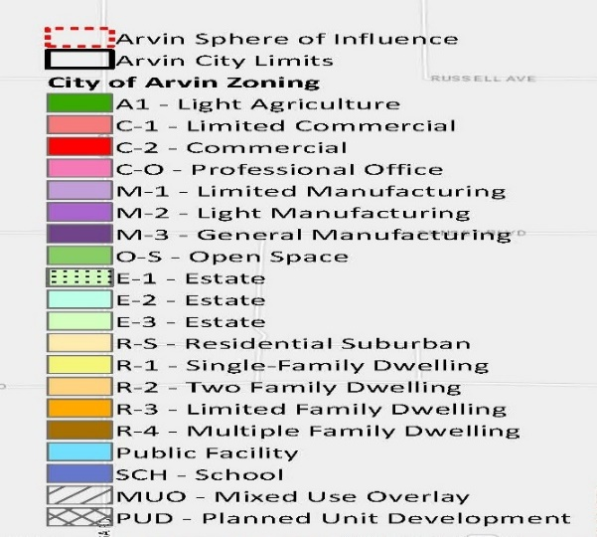 | 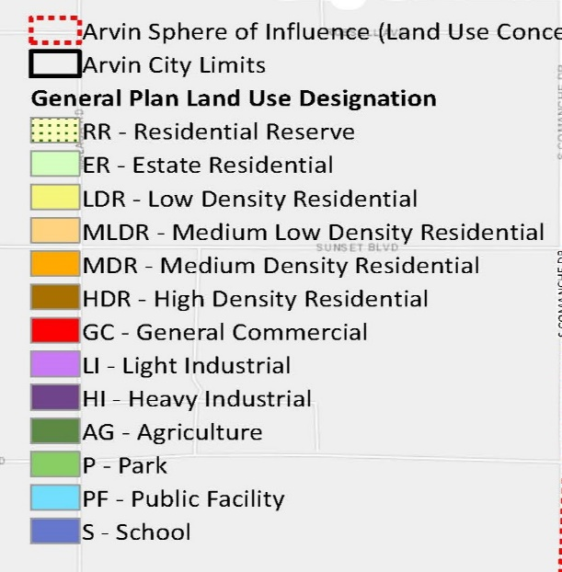
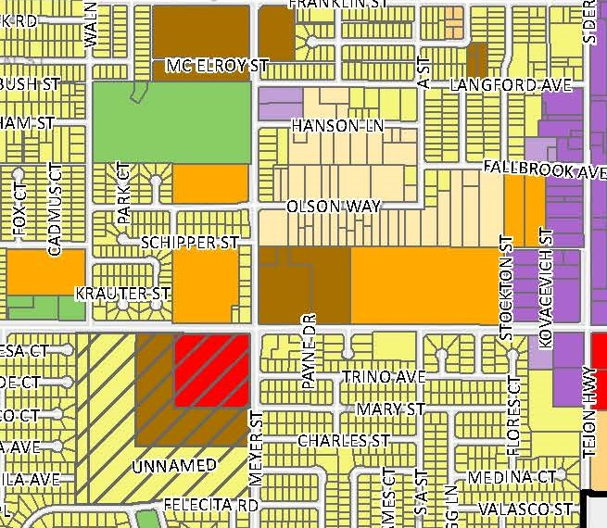 | 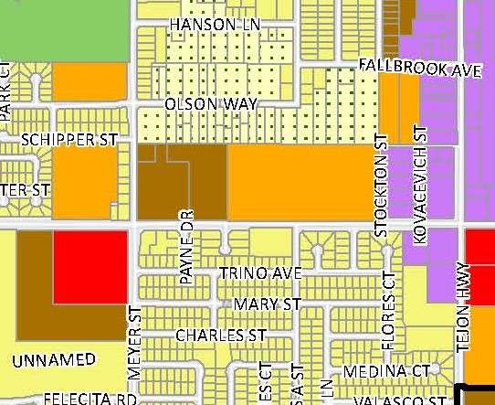

Proposed Minor Land Division: – PM 2024-WSR-01 proposed land division, creating Parcel 1, Phase 1 creating a 3.083 Gross Acres (2.690 Acres Net), Parcel II, Phase 2 creating a 1.617 Gross Acres (1.439 Acres Net) and Remainder Parcel consisting of 14.125 Acres Gross
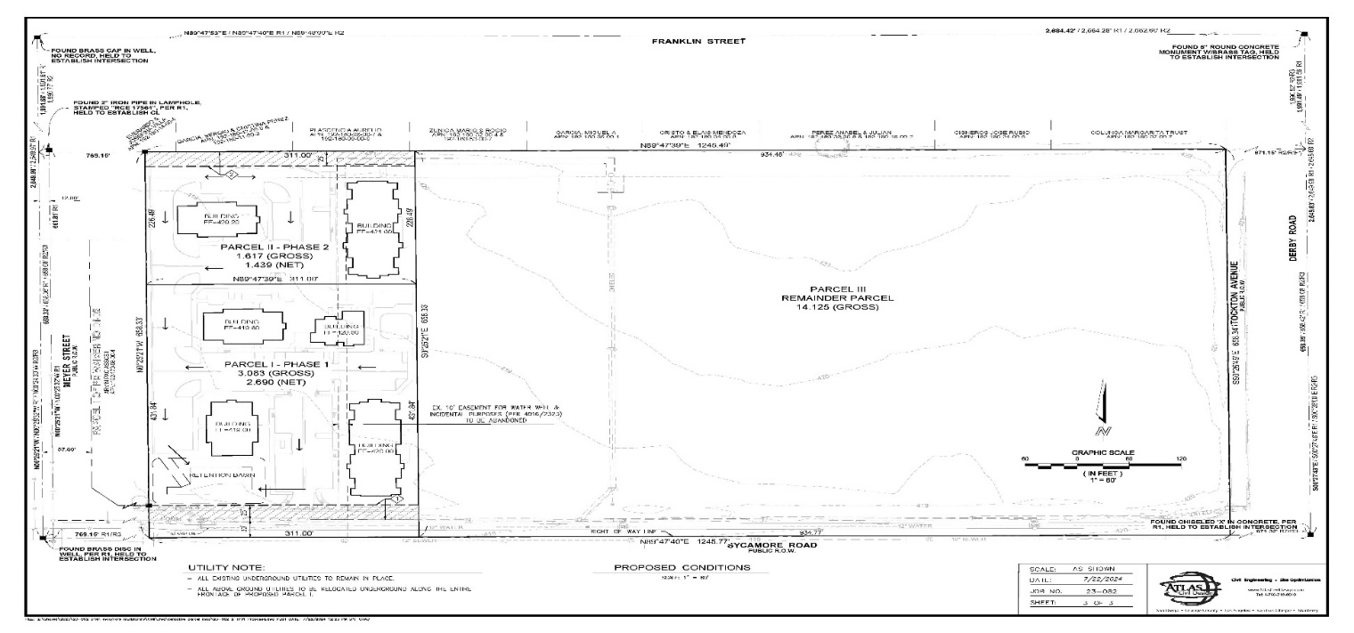

Proposed Street Layout and Dedication of Right of Way for public utility easements and street purposes
Staff and the project engineer had email correspondence regarding the need for dedication of right-of-way for utility easements and street purposes. The future development of the project site will be required to dedicated right-of-way for utility easements and for street purposes.
- Schipper Avenue - Right-of-way – Local Street dedication of 50’-0”:
- West Sycamore Road – Right-of-way- Minor Arterial dedication of 110’-0”:
- Stockton Ave Right-of-way – Local Street Dedication of 50’-0”: Stockton Ave. is a north-south local street connecting Schipper Ave to the north and West Sycamore to the south.

West Sycamore Road - Minor Arterials is to be constructed with right-of-way widths of 110 feet. Minor arterials to have 4 through lanes of travel. Where feasible, minor arterials should have medians and channelized turn lanes at intersections with minor arterials and collectors. Minor arterials include Sunset Boulevard, Sycamore Road, Millux Road, Comanche Drive, Tejon Highway/Derby Street, and Tower Line Road – West Sycamore Road is to have a 110’-0” right-of-way to match the right-of-way dedication to the east.

Schipper Avenue, Stockton Avenue - Local roadways are constructed with right-of-way widths of 50 feet. Local roads at typically 2-lane roads without medians or turn lanes. Schipper Avenue and Stockton Avenue are required to have a 50’-0” right-of-way. Schipper Avenue right-of-way of 50’-0” to be from the westerly property line of Parcel II, Phase 2 then easterly to Stockton Avenue. Stockton Avenue right-of-way of 50’-0” west from Schipper Avenue to West Sycamore Road.

Offer of Dedication for all rights-of-way shall occur at the recording of the parcel map and improvements are to be deferred until development. Road improvements and installation of utilities shall be required prior to the Certificate of Occupancy and/or security such as bonding or other security acceptable to the city to be provided to ensure that all improvements are constructed. The frontage improvements along Parcel II, Phase 2 may be deferred until the Easterly segment of Schipper Avenue is developed. Improvements for West Sycamore Road shall be completed upon the development of Parcel I, Phase 1. All new and existing utilities shall be underground and to occur in concurrence with the development of the parcels.

Aerial of TPM 2024-WSR-01 Showing Rights-of-Way for West Sycamore Road, Schipper Avenue, and Stockton Avenue.
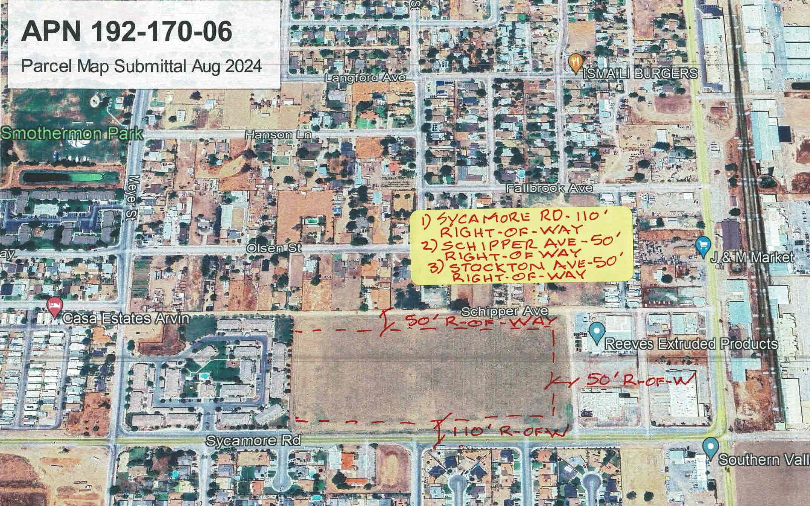

TPM 2024-WSR-01 Showing Rights-of-Way for West Sycamore Road, Schipper Avenue, and Stockton Avenue
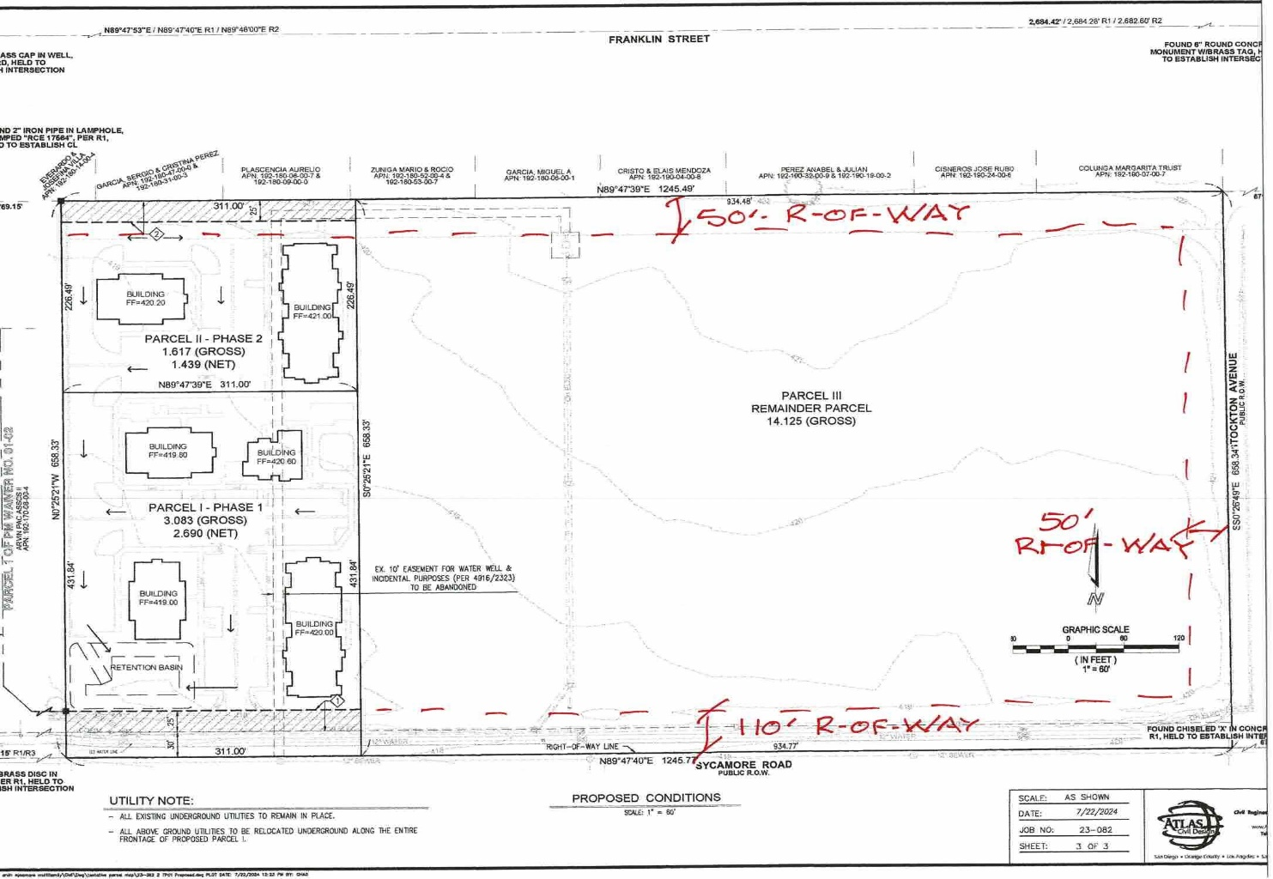

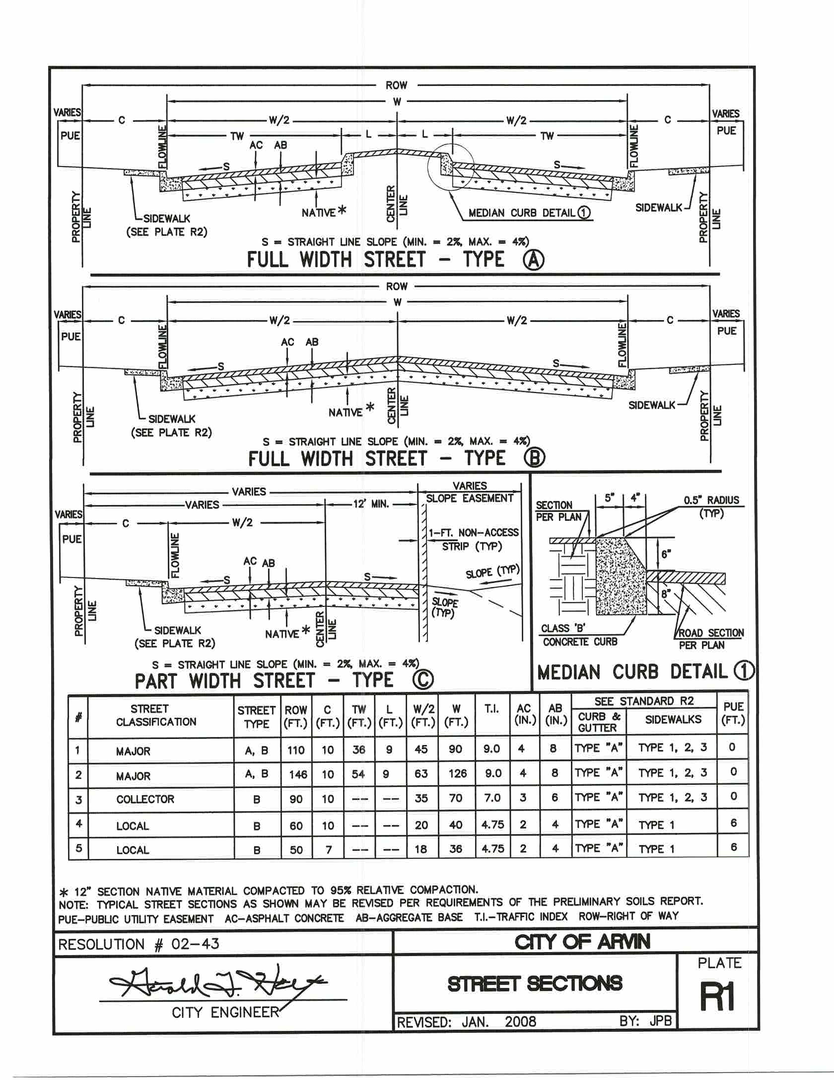

Deferred Off-Site Improvement Agreement:

In accordance with Section 66411.1 of the State of California Subdivision Map Act the City will require a Deferred Off-Site Improvement Agreement for the dedication of off-site rights-of-way for street, pedestrian, and bicycle routes, and utility purposes. The city is requiring the dedication of rights-of-way for West Sycamore Road, Schipper Avenue, and Stockton Avenue to be noted on the Tentative Parcel Map and be included on the Final Parcel Map. Upon presentation of the Final Parcel Map to the City Council, the City Council may accept the offers of dedication or may reject said offers. The Deferred Off-Site Improvement Agreement final form and content shall be subject to the review and approval by the City Engineer, City Manager, and City Attorney. Attached as Exhibit C – Deferred Off-Site Improvement Agreement.

State of California, Subdivision Map Act, Section 66411.1 Improvements for Divisions Not Subdivisions of Five or More Lots; Construction Requirements

(a) Notwithstanding Section 66428, whenever a local ordinance requires improvements for a division of land which is not a subdivision of five or more lots, the regulations shall be limited to the dedication of rights-of-way, easements, and the construction of reasonable offsite and onsite improvements for the parcels being created. Requirements for the construction of offsite and onsite improvements shall be noticed by a statement on the parcel map, on the instrument evidencing the waiver of the parcel map, or by a separate instrument and shall be recorded on, concurrently with, or prior to the parcel map or instrument of waiver of a parcel map being filed for record.

(b) Notwithstanding Section 66428, fulfillment of the construction requirements shall not be required until the time a permit or other grant of approval for development of the parcel is issued by the local agency or, where provided by local ordinances, until the time the construction of the improvements is required pursuant to an agreement between the subdivider and the local agency, except that in the absence of an agreement, a local agency may require fulfillment of the construction requirements within a reasonable time following approval of the parcel map and prior to the issuance of a permit or other grant of approval for the development of a parcel upon a finding by the local agency that fulfillment of the construction requirements is necessary for either of the following reasons:
(1) The public health and safety.
(2) The required construction is a necessary prerequisite to the orderly development of
the surrounding area.

City of Arvin Title 16 – Subdivisions, Section 16.04.100 Dedication requirement. Pursuant to Section 66475 of the Map Act, as a condition of approval of a subdivision, the subdivider shall dedicate or make an irrevocable offer of dedication of all land within the subdivision that is needed for public streets, alleys, including access rights and abutter's rights, drainage, public utility easements and other public easements.

COMMENTS RECEIVED:
Staff distributed the tentative parcel map application to various public agencies that have review authority and to city departments for their review, comments, and potential conditions that may be imposed on the minor land division. As of October 3, 2024, staff received comments from the following agencies. Comments may be incorporated as condition of approval and have been forwarded to the project engineer.

No. | Date | Agency and Contact Information | Comment received | Staff Recommendation/Action
1. | 9-11-24 | Arvin-Edison Water Storage District  20401 East Bear Mountain Boulevard  Arvin, CA 93203  Samuel Blue, P.E.  Resource Manager | Concerned about water supply issues. | Forwarded comment to project engineer.  Emails with Arvin-Edison, Arvin CSD, and Project Engineer – water supply request submitted.
2. | 9-6-24 | Office of the Fire Marshal Kern County Fire Department Fire Prevention Unit  2820 M St. • Bakersfield, CA 93301  Roxanne Routh  Assistant Fire Marshal  Kern County Fire Department | New Construction requires fire water flowing a minimum 1,500 GPM for 2 hours with 20 PSI residual.  All new residential construction will require automatic fire sprinklers and shall meet all other fire requirements of the California Fire Code. Residential hydrant spacing shall be 660 feet.  A more detailed review and project comments will be conducted when the building permit is obtained, and plans are submitted to KCFD. | Staff forwarded comments to project engineer.  Proposed condition requires fire clearance from Kern County Fire Department at building permit stage.
3. | 9-13-24 | Arvin Unified School District  Curriculum Secretary  737 Bear Mountain Blvd  Arvin, CA 93203  Georgia Rhatt  rhett@arvin-do.com | Response to question – will the project affect your agency/jurisdiction.  Response received via email – No affect. | Staff forwarded comment to project engineer.  Note: land divisions must provide school districts a minimum of 15 days to respond. School district staff responded within 8 days of notification.
4 | 9-26-24 | PGE Plan Review <PGEPlanReview@pge.com> | PG&E provided general construction restrictions and guidelines – incorporate these preliminary notes into the project design. | Staff forwarded comment to project engineer.
5 | 9-16-24 | Arvin Community Services District  Raul Barraza, Jr.  General Manager  309 Campus Drive  Arvin, CA 93203 | Arvin CSD wrote- Applicant should apply for a Will Serve first. With the Sustainable Groundwater Management Act, we may not be able to provide the water they are looking for | Staff forwarded comment to project engineer.  Project Engineer email to Arvin CSD to file request for will serve letter for water service.

6 | 10-1-2024  And  10-3-2024 | PG and E  Pacific Gas and Electric Company  Plan Review Team  Email: pgeplanreview@pge.com | Should this project have the potential to interfere with PG&E’s facilities, we intend to respond to you with project specific comments. Attached is some general information when working near PG&E facilities that must be adhered to when working near PG&E’s facilities and land rights. | Staff forwarded comment to project engineer on 10-7-2024
7 | 10-3-2024 | PG and E  Pacific Gas and Electric Company  Plan Review Team  Email: pgeplanreview@pge.com | Letter dated 10-3-2024 – Not Impact to PG and E facilities or impact to easements | Staff forwarded comment to project engineer on 10-7-2024

ENVIRONMENTAL REVIEW

The tentative parcel map is Categorically Exempt per CEQA guidelines Section 15315 Minor Land Divisions Class 15 where the division of property in urbanized areas zoned for residential, commercial, or industrial use into four of fewer parcels when the division is in conformance with the General Plan and zoning, no variance or exception are available, the parcel was not involved in a division of a larger parcel within the previous 2 years, and the parcel does not have an average slope greater than 20 percent.

FINDINGS FOR APPROVAL:
Staff has reviewed the Subdivision Map Act, Section 66474, establishes mandatory disapproval of a subdivision if any of the following findings exist:
(a) That the proposed map is not consistent with applicable general and specific plans as specified in Section 65451. FINDING: The proposed minor land division is consistent with the City of Arvin’s General Plan.
(b) That the design or improvement of the proposed subdivision is not consistent with applicable general and specific plans. FINDING: The proposed minor land division design and improvements recommended as conditions of approval result in a finding that the proposed minor land division is consistent with the City of Arvin’s General Plan.
(c) That the site is not physically suitable for the type of development. FINDING: The existing site is physically suitable for the development of multiple family residential development.
(d) That the site is not physically suitable for the proposed density of development. . FINDING: The existing site is physically suitable for the development of multiple family residential development.
(e) That the design of the subdivision or the proposed improvements are likely to cause substantial environmental damage or substantially and avoidably injure fish or wildlife or their habitat. FINDING: The design of the minor land division and the proposed improvements will not cause substantial environmental damage or substantially and avoidably injure fish or wildlife or their habitat.
(f) That the design of the subdivision or type of improvements is likely to cause serious public health problems. FINDING: The design of the minor land division and the proposed improvements will not cause serious public health problems.
(g) That the design of the subdivision or the type of improvements will conflict with easements, acquired by the public at large, for access through or use of, property within the proposed subdivision. In this connection, the governing body may approve a map if it finds that alternate easements, for access or for use, will be provided, and that these will be substantially equivalent to ones previously acquired by the public. This subsection shall apply only to easements of record or to easements established by judgment of a court of competent jurisdiction and no authority is hereby granted to a legislative body to determine that the public at large has acquired easements for access through or use of property within the proposed subdivision. FINDING: The design of the minor land division and the proposed improvements and the type of improvements required will not conflict with easements, acquired by the public at large, for access through or use of, property within the proposed subdivision.

Based upon consultation and Staff review of the proposed land division, Staff is recommending that none of the findings listed in Section 65451 are found to exist. Furthermore, Staff is recommending the Planning Commission approve Resolution of the City Of Arvin Planning Commission Approving TPM 2024-WSR-01, Minor land division subdividing Assessor Parcel Number 192-170-06 into two (2) parcels and one remainder located on the North side of West Sycamore Road and West of Stockton Avenue and East of Meyer Road subject to Conditions of Approval, Exhibit B, and Deferred Off-Site Improvement Agreement Exhibit C and Acceptance of CEQA Notice of Exemption Per Section 15305- Minor Alterations in Land Use Limitations.

PUBLIC HEAING NOTICE, POSTING OF ON-SITE NOTICE, AND NOTICE TO THE SURROUNDING PROPERTIES
The City required the developer to prepare and post an ON-SITE NOTICE at the project location ten (10) days prior to the October 15, 2024, Planning Commission hearing pursuant to Government Code sections 36933, 65854, and 65090. The applicant caused the Posting of the Site on October 4, 2024 at 7:00 P.M.. In addition, the City Clerk’s office posted the Public Hearing Notice on October 4, 2024 at the following designated places for posting of public notices: (1) Arvin City Hall/City Council Chambers; (2) Arvin Police Department; and (3) Community Development Department. In addition, the City Clerk’s office provided notice by mailing to all property owners within 300-foot radius providing a 10-day review, in accordance with Government Code Sections 36933, 65854, and 65090.

Please be advised the sign went up last night by 7pm. The size is 4’ by 5’, larger than the minimum 2’ by 4’ – Jacob Soroudi – Applicant.
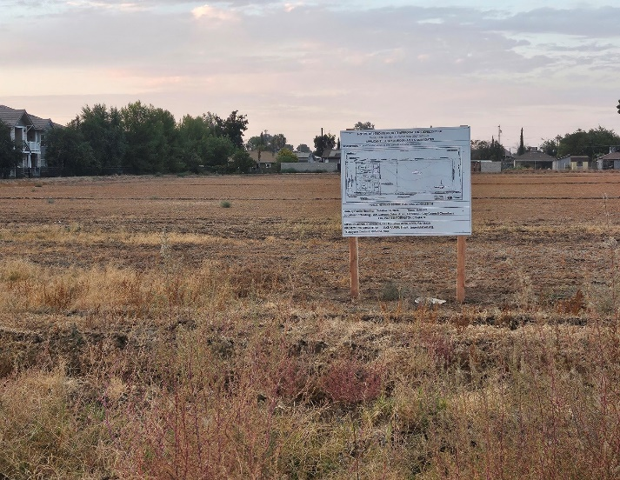 | 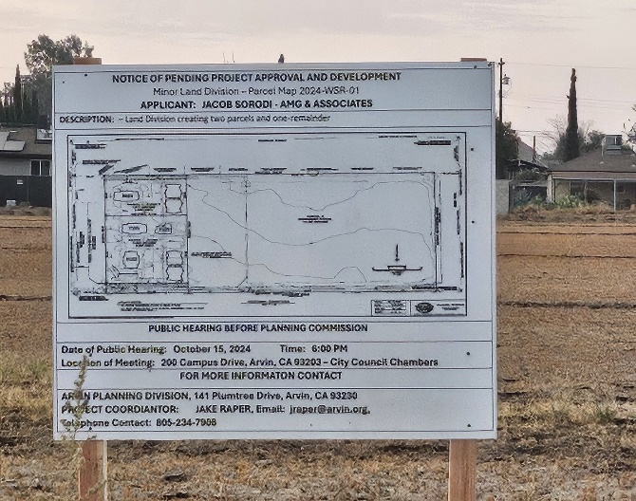

FISCAL CONSIDERATIONS
The adoption of the resolution conditionally approving the tentative parcel map and further actions by Planning Commission are based upon the fees as adopted by the City Council. The processing of the tentative parcel map and time expended by city staff and consultations are full cost recovery.

APPEAL BY APPLICANT OR INTERESTED PARTY:
The action of the Planning Commission may be appealed to the City Council. If an appeal is filed, the appeal must be in writing stating the reasons for the appeal, pay the appeal fee as established by the City Council, and the written appeal must be filed within 10 calendar days of the Planning Commission’s decision. The Applicant is required to sign the Acceptance of Conditions or Appeal the Decision of the Planning Commission.

END OF REPORT.

Resolution and Exhibits:
A Resolution of the City Of Arvin Planning Commission Approving TPM 2024-WSR-01, Minor land division subdividing Assessor Parcel Number 192-170-06 into two (2) parcels and one remainder Located on the North side of West Sycamore Road and West of Stockton Avenue and East of Meyer Road subject to Conditions of Approval, Exhibit B, and Deferred Off-Site Improvement Agreement Exhibit C and Acceptance of CEQA Notice of Exemption Per Section 15305- Minor Alterations in Land Use Limitations.

Attachments:
- Attachment - Comments Received.
1-AE. Comments TPM APN 192-270
2-Kern County Fire - APN 192-270-06 - 9-6-2024
3-Arvin Unified School District - 9-13-2024
4-PGE Response 9-26-2024 - PM West Sycamore Rd
5-Arvin CSD 9-16-24 - Apply for Will Serve Letter
6-PGE Response 10-1--2024 – Listing of PG and E common responses
7-PGE Response 10-3-2024 – No Impact to P G and E facilities.

