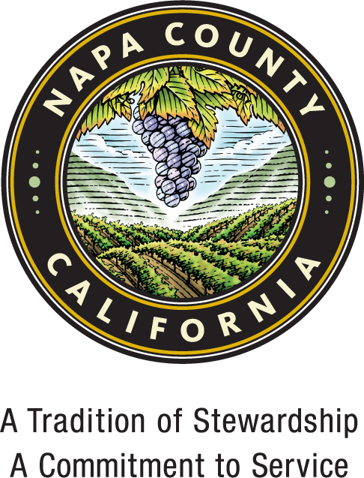
PUBLIC NOTICE

NOTICE OF PLANNING COMMISSION HEARING &
NOTICE OF INTENT TO ADOPT A NEGATIVE DECLARATION

On Wednesday morning, the 20th day of November 2024, at 9:00 a.m. at 1195 Third Street, Suite 305, Napa, California, a public hearing will be conducted by the Napa County Planning Commission regarding the project identified below. All interested persons are invited to attend the hearing and be heard.

E & P Technology Way, Buildings A & B – Use Permits #P22-00307 & #P22-00308

Location: North side of Technology Way & Morris Court, Napa - Assessor’s Parcel No’s (057-250-030 Building A) & 057-250-031, - 032 (Building B); 20-acres combined
Zoning and General Plan Designation: Industrial Park: Airport Compatibility (IP:AC) zoning district and Industrial general plan designation; within the Napa Valley Business Park Specific Plan area.

CEQA Status: Consideration and possible adoption of a Mitigated Negative Declaration. According to the proposed Mitigated Negative Declaration, the proposed project would not have any potentially significant environmental impacts after implementation of mitigation measures. Mitigation measures are proposed for the following areas: Biological Resources, Cultural Resources, and Transportation. The project site is not included on a list of hazardous materials sites compiled pursuant to Government Code Section 65962.5.

Request: Approval of two Use Permit applications to allow the construction of two separate buildings: Building A – a 450,000 gallon per year wine production and storage facility within a proposed 143,312 sf building (P22-00307-UP) and Building B – speculative warehouse/office uses within a proposed 66,915 sf building (P22-00308-UP).

The Building A project proposes winery uses that will include grape crushing, bulk wine processing and storage, stainless steel tank and barrel storage, bottling, and office space. In addition, approximately 13,000 square feet of covered work outdoor area will be located on the north side of the building. The proposal also includes 129 parking spaces and eight (8) spaces for semi-trailers. Access will be provided by three (3) new driveways; one (1) on Technology and two (2) on Morris Court. Tours, tastings, and marketing events are not proposed with this application. The applicant is requesting a variation to the development regulations of the Specific Plan to reduce the required 40-foot average building setback along the south property line to approximately 31-feet. The proposed building exceeds the minimum 25-foot building and landscape setback along Technology Way.

The Building B project proposes to allow warehouse and office uses within the proposed 66,915 sf building. The proposal also includes 82 parking spaces. Access will be provided via two new access driveways off Technology Way on the far west and east sides of the project site. The warehouse uses are consistent with allowable warehouse uses as outlined in Napa County Code Industrial Park zoning district (18.40.020) and the Napa Valley Business Park Specific Plan (NVBPSP.)

Both buildings will be provided with water service from the City of American Canyon. Napa Sanitation District (NSD) will provide sewer. The buildings will be sprinklered for fire protection.

Application materials, including the draft environmental determination, are available on the Department’s Current Projects Explorer at: https://www.countyofnapa.org/2876/Current-Projects-Explorer

Copies of documents and other information relating to the project described above may be examined between 8:00 AM and 4:00 PM Monday through Friday at the office of the Planning, Building, and Environmental Service Department, Napa County Administration Building, 1195 Third St, Ste 210, Napa, California. For documents that are publicly available on the Current Projects Explorer, there will be a Public Record Copying Fee associated with the physical printing of documents. While drops-in may be accommodated to the extent possible on a case-by-case basis, we strongly encourage you to schedule an appointment for document review.

Written and verbal comments regarding this project and comments regarding the environmental effects of this project and the adequacy of the proposed Mitigated Negative Declaration are solicited. Comments or appointment requests to review documents should be directed to Sean Trippi, Napa County Planning, Building & Environmental Services Department, 1195 Third Street, Suite 210, Napa, California; (707) 299-1353 or sean.trippi@countyofnapa.org. Comments must be received before Noon on November 19, 2024.

If you challenge the particular proceeding in court, you may be limited to raising only those issues you or someone else raised at the public hearing described in this notice, or in written correspondence delivered to the Planning Commission at, or prior to the public hearing.

DATED: October 18, 2024

Brian D. Bordona
Director of Planning, Building, & Environmental Services

