NOTICE OF EXEMPTION

LOS ANGELES COUNTY
SANITATION DISTRICTS
Converting Waste into Resources
Sanitation District No. 3 of Los Angeles County 1955 Workman Mill Road
Whittier, CA 90601

2024 182522
Aug 29 2024
THIS NOTICE WAS POSTED ON August 29 2024
UNTIL September 30 2024
Dean C. Wynn, Registrar —liecorderICounty Clerk
REGISTRAR — RECORDER!COUNTY CLERK — Electronically signed by11171Mr1"

County Clerk, County of Los Angeles 12400 East Imperial Highway
To:
Project Title: Project Locati9n:
Project Description:
Room 2001
Norwalk, CA 92650
Marina Trunk Sewer Section 1 A Relief
The project begins at MH 03 0348 and runs along Mira Mar Avenue and continues along the Pacific Greenbelt (former railroad right-of-way) then Grand Avenue and ties into Joint Outfall C unit 3C sewer near MH C 0100, all within the City of Long Beach.
This project consists of construction of approximately 1,560 feet 18-inch diameter relief sewer, five (5) manholes, including two (2) junction structures adjacent to Marina Trunk Sewer Section 1A.

Public Agency
DOC 7306674
Approving Project: Sanitation District No. 3 of Los Angeles County
Person or Agency
Carrying Out Project: Sanitation District No. 3of Los Angeles County
Exempt Status: (check one)
- Ministerial
111 Declared Emergency
- Emergency Project
Categorical Exemption — Section 15301 of the CEQA Guidelines
El Statutory Exemption — Section 21080(b)(4) of the Public Resources Code
Reasons Why
Project Is Exempt: The project includes repairs and modifications to an existing public facility with no expansion of use. The project is also necessary to prevent or mitigate..an emergency.
Contact Person: Marvin Holmes, Project Engineer
Wastewater Planning Section
County Sanitation Districts of Los Angeles County Telephone (562) 908-4288, extension 2729
Date: | August 28, 2024 |  |  | 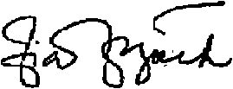
 | August 28, 2024 |  |  | Ziad El Jack  Supervising Engineer  Facilities Planning Department

Dates Notice Posted:



Cashier: T, TEN

Dean , C, Cogan
Los Angeles.County Registtat. [Reoprdr.
12400:10erlaHjgNoy, Nor'' CA
(800)201.78999
BUSINESS FILINGS RESTRATION
OAK BEP4RTMENT HEADQUARTER

, 111111111111111111,111111111111111111
02.4 O819'.'04110 0 5 *
1Thur day, Au9ust,19 2024 3:28 RI
306,q,

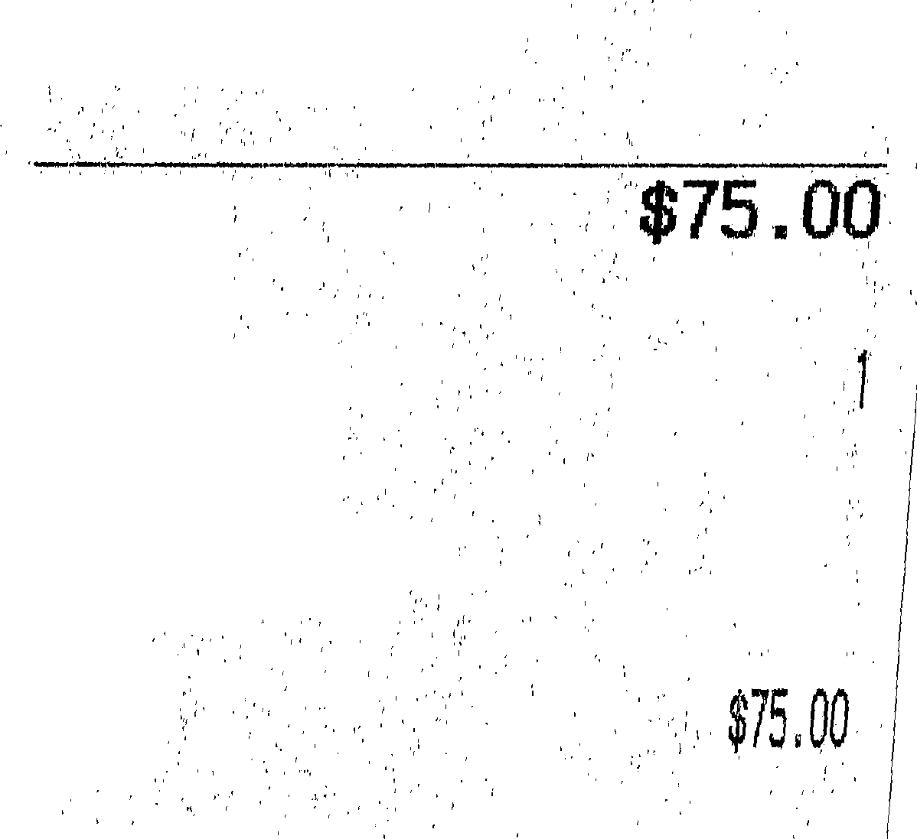
County Sanitation Bistrict 1149
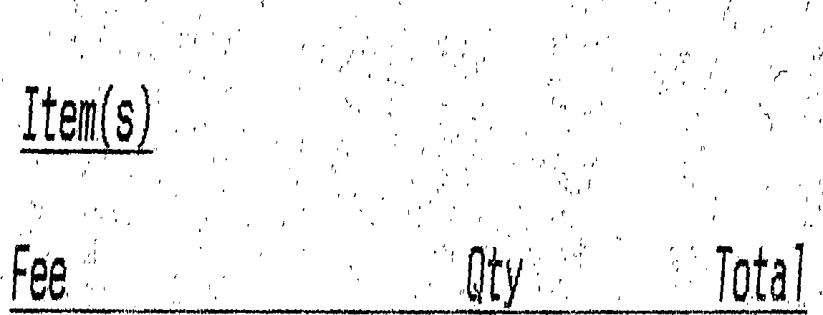

From: Mendez, Brianna
To: RRCCCEQAFilingarrcc.lacounty.gov
Cc: Holmes, Marvin; Hong, Deborah
Subject: CEQA Filing - Marina Trunk Sewer Section 1A Relief
Date: Thursday, August 29, 2024 7:47:00 AM
Attachments: DMS-#7306674-v1-Marina Trunk Sewer Section 1A Relief.pdf
image001.onq
Good morning,
Attached please find the completed transmittal form and Notice of Exemption for the subject project. Thank you,
Brianna Mendez
Secretary I I Facilities Planning 562-908-4288 ext. 2702
briannamendez@lacsd.orq
LOS ANGELES COUNTY
da
ySANITATION DISTRICTS Converting Waste Into Resources Website I Facebook I X (Twitter) I Instaqram I YouTube

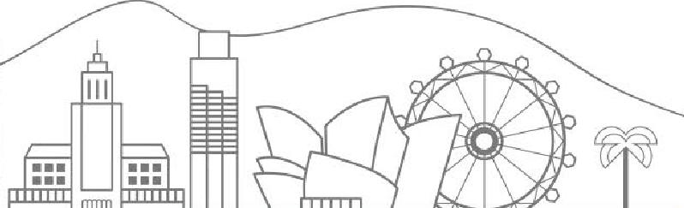
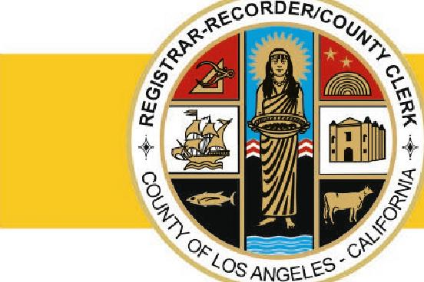

•
LOS ANGELES COUNTY REGISTRAR-RECORDER/COUNTY CLERK

DEAN C. LOGAN
12400 IMPERIAL HIGHWAY, NORWALK, CA 90650 LAVOTE.GOV
Registrar-Recorder/County Clerk
CEQA Email Filing Customer Transmittal
This form must be completed in full and emailed to the following email
address: _rrccceqafiling@rrcc.lacounty.gov. Along with this PDF,
you must include your completed and scanned
CEQA document(s) for filing. Your filed documents will be returned to you via email once complete. Monthly invoices will be sent out for you to pay for your transactions.
- Company Name
- Customer Code/Billing Account #
- Contact Name
- Contact Email
- Number of filings attached
Please reach out to our call center with any questions (800)201-8999 option #4.

 | LOS ANGELES COUNTY AN DISTRICTS  Converting Waite Into Resources
Sanitation District No. 3 of Los Angeles County 1955 Workman Mill Road
Whittier, CA 90601
NOTICE OF EXEMPTION

County Clerk, County of Los Angeles 12400 East Imperial Highway
To:
Project Title: Project Location:
Project Description:
Room 2001
Norwalk, CA 92650
Marina Trunk Sewer Section lA Relief
The project begins at MH 03 0348 and runs along Mira Mar Avenue and continues along the Pacific Greenbelt (former railroad right-of-way) then Grand Avenue and ties into Joint Outfall C unit 3C sewer near MH C 0100, all within the City of Long Beach.
This project consists of construction of approximately 1,560 feet 18-inch diameter relief sewer, five (5) manholes, including two (2) junction structures adjacent to Marina Trunk Sewer Section 1A.

Public Agency
DOC 7306674
Approving Project: Sanitation District No. 3 of Los Angeles County
Person or Agency
Carrying Out Project: Sanitation District No. 3of Los Angeles County
Exempt Status: (check one)
- Ministerial
- Declared Emergency
- Emergency Project
Categorical Exemption — Section 15301 of the CEQA Guidelines Statutory Exemption — Section 21080(b)(4) of the Public Resources Code
Reasons Why
Project Is Exempt: The project includes repairs and modifications to an existing public facility with no expansion of use. The project is also necessary to prevent or mitigate an emergency.
Contact Person: Marvin Holmes, Project Engineer
Wastewater Planning Section
County Sanitation Districts of Los Angeles County Telephone (562) 908-4288, extension 2729
Date: August 28, 2024 |  |  | 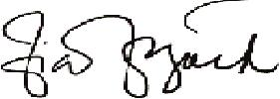
Date: August 28, 2024 |  |  | Ziad El Jack  Supervising Engineer  Facilities Planning Department

Dates Notice Posted:

