CITY OF ARVIN NOTICE OF PUBLIC HEARING

SITE DEVELOPMENT PERMIT NO. 2024-802BMB – 802 BEAR MOUNTAIN BOULVARD

Notice is hereby given that the Planning Commission, City of Arvin, California, will conduct a public hearing, at which time you may be present and be heard, to consider a proposed Site Development Permit No. 2024-802BND and CEQA determination.
City of Arvin
PLANNING COMMISSION
Date: Tuesday, September 17, 2024
Time: 6:00 PM
Place: City of Arvin City Council Chambers, 200 Campus Drive, Arvin, CA 93203

Applicant: Danny Nunez – 1430 Truxtun Ave., Suite 105, Bakersfield, CA

Location: N802 Bear Mountain Blvd., Arvin, CA 93230

Project Description: Site Development Permit 2024-802BMB - 802 Bear Mountain Boulevard, APN 190-270-16– Repurposing of existing commercial restaurant with drive-thru service, formerly Burger King Restaurant. Exterior remodel by removing inclined roof, removing Spanish tile, creating new vertical exterior and new exterior color palette, approving the proposed architectural design, and approving the continued use of the existing pole sign, and accept the CEQA determination of a Notice of Exemption.

- Proposed modern architectural design to replicate other Taco La Villa operations in California which deviates from the Mediterranean architecture. Existing Pole Sign to remain.
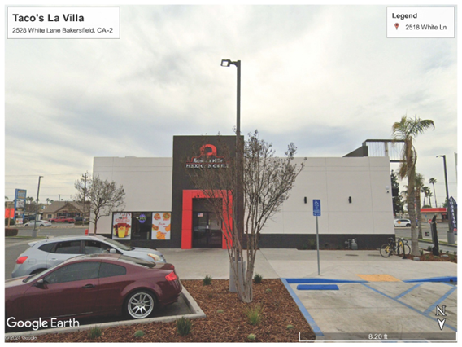 | 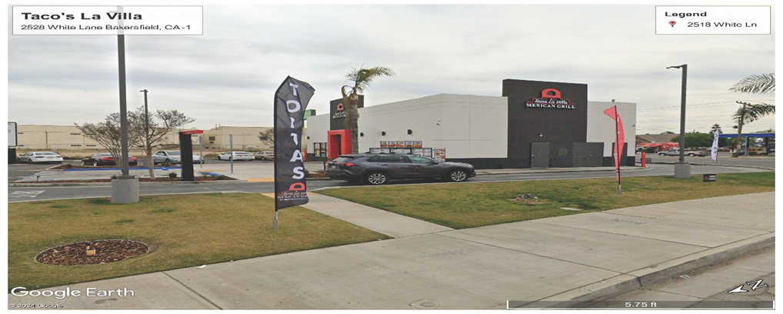

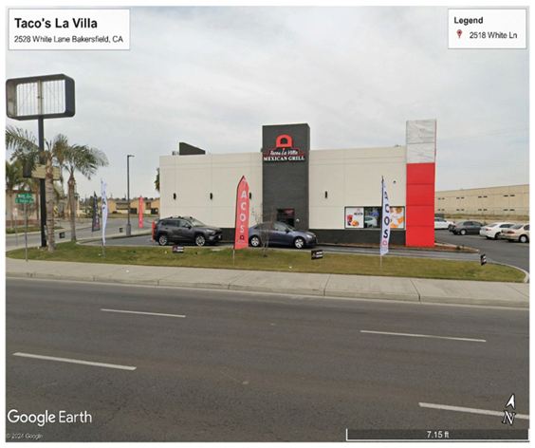 | 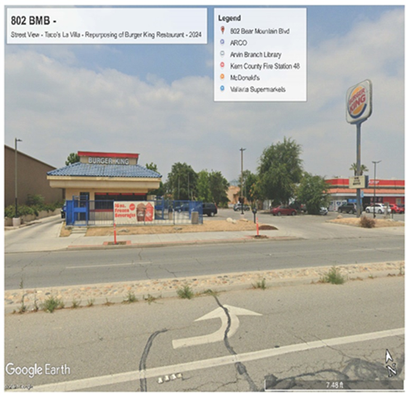

The purpose of the public hearing will be to give citizens an opportunity to make their comments known. If you are unable to attend the public hearing, you may direct written comments to City of Arvin, City Clerk’s Office, 200 Campus Drive, Arvin, CA 93203 or emailed to cvela@arvin.org. In the subject line, please provide “PUBLIC COMMENT – SDP 2024-802BMB”. All public comments will be provided to the City Staff and may be read into the record or compiled as part of the record. Additional information on the proposed site development permit, including copies in hard copy or electronic format, may be obtained from the City Clerk’s office at Arvin City Hall, 200 Campus Drive, Arvin, California, 93203, or the City’s website at www.arvin.org.

All persons interested in this topic who would like to provide feedback or ask questions are invited to attend. Written comments on this matter may be submitted to the City Clerk’s office by 8:00am on the date of this hearing. If you challenge the approval or denial of these matters in court, you may be limited to raising only those issues you or someone else raised at the public hearing described in this notice, or in written correspondence delivered to the City Clerk, at or prior to the public hearing. Address any communications or comments regarding the project to Cecilia Vela, City Clerk, 200 Campus Drive, Arvin, CA 93203, (661) 854-3134, cvela@arvin.org.

Note: If you challenge the nature of the proposed action in court, you may be limited to raising only those issues you or someone else raised at the Public Hearing(s) described in this notice, or in written correspondence delivered to the City at, or prior to, the Public Hearing (Govt. Code Sec. 65009).

/s/
Cecilia Vela, City Clerk City of Arvin, California
Post as follows: City Website; City Hall/City Council Chambers; Arvin Police Dept.; Community Development Dept.

