TO: Arvin City Planning Commission

FROM: Jake Raper – Planning Consultant
Jeffrey Jones – City Manager/Finance Director

SUBJECT: Public Hearing – Site Development Permit 2024-802BMB - 802 Bear Mountain Boulevard, APN 190-270-16– Repurposing of existing commercial restaurant with drive-thru service, formerly Burger King Restaurant, exterior remodel by removing inclined roof, removing Spanish tile, creating new vertical exterior and new exterior color palette, approving the proposed architectural design, and approving the continued use of the existing pole sign, and accept the CEQA determination of a Notice of Exemption.

RECOMMENDATION – PLANNING COMMISSION ACTION:
Staff is recommending that the Planning Commission Approve the attached Resolution of the City of Arvin Planning Commission Conditionally Approving Site Development Permit 2024-802BMB - 802 Bear Mountain Boulevard, APN 190-270-16– Repurposing of existing commercial restaurant with drive-thru service, formerly Burger King Restaurant. Exterior remodel by removing inclined roof, removing Spanish tile, creating new vertical exterior and new exterior color palette, approving the proposed architectural design, and approving the continued use of the existing pole sign, and accept the CEQA determination of a Notice of Exemption.

Applicant: | Danny Nunez – 1430 Truxtun Ave., Suite 105, Bakersfield, CA  Email: danny.nunez@tacoslavillamg.com
Project Address: | 802 Bear Mountain Blvd. Arvin California, 93203 (formerly Burger King Restaurant and Drive-Thru Service)
Project Location: | Located on the north side of Bear Mountain Blvd. and approximately 150 feet west of Campus Drive
Assessor Parcel No. and Size: | APN 190-270-16
Zoning: | C-2, Commercial
General Plan Designation: | Commercial

Project Location: 802 Bear Mountain Blvd., Arvin, CA 932023, APN 190-270-16
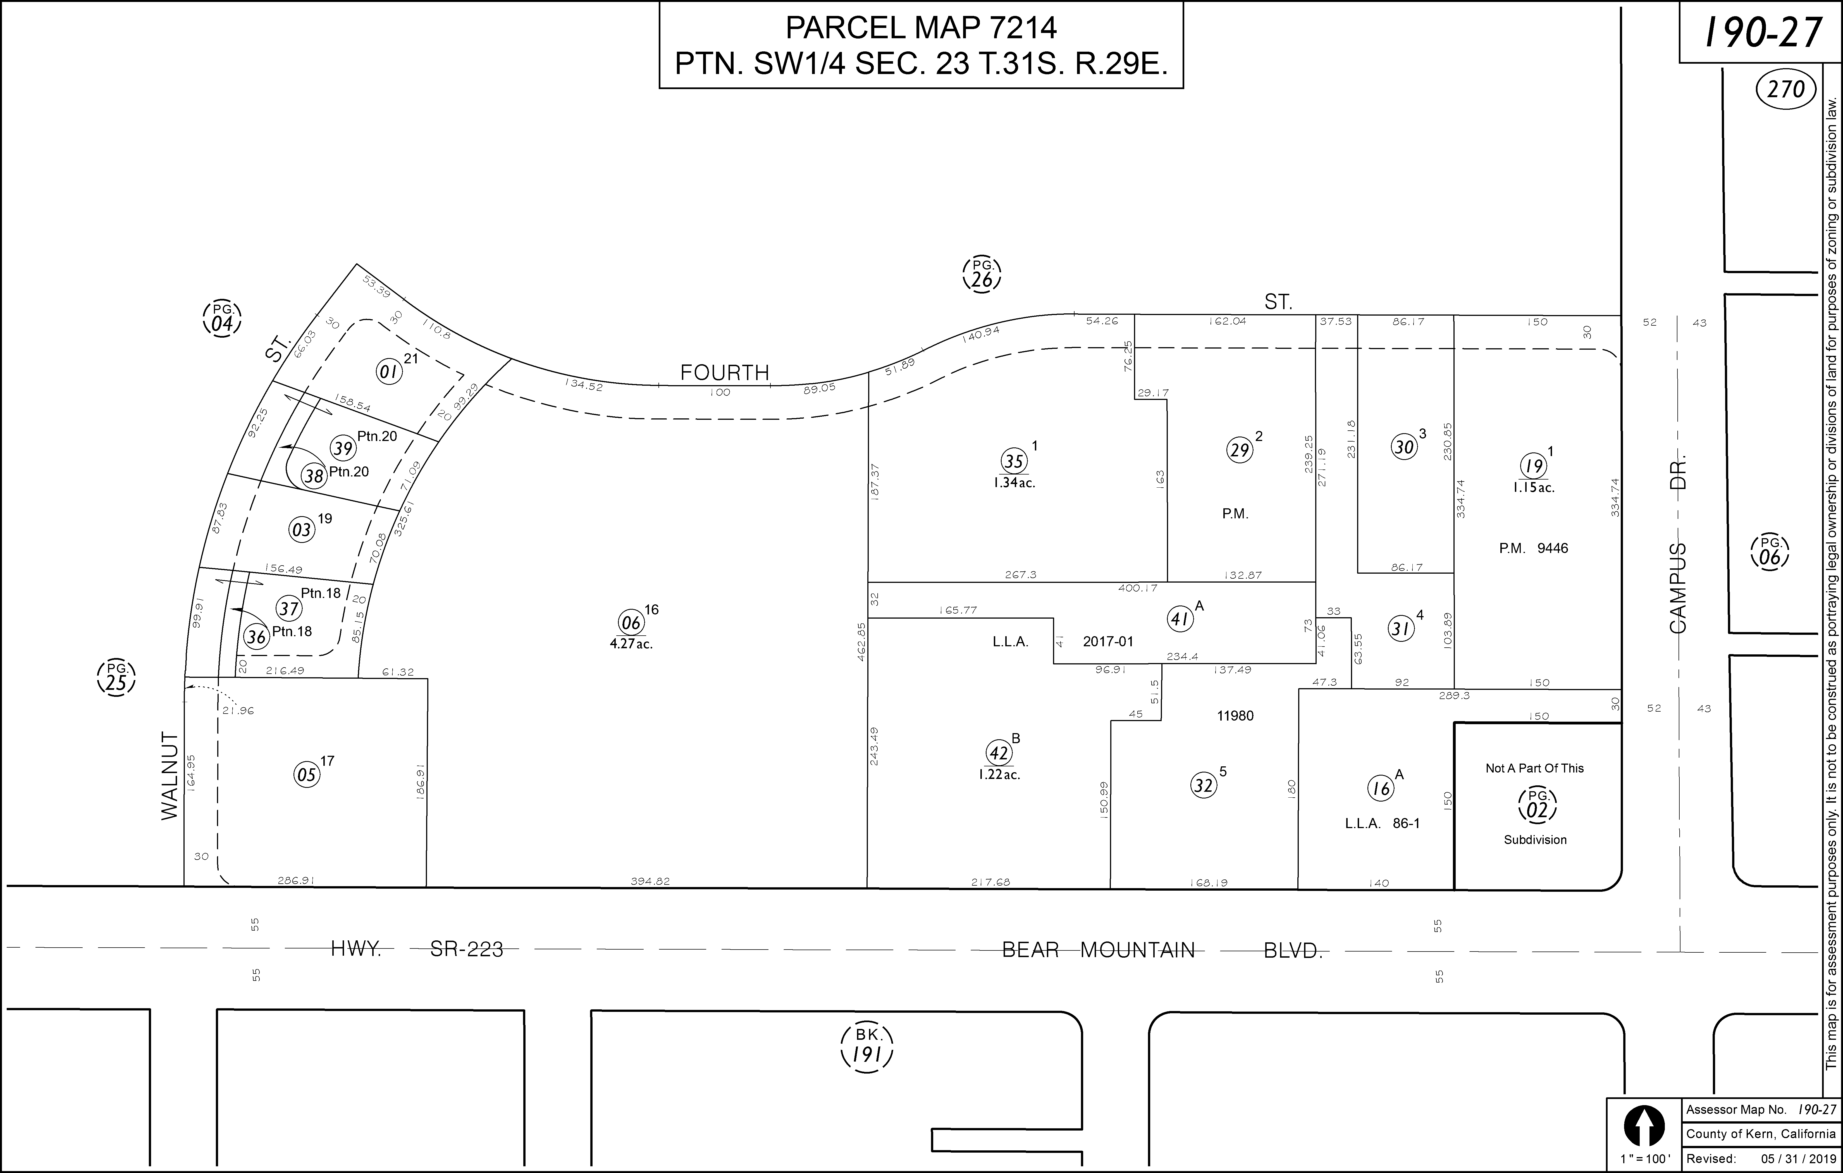

Existing Project Site Plan – No on site modifications are proposed - 802 Bear Mountain Boulevard:
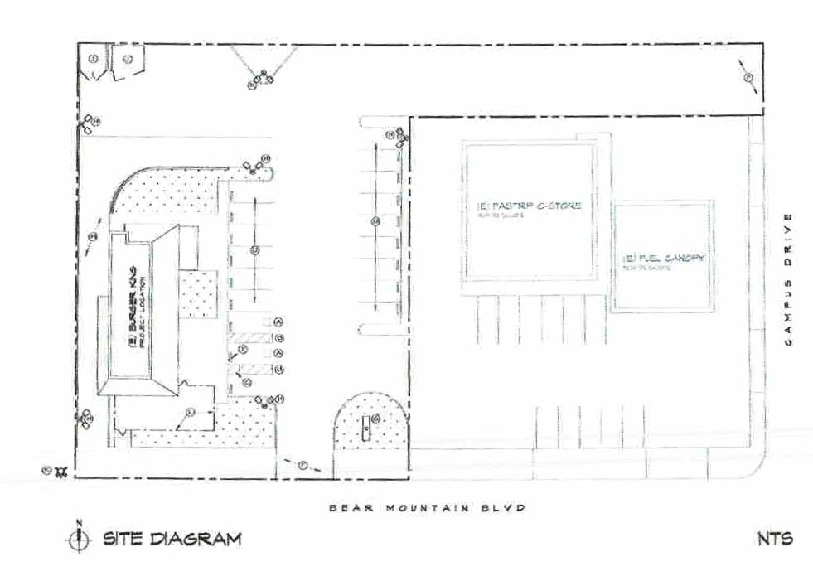

Existing Site and Structures: The site is developed, formerly Burger King Restaurant, 2,400 Sq. Ft., and Drive-thru service. Street access. ingress and egress from Bear Mountain Boulevard and ingress from Campus Drive. The existing master sign program includes a legal non-conforming pole sign. The proposal is the repurposing of the Burger King Restaurant and Drive-thru service and establishing a new restaurant with a modern architectural treatment – Taco’s La Villa branding and continued use of the existing pole sign.

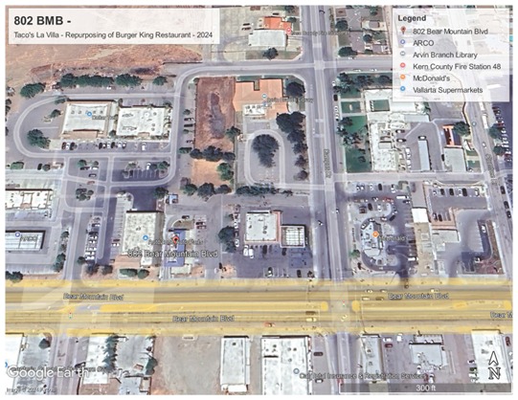 | 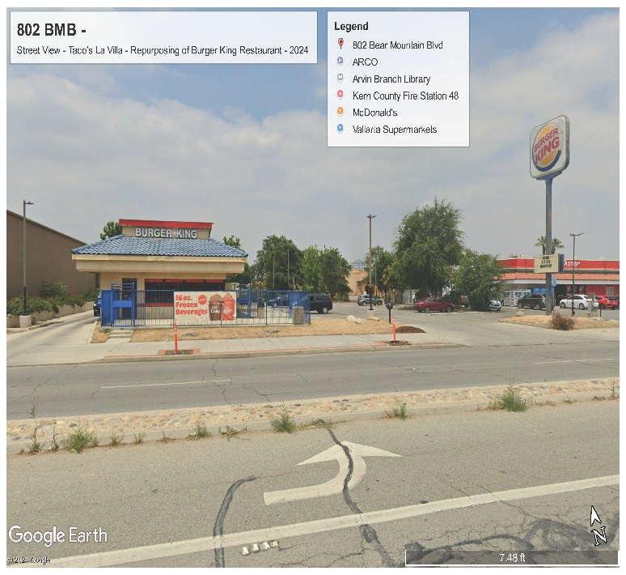

Existing Elevations – 802 Bear Mountain Boulevard:
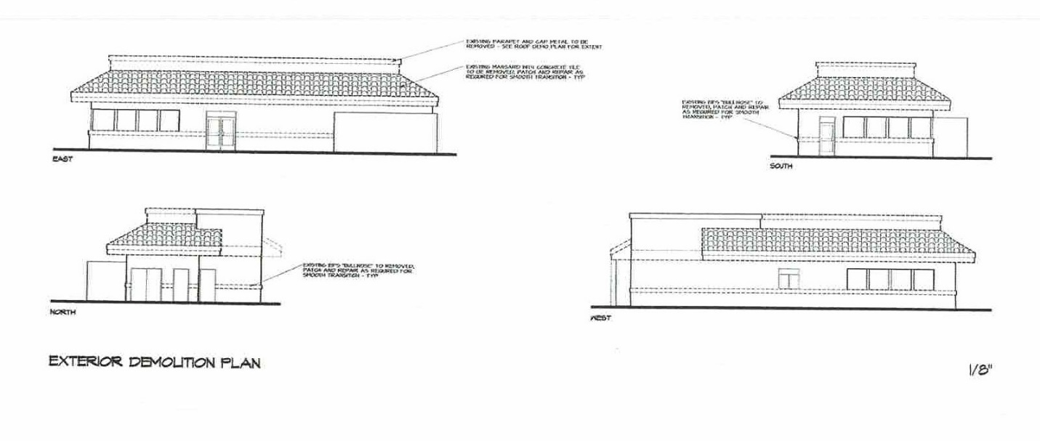

Color Renderings – Exterior Remodel – 802 Bear Mountain Blvd. – Taco’s La Villa
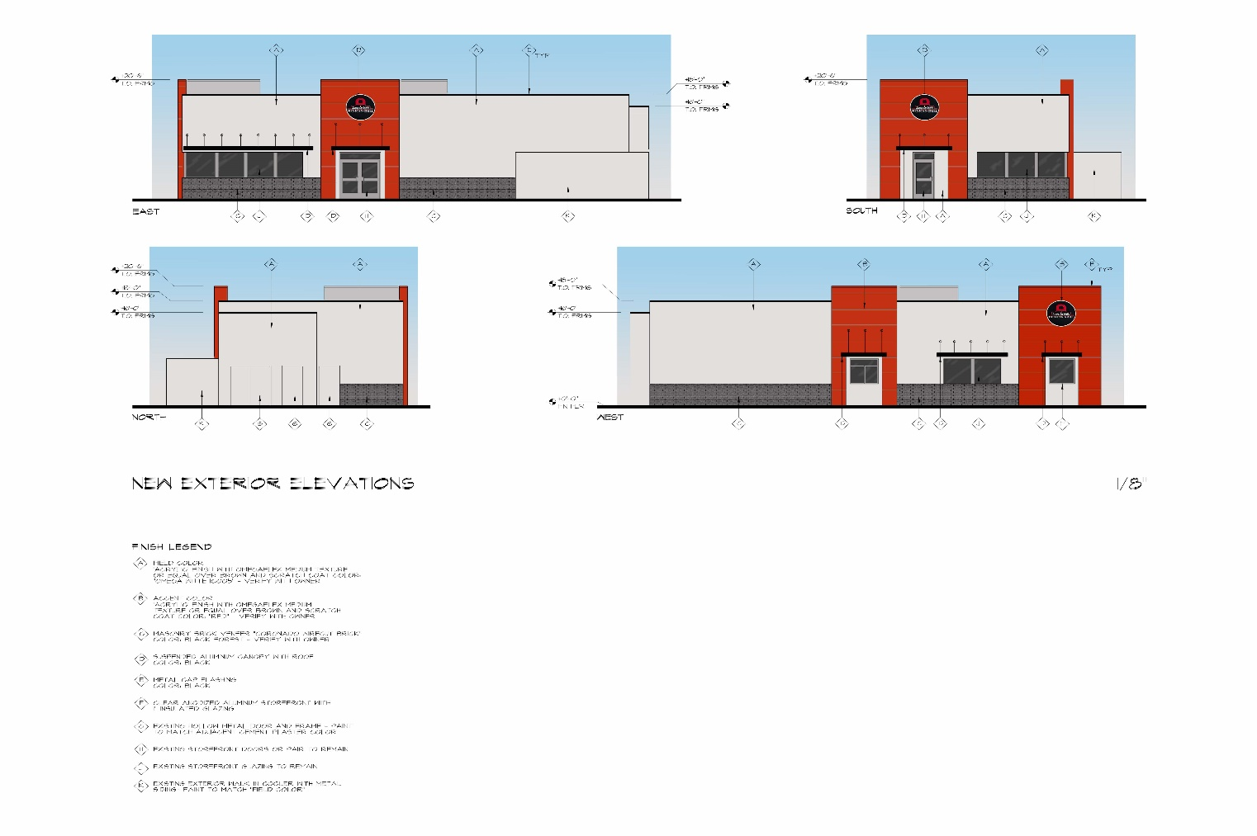

- Proposed modern architectural design to replicate other Taco La Villa operations in California which deviates from the Mediterranean architecture.
- Existing Pole Sign to remain.
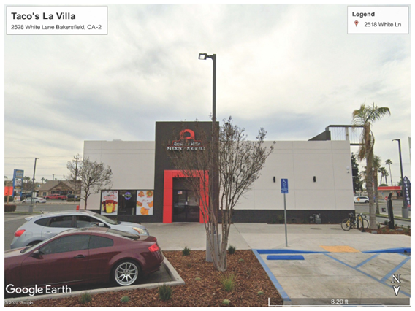 | 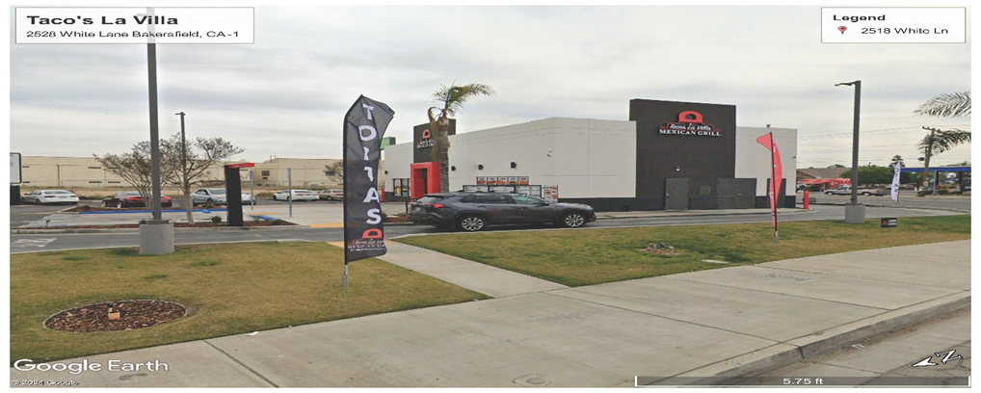

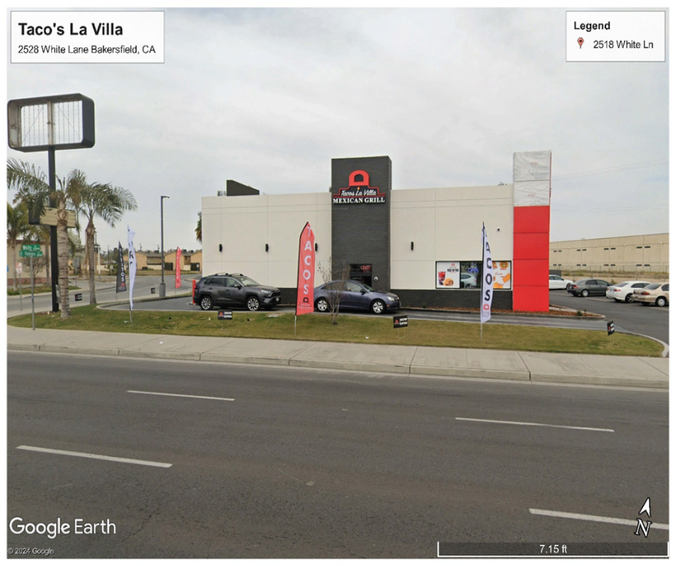 | 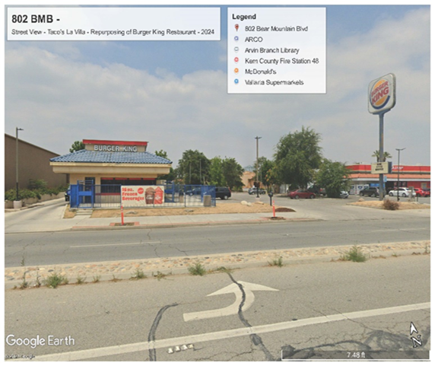

PROJECT INFORMATION AND DESCRIPTION:
Project Description: 802 Bear Mountain Boulevard, APN 190-270-16- Repurposing of existing commercial restaurant with drive-thru service, formerly Burger King Restaurant. Exterior remodel by removing inclined roof, removing Spanish tile, creating new vertical exterior and new exterior color palette. Proposed modern architectural design to replicate other Taco La Villa operations in California which deviates from the Mediterranean architecture. Proposed continued utilization of the existing pole sign.

Project Elevations – Proposed – 802 Bear Mountain Boulevard:
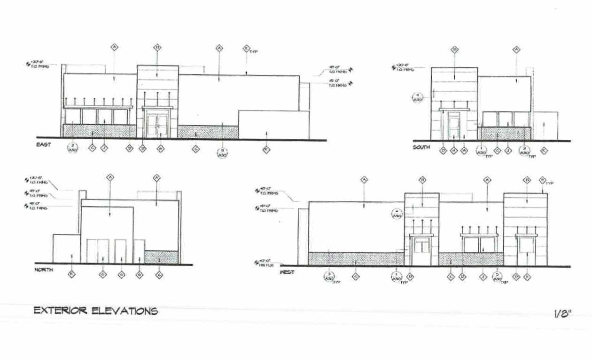

Landscaping and Irrigation Design:
The existing landscape areas at the existing site has not been maintained and requires new landscape improvements. The applicant shall be required to install new landscaping and upgrade the existing irrigation system. The applicant shall submit a revitalized Landscape and irrigation plan along Bear Mountain Boulevard prior to the issuance of the Certification of Occupancy by the Building Official.

STAFF REVIEW AND FINDINGS:
Planning Staff has reviewed the proposed project and the preliminary submittals and based upon the information provided by the applicant and comments received, Staff believes that the findings as is required by Chapter 17.60 Site Development Permit, Section 17.60.040 Application – Criteria for Review; and upon implementation of Chapter 17.70 Site Development Standards, may be made. The following findings are included in the proposed Planning Commission Resolution recommending conditional approval:

“The Site Development Permit Application for SDP 2024-802BMB – 802 Bear Mountain Boulevard may be conditionally approved by the Planning Commission based upon the following:
a. The project is conditioned and must comply with all applicable laws and ordinances.

b. The project will be in compliance with all applicable city policies duly adopted by a majority vote of the planning commission or the city council; and

c. The project will be in conformance to latest accepted planning and engineering standards covering the following area: site layout, building appearance and structural design, landscaping, water and sewer service and other utilities, surface drainage and erosion control, fire protection, access, traffic circulation and parking.

d. The conditional approval of SDP 2024-802BMB -802 Bear Mountain Boulevard - Permit 2024-802BMB - 802 Bear Mountain Boulevard, APN 190-270-16– Repurposing of existing commercial restaurant with drive-thru service, formerly Burger King Restaurant. Exterior remodel by removing inclined roof, removing Spanish tile, creating new vertical exterior and new exterior color palette, approving the proposed architectural design, and approving the continued use of the existing pole sign the Planning Commission finds that under the circumstances of this application, the proposed use and/or buildings will not be detrimental to the health, safety, peace, morals, comfort or general welfare of persons residing or working in the neighborhood.

e. The applicant will be required to pay all fees associated with the processing of the application and for its cost of all reviews and implementation by City Staff, the City’s consultants, as well as all costs associated with the on-site and off-site improvements.

f. The project will be required to implement all applicable development standards as established by Chapter 17.70 Site Development Standards and those conditions as required by Planning Commission action.”

PUBLIC HEAING NOTICE, POSTING OF ON-SITE NOTICE, AND NOTICE TO THE SURROUNDING PROPERTIES
The City required the developer to prepare and post an ON-SITE NOTICE at the project location ten (10) days prior to the September 17, 2024, Planning Commission hearing pursuant to Government Code sections 36933, 65854, and 65090. In addition, the City Clerk provided notice by mailing the public notice to all property owners within the 300-foot radius

CEQA DETERMINATION- Notice of Exemption Section 15061 (b) (3): The City has performed a preliminary assessment of this project and, pursuant to the California Environmental Quality Act (CEQA) Guidelines Section 15061(b)(3), proposes to determine with certainty that there is no possibility this project will have a significant effect on the environment.

APPEAL BY APPLICANT OR INTERESTED PARTY:
The action of the Planning Commission may be appealed to the City Council. If an appeal is filed, the appeal must be in writing stating the reasons for the appeal, pay the appeal fee as established by the City Council, and the written appeal must be filed within 10 calendar days of the Planning Commission’s decision. The Applicant is required to sign the Acceptance of Conditions or Appeal the Decision of the Planning Commission.

END OF REPORT.

Attachments:
- Resolution of the City of Arvin City Planner Conditionally Approving SDP 2024-802BMB
- Exhibit A - Conditions of Approval
- Acceptance of Conditions of Approval
- Notice of Exemption –SDP2024-802BMB – On file at the City Clerk’s Office.

