To: | Office of Planning & Research
 | (Agency)
 | P.O. Box 3044, 1400 Tenth Street, Room 212
 | (Address)
 | Sacramento, CA 95812-3044

Subject: Notice of Preparation of a Draft Environmental Impact Report

Lead Agency: Consulting Firm (If applicable):

Agency Name | Imperial County, Planning & Dev Svcs. | Firm Name | HDR
Street Address | 801 Main Street | Street Address | 591 Camino de la Reina, Suite 300
City/State/Zip | El Centro, CA 92243 | City/State/Zip | San Diego, CA 92108
Contact | Diana Robinson | Contact | Tim Gnibus

The County of Imperial will be the Lead Agency and will prepare an Environmental Impact Report (EIR) for the project identified below. We need to know the views of your agency as to the scope and content of the Environmental Information, which is germane to your agency’s statutory responsibilities in connection with the proposed project. Your agency will need to use the EIR prepared by our agency when considering your permit or other approval for the project.

The project description, location, table of Assessor’s Parcel Numbers (APN), and the potential environmental effects are contained in the attached materials. A copy of the Initial Study is attached.

Due to the time limits mandated by State law, your response must be sent at the earliest possible date but not later than 35 days after receipt of this notice.

Please send your response to Imperial County Planning & Development Services, Attn: Diana Robinson at the address shown above. We will need the name for a contact person in your agency.

Project Title: Big Rock 2 Cluster Solar & Storage Project

Project Location: The project site is located on approximately 1,849 acres of privately-owned, vacant land in Imperial County, California. Please refer to Attachment A for the list of APNs and Figures 1 and 2 for the general project location. The project site is located in unincorporated Imperial County, south of Interstate 8, approximately one mile southwest of the town of Seeley, California, and approximately six miles north of the United States International Border with Mexico. The project site is west of Drew Road and east and north of Mandapa Road.
Project Description (brief): The Project would include the construction and operation of a photovoltaic ( PV) solar energy generation and battery energy storage system (BESS) facility comprised of up to 500 megawatts alternating current (MWac) PV solar and up to 500 MWac of BESS. Power generated by the Project would be collected using up to 66-kV collector lines which could run overhead and/or underground to a dedicated Project substation, with a 230-kV overhead generation transmission line or “gen-tie” line linking a Project substation to the Imperial Irrigation District (IID) Liebert Switchyard. The Liebert Switchyard would then be connected to the San Diego Gas & Electric (SDG&E) Imperial Valley substation via an overhead 230-kV gen-tie line. Two gen-tie line alternatives are proposed.
The County Land Use Ordinance, Division 17, includes the Renewable Energy (RE) Overlay Zone, which authorizes the development and operation of renewable energy projects with an approved conditional use permit (CUP). CUP applications proposed for specific renewable energy projects not located in the RE Overlay Zone would not be allowed without an amendment to the RE Overlay Zone. The majority of the project site is located outside of the RE Overlay Zone.
Implementation of the project requires an amendment to the County’s General Plan Renewable Energy and Transmission Element, Zone Change, and approval of four CUPs, as described below:
- General Plan Amendment: The applicant is requesting a General Plan Amendment to include/classify all project parcels into the RE Overlay Zone. No change in the underlying General Plan land use (Agriculture) is proposed.
- Zone Change: The project site is currently zoned A-2 (General Agricultural), A-2-R (General Agricultural/Rural), A-3 (Heavy Agricultural), A-2-RE (General Agricultural – Renewable Energy Overlay) and A-3-RE (Heavy Agricultural – Renewable Energy Overlay). The applicant is requesting a Zone Change to include/classify all project parcels into the Renewable Energy Overlay Zone.
- Conditional Use Permit: Implementation of the project would require the approval of four CUPs by the County to allow for the construction and operation of the proposed solar energy facility with an integrated BESS on land zoned A-2, A-2-R, A-3, A-2-RE and A-3-RE.
- Water Supply Assessment: Implementation of the project would require the approval of the Water Supply Assessment.
Project Applicant: 90FI 8me, LLC

Date |  | Signature
 |  | Title
 |  | Telephone

Reference: California Administrative Code, Title 14, (CEQA Guidelines) Section 15082(a), 15103, 15375.

Figure 1. Project Location
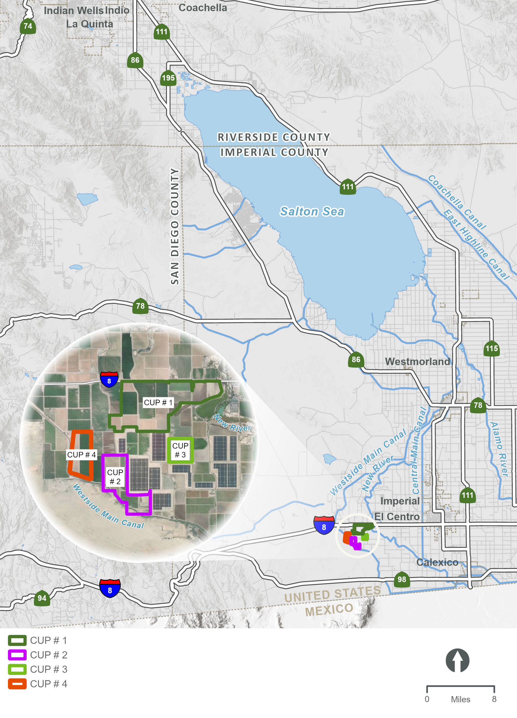
This page is intentionally blank.

Figure 2 Project Site Boundaries/Local Vicinity
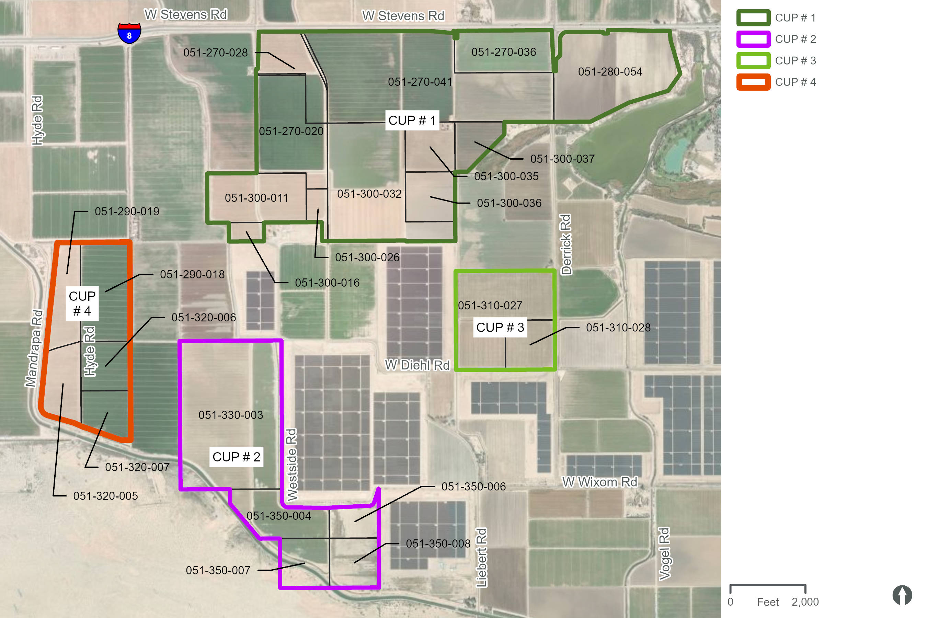
ATTACHMENT A – Big Rock 2 Cluster Solar & Storage Project Assessor’s Parcel Numbers (APN), Zoning, and Acreage
Big Rock Cluster North: CUP No. 24-0006
 | APN | Zoning | Acres
1 | 051-270-020 | A-2-R | 101.8
2 | 051-270-028 | A-2 | 52.3
3 | 051-270-036 | A-2 | 67.4
4 | 051-270-041 | A-2-R | 279.0
5 | 051-280-054 | A-2 | 149.5
6 | 051-300-011 | A-2 | 79.6
7 | 051-300-016 | A-2 | 10.8
8 | 051-300-026 | A-2 | 13.4
9 | 051-300-035 | A-3 | 40.3
10 | 051-300-037 | A-3 | 28.9
11 | 051-300-032 (northern portion) | A-2 | 85.5
 | Sub-total |  | 910.0
Laurel 2 North CUP #21-0014 (Expires December 2024)
12 | 051-300-032 (southern portion) (to be re-entitled) | A-2-RE | 80.0
13 | 051-300-036 (to be re-entitled) | A-3-RE | 40.3
 | Sub-total |  | 120.3
 | TOTAL ACRES |  | 1,030

Big Rock Cluster South: CUP No. 24-0007
 | APN | Zoning | Acres
1 | 051-330-003 | A-3 | 246.5
2 | 051-350-004 | A-3 | 57.4
3 | 051-350-006 | A-3 | 26.3
4 | 051-350-007 | A-3 | 40.0
5 | 051-350-008 | A-3 | 40.0
 | TOTAL ACRES |  | 410.0

Big Rock Cluster East/Laurel Cluster South: CUP No. 24-0008
 | APN | Zoning | Acres
1 | 051-310-027 | A-2-R-RE | 120.0
2 | 051-310-028 | A-2-R-RE | 39.9
 | TOTAL ACRES |  | 160.0

Big Rock Cluster West: CUP No. 24-0009
 | APN | Zoning | Acres
1 | 051-290-018 | A-2-R | 79.8
2 | 051-290-019 | A-3 | 48.7
3 | 051-320-005 | A-3 | 45.0
4 | 051-320-006 | A-3 | 39.9
5 | 051-320-007 | A-3 | 35.3
 | TOTAL ACRES |  | 249.0

