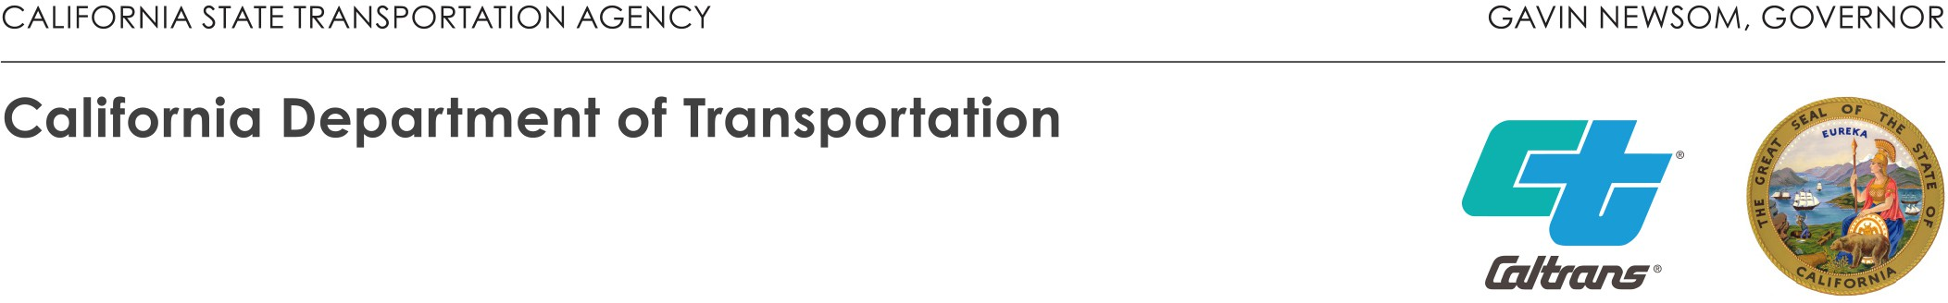

OFFICE OF THE DISTRICT 10 DIRECTOR
P.O. BOX 2048 | STOCKTON, CA 95201
(209) 948-7943 | FAX (209) 948-7179 TTY 711
www.dot.ca.gov

September 4, 2024

10-MER-165-PM 10.820
Basins and Stormwater Capture Project
Mitigated Negative Declaration
State Clearinghouse No. 2024081193

Charles Bergson
Public Works Director/City Engineer
City of Los Banos Public Works
411 Madison Avenue
Los Banos, CA 93635

Dear Mr. Bergson:

The Department of Transportation (Caltrans) appreciates the opportunity to review and comment on the Basins and Stormwater Capture Project for the purpose of surface and storm water capture as well as for incidental groundwater recharge. The basin would provide multiple benefits in terms of storage, incidental recharge, and re-regulation of various City and Grasslands Water District (GWD) water sources and possess a combined storage capacity of approximately 500 AF. GWD operates the two canals near the Project site: The San Luis Canal bordering the site on the west and the Santa Fe Canal to the east in the City of Los Banos.

Caltrans has no additional comments at this time. However, Caltrans requests to be included in the review process for all future development at this location.

If you have any questions, please contact Janet Jaramillo at (209) 986-9825 or me at (209) 483-2582.

Sincerely,

Tom Dumas
Chief, Office of Metropolitan Planning

c: State Clearinghouse
Amy M. Wilson, Provost & Pritchard Consulting Group

