Chapter 17.68 Commercial – Bear Mountain Central Business District Standard, Attachment 1, lists the reduced standards and exemptions for commercial uses with conforming or legally non-conforming structures as of January 1, 2010, including conditions related to parking and landscaping.
Chapter 17.70 Site Development Standards, Attachment 2, lists the minimum site development standards that are required for new or expanded development within the City of Arvin.

Chapter 17.60 Site Development Permits, Attachment 3, lists types of projects that may be reviewed and approved by the Community Development Director and Planning Commission with appeal processes for each level of review.

Chapter 17.05 Administrative Approval lists uses that are subject to issuance by the City Planner and Administrative Permit.

SUBJECT: Variance 2023-01 and SDP 2024-533BMB – 533 Bear Mountain Boulevard, APN 191-181-01- Construction of a 1,752 Sq. Ft. new commercial structure located at the Southwest corner of South Hill Street and Bear Mountain Boulevard – Encroachment Permit removing existing drive access to Bear Mountain Boulevard.

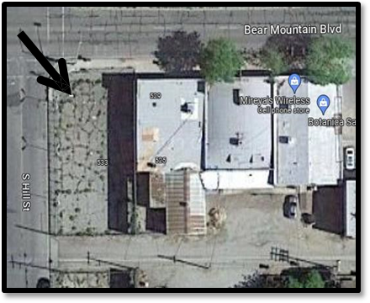 | Project Location: 533 Bear Mountain Blvd., Arvin, CA 932023, APN 191-181-01  Existing Site and Structures: The site is currently undeveloped; a proposed 1,752 sq. ft. structure is currently seeking building permit approvals.

Applicant: | Mireya Taylor
Project Address: | 533 Bear Mountain Blvd. Arvin California, 93203
Project Location: | Located on the Southeast corner of Bear Mountain Blvd. and South Hill Street.
Assessor Parcel No. and Size: | APN 191-181-01
Zoning: | C-2, Commercial
General Plan Designation: | Commercial

PROJECT INFORMATION AND DESCRIPTION:
Variance Granted: Front Yard Requirements- In the C-2 zone, all buildings shall be located not nearer than forty (40) feet from the centerline of a street; provided, however, that along any secondary highway, as designated by the city's highway plan, a minimum setback of forty-five (45) feet from the centerline of the highway shall be required, and along any major highway, as designated by the city's highway plan, minimum setback of fifty-five (55) feet from the centerline of the highway shall be required. Setback from the centerline of Bear Mountain Boulevard (State Route 223) shall be seventy-two (72) feet. The Planning Commission approved the reduction in setback via Resolution No. 2023-01 dated September 19, 2023.
Site Development Permit:
Project Description: 533 Bear Mountain Boulevard, APN 191-181-01- Construction of a 1,752 Sq. Ft. new commercial structure located at the Southwest corner of South Hill Street and Bear Mountain Boulevard – Encroachment Permit removing existing drive access and construction of new curb, gutter and ADA ramp along Bear Mountain Boulevard.

Project Elevations:
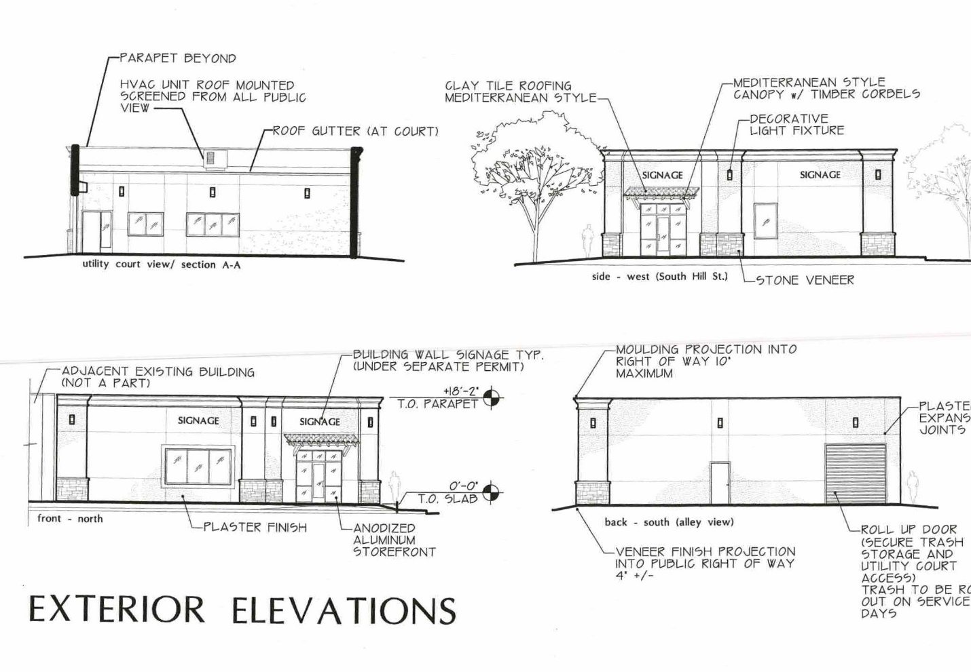

Project Site Plan:
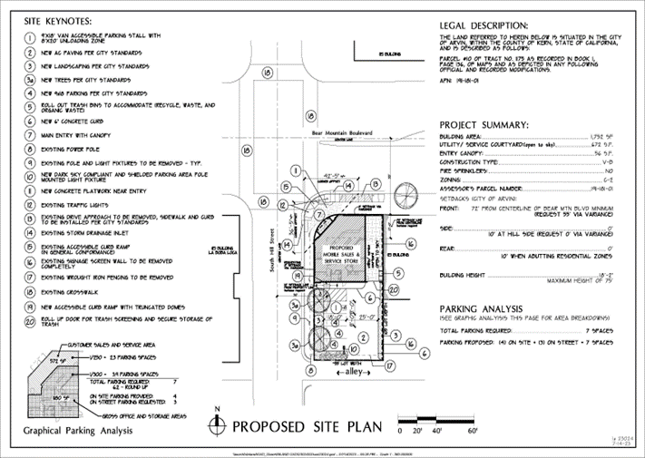

CEQA DETERMINATION: Notice of Exemption Section 15061 (b) (3):
The City has performed a preliminary assessment of this project and, pursuant to the California Environmental Quality Act (CEQA) Guidelines Section 15061(b)(3), proposes to determine with certainty that there is no possibility this project will have a significant effect on the environment. Further, none of the exceptions to categorical exemptions set forth in CEQA Guidelines, section 15300.2, apply to this project.

PUBLIC HEAING NOTICE AND NOTICE TO THE SURROUNDING PROPERTIES:
Published: Bakersfield Californian, August 04, 2023
The City properly noticed the August 15, 2023 hearing before the Planning Commission for the proposed Variance request pursuant to Government Code sections 65090 and 65091 by publication in the newspaper on August 4, 2023. A copy of the notice is attached to this Staff report. In addition, the City Clerk provided notice by mailing the public notice to all property owners within the 300-foot radius. There was no quorum present for the Planning Commission Meeting of August 15, 2023 and an announcement was provided at the meeting that the hearing was continued to the Regular Planning Commission Meeting of September 19, 2023.

The Staff Report stated that the project is subject to Chapter 17.60 Site Development Permit for the new construction.

ACTION – SITE DEVELOPMENT PERMIT 2023-01 – Variance/Site Development Permit 2023-01 – 533 Bear Mountain Boulevard, APN 191-181-01- Construction of a 1,752 Sq. Ft. new commercial structure located at the Southwest corner of South Hill Street and Bear Mountain Boulevard – Encroachment Permit removing existing drive access to Bear Mountain Boulevard: The City Planner Conditionally approves the SDP 2024-533BMB – August 20, 2024

Attachment 1- CDD Resolution No. 2024-533BMB – Site Development Permit Conditional Approval. Summary. The City Planner has conditionally approved the site development permit.
Attachment 2 – Conditions of Approval – SDP 2024-533BMB

APPEAL BY APPLICANT OR INTERESTED PARTY - NOTICE:
The action of the City Planner may be appealed to the Planning Commission. If an appeal is filed, the appeal must be in writing stating the reasons for the appeal, pay the appeal fee as established by the City Council, and the written appeal must be filed within 10 calendar days of the City Planner’s decision. Applicant is required to sign the Acceptance of Conditions or Appeal the Decision of the City Planner

Attachments:
- Resolution of the City of Arvin City Planner Conditionally Approving SDP 2024-533BMB
- Conditions of Approval
- Notice of Exemption –SDP2024-533BMB.
- Acceptance of Conditions of Approval

ATTACHMENT 1
CDD Resolution No. 2023-533 Bear Mountain Boulevard
Site Development Permit 2023-533BMB – New Construction of a 1,735 Sq. Ft. Commercial Structure and Acceptance of CEQA Notice of Exemption Per Section 15061(b)(3)

WHEREAS, Mireya Taylor, applicant filed an application for a variance and site development permit for the following project:

Variance Site Development Permit 2023-01 – 533 Bear Mountain Boulevard, APN 191-181-01- Construction of a 1,752 Sq. Ft. new commercial structure located at the Southwest corner of South Hill Street and Bear Mountain Boulevard – Encroachment Permit removing existing drive access to Bear Mountain Boulevard was considered by the Planning Commission on September 19, 2023.

WHEREAS, the project is California Environmental Quality Act (CEQA) Guidelines Section 15061(b)(3), proposes to determine with certainty that there is no possibility this project will have a significant effect on the environment. Further, none of the exceptions to categorical exemptions set forth in CEQA Guidelines, section 15300.2, apply to this project.

WHEREAS, the City, as lead agency, provided all applicable notices required by CEQA; and
WHEREAS, Public hearing notice was provided by posting the notice in the Bakersfield Californian on August 4, 2023 and notification of properties within 300 feet; and

WHEREAS, The City Planner finds in accordance with Section 17.60.040 Application-Criteria for review the following:

- Site development permits may be granted by the city planner community development director, the planning commission or the city council. Within forty-five (45) days of the receipt of any application for a site development permit, the city planner planning director shall review the application and render a decision to approve, conditionally approve, or deny the application. In reviewing any such application, the following should be considered.
- The proposed development is in compliance with all applicable laws and ordinances.
- The proposed development is in compliance with all applicable city policies duly adopted by a majority vote of the planning commission or the city council; and
- The proposed development is in conformance to latest accepted planning and engineering standards covering the following area: site layout, building appearance and structural design, landscaping, water and sewer service and other utilities, surface drainage and erosion control, fire protection, access, traffic circulation and parking.

WHEREAS, prior to conditionally approving SDP 2023-01- 533 Bear Mountain Boulevard, the city planner finds that under the circumstances of the particular case, the proposed use or buildings will not be detrimental to the health, safety, peace, morals, comfort or general welfare of persons residing or working in the neighborhood, and

WHEREAS, after review and consideration of all the information in the record, the City Planner of the City of Arvin adopted the Notice of Exemption for the project and conditionally approved Site Development Permit 2023-533BMB.

THEREFORE, BE IT RESOLVED, by the City Planner of the City of Arvin as follows:

- The recitals are true and correct and are incorporated herein as if set forth in full.

- The City Planner of the City of Arvin hereby finds and adopts the findings as is required Section 17.60.040.

- After the conclusion of the public hearing held by the Planning Commission on September 19, 2023, the City Planner conditionally approves Site Development Permit – 2023-01 533 Bear Mountain Boulevard subject to the conditions of approval attached hereto and subject to compliance with Exhibit A.

I HEREBY CERTIFY that the foregoing Resolution was passed and adopted by the Arvin Planning Community Development Department on August 20, 2024.
City of Arvin

Jake Raper

Jake Raper, Project Coordinator/Planning Consultant

DATE: August 20, 2024

Conditions of Approval

Site Development Permit No. 2024-533BMB

533 Bear Mountain Boulevard
Mireya Taylor

Variance Site Development Permit 2024-533 BMB – 533 Bear Mountain Boulevard, APN 191-181-01- Construction of a 1,752 Sq. Ft. new commercial structure located at the Southwest corner of South Hill Street and Bear Mountain Boulevard – Encroachment Permit removing existing drive access to Bear Mountain Boulevard.

COMMUNITY DEVELOPMENT DEPARTMENT

General (G)
G-1 All exhibits and references identified in the following conditions and the resolution approving this project are conditions of approval unless otherwise waived. Therefore, all requirements, conditions, mitigation measures, standards, policies are to be implemented by the project applicant and successors in interest unless specifically waived by the City of Arvin.

G-2 There may also be conditions that are incorporated in the project approval that are not specific and are subject to interpretation, review and approval or conditional. approval by City staff that are not established by City ordinance, resolution, policy, etc. Those conditions give authority to City Staff to use their judgment in the final resolution of the issue identified. City Staff identified in the condition shall interpret the compliance of those condition(s) at their discretion. This may create costs to the project that are not otherwise clearly identified.

G-3 The projects are subject to the California Environmental Quality Act (CEQA) Guidelines Section 15061(b)(3), proposes to determine with certainty that there is no possibility this project will have a significant effect on the environment. Further, none of the exceptions to categorical exemptions set forth in CEQA Guidelines, section 15300.2, apply to this project A Notice of Exemption is on file at the Community Development Department, 141 Plumtree Drive, Arvin, CA and may be viewed during normal business hours.

G-4 Contractors and subcontractors shall obtain a business license from the City of Arvin prior to beginning any work.

G-5 Right of Way improvements along Highway 223 and Hill Street shall be completed prior to a certificate of occupancy being issued by the Building Official.

G-6. The improvements at the Southeast intersection of Hill Street and Highway 223 (Bear Mountain Boulevard) shall be subject to receiving an encroachment permit from Cal Trans and the elimination of the existing drive and construction of new ADA pedestrian ramp shall occur prior to the issuance of the Certificate of Occupancy by the Building Official.

G-6. On-site improvements shall be completed in coordination with future developments as may be required by the City prior to the issuance of the Certificate of Occupancy by the Building Official.

PUBLIC WORKS – CITY ENGINEER:

PW-CE-1 All plans and specifications for future work required on the public right of way shall be prepared by a Registered Civil Engineer licensed in the state of California (Engineer of Record) and to the satisfaction of the City Engineer.

NOTICE TO PROJECT APPLICANT
In accordance with the provisions of Government Code Section 66020(d)(1), the imposition of fees, dedication, reservations or exactions for this project are subject to protest by the project applicant at the time of approval or conditional approval of the development or within 90 days after the date of imposition of fees, dedications, reservation, or exactions imposed on the development project.

This notice does not apply to those fees, dedications, reservations, or exactions which were previously imposed and duly noticed; or, where no notice was previously required under the provisions of Government Code Section 66020(d)(1) in effect before January 1, 1997.

Appeal of Action by The City Planner’s Decision:
The applicant may appeal to the City Planner’s action to the Planning Commission. Said appeal and payment of the appeal fee as established by the City Council must occur within ten (10) calendar days of the dated action of the City Planner.

TO:

City of Arvin
Planning Division
141 Plumtree Drive
Arvin, CA 93203
Attn: Jake Raper Project Coordinator/Planning Consultant
Email: jraper@arvin.org

APPLICANT ACCEPTANCE OF CODTIONS OF APPROVAL

SDP 2023-533BMB

Scott Taylor, 4301 Scribner Way, Bakersfield, CA 93311

Email: staylor@LPUD.org

Phone Number: 661-845-1213

I, ___________________________________(Print) DO HERE BY ACCEPT THE
CONDITIONS OF APPROVAL AND HEREBY CERTIFY THAT I AM AN AUTHORIZED AGENT OF THE APPLLICANT AND OF THIS PROJECT:

____________________________________
Signature

DATED: ___________________.

OR

I, AS AUTHORIZED AGENT OF THE APPLICANT AND OF THIS PROJECT, _________________________________(Print) __, DO NOT ACCEPT THE CONDITIONS OF APPROVAL AND ELECT TO APPEAL THE CITY PLANNER’S DECISION AND ELECT TO FILE THE APPEAL AND PAY THE REQUIRED FEE TO THE CITY CLERK WITHIN 10 DAYS OF THE DATED ACTION OF, August 20, 2024

