Project Description: Urban Greening Phase I – North of 4th Street and Eastside of Walnut Street (Formerly “Pathways To A Greener Arvin – 2018) Redesign by removing portion of the project from 4th Street and Expanding the planned pocket park on a portion of APN 190-260-06 and creating additional dual-purpose bike and pedestrian permeable 8’ wide tree-lined path with solar lighting east of Walnut Street
Urban Greening Phase I (Formerly “Pathways To A Greener Arvin – One Step At A Time”2018) removes portion of the project from 4th Street and expands the pocket park on a portion of APN 190-260-06 and creates additional 8’-0” wide dual-purpose bike and pedestrian pathways on the east side of Walnut Street.

Site Plan – Urban Greening Phase I - New Design Concept - First Phase - Portion of Assessor Parcel No. 190-260-06
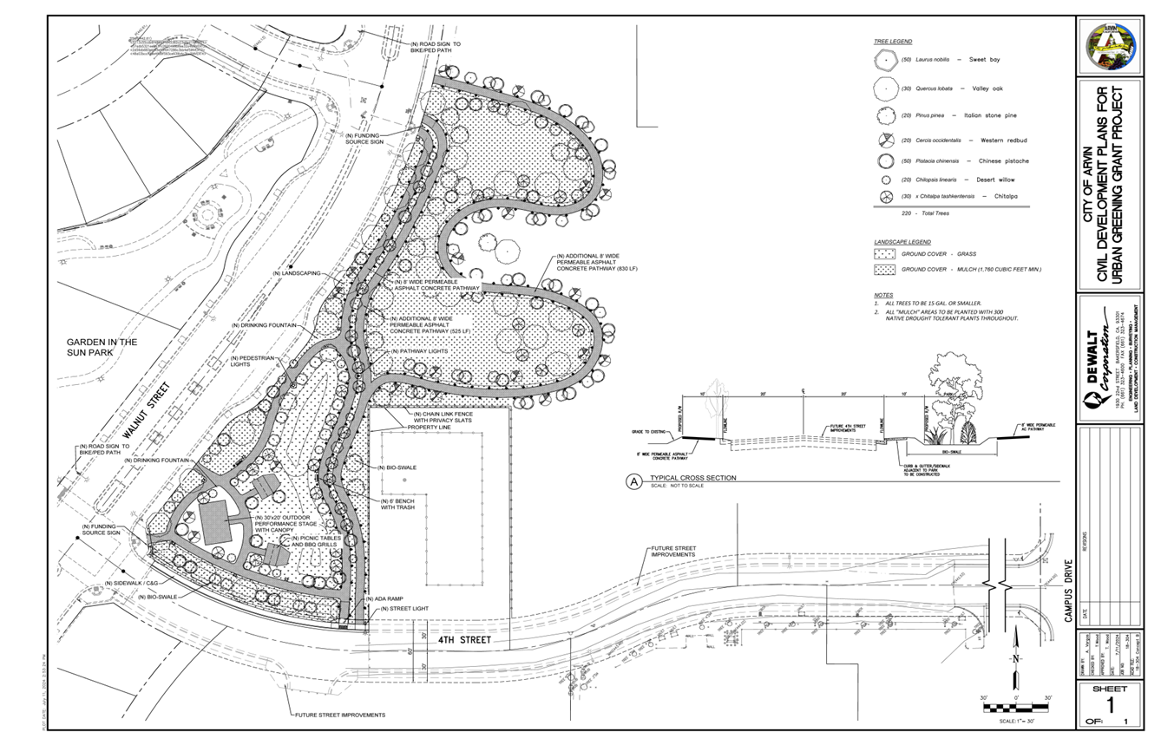

2018 Phase I Description
The 2018 design concept and project description envisioned the development of pathways and trees along the south side of 4th Street. The 2018 project description:
“The City's proposed "Pathways to a Greener Arvin- One Step at a Time" is an urban greening project that would establish lush green pathways and add green trees along 4th Street and would loop into unimproved and vacant City owned property east of Walnut Street. This project is an expansion of the "Garden Under The Sun Park" project that was previously approved and is currently under construction.” The City Council approved the project in April 27, 2018 and the Notice of Exemption was filed with the Kern County Clerk’s Office in March 27, 2028.

Site Plan – Urban Greening – Phase I – 2018 Concept
Portion of Assessor Parcel No. 190-260-06
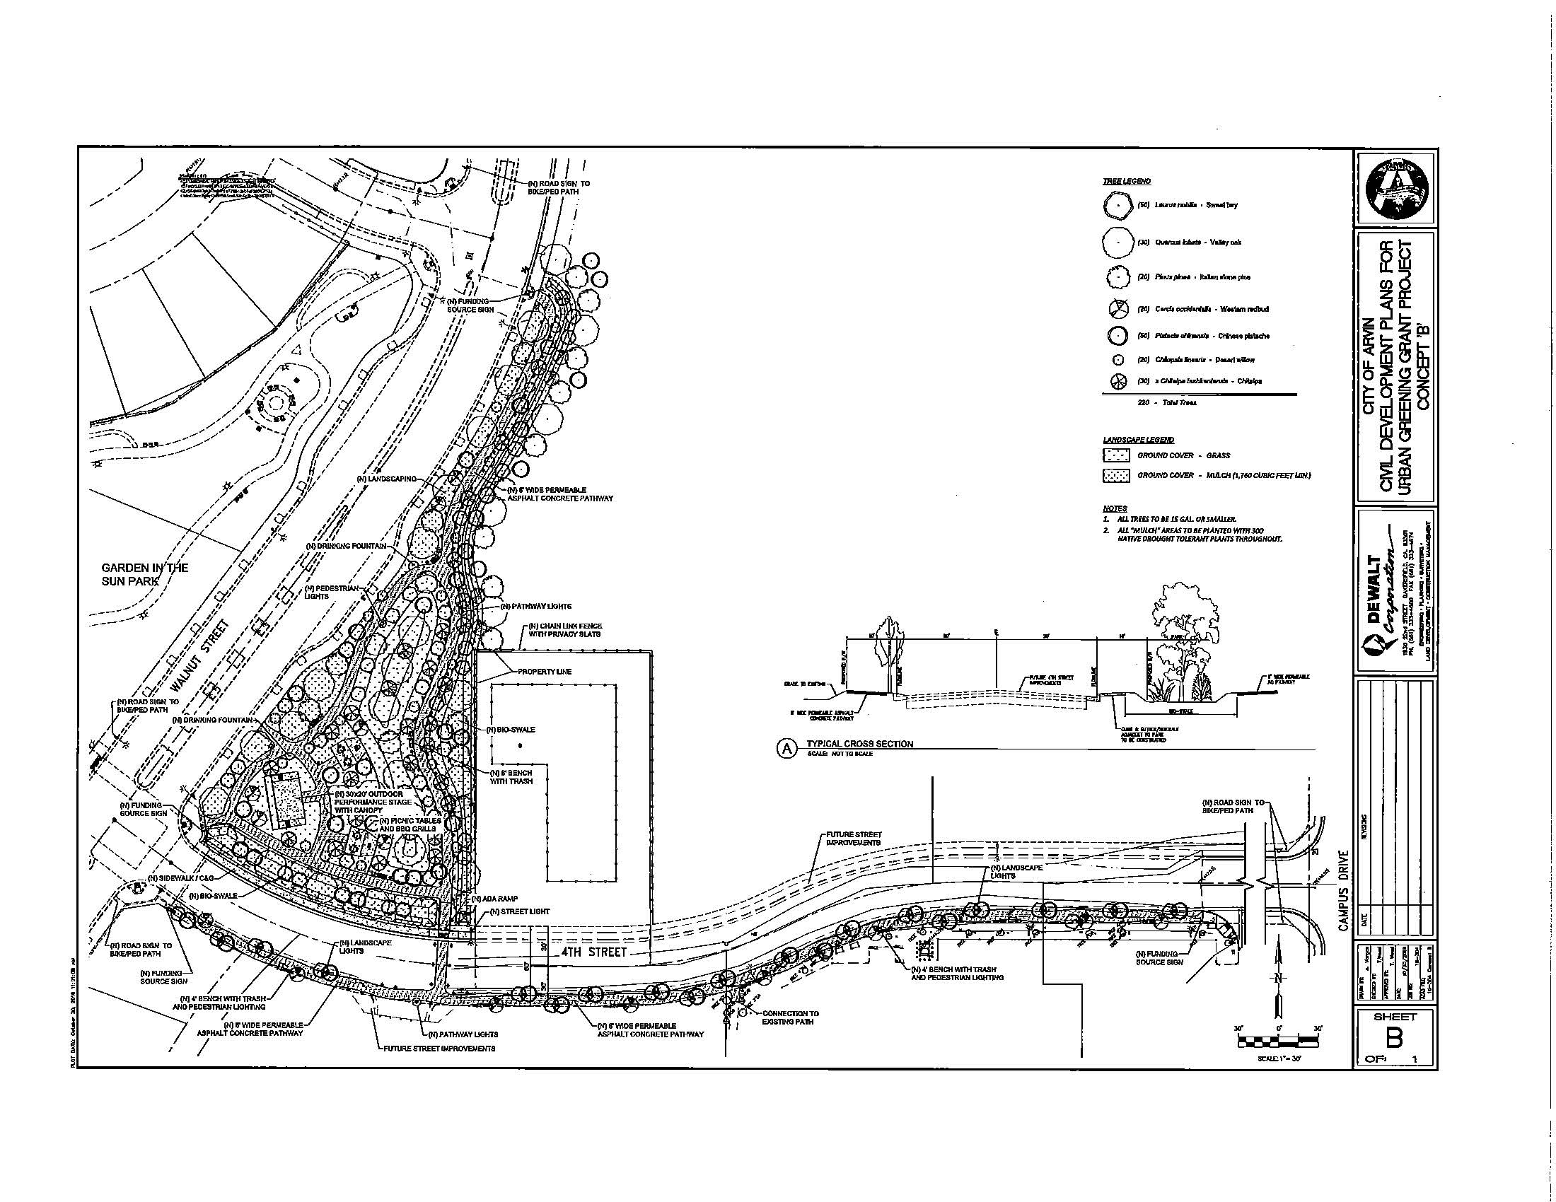

Aerial View of Project Area
Phase I - 2018 DELETED CONCEPT HIGHLIGHTED In Black along 4th Street then to the north into a portion of APN 190-260-26.
Phase I - 2024 Concept Highlighted in Green North of 4th Street and East of Walnut.
Phase II - 2024 Concept Highlighted in Red North of Alderette to Grapevine on the east side of Walnut.
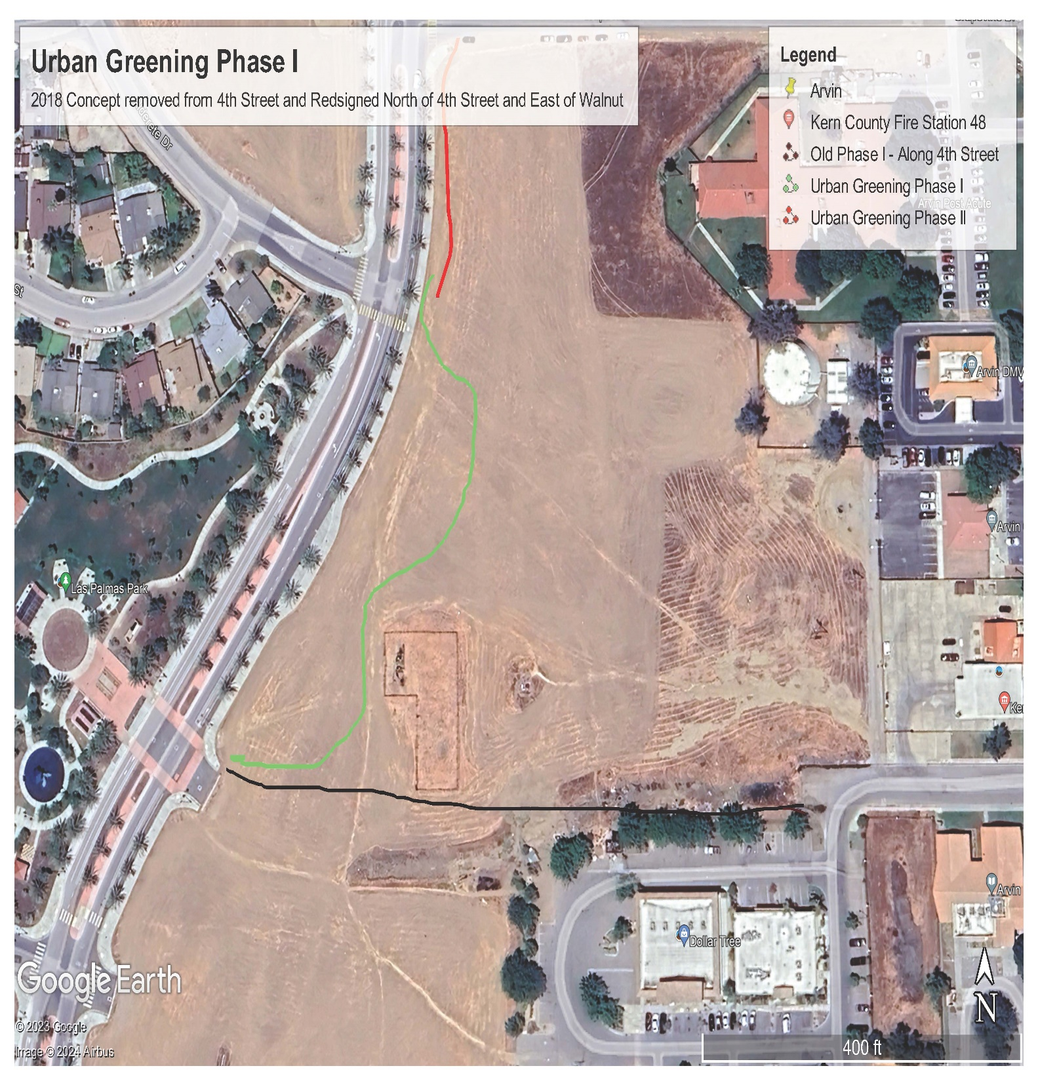

ASSESSOR PARCEL NO. 190-260-06 – PORTION OF THE SITE FOR THE
URBAN GREENING PHASES I AND II – Pocket Park with BIKE AND PEDISTRIAN PATH NORTH OF 4TH STREET AND EAST OF WALNUT
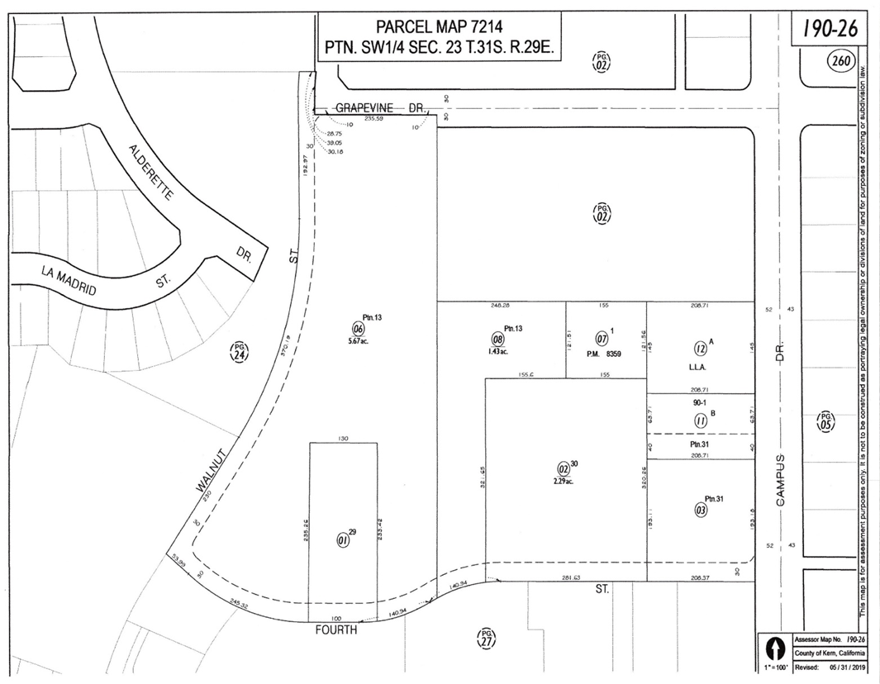
Phase I - 2018 CONCEPT HIGHLIGHTED In Black along 4th Street then to the north into a portion of APN 190-260-26.
Urban Greening Phase I - 2024 Concept Highlighted in Yellow North of 4th Street and East of Walnut.
Urban Greening Phase II - 2024 Concept Dual Bike and Pedestrian Path Highlighted in Red east of Walnut then North from Alderette to Grapevine

