Project Description: 2024 Phase II – Urban Greening Grant- expands a planned pocket park by extending a dual-purpose bike and pedestrian permeable 8’ wide tree-lined walkway/bikeway with solar lighting from Alderette Drive to Grapevine Drive
Urban Greening Phase II– Alderete Drive to Grapevine: Phase II expands a planned pocket park by extending a dual-purpose bike and pedestrian permeable 8’ wide tree-lined walkway/bikeway with solar lighting from Alderette Drive to Grapevine Drive (that parallels the east side Walnut Drive). (See 18-304 Revised concept which is Phase II)

2024 Urban Greening Phase II – Preliminary Cost Estimate - $500,000.00

GARDEN IN THE SUN EXPANSION: - PHASE II:
1 | 1 | LS | Mobilization/Demobilization, Bonds, Insurance, Permits, Licenses and Fees
2 | 1 | LS | Traffic Control
3 | 1 | LS | Demolition/Site Preparation/Earthwork, excavate and import/export soil
4 | 1 | LS | Storm Water Pollution Prevention Plan
5 | 0 | SF | 4" Concrete complete and in place
6 | 0 | SF | 4" Concrete Sidewalk complete and in place
7 | 0 | LF | 6" Curb with 24" Gutter
8 | 0 | EA | Access Ramp
9 | 2,600 | SF | Permeable Pathway Surface
10 | 600 | LF | 18"x8" Concrete Mow Strip
11 | 0 | LF | 6' Chainlink Fence with Privacy Slats
12 | 0 | EA | Drinking Fountain
13 | 2 | EA | 6' Bench as shown on plans and specifications
14 | 0 | EA | 4' Bench as shown on plans and specifications
15 | 2 | EA | Trash Receptacles
16 | 0 | EA | Picnic Tables
22 | 1 | EA | Funding acknowledgement signs
LANDSCAPING:
1 | 1 | LS | Landscape Planting complete and in place per plans (including 130 native, drought tolerant plants)
2 | 0 | LS | ACSD Water Service Connection Fee*
3 | 0 | LF | 2" Domestic Water PVC Pipe with Isolation Valves complete and in place per plans
4 | 0 | EA | Reduced Pressure Backflow Preventer Assembly and Enclosure
5 | 22 | EA | Drought Tolerant Trees (15gal)
6 | 1 | LS | Irrigation System and Controller complete and in place per plans
7 | 0 | EA | Irrigation Booster

ELECTRICAL
1 | 1 | LS | On-Site Electrical conduits, wiring, grounding, pull boxes and all appurtenances complete and in place
2 | 34 | EA | Pathway Lights
3 | 0 | EA | Landscape Lights
4 | 3 | EA | Pedestrian Lights
5 | 0 | EA | Connection to PG&E Panel
6 | 0 | EA | PG&E Connection to Meter

Site Plan – Urban Greening - Second Phase - Portion of Assessor Parcel No. 190-260-06
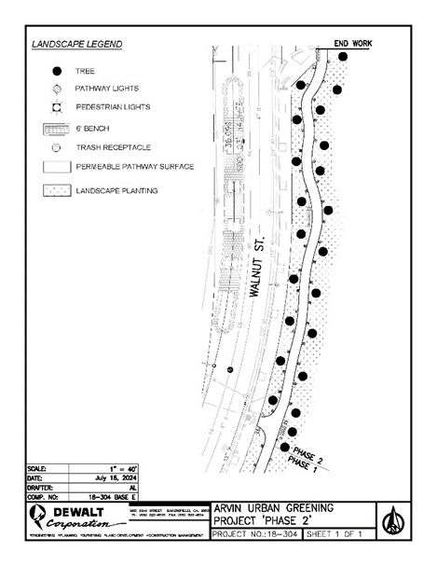

Aerial Project Area – Phase II Urban Greening – Bike path and walkway from Alderette Drive to Grapevine Drive
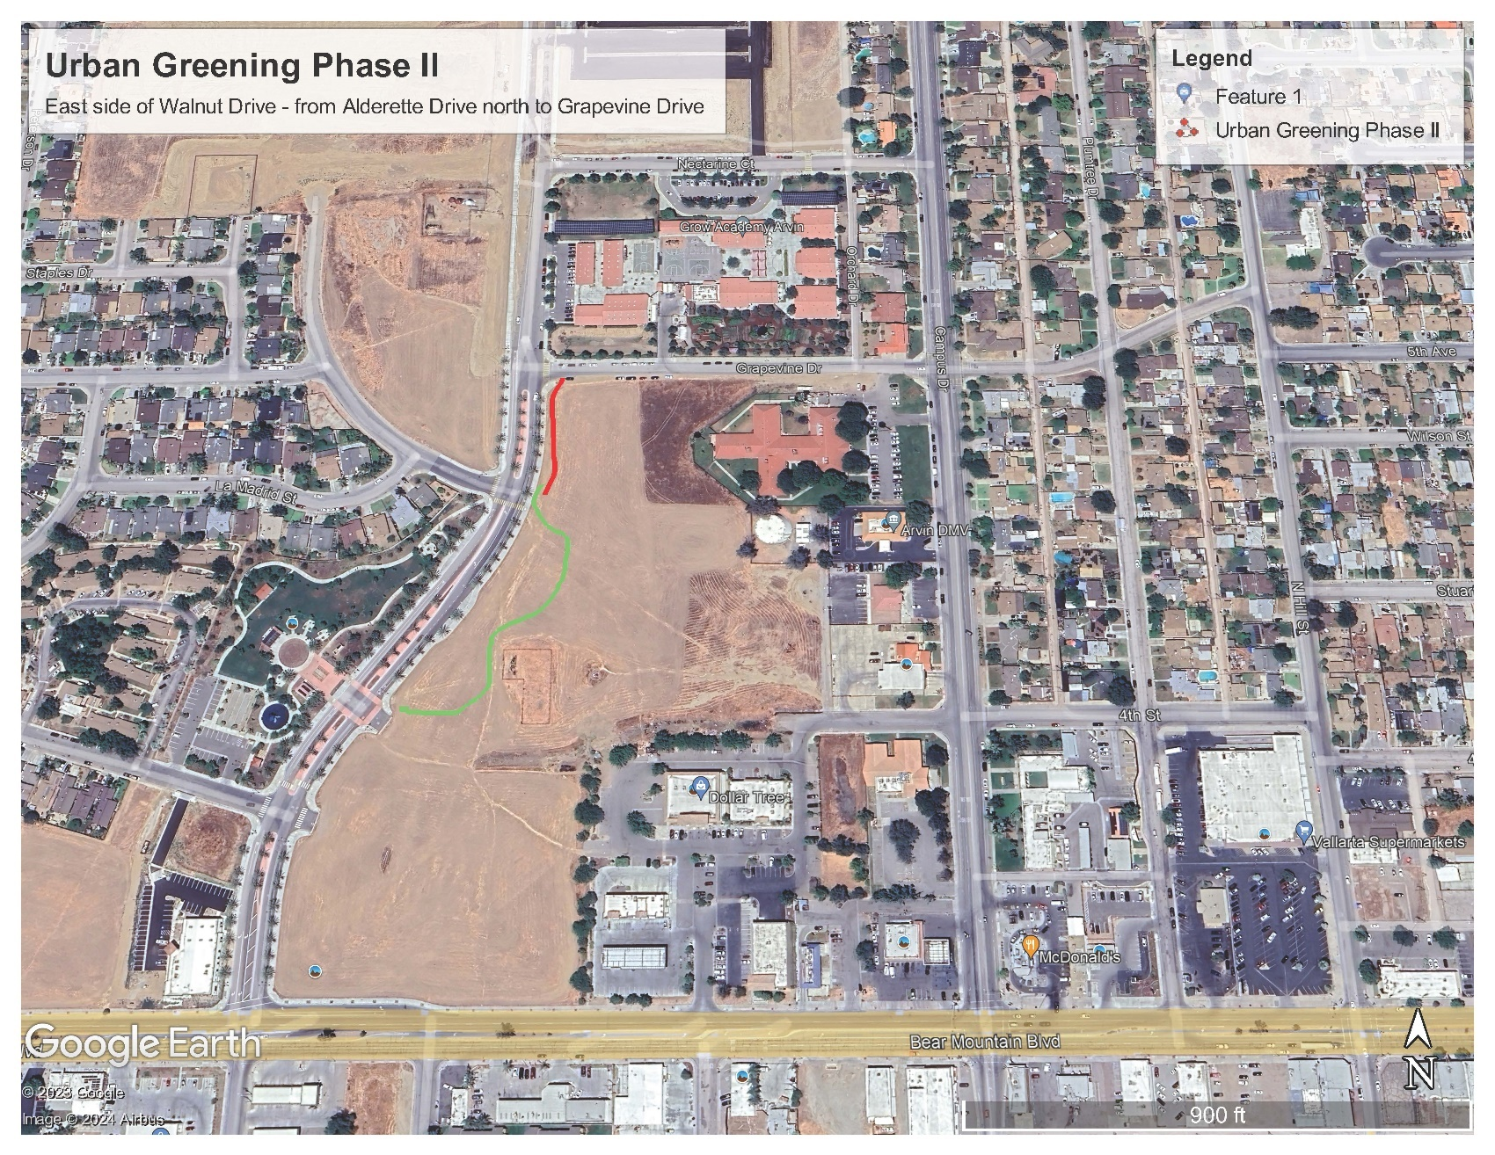

Site Plan – Urban Greening Phase I - First Phase - Portion of Assessor Parcel No. 190-260-06
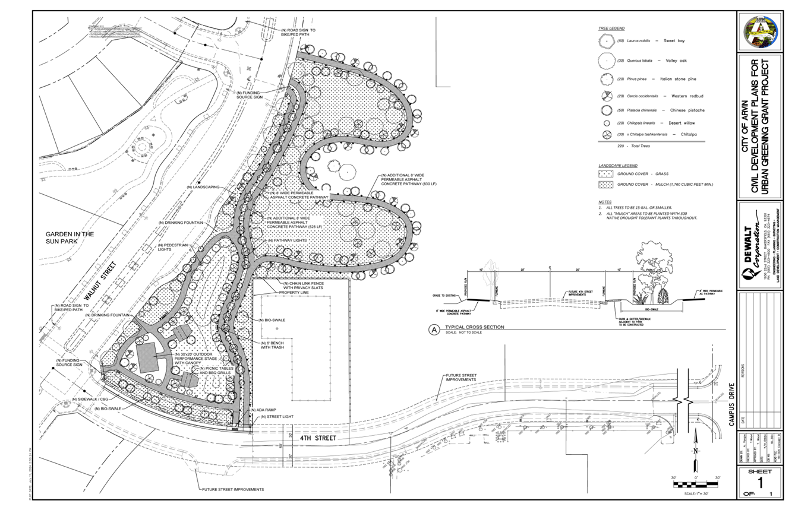

ASSESSOR PARCEL NO. 190-260-06 – PORTION OF THE SITE FOR THE
URBAN GREENING PHASE II BIKE AND PEDISTRIAN PATH FROM ALDERETTE DRIVE TO GRAPEVINE DRIVE
