2024 Renovation of and Improvement of Smothermon Park Open Space Area and Facilities: – Consist of the following: (1) Resilience HUB; Community Center- Retrofit Rooftop and Solar EV Charging Station; (2) Add Smothermon CC Expansion Add HVAC, Filtration, Food Storage; (3) Installation 6’-0” walkway, updated of irrigation, tree planting, sump renovation, bioswale renovation of soccer field and retention basin

Project Description: Smothermon Park, APN 192-08-04-19.10 Acres, City of Arvin, Renovation of and Improvement of Smothermon Park open space area and facilities – Consist of the following: -
- Resilience HUB – Smothermon Community Center, existing facility and retrofit of and installation of rooftop solar and solar EV Charging station – installation of transformer and PG&E infrastructure, installation of solar EV charging stations (3 level 2 chargers and networking), installation of solar Community Center/Cooling Center.
- Smotherman CC Expansion Add HVAC, Filtration, Food Storage; Add HVAC, filtration, and Food Storage within existing facility.
- Remove existing 6’-0” asphalt trail, approximately 12,600 lineal feet, and install 6’-0” Class II Aggregate Base, (Stabilized DG) Trail within park area, updated of irrigation system within park area, tree planting within existing park, renovation of existing retention basin (sump) renovation, renovation of existing bioswale located in soccer field.

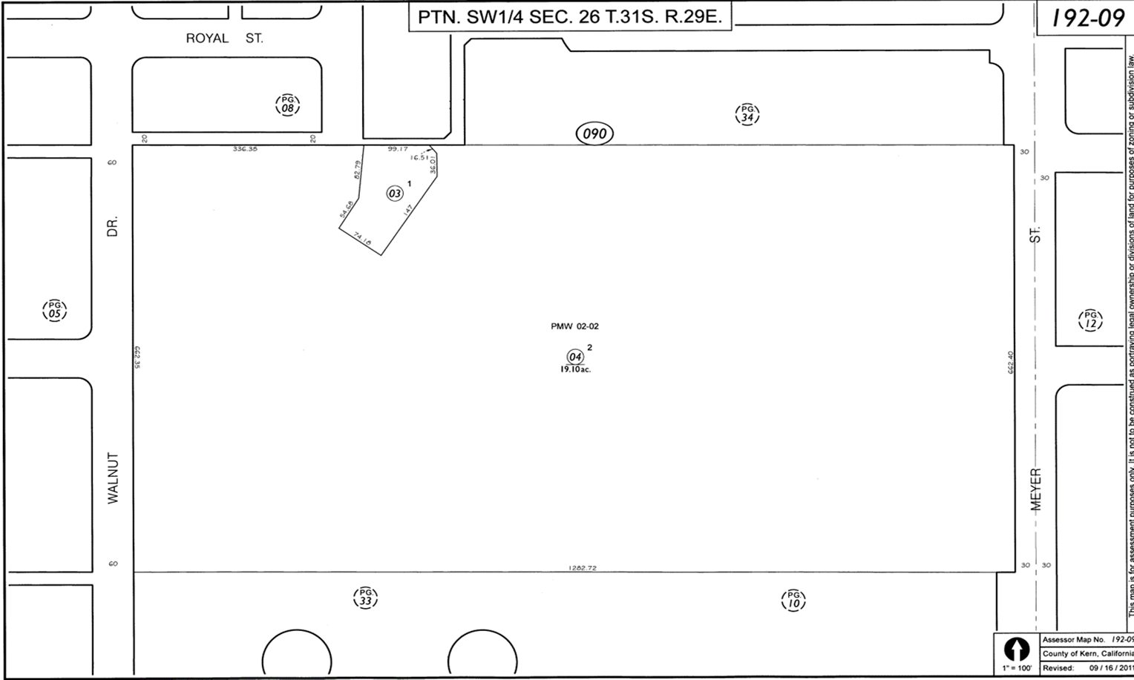

2024 Renovation of and Improvement of Smothermon Park- Arvin Community Facilities

- Resilience HUB – Smothermon Community Center, existing facility and retrofit of and installation of rooftop solar and solar EV Charging station – installation of transformer and PG&E infrastructure, installation of solar EV charging stations (3 level 2 chargers and networking), installation of solar Community Center/Cooling Center.
- Smotherman CC Expansion Add HVAC, Filtration, Food Storage; Add HVAC, filtration, and Food Storage within existing facility.

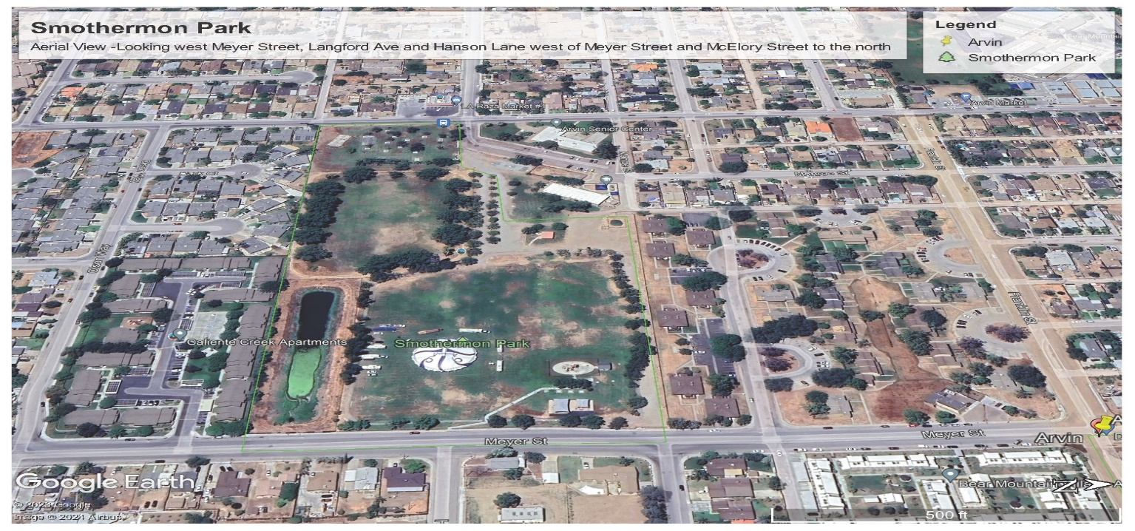

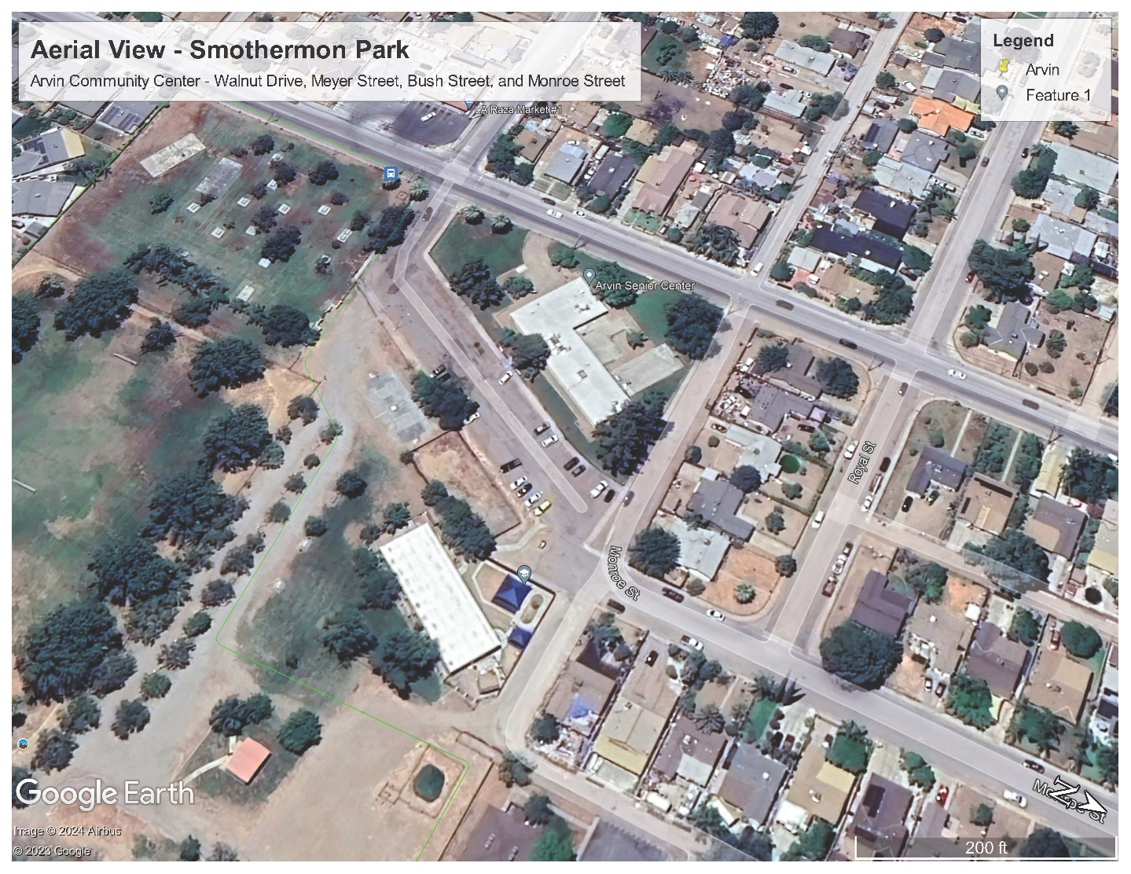

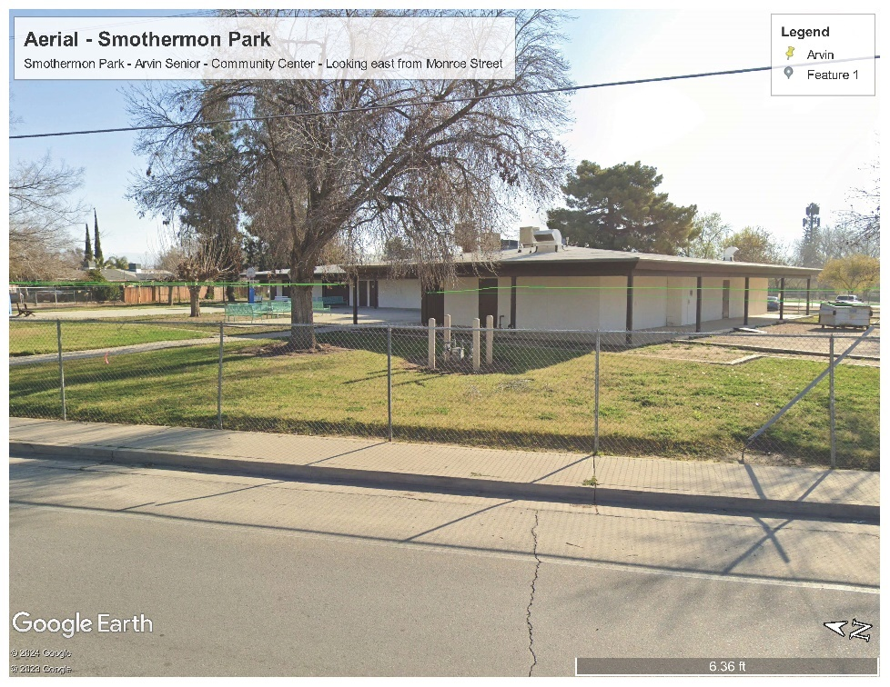

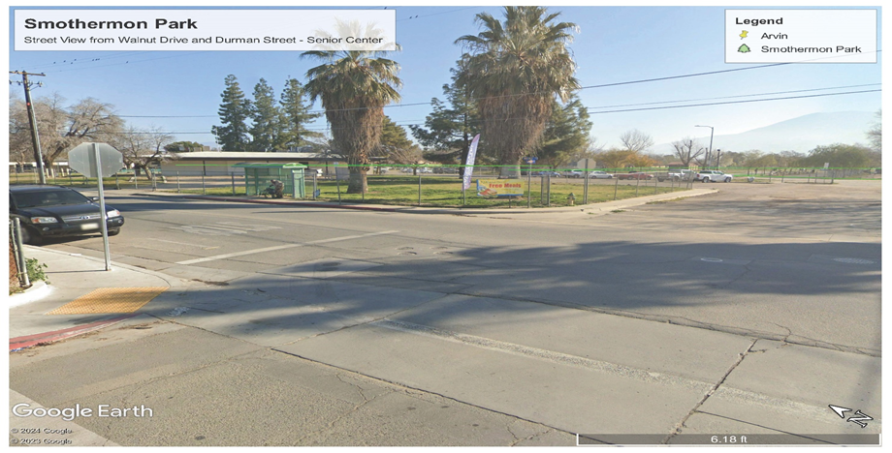

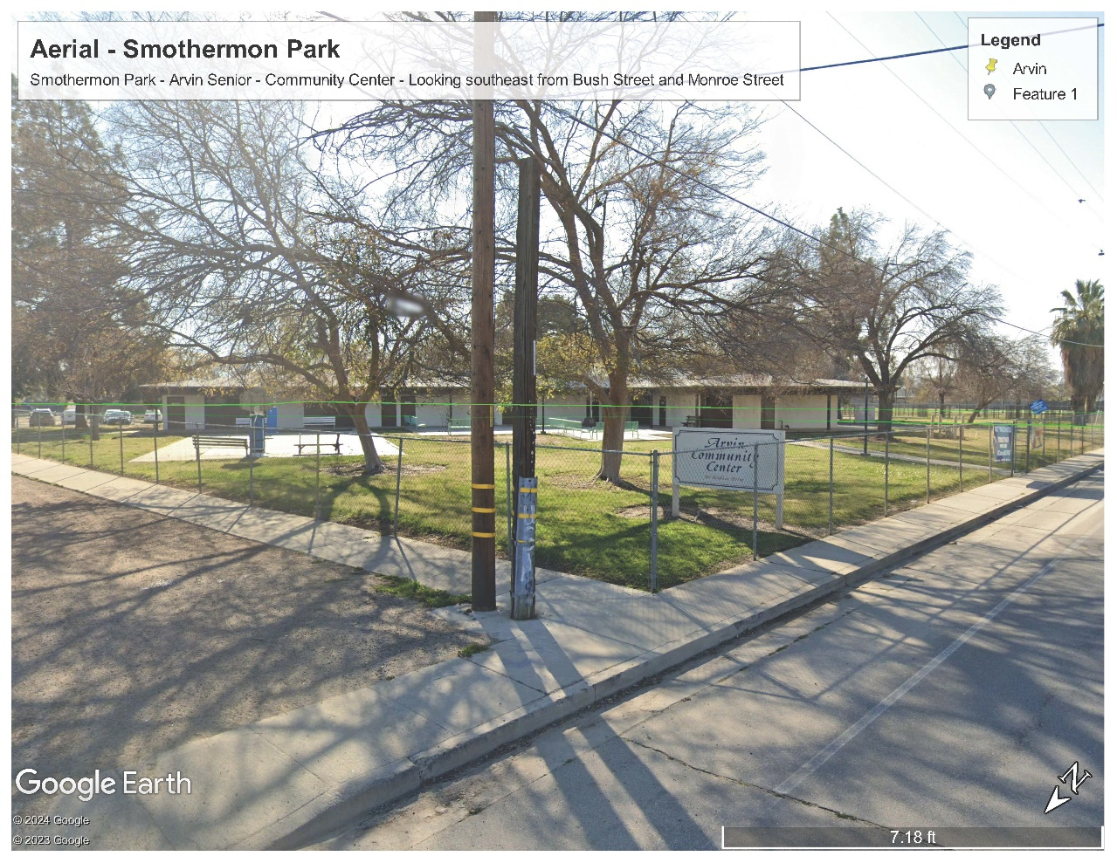

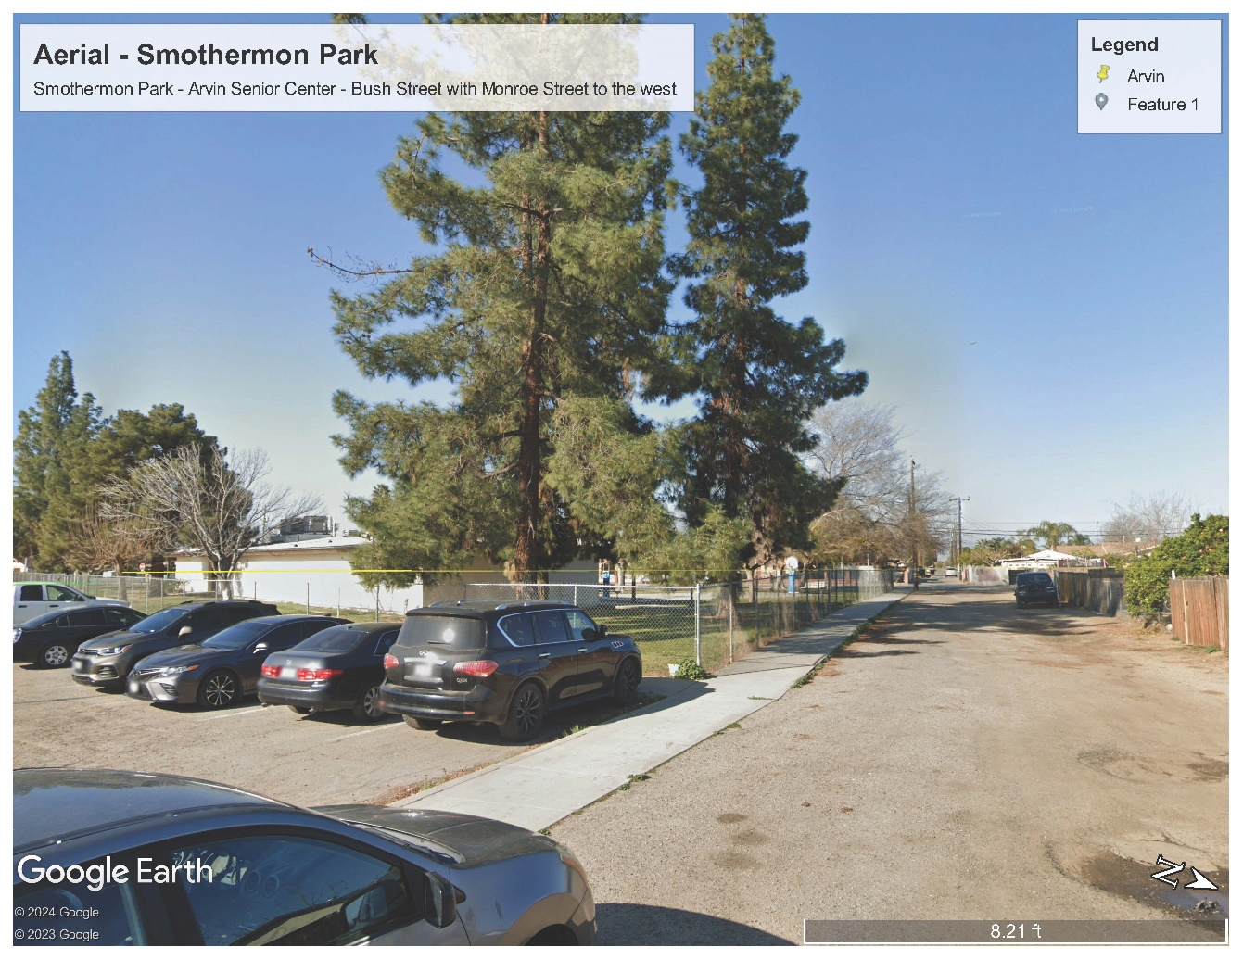

2024 Renovation of and Improvement of Smothermon Park Open Space Area and Facilities: – Installation 6’-0” walkway, updated of irrigation, tree planting, sump renovation, bioswale renovation of soccer field and retention basin

(3) Remove existing 6’-0” asphalt trail, approximately 12,600 lineal feet, and replace with and install 6’-0” Class II Aggregate Base, (Stabilized DG) Trail within park area, update of irrigation system within park area, tree planting within existing park, renovation of existing retention basin (sump) renovation, renovation of existing bioswale located in soccer field.

2024 Renovation of and Improvement of Smotherman Park Open Space Area and Facilities - Renovation and Installation of Facility Improvements – Cost Estimate by Quad Knopf Engineering -2024

City of Arvin ate: /13/2024
Project: Smotherman Park Estimate Prepared By: JK
Smotherman Park on Meyer Street Checked BY RG

I. CONSTRUCTION ITEMS | Quantity | Unit | Unit Cost | Total
1. SWPPP Preparation and Implementation | 1 | LS | $15,000.00 | $15,000.00
2. Contractor mobilization/demobilization | 1 | LS | $40,000.00 | $40,000.00
3. Traffic Control | 1 | LS | $ 30,000.00 | $30,000.00
4. Remove Asphalt Trail | 12,600 | SF | $1.50 | $18,900.00
5. Site Grading & Over excavation | 1 | LS | $100,000.00 | $100,000.00
6. Basin Clearing & Grubbing | 1 | LS | $50,000.00 | $50,000.00
7. Basin Removal & Haul Off of Contaminated Soil | 1 | LS | $255,400.00 | $255,400.00
8. Basin Haul In & Compacting of Permeable Clean Soil | 1 | LS | $201,070.00 | $201,070.00
9. Class II Agg. Base | 470 | CY | $70.00 | $32,900.00
10. 6' Wide (Stabilized DG) Trail | 6,300 | SF | $7.50 | $47,250.00
11. Installation of Trees & Irrigation | 1 | LS | $ 50,000.00 | $50,000.00
12. Construction materials testing | 1 | LS | $ 25,000.00 | $25,000.00
 |  |  | Subtotal: | $865,520.00
II. ENGINEERING ITEMS
13. Topographic Survey | 1 | LS | $10,000.00 | $10,000.00
14. Caltrans Encroachment Permit | 1 | LS | $7,500.00 | $7,500.00
15. Geotechnical | 1 | LS | $7,500.00 | $7,500.00
 |  |  | Subtotal: | $25,000.00
Contingencies @ 20%: |  |  |  | $178,104.00
Total Probable Construction Cost: |  |  |  | $1,068,624.00
Engineering Design (15%) |  |  |  | $160,293.60
Construction Management (10%) |  |  |  | $106,862.40
TOTAL CONSTRUCTION COST W/CONTINGENCY: |  |  |  | $1,335,780.00

Aerial of 2024 Renovation of and Improvement of
Smotherman Park Open Space Area
