Plumtree Drive (Street) Restoration and Resurfacing Project – 2024

Project Description: Plumtree Drive Street restoration and resurfacing beginning at Bear Mountain Boulevard intersection proceeding north crossing 4th Street intersection, Grapevine Drive intersection to Orchard Drive intersection (Approximately 4,700 lineal feet) will occur within the existing right-of-way and between existing curb lines. Removal, demolition, installation of new aggregate base will not exceed twelve (12) inches in depth for the entire length of the project. The project consists of the demolition of approximately 87,839 square feet of existing asphalt, installation of new aggregate base from Bear Mountain Boulevard to the intersection of Orchard Drive, replacement of three (3) existing commercial driveways, upgrade and replacement of existing sidewalks without change to the curb line, restriping of Plumtree Drive, installation of ADA Ramps, minor fence relocations, encroachment permits from the City Engineer and Cal Trans District No. 6.

Plumtree Drive (Street) Renovation Project – Cost Estimate by Quad Knopf Engineering -2024

City of Arvin Date: /13/2024
Project: Plumtree Drive Estimate Prepared By: JK
Plumtree Drive, Between Bear Mountain and Orchard Drive Checked BY RG

I. | CONSTRUCTION ITEMS | Quantity | Unit | Unit Cost | Total
1. | SWPPP Preparation and Implementation | 1 | LS | $15,000.00 | $15,000.00
2. | Contractor mobilization/demobilization | 1 | LS | $10,000.00 | $10,000.00
3. | Asphalt Demo | 87,828 | SF | $1.00 | $87,828.00
4. | Traffic Control | 1 | LS | $30,000.00 | $30,000.00
5. | Off-haul trucking | 1 | LS | $150,000.00 | $150,000.00
6. | Grading | 1 | LS | $100,000.00 | $100,000.00
7. | Ag Base - Bear Mt. - Fourth Street (10") | 675 | CY | $175.00 | $118,125.00
8. | Ag Base - Fourth Street - Orchard (6") | 1,225 | CY | $175.00 | $214,375.00
9. | Paving - Bear Mt. - Fourth Street (5") | 660 | TONS | $200.00 | $132,000.00
10. | Paving - Fourth Street - Orchard (3") | 2,000 | TONS | $200.00 | $400,000.00
11. | Striping | 1 | LS | $5,500.00 | $5,500.00
12. | Concrete Demo | 1 | LS | $7,500.00 | $7,500.00
13. | New Commercial Drive Approach | 3 | EA | $8,500.00 | $25,500.00
14. | New Sidewalk | 1,325 | SF | $20.00 | $26,500.00
15. | ADA Ramps | 8 | EA | $8,250.00 | $66,000.00
16. | Crosswalk | 1 | LS | $18,000.00 | $18,000.00
17. | Crossgutter @ Bear Mtn. | 160 | SF | $20.00 | $3,200.00
18. | Crossgutter at Fourth Street | 160 | SF | $20.00 | $3,200.00
19. | Fence relocations, misc. | 1 | LS | $12,500.00 | $12,500.00
20. | Construction Materials Testing | 1 | LS | $35,000.00 | $35,000.00
21. | Misc (drains, utilities) | 1 | LS | $20,000.00 | $20,000.00
 |  |  |  | Subtotal: | $1,480,228.00
II. | ENGINEERING ITEMS
22. | Topographic Survey | 1 | LS | $10,000.00 | $10,000.00
23. | Caltrans Encroachment Permit | 1 | LS | $7,500.00 | $7,500.00
24. | Geotechnical | 1 | LS | $7,500.00 | $7,500.00
 |  |  |  | Subtotal: | $25,000.00
Contingencies @ 20%: |  |  |  |  | $301,045.60
Total Probable Construction Cost: |  |  |  |  | $1,806,273.60
Engineering Design (15%) |  |  |  |  | $270,941.04
Construction Management (10%) |  |  |  |  | $180,627.36
TOTAL CONSTRUCTION COST W/CONTINGENCY: |  |  |  |  | $2,257,842.00

Aerial of Plumtree Drive (Street) Renovation Project – Between Bear Mountain Boulevard and Orchard Drive – 2024
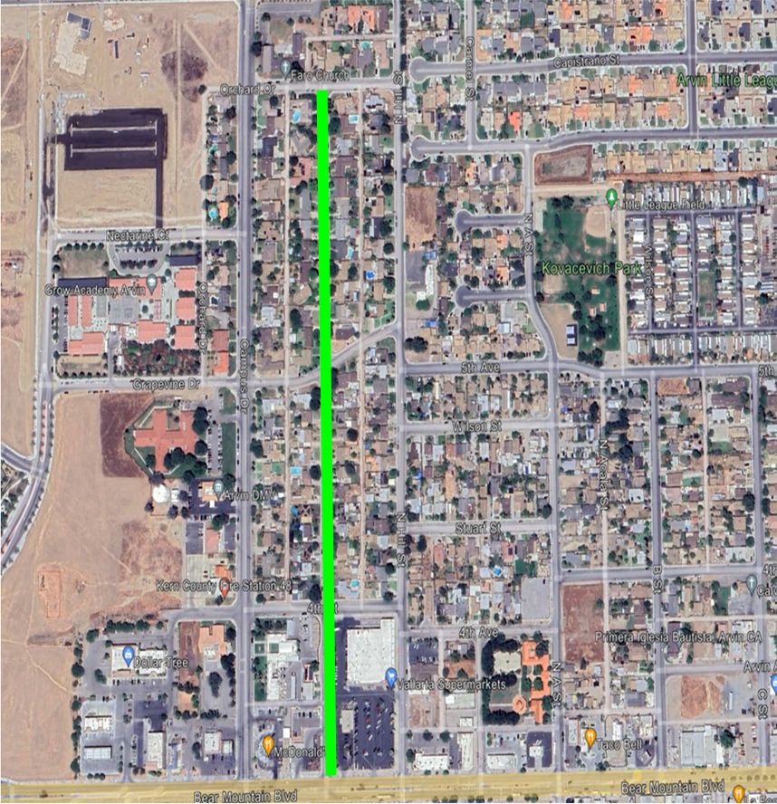

Photographs of Plumtree Drive (Street) Renovation Project – 2024

