City of Milpitas
Notice of Preparation of
an SuBSEQUENT Environmental Impact report
And Notice of Public Scoping Meeting
for the Gateway-Main Street Specific Plan Project
Date: July 15, 2024
To: Responsible Agencies, Trustee Agencies, and Interested Persons
RE: Notice of Preparation of a Draft Subsequent Environmental Impact Report for the Gateway-Main Street Specific Plan Project
In accordance with the provisions of the California Environmental Quality Act (CEQA), the City of Milpitas (City) has prepared a Notice of Preparation (NOP) for a Draft Subsequent Environmental Impact Report (SEIR) for the proposed Gateway-Main Street Specific Plan (Specific Plan). The SEIR tiers from the City’s adopted General Plan 2040 to implement the General Plan policies (LU 1-1 and LU 1-2) Action LU-2a for the update and implementation of the Milpitas Midtown Specific Plan. The NOP includes a project description, exhibits, summary of key issues to be addressed in the SEIR, and an overview of the purpose of this notice and the environmental review process. The purpose of this NOP is to provide an opportunity for the public, interested parties, and public agencies to comment on the scope and proposed content of the SEIR.

Providing Comments on this Notice of Preparation
Agencies and interested parties may provide the City with written comments on environmental topics to be addressed in the SEIR for the project. Because of time limits mandated by State law, written and/or email comments should be provided no later than 5:00 p.m. on August 13, 2024. Please send all comments on the NOP to:
City of Milpitas, Planning Department
455 E. Calaveras Blvd.
Milpitas, CA 95035
Attn: Jay Lee, Planning Director
Phone: (408) 586-3077
E-mail: jlee@milpitas.gov

PUBLIC SCOPING MEETING
The City will conduct a public scoping meeting to receive comments on environmental issues that should be addressed in the Draft SEIR as well as the range of practicable alternatives to be evaluated in the Draft SEIR. The public scoping meetings are scheduled virtually via Zoom at the following date, time and location:
DATE: August 1, 2024, 6:00 p.m. to 7:30 p.m.
MEETING LINK: https://us06web.zoom.us/j/81649348310?pwd=XybwZmZWwtvqy2z5mH9CPim1p5ix9W.1
Meeting ID: 816 4934 8310
Passcode: 816975

Project Location
The Gateway-Main Street Specific Plan Area (Specific Plan Area) covers approximately 605 acres within the City of Milpitas. The City, located in northern Santa Clara County, within the South San Francisco Bay Area, is situated north of San Jose and east of Santa Clara, Sunnyvale, and Mountain View along State Route 237 (Highway 237) (Figure 1, Regional Location). The City is served by three major freeways: Interstate (I)-880, I-680, Highway 237/Calaveras Boulevard, and the County-managed Montague Expressway.
The Specific Plan Area is located within the western portion of the city, west of the Union Pacific Railroad (UPRR) line. It encompasses Calaveras Boulevard, Main Street, and the Milpitas Midtown Specific Plan project area bordered by I-880 to the west, the UPRR tracks to the east, and Great Mall Parkway to the south. Two heavy rail lines, the UPRR freight line and Bay Area Rapid Transit (BART) commuter rail lines, traverse the Specific Plan Area on the east. The Valley Transportation Authority (VTA) operates light rail transit (LRT) and interconnecting bus lines into the Specific Plan Area along the Great Mall Parkway.
Existing land uses in the Specific Plan Area consist of single-family residential, multi-family residential, retail, office, civic/institutional, park/open space, and industrial uses. Commercial uses (retail, office, and hospitality) are located throughout the Specific Plan Area. A mix of single-family and multi-family housing is scattered throughout the Specific Plan Area. Public uses, including religious, educational, and cultural facilities, comprise a portion of the Specific Plan Area, including the County-operated Elmwood Correctional Facility. Transportation and industrial uses, in the Specific Plan Area, are primarily focused between the two railroad lines.

Project Background
The Milpitas Midtown Specific Plan (Midtown Plan), adopted in 2002, is the predecessor plan to the Milpitas Gateway-Main Street Specific Plan. The Midtown Plan was last updated in 2010 to respond to a series of development activities in the Midtown area, including the construction of new housing, reinvestment in the Great Mall, a retail shopping center, and the extension of the Tasman East Valley Transportation Authority (VTA) light rail transit line, and proposals, at the time, to extend the Bay Area Rapid Transit (BART) through the area.
The City of Milpitas General Plan 2040, adopted in 2021, is the guiding, long-term plan and policy document for the physical development of the city through 2040. The planned update of the Midtown Plan to the Gateway-Main Street Specific Plan, as described in the General Plan, is intended to create an economically-viable main street type development that serves as the cultural hub of the city. The General Plan 2040 provides goals and policies for the Gateway-Main Street Area, to create a mixed-use neighborhood with a variety of residential, commercial, civic, and cultural uses in a compact, walkable, and centralized setting.
The Specific Plan Area includes the historic commercial core of the City, centered on Main Street and Serra Way, and Calaveras Boulevard, near Interstate 880. The Gateway-Main Street Specific Plan Update would provide the vision, standards, and policies of the Midtown Plan. The project would implement the General Plan goals and policies to update the Midtown Plan with a focus on revitalizing Main Street as the city’s historic core and improving Calaveras Boulevard as a western gateway into the city.

PROJECT DESCRIPTION

Overview
The purpose of the Gateway-Main Street Specific Plan (Specific Plan) is to guide land use and development consistent with the General Plan; implement the City’s economic development strategy and help facilitate investment in the Specific Plan’s Focus Areas; preserve and enhance existing neighborhoods; and plan for the future transition of Urban Reserve lands. The Specific Plan identifies four focus areas: Gateway District, Crossroads District, Main Street District, and Abbott District.
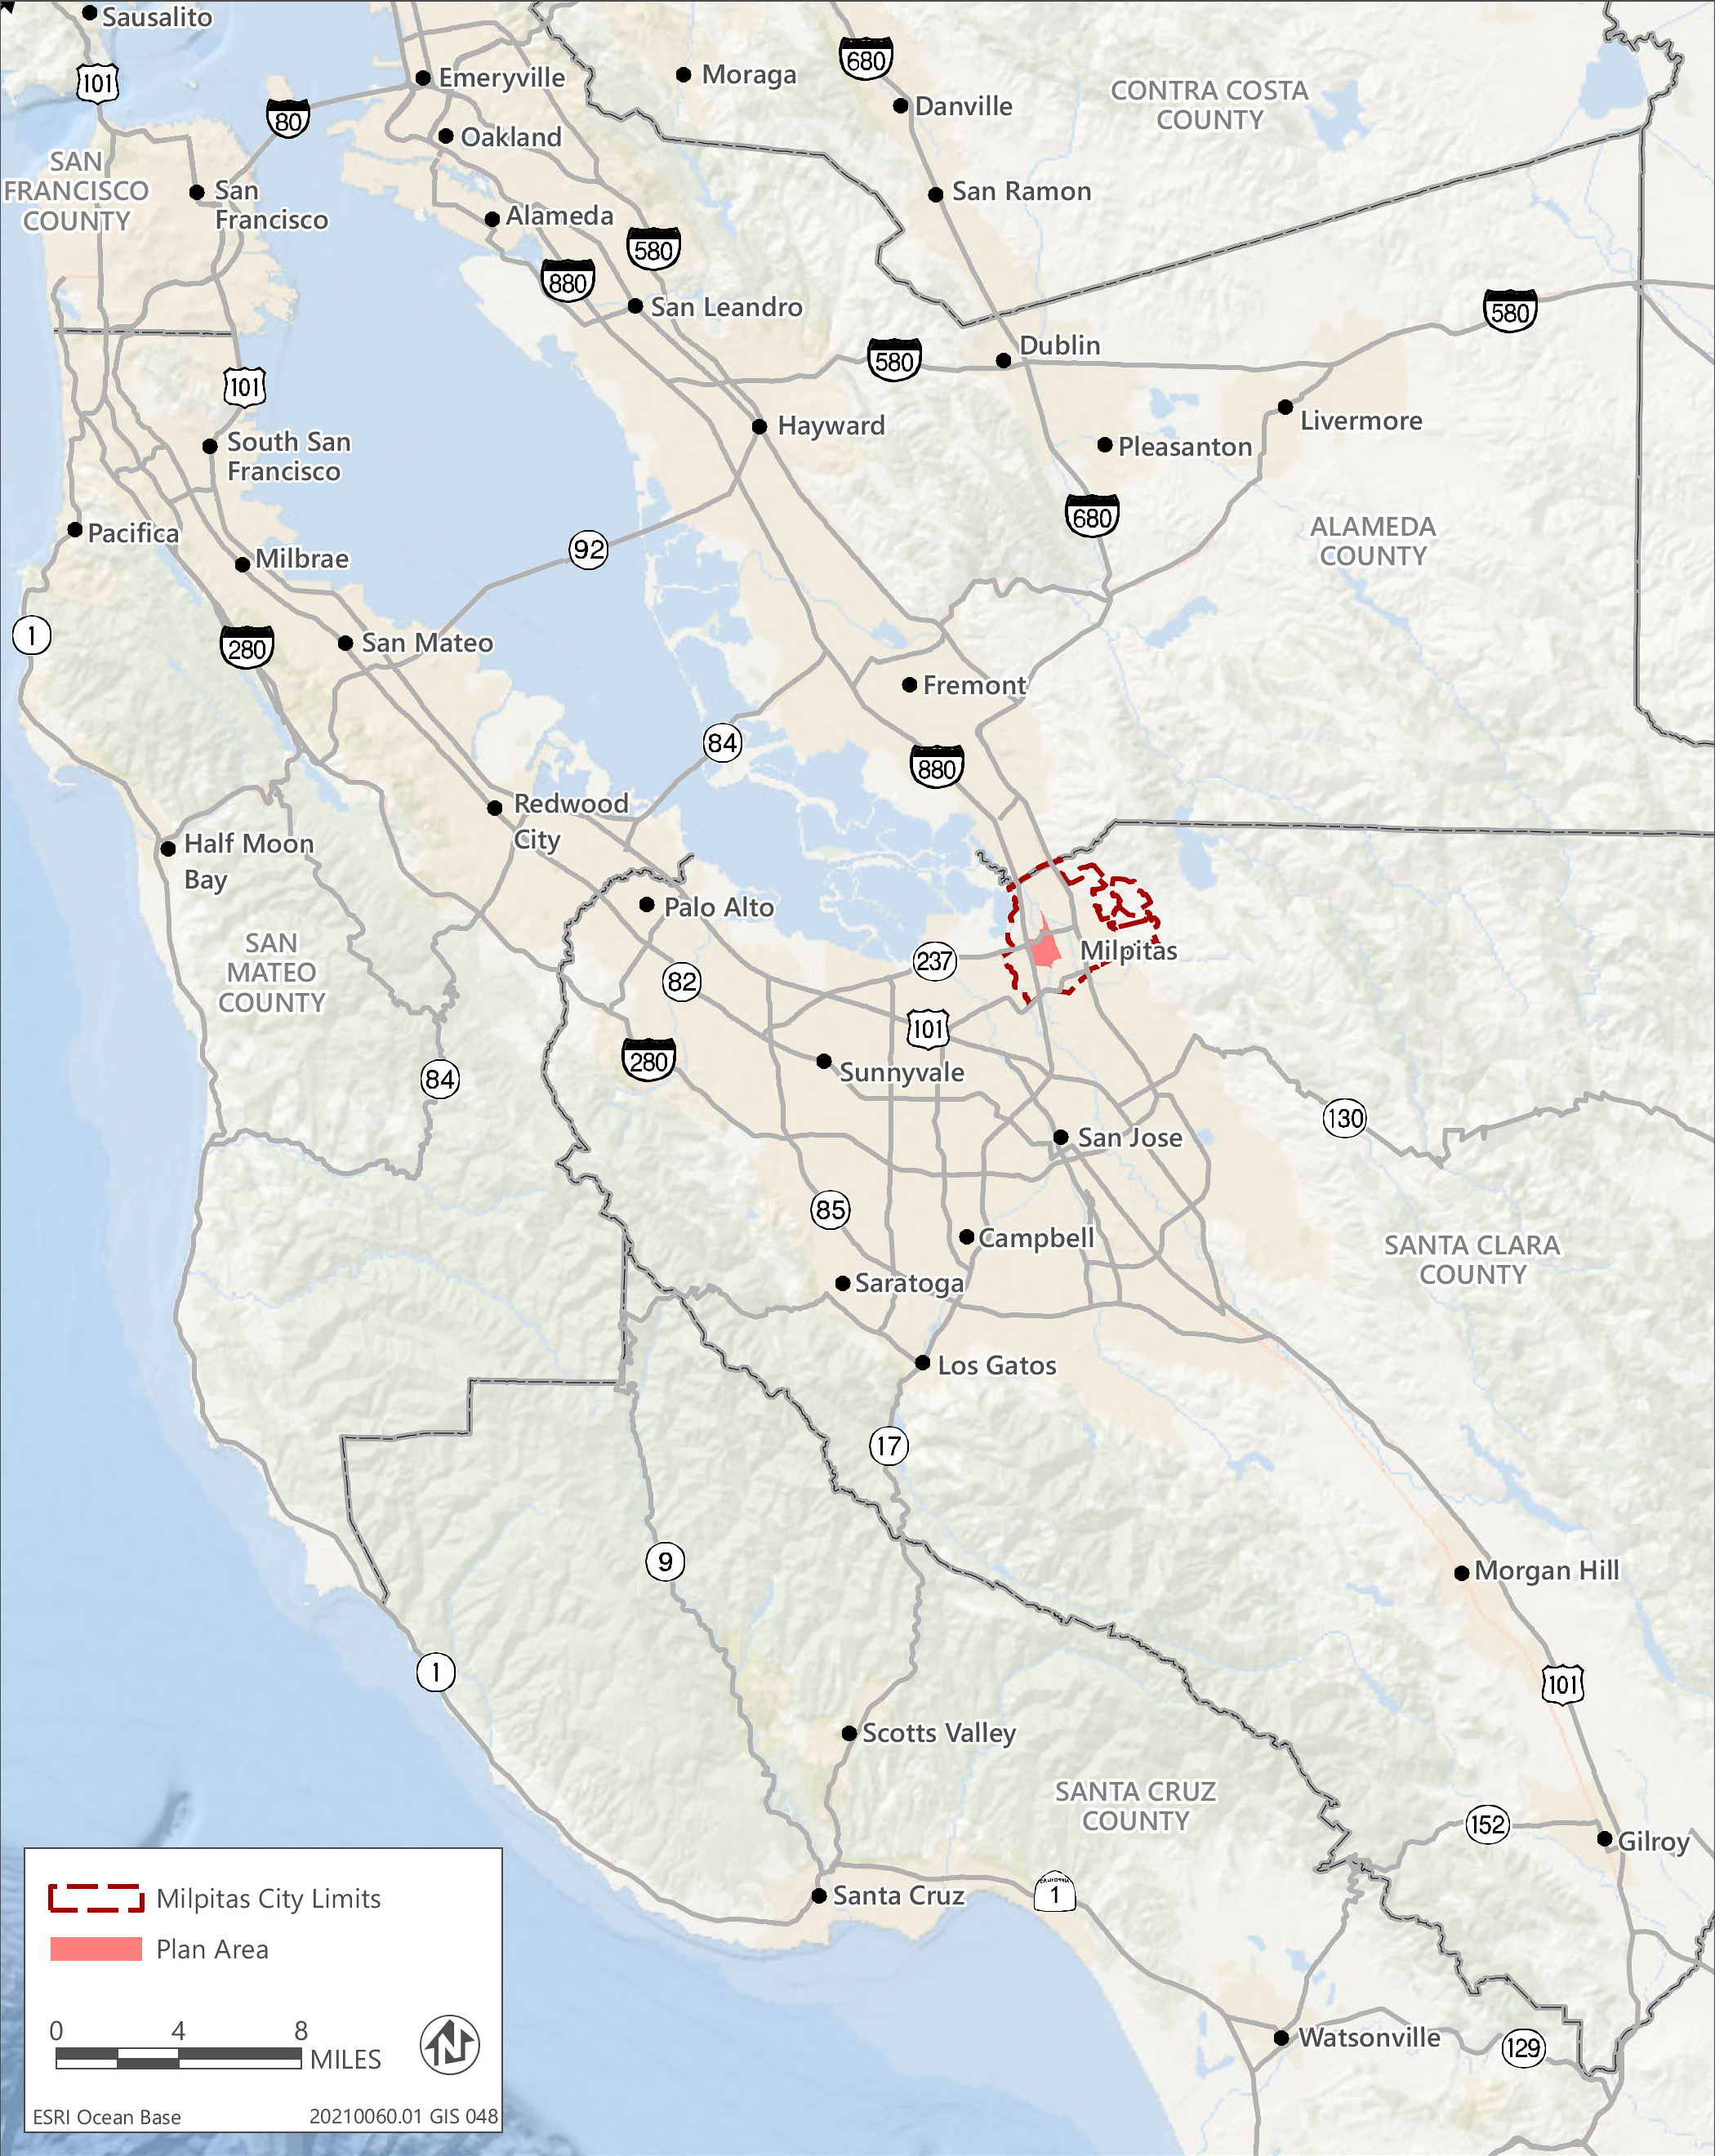
Source: Adapted by Ascent in 2024.
Figure 1 Regional Location
The City’s General Plan Land Use Element designates the adopted Midtown Plan area as MGSP - Milpitas Gateway-Main Street Specific Plan. The General Plan includes the following actions related to the Specific Plan: Action LU-2A to maintain and implement the Gateway-Main Street Specific Plan goals, policies and development standards and guidelines to create a mixed-use community that includes high-density, transit-oriented housing and a central community ‘gathering place’ while maintaining needed industrial, service and commercial uses; and Action ED-3H to work with property owners to facilitate development of vacant and underutilized properties on Main Street to achieve the highest and best use (Figure 2).

Gateway-Main Street Specific Plan
The proposed Specific Plan would change the development currently allowed under the General Plan. The Specific Plan would require amendments to the General Plan as changes to the boundaries and land use and development standards of the adopted Midtown Plan Area are proposed. The Specific Plan Update proposes a new project area boundary that removes the portion of the Midtown Specific Plan Area south of the Great Mall Parkway, and adds area in the northwestern portion of the Specific Plan Area.
The proposed Specific Plan would allow for additional residential development beyond what is allowed under the General Plan through increases in density and implementation of an incentive program. This would also include alterations in nonresidential development potential through mixed-use development.

POTENTIAL ENVIRONMENTAL EFFECTS
As required by CEQA, the SEIR will describe existing conditions and evaluate the potential environmental effects of the proposed project and a reasonable range of alternatives, including the no-project alternative. It will address direct, indirect, and cumulative effects. The SEIR will also discuss potential growth-inducing impacts and summarize significant and unavoidable environmental effects. The SEIR will identify feasible mitigation measures, if available, to reduce potentially significant impacts. Potential issues and impacts to the existing environment to be analyzed in the Draft SEIR include the following environmental topics:
- Aesthetics  - Air Quality  - Energy  - Biological Resources  - Archaeological, Historical, and Tribal Cultural Resources  - Noise and Vibration | - Land Use and Planning  - Population and Housing  - Public Services and Utilities  - Traffic and Circulation  - Recreation  - Greenhouse Gas Emissions
Implementation of the project would have no impact on agricultural resources, forestry resources, or mineral resources as these resources do not exist in the proposed Specific Plan area. The proposed Specific Plan Area is surrounded by urban development and is not adjacent to or intermixed with open space, natural land, or rural/agricultural lands. New construction is subject to the City Municipal Code, California Building Code, and the California Fire Code, which includes safety measures to minimize the threat of geologic hazards and fire. Thus, the project would have no impact related to geology and soils or wildfire risk. The majority of development allowed under the proposed Specific Plan would be within areas currently developed with urban uses and the amount and type of runoff that could result in hydrology and water impacts generated by new development would be similar to existing conditions.
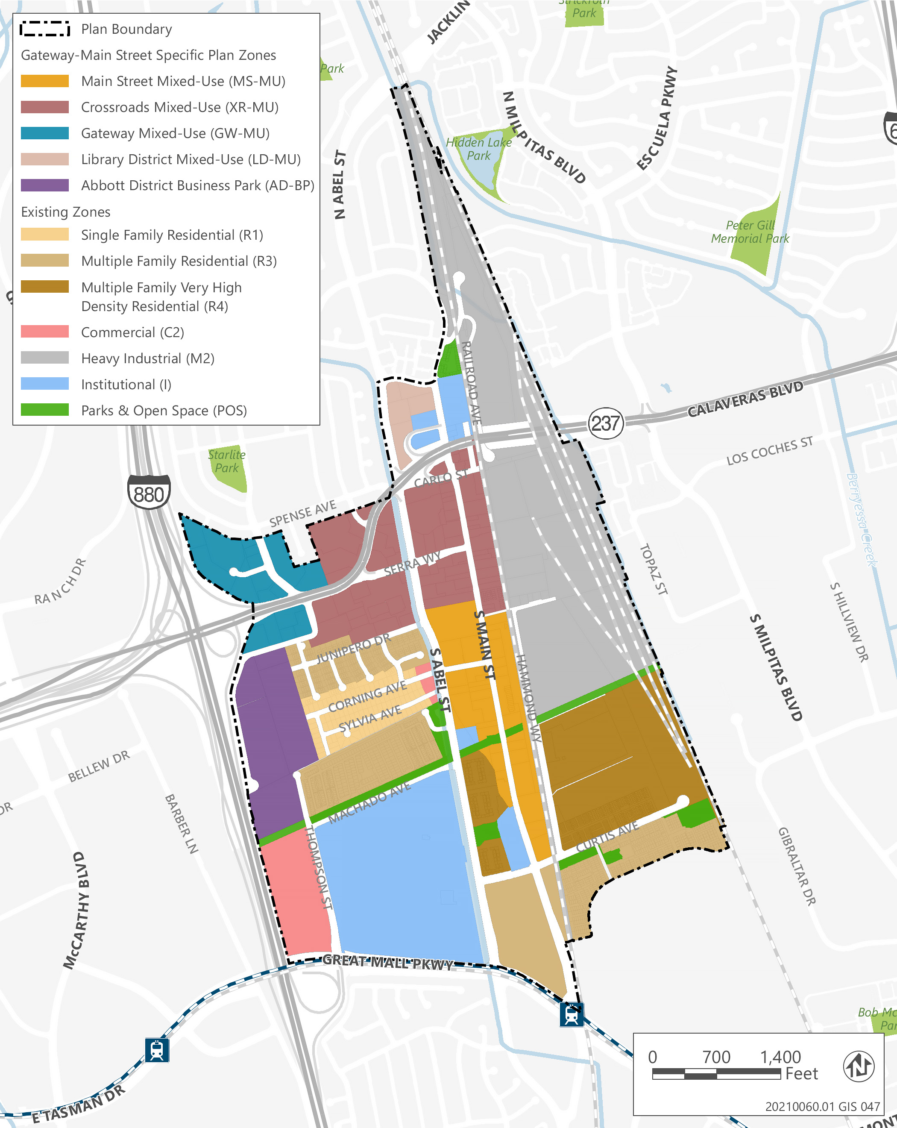
Source: Adapted by Ascent in 2024.
Figure 2 Proposed Land Use
Further, future development would be required to prepare a detailed project specific drainage plan, Water Quality Management Plan, and a Storm Water Pollution Prevention Plan (SWPPP). Thus, the project would have no impact related to hydrology or water quality. New construction would be subject to a comprehensive set of California regulatory requirements that are designed to assure the safe handling and disposal of hazardous materials. These issues will not be evaluated in the Draft SEIR.
Other SEIR Sections: In addition to the above environmental topics, the Draft SEIR will also evaluate the potential cumulative and growth inducing effects of the project, as required by CEQA. Reasonably foreseeable future projects in the project vicinity will be considered in this analysis.
In accordance with section 15126.6 of the State CEQA Guidelines, an EIR must “describe a range of reasonable alternatives to the project, or to the location of the Project, which would feasibly attain most of the basic objectives of the project but would avoid or substantially lessen any of the significant effects of the project and evaluate the comparative merits of the alternatives.” As required by CEQA, the SEIR will evaluate a No Project Alternative. Aside from the No Project Alternative, the City has not yet determined what additional alternatives to the project will be evaluated in the SEIR. These will be identified during the environmental review process. Once selected, the alternatives will be analyzed at a qualitative level of detail in the Draft SEIR for comparison against the impacts identified for the proposed project, consistent with the requirements of CEQA.

Purpose of this Notice
In accordance with the State CEQA Guidelines (14 California Code of Regulations [CCR] Section 15082), the City has prepared this NOP to inform agencies and interested parties that an EIR will be prepared for the above-referenced project. The purpose of an NOP is to provide sufficient information about the project and its potential environmental impacts to allow agencies and interested parties the opportunity to provide a meaningful response related to the scope and content of the EIR, including mitigation measures that should be considered and alternatives that should be addressed (State CEQA Guidelines 14 CCR Section 15082[b]).

Environmental Review Process
Following completion of the 30-day NOP public review period, the City will incorporate relevant information into the Draft SEIR, including results of public scoping and technical studies. The Draft SEIR will be circulated for public review and comment for 45-day public review period. All parties that have requested to be included on the project mailing list will be provided a Notice of Availability for the Draft SEIR.
A copy of this NOP has been posted on the project website: Milpitas Gateway-Main Street Specific Plan (milpitasmainstreet.org)
If you would like to be placed on the project mailing list or have any questions or comments, please contact Jay Lee, Planning Director, City of Milpitas, at (408) 586-3077 or jlee@milpitas.gov.

