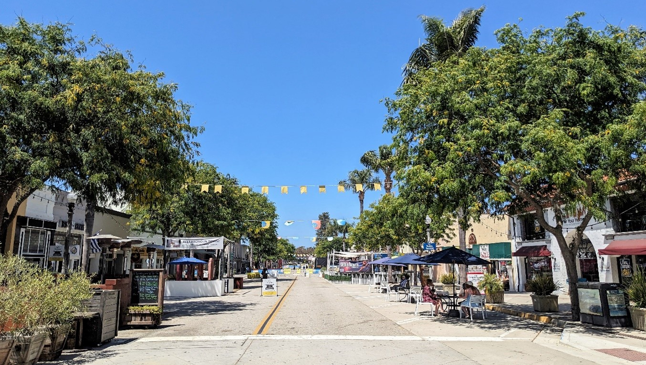
Main Street Moves

Draft Addendum to the Environmental Impact Report
SCH#2024060943
prepared by
City of Ventura
Planning Division
501 Poli Street
Ventura, California 93001
Contact: AJ Bernhardt
prepared with the assistance of
Rincon Consultants
2060 Knoll Drive
Ventura, California 93003
December 2025

Table of Contents
1 Introduction 1
1.1 Background and Purpose of the EIR Addendum 1
1.2 Basis for the Addendum 4
2 Modified Project Description 6
2.1 Modified Project Characteristics 6
2.2 Retained Original Project Characteristics 6
3 Impact Analysis 8
3.1 Final EIR Analysis Summary 8
3.2 Environmental Impact Analysis of the Modified Project 9
4 Conclusion 17
5 List of Preparers 18
Figures
Figure 1 Regional Location 2
Figure 2 Project Site Location and Characteristics 3

This page intentionally left blank.

Introduction
This document was prepared in accordance with the California Environmental Quality Act (CEQA) and the 2025 CEQA Guidelines. It is presented as an addendum to the previously approved Final Environmental Impact Report (Final EIR, State Clearinghouse [SCH] #2024060943, certified January 2025) for the Main Street Moves Project to address minor changes to the project design. The City of Ventura was the lead agency for the 2025 Final EIR and is the lead agency for the environmental review in this Addendum. This is the first EIR Addendum for the project.
This addendum addresses the environmental effects of proposed modifications to the Original Project. Section 15164 of the CEQA Guidelines requires an addendum under the following circumstances:
- If some changes or additions are necessary but none of the conditions described in Section 15162 calling for preparation of a subsequent EIR have occurred (Section 15164[a])
- If only minor technical changes or additions are necessary or none of the conditions described in Section 15162 calling for the preparation of a subsequent EIR or negative declaration have occurred (Section 15164[b])
A brief explanation of the decision not to prepare a subsequent EIR pursuant to Section 15162, supported by substantial evidence, should be included in an addendum to an EIR, the lead agency's findings on the project, or elsewhere in the record (Section 15164[e]).

Background and Purpose of the EIR Addendum
The Final EIR for the Original Project (SCH #2024060943) was certified by the Ventura City Council on January 28, 2025. The Final EIR evaluated the environmental effects of the Original Project. The certified Final EIR consisted of the Draft EIR, responses to public and agency comments received during the review period, and the revised text to the Draft EIR based on responses to comments and other information. Technical analyses from the certified Final EIR are used or referenced throughout this Addendum. Relevant passages from the certified Final EIR are cited herein, and available for review online at https://www.cityofventura.ca.gov/2165/Main-Street-Moves-MSM. In conjunction with certification of the Final EIR, the City of Ventura also adopted a mitigation monitoring and reporting program (MMRP) and approved the Original Project.
The Final EIR addressed the physical environmental effects associated with the Main Street Moves Project, which involved the full-time, long-term closure of Main Street, from Fir Street to Figueroa Plaza; South California Street, from Main Street to the north side of the alleys located south of Main Street; and North California Street, from Main Street to the North California Street parking lot. The Original Project also consisted of the reopening of South California Street, south of the alleys, to vehicles traveling in both the northbound and southbound directions. The full-time street closure facilitated by the Original Project would create a pedestrian-only environment within the roadway. The Original Project would require either promulgating a new resolution or ordinance pursuant to Section 21101 of the California Vehicle Code, or following the process delineated in the Pedestrian Mall Law. The project location and project site used in the Final EIR are shown on Figure 1 and Figure 2.
Figure 1 Regional Location
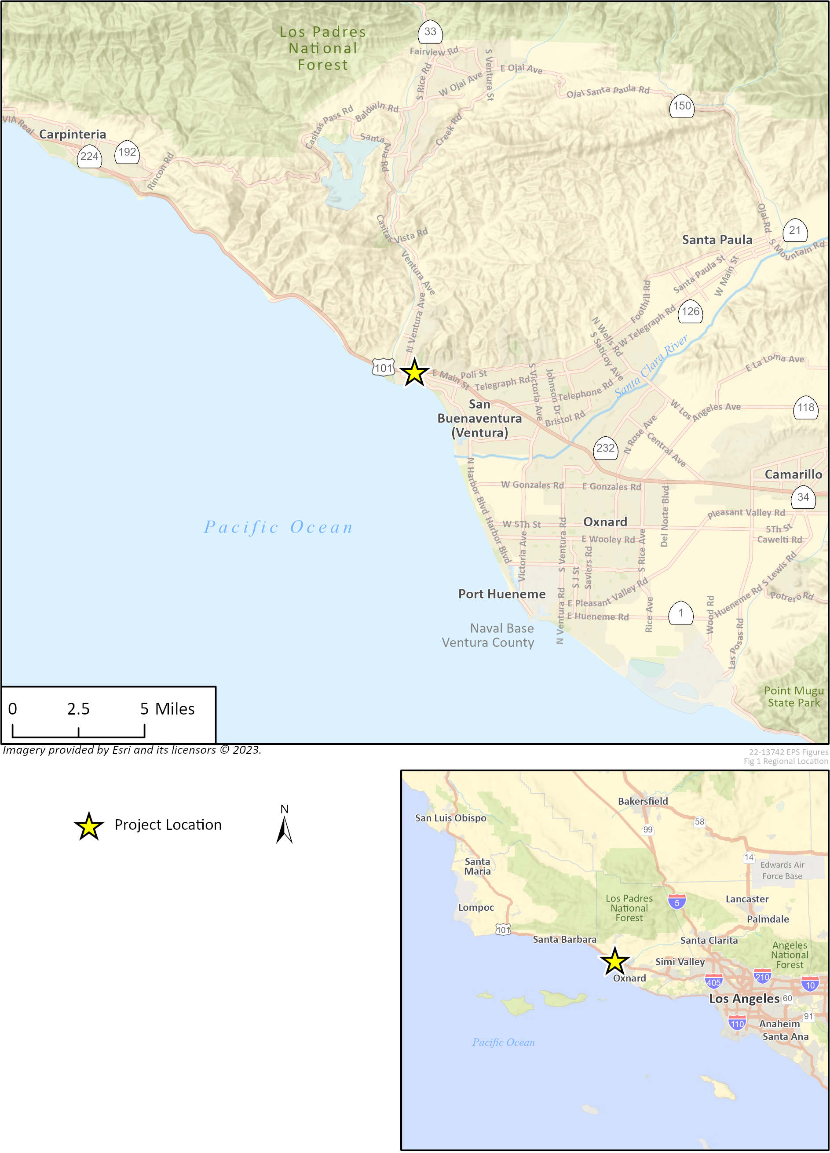

Figure 2 Project Site Location and Characteristics
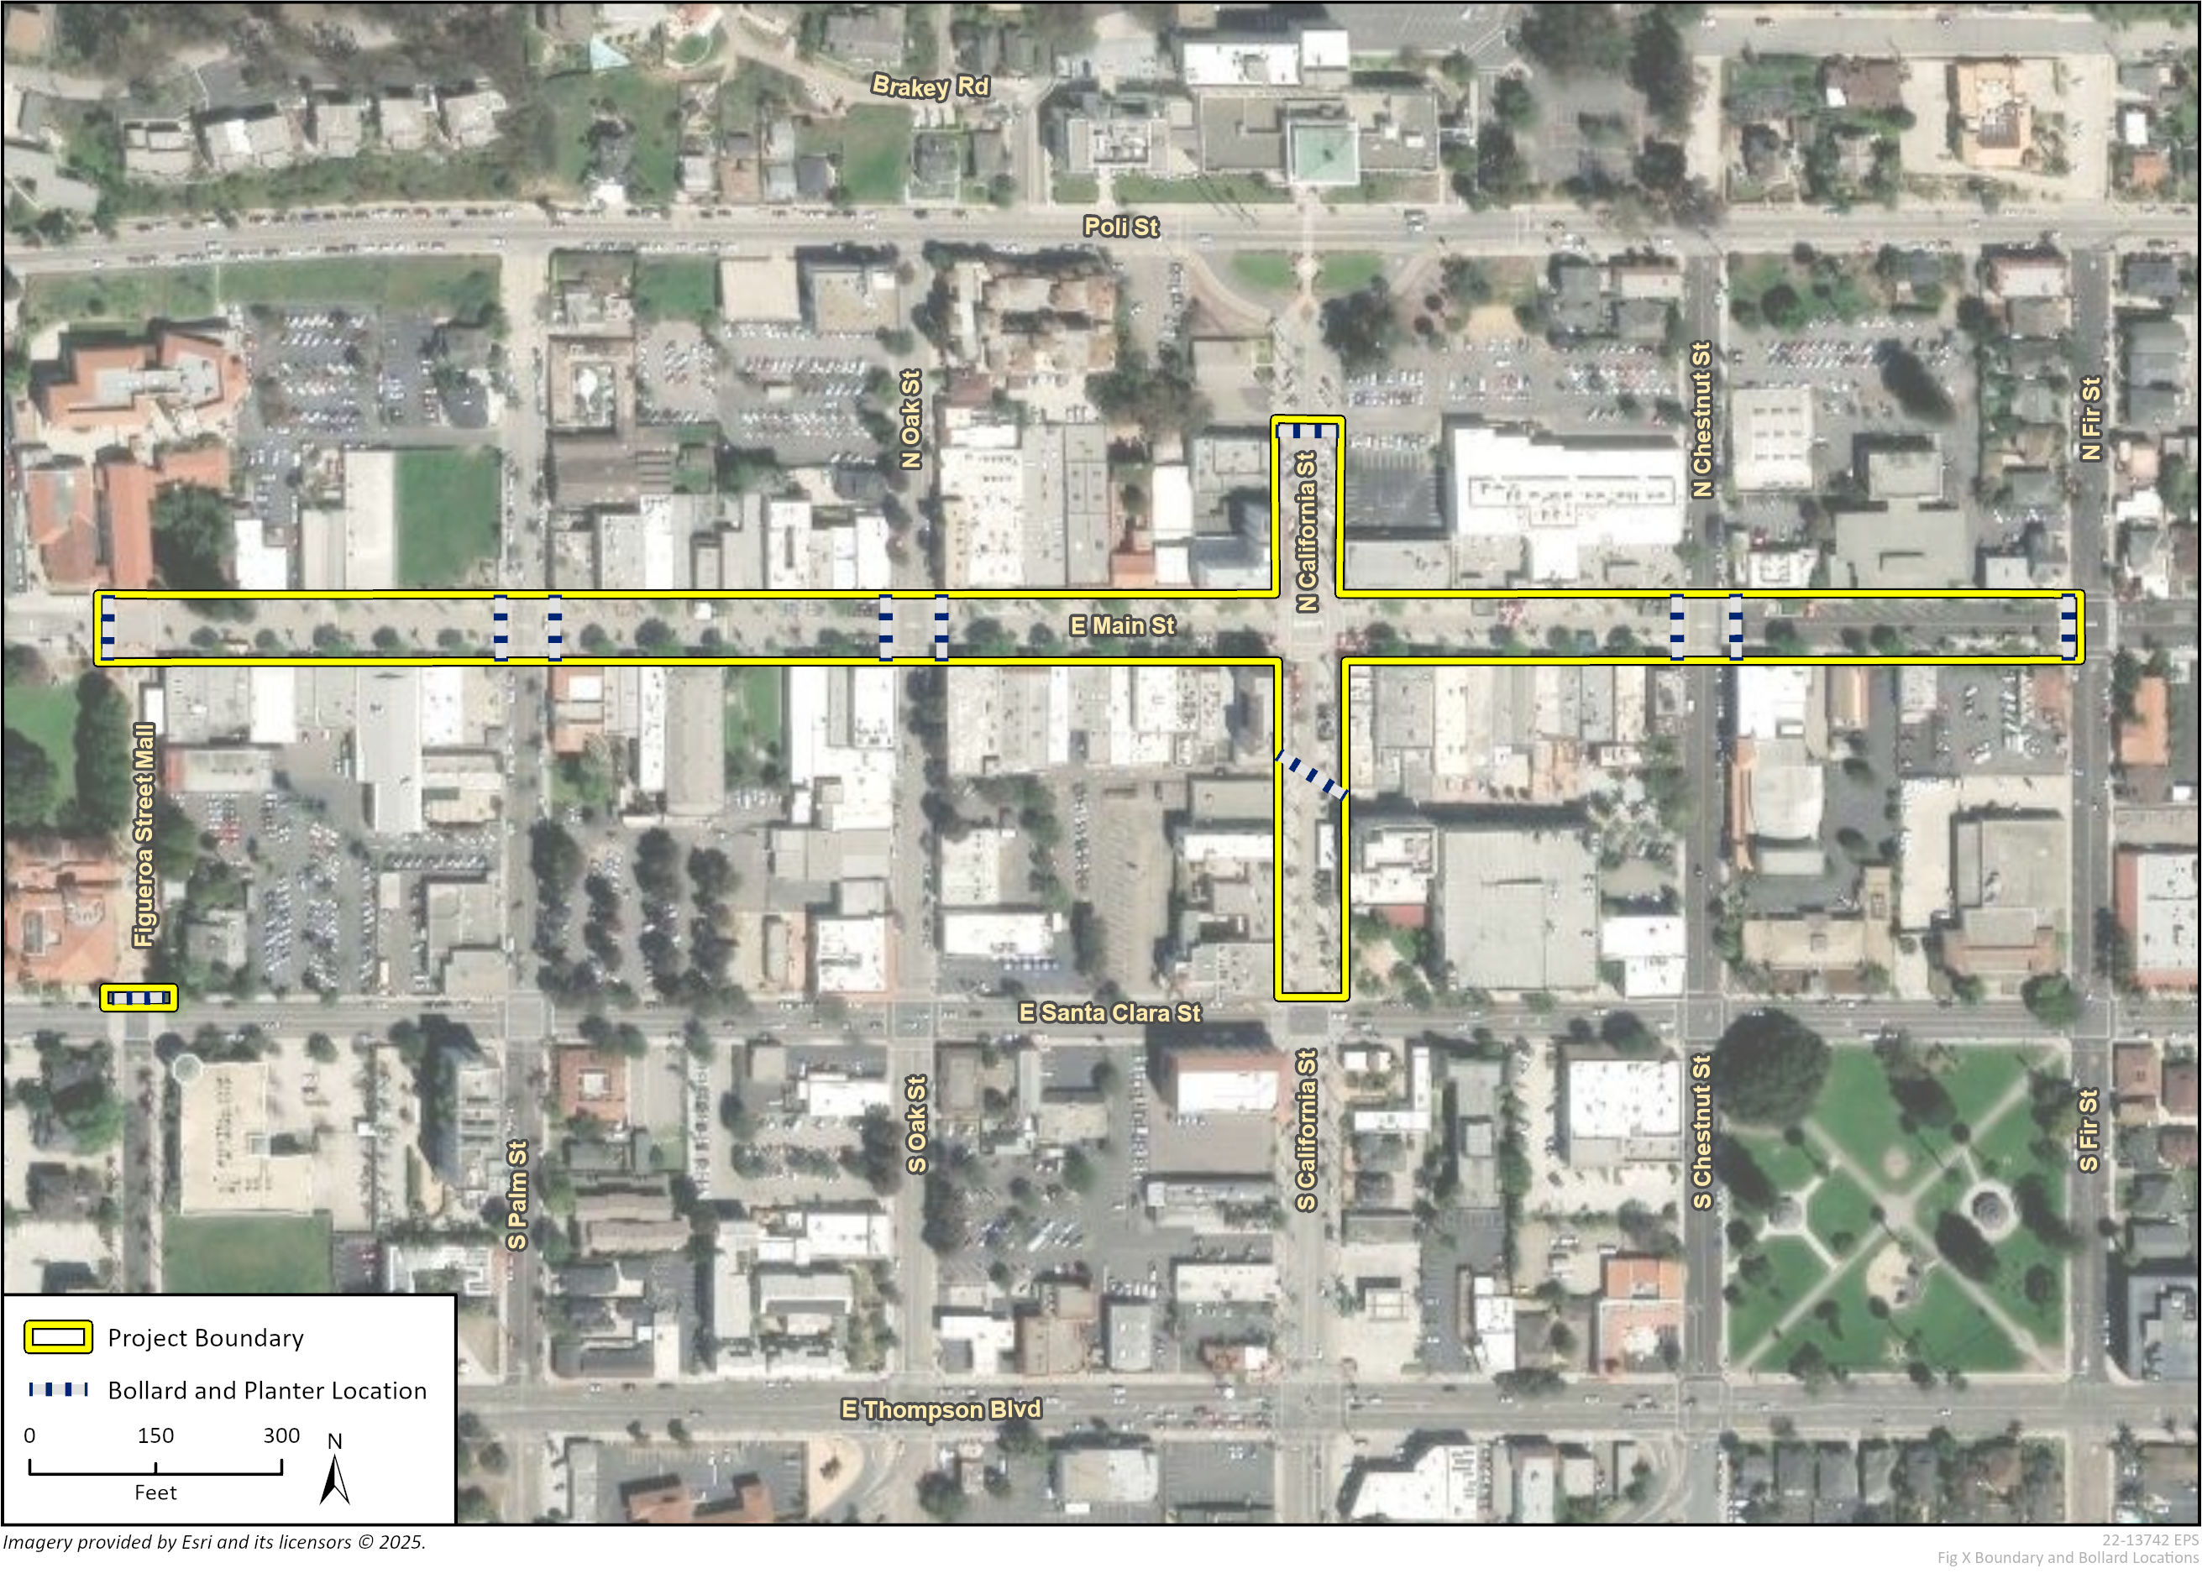

Original Project (Final EIR)
In addition to the proposed roadway closure of Main Street and partial re-opening of South California Street, the Original Project would result in the installation of semi-permanent removeable bollards, semi-permanent lift-assist bollards, and crash-rated planters to limit general traffic flow while accommodating emergency vehicle access. Proposed bollard and planter locations are shown in Figure 2. Installation of the semi-permanent bollards and bollard sleeves was anticipated to result in ground disturbance at a depth of up to 5.5 feet and a width of up to three feet, requiring a total of up to 205 cubic yards of excavation. Existing pavement was expected to be demolished in some places within the project site to allow for construction of the bollard foundations, but overall, the Original Project would retain the existing sidewalk, curb, and gutter configuration.

Modified Project
The City of Ventura is proposing design modifications related to the installation of semi-permanent removeable bollards and semi-permanent lift-assist bollards. This modified project is referred to hereafter as the “Modified Project.” A detailed description of the Modified Project is provided in Section 2, Modified Project Description, of this Addendum.

Basis for the Addendum
When a Final EIR has been adopted and a project is modified or otherwise changed after adoption, additional CEQA review may be necessary. The key considerations in determining the need for the appropriate type of additional CEQA review are outlined in Section 21166 of the Public Resources Code (CEQA) and Sections 15162 and 15164 of the CEQA Guidelines.
Section 15162(a) of the CEQA Guidelines provides that a subsequent EIR is not required unless the following occurs:
(1) Substantial changes are proposed in the project which will require major revisions of the previous EIR or negative declaration due to the involvement of new significant environmental effects or a substantial increase in the severity of previously identified significant effects;
(2) Substantial changes occur with respect to the circumstances under which the project is undertaken which will require major revisions of the previous EIR or Negative Declaration due to the involvement of new significant environmental effects or a substantial increase in the severity of previously identified significant effects; or
(3) New information of substantial importance, which was not known and could not have been known with the exercise of reasonable diligence at the time the previous EIR was certified as complete or the Negative Declaration was adopted, shows any of the following:
(A) The project will have one or more significant effects not discussed in the previous EIR or negative declaration;
(B) Significant effects previously examined will be substantially more severe than shown in the previous EIR;
(C) Mitigation measures or alternatives previously found not to be feasible would in fact be feasible, and would substantially reduce one or more significant effects of the project, but the project proponents decline to adopt the mitigation measure or alternative; or
(D) Mitigation measures or alternatives which are considerably different from those analyzed in the previous EIR would substantially reduce one or more significant effects on the environment, but the project proponents decline to adopt the mitigation measure or alternative.
Pursuant to Section 15164(b) of the CEQA Guidelines, an addendum to an adopted Final EIR may be prepared by the Lead Agency that prepared the original Final EIR if only minor technical changes or additions are necessary or none of the conditions described in Section 15162 have occurred that require preparation of a subsequent EIR. An addendum should include a brief explanation of the agency’s decision not to prepare a subsequent EIR and be supported by substantial evidence in the record as a whole (Section 15164[e]). The addendum to an adopted Final EIR need not be circulated for public review but it may be included in or attached to the adopted Final EIR (Section 15164[c]). The decision-making body must consider the addendum with the Final EIR prior to making a decision on the project (Section 15164[d]).
An addendum to the Final EIR is appropriate to address the Modified Project because the proposed changes to the approved project do not meet the conditions of Section 15162(a) for preparation of a subsequent EIR. As described in Section 2, Modified Project Description, the City proposes to install the same bollard type previously analyzed in the EIR; however, due to site-specific soil conditions that differ from the ideal conditions assumed in the vendor’s typical installation details, the bollard foundations would extend to a greater depth than previously assumed, up to approximately eight feet below ground surface.
As discussed in detail in Section 3, Impact Analysis, the Modified Project would not result in new or more severe impacts related to: 1) substantial changes to the Original Project which requires major revisions to the Final EIR; 2) substantial changes to the circumstances under which the Original Project are being undertaken which will require major revisions to the Final EIR; or 3) new information of substantial importance showing significant effects not previously examined.
The Final EIR and this Addendum serve as informational documents to inform decision-makers and the public of the potential environmental consequences of approving the project. This addendum neither controls nor determines the ultimate decision for approval of the proposed project, described herein in Section 2, Modified Project Description. The information presented in this Addendum to the Final EIR will be considered by the City of Ventura alongside the Final EIR prior to making a decision on the Modified Project through review of revised entitlements.

Modified Project Description

Modified Project Characteristics
The changes proposed under the Modified Project include an increase in the anticipated depth of excavation required for the installation of bollards and bollard sleeves. Under the Original Project analyzed in the Final EIR, installation of the semi-permanent bollards and bollard sleeves was expected to require ground disturbance at a depth of 5.5 feet and a width of up to three feet. The City of Ventura is proposing design modifications related to the installation of semi-permanent removeable bollards and semi-permanent lift-assist bollards. Based on updated engineering specifications, the City now anticipates that bollard foundations would require excavation to a depth of up to eight feet, with the same approximate width of up to three feet. This change would not alter the number or location of bollards, bollard sleeves, or crash-rated planters disclosed in the Final EIR, nor would it affect the overall project footprint, duration of construction, or operational characteristics described in the Final EIR. No other physical changes to related to the project site, project construction, or project operation are proposed.

Retained Original Project Characteristics
The Modified Project would retain all previously approved components of the Main Street Moves Project, including:
- Project Location and Boundaries: The Modified Project site would encompass a five-block portion of East Main Street and California Street, which is approximately 5.4 acres of the downtown Ventura area. Specifically, the project site includes Main Street between Fir Street and Figueroa Plaza; South California Street, from Main Street to the north side of the alleys located south of Main Street; and North California Street, from Main Street to the North California Street parking lot.
- Street Closure Configuration: The Modified Project would involve the full-time, long-term closure of the portions of East Main Street and California Street, as described above, to general vehicular traffic with the goal of facilitating a pedestrian-only environment while maintaining access for emergency vehicles.
- Traffic Signal Modifications: As described in the Final EIR, the Modified Project would involve the removal of signal equipment at the intersections of South California Street and Main Street and Figueroa Plaza and Main Street, as well as the conversion of signals at Chestnut, Oak, and Palm Streets to full-time red flash operation.
- Parking Changes: The Modified Project would involve the permanent removal of up to 171 on-street parking spaces within the project site, supported by the continued availability of nearby public parking facilities.
- Permits and Approvals: A Coastal Development Permit, a building permit for bollard foundations, and an encroachment permit for work within the public right-of-way would all be required, as described in the Final EIR.
- Construction Duration and Methods: Construction of the Modified Project would maintain the proposed construction schedule anticipated in the Final EIR, involving approximately six weeks of construction which would include activities such as pavement demolition, excavation (at an increased depth of what was described in the Final EIR), installation of bollards and planters, and surface restoration.
- Project Objectives: The Modified Project maintains the same objectives as the Original Project. Project objectives are as follows:
  - Enhance downtown vibrancy
  - Create a fun and active destination for residents and visitors
  - Increase accessibility to businesses and fitness opportunities on Main Street for individuals with disabilities by providing a space to enjoy downtown free from vehicular traffic
  - Enhance opportunities for public art
  - Provide a venue for community events (such as the weekly Farmer’s Market)
  - Promote pedestrian activity
  - Support low- and moderate-income residents by providing an attraction and event venue with fitness opportunities in proximity to nearby residences, thus reducing the transportation barriers to participating in community events.
No changes are proposed to the project objectives, design, or operational activities beyond the increased bollard installation depth described in Section 2.1, Modified Project Characteristics.

Impact Analysis
As described under Section 1.2, Basis for the Addendum, when a Final EIR has been adopted and a project is modified or otherwise changed after adoption, additional CEQA review may be necessary. In accordance with the CEQA Guidelines, the City of Ventura has determined that an addendum to the Final EIR is the appropriate form of environmental review for the proposed project modifications. This examination includes an analysis of the provisions of Section 21166 of CEQA and Sections 15162 to 15164 of the CEQA Guidelines and their applicability to the Modified Project.
As discussed in the impact analysis that follows, the Modified Project would not introduce new significant environmental impacts beyond those which have already been identified and characterized in the Final EIR. None of the conditions described in CEQA Guidelines Section 15162 calling for preparation of a subsequent EIR have occurred or would occur as a result of the Modified Project. This addendum will be considered by the Planning Commission and City Council in making a decision on the proposed project modification.
Appendix G of the CEQA Guidelines provides a checklist of 20 environmental issue areas that should be assessed in CEQA analyses. In addition to Appendix G issue areas, the Final EIR analyzed the Original Project’s potential impact to Urban Blight, which refers to the deterioration of urban areas resulting from neglect, disinvestment, or abandonment, and is perceived as run-down buildings, vacant or underutilized lots, and declining infrastructure. Under CEQA Guidelines Section 15131, such effects are not treated as significant environmental impacts unless they lead to physical changes. The key conclusions of the Final EIR are summarized in Section 3.1. Because the existing environmental conditions in the project site and its surroundings remain substantially similar to the environmental conditions described in the Final EIR, the potential environmental effects of the Modified Project are similar to the Original Project for many of the environmental issue areas. Therefore, the Modified Project’s potential environmental effects are discussed at the appropriate level of detail in Section 3.2, to determine whether the potential environmental impacts are consistent with the impact analysis provided in the Final EIR, and whether any additional mitigation would be necessary to minimize or avoid potentially significant environmental impacts.

Final EIR Analysis Summary
The Final EIR determined that the Original Project would result in significant impacts to the following issue areas: Aesthetics, Agriculture and Forestry Resources, Air Quality, Biological Resources, Energy, Geology and Soils, Greenhouse Gas Emissions, Hydrology and Water Quality, Land Use and Planning, Mineral Resources, Noise, Population and Housing, Public Services, Recreation, Utilities and Service Systems, Wildfire, and Urban Blight. The Final EIR concluded that the Original Project would have no impact or less than significant impacts to each of these environmental topics.
The Final EIR determined that the Original Project had the potential to result in significant environmental impacts to the following issue areas: Cultural Resources, Hazards and Hazardous Materials, Transportation, and Tribal Cultural Resources. Impacts to these environmental issue areas would be reduced to a less than significant level with implementation of mitigation measures. Mitigation measures identified in the Final EIR included:
- Cultural Resources and Tribal Cultural Resources. Mitigation Measures CUL-2(a) through CUL-2(d) and TCR-1 require the project developer and contractor(s) to implement archaeological and Native American monitoring during all ground-disturbing activities, to prepare and implement a Cultural Resources Monitoring Plan and avoidance or data recovery procedures if archaeological or tribal cultural resources are discovered, and to conduct Worker Environmental Awareness Program training prior to construction.
- Hazards and Hazardous Materials. Mitigation Measures HAZ-1 requires the preparation and implementation of a Soil Management Plan prior to ground disturbance activities to ensure proper worker safety measures, particularly regarding the handling and disposal of potentially contaminated soils.
- Transportation. Mitigation Measure TRA-3 would require the City of Ventura to modify the configuration of California Street north of Santa Clara Street and south of the proposed closure to be a one-way roadway with one vehicle lane and one bicycle lane to facilitate northbound travel only, and to modify the striping on this portion to allow for angled parking on either side of the roadway.
The Final EIR determined that implementation of these mitigation measures would reduce all of the Original Project’s potentially significant environmental impacts, including cumulative impacts, to a less than significant level. As such, the Final EIR concluded that the Original Project would not result in any significant and unavoidable impacts, and no Statement of Overriding Considerations was required for project approval.

Environmental Impact Analysis of the Modified Project
The Modified Project described in Section 2, Modified Project Description, would include the same project components as the Original Project and would involve similar construction activities as described for the Original Project in the Final EIR. Because the only change between the Original Project and the Modified Project would be the increased depth of excavation required for bollard installation, the Modified Project would disturb the same surface area as was evaluated in the Final EIR and all work would occur within the project boundary evaluated in the previously adopted and certified environmental document. No other features of the Original Project would be altered under the Modified Project. As such, the Modified Project would not change any of the environmental conclusions from the Final EIR, or project-level, or cumulative impacts related to the following environmental topics:
- Aesthetics  - Agriculture and Forestry Resources  - Air Quality  - Biological Resources  - Cultural Resources  - Energy  - Geology and Soils  - Greenhouse Gas Emissions  - Hydrology and Water Quality | - Land Use and Planning  - Mineral Resources  - Noise  - Population and Housing  - Public Services  - Recreation  - Tribal Cultural Resources  - Utilities and Service Systems  - Wildfire
All required mitigation measures from the Final EIR would continue to apply to the Modified Project and would continue to ensure potential environmental impacts would be reduced below the applicable thresholds of significance for those environmental topics. There is no new information indicating that the Modified Project would have new significant impacts or substantially more severe significant impacts with respect to these environmental topics than were identified in the Final EIR. However, given the greater depth of excavation required for bollard installation, there is potential for slightly greater impacts to Cultural Resources, Geology and Soils, Hazards and Hazardous Materials, Hydrology and Water Quality, and Tribal Cultural Resources under the Modified Project. As a result, the following discussion focuses on the potential impacts of the Modified Project on these issue areas.

Cultural Resources
The Final EIR evaluated the potential for project construction activity to encounter or cause a substantial adverse change in the significance of historical cultural resources. The Final EIR included a Cultural Resources Assessment, which identified two historic districts that encompass portions of the project site and areas immediately surrounding the project site: the Mission Historic District and the Main Street Commercial Historic District.
The Final EIR found that although the existence of the Main Street right-of-way through the Mission and Main Street Commercial Historic Districts aids in defining their character to an extent, the presence of the roadway corridor, as opposed to its materials and detailing, is that which is defining. Given the change within the historic districts over time, and because elements proposed by the project would be consistent with the urban environment that currently comprises both historic districts, the Final EIR determined these resources would not be significantly altered or impaired by the Original Project. Furthermore, aboveground elements of the Original Project are considered semi-permanent and could be removed with little, if any, permanent visual change to the area. Given that above-ground components of the Modified Project would generally be the same as the Original Project, impacts to historical cultural resources would remain less than significant.
The Final EIR determined that ground-disturbing activities could affect archaeological resources due to the presence of known cultural sensitivity within the Mission Historic District. The Final EIR also determined that ground disturbance at depths up to 5.5 feet would have the potential to encounter buried resources, which could cause a substantial adverse change to the significance of a known historical resource (the Mission Historic District; P-56-150222) and its potential contributors (CA-VEN-1071H and P-56-152846), as well as previously unknown and intact archaeological resources that may exist within the project site. The Final EIR concluded that the project’s potential to cause a substantial adverse change in the significance of an archaeological resource was potentially significant and required mitigation.
Under the Modified Project, the City proposes to use install the same bollard type previously analyzed in the EIR; however, due to site-specific soil conditions that differ from the ideal conditions assumed in the vendor’s typical installation details, the bollard foundations would extend to a greater depth than previously assumed, up to approximately eight feet below ground surface. Given that the Modified Project would involve the same ground-disturbing activities but to a greater depth, the additional ground disturbance would increase the likelihood of uncovering previously unknown and intact archaeological resources. Although the likelihood of encountering an archaeological resource would be slightly increased, the nature of the construction activities, including excavation tools and methods, under the Modified Project would remain the same as the Original Project. Archaeological resources encountered during construction of the Modified Project would be subject to the same treatment and protection measures required for the Original Project. Therefore, the Modified Project would not substantially increase the severity of impacts related to cultural resources. Furthermore, consistent with the Final EIR, the Modified Project would incorporate the following mitigation measures:

Mitigation Measures
- CUL-2(A): Project Avoidance Measures within Mission Historic District (P-56-150222)
- CUL-2(B): Workers Environmental Awareness Program Training
- CUL-2(C): Development and Implementation of Cultural Resources Monitoring Plan
- CUL-2(D): Archaeological and Native American Monitoring
Implementation of Mitigation Measure CUL-2(a) would reduce impacts to known archaeological resources associated with the Mission Historic District to a less-than-significant level by avoiding ground disturbance below the existing road base layer to the extent feasible, thereby protecting the resources in place. If avoidance of these known archaeological resources is infeasible, Mitigation Measure CUL-2(c) would reduce potential impacts to known archaeological resources associated with the Mission Historic District by developing and implementing a Cultural Resources Monitoring Plan to identify, document, and treat archaeological resources encountered during construction.
Implementation of Mitigation Measures CUL-2(b) and CUL-2(d) would reduce potential impacts to unknown archaeological resources throughout the project site to a less-than-significant level by requiring archaeological sensitivity training for all construction personnel prior to the commencement of any ground-disturbing activities, ensuring archaeological and Native American monitoring of all project-related, ground-disturbing activities within the project site, and developing and implementing a Cultural Resources Monitoring plan to identify, document, and treat archaeological resources encountered during construction.
With implementation of the mitigation measures listed above and described in Section 4.3, Cultural Resources, of the Final EIR, the Modified Project would have a less than significant impact on cultural resources. Therefore, the Modified Project would not substantially increase the severity of the Original Project’s impacts and would have a similar impact to cultural resources as the Original Project.

Geology and Soils
The Final EIR evaluated potential impacts to geology and soils associated with the installation of semi-permanent bollards and bollard sleeves, which were anticipated under the Original Project to require excavation to a depth of 5.5 feet. Specifically, the Final EIR analyzed the Original Project’s potential to directly or indirectly destroy a unique paleontological site or unique geologic feature. The Final EIR determined that the Original Project would not have any potential to cause a significant impact related to the risk of loss, injury, or death involving rupture of a known earthquake fault, strong seismic ground shaking, liquefaction, or landslides. The Final EIR also determined that the Original Project would not result in substantial erosion or loss of topsoil, be located on an unstable geologic unit that could result in landslide lateral spreading, subsidence, liquefaction, or collapse, or be located on expansive soils or soils incapable of adequately supporting the use of septic tanks or alternative wastewater disposal systems. As such, these significance thresholds were not analyzed in detail in the Final EIR, and were instead discussed in Section 4.14, Effects Found Not to be Significant.
The Final EIR determined that the project site consists of previously disturbed urban soils with paved roadway areas that do not contain unique geologic resources or paleontological resources. The Final EIR concluded that the ground-disturbing activities required by construction of the Original Project, such as excavation for bollard installation, would disturb sediments with low paleontological sensitivity. Under the Modified Project, the City proposes to install the same bollard type previously analyzed in the EIR; however, due to site-specific soil conditions that differ from the ideal conditions assumed in the vendor’s typical installation details, the bollard foundations would extend to a greater depth than previously assumed, up to approximately eight feet below ground surface. Although the Modified Project would disturb sediments at a greater depth than was previously analyzed under the Original Project, the active alluvial fan deposits underlying the project site have low paleontological sensitivity from the ground surface to 10 feet below the surface. In addition, the nature of the construction activities, including excavation tools and methods, under the Modified Project would remain the same as the Original Project. Therefore, the excavations at depths of up to eight feet under the Modified Project would have a similar level of impact to the Original Project, as excavations would impact a small volume of sediment with low paleontological sensitivity, and construction activities would be unlikely to encounter paleontological resources. Therefore, the Modified Project would have a less than significant impact regarding direct or indirect impacts to unique paleontological resources or geologic features.

Hazards and Hazardous Materials
The Final EIR determined that the installation of proposed semi-permanent bollards would require the excavation and transport of paving materials (e.g. asphalt, concrete, roadbed fill materials) and soils, which could possibly be contaminated by vehicle-related pollution (e.g. oil, gasoline, diesel, and other automotive chemicals). In addition, roadways constructed before the 1970s were known to use asbestos-containing materials in asphalt and lead based paint for roadway markings. Therefore, the existing pavement may contain asbestos and/or lead based paint due to its age. Yellow paint striping may also contain metals, such as lead and chromium, that require special handling and disposal. Operation of the Modified Project would be the same as was described in the Final EIR, and would have no impact related to the routine transport, use, or disposal of hazardous materials or the release of hazardous materials due to reasonably foreseeable upset or accident conditions during project operation.
There are three closed Leaking Underground Storage Tank sites adjacent to the project site. While ground disturbance would not occur in these locations, the Final EIR determined that there is a possibility that contamination from these former sites has migrated through soil and could be present in soils where ground disturbance is anticipated to occur. Therefore, ground disturbance associated with bollard installation could have the potential to create a significant hazard to the public or environment. Under the Modified Project, the City proposes to install the same bollard type previously analyzed in the EIR; however, due to site-specific soil conditions that differ from the ideal conditions assumed in the vendor’s typical installation details, the bollard foundations would extend to a greater depth than previously assumed, up to approximately eight feet below ground surface. Given that the Modified Project would involve similar ground-disturbing activities to a greater depth than what was anticipated under the Original Project, ground disturbance associated with the Modified Project would have a similar but slightly greater risk of creating a significant hazard to the public or environment due to the additional earth work and soil movement required at greater depths of excavation. An increase in the amount of soil movement associated with the greater excavation depth would increase the likelihood of encountering migrated contamination from former Leaking Underground Storage Tank sites. However, construction activities for excavation under the Modified Project would be the same as the Original Project, and the Modified Project would continue to comply with all applicable regulations described in the Final EIR. Furthermore, consistent with the Final EIR, the Modified Project would incorporate the following mitigation measures:

Mitigation Measures
- HAZ-1: Soil Management Plan
Implementation of Mitigation Measure HAZ-1 would require the City to retain a qualified consultant to prepare a Soil Management Plan prior to commencement of ground-disturbing activities. The Soil Management Plan would establish remedial measures and soil management practices to ensure construction worker safety and prevent the off-site migration of contaminants from the project site. The City would be required to review and approve the Soil Management Plan prior to construction activities and the issuance of grading permits, and would be responsible for implementing the Soil Management Plan during grading and construction at the project site.
Although the Modified Project would slightly increase the likelihood of encountering contaminated soils compared to the Original Project, the Modified Project would not have a substantially greater risk of creating a significant hazard to the public or environment through the routine transport, use, or disposal of hazardous materials, or reasonably foreseeable accident and upset conditions, as implementation of Mitigation Measure HAZ-1 would ensure that potential hazardous materials encountered during construction would be properly transported and disposed of, reducing impacts to a less-than-significant level. Therefore, the Modified Project would not substantially increase the severity of the Original Project’s impacts and would have a similar impact related to hazards and hazardous materials.

Hydrology and Water Quality
The Final EIR determined that the Original Project would have a less than significant impact on all Appendix G significance thresholds related to Hydrology and Water Quality. As such, the Original Project’s impacts to Hydrology and Water Quality resources were not analyzed in detail in the Final EIR, and instead were discussed in Section 4.14, Effects Found Not to be Significant.
Construction activities under the Original Project and the Modified Project would be limited to pavement demolition, excavation, and re-paving associated with installation of the semi-removable bollards, bollard sleeves, and planters. As described in the Final EIR, potential pollutants in runoff from construction activities that could affect surface or groundwater quality include sediment and contaminants such as nutrients, pesticides, trace metals, and hydrocarbons, as well as fluids used for equipment operation. The Final EIR determined that construction compliance with the Ventura Countywide Stormwater Quality Management Program and San Buenaventura Municipal Code Chapter 8.600, Stormwater Quality Management, which would require the implementation of best management practices and design features to control stormwater runoff from the project site, would reduce construction impacts related to the violation of water quality standards or discharge requirements to a less than significant level. In addition, the Final EIR concluded that the direct contamination of surface water is unlikely due to the project site’s distance to the nearest bodies of water. As described in Section 2, Modified Project Description, the City of Ventura is proposing design modifications related to the installation of semi-permanent removeable bollards and semi-permanent lift-assist bollards, which would require excavation at a greater depth than what was analyzed in the Final EIR. However, the Modified Project would include the same construction activities and similar overall footprint as the Original Project. Therefore, the Modified Project would have a similar impact related to the degradation of surface or groundwater quality compared to the Original Project, and this impact would be less than significant.
In addition, the Final EIR analyzed the Original Project’s potential to substantially decrease groundwater supplies or recharge such that the project may impede sustainable groundwater management of the basin and the potential to substantially alter the existing drainage pattern of the project site. Construction of both the Original Project and the Modified Project would require small quantities of water for dust suppression, and small quantities of water would be required during operation of the project for occasional landscaping activities, such as watering of landscaping within the crash-rated planters. The Modified Project would involve deeper excavation than analyzed in the Final EIR, which would result in a minor increase in the amount of water used in construction. However, neither the Original nor the Modified Project would involve development that would necessitate permanent water supply such that groundwater supplies would be substantially increased. Although the Modified Project would require excavation to a greater depth than analyzed in the Final EIR, increased ground disturbance would not pose a risk of encountering groundwater. The project site is underlain by the Mound Groundwater Basin and is located in the western portion of the basin. The Mound Basin Groundwater Sustainability Plan indicates that groundwater elevations in the western basin range from approximately -20 to +40 feet mean sea level (msl). Ground surface elevations around the project site are approximately +30 feet msl. Therefore, groundwater at the project site is expected to be present approximately 20 to 50 feet below ground surface, substantially below the depth of excavation proposed for the Modified Project. Neither the Original nor Modified Project would interfere substantially with groundwater recharge or existing drainage patterns, as the project site is an existing paved area, and project implementation would not result in an increase of impervious surfaces.
The Final EIR also analyzed the Original Project’s potential to release pollutants in a flood hazard, tsunami, or seiche zone or to conflict with or obstruct implementation of a water quality control plan or sustainable groundwater management plan. The project site is located within an “area of minimal flood hazard” (Zone X) as defined by flood map number 06111C0743F, effective January 29, 2021. In addition, the Original Project site is not located within a tsunami zone, nor is it located within or near an inland body of water that could experience a seiche. The Modified Project would occur on the same site and involve similar construction and operational activities. Therefore, no impacts related to inundation or flood flows would occur. The project site is underlain by the Mound Groundwater Basin, which is regulated by the Mound Basin Groundwater Sustainability Plan. The Final EIR concluded that since the Original Project would not involve physical development beyond installation of bollards, bollard sleeves, and planters, the development facilitated by the Original project would not conflict with or obstruct implementation of the Mound Basin Groundwater Sustainability Plan. Construction of the Modified Project would generally be the same as was anticipated for the Original Project, except that bollard installation may require excavation up to a depth of eight feet rather than the depth of 5.5 feet that was analyzed in the Final EIR. Aside from the increased depth of excavation that may be required, construction and operation of the Modified Project would be similar to what was analyzed for the Original Project. Therefore, development of the Modified Project would not conflict with or obstruct implementation of the Mound Basin Groundwater Sustainability Plan.
Construction of the Modified Project would result in a negligibly larger volume to be excavated compared to the Original Project, and operation of the Modified Project would be the same as was described by the Final EIR. The nature of the construction activities, including excavation tools and methods, under the Modified Project would remain the same as the Original Project. Given that the only change between the Original and Modified Projects is the increased depth of excavation, the Modified Project would not substantially increase the severity of the Original Project’s impacts and would have similar impact to hydrology and water quality as the Original Project.

Tribal Cultural Resources
The Final EIR evaluated the potential for project construction activity to cause a substantial adverse change in the significance of a Tribal Cultural Resource. Both the Original Project and the Modified Project would involve the installation of semi-permanent removable bollards, bollard sleeves, and crash-rated planters to restrict general traffic flow in a five-block portion of Main Street and California Street. The Final EIR concluded that no specific Tribal Cultural Resources have been identified within the project site during the Original Project’s AB 52 consultation process. However, given the known archaeological sensitivity of the area, project-related, ground-disturbing activities have the potential to encounter previously undiscovered cultural resources of Native American origin that could be considered Tribal Cultural Resources. As described in the Final EIR, impacts to Tribal Cultural Resources are highly dependent on the nature of the resource but, in general, could occur if there is destruction or alteration of the resource and its surroundings, restricted access to the resource, or other disturbances.
The Modified Project would involve the same ground-disturbing activities as were described for the Original Project in the Final EIR. However, under the Modified Project, the City of Ventura is proposing design modifications related to the installation of semi-permanent removeable bollards and semi-permanent lift-assist bollards, which would require excavation at a greater depth than what was analyzed in the Final EIR. Under the Modified Project, bollard installation may require excavation to a depth of eight feet, which is 2.5 feet deeper than what was anticipated for the Original Project. Although the likelihood of encountering unknown and intact cultural resources of Native American origin that could be considered Tribal Cultural Resources would be slightly increased, the nature of the construction activities, including excavation tools and methods, under the Modified Project would remain the same as the Original Project. Tribal Cultural Resources encountered during construction of the Modified Project would be subject to the same treatment and protection measures required for the Original Project. Therefore, the Modified Project would not substantially increase the severity of impacts related to Tribal Cultural Resources.
Furthermore, consistent with the Final EIR, the Modified Project would incorporate the following mitigation measures:

Mitigation Measures
- CUL-2(D): Archaeological and Native American Monitoring
- TCR-1: Inadvertent Discovery of Tribal Cultural Resources
Implementation of Mitigation Measures CUL-2(D) and TCR-1 would ensure that consultation with local Native Americans would occur if resources of Native American origin are unearthed during construction, and that implementing a mitigation plan would be required if a previously unknown Tribal Cultural Resource is discovered during project construction. Implementation of Mitigation Measures CUL-2(D) and TCR-1 would ensure that the Modified Project would have a less than significant impact on Tribal Cultural Resources. Upon completion of construction activities, ground-disturbing activities would cease, and project operation would not substantially increase the severity of impacts to Tribal Cultural Resources. Therefore, the Modified Project would not substantially increase the severity of the Original Project’s impacts and would have a similar impact to Tribal Cultural Resources as the Original Project.

Cumulative Effects
A project’s environmental impacts are “cumulatively considerable” if the “incremental effects of an individual project are significant when viewed in connection with the effects of past projects, the effects of other current projects, and the effects of probable future projects” (CEQA Guidelines Section 15065[a][3]). The Final EIR determined that implementation of required mitigation measures (listed above in Section 3.2) would reduce all of the project’s potentially significant environmental impacts, including cumulative impacts, to a less than significant level.
Because the Modified Project would disturb a similar area to what was evaluated in the Final EIR, would occur within the project boundary evaluated in the previously adopted and certified environmental documentation, and would continue to implement all required mitigation measures for temporary impacts from the Final EIR, the modified project would not change any of the environmental conclusions from the Final EIR, or otherwise result in any new or substantially more severe cumulative impacts compared to those disclosed in the Final EIR.

Conclusion
As discussed in Section 3, Impact Analysis, there are no new or substantially more severe impacts associated with the modified project than those identified and mitigated for in the Final EIR. Implementation of mitigation measures required in the Final EIR would continue to be required as part of the Modified Project. With the implementation of required mitigation, the modified project would not result in a new significant environmental effect, or a substantial increase in the severity of previously identified effects. The modified project does not involve any substantial changes that require major revisions to the Final EIR.
This conclusion is consistent with the environmental analysis and conclusions presented in the Final EIR. Therefore, the project is consistent with the requirements of Sections 15162 and 15164 of the CEQA Guidelines, and a subsequent EIR is not required, because no new impacts or impacts of substantially greater severity than previously described would occur as a result of the modified project. Therefore, the following determinations have been made:
- No further evaluation of environmental impacts is required for the modified project;
- No subsequent EIR is necessary per CEQA Guidelines Section 15162; and
- This addendum is the appropriate level of environmental analysis and documentation for the proposed project in accordance with CEQA Guidelines Section 15164.
Pursuant to CEQA Guidelines Section 15164(c), this addendum will be included in the public record for the Final EIR. Documents related to this addendum will be available on the City of Ventura’s website at https://www.cityofventura.ca.gov/.

List of Preparers
This addendum was prepared by Rincon Consultants, Inc. under contract to the City of Ventura. Persons and firms involved in data gathering, analysis, project management, and quality control include:

City of Ventura
Rachel Dimond, Community Development Director
Alejandro Puga, P.E., Senior Transportation Engineer
AJ Bernhardt, Senior Planner

Rincon Consultants, Inc.
Megan Jones, MPP, Principal
Taylor Freeman, MEERM, Senior Environmental Planner
Ryan Perry, Environmental Planner
Augusta Boyer, GIS Analyst
Debra Jane Seltzer, Formatting Specialist

The City of Ventura is in the process of preparing a Coastal Development Permit that will cover both the installation of bollards and future parklet construction within the roadway. In April 2024, the Ventura City Council approved a Categorical Exemption pursuant to CEQA Guidelines Sections 15303, 15304, and 15311 for the Main Street Moves License Agreement and Fee Structure Program, which allowed for ministerial approval of parklets on Main Street and California Street (refer to Section 1.3, Background, of Chapter 1, Introduction, from the Final EIR for additional information). This EIR Addendum is not intended to provide additional environmental clearance for the License Agreement and Fee Structure Program.
Bedrossian, T.L., C.A. Hayhurst, and P.D. Roffers. 2010. “Geologic compilation of Quaternary surficial deposits in southern California: onshore portion of the Santa Barbara 30’ x 60’ quadrangle.” [map.] California Geological Survey. CGS Special Report 217, Plate 17, scale 1:100,000.
State Water Resources Control Board. 2025. GeoTracker. https://geotracker.waterboards.ca.gov/map/?CMD=runreport&myaddress=ventura. Accessed November 2025.
Mound Basin Groundwater Sustainability Agency. 2021. Mound Basin Groundwater Sustainability Plan. https://cawaterlibrary.net/wp-content/uploads/2022/05/Part-1_MBGSA_GSP_FINAL_FULLREPORT_20211214-1-2.pdf. Accessed December 2025.
United States Geological Survey. 2022, Ventura, CA 7.5-Minute Topographic Quadrangle, Scale 1:24:000. https://ngmdb.usgs.gov/topoview/viewer/#17/34.28044/-119.29363. Accessed December 2025.
Depth to Groundwater= Ground Surface Elevation-Groundwater Elevation.
Federal Emergency Management Agency. 2021. FEMA Flood Map Service Center. https://msc.fema.gov/portal/search?AddressQuery=e%20main%20street%20and%20california%20ave%2C%20ventura%2C%20CA. Accessed November 2025.
California Geological Survey. 2022. California Tsunami Maps [map]. https://maps.conservation.ca.gov/cgs/informationwarehouse/ts_evacuation/. Accessed November 2025.
Mound Basin Groundwater Sustainability Agency. 2021. Mound Basin Groundwater Sustainability Plan. https://s33630.pcdn.co/wp-content/uploads/2021/10/1_MBGSA_GSP_DRAFT_TEXT_20211020.pdf. Accessed November 2025.

