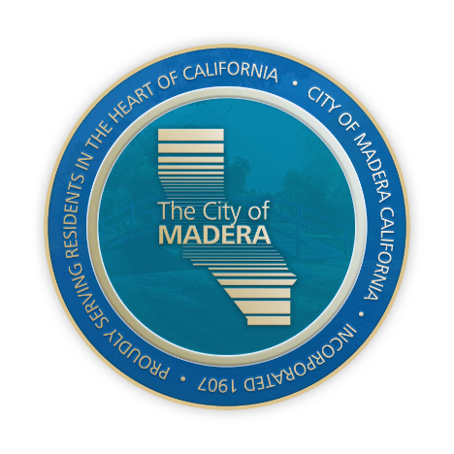
PLANNING DEPARTMENT

Will Tackett, Community Development Director

CITY OF Madera

NOTICE OF INTENT TO ADOPT A MITIGATED NEGATIVE DECLARATION

NOTICE IS HEREBY GIVEN that the City of Madera (City), as the Lead Agency, plans to adopt a Mitigated Negative Declaration (MND) and Mitigation Monitoring and Reporting Program (MMRP) for Vesting Tentative Map 2022-02, and Precise Plan (PPL) 2024-03 (collectively, the “Project”) pertaining to ±7.7-acres of property located on the southeast corner of the intersection of Adell Street and North D Street (the “project site”).

These applications have been filed to facilitate a Planned Development subdivision of an ±7.7-acre portion of the project site (APNs 004-170-009 and 004-170-010) into 51 lots for single-family residential use PPL 2024-03; TSM 2022-02.

Pursuant to the California Environmental Quality Act (CEQA), an Initial Study/MND has been prepared, describing the degree of potential environmental impacts of the proposed Project. The site has been reviewed in accordance with Government Code Section 65962.5 and is not listed as a hazardous waste or materials site. The City has assessed the potential environmental impacts of this Project and has determined that the impacts will either be less than significant or less than significant with mitigation measures incorporated. Copies of the Initial Study and proposed Mitigated Negative Declaration are on file and available for public review at the City of Madera Planning Department, 205 West 4th Street, Madera, CA 93637. A copy of the Initial Study and proposed Mitigated Negative Declaration can also be found at www.madera.gov/home/departments/planning/#tr-current-projects-environmental-review-436011.The public review period during which the City will receive comments on the proposed Mitigated Negative Declaration will begin on June 8, 2024 and will close 4:00 PM on July 1, 2024. Comments shall be submitted in writing and addressed to Robert Smith, Senior Planner at the City of Madera Planning Department, 205 West 4th Street, Madera, CA 93637 or at rsmith@madera.gov. For additional information, please contact Robert Smith at (559) 662-4916 or by email at rsmith@madera.gov, or visit the website address noted above.

A public hearing to consider the Project and the accompanying MND and MMRP is tentatively scheduled for Planning Commission on Tuesday, July 9, 2024, at 6:00 pm. Hearing information can be found at http://www.madera.gov/home/departments/planning/agendas-minutes/.

