
NOTICE OF PUBLIC HEARING

AND

INTENT TO ADOPT A MITIGATED NEGATIVE DECLARATION

TIME OF HEARING: 6:00 p.m. or as soon as possible thereafter.
DATE OF HEARING: June 26, 2024
PLACE OF HEARING: MENIFEE CITY COUNCIL CHAMBERS

29844 HAUN ROAD MENIFEE, CA 92586
A PUBLIC HEARING has been scheduled, pursuant to the City of Menifee Municipal Code, before the CITY OF MENIFEE PLANNING COMMISSION to consider the project shown below:

Project Title:  MAJOR PLOT PLAN No. PLN21-0375, GENERAL PLAN AMENDMENT NO. PLN21-0376 and CHANGE OF ZONE No. PLN21-0377 for Villagio Villas Apartment Building Addition  Project Location:  The site is located south of McCall Boulevard and east of Interstate 215 at the southern terminus of Encanto Drive (APN: 336-030-016).  Existing General Plan Land Use / Zoning:  None (ROW)  Proposed General Plan Land Use:  20.1 – 24 du/ac Residential  Proposed Zoning:  High Density Residential (HDR)  The Planning Commission will consider making a recommendation on the following project at a public hearing: | 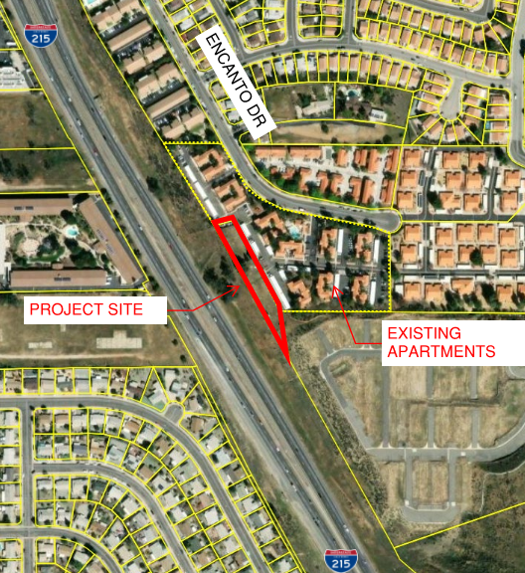
Plot Plan (PP) No. PLN21-0375 proposes two new 2-story apartment buildings totaling 22,588 square feet at an existing apartment complex (“Villagio Villas”) located at the terminus of Encanto Drive. Each building proposes 12 units (24 total) bringing the total number of units within the Villagio Villas apartment complex to 120 units (96 existing). The project site is approximately 0.82 and total site area is approximately 6.99-acres when including the existing apartment site. The project includes approximately 21,000 square feet of newly landscaped area.

General Plan Amendment (GPA) PLN21-0376 and Change of Zone (CZ) PLN21-0377 is required as the proposed project location was previously owned by Caltrans and had no Zoning or General Plan Land Use designations. The proposed General Plan Land Use density is 20.1-24 du/ac with a Zoning designation of High Density Residential both of which are consistent with nearby land uses.

Environmental Information:
Public Review Period: May 20, 2024 – June 18, 2024
The City of Menifee Community Development Department has determined that the above project will not have a significant effect on the environment and has recommended adoption of a Mitigated Negative Declaration. The Menifee Planning Commission will consider the proposed project and the proposed Mitigated Negative Declaration at the public hearing. In addition, the project site is not included on a list of hazardous materials sites compiled pursuant to Government Code Section 65962.5 (California Department of Toxic Substances Control list of various hazardous sites).
The IS/MND is being circulated for a review period pursuant to State law. All comments on the IS/MND must be submitted in writing to the address or e-mail provided below and received no later than Tuesday, June 18, 2024. The IS/MND can be found at the following web address: http://www.cityofmenifee.us/325/Environmental-Notices-Documents.

Any person wishing to comment on the proposed project may do so in writing between the date of this notice and the public hearing and be heard at the time and place noted above. All comments must be received prior to the time of public hearing. All such comments will be submitted to the Planning Commission, and the Planning Commission will consider such comments, in addition to any oral testimony, before making a decision on the proposed project.

If this project is challenged in court, the issues may be limited to those raised at the public hearing, described in this notice, or in written correspondence delivered to the Planning Commission at, or prior to, the public hearing. Be advised that as a result of public hearings and comment, the Planning Commission may amend, in whole or in part, the proposed project. Accordingly, the designations, development standards, design or improvements, or any properties or lands within the boundaries of the proposed project, may be changed in a way other than specifically proposed.

For further information regarding this project, please contact Russell Brown, at (951) 723-3745 or e-mail rbrown@cityofmenifee.us, or go to the City of Menifee’s agenda web page at http://www.cityofmenifee.us. To view the case file for the proposed project contact the Community Development Department office at (951) 672-6777 Monday through Friday, from 8:00 A.M. to 5:00 P.M. Please send all written correspondence to:

CITY OF MENIFEE COMMUNITY DEVELOPMENT DEPARTMENT
Attn: Russell Brown, Senior Planner 29844 Haun Road
Menifee, CA 92586

