
NOTICE OF PUBLIC HEARING

AND

INTENT TO ADOPT A NEGATIVE DECLARATION

TIME OF HEARING: 6:00 p.m. or as soon as possible thereafter.
DATE OF HEARING: June 12, 2024
PLACE OF HEARING: MENIFEE CITY COUNCIL CHAMBERS

29844 HAUN ROAD MENIFEE, CA 92586
A PUBLIC HEARING has been scheduled, pursuant to the City of Menifee Municipal Code, before the CITY OF MENIFEE PLANNING COMMISSION to consider the project shown below:

Project Title:  HOME2SUITES – Plot Plan (PP) No. PLN23-0069 and Conditional Use Permit (CUP) No. PLN23-0070  Project Location:  The project site is located east of Interstate 215, west of Antelope Road, south of Newport Road and north of La Piedra Road (APN: 364-010-015).  General Plan Land Use and Zoning:  Menifee Village Specific Plan (SP No. 158)  The Planning Commission will consider the following project at a public hearing: | 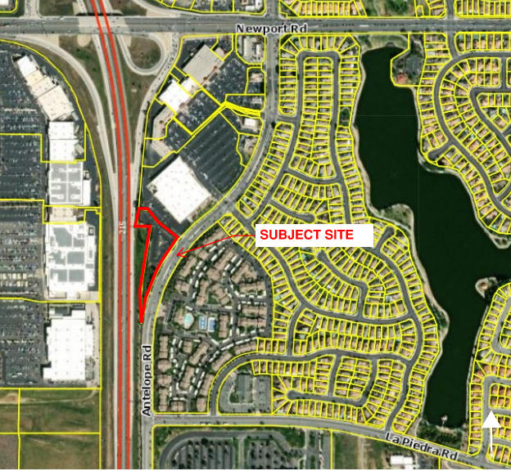
Plot Plan No. PLN23-0069 proposes a 4-story, 65,463 square foot hotel, consisting of 106-rooms located behind (or to the south) of Living Spaces within the Menifee Village Shopping Center. The existing approx. 2-acre site has partial improvements consisting of an overflow parking lot and associated landscaping that serve the existing retail shopping center to the north. The project proposes 106 parking spaces, 46 of which are located within the existing shopping center project site via reciprocal parking. The project site is part of the Menifee Village Specific Plan (SP No. 158).

Conditional Use Permit No. PLN23-0070 is proposed as the maximum height allowed is 35-feet per the applicable development standards of the specific plan. The current proposal includes a maximum height of approximately 54’3”. The maximum height limit may be increased per Section 18.34 of Ordinance 348.

Environmental Information:
Public Review Period: May 15, 2024 – June 3, 2024
The City of Menifee Community Development Department has determined that the above project will not have a significant effect on the environment and has recommended adoption of a Negative Declaration. The Menifee Planning Commission will consider the proposed project and the proposed Negative Declaration at the public hearing. In addition, the project site is not included on a list of hazardous materials sites compiled pursuant to Government Code Section 65962.5 (California Department of Toxic Substances Control list of various hazardous sites).
The IS/ND is being circulated for a review period pursuant to State law. All comments on the IS/ND must be submitted in writing to the address or e-mail provided below and received no later than Monday, June 3, 2024. The IS/ND can be found at the following web address: http://www.cityofmenifee.us/325/Environmental-Notices-Documents.

Any person wishing to comment on the proposed project may do so in writing between the date of this notice and the public hearing and be heard at the time and place noted above. All comments must be received prior to the time of public hearing. All such comments will be submitted to the Planning Commission, and the Planning Commission will consider such comments, in addition to any oral testimony, before making a decision on the proposed project.

If this project is challenged in court, the issues may be limited to those raised at the public hearing, described in this notice, or in written correspondence delivered to the Planning Commission at, or prior to, the public hearing. Be advised that as a result of public hearings and comment, the Planning Commission may amend, in whole or in part, the proposed project. Accordingly, the designations, development standards, design or improvements, or any properties or lands within the boundaries of the proposed project, may be changed in a way other than specifically proposed.

For further information regarding this project, please contact Russell Brown, at (951) 723-3745 or e-mail rbrown@cityofmenifee.us, or go to the City of Menifee’s agenda web page at http://www.cityofmenifee.us. To view the case file for the proposed project contact the Community Development Department office at (951) 672-6777 Monday through Friday, from 8:00 A.M. to 5:00 P.M. Please send all written correspondence to:

CITY OF MENIFEE COMMUNITY DEVELOPMENT DEPARTMENT
Attn: Russell Brown, Senior Planner 29844 Haun Road
Menifee, CA 92584

