
State of California - Department of Fish and Wildlife
2023 ENVIRONMENTAL DOCUMENT FILING FEE
CASH RECEIPT
DFW 753.5a (REV. 01/01/23) Previously DFG 753.5a

SEE INSTRUCTIONS ON REVERSE. TYPE OR PRINT CLEARLY. |  | RECEIPT NUMBER:  39-12152023-349
 |  | STATE CLEARINGHOUSE NUMBER (If applicable)
LEAD AGENCY  EASTERN SJ GROUNDWATER AUTHORITY | LEADAGENCY EMAIL |  | DATE  12/15/2023
COUNTY/STATE AGENCY OF FILING  SAN JOAQUIN |  |  | DOCUMENT NUMBER  39-12152023-349
PROJECT TITLE

EASTERN SAN JOAQUIN SUBBASIN DELTA MONITORING WELL INSTALLATION

PROJECT APPLICANT NAME  EASTERN SJ GROUNDWATER AUTHORITY | PROJECT APPLICANT EMAIL | PHONE NUMBER  (209) 468-3100
PROJECT APPLICANT ADDRESS  1810 E HAZELTON AVE PO BOX 1810 | CITY STATE  STOCKTON CA | ZIP CODE  95201
PROJECT APPLICANT (Chee/< appropriate box)
[2g Local Public Agency D School District D Other Special District D State Agency D Private Entity

CHECK APPLICABLE FEES:
$
D | Environmental Impact Report (EIR) | $3,839.25
D | Mitigated/Negative Declaration (MND)(ND) | $2,764.00
D | Certified Regulatory Program (CRP) document - payment due directly to CDFW | $1,305.25

$
$

(2g Exempt from fee
QI Notice of Exemption (attach)
D CDFW No Effect Determination (attach)
D | Fee previously paid (attach previously issued cash receipt copy)
D | Water Right Application or Petition Fee (State Water Resources Control Board only) | $850.00 | $
IBl | County documentary handling fee |  | $ $50.00
D | other |  | $

PAYMENT METHOD:
D Cash D Credit 0 Check Kl Other

TOTAL RECEIVED $

$50.00

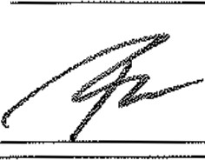
SIGNATURE

X
AGENCY OF FILING PRINTED NAME AND TITLE

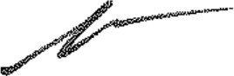
Rosa Arceo ,Deputy



ORIGINAL· PROJECT APPLICANT COPY· CDFW/ASB COPY· LEAD AGENCY COPY. COUNTY CLERK DFW 753.Sa (Rev. 01/01/2023)

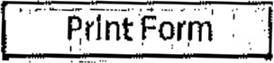

Notice of Exemption Appendix E

To: Office of Planning and Research
P.0. Box 3044, Room i 13
Sacramento, CA 95812-3044
County Clerk
County of: SanJ 0_"'lljl _
From: (Public Agency}: Eastern San Joaquin Groundwater Authority 1810 E. Hazelton Avenue P. 0. Box 1810
Stockton, CA 95201

(Address)

Project Title: Eastern San Joaquin Subbasin Delta Monitoring Well Installation Project Applicant: Eastern San Joaquin Groundwater Authority
Project Location - Specific:

38.122924; 121.493224
Project Location - City: Lodi Project Location - County: San Joaquin County Description of Nature, Purpose and Beneficiaries of Project:
Construct onemulti-completionmonllorlng well In the northwestern po1llon of .theEastern San Joaquin Groundwater Subbasln al Westgate Landing Regional Park, near the Sacramento-San Joaquin Della (Della), lo conduct groundwater monllorlng and sampling acllvflles relallve lo monitoring tor Impacts from chlorides and to nilhydrogeologic dala gapsIn that po1Uon of !he Subbas!n. Data collecled from the well will be used to suppo1t the sustainable management of the Eastern San Joaquin Groundwater Subbasln as ouUlned In lheGroundwaler SustalnabllllyPlan (GSP) for that basin.

Name of Public Agency Approving Project: Eastern San Joaquin Groundwater Authority
Name of Person or Agency Carrying Out Project: Frilz Buchman, Publlo Works Director, San Joaquin County Department of Public Works

Exempt Status: (check one):
□ Mlnlsterial (Sec. 21080(b)(1); 15268);
□ Declared Emergency (Sec. 21080(b)(3); 15269(a));
D Emergency Project (Sec. 21080(b)(4); 15269(b)(c)};
IN Categorical Exemption. State type and section number: Class 6 (Section15306)
D Statutory Exemptions. Stale code number:
Reasons why project Is exempt:
Project consists of the construction of one multi-completion groundwater monitoring well to support data collection for groundwater subbasln management. The monitoring well will be Installed on disturbed surfaces and wilt not result In a serious or major disturbance to an environmental resource, Cal. Code Regs.,lit.14 Section 15306provides that projects v.lllch consist of basic data collecllon, research, experimental management, and resource evaluation acllvllles, and llhlch do not result Ina serious or major disturbance to an environmental resource are categorically exempt from theprovisions of the Callfornla Environmental Quallly Act.
Lead Agency .
Contact Person: Fntz Buchman Area Code/Telephone/Extension: (209) 468-3100

If filed by applicant:
. '
1. Attach certified document of exemption finding.
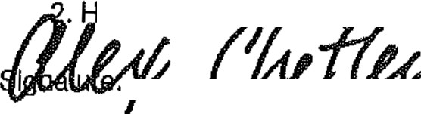
as a Notice xem Ion been flied by the publlc agency approving the project? Yes No

FOR Fritz Buchman
F--....\,,,' Q_-= --F-=--- Date: 12-4-2023 Title: Deputy Director - Development

Signed by Lead Agency • Signed by Applicant

Authority cited: Sections 21083 and 2111o, Public Resources Code. Reference: Sections 21108, 21152, and 21152.1, Public Resources Code.

Date Received for filing at OPR:

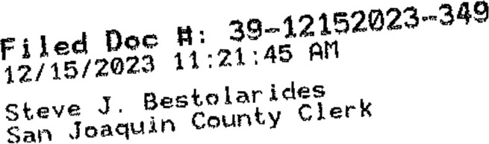
Revised 2011

□

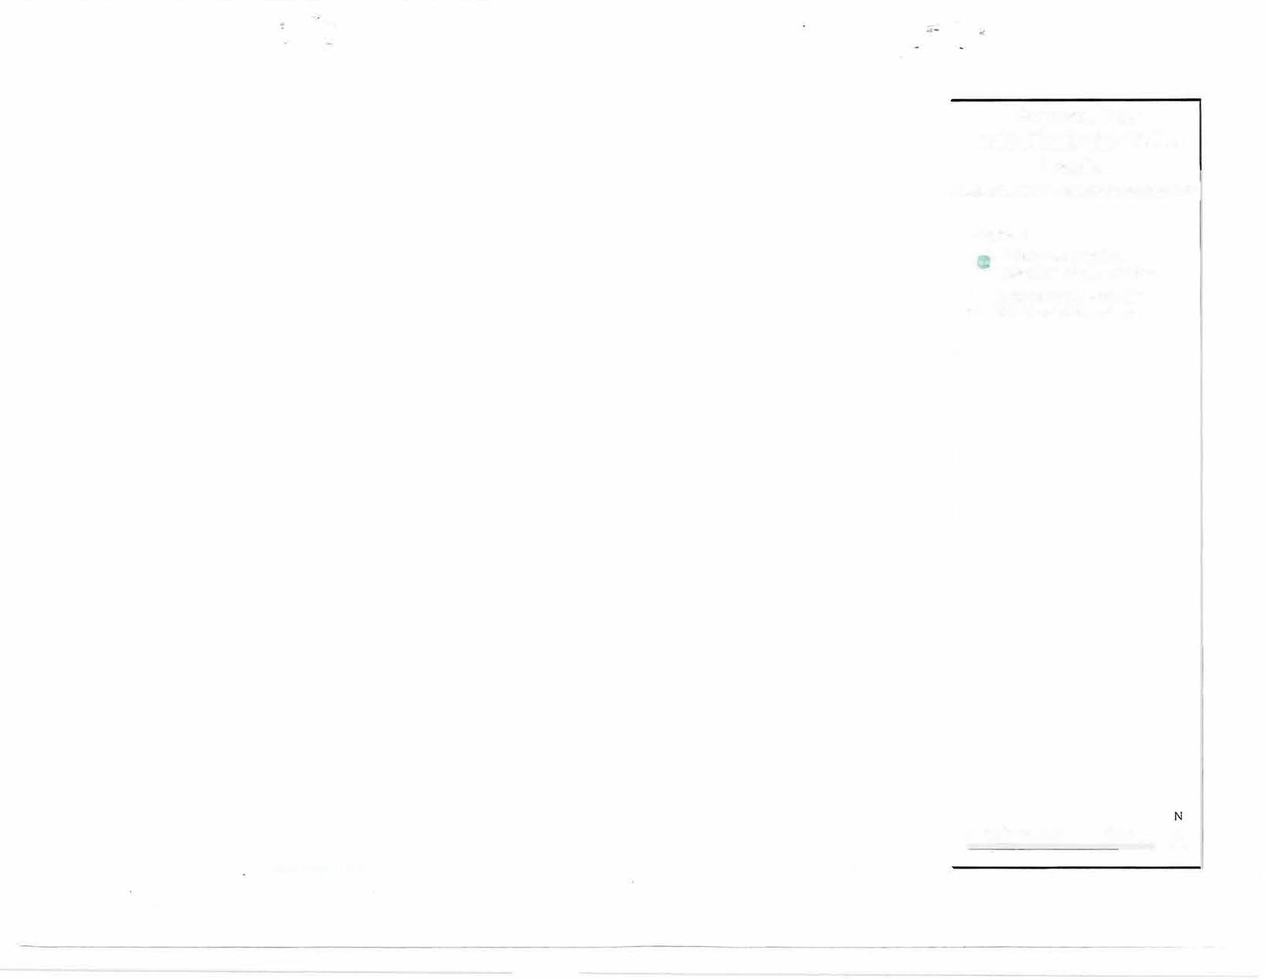
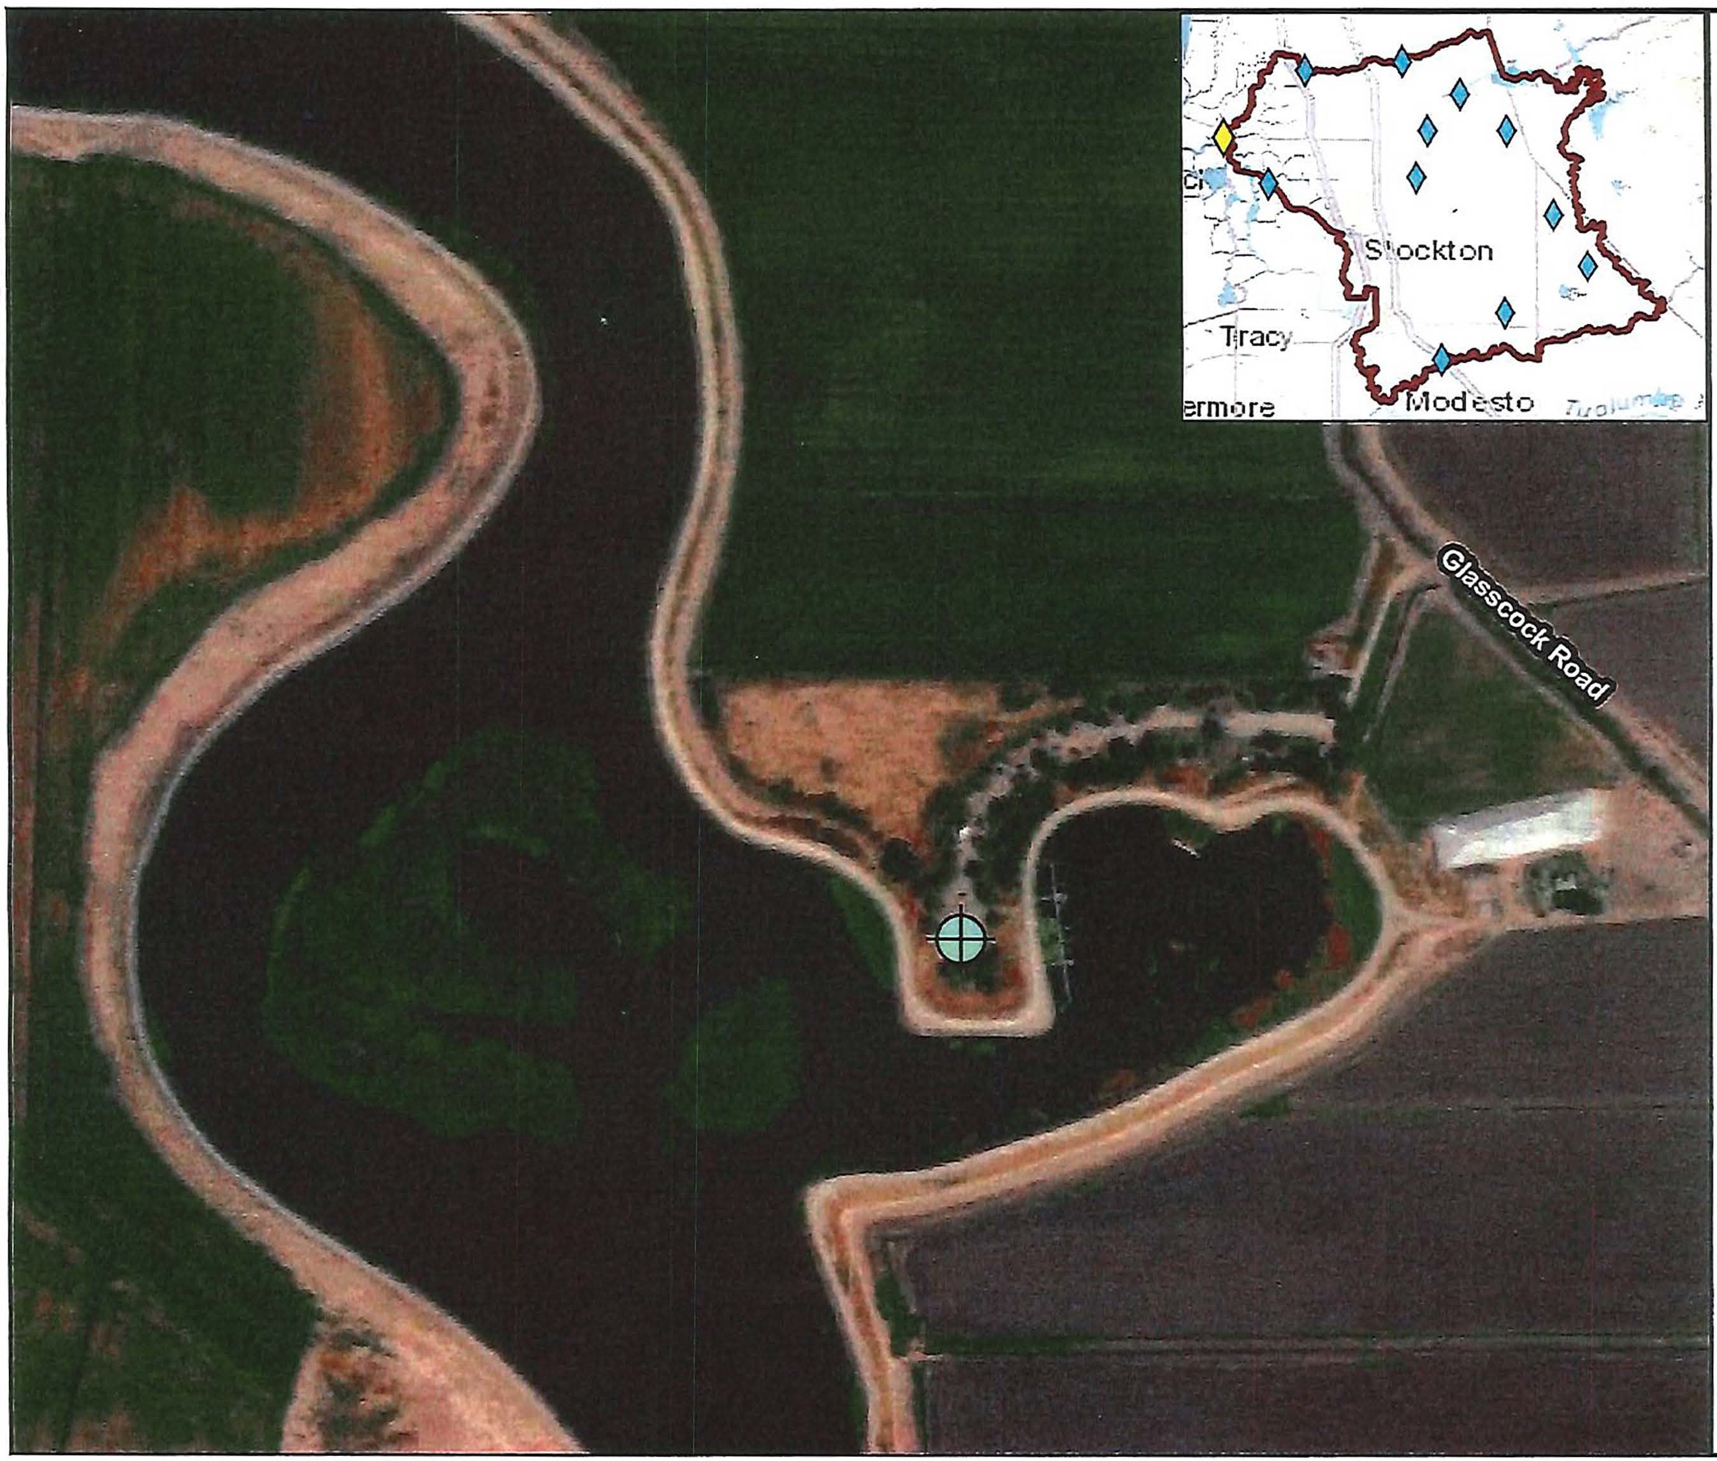
...,

Proposed New Delta Monitoring Well J
Location
Eastern San Joaquin Subbasin GSP Implementation!

Legend
___.,-h_ Westgate Landing
V- Regional Park Location
D
Eastern San Joaquin Subbasin Boundary

0 0.0325).065 o.1r�iles A

San Joaquin County Recorders
Steve J. Bestolarides
44 N. San Joaquin Street, Roon, 260
Stockton, Ca 95202
/ Receipt: 1686270

ProauctName
FISH Cl.ERK CLERK FISl-i ANO GAME:
FILINGS
# Pages

E tended
$50.00

2

Docurnent #
C..l.e...r.k. FIiing Fee
39-12152023--349
$50.00

Total
········--• ·,-,....,-..,.. , .. ,.,,, . ... -----·--. . -- ...........-.... .
$50.00

Tender (On Account (Charge or Prepay)) Accoltnt# SJPW.
Account SAN JOAQUIN COU PUBLIC
Name WORKS
50 00

Thanl<You!

12115/2311:21 AM rosaa

