APPLICATION | DEV23-0017 | Environmental Document No. |  |  |  | 2023-0004
PROJECT TITLE | Mannon Residence #2
APPLICANT NAME & PHONE NUMBER | Robert C Mannon  (805) 235-6146 |  |  | Email | kgleason@atascadero.org
MAILING ADDRESS: | PO Box 2359 |  |  | Atascadero, CA |  |  |  | 93422
STAFF CONTACT: | Kelly Gleason |  | (805) 470-3436 |  | kgleason@atascadero.org
PROJECT ADDRESS: | 10200 West Front |  | Atascadero, CA 93422 |  |  | APN: | 056-162-048

PROJECT DESCRIPTION:
The project includes the construction of an accessory dwelling unit (ADU) outside of the approved building envelope on an existing 1-acre lot in the Residential Single-Family zoning district (RSF-Y). The proposed ADU is located near a jurisdictional waterway. The project will include installation of a 24” culvert crossing and utility trench across an unnamed ephemeral drainage that bisects the property. The project will require utility and vehicular connection via a private driveway from West Front Road for the residence and ADU. Grading is expected to be minor. Several oak and pine trees existing on the site are intended to remain.

LEAD AGENCY: | City of Atascadero  Community Development Department  6500 Palma Avenue  Atascadero, CA 93422
DOCUMENT AVAILABLE ONLINE: |  |  | http://www.atascadero.org/environmentaldocs
STATE CLEARING HOUSE REVIEW: |  |  | ☐ Yes NO ☒
REVIEW PERIOD BEGINS: |  | 8/8/2023 |  |  | REVIEW PERIOD ENDS: | 9/7/2023
PUBLIC HEARING REQUIRED: |  | ☒No |  | ☐ Yes
PUBLIC NOTICE: | The City of Atascadero is releasing a draft Initial Study and Mitigated Negative Declaration at 10200 West Front Road for review and comment to all effected agencies, organizations, and interested parties. Reviewers should focus on the content and accuracy of the report and the potential impacts upon the environment. The notice for this project is in compliance with the California Environmental Quality Act (CEQA). Persons responding to this notice are urged to submit their comments in writing. Written comments should be delivered to the City (lead agency) no later than 5pm on the date listed as “review period ends”. Submittal of written comments via email is also accepted and should be directed to the Staff contact at the above email address. This document may be viewed by visiting the Community Development Department, listed under the lead agency address, or accessed via the City’s website.


CITY OF ATASCADERO
COMMUNITY DEVELOPMENT DEPARTMENT
Initial Study Summary – Environmental Checklist

APPLICATION | DEV23-0017 | Environmental Document No. | 2023-0004
PROJECT TITLE: | Mannon Residence #2

Environmental Factors Potentially Affected: The environmental factors checked below would be potentially affected by this project, involving at least one impact that is a “Potentially Significant Impact” as indicated by the checklist on the following pages.
☐ Aesthetics | ☐ Hazards / Hazardous Materials | ☐ Recreation
☐ Agricultural Resources | ☐ Hydrology / Water Quality | ☐ Transportation / Traffic
☐ Air Quality | ☐ Land Use / Planning | ☐ Tribal Cultural Resources
☒ Biological Resources | ☐ Mineral Resources | ☐ Utilities / Service Systems
☐ Cultural Resources | ☐ Noise | ☐ Mandatory Findings of Significance
☒ Geology and Soils | ☐ Population / Housing | ☐ Mandatory Findings of Significance
☐ Greenhouse Gas Emissions | ☐ Public Services

DETERMINATION: (To be completed by the Lead Agency)
On the basis of this initial evaluation, the Community Development Director finds that:

☐ | The proposed project COULD NOT have a significant effect on the environment, and a NEGATIVE DECLARATION will be prepared.
☒ | Although the proposed project could have a significant effect on the environment, there will not be a significant effect in this case because revisions in the project have been made by or agreed to by the project proponent. A MITIGATED NEGATIVE DECLARATION will be prepared.
☐ | The proposed project MAY have a significant effect on the environment, and an ENVIRONMENTAL IMPACT REPORT is required.
☐ | the proposed project MAY have a "potentially significant impact" or "potentially significant unless mitigated" impact on the environment, but at least one effect 1) has been adequately analyzed in an earlier document pursuant to applicable legal standards, and 2) has been addressed by mitigation measures based on the earlier analysis as described on attached sheets. An ENVIRONMENTAL IMPACT REPORT is required, but it must analyze only the effects that remain to be addressed.
☐ | Although the proposed project could have a significant effect on the environment, because all potentially significant effects (a) have been analyzed adequately in an earlier EIR or NEGATIVE DECLARATION pursuant to applicable standards, and (b) have been avoided or mitigated pursuant to that earlier EIR or NEGATIVE DECLARATION, including revisions or mitigation measures that are imposed upon the proposed project, nothing further is required.

Mariah Gasch
Prepared by (Print) Signature Date

Phil Dunsmore
Reviewed by (Print) Signature Date

PROJECT ENVIRONMENTAL ANALYSIS
The City of Atascadero’s environmental review process incorporates all of the requirements for completing the Initial Study as required by the California Environmental Quality Act (CEQA) and the CEQA Guidelines. The Initial Study includes Staff’s on-site inspection of the project site and surrounding and a detailed review of the information on file for the proposed project. In addition, available background information is reviewed for each project. Relevant information regarding soil types and characteristics, geological information, significant vegetation and/or wildlife resources, water availability, wastewater disposal service, existing land uses and surrounding land use categories and other information relevant to the environmental review process are evaluated for each project. Exhibit A includes the references used, as well as the agencies or groups that were contacted as part of this initial study. The City of Atascadero uses the checklist to summarize the results of the research accomplished during the initial environmental review of the project.

Persons, agencies, or organizations interested in obtaining more information regarding the environmental review process for a project should contact the Community Development Department, 6500 Palma Avenue, Atascadero, CA 93422 or call (805) 461-5000.

A. PROPOSED PROJECT
Description: | The project is proposed on an existing 1-acre (43,324 square foot) lot in the Residential Single-Family zoning district (RSF-Y). The project would create an ADU (accessory dwelling unit) of approximately 1,199 square feet on a site with a natural grade not exceeding 20%. This ADU is in addition to a proposed 2,420- square-foot two-story residence with an attached garage (Approx. 600 square feet). This residence is located in the recorded building envelope for the parcel, but the ADU is outside this area, therefore requiring this discretionary action. The proposed ADU is located near a jurisdictional waterway. The project will include installation of a 24” culvert crossing and utility trench across an unnamed ephemeral drainage that bisects the property. The project will require utility and vehicular connection via a private driveway from West Front Road for the residence and ADU. Grading is expected to be minor. Several oak and pine trees existing on the site are intended to remain.
Assessor parcel number(s): |  | 056-162-048
Latitude: | 35° 27' 41.118" N |  | Longitude: | 120° 38' 54.052" W
Other public agencies whose approval is required: |  | None

B. EXISTING SETTING
Land use designation: | Single Family Residence with a 1.0-acre minimum lot size (SFR-Y)
Zoning district | Residential Single Family with a 1.0-acre minimum lot size (RSF-Y)
Parcel size: | 1 acre
Topography: | Gently sloping |  |  |  | <20%
Vegetation: | Blue Oak Pine and Coastal Oak Woodland with annual grasses
Existing use: | Single-family residence
Surrounding land use: | Small-lot residential neighborhood
Surrounding zoning:
North: | South: | East: |  | West:
RSF-Y | RSF-Y | RMF-10 |  | RSF-Y
C. ENVIRONMENTAL ANALYSIS
During the initial study process, there were no significant impacts identified. The initial study attached contains analysis in determining impact significance level.

CITY OF ATASCADERO
INITIAL STUDY CHECKLIST

1. AESTHETICS – Will the project:
 | Potentially Significant | Impact Requires Mitigation | Less than significant Impact | Not Applicable
a) Have a substantial adverse effect on an adopted scenic vista? | ☐ | ☐ | ☐ | ☒
b) Substantially damage scenic resources, including, but not limited to, trees, rock outcroppings, and historic buildings within a state scenic highway? | ☐ | ☐ | ☐ | ☒
c) Substantially degrade the existing visual character or quality of the site and its surroundings? | ☐ | ☐ | ☐ | ☒
d) Create a new source of substantial light or glare which would adversely affect day or nighttime views in the area? | ☐ | ☐ | ☐ | ☒

EXISTING SETTING: The City of Atascadero reviews all new projects for appropriate building design. New projects must have a design that is sensible within the context of the community. The design must be similar or complimentary to the surrounding developments. Additionally, developers must consider how a project may affect historical and natural resources in and around their site. The promotion of purposeful design helps preserve community character and aesthetic as well as prevents negative impacts on surrounding property values.

The property is a 1-acre parcel located in the Residential Single-Family zoning district on West Front Road, between the cross-streets San Gabriel Road and San Rafael Road. The immediate surrounding area includes rural residential land to the north, south, and west, and U.S. Highway 101 to the east. The project site is largely comprised of disturbed grassland. One ephemeral drainage bisects the center of the property and is bordered by individual blue oak pine and coastal oak woodland trees, with limited understory present. Topography on site is flat, with elevations ranging from 74 to 76 meters. Native oak and pine trees currently exist in the location proposed for the development of an ADU and single-family residence. One ephemeral drainage bisects the center of the property and is bordered by individual oak and pine trees, with limited understory present.

PROPOSED PROJECT: The ADU building footprint is 1,199 square feet. This is in addition to a proposed 2,420-square-foot two-story residence with an attached 2-car garage (601 sf). This residence is located in the recorded building envelope for the parcel, but the ADU is outside this area. The proposed ADU is located near a jurisdictional waterway. The project will include installation of a 24” culvert crossing and utility trench across an unnamed ephemeral drainage that bisects the property. The project will require utility and vehicular connection via a private driveway from West Front Road for the residence and ADU. Grading is expected to be minor. Several oak and pine trees existing on the site are intended to remain.
The Atascadero General Plan (General Plan) and Atascadero Municipal Code (AMC) provide thresholds of significance for the aesthetic qualities of new developments. The General Plan Land Use Conservation Element Policies 1.4 and 2.1 specify the avoidance of light pollution and compatibility with existing surrounding neighborhoods. Additionally, Policy 5.2 of the same element requires for all new hillside developments to blend in with the surrounding topography. Section 9.4.137 of the AMC regulates exterior lighting to avoid light pollution onto neighboring properties.

The project fits into the existing character of the single-family residences that compose the neighborhood. The natural topography of the area and its location on the parcel do not qualify the project as hillside development. Thus, the project will not impact the aesthetic quality of the surrounding environment.

MITIGATION / CONCLUSION: No impacts are expected. No mitigation is required

2. AGRICULTURE AND FORESTRY RESOURCES – Will the project:
 | Potentially Significant | Impact Requires Mitigation | Less than significant Impact | Not Applicable
a) Convert Prime Farmland, Unique Farmland, or Farmland of Statewide Importance (Farmland) to nonagricultural use? | ☐ | ☐ | ☐ | ☒
b) Conflict with existing zoning for agricultural use, or a Williamson Act contract? | ☐ | ☐ | ☐ | ☒
c) Conflict with existing zoning for, or cause rezoning of, forest land, timberland, or timberland zoned Timberland Production? | ☐ | ☐ | ☐ | ☒
d) Result in the loss of forest land or conversion of forest land to non-forest use? | ☐ | ☐ | ☐ | ☒
e) Involve other changes in the existing environment which, due to their location or nature, could result in conversion of Farmland to non-agricultural use or conversion of forest land to non-forest use? | ☐ | ☐ | ☐ | ☒

EXISTING SETTING: Preservation of agricultural lands is important to the State of California as they provide economic benefits and important ecosystem services. Historically, urban development in the state has correlated with diminishing farmlands. This trend has led to various legislative measures at the state and local levels to protect vulnerable agricultural resources (California Department of Food and Agriculture, 2015). The California State Department of Conservation identifies, categorizes, and helps preserve important farmland. Their Farmland Mapping and Monitoring Program tracks and maps the conversion of farmland into urban development. In particular, those areas that fall under the categories of “Prime Farmland,” “Farmland of Statewide Importance,” or “Unique Farmland” may have an opportunity to receive state funding or take advantage of incentive programs for the if preservation.

Currently, the subject property is an undeveloped, 1-acre lot located in Residential Single Family zoning district on West Front Road. The surrounding parcels are Single Family Residences. The site has average slope of less than 20%.

The site is categorized as “Urban and Built-Up Land” by the California Department of Conservation (Figure 6) and is not under a Williamson Act contract.

PROPOSED PROJECT: The proposed project will create an ADU and one single family residence on West Front Road, between the cross-streets San Gabriel Road and San Rafael Road. The parcel is surrounded by other developed single-family residences. Existing urban development surrounding the parcel excludes it from use as prime farming land.

MITIGATION / CONCLUSION: No impacts are expected. No mitigation is required.

3. AIR QUALITY – Will the project:
 | Potentially Significant | Impact Requires Mitigation | Less than significant Impact | Not Applicable
a) Conflict with or obstruct implementation of the applicable air quality plan? | ☐ | ☐ | ☐ | ☒
b) Violate any air quality standard or contribute substantially to an existing or projected air quality violation? | ☐ | ☐ | ☐ | ☒
c) Result in a cumulatively considerable net increase of any criteria pollutant for which the project region is non-attainment under an applicable federal or state ambient air quality standard (including releasing emissions which exceed quantitative thresholds for ozone precursors)? | ☐ | ☐ | ☒ | ☐
d) Expose sensitive receptors to substantial pollutant concentrations? | ☐ | ☐ | ☐ | ☒
e) Create objectionable odors affecting a substantial number of people? | ☐ | ☐ | ☐ | ☒

EXISTING SETTING: All new developments have impacts on local air quality that vary in extent depending on construction practices, land use, size, and vehicle trip generation. Poor air quality can have adverse effects on public health including increases in cardio respiratory diseases (World Health Organization, 2018). The City of Atascadero and the San Luis Obispo County Air Pollution Control District (SLOAPCD) work to create policies and programs to maintain air quality in a healthy state. Furthermore, the Federal Environmental Protection Agency (EPA) helps regional agencies monitor and regulate air quality by identifying and classifying target air pollutants.

The site is located on a on West Front Road, between the cross-streets San Gabriel Road and San Rafael Road. The surrounding neighborhood is in the Residential Single Family district and composed of single-family residences. The neighboring properties are mostly developed with single-family homes amongst oak pine and woodland.

The subject parcel where the new residence is proposed is currently undeveloped. The site has average slope of less than 20%. Topography on site is flat, with elevations ranging from 74 to 76 meters. According to the City’s geographic information system (GIS) database derived from USDA Soil Survey data, soil drainage on the site is classified as “Moderately Drained”. The site has “Moderate” erodibility.

The EPA ranks levels of specific air pollutants in a region as being at “attainment” or “nonattainment.” Nonattainment status is given to regions where the air quality does not meet the national primary or secondary standards provided in the EPA Green Book. According to SLOAPCD, San Luis Obispo County is at nonattainment for ozone (O2) and respiratory particulate matter (PM10) (Table 1). Atascadero General Plan Land Use, Open Space and Conservation Element program 10.3.1 requires dust control and emissions regulation during the construction phases of any project. The associated policy aims to support regional efforts to maintain clean air.

PROPOSED PROJECT: The applicant is proposing an ADU (accessory dwelling unit) in addition to a proposed two-story residence with an attached garage. This residence is located in the recorded building envelope for the parcel, but the ADU is outside this area. The project will include installation of a 24” culvert crossing and utility trench across an unnamed ephemeral drainage that bisects the property. Grading is expected to be minor. The project is surrounded by occupied single-family houses.

The residence is too small of a project to create significant contribution to pollutants at nonattainment levels according to the screening thresholds provided by SLO County APCD. Since the project will not create significant cumulative contributions of Ozone, greenhouse gases or particulate matter, then the impact is less than significant.

MITIGATION / CONCLUSION: No significant impacts are expected. No mitigation is required.

4. BIOLOGICAL RESOURCES – Will the project:
 | Potentially Significant | Impact Requires Mitigation | Less than significant Impact | Not Applicable
a) Have a substantial adverse effect, either directly or through habitat modifications, on any species identified as a candidate, sensitive, or special status species in local or regional plans, policies, or regulations, or by the California Department of Fish and Wildlife (CDFW) or U.S. Fish and Wildlife Service (USFWS)? | ☐ | ☒ | ☐ | ☐
b) Have a substantial adverse effect on any riparian habitat or other sensitive natural community identified in local or regional plans, policies, regulations or CDFW and USFWS? | ☐ | ☒ | ☐ | ☐
c) Have a substantial adverse effect on federally protected wetlands as defined by Section 404 of the Clean Water Act through direct removal, filling, hydrological interruption, or other means? | ☐ | ☐ | ☐ | ☒
d) Interfere substantially with the movement of any native resident or migratory fish or wildlife species or with established native resident or migratory wildlife corridors, or impede the use of native wildlife nursery sites? | ☐ | ☒ | ☐ | ☐
e) Conflict with policies or ordinances protecting biological resources, such as the tree native tree ordinance? | ☐ | ☒ | ☐ | ☐
f) Conflict with the provisions of an adopted Habitat Conservation Plan, Natural Community Conservation Plan, or other approved local, regional, or state habitat conservation plan? | ☐ | ☐ | ☐ | ☒

EXISTING SETTING: The City of Atascadero as well as San Luis Obispo County and the state of California emphasize the protection of their diverse ecosystems and the vulnerable species to which they provide habitats.

The existing property is a 1-acre, undeveloped parcel. The surrounding vegetative landscape is oak pine and woodland with annual grasses, which has been developed for single family residential uses. There are oak and pine trees on the parcel, which are to remain and shall be protected in place. One ephemeral drainage bisects the center of the property and is bordered by individual oak and pine trees, with limited understory present. Grading is expected to be minor.

The Atascadero General Plan Land Use, Open Space and Conservation Element Policies 7.1 and 7.2 call for the enforcement of the City’s native tree ordinance in order to protect and preserve native trees. Policy 8.1 requires the review of developments near riparian areas to ensure that they do not negatively impact natural flows or existing ecosystems.

PROPOSED PROJECT: The applicant is proposing an ADU (accessory dwelling unit) in addition to a proposed two-story residence with an attached garage. This residence is located in the recorded building envelope for the parcel, but the ADU is outside this area. The project will include installation of a 24” culvert crossing and utility trench across an unnamed ephemeral drainage that bisects the property. GIS is used to identify local bodies of water and riparian areas within the city (Figure 7). The project falls outside of the riparian zones. The site isn’t designated as part of a wildlife corridor or habitat for sensitive species by the California Department of Fish and Wildlife or the United States Fish and Wildlife Service.

SWCA Environmental Consultants prepared a biological resources assessment for the project site. This assessment reported 3 wildlife special status species and no botanical special status species on site. three special-status wildlife species are known to occur within the vicinity of the project site (see Attachment A – Figure 3), including:
  - Northern California legless lizard (Anniella pulchra), State Species of Special Concern, (CSC)
  - Crotch bumble bee (Bombus crotchii), State Candidate Endangered
  - Purple martin (Progne subis), CSC
State Special Animals have been omitted from this list because these taxa do not currently have a protected status. As such, Atascadero June beetle (Polyphylla nubila) is omitted from this list. Further, no USFWS-designated Critical Habitat overlaps the project site.

Northern California Legless Lizard

Northern California legless lizard requires moist, sandy, or loose loamy soils within coastal dune scrub, coastal sage scrub, chaparral, woodland, riparian, or forest habitats. It shelters in leaf litter and under bushes, rocks, or detritus like logs and driftwood. Relatively little is known about the specific behavior and ecology of this species, but it is thought to be a diurnal species that breeds between the months of March and July. It gives birth to live young in the early fall. Population declines have been attributed to agricultural development, sand mining, use of off-road recreational vehicles, and habitat loss through spread of invasive, non-native vegetation such as iceplant (Zeiner et al. 1988-1990). According to CNDDB (CDFW 2023) the nearest documented occurrence of this species is 1.2 miles northwest of the project location. Habitat within the proposed project area is considered low suitability based on the disturbed nature of the site. However, leaf litter and fallen branches in the understory of the oak and pine trees may provide suitable habitat for this species.

Crotch bumble bee

Crotch bumble bee inhabit open grassland and scrub habitats primarily in California, from Sacramento south into Mexico, and from the coast east into Nevada. Bumble bee colonies are annual with the queen mating in the fall before overwintering alone. In the spring the queen emerges and established a new colony by producing female workers and male drones. Not much is known about Crotch bumble bee overwintering sites (Hatfield et al. 2020). Generally, bumble bees overwinter in soft, disturbed soil (Goulson 2010), or under leaf litter or other debris (Williams et al. 2014). Queens emerge between February and April (Thorp et al. 2010) and establish a colony. Colonies are usually underground in abandoned holes made by ground squirrels, mice, and rats, or occasionally abandoned bird nests (Osborne et al. 2008). However, bumble bees may also nest above ground in tufts of grass or cavities in downed wood, rock walls or brush piles. Crotch bumble bee are generalist foragers, feeding on a variety of flowering plants (Hatfield et al. 2020). Like other bumble bees, this species feeds on both the nectar and the pollen. Select food plant genera include Fabaceae, Apocynaceae, Asteraceae, Lamiaceae, and Boraginaceae (Hatfield et al. 2020). Queens mate in the fall and overwinter starting in October. Threats to this species include loss of habitat due to agriculture and development, degradation of habitat due to invasive species, livestock grazing, and herbicide use, and decreases in small mammal population due to poisoning. According to CNDDB (CDFW 2023) the nearest documented occurrence of this species is 1.2 miles northwest of the project location. Suitable nesting habitat (e.g., small mammal burrows and brush piles) and select food plant genera are present on site. There is potential to encounter this species on site.

Purple martin

Purple martin use low-elevation wooded habitats such as valley foothills, montane hardwood-conifer forests, and riparian forests. Nesting usually occurs in cavities of tall and old trees, isolated tree snags, or woodlands between April and August. Less common nest locations include culverts and under bridges. During migration, purple martins can be found in grasslands, wet meadows, and freshwater emergent wetlands. Forage is comprised of gliding insects, ants, and other ground insects. According to CNDDB (CDFW 2023) the nearest documented occurrence of this species is 1.4 miles west of the project location. Habitat within the proposed project area is considered low suitability for nesting and foraging, however, purple martin may utilize the mature trees onsite for nesting.

Nesting birds

In addition to species protected by the state or federal Endangered Species Acts, all native avian species are protected by state and federal legislature, most notably the Migratory Bird Treaty Act and the CDFW Fish and Game Code. Collectively, these and other international regulations make it unlawful to collect, sell, pursue, hunt, or kill native migratory birds, their eggs, nests, or any parts thereof.

Avian species can be expected to occur within and adjacent to the project site during all seasons and throughout construction of the proposed project. The potential to encounter and disrupt these species is highest during the nesting season (i.e., February 1 through August 31), when nests are likely to be active, and eggs and young are present. Mature trees, shrubs, and grassland provide suitable foraging and nesting habitat for many species. Avian species may also nest in stored materials on site. No special-status birds were observed during the February 2023 surveys. However, suitable nesting habitat is present on site and in adjacent areas for a variety of common and special-status passerines and raptors during the typical nesting period (February 1 through August 31).

The biologist’s letter also indicated that six special-status plant species are known to occur within vicinity of the project site (i.e., 2-mile) (see Attachment A – Figure 3), including:
  - Santa Margarita manzanita (Arctostaphylos pilosula), California Rare Plant Rank (CRPR) 1B.2
  - Miles’ milkvetch (Astragalus didymocarpus var. milesianus), CRPR 1B.2
  - Straight-awned spineflower (Chorizanthe rectispina), CRPR 1B.3
  - Eastwood's larkspur (Delphinium parryi subsp. Eastwoodiae) CRPR 1B.2
  - Yellow-flowered eriastrum (Eriastrum luteum) CRPR 1B.2
  - Mesa horkelia (Horkelia cuneata var. puberula) CRPR 1B.1

The proposed project site is largely comprised of non-native annual grasses such as wild oats (Avena sp.), and bromes (Bromus sp.). Weedy herbaceous species such as black mustard (Brassica nigra), bull thistle (Cirsium vulgare), bur clover (Medicago polymorpha), redstem filaree (Erodium cicutarium), and broadleaf filaree (Erodium botrys) were apparent throughout the grassland. The project site is highly disturbed and experiences ongoing disturbance (i.e., grazing, mowing, equipment staging). As such, no suitable habitat is present for any special status plants and no special-status plants are expected to occur.
Because the unnamed drainage would likely be considered a jurisdictional feature by the federal and state governments, the project must comply with the applicable laws and regulations.

With respect the federal jurisdiction, the proposed project would likely qualify for a non-notifying Nationwide Permit 29 (Residential Developments) under the new 2021 Nationwide Permit Program which is valid through March 14, 2026. Under Nationwide Permit 29, the discharge (fill) to waters of the U.S. must not cause the loss of greater than 1/2-acre. Because the impacts are below the threshold for this permit, the action may be non-notifying to the USACE for the Clean Water Act (Section 404).

To comply with the Clean Water Act with the State (Section 401), a Notice of Intent would need to be submitted to the Regional Water Quality Control Board to disclose the proposed project and request a Section 401 Water Quality Certification from the RWQCB.

To comply with the California Fish and Game Code, a Lake and Streambed Alteration Agreement must be submitted to CDFW with the subject application fee and supporting documentation.

Through the regulatory permitting process, additional avoidance and minimization measures may be required to protect the jurisdictional feature or wildlife utilizing the area.

BIO Impact-1: Based on the disturbed nature of the site, the potential to impact special-status wildlife species is considered very low. Direct and indirect impacts may occur to common and special-status wildlife species. Specifically, the proposed project may impact Northern California legless lizard, Crotch bumble bee, purple martin, and migratory nesting birds. If these species are present at the time of construction, they may be vulnerable to vehicle strikes and crushing from equipment. Indirect impacts may occur by deterring movement patterns of wildlife caused by construction disturbances.

BIO Impact-2: No special-status botanical species were observed during SWCA’s field survey. Although the survey was conducted outside of the typical blooming period for most annual special-status species (April-June) within the project vicinity, none are expected to occur in the project footprint, and therefore no impacts to special-status plants are expected to occur. The impact is less than significant.

MITIGATION / CONCLUSION:
BIO-1 The use of heavy equipment and vehicles should be limited to the proposed project limits and defined staging areas/access points. The boundaries of the work area should be clearly defined and marked in the field. No project-related construction should occur outside these limits.

BIO-2 Equipment staging areas for vehicle fueling and storage should be at least 50 feet away from the drainage in a location where fluids or accidental discharges cannot flow into the drainage.

BIO-3 A biologist should conduct a pre-activity survey immediately prior to the start of construction to ensure Northern California legless lizard and Crotch bumble bee are not present within proposed work areas. If special-status wildlife species are found, they shall be allowed to leave the area on their own volition or be relocated (as permitted) to suitable habitat outside of the work area. If necessary, a qualified biologist or resource agencies will be contacted for further guidance.

BIO-4 If project activities are expected to occur during the typical avian nesting season (i.e., February 1 – August 31), pre-activity surveys should be completed by a qualified biologist within one week prior to project initiation. Surveys for raptors should be conducted within a 250-foot radius of the project site. If any active non-listed raptor nests are observed, these nests and nest trees should be designated, and a no-work buffer of 250 feet should be established until the young have fledged and are no longer reliant on the nest tree or parental care, or the nest is no longer active. Surveys for other non-listed avian species should be conducted within a 50-foot radius of the project site. If any active nests are observed, these nests and nest trees should be protected with a 50-foot no-work buffer. All activity will remain outside of the designated buffers until a qualified biologist has determined that the young have fledged or that proposed construction activities would not cause adverse impacts to the nest, adults, eggs, or young. If work activities are deemed to not be a threat to a given nest within a buffer zone, a qualified biologist may monitor the nest during work to ensure that the nesting birds are not disturbed (e.g., showing signs of stress or changes in behavior as a result of work activity). If any active nests of listed, fully protected, or otherwise special-status species are detected during the surveys, a qualified biologist should be contacted for guidance on how to proceed.

BIO-5 Construction best management practices (BMPs) such as silt fencing and wattles should be installed prior to any work in upland areas of the site during the rainy season, to prevent any sediment or other materials from entering the drainage during construction.

BIO-6 Erosion and sediment control measures and other BMPs should be implemented and maintained in accordance with all manufacturer’s specifications detailing the installation, operation, and maintenance of the BMPs. Erosion control materials should not contain monofilament materials as these materials are known to entangle wildlife.

5. CULTURAL RESOURCES – Will the project:
 | Potentially Significant | Impact Requires Mitigation | Less than significant Impact | Not Applicable
a) Cause a substantial adverse change in the significance of a historical resource? | ☐ | ☐ | ☐ | ☒
b) Cause a substantial adverse change in the significance of an archaeological resource? | ☐ | ☐ | ☒ | ☐
c) Directly or indirectly destroy a unique paleontological resource or site or unique geologic feature? | ☐ | ☐ | ☐ | ☒
d) Disturb any human remains, including those interred outside of formal cemeteries? | ☐ | ☐ | ☐ | ☒

EXISTING SETTING: The City of Atascadero recognizes the impact of various cultures and ecosystems that have shaped it over generations. Therefore, the City as well as the county and state make an effort to preserve cultural resources, known or discovered, during the development of new projects.

The existing property is a 1-acre, undeveloped parcel. The surrounding area is composed of mostly single-family residential houses developed amongst oak pine and woodland. One ephemeral drainage bisects the center of the property and is bordered by individual pine and oak trees, with limited understory present. City GIS data derived from USDA Soil Survey data lists the soil type underlying the area where the site is located as Botella Sandy Loams.

The City of Atascadero’s General Plan Land Use, Open Space, and Conservation Element Programs 6.2.4-6 require the mitigation and noticing of pertinent parties when archaeological discoveries are made in the city. The AMC lists standards to be adhered to should archeological remains be discovered during the development process, which include the cessation of all construction activity until proper local, state, and federal protocol is completed. (AMC 9-4.162)

PROPOSED PROJECT: The project involves the construction of 1,199 square foot ADU (accessory dwelling unit). This is in addition to a proposed 2,420-square-foot two-story residence with an attached 2-car garage (601 sf). This residence is located in the recorded building envelope for the parcel, but the ADU is outside this area. The project proposes to install one 24-inch High Density Polyethylene (HDPE) culvert crossing and utility installation (gas line). The parcel being developed is 1 acre in size. Grading is expected to be minor.

According to the City’s internal database, the nearest known archaeological sites are located about 0.56 miles from the site. However, this does not eliminate the possibility of a new site being discovered during development. Mitigation measures must be established to prevent the degradation of any newly discovered archeological resources.

Because AMC 9-4.162 requires the applicant to stop work and notify interested parties if archeological or historical resources are discovered during construction, then the impact is less than significant.

MITIGATION / CONCLUSION: No significant impacts are expected. No mitigation is required.

6. ENERGY – Would the project:
 | Potentially Significant  Impact | Less Than Significant with Mitigation Incorporated | Less Than Significant Impact | No Impact
a) Result in potentially significant environmental impact due to wasteful, inefficient, or unnecessary consumption of energy resources, during project construction or operation? | ☐ | ☐ | ☐ | ☒
b) Conflict with or obstruct a state or local plan for renewable energy or energy efficiency? | ☐ | ☐ | ☐ | ☒

EXISTING SETTING: The property is an existing parcel zoned for single-family residential uses.

PROPOSED PROJECT: The project is one ADU and single-family residence with an attached garage. The residence is subject to energy-efficiency standards of the California Building Code.

MITIGATION / CONCLUSION: No significant impact is expected. No mitigation is required.

7. GEOLOGY AND SOILS – Will the project:
 | Potentially Significant | Impact Requires Mitigation | Less than significant Impact | Not Applicable
a) Result in the exposure to or production of unstable earth conditions including the following:  - Landslides;  - Earthquakes;  - Liquefaction;  - Land subsidence or other similar hazards? | ☐ | ☐ | ☐ | ☒
b) Be within a California Geological Survey “Alquist-Priolo” Earthquake Fault Zone, or other known fault zone? (consultant Division of Mines and Geology Special Publication #42) | ☐ | ☐ | ☐ | ☒
c) Result in soil erosion, topographic changes, loss of topsoil or unstable soil conditions from proposed improvements such as grading, vegetation removal, excavation or use of fill soil? | ☐ | ☒ | ☐ | ☐
d) Include any structures located on known expansive soils? | ☐ | ☐ | ☐ | ☒
e) Be inconsistent with the goals and policies of the City’s Safety element relating to geologic and seismic hazards? | ☐ | ☐ | ☐ | ☒
f) Have soils incapable of adequately supporting the use of septic tanks or alternative waste water disposal systems where sewers are not available for the disposal of waste water? | ☐ | ☐ | ☐ | ☒

EXISTING SETTING: According to the EQ Zapp website of the California Department of Conservation (https://maps.conservation.ca.gov/cgs/EQZApp/app/) the subject property is not within an earthquake fault zone.

The City of Atascadero’s General Plan lists and maps potential ground shaking sources that can threaten developments within its boundaries as seen in Table 2 below. The California Department of Conservation developed the Earthquake Hazard Zone App, which allows users to determine if a parcel is located in an earthquake zone. The subject parcel is not on an earthquake fault zone.

The General Plan Safety and Noise Element Goal 4 and its respective policies and program areas address geologic and seismic hazards as they affect development and emergencies. The City also keeps a GIS database with data regarding soil type and risk of hazards for areas within city limits. The USDA Natural Resources Conservation Service provides GIS data regarding the site’s soils, stability and risk of hazards. One ephemeral drainage bisects the center of the property and is bordered by individual blue oak pine and coastal oak woodland trees, with limited understory present. The soil on the site is composed of Botella Sandy Loams. The USDA classifies the soil of the entire parcel as “Moderately Drained”. The USDA categorized the soil as having “Moderate” erodibility throughout the lot as well. (Figure 8). Soil shrink and swell is characterized as being “Moderate”. San Luis Obispo County categorized the building site as being at “Moderate” risk for landslides and “Low” risk for liquefaction (Figure 10). Septic suitability on the site is labeled as “Severe”, due to excessive slope and/or depth to rock and/or slow percolation (Figure 9).

PROPOSED PROJECT: The project involves the construction of 1,199 square foot ADU (accessory dwelling unit). This is in addition to a proposed 2,420-square-foot two-story residence with an attached 2-car garage (601 sf). This residence is located in the recorded building envelope for the parcel, but the ADU is outside this area. The project proposes to install one 24-inch High Density Polyethylene (HDPE) culvert crossing and utility installation (gas line). The parcel being developed is 1 acre in size. The applicant has designed a project that minimizes exposure to risks on the parcel. Atascadero Municipal Code 9-4.145 requires the installation and maintenance of erosion control measures to stabilize soil surfaces after disturbance between the dates October 15 and April 15. Grading is expected to be minor.

The site will have restricted options when it comes to locating the septic system due to setback requirements from the nearby waterway. Before building permits are approved, City Staff will review the septic design to ensure that it complies with state standards.

City staff will also review the erosion control plan as required by the Atascadero Municipal Code. The grading and foundation plan will be reviewed and must be found in conformance with the recommendations of the applicant’s civil engineer. The applicant is expected to follow the construction guidelines provided in the geotechnical report and required by the California Building Code.

GEO Impact-1: Minimal cut and fill grading has been proposed to make the site suitable for development of an ADU and single-family residence with an attached garage. The removal of vegetation and topsoil will make the graded areas less stable, this impact requires mitigation.

GEO Impact-2: GIS data from the United States Geologic survey characterizes the soil on the property where the residence will be developed as having “Moderate” erodibility. The Atascadero Municipal Code requires a sedimentation and erosion control plan to be submitted to the city engineer for revision and approval review. Since the Atascadero Municipal Code addresses issues with sedimentation and erodibility, then the impact is less than significant.

GEO Impact-3: GIS data labeled the septic suitability of this site as “Severe”. Due to its location, the residence will require an on-site septic system. Since the septic system will follow regulations per the Local Area Management Plan, then the impacts are less than significant.

MITIGATION / CONCLUSION:

GEO-1 Seeds and other plant materials used for erosion control and slope stabilization shall consist of native species matching the existing plant species within the tributary stream. The seed and plant material shall not contain any non-native plant species.

8. GREENHOUSE GAS EMISSIONS – Will the project:
 | Potentially Significant | Impact Requires Mitigation | Less than significant Impact | Not Applicable
a) Generate greenhouse gas emissions, either directly or indirectly, that may have a significant impact on the environment? | ☐ | ☐ | ☒ | ☐
b) Conflict with an applicable plan, policy or regulation adopted for the purpose of reducing the emissions of greenhouse gases? | ☐ | ☐ | ☒ | ☐

EXISTING SETTING: Greenhouse gases (GHG) including carbon dioxide (CO2), Methane (CH4), Nitrous Oxide(N2O), fluorinated gases, and water vapor, can cause significant harm to the environment and have adverse effects public health. The City of Atascadero and the State of California attempt regulate GHG emissions to promote environmental and public health as well as energy efficiency.

The site where the residence is proposed is located on a 1-acre parcel in the Residential Single Family zoning district of Atascadero. The site is bordered by 4 other parcels that vary in size (about 1 to 2 acres) with single-family residences on all of the lots. Currently, the subject property is undeveloped and does not contribute GHG emissions to the environment.

In 2014, the City of Atascadero adopted a climate action plan (CAP) to help guide the city in reducing their GHG emissions in accordance with California Assembly Bill 32 (AB32). AB32 aims at a reduction of 15% in GHG emissions by 2020. According to this plan, in 2005 the City of Atascadero produced 141,428 metric tons (MT) of carbon dioxide equivalent (CO2e) in GHG emissions. Residential land uses contributed 29% of the total emissions (Rincon Consultants, Inc., 2014). Figure 14 below shows the portion of total emissions contributed by each sector of the community in 2005. The City aims to reduce their community-wide emission levels to 120,214 MT CO2e by 2020.

PROPOSED PROJECT: The applicant is proposing an ADU, in addition to a single-family residence with an attached garage. The parcel being developed is 1 acre in size.

SLO APCD establishes a significance threshold of 1,150 metric tons per year (MT/yr.) of CO2 for new residential and commercial projects. Any projects that exceed this threshold must take action to mitigate their level of emission. SLO County APCD also provides a table to assist with screening projects based on project characteristics such as floor area, dwelling units, or service capacity. According to this table, a rural, single-family residential development requires fifty-four dwelling units to meet the threshold. (SLO County APCD, 2017)

GHG Impact 1: The residence only includes two dwelling units. SLO county APCD provides a threshold of 49 dwelling units for projects that are likely to have a significant impact on GHG emissions. Since the project does not surpass the threshold, then the impact is less than significant.

MITIGATION / CONCLUSION: No significant impacts are expected. No mitigation is required.

9. HAZARDS AND HAZARDOUS MATERIALS – Will the project:
 | Potentially Significant | Impact Requires Mitigation | Less than significant Impact | Not Applicable
a) Create a significant hazard to the public or the environment through the routine transport, use, or disposal of hazardous materials? | ☐ | ☐ | ☐ | ☒
b) Create a hazard to the public or the environment through reasonably foreseeable upset and accident conditions involving the release of hazardous materials into the environment? | ☐ | ☐ | ☐ | ☒
c) Emit hazardous emissions or handle hazardous or acutely hazardous materials, substances, or waste within one-quarter mile of an existing or proposed school? | ☐ | ☐ | ☐ | ☒
d) Be located on a site which is included on a list of hazardous materials sites compiled pursuant to Government Code Section 65962.5 and, as a result, would it create a significant hazard to the public or the environment? | ☐ | ☐ | ☐ | ☒
e) For a project located within an airport land use plan or, where such a plan has not been adopted, within two miles of a public airport or public use airport, would the project result in a safety hazard for people residing or working in the project area? | ☐ | ☐ | ☐ | ☒
f) For a project within the vicinity of a private airstrip, would the project result in a safety hazard for people residing or working in the project area? | ☐ | ☐ | ☐ | ☒
g) Impair implementation of or physically interfere with an adopted emergency response plan or emergency evacuation plan? | ☐ | ☐ | ☐ | ☒
h) Expose people or structures to a significant risk of loss, injury or death involving wildland fires, including where wildlands are adjacent to urbanized areas or where residences are intermixed with wildlands? | ☐ | ☐ | ☒ | ☐

EXISTING SETTING: The City of Atascadero attempts to disperse development in a way that reduces risk for damage during disasters as well exposure to hazardous materials. Where this cannot be achieved, the city has created regulations and standards to protect public health and safety as much as possible.

The existing property is an undeveloped parcel located in the Residential Single Family zoning district. The nearest airports are the Oak Country Ranch Airport in Templeton and the Hart Ranch Airport in Santa Margarita. Both of these are privately owned. Further north there is the Paso Robles Municipal Airport and further south is the San Luis Obispo Regional Airport. The site is not in proximity to any of these airports. Vegetation on the site is oak pine and woodland. The San Luis Obispo County Fire Department categorizes the site as at a high risk for fire (Figure 11). The Atascadero Fire Department estimates response time for an emergency on the site would be 8-9 minutes.

The Atascadero General Plan anticipates the full development of the site and the fire department has created an evacuation plan for the community should there be a need to evacuate (Figure 12). The General Plan also addresses the construction of new developments in high fire risk areas by requiring fire resistant material to be used in construction as well as the use of defensible spaces around all structures. Furthermore, AMC requires compliance to fire code standards and review of new projects by the Atascadero Fire Department.

PROPOSED PROJECT: The applicant is proposing an ADU, in addition to a single-family residence with an attached garage. The project will be built in an area at high risk for fire hazard according the County Fire Department.

City and State building regulation provide thresholds of significance for the project. The AMC requires that all new projects be reviewed by the fire department for compliance with the California fire code or to make modifications where necessary. All new projects are expected to conform to the California Fire Code as well as the local modifications found in AMC 4-7.

HAZ Impact-1: The residence is proposed on a site identified as being at high risk for fire hazards. The project will be reviewed by the local fire marshal for compliance with local and state fire codes prior to building permits being issued. Since the Atascadero Municipal code addresses fire hazards before building permits are issued, the impact is less than significant.

MITIGATION / CONCLUSION: No significant impacts are expected. No mitigation is required.

10. HYDROLOGY AND WATER QUALITY – Would the project:
 | Potentially Significant  Impact | Less Than Significant with Mitigation Incorporated | Less Than Significant Impact | No Impact
a) Violate any water quality standards or waste discharge requirements or otherwise substantially degrade surface or ground water quality? | ☐ | ☐ | ☐ | ☒
b) Substantially decrease groundwater supplies or interfere substantially with groundwater recharge such that the project may impede sustainable groundwater management of the basin? | ☐ | ☐ | ☐ | ☒
c) Substantially alter the existing drainage pattern of the site or area, including through the alteration of the course of a stream or river, or through the addition of impervious surfaces, in a manner that would:

(i) result in substantial erosion or siltation on- or off-site; | ☐ | ☐ | ☒ | ☐
(ii) Substantially increase the rate or amount of surface runoff in a manner that would result in flooding on- or off-site; | ☐ | ☐ | ☒ | ☐
(iii) Create or contribute runoff water, which would exceed the capacity of existing or planned stormwater drainage systems or provide substantial additional sources of polluted runoff; or | ☐ | ☐ | ☒ | ☐
(iv) Impede or redirect flood flows? | ☐ | ☐ | ☐ | ☒
d) In flood hazard, tsunami, or seiche zones, risk release of pollutants due to project inundation? | ☐ | ☐ | ☐ | ☒
e) Conflict with or obstruct implementation of a water quality control plan or sustainable groundwater management plan? | ☐ | ☐ | ☐ | ☒

EXISTING SETTING: Alterations to existing landscapes developed or otherwise, can affect hydrology on the site by increasing run off, risk of flooding, or contaminating ground water. These impacts to the hydrologic cycle can have adverse effects on human health as well as the health of existing ecosystems.

The subject property is a 1-acre, undeveloped parcel located in the Residential Single Family zoning district. The surrounding area is composed of mostly single-family residential houses developed amongst oak pine and woodland with annual grasses. The site has a natural slope of less than 20%. The USDA characterizes the site as having “Moderate” erodibility. One ephemeral drainage bisects the center of the property with limited understory present. FEMA Flood Maps show flood plain and flood hazard areas within the city; the site does not fall within either of these areas.

The urbanized areas of the Central Coast are divided into ten water management zones (WMZs) based on the receiving water type and common watershed processes. The California Regional Water Quality Control Board (CRWQCB) provides maps showing that the site is located in Water WMZ 2 (CRWQCB, 2013) (Figure 7). The California Department of Water Resources provides a tool to assess the boundaries of significant groundwater basins in California. The subject site is not within any significant groundwater basin. The nearest basin is the Atascadero sub-basin of the Salinas Valley Basin on the eastern side of the city.

That Atascadero Storm Water Management Program (SWMP) (Wallace Group, 2009) and the central coast post Construction storm water requirements (CRWQCB, 2013) provide standards to protect water quality and control runoff from new developments. These documents require mitigation or alterations in design for projects that significantly increase the amount of impervious surfaces. Additionally, they address erosion control for new developments.

PROPOSED PROJECT: The applicant is proposing an ADU, in addition to a single-family residence with an attached garage. The project proposes to install one 24-inch High Density Polyethylene (HDPE) culvert crossing and utility installation (gas line). The installation of the gas line would only result in temporary impacts within the existing ephemeral drainage feature and would not extend beyond the width of the equipment necessary to install the utility line. Following installation of the gas line across the drainage feature, a 24-inch double wall high-density polyethylene pipe culvert would then be placed within the channel and the creek would be backfilled with soil onsite and compacted. Construction activities would result in approximately 0.005 acres and 16 linear feet of permanent impacts to the drainage feature. The applicant is also proposing a new septic system connection for the new structure.

Regulations created by the City of Atascadero SWMP, AMC and the CRWQCB are used as thresholds of significance regulation for issues concerning water quality and hydrology for the residence. The City of Atascadero Storm Water Management Plan provides goals and implementation measures for run off control through best practices. Many of these goals are achieved through following state standards for storm water runoff. The central coast post construction storm water requirements provide standards to protect water quality and ensure runoff control from new developments (CRWQCB, 2013)
Additionally, the AMC requires sediment and erosion control plans for projects that create land disturbances on sites with risks of geologic hazard, and that are on slopes greater than 34%.

As proposed, the residence would comply with the requirements laid out by the CRWQCB and the SWMP. By adhering to the regulations, the project has addressed the potential issues raised by this section of the initial study.

WQH Impact-1: The residence will alter drainage on a site categorized by the USDA as having soil with “Moderate” erodibility (See Figure 8). The Atascadero SWMP and Atascadero Municipal code address concerns regarding erodibility by requiring a Sediment and Erosion Control Plan from applicants attempting to develop on properties with severe erosion hazards. Since the Atascadero Municipal Code requires this issue to be addressed prior to development, then the impact is less than significant.

WQH Impact-2: The residence will alter historic drainage of the existing site by introducing impervious surfaces that increase run off and may risk of flooding on or near the site. Since the City and State regulations require this issue to be addressed prior to development, then the impact is less than significant.

WQH Impact-3: The residence will introduce impervious surfaces that increase polluted run-off and create additional demand on City drainage infrastructure. The City of Atascadero Sewage Master Plan accounts for all existing and future demands on the city’s drainage infrastructure (City of Atascadero, 2003); furthermore, the Storm Water Management Plan (Wallace Group, 2009) and central coast post construction storm water rules require for reductions in run-off from new developments. Since City and State regulations require this issue to be addressed prior to development, then the impact is less than significant.

MITIGATION / CONCLUSION: No significant impacts are expected. No mitigation is required.

11. LAND USE & PLANNING – Would the project:
 | Potentially Significant  Impact | Less Than Significant with Mitigation Incorporated | Less Than Significant Impact | No Impact
a) Physically divide an established community? | ☐ | ☐ | ☐ | ☒
b) Cause a significant environmental impact due to a conflict with any land use plan, policy, or regulation adopted for the purpose of avoiding or mitigating an environmental effect? | ☐ | ☐ | ☐ | ☒

EXISTING SETTING: The City of Atascadero regulates land uses in attempt to create a sensible, safe, and healthy environment for the residents of the city. Policies regarding land use planning and conservation can be found in the Atascadero General Plan and associated documents.

The existing property is a 1-acre, undeveloped parcel located in the Residential Single Family zoning district. The surrounding area is composed of mostly single-family residential houses developed amongst oak pine and woodland. One ephemeral drainage bisects the center of the property with limited understory present. The site has a natural slope of less than 20%. US Highway 101 is located to the east.

According to the Atascadero General Plan Land Use, Open Space and Conservation Element, the Residential Single Family zoning district is designated for the following land use: Single Family Residential. The General Plan states that, “These areas are intended for detached single-family homes on lot sizes of 0.5 – 2.5 acres…Accessory agricultural and farm animal raising may be allowed based on zoning.” Allowable lot sizes in this zoning district are based on performance standards dictated by existing features of the site and neighborhood. The Atascadero Zoning Ordinance specifies requirements including but not limited to setbacks, parking, height, and lighting. The General Plan also requires the conservation of a rural character in residential communities as well as the preservation of natural and historic resources.

PROPOSED PROJECT: The project involves the construction of an ADU (accessory dwelling unit) of approximately 1,199 square feet on a site with a natural grade not exceeding 20%. This ADU is in addition to a proposed 2,420- square-foot two-story residence with an attached garage (Approx. 600 square feet). This residence is located in the recorded building envelope for the parcel, but the ADU is outside this area. The project proposes to install one 24-inch High Density Polyethylene (HDPE) culvert crossing and utility installation (gas line). The new residence will require the installation of a new septic system. The project will be located on a lot within an existing community.

Thresholds of significance are provided by the City of Atascadero General Plan and Zoning Ordinance which regulate the type of land uses allowable in each zoning district and what specifications are required of their development. Additionally, the General Plan accounts for all existing and future developments within the City. All development plans submitted require review by City staff to ensure conformance to existing standards.

As proposed, the new residence would comply with the requirements laid out by the Atascadero General Plan and Zoning Ordinance. By adhering to these requirements, the project has addressed the potential issues raised by this section of the initial study and there are no impacts expected from the project.

MITIGATION / CONCLUSION: No significant impacts are expected. No mitigation is required.

11. MINERAL RESOURCES – Will the project:
 | Potentially Significant | Impact Requires Mitigation | Less than significant Impact | Not Applicable
a) Result in the loss of availability of a known mineral resource that would be of value to the region and the residents of the state? | ☐ | ☐ | ☐ | ☒
b) Result in the loss of availability of a locally important mineral resource recovery site delineated on a local general plan, specific plan or other land use plan? | ☐ | ☐ | ☐ | ☒

EXISTING SETTING: Mineral resources are protected in the state of California for their economic benefits.

The subject property is a 1-acre, undeveloped parcel located in the Residential Single Family zoning district. The surrounding area is composed of mostly single-family residential houses developed amongst oak pine and woodland. One ephemeral drainage bisects the center of the property limited understory present. According to city GIS data from USGS, the soil type is identified Botella Sandy Loams. There are no records that show evidence of mineral resources on the site.

PROPOSED PROJECT: The applicant is proposing an ADU, in addition to a single-family residence with an attached garage. The project will include installation of a 24” culvert crossing and utility trench across an unnamed ephemeral drainage that bisects the property. The applicant is also proposing a new septic system. There is no evidence of mineral resources existing on the site.

MITIGATION / CONCLUSION: No significant impacts are expected. No mitigation is required.

13. NOISE – Would the project:
 | Potentially Significant  Impact | Less Than Significant with Mitigation Incorporated | Less Than Significant Impact | No Impact
a) Result in generation of a substantial temporary or permanent increase in ambient noise levels in the vicinity of the project in excess of standards established in the local general plan or noise ordinance, or applicable standards of other agencies? | ☐ | ☐ | ☒ | ☐
b) Result in generation of excessive ground borne vibration or ground borne noise levels? | ☐ | ☐ | ☒ | ☐
c) For a project located within the vicinity of a private airstrip or an airport land use plan or, where such a plan has not been adopted, within two miles of a public airport or public use airport, would the project expose people residing or working in the project area to excessive noise levels? | ☐ | ☐ | ☐ | ☒

EXISTING SETTING: The City of Atascadero regulates noise pollution from any given development because of the potential for adverse effects on human health and safety.

The existing property is a 1-acre, undeveloped parcel located in the Residential Single Family zoning district. The surrounding area is composed of mostly single-family residential houses developed amongst oak pine and woodland. US Highway 101 is located to the east of the site. There is minimal noise that carries to the site aside from those associated with residential communities. Noise carries to the site from the adjacent highway.

PROPOSED PROJECT: The applicant is proposing an ADU, in addition to a single-family residence with an attached garage. Operational noises are not expected to significantly affect noise levels in the existing residential community. However, construction of the residence will create excessive noise for nearby residents during the construction process.

The Atascadero Municipal code provides the threshold of significance for noise created during the construction process of new developments. The AMC states that all noises created by construction activities are exempt from city regulation as long as the activities occur between seven AM and nine PM. During the hours of nine PM to seven AM the maximum allowable decibel range for all noise created is sixty-five decibels.

The City of Atascadero Noise Element contains noise standards for the maximum acceptable noise levels, in order to minimize noise exposure and generation in new development. These levels are measured in Day/Night Average Sound Level (Ldn). The maximum allowable noise exposure to transportation noise sources for residential development is 60 Ldn for outdoor activity areas and 45 for interior spaces. The Atascadero Noise Element contains a Noise Contour Map which displays noise level contours (Figure 15). Due to its highway-adjacent location, the parcel is located within the 60 L Noise Level contour.

NOI Impact-1: The residence will create a temporary source of noise pollution during the construction process. The Atascadero Municipal Code exempts construction activities from the city’s noise regulations during the hours of 7am and 9pm, and limits noise to a maximum of sixty-five decibels during the hours of nine PM and seven AM. Since the Atascadero Municipal code address noise concerns, the impact is less than significant.

MITIGATION / CONCLUSION: No significant impacts are expected. No mitigation is required.

14. POPULATION & HOUSING – Would the project:
 | Potentially Significant  Impact | Less Than Significant with Mitigation Incorporated | Less Than Significant Impact | No Impact
a) Induce substantial unplanned population growth in an area, either directly (for example, by proposing new homes and businesses) or indirectly (for example, through extension of roads or other infrastructure)? | ☐ | ☐ | ☐ | ☒
b) Displace substantial numbers of existing people or housing, necessitating the construction of replacement housing elsewhere? | ☐ | ☐ | ☐ | ☒

EXISTING SETTING: The State of California aims to ensure adequate housing and quality living environments by requiring cities to take detailed accounts of current housing stock and needs as well as projections of expected future needs. The Atascadero General Plan Housing Element identifies housing related goals for the city and methods by which to achieve them.

The property is a 1-acre, undeveloped parcel located in the Residential Single Family zoning district. The surrounding area is composed of parcels designated for single-family uses, most of which are already developed. US Highway 101 is located to the east of the site.

The General Plan Housing Element and existing data from the 2000 and 2010 United States Censuses provide a snapshot of population growth in the City of Atascadero. The city’s population grew by about 14.1 percent in the 1990s. From 2000 to 2010 city population grew by only 7.2% percent. Housing needs are reported by the San Luis Obispo County Council of Governments (SLOCOG). SLOCOG provides the Regional Housing Needs Allocation (RHNA) for incorporated areas of San Luis Obispo County. Allotments are further categorized into affordability types. Each city is then responsible for dedicating the needed resources and amending their General Plan Housing Element to attain their allotment of housing.

PROPOSED PROJECT: The applicant is proposing an ADU, in addition to a single-family residence with an attached garage. This development is slated to take place in the Residential Single Family zone.
The General Plan Housing Element provides the thresholds for the addition of new housing and preservation of existing housing in the city. This element takes into account all existing and new housing in the context of existing population and demographics. Furthermore, the element is amended periodically to reflect the units allotted by the RHNA. In their 2019 Regional Housing Needs Plan, SLOCOG allotted Atascadero 843 new units to be accounted for by 2028 (Table 3).

MITIGATION / CONCLUSION: No significant impacts are expected. No mitigation is required.

15. PUBLIC SERVICE:
Will the proposed project have an effect upon, or result in the need for new or altered public services in any of the following areas: | Potentially Significant | Impact Requires Mitigation | Less than significant Impact | Not Applicable
a) Emergency Services (Atascadero Fire)? | ☐ | ☐ | ☒ | ☐
b) Police Services (Atascadero Police)? | ☐ | ☐ | ☒ | ☐
c) Public Schools? | ☐ | ☐ | ☒ | ☐
d) Parks? | ☐ | ☐ | ☒ | ☐
e) Other public facilities? | ☐ | ☐ | ☒ | ☐

EXISTING SETTING: New developments in the City of Atascadero place increased demand on local public service. For this reason, the city must ensure that existing services and future improvements for them can accommodate expected new developments.

PROPOSED PROJECT: The applicant is proposing an ADU, in addition to a single-family residence with an attached garage. The City requires all new developments to pay development impact fees that help fund and provide local public services including but not limited to emergency services, parks, and public facilities. The Atascadero Unified School District charges a per-square-foot fee on new development to account for the impact on schools.

PS Impact-1: The new residence will increase demand of local public services including but not limited to emergency services, schools, parks, and public facilities. Since the City of Atascadero and the Atascadero Unified School District account for impacts to public services by charging development impact fees, then the impacts are less than significant.

MITIGATION / CONCLUSION: No significant impacts are expected. No mitigation is required.

16. RECREATION:
 | Potentially Significant | Impact Requires Mitigation | Less than significant Impact | Not Applicable
a) Would the project increase the use of existing neighborhood and regional parks or other recreational facilities such that substantial physical deterioration of the facility would occur or be accelerated? | ☐ | ☐ | ☒ | ☐
b) Does the project include recreational facilities or require the construction or expansion of recreational facilities which might have an adverse physical effect on the environment? | ☐ | ☐ | ☐ | ☒

EXISTING SETTING: The City of Atascadero attempts to provide quality open spaces and recreation areas for its residents as it continues to grow.

The Atascadero General Plan recognizes the importance of access to parks and recreation areas. The General Plan Land Use, Conservation and Open Space Element Program areas 11.1.3-5 promote this access and aim for a ration of five acres of open space for every one thousand residents. Associated development impact fees are used to fund maintenance of existing parks and potential acquisition of new open spaces to make these goals achievable. The proposed residence is located approximately 1.5 miles away from the closest public park.

The applicant is proposing an ADU, in addition to a single-family residence, which will not create a dramatic increase in park usage or necessary maintenance. Moreover, the city requires impact fees for new developments in order to account for added demand on public parks and areas of recreation.

PROPOSED PROJECT: The applicant is proposing an ADU, in addition to a single-family residence, which will not create a dramatic increase in park usage or necessary maintenance. Moreover, the city requires impact fees for new developments in order to account for added demand on public parks and areas of recreation.

REC Impact-1: The residence will contribute minimal usage to public parks and recreation. All new developments are required to pay impact fees towards parks and recreation services. Since the City of Atascadero accounts for impacts to park and recreation services by charging development impact fees, then the impact is less than significant.

MITIGATION / CONCLUSION: No significant impacts are expected. No mitigation is required.

17. TRANSPORTATION – Would the project:
 | Potentially Significant | Impact Requires Mitigation | Less than significant Impact | Not Applicable
a) Conflict with a program, plan, ordinance or policy addressing the circulation system, including transit, roadway, bicycle and pedestrian facilities? | ☐ | ☐ | ☐ | ☒
b) Would the project conflict or be inconsistent with CEQA Guidelines section 15064.3, subdivision (b) (criteria for analysis of vehicle miles traveled)? | ☐ | ☐ | ☒ | ☐
c) Substantially increase hazards due to a geometric design feature (e.g., sharp curves or dangerous intersections) or incompatible uses (e.g., farm equipment)? | ☐ | ☐ | ☐ | ☒
d) Result in inadequate emergency access? | ☐ | ☐ | ☐ | ☒

EXISTING SETTING: The City of Atascadero strives to provide a quality transportation network that is feasible and practical for the needs of the city.

The Atascadero General Plan Circulation Element sets policies aimed at encouraging use of different transportation modalities and ensuring network efficiency. Regional highways and county roads fall under the jurisdiction of CalTrans and the County of San Luis Obispo. SLOCOG provides standards and regulations for countywide transportation networks.

PROPOSED PROJECT: The applicant is proposing an ADU, in addition to a single-family residence. Single-family residences are projected to generate 9.57 trips a day per dwelling unit according to the 8th Edition of the Institute of Transportation Engineers’ Trip Generation Manual.

The City of Atascadero General Plan Circulation Element provides the threshold of significance for transportation and traffic. The City has designated level C as the minimum level of service require of all city facilities. The Circulation Element accounts for expected future land uses as projected by the Land Use, Conservation and Open Space Element. Additionally, the City of Atascadero requires impact fees to be paid towards public services that include the local circulation system.

As proposed, the project is not expected to create significant issues or conflicts with current traffic patterns or programs laid out by the City or SLOCOG.

TRT Impact-1: The residence will incrementally increase demand on the Atascadero transportation network by generating new trips and contributing to infrastructure usage. The City requires impact fees from new developments that cover impacts to the circulation system. Since the City addresses concerns regarding transportation and traffic before development, then the impact is less than significant.

MITIGATION / CONCLUSION: No significant impacts are expected. No additional mitigation is required.
18. TRIBAL CULTURAL RESOURCES – Would the project:
 | Potentially Significant | Impact Requires Mitigation | Less than significant Impact | Not Applicable
a) Cause a substantial adverse change in the significance of a tribal cultural resource, defined in Public Resources Code section 21074 as either a site, feature, place, cultural landscape that is geographically defined in terms of the size and scope of the landscape, sacred place, or object with cultural value to a California Native American tribe, and that is:
(i) Listed or eligible for listing in the California Register of Historical Resources, or in a local register of historical resources as defined in Public Resources Code section 5020.1(k), or | ☐ | ☐ | ☐ | ☒
(ii) A resource determined by the lead agency, in its discretion and supported by substantial evidence, to be significant pursuant to criteria set forth in subdivision (c) of Public Resources Code Section 5024.1. In applying the criteria set forth in subdivision (c) of Public Resource Code Section 5024.1, the lead agency shall consider the significance of the resource to a California Native American tribe. | ☐ | ☐ | ☒ | ☐

EXISTING SETTING San Luis Obispo County and the surrounding region is an ancestral home to various Native American tribes. This leads to the occasional discovery of tribal resources during development. Local and State regulation recognize the importance of coordinating with local tribes and archeological services to preserve these resources.

The City of Atascadero’s General Plan Land Use, Open Space, and Conservation Element Programs 6.2.4-6 require the mitigation and noticing of pertinent parties when archaeological discoveries are made in the city. The AMC lists standards to be adhered to should archeological remains be discovered during the development process which include the cessation of all construction activity until proper local, state, and federal protocol is completed. (AMC 9-4.162) Finally, The California Environmental Quality Act requires the lead agency to notify regional tribes about projects that trigger environmental review. After notifying the regional tribes, they are allowed to require further studies to be administered during any project if they believe that there is potential for cultural artifacts to be found.

PROPOSED PROJECT: The project includes the construction of an ADU, in addition to a single-family residence with an attached garage. The local Native America Tribes were notified about this development and did not request any further archaeological studies or monitoring. However, construction has the potential to uncover previously unknown tribal cultural resources.

According to the City’s internal database, the nearest known archaeological sites are located about 0.56 miles from the site. However, this does not eliminate the possibility of a new site being discovered during development. Mitigation measures must be established to prevent the degradation of any newly discovered archeological resources.

TCR Impact-1: AMC 9-4.162 requires the applicant to stop work and notify interested parties if archeological or historical resources are discovered during construction, then the impact is less than significant.

MITIGATION / CONCLUSION: No significant impacts are expected. No mitigation is required.

19. UTILITIES AND SERVICE SYSTEMS – Would the project:
 | Potentially Significant | Impact Requires Mitigation | Less than significant Impact | Not Applicable
a) Require or result in the relocation or construction of new or expanded water, wastewater treatment, or storm water drainage, electric power, natural gas, or telecommunications facilities or expansion of existing facilities, the construction or relocation of which could cause significant environmental effects? | ☐ | ☐ | ☒ | ☐
b) Have sufficient water supplies available to serve the project and reasonably foreseeable future development during normal, dry and multiple dry years? | ☐ | ☐ | ☐ | ☒
c) Result in a determination by the wastewater treatment provider which serves or may serve the project that it has adequate capacity to serve the project’s projected demand in addition to the provider’s existing commitments? | ☐ | ☐ | ☐ | ☒
d) Generate solid waste in excess of State or local standards, or in excess of the capacity of local infrastructure, or otherwise impair the attainment of solid waste reduction goals? | ☐ | ☐ | ☐ | ☒
e) Comply with federal, state, and local management and reduction statutes and regulations related to solid waste? | ☐ | ☐ | ☐ | ☒
EXISTING SETTING: The City of Atascadero must account for all impacts to infrastructure and utilities to ensure that existing infrastructure is able to handle current and future demands. The project is located in a rural residential area of the City with a minimum lot size range of 1.0-acre minimum. City sewer is not available to the subject property. The utility/septic area of the site has an approximate average slope of less than 20%.

All properties within the City limits are entitled to water from Atascadero Mutual Water Company (AMWC) who pumps water from several portions of Atascadero sub-basin using a series of shallow and deep wells located adjacent to the Salinas River, approximately 3 miles from the subject site. The water company anticipates that it will be able to meet the city’s needs through build-out and beyond. Water demand at build-out is estimated to be at 16,000-20,000 acre-feet per year (AFY). The City is projected to have enough water to meet the demand with the approval of the Nacimiento Water Project, which has allocated the City an additional 3,000 AFY with a flow rate of 3.48 million gallons per day (mgd).

Waste Management, Inc. (WM) is the city’s contracted waste management service. 99% of Atascadero solid waste from the City is taken to the Chicago Grade Landfill, a 188-acre privately-owned facility. Also, the new owner of the landfill, estimates the landfill has 70 years of projected disposal capacity.

PROPOSED PROJECT: The applicant is proposing an ADU, in addition to a single-family residence with an attached garage. The project will not be attached to the public sewer. Development will require the installation of a new septic system. The project will include installation of a 24” culvert crossing and utility trench across an unnamed ephemeral drainage that bisects the property. The project will also require new drainage infrastructure including a swale and storm drain lines.

The site has an above average slope of less than 20%. The site is a mostly flat vacant lot with a ridge on the west side of the site.

The Regional Water Quality Control Board provides standards for the design of onsite septic disposal systems and post-construction storm water management enforced by the city. The AMWC’s Urban Water Management Plan provides regulations based on SLOCOG population projections and historic water use for their service areas. Their projections for water supply and demand, assuming normal conditions though 2040, can be seen in Table 4. These projections go beyond the time period of the most recent General Plan in which the City anticipates build out by the year 2025. Their projections show that they will have sufficient water supplies to meet the demand.

CalRecycle monitors and collects data on all permitted landfills in the State of California. According to CalRecycle, the Chicago Grade Landfill had a remaining capacity of 6,022,396 cubic yards as of November of 2017 with an operations estimated to cease by 2039.

Construction of new drainage infrastructure is expected to conform to city policies and AMC requirements. All new runoff created by the site will be directed towards surrounding vegetated areas as stated in the drainage report for the project. Construction work on the property and residential uses are expected to abide by waste collection standards stated in the AMC.

A new single-family residence is not expected to impose unexpected demands on the AMWC water resources or the landfill capacity at Chicago Grade Landfill.

USS Impact-1: The residence will require the installation of a new septic system. Requirements from the Atascadero Municipal Code and the State address potential environmental impacts prior to development. Since the concerns regarding environmental impacts from new drainage infrastructure are addressed, then the impact is less than significant.

USS Impact-2: The residence will require the installation of a new swale and drainage pipes. Requirements from the Atascadero Municipal Code and the State address potential environmental impacts prior to the development. Since the concerns regarding environmental impacts from new drainage infrastructure are addressed, then the impact is less than significant.

USS Impact-3: The residence will create new demand on existing water resources provided by the Atascadero Mutual Water Company. The Atascadero Mutual Water Company is projected to be able to meet water needs for all new uses expected within the City through the year 2040. Since adequate water resources are available, the impact is less than significant.

USS Impact-4: The residence will create new demand on existing landfill capacity of the Chicago Grade Landfill. CalRecycle reports that this landfill is not at capacity and able to meet landfill need until 2039. Since adequate resources are available, the impact is less than significant.

MITIGATION / CONCLUSION: No significant impacts are expected. No mitigation is required.

20. WILDFIRE:
 | Potentially Significant  Impact | Less Than Significant with Mitigation Incorporated | Less Than Significant Impact | No Impact
If located in or near state responsibility areas or lands classified as very high fire hazard severity zones, would the project:
a) Substantially impair an adopted emergency response plan or emergency evacuation plan? | ☐ | ☐ | ☒ | ☐
b) Due to slope, prevailing winds, and other factors, exacerbate wildfire risks, and thereby expose project occupants to pollutant concentrations from a wildfire or the uncontrolled spread of a wildfire? | ☐ | ☐ | ☒ | ☐
c) Require the installation or maintenance of associated infrastructure (such as roads, fuel breaks, emergency water sources, power lines or other utilities) that may exacerbate fire risk or that may result in temporary or ongoing impacts to the environment? | ☐ | ☐ | ☒ | ☐
d) Expose people or structures to significant risks, including downslope or downstream flooding or landslides, as a result of runoff, post-fire slope instability, or drainage changes? | ☐ | ☐ | ☐ | ☒

EXISTING SETTING: The property is in the high fire-hazard severity zone and about 2.5 miles from a very-high fire-hazard severity zone to the southeast. The property is gently-sloping oak pine and woodland with annual grasses. There are multiple hydrants located both at the end of West Front Road, with closest one on the parcel directly north of the site. There are also hydrants located in the closest surrounding streets: San Gabriel Road, San Rafael Road, Atascadero Avenue, and Circle Oak Drive.

PROPOSED PROJECT: The project would be an ADU, in addition to a single-family residence in the Single Family Residential zone. The project is required to comply with all fire codes as set by the City and State.

WF IMPACT-1: Adding a new ADU and residence here may increase the demand on emergency services. The City collects a Development Impact Fee with every new residence built. Part of this fee is allocated to emergency services such as fire. Therefore, the impact is less than significant.

WF IMPACT-2: The proposed ADU and residence would be located in the high fire severity zone, exposing the residents to the risk of fire. Because the City has emergency services and an adopted evacuation plan, the impact is less than significant.

WF IMPACT-3: The applicant will be creating a new driveway and adding utilities to the site, potentially exacerbating fire risks. The applicant will add a firetruck turnaround to the new section of the driveway and all new utilities are required to be underground. Therefore, the impact is less than significant.

MITIGATION / CONCLUSION: No mitigation measures are required.

21. MANDATORY FINDINGS OF SIGNIFICANCE:
 | Potentially Significant | Impact Requires Mitigation | Less than significant Impact | Not Applicable
a) Does the project have the potential to degrade the quality of the environment, substantially reduce the habitat of a fish or wildlife species, cause a fish or wildlife population to drop below self-sustaining levels, threaten to eliminate a plant or animal community, reduce the number or restrict the range of a rare or endangered plant or animal or eliminate important examples of the major periods of California history or prehistory? | ☐ | ☐ | ☐ | ☒
b) Does the project have impacts that are individually limited, but cumulatively considerable? ("Cumulatively considerable" means that the incremental effects of a project are considerable when viewed in connection with the effects of past projects, the effects of other current projects, and the effects of probable future projects) | ☐ | ☐ | ☒ | ☐
c) Does the project have environmental effects which will cause substantial adverse effects on human beings, either directly or indirectly? | ☐ | ☐ | ☒ | ☒

EXISTING SETTING: The property is an undeveloped, 1-acre parcel. The applicant proposes to build an ADU, in addition to a single-family residence. The location of the site does not coincide with any sensitive habitats or species protected by the state or federal government.

PROPOSED PROJECT: The project is an ADU, in addition to a single-family residence. Each new residence has an incremental impact on the environment. As mitigated, the project will not have a significant impact on the environment.

MFS Impact-1: Since the project is expected to comply with policies, regulations and mitigations provided by the city, then there is no significant impact.

MITIGATION / CONCLUSION: No significant impact is expected. No mitigation is required.

For further information on California Environmental Quality Act (CEQA) or the City’s environmental review process, please visit the City’s website at www.atascadero.org under the Community Development Department or the California Environmental Resources Evaluation System at: http://resources.ca.gov/ceqa/ for additional information on CEQA.
Exhibit A – Initial Study References & Outside Agency Contacts
The Community Development Department of the City of Atascadero has contacted various agencies for their comments on the proposed project. With respect to the proposed project, the following outside agencies have been contacted (marked with a ☒) with a notice of intent to adopt a proposed negative / mitigated negative declaration.

☒ | Atascadero Mutual Water Company | ☐ | Native American Heritage Commission
☒ | Atascadero Unified School District | ☐ | San Luis Obispo Council of Governments
☒ | Atascadero Waste Alternatives | ☒ | San Luis Obispo Air Pollution Control District
☒ | AB 52 – Salinan Tribe | ☐ | San Luis Obispo Integrated Waste Management Board
☒ | AB 52 – Northern Chumash Tribe | ☒ | Regional Water Quality Control Board District 3
☒ | AB 52 – Xolon Salinan Tribe | ☐ | HEAL SLO – Healthy Communities Workgroup
☒ | AB 52 – SLO County Chumash Council | ☐ | US Postal Service
☒ | AB 52 – Santa Ynez Chumash | ☐ | Pacific Gas & Electric (PG&E)
☒ | AB 52 – Barbareno/Ventureno Band of Mission Indians | ☐ | Southern California Gas Co. (SoCal Gas)
☒ | AB 52 – Chumash Council of Bakersfield | ☐ | San Luis Obispo County Assessor
☒ | AB 52 – Coastal Band of the Chumash Nation | ☐ | LAFCO
☐ | California Highway Patrol | ☐ | Office of Historic Preservation
☒ | California Department of Fish and Wildlife (Region 4) | ☐ | Charter Communications
☐ | California Department of Transportation (District 5) | ☐ | CA Housing & Community Development
☐ | San Luis Obispo County Planning & Building | ☐ | CA Department of Toxic Substances Control
☐ | San Luis Obispo County Environmental Health Department | ☒ | US Army Corp of Engineers
☐ | Upper Salinas – Las Tablas RCD | ☐ | Other:
☐ | Central Coast Information Center (CA. Historical Resources Information System) | ☐ | Other:
☐ | CA Department of Food & Agriculture | ☐ | Other:
☐ | CA Department of Conservation
☐ | CA Air Resources Board
☐ | Address Management Service

The following checked (“☒”) reference materials have been used in the environmental review for the proposed project and are hereby incorporated by reference into the Initial Study. The following information is available at the Community Development Department and requested copies of information may be viewed by requesting an appointment with the project planner at (805) 461-5000.

☒ | Project File / Application / Exhibits / Studies | ☒ | Adopted Atascadero Capital Facilities Fee Ordinance
☒ | Atascadero General Plan 2025 / Final EIR | ☐ | Atascadero Inclusionary Housing Policy
☒ | Atascadero Municipal Code | ☒ | SLO APCD Handbook
☐ | Atascadero Appearance Review Manual | ☐ | Regional Transportation Plan
☐ | Atascadero Urban Stormwater Management Plan | ☒ | Flood Hazard Maps
☒ | Atascadero Hillside Grading Guidelines | ☒ | CDFW / USFW Mapping
☒ | Atascadero Native Tree Ordinance & Guidelines | ☐ | CA Natural Species Diversity Data Base
☒ | Atascadero Climate Action Plan (CAP) | ☒ | Archeological Resources Map
☐ | Atascadero Downtown Revitalization Plan | ☒ | Atascadero Mutual Water Company Urban Water Management Plan
☐ | Atascadero Bicycle Transportation Plan | ☐ | CalEnvironScreen
☒ | Atascadero GIS mapping layers | ☐ | Other _______________
☐ | Other _______________ | ☐ | Other _______________

EXHIBIT B – MITIGATION SUMMARY TABLE
Mannon Residence #2
DEV 23-0017

Per Public Resources Code § 21081.6, the following measures also constitutes the mitigation monitoring and/or reporting program that will reduce potentially significant impacts to less than significant levels. The measures will become conditions of approval (COAs) should the project be approved. The City of Atascadero, as the Lead Agency, or other responsible agencies, as specified, are responsible to verify compliance with these COAs.

 | MITIGATION MEASURE | TIMING
Biological Resources
BIO-1 | The use of heavy equipment and vehicles should be limited to the proposed project limits and defined staging areas/access points. The boundaries of the work area should be clearly defined and marked in the field. No project-related construction should occur outside these limits. | During construction
BIO-2 | Equipment staging areas for vehicle fueling and storage should be at least 50 feet away from the drainage in a location where fluids or accidental discharges cannot flow into the drainage. | During Construction
BIO-3 | A biologist should conduct a pre-activity survey immediately prior to the start of construction to ensure Northern California legless lizard and Crotch bumble bee are not present within proposed work areas. If special-status wildlife species are found, they shall be allowed to leave the area on their own volition or be relocated (as permitted) to suitable habitat outside of the work area. If necessary, a qualified biologist or resource agencies will be contacted for further guidance. | Prior to construction activities
BIO-4 | If project activities are expected to occur during the typical avian nesting season (i.e., February 1 – August 31), pre-activity surveys should be completed by a qualified biologist within one week prior to project initiation. Surveys for raptors should be conducted within a 250-foot radius of the project site. If any active non-listed raptor nests are observed, these nests and nest trees should be designated, and a no-work buffer of 250 feet should be established until the young have fledged and are no longer reliant on the nest tree or parental care, or the nest is no longer active. Surveys for other non-listed avian species should be conducted within a 50-foot radius of the project site. If any active nests are observed, these nests and nest trees should be protected with a 50-foot no-work buffer. All activity will remain outside of the designated buffers until a qualified biologist has determined that the young have fledged or that proposed construction activities would not cause adverse impacts to the nest, adults, eggs, or young. If work activities are deemed to not be a threat to a given nest within a buffer zone, a qualified biologist may monitor the nest during work to ensure that the nesting birds are not disturbed (e.g., showing signs of stress or changes in behavior as a result of work activity). If any active nests of listed, fully protected, or otherwise special-status species are detected during the surveys, a qualified biologist should be contacted for guidance on how to proceed. | Prior to construction activities/ During Construction
BIO-5 | Construction best management practices (BMPs) such as silt fencing and wattles should be installed prior to any work in upland areas of the site during the rainy season, to prevent any sediment or other materials from entering the drainage during construction. | During Construction
BIO-6 | Erosion and sediment control measures and other BMPs should be implemented and maintained in accordance with all manufacturer’s specifications detailing the installation, operation, and maintenance of the BMPs. Erosion control materials should not contain monofilament materials as these materials are known to entangle wildlife. | During Construction
Geology & Soils
GEO-1 | Seeds and other plant materials used for erosion control and slope stabilization shall consist of native species matching the existing plant species within the tributary stream. The seed and plant material shall not contain any non-native plant species. | Prior to building permit final
The applicant agrees to incorporate the above measures into the project. These measures become a part of the project description and therefore become a part of the record of action upon which the environmental determination is based. All development activity must occur in strict compliance with the above mitigation measures. The measures shall be perpetual and run with the land. These measures are binding on all successors in interest of the subject property.

The applicant understands that any changes made to the project description subsequent to this environmental determination must be reviewed by the Community Development Director or their designee and may require a new environmental analysis for the project. By signing this agreement, the owner(s) agrees to and accepts the incorporation of the above mitigation measures into the proposed project description.

Signature of Owner(s) Name (Print) Date

Signature of Owner(s) Name (Print) Date
Figure 1 – Location Map / General Plan & Zoning

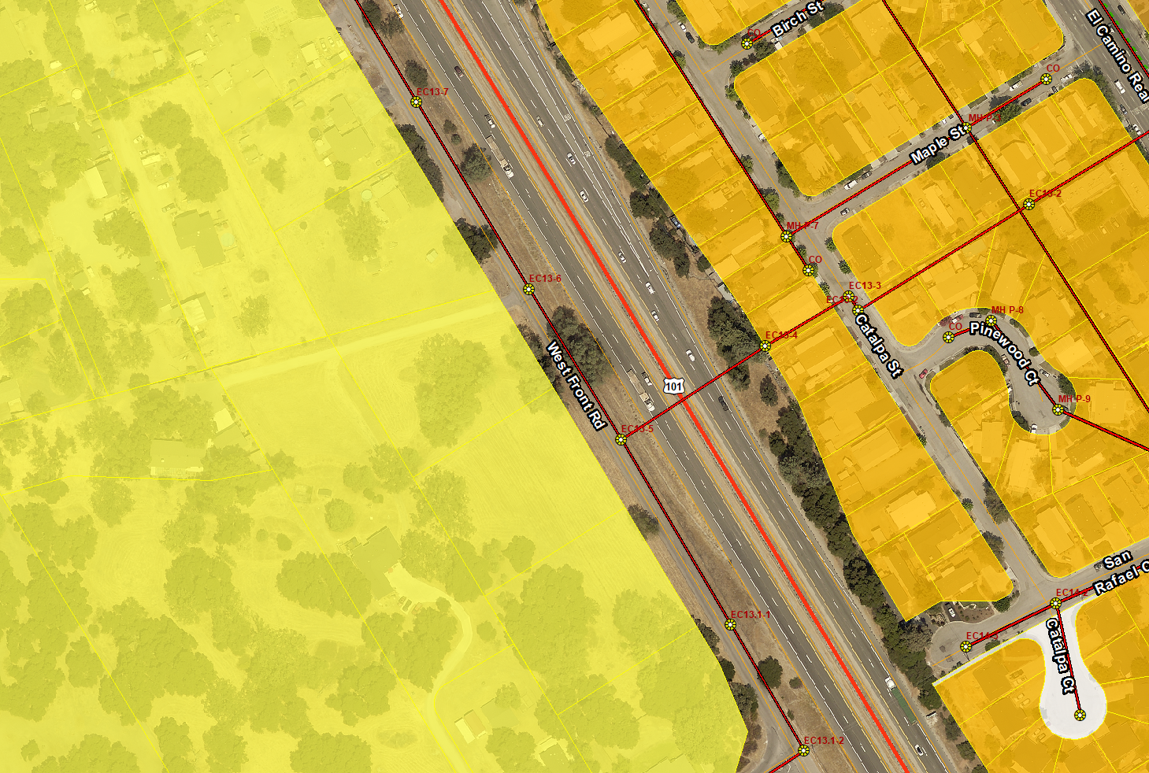
Residential Multiple Family
Residential Single Family
Building Site

Figure 1 – Location Map / General Plan & Zoning

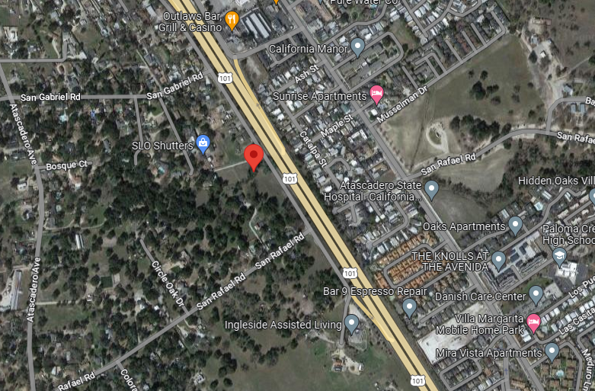
Figure 2 – 2023 Aerial Image

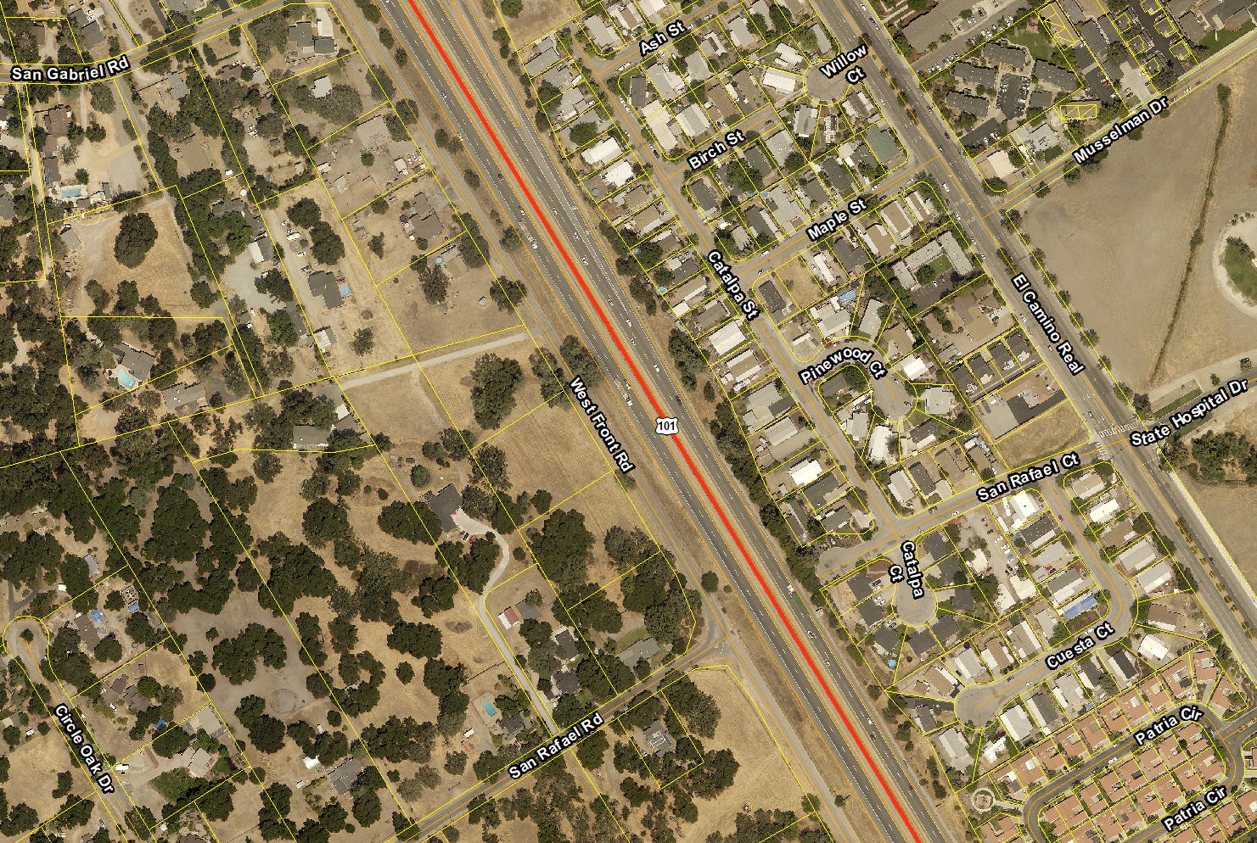

Figure 3 – Tentative Site Plan DEV21-0061
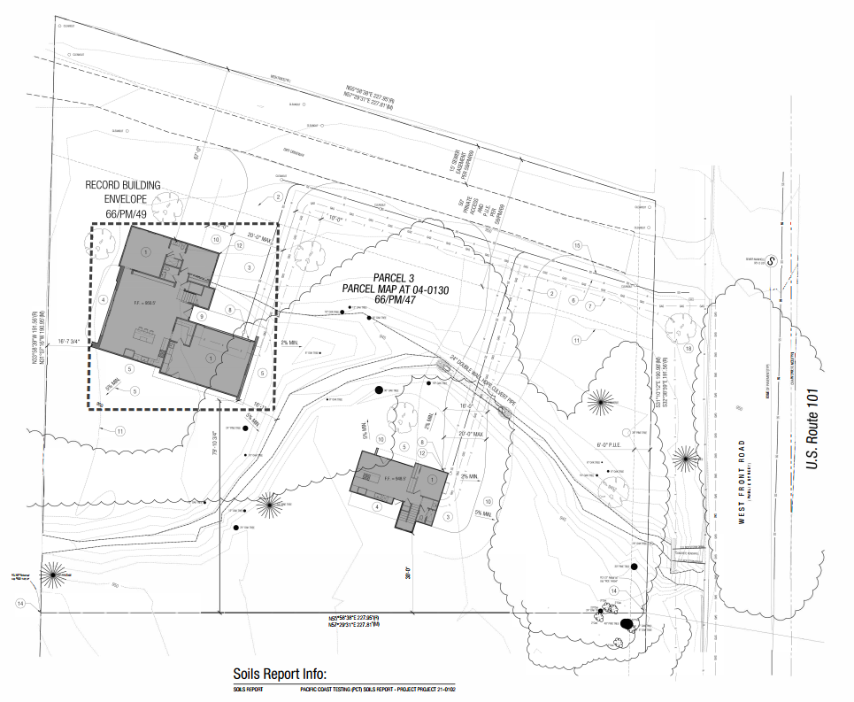
Figure 4 – Elevations & Sections

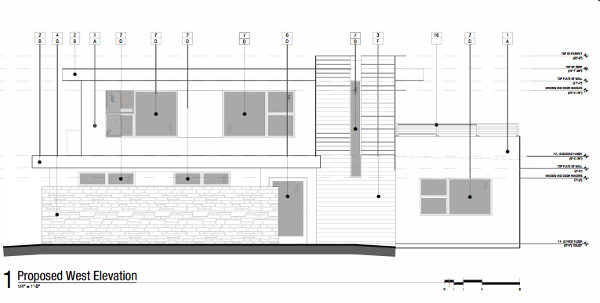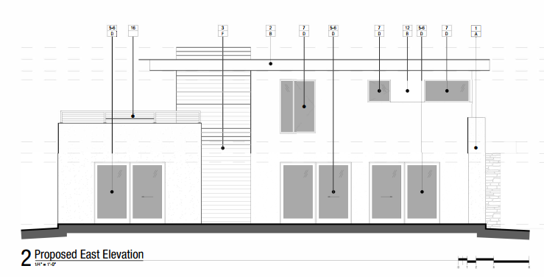
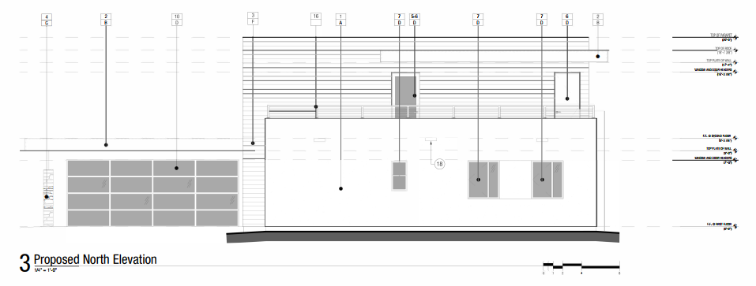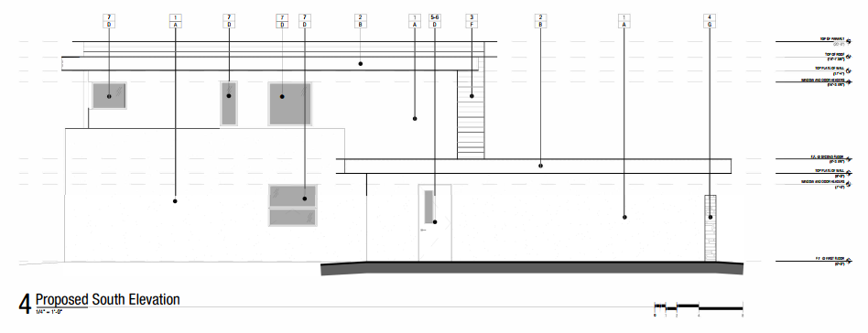

Figure 5 – Elevations & Sections
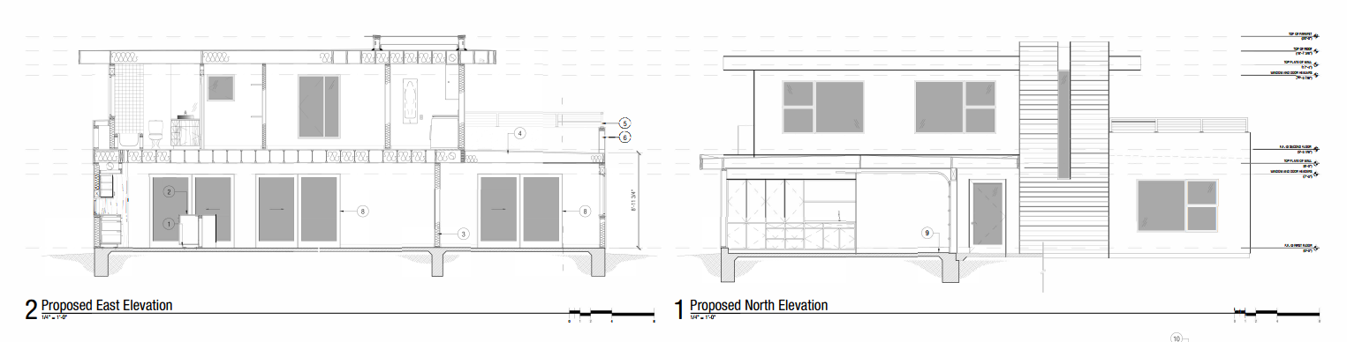
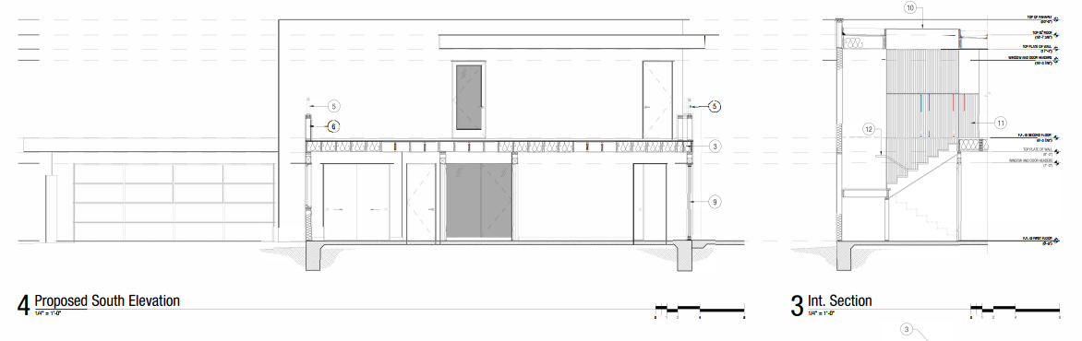
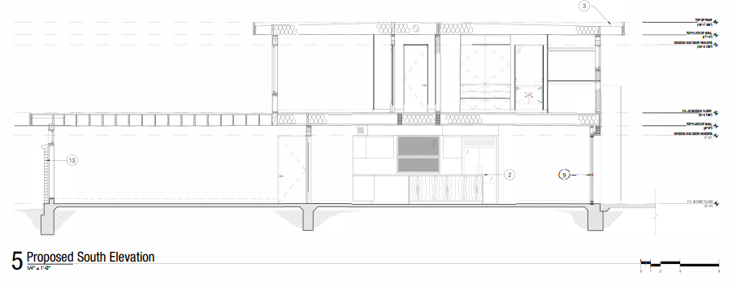

Figure 6 – Farmland Mapping

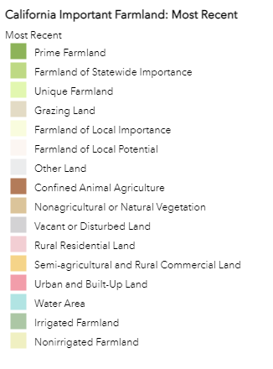
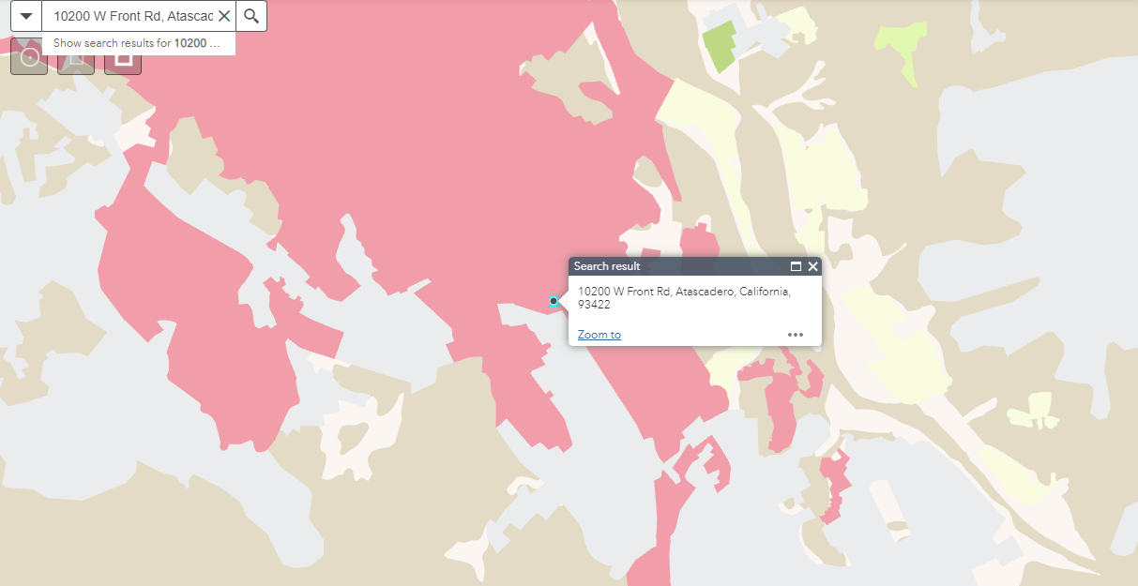

Figure 7 – Flood Zones, Hydrology, & Water Management Zones
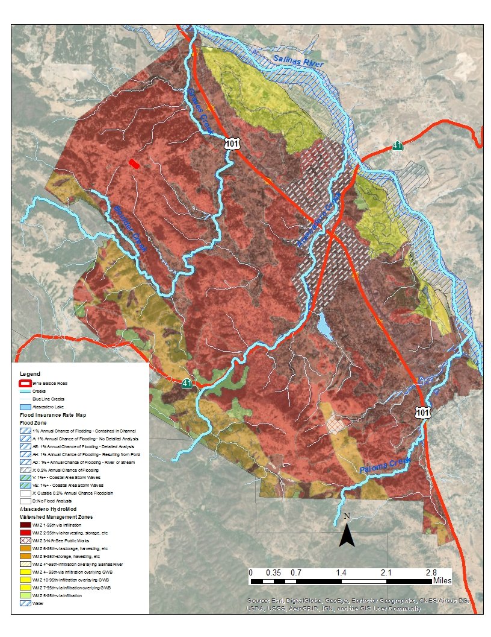
Figure 8 – Soil Erodibility

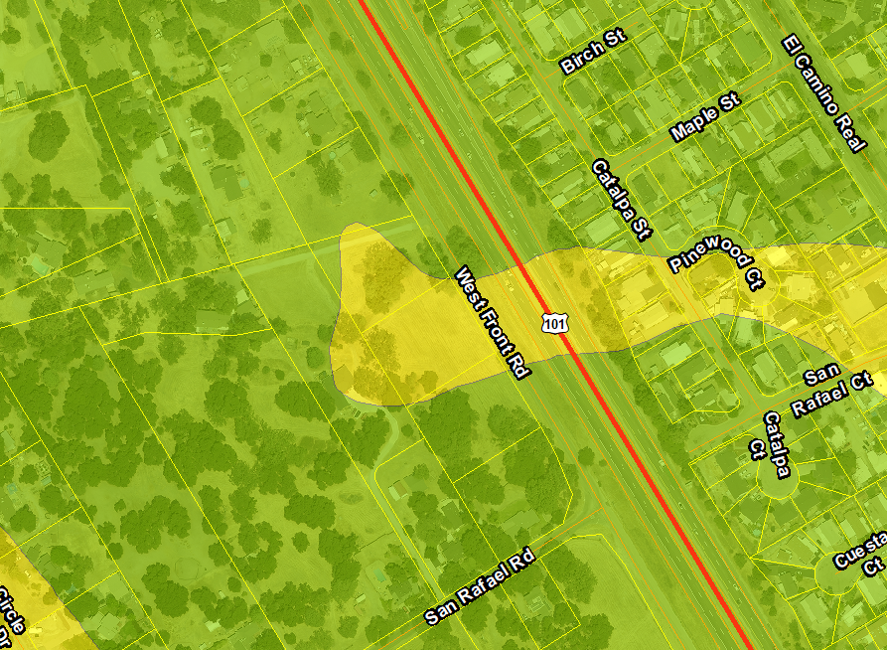
Moderate
Low to Moderate

Figure 9 – Soil Septic Suitability
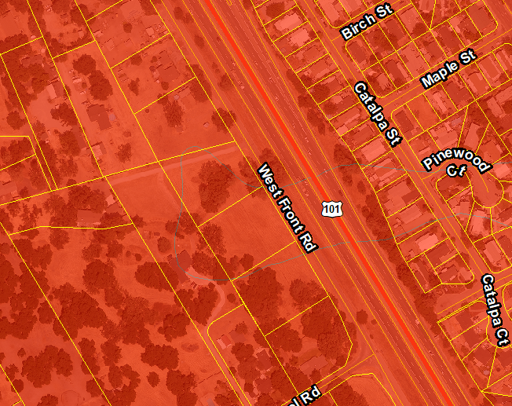
Severe: Slow percolation
Severe: Depth to rock and/or slow percolation

Figure 10 – Landslide and Liquefaction

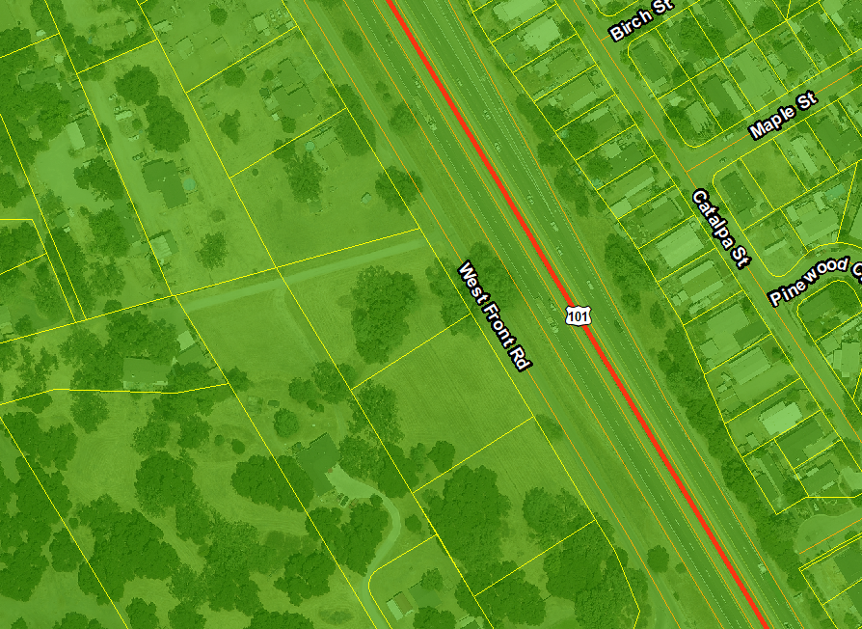
Low
Landslide
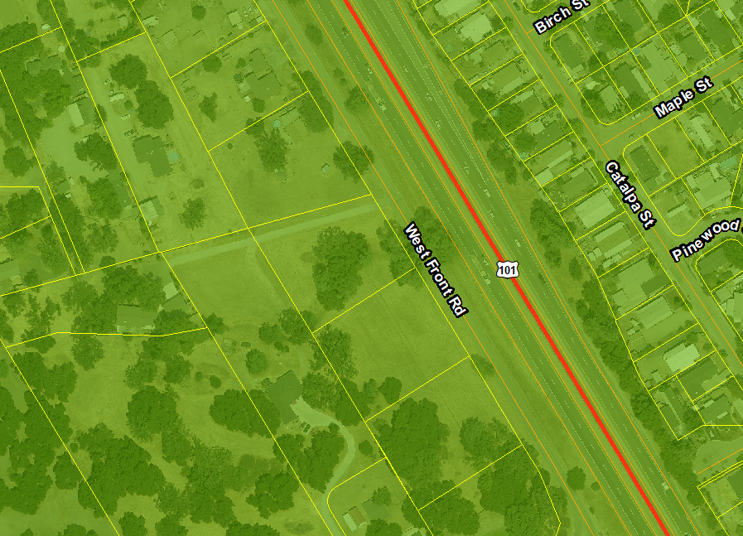
Liquefaction
Low

Figure 11 – Fire Hazard

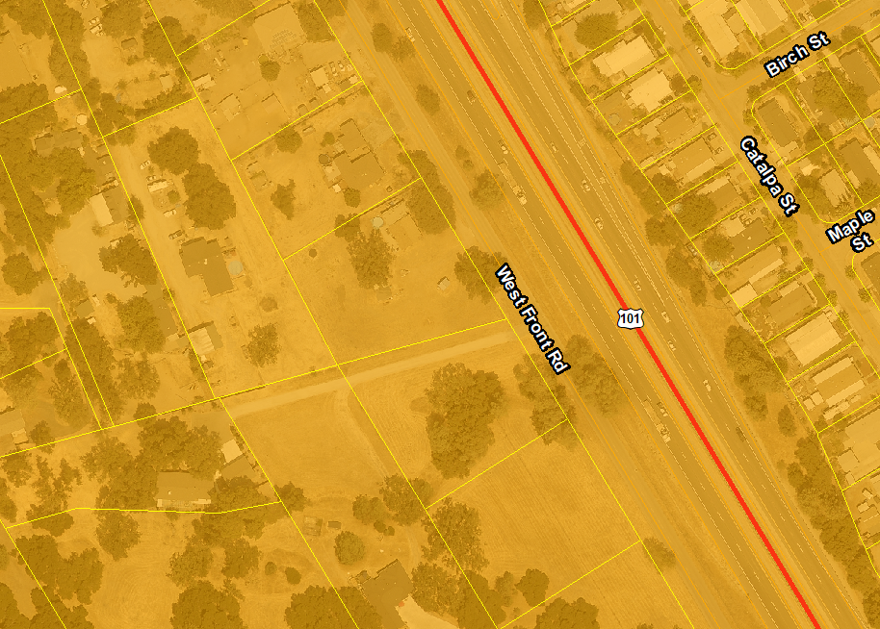
High

Figure 12 – Evacuation Map

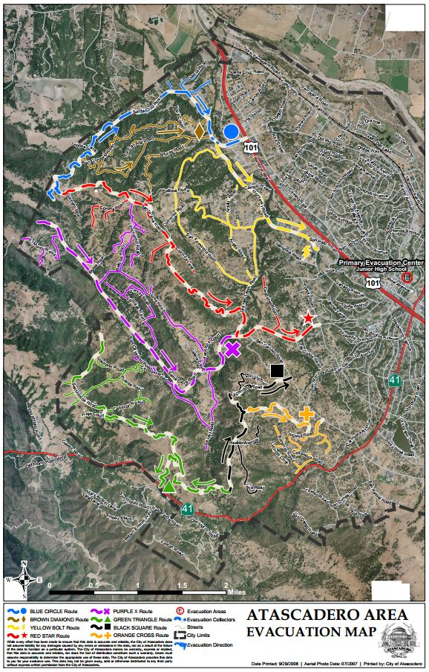

Figure 13 – Atascadero Mutual Water Company Service Area
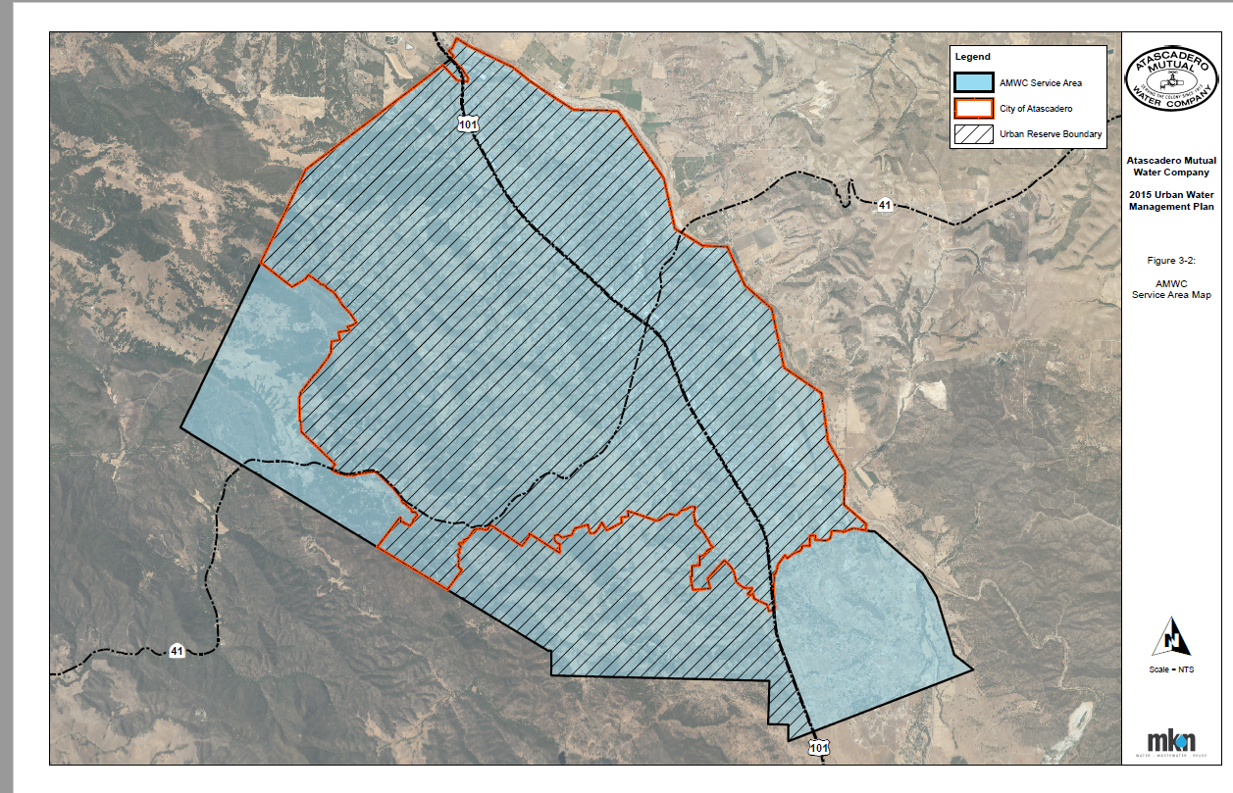

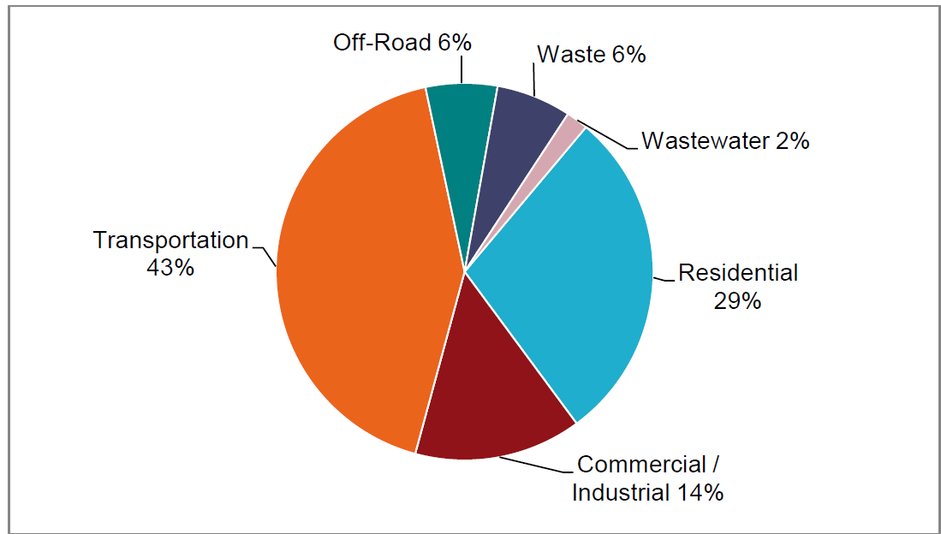
Figure 14 – Atascadero Community Wide Emissions by Sector

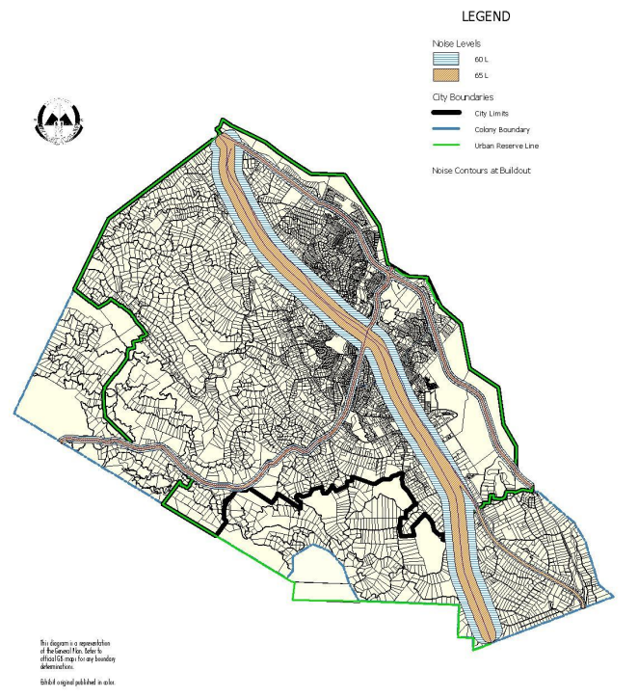
Figure 15 – Atascadero General Plan Noise Contour Map

Table 1 – San Luis Obispo Air Pollution Attainment Status
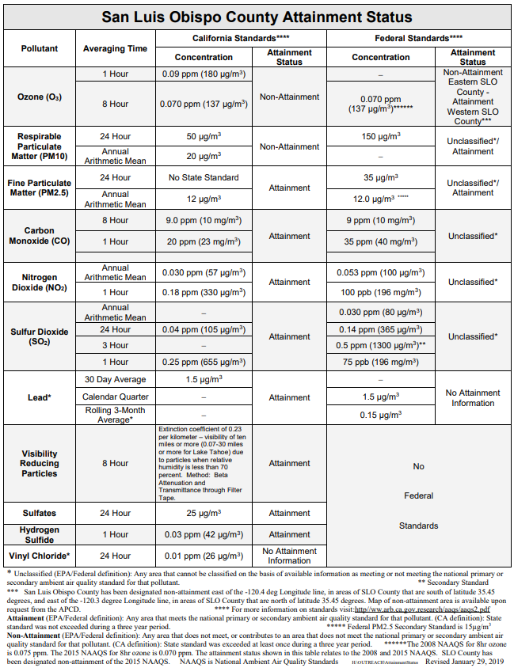

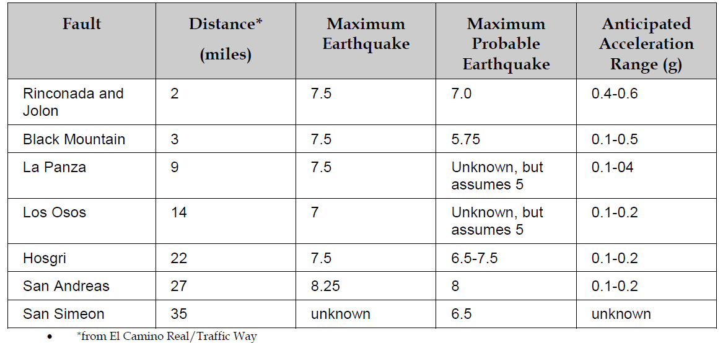
Table 2 – Potential Ground Shaking sources

Table 3 – Regional Housing Needs Allocation

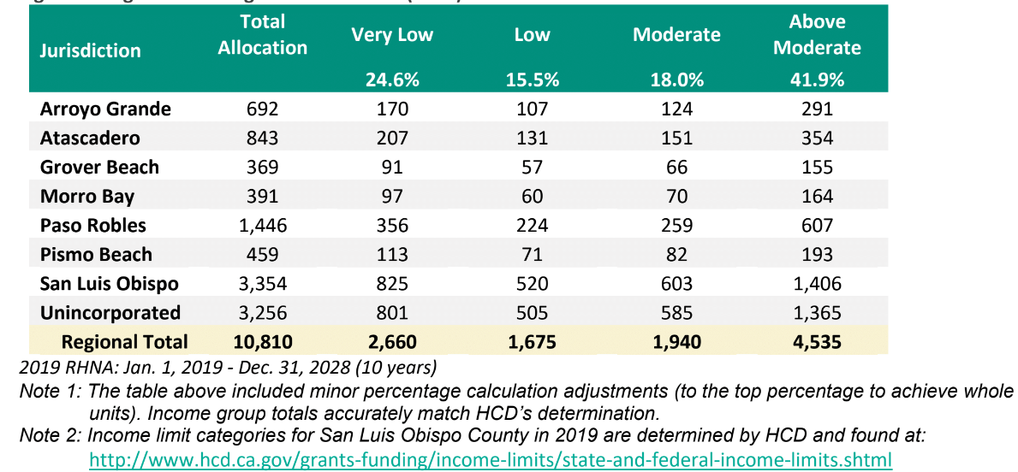

Table 4 – Atascadero Mutual Water Company Supply/Demand Projection

