NOTICE OF EXEMPTION

TO: Office of Planning and Research FROM: City of Ridgecrest
1400 Tenth Street Department of Public Works
Sacramento, California 95814 100 W. California Avenue
Ridgecrest, California 93555
X County Clerk
County of Kern California
1115 Truxtun Avenue, 1st Floor
Bakersfield, CA 93301-4639

Project Title: Bowman Flood Control Channel Culvert Crossing at Norma Street, Construction of Check Structures for Flood Flow Management Within Channel

Project Location: Bowman Channel at N. Norma St. (North of Bowman Road), Ridgecrest

Description of Nature, Purpose, and Beneficiaries: See attached project description

Public Agency Approving Project: City of Ridgecrest Public Works Department

Name of Agency Carrying Out Project: City of Ridgecrest________________________

This is to advise that the City of Ridgecrest Public Works Department has approved the above described project on _________________________ and has made the determination that the project is exempt due to the following:

Exempt Status (check one):

__ Ministerial (§ 21080 (b) (1); § 15268)
Declared Emergency (§ 21080 (b) (3); § 15269(a))
Emergency Project (§ 21080 (B) (4); § 15269(b) (c))
X Categorical Exemption: Class 1: Repair/Maintenance of Existing Facilities (§ 15301(c);
Class 2: Replacement or Reconstruction of Existing Facilities (§ 15302(c)
Statutory Exemption (§ _________)

Reason(s) why the project is exempt: The project is limited to work within an existing flood-control channel that is not connected to a natural drainage way. A habitat assessment, a field survey and a jurisdictional waters determination were performed for the project. See Project Description on following page.

Lead Agency Contact Person: Travis Reed, Public Works Director, Department of Public Works

Signature: Date: __________
Project Description:

The proposed project will install a new 6’-3” by 20’-8” corrugated steel pipe arch culvert under South Norma Street in accordance with the City’s Master Drainage Plan for Bowman Channel. Bowman Channel, originally constructed by the City, carries stormwater flows from west to east from approximately S. Downs Street to SR 178. The channel is not hydrologically connected to any natural waterway, and South Norma Street blocks flows from the west to east. As a result, storm flows pond on the west side of South Norma Street, and accumulated sediment has created a flat area in the bottom of the channel. The proposed project will connect the western upstream segment to the eastern downstream channel segments under South Norma Street to allow storm flows to flow downstream within the channel.

The eastern segment of Bowman Channel receives storm flows via two (2) 24-inch culverts that are located on the immediate northeast corner of South Norma Street and Bowman Road.

In addition to the culvert installation, the channel will be re-graded to conform to the original design grade, riprap rock will be placed along the channel, and “check structures” will be placed across the channel bed to reduce the water flow force and to trap sediment, protecting the culvert from early failure.

The habitat assessment performed for the project (ELMT Consulting, 2020) indicates that there is approximately 0.47 acre, comprising 2,065 linear feet, of jurisdictional “waters of the State” in the project footprint, and that 0.003 acre/26 linear feet would be permanently impacted (see Figure 2 below). The City will submit a Clean Water Act Section 401 WDR (water dredge-fill) application to the Lahontan Regional Water Quality Control Board, and a Lake and Streambed Alteration notification to the California Department of Fish and Wildlife to determine if permits are required. The habitat/jurisdictional waters report is available on request from the City of Ridgecrest, Department of Public Works; contact information provided above.

The project has independent utility and will not require future construction to function. The project does not require new right-of-way for construction. The project does not involve landscaping activities that use known invasive plant species. All work is within operational right-of-way.

Setting: Norma Street is bordered by residential, commercial and institutional land uses. There is no natural habitat within or immediately adjacent to the project boundaries. The habitat assessment performed for the project concluded that there is minimal to no habitat value in the engineered channel bed, and found no evidence of protected plant or animal species. See Project Location aerial view (Figure 2) below.

Beneficiaries: The general public will benefit from improved floodwater management, including reduced ponding in the channel. Reducing ponding will minimize the need for vector control in the channel.

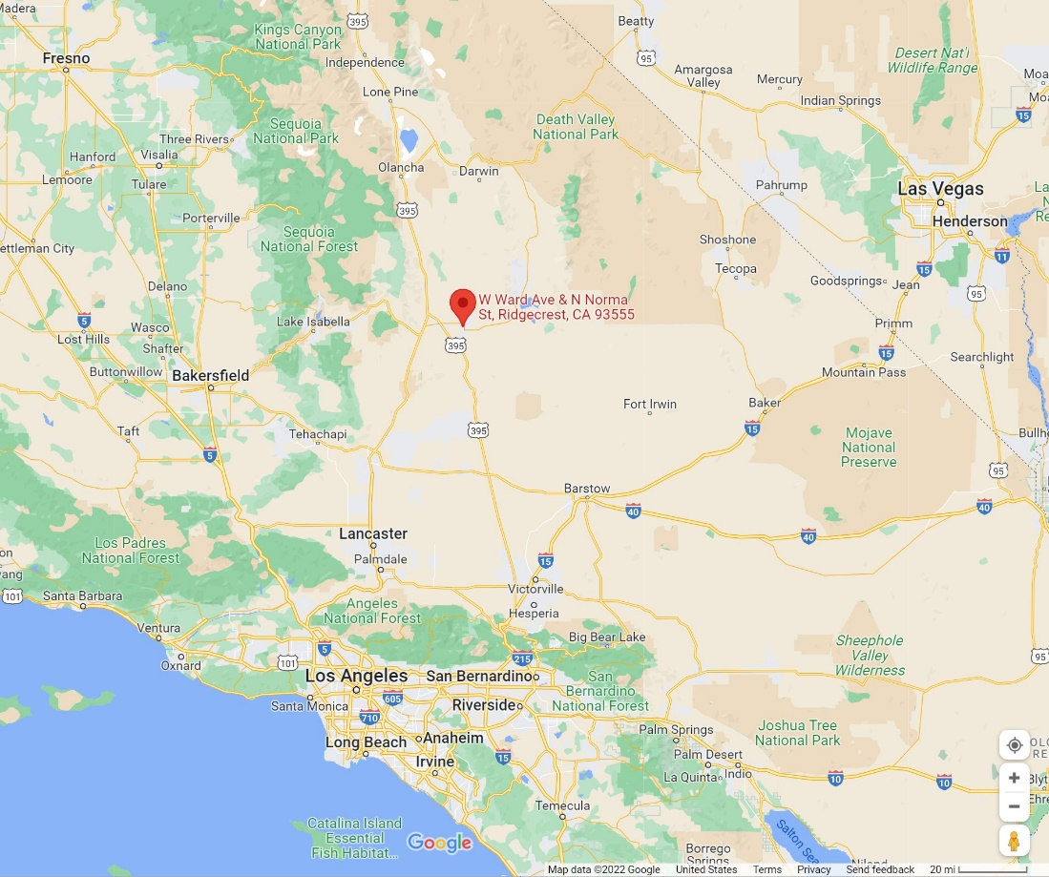
Figure 1 -Regional Location

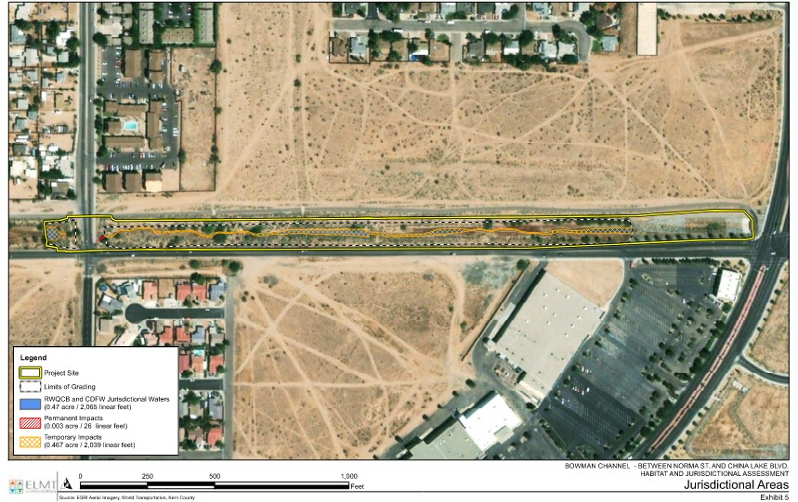
Figure 2– Project Location and Jurisdictional Areas

