September 6, 2024
Nick Graehl
California Geological Survey
715 P Street, MS 1901, Sacramento, CA 95814
To whom it may concern:
The California Geological Survey has reviewed the 2024 Draft Program Environmental Impact Report for Redondo Beach and has provided the following comments for your consideration. These comments are intended to offer insights and recommendations to ensure that the environmental impact assessment accurately reflects tsunami considerations pertinent to the project. Should you have any questions or require further clarification, do not hesitate to reach out.

- Page 5.6-5 bullet Title 10 Chapter 5. 1542.
  - Instead of an elevation datum (i.e., 15 feet MSL), consider having the applicant review the State Tsunami Hazard Area maps (https://www.conservation.ca.gov/cgs/tsunami/maps) and ASCE Tsunami Design Zone maps (https://asce7tsunami.online/) to identify their appropriate tsunami hazard.
- Page 5.9-13 Chapter 5, Coastal Land Use Plan Implementing Ordinance
  - Refer to comment 1a about using an elevation datum to define areas that require an application for development.
- Page 5.9-23 Figure 5.9-3 Tsunami Hazards Areas in Redondo Beach
  - Confirm that the mapped tsunami area shown on this figure is the California Geological Survey’s 2021 Tsunami Hazard Area Map for Los Angels County.
    - State of California, 2021. Tsunami Hazard Area Map, Los Angeles County; produced by the California Geological Survey and the California Governor’s Office of Emergency Services; dated 2021, displayed at multiple scales.
  - If it is indeed the State of California (2021) map, then update the reference within the figure (California Geological Survey 2021).
  - For clarification, the Tsunami Hazard Area maps are not inundation zones. They are intended for local jurisdictional, coastal evacuation planning uses only. They are not legal documents and do not meet disclosure requirements for real estate transactions nor for any other regulatory purpose. See the Tsunami Hazard Area online metadata for additional information. https://www.conservation.ca.gov/cgs/tsunami/maps
  - Consider including a Figure for the ASCE Tsunami Design Zones at Redondo Beach.
    - 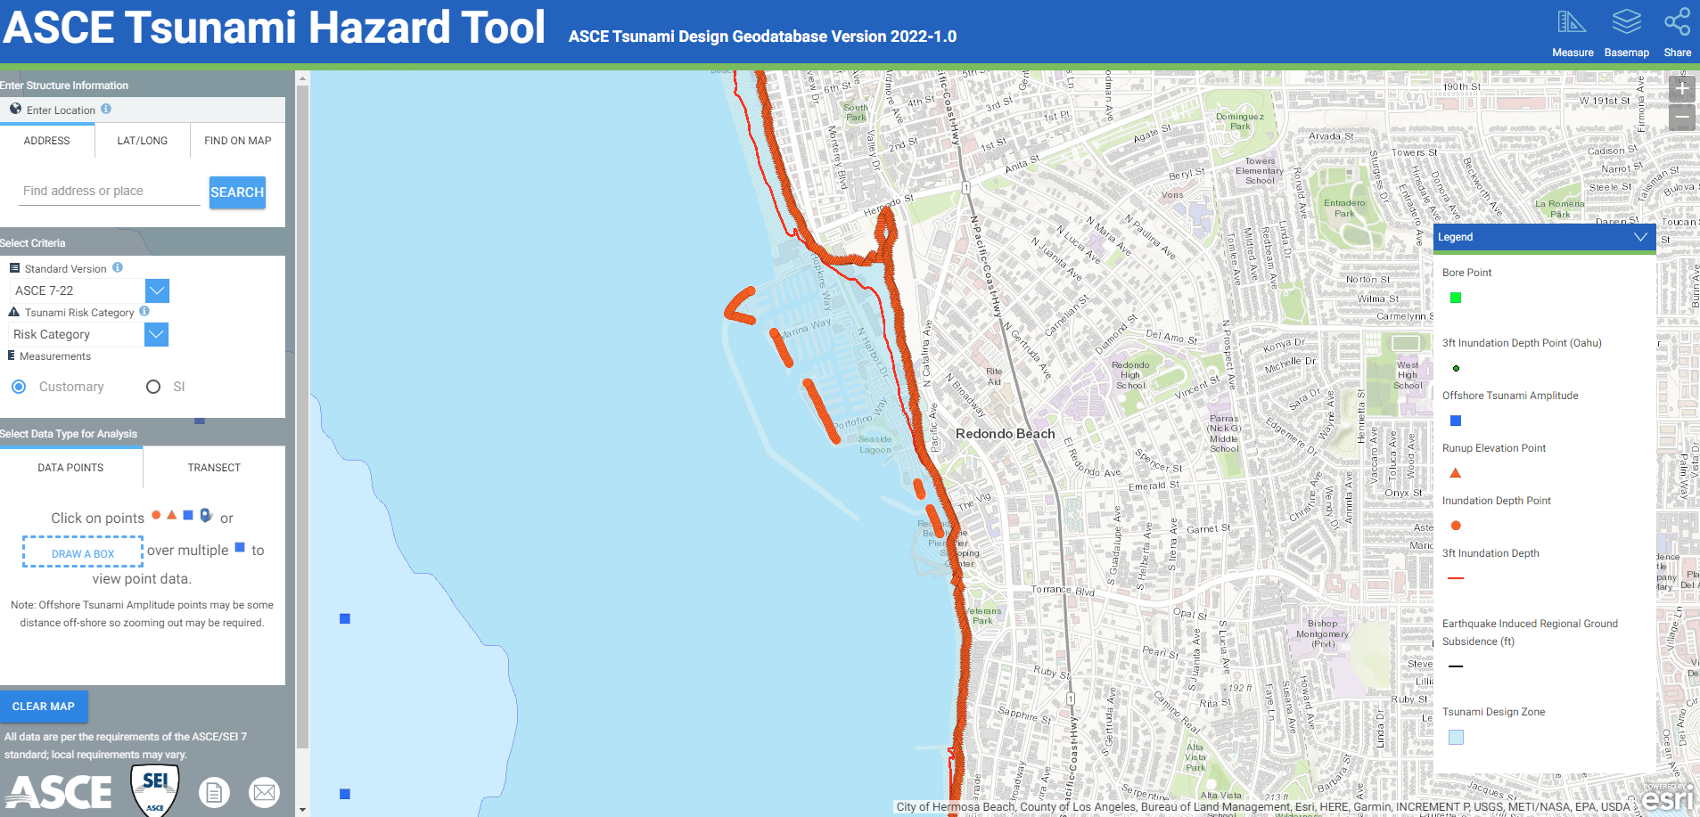
- Page 5.9-25 Tsunami
  - Consider using the term “Tsunami Hazard Area” to describe the tsunami area/maps, as these are not inundation maps. Refer to comment 3c for more information.
  - Update reference to Tsunami Hazard Area Map for Los Angeles (see 3ai).
  - Please refer to the following table for distant and local tsunami source information:
  - 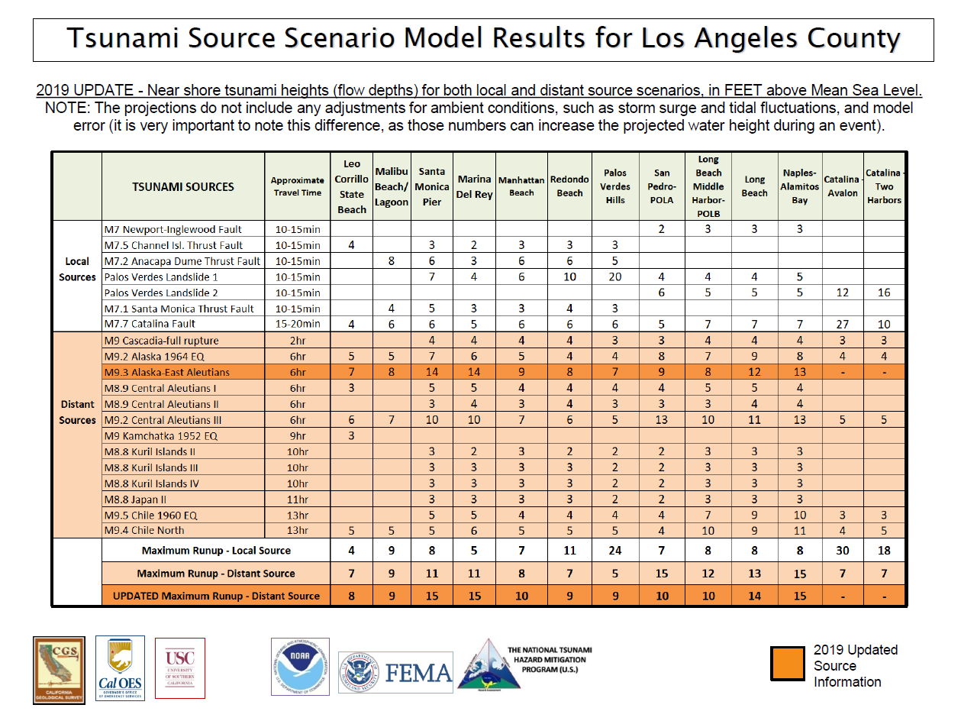
  - Please update distant/local source text in this section to align with this table.
  - Consider adding a section here on ASCE Chapter 6 standards, as they are used in the CBC for specific risk category structures.
- Page 5.9-26 Seiche
  - Consider that seiche may occur within King Harbor.
- Page 5.9-40 Pollutant Release from Dam Inundation, Tsunamis, and Seiches
  - See comment 4a on “Tsunami Hazard Area”.
  - CGS has completed Probabilistic Tsunami Hazard Analyses (PTHA) at several return periods (i.e., 72, 100, 200, 475, 975, 2475, 3000-year average return periods) found online here: https://www.conservation.ca.gov/cgs/tsunami/reports#other
  - 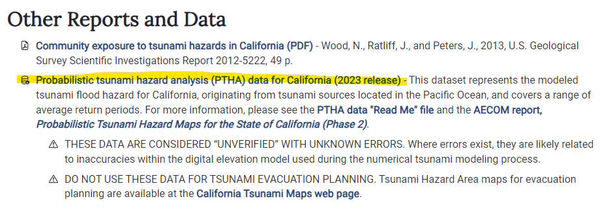
  - The PTHA data can be used to assess the impact of tsunami at Redondo Beach at each return period.
  - 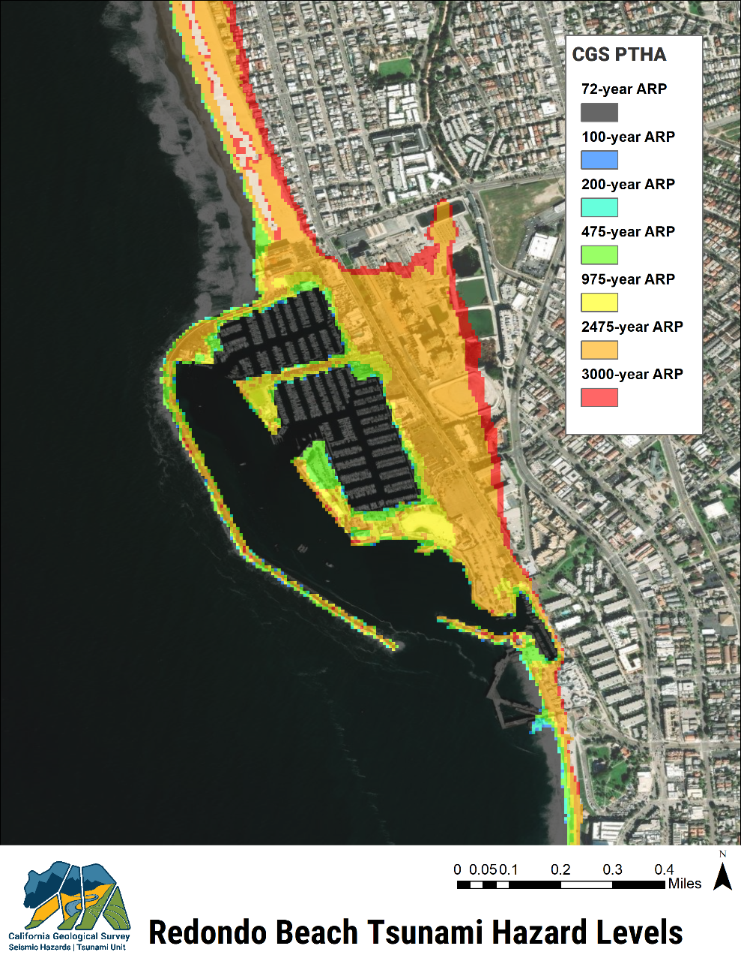
  - The National Tsunami Warning Center (NTWC) provides tsunami alert information to the public. NTWC does not provide information on evacuation orders/warnings; that is done by local officials. Consider modifying text to clarify the difference.
- Page 5.9-43 References
  - Update tsunami map reference (see comment 3ai).
  - Consider adding a reference to the ASCE Chapter 6 tsunami standards and online ASCE Tsunami Hazard Tool (https://asce7tsunami.online/)
- Page 5.9-44 References
  - 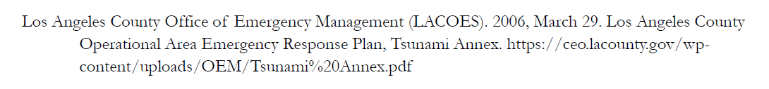
  - Consider using a newer LA County Office of EM’s OA Emergency Response Plan Tsunami annex, if available. The 2006 Tsunami Annex predates both of our CGS 2021 Tsunami Hazard Area maps and 2009 Tsunami Inundation Maps.
- Page 13-3 Reference
  - Update reference (see comment 3ai)

Very respectfully,

 | Nick Graehl  Engineering Geologist | Tsunami Unit  California Geological Survey  715 P St, MS-1901 Sacramento, CA 95814  M: (661) 549-7788 W: (916) 879-1850  Nicholas.Graehl@conservation.ca.gov  State Tsunami Info: www.tsunami.ca.gov
CONFIDENTIALITY NOTICE: This communication with its contents may contain confidential and/or legally privileged information. It is solely for the use of the intended recipient(s). Unauthorized interception, review, use or disclosure is prohibited and may violate applicable laws including the Electronic Communications Privacy Act. If you are not the intended recipient, please contact the sender and destroy all copies of the communication.

