
NOTICE OF INTENT TO ADOPT A MITIGATED NEGATIVE DECLARATION
NOTICE O
AND NOTICE OF PUBLIC HEARING

Notice is hereby given that the public agency named below has completed an Initial Study of the following described project at the following location: 755 and 855 Ashley Way, Colton CA
Public Agency/Lead Agency: |  | City of Colton
Project Name: |  | Ashley Furniture
Project Location – 755 and 855 Ashley Way, Colton, CA 92343  APNs: 0276-131-92, 0276-131-90 |  | DAP-001-745- Architectural and Site Plan Review for a 40,000 sf addition to an existing furniture store, lot line adjustment, landscape improvements, and site improvements on a 3.71 acre parcel within C-2 (General Commercial) zone and DAP-001-746- Architectural and Site Plan Review for removal of 2 service bays to an existing building, lot line adjustment, landscape improvements, and site improvements on a 4.85 acre parcel within M-1 (Light Industrial) zone.
This Initial Study was completed in accordance with the Lead Agency’s Guidelines for Implementing the California Environmental Quality Act. This Initial Study was undertaken for the purpose of deciding whether the project may have a significant effect on the environment. On the basis of such Initial Study, the Lead Agency’s Staff has concluded that the project will not have a significant effect on the environment and has therefore prepared a Draft Mitigated Negative Declaration. The Initial Study reflects the independent judgment of the Lead Agency.
The Project site IS on a list compiled pursuant to Government Code section 65962.5.
The Project site IS NOT on a list compiled pursuant to Government Code section 65962.5.
The proposed project IS considered a project of statewide, regional or area wide significance.
The proposed project IS NOT considered a project of statewide, regional or area wide significance.
The proposed project WILL affect highways or other facilities under the jurisdiction of the State Department of Transportation.
The proposed project WILL NOT affect highways or other facilities under the jurisdiction of the State Department of Transportation.
A scoping meeting WILL be held by the Lead Agency.
A scoping meeting WILL NOT be held by the Lead Agency
If the project meets the criteria requiring the scoping meeting, or if the agency voluntarily elects to hold such a meeting, the date, time and location of the scoping meeting are as follows:
Date: N/A |  |  | Time: N/A | Location: N/A
Copies of the Initial Study and Draft Mitigated Negative Declaration are on file and are available for public review at the Lead Agency’s office, located at: 659 N. La Cadena Drive, Colton, California 92324
The proposed Mitigated Negative Declaration can be obtained in electronic format by the following method: A copy may be viewed
at the Development Services webpage at: http://www.ci.colton.ca.us/index.aspx?nid=779
Lead Agency address: 659 N. La Cadena Drive, Colton, CA 92324
Comments will be received from April 24 to May 15, 2023 (20-day circulation)
Any person wishing to comment on this matter must submit such comments, in writing, to the Lead Agency on or prior to
May 15, 2023. Comments of all Responsible Agencies are also requested.
The City of Colton, acting as the Lead Agency under CEQA, will consider the project and the Draft Negative Declaration at its meeting on:
Date: May 23, 2022 | Time: 5:30 p.m. in City Hall Council Chambers, 650 N. La Cadena Dr., Colton, CA 92324
If the Lead Agency finds that the project will not have a significant effect on the environment, it may adopt the Mitigated Negative Declaration. This means that the Lead Agency may proceed to consider the project without the preparation of an Environmental Impact Report.

Ashley Furniture Site


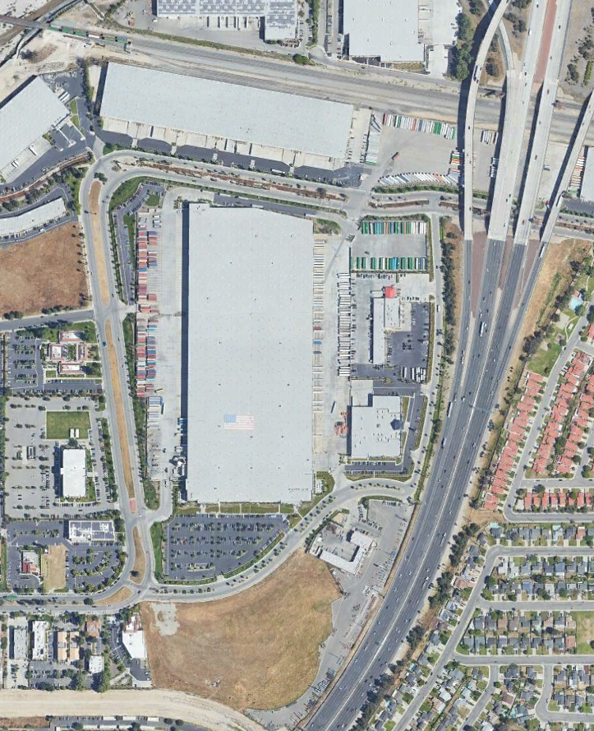
Ashley Way
Project
Site
Ashley Way
Cooley Dr.
Cooley Dr.

