Notice of Exemption Appendix E

To: Office of Planning and Research
P.O. Box 3044, Room 113 Sacramento, CA 95812-3044
County Clerk
From: (Public Agency):
California Department of Parks and Recreation; State Parks

County of:
Orange

(Address)
3030 Avenida del Presidente
San Clemente CA 92672

Project Title:

Bolsa Chica State Beach Emergency Asphalt Repairs 22/23

Project Applicant:

California Department of Parks and Recreation; State Parks

Project Location - Specific:

Bolsa Chica State Beach.
17851 Pacific Coast Hwy, Huntington Beach, CA

Project Location - City:

Huntington Beach

Project Location - County:

Orange

Description of Nature, Purpose and Beneficiaries of Project:
This project is in response to damage caused by king tide and storm damage which occurred during January 2023 that flooded portions of Bolsa Chica State Beach, causing damage to the internal access road along Pacific Coast Highway (SR-1). The damaged sections of asphalt will be repaired based on their original design. The entire stretch of service road should be re-surfaced with slurry to seal the joint between the asphalt and the curb.
Name of Public Agency Approving Project: California Department of Parks and Recreation; State Parks

Name of Person or Agency Carrying Out Project: California State Parks

Exempt Status: (check one):
Ministerial (Sec. 21080(b)(1); 15268);
Declared Emergency (Sec. 21080(b)(3); 15269(a)); Emergency Project (Sec. 21080(b)(4); 15269(b)(c));
Categorical Exemption. State type and section number: Class 2; Section 15302
X

Statutory Exemptions. State code number:
Reasons why project is exempt:
The project is considered maintenance and improvement to existing infrastructure. No potential for significant impacts to the environment is anticipated in compliance with Section 15300.4. To avoid, minimize, or mitigate potential impacts of the project to below a significant level, the Department (and its contractors) shall following all avoidance and minimization measures outlined in the Project Evaluation Form. If the project is implemented as indicated within the project description, then it is exempt under CEQA §15302 – Replace or Reconstruct. The action falls under the Departmental List of Exempt activities according to CEQA §15300.4 as outlined in the Department of Operations Manual, Chapter 0600:

Class 2, Section 15302: “Replace or Reconstruct”

Lead Agency

Contact Person: Joe Fayer Area Code/Telephone/Extension: (949) 366-8526

If filed by applicant:
- Attach certified document of exemption finding.
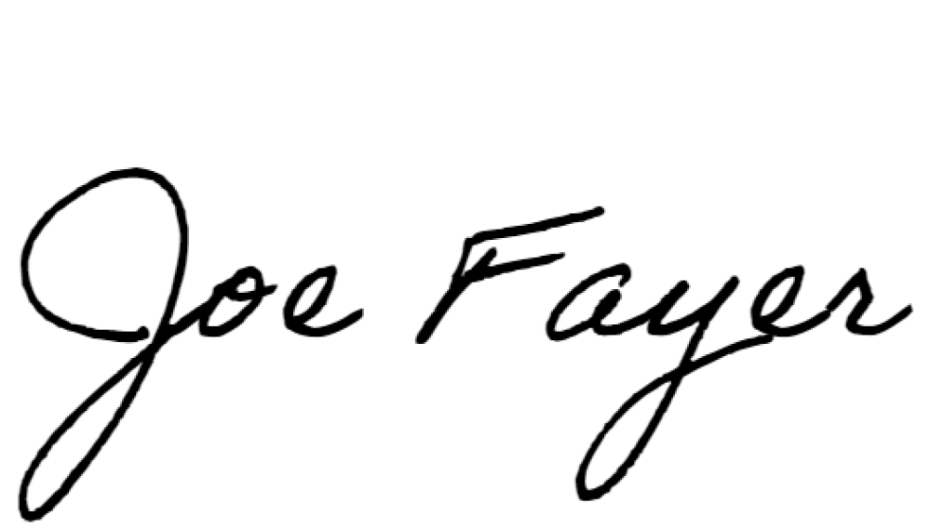
- Has a Notice of Exemption been filed by the public agency approving the project? Yes No
■

Signature: Date:

03/09/2023

Title:
Associate State Archaeologist

Print Form
Signed by Lead Agency Signed by Applicant
■
■

Authority cited: Sections 21083 and 21110, Public Resources Code. Date Received for filing at OPR: Reference: Sections 21108, 21152, and 21152.1, Public Resources Code.

Revised 2011

