California Environmental Quality Act (CEQA)
Initial Study/Mitigated Negative Declaration
Rancho 38 Industrial Project
LDP 23-01
South of the Rancho Road and Emerald Road Intersection



Lead Agency
City of Adelanto
Development Services – Planning Division
11600 Air Expressway
Adelanto, CA 92301

Project Proponent
IPG Rancho 38 Holdings, LLC
℅ Industrial Property Group, Inc
10515 20th Street Southeast
Lake Stevens, WA 98258

Prepared By
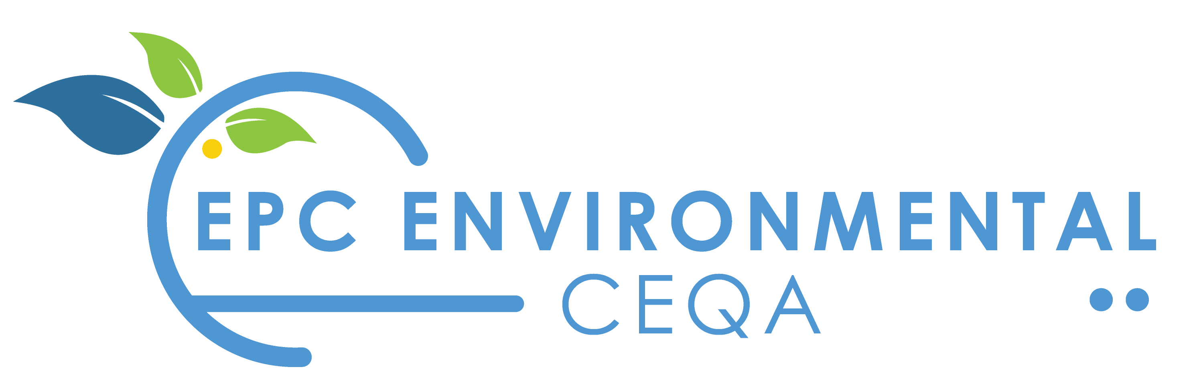

11801 Pierce Street, Ste. 200
Riverside, CA 92505

March 8, 2023

Contents
1.0 Background Information 1
2.0 Introduction 4
2.1 Purpose of the Initial Study/Mitigated Negative Declaration 4
2.2 Environmental Impacts Requiring Mitigation 4
3.0 Project Description/Environmental Setting 8
3.1 Project Location 8
3.2 Project Description 8
3.3 Proposed Improvements 8
3.4 Construction and Operational Characteristics 14
3.5 Environmental Setting 14
4.0 Environmental Analysis 18
4.1 Aesthetics 19
4.2 Agriculture and Forestry Resources 23
4.3 Air Quality 26
4.4 Biological Resources 33
4.5 Cultural Resources 41
4.6 Energy 43
4.7 Geology and Soils 45
4.8 Greenhouse Gas Emissions 50
4.9 Hazards and Hazardous Materials 53
4.10 Hydrology and Water Quality 59
4.11 Land Use and Planning 64
4.12 Mineral Resources 66
4.13 Noise 67
4.14 Population and Housing 79
4.15 Public Services 81
4.16 Recreation 83
4.17 Transportation 84
4.18 Tribal Cultural Resources 88
4.19 Utilities and Service Systems 91
4.20 Wildfire 97
4.21 Mandatory Findings of Significance 98
Figures
Figure 3-1 Regional Map 9
Figure 3-2 Local Area Map 10
Figure 3-3 Aerial View 11
Figure 3-4 Site Plan 13
Figure 3-5 Aerial View of Adjacent Land Uses 16
Figure 3-6 Street Views 17
Figure 4.1-1 Architectural Elevations 21
Figure 4.9-1 Southern California Logistics Airport Compatibility Review Areas 56
Figure 4.13-1 Noise Measurement Locations 68
Figure 4.13-2 National Transportation Noise Map: Adelanto Area 70
Figure 4.13-3 Long-Range Noise Contours 78

Tables
Table 2-1 Summary of Environmental Impacts and Mitigation Measures 4
Table 3-1 Land Uses, General Plan Land Use Designations, and Zoning Classifications 15
Table 4.3-1 Attainment Status of Criteria Pollutants in the Mojave Desert Air Basin 27
Table 4.3-2 MDAQMD Air Quality Significance Thresholds 29
Table 4.3-3 Construction Emissions 29
Table 4.3-4 Operational Emissions (Average of Summer and Winter) 30
Table 4.4-1 Presence of Candidate, Sensitive, or Special Status Wildlife Species 35
Table 4.8-1 Project Greenhouse Gas Emissions (Annual) 51
Table 4.8-2 Project Greenhouse Gas Emissions Summary 51
Table 4.10-1 Pre-Development vs. Post Development Storm Water Runoff 62
Table 4.13-1 Occupied Structures/Receptors 67
Table 4.13-2 Ambient Noise Level Measurements 67
Table 4.13-3 Construction Equipment Noise Levels at the Nearest Sensitive Receptor (Adelanto Medical Center) 71
Table 4.13-4 Construction Equipment Noise Levels at the Nearest Sensitive Receptor (Western States Wholesale Building Materials) 71
Table 4.13-5 Worst Case Construction Noise Levels (Site Preparation and Grading) 73
Table 4.13-6 Reference Noise Level Measurements 74
Table 4.13-7 Vibration Source Levels for Construction Equipment 76
Table 4.17-1 Rancho 38 Warehouse – Employment Estimates 85
Table 4.17-2 Project VMT Analysis 86
Table 4.17-3 Roadway VMT within San Bernardino County 86

Appendices
Appendix A Title Insurer Packet Zoning Summary, PZR Report, August 30, 2022
Appendix B Phase 1 Environmental Site Assessment, WSP USA Environmental & Infrastructure Inc., October 19, 2022
Appendix C Air Quality/GHG Assessment, KPC EHS Consultants, February 11, 2023
Appendix D Biological Resources Assessment, ELMT Consulting, November 16, 2022
Appendix E Historical/Archaeological Resources Survey Report, CRM TECH, January 15, 2023
Appendix F Preliminary Geotechnical Evaluation, LGC Geotechnical, Inc., November 30, 2022
Appendix G Preliminary Hydrology Study, Keir + Wright, February 28, 2023
Appendix H Water Supply Assessment, KPC EHS Consultants, LLC, January 30, 2023
Appendix I Sewer and Water Analysis, Kier + Wright, November 18, 2022
Appendix J Noise Assessment, KPC EHS Consultants, February 14, 2023
Appendix K Traffic Impact Analysis, David Evans and Associated Inc., March 5, 2023
Appendix L Vehicle Miles Traveled (VMT) Analysis, General Technologies and Solutions, February 24, 2023
Appendix M Determination of No Hazard to Air Navigation, Federal Aviation Administration, December 1, 2022

Background Information
1. Project Title: Location and Development Plan 23-01, Rancho 38 Industrial Project.
2. Lead Agency Name, Address, and Telephone Number: Development Services-Planning Division, 11600 Air Expressway, Adelanto, CA 92301
3. Description of Project: The Applicant is proposing to develop a 689,824-square-foot warehouse/‌distribution building including on an approximately 39.24-acre vacant parcel. (See 3.0, Project Description, for additional details.
4. Project Location: The proposed project site is located on the south side of Rancho Road, on the southwest corner of the intersection of Rancho Road and Emerald Road, and is also referred to as San Bernardino County Tax Assessor’s Parcel Number (APN) 3128-291-02.
5. General Plan and Zoning Designation: Light Manufacturing (LM). The LM district provides for a more limited range of uses, including only light industrial and manufacturing uses that benefit from separation from residential, office, and retail districts.
6. Other Public Agencies whose Approval is Required: Issuance of building permits, and completion of structures to current building code are required by the City prior to the establishment of the use. Additionally, approvals from the following agencies are required:
- Lahontan Regional Water Quality Control Board (National Pollutant Discharge Elimination System Permit and Report of Waste Discharge)
- Mohave Desert Air Quality Management District (Authority to Construct)
7. Native American Tribal Consultation: The City commenced the AB 52 process by sending consultation invitation letters to tribes previously requesting notification pursuant to Public Resources Code §21080.3.1. The Project site is located within Serrano ancestral territory and, therefore, is of interest to the Yuhaaviatam of San Manuel Nation (YSMN). As a result, Mitigation Measure TCR-1 is included in the project/permit/plan conditions.

Significant or Potentially Significant Environmental Factors
The following environmental factors have been evaluated in this Initial Study to determine if development of the Project will result in a Significant or Potentially Significant impact(s) to the environment that cannot be mitigated to a level of insignificance. The environmental factors checked below require mitigation measures to reduce impacts to a level of insignificance.

Aesthetics | Mineral Resources
Agriculture and Forestry Resources | Noise
Air Quality | Population/Housing
Biological Resources | Public Services
Cultural Resources | Recreation
Energy | Transportation
Geology/Soils | Tribal Cultural Resources
Greenhouse Gas Emissions | Utilities/Service Systems
Hazards and Hazardous Materials | Wildfire
Hydrology/Water Quality | Mandatory Findings of Significance
Land Use/Planning

Because the environmental factors above have been mitigated to less than significant, the adoption of a Mitigated Negative Declaration is recommended. View Table 2-1 below for further information.

Determination
Based on this initial evaluation:
I find that the proposed use COULD NOT have a significant effect on the environment, and a NEGATIVE DECLARATION will be recommended for adoption.
I find that although the proposal could have a significant effect on the environment, there will not be a significant effect in this case because revisions in the Project have been made by or agreed to by the Project Applicant. A MITIGATED NEGATIVE DECLARATION will be recommended for adoption.
I find that the proposal MAY have a significant effect on the environment, and an ENVIRONMENTAL IMPACT REPORT is required.
I find that the proposal MAY have a significant effect(s) on the environment, but at least one effect 1) has been adequately analyzed in an earlier document pursuant to applicable legal standards, and 2) has been addressed by mitigation measures based on the earlier analysis as described on attached sheets if the effect is a “potentially significant impact” or “potentially significant unless mitigated.” An ENVIRONMENTAL IMPACT REPORT is required, but it must analyze only the effects that remain to be addressed.
I find that although the proposed Project could have a significant effect on the environment, because all potgentially significnat effect (a) have been analyzed adequately in an earlier EIR or NEGATIVE DECLARATION, pursuant to all applicable standards, and (b) have been avoided or mitigated pursuant to that earlier EIR or NEGATIVE DECLARATION, including revisions or mitigation measures are are imposed upon the proposed Project, nothing further is required.

James Hirsch |  | City of Adelanto
Signature |  | Lead Agency
James Hirsch, Contract Planner |  | 3/7/23
Printed Name/Title |  | Date

Introduction

Purpose of the Initial Study/Mitigated Negative Declaration
An Initial Study is a preliminary analysis conducted by the City of Adelanto (City) to determine if a project may have a significant physical effect on the environment. The Initial Study also aids in determining what type of environmental document to prepare:
- Negative Declaration: If the initial study concludes that the project will not cause a significant effect on the environment, the city can prepare a Negative Declaration. (California Public Resources Code §21080(c); CEQA Guidelines §15070 et seq. (negative declaration process). A Negative Declaration is a written statement that an EIR is not required because a project will not have a significant adverse impact on the environment. (California Public Resources Code §§21064, 21080(c).)
- Mitigated Negative Declaration: The City may attach conditions to a Negative Declaration for the purpose of mitigating potential environmental effects. This is referred to as a “Mitigated Negative Declaration” (CEQA Guidelines §15070(b); Public Resources Code §21064.5). A Mitigated Negative Declaration states that revisions in the project made or agreed to by the applicant would avoid the potentially significant adverse impacts, and that there is no substantial evidence that the revised project will have a significant effect on the environment. (California Public Resources Code §21064.5; CEQA Guidelines §15070(b).
- Environmental Impact Report: If the Initial Study determines that there are potentially significant physical effects on the environment that cannot be mitigated to a less than significant level, the city will prepare an Environmental Impact Report. Environmental Impact Reports are reports to inform the public and City decision-makers of significant environmental effects of proposed projects, identify possible ways to minimize those effects, and describe reasonable alternatives to those projects.
Based on the Initial Study prepared for the Project, it is recommended that a Mitigated Negative Declaration be adopted.

Environmental Impacts Requiring Mitigation
Table 2-1 lists all the Mitigation Measures contained in this ISMND document.

Summary of Environmental Impacts, Mitigation Measures, and Best Management Practices
Environmental Impact | Mitigation Measures (MM) or Best Management Practices (BMPs)
4.3 (b) Air Quality  Although the Project will not exceed air quality emission thresholds established by the MDAQMD, BMPs are recommended to reduce impacts to the maximum extent feasible. | BMP-AQ-1 TRU Electrical Connections: Electrical hookups shall be provided as part of the tenant improvements for any tenant that requires cold storage. The electrical hookups shall be provided at loading bays for truckers to plug in any onboard auxiliary equipment and power refrigeration units while their truck is stopped.  BMP-AQ-2 Truck Access Gate Signage: All truck access gates and loading docks within the project site shall have a sign posted that states:  - Truck drivers shall turn off engines when not in use.  - Truck drivers shall shut down the engine after five minutes of continuous idling operation once the vehicle is stopped, the transmission is set to “neutral” or “park”, and the parking brake is engaged.  - Telephone numbers of the building facilities manager and CARB to report Violations.
4.4 (a) Biological Resources  Construction will impact species identified as a candidate, sensitive, or special status species in local or regional plans, policies, or regulations, or by the California Department of Fish and Wildlife or U.S. Fish and Wildlife Service. | MM BIO-1. Burrowing Owl Pre-Construction Survey. Prior to any ground disturbance, pre-construction surveys for Burrowing Owls on the project site and in the surrounding area in accordance with the Staff Report on Burrowing Owl Mitigation, State of California Natural Resource Agency, Department of Fish and Game, May 7, 2012, shall be conducted no more than 14-days prior to the beginning of project activities, and a secondary survey must be conducted by a qualified biologist within 24 hours prior to the beginning of project construction to determine if the project site contains suitable burrowing owl or sign thereof and to avoid any potential impacts to the species. The surveys shall include 100 percent coverage of the project site. If both surveys reveal no burrowing owls are present or sign thereof, no additional actions related to this measure are required and a letter shall be prepared by the qualified biologist documenting the results of the survey. The letter shall be submitted to CDFW prior to construction. If occupied active burrows or sign thereof are found within the development footprint during the pre-construction clearance survey, Mitigation Measure BIO-3 shall apply.  MM BIO-2. Burrowing Owl Avoidance/Relocation. If active burrows or signs thereof are found within the development footprint during the pre-construction clearance surveys, site-specific non-disturbance buffer zones shall be established by the qualified biologist and shall be no less than 300 feet. If determined appropriate, a smaller buffer may be established by the qualified biologist following monitoring and assessments of the Project’s effects on the burrowing owls. If it is not possible to avoid active burrows, passive relocation shall be implemented if a qualified biologist has determined there are no nesting owls and/or juvenile owls are no longer dependent on the burrows. A qualified biologist, in coordination with the applicant and the City, shall prepare and submit a passive relocation program in accordance with Appendix E (i.e., Example Components for Burrowing Owl Artificial Burrow and Exclusion Plans) of the CDFW’s Staff Report on Burrowing Owl Mitigation (CDFG 2012) for CDFW review/approval prior to the commencement of disturbance activities onsite and proposed mitigation for permanent loss of occupied burrow(s) and habitat consistent with the 2012 Staff Report on Burrowing Owl Mitigation. When a qualified biologist determines that burrowing owls are no longer occupying the Project site and passive relocation is complete, construction activities may begin. A final letter report shall be prepared by the qualified biologist documenting the results of the passive relocation. The letter shall be submitted to CDFW.  MM BIO-3. Mohave Ground Squirrel Pre-Construction Survey. Pre-construction surveys following the Mohave Ground Squirrel Survey Guidelines (CDFG 2010), or most recent version shall be performed by a qualified biologist authorized by a Memorandum of Understanding issued by CDFW. The pre-construction surveys shall cover the Project Area and a 50- foot buffer zone. If Mohave ground squirrel presence is confirmed during the survey, the Project Proponent should obtain an ITP for Mohave ground squirrel prior to the start of Project activities. CDFW shall be notified if Mohave ground squirrel presence is confirmed during the pre-construction survey. If a Mohave ground squirrel is observed during Project activities, and the Project Proponent does not have an ITP, all work shall immediately stop, and the observation shall be immediately reported to CDFW.  MM BIO-4. Desert Tortoise Pre-Construction Survey. A CDFW – approved biologist shall conduct pre-construction presence/absence surveys for desert tortoise during the desert tortoise active season (April to May or September to October) 48 hours prior to initiation of Project activities and after any pause in Project activities lasting 30 days or more. Desert tortoise preconstruction surveys shall be conducted in accordance with the U.S. Fish and Wildlife Service (USFWS) 2019 desert tortoise survey methodology. Preconstruction surveys shall be completed using 100-percent visual coverage for desert tortoise and their sign and shall use perpendicular survey routes within the Project site and 50-foot buffer zone. Pre-construction surveys cannot be combined with other surveys conducted for other species while using the same personnel. Project Activities cannot start until 2 negative results from consecutive surveys using perpendicular survey routes for desert tortoise are documented.  Results of the survey shall be submitted to CDFW prior to start of Project activities. If the survey confirms desert tortoise absence, the CDFW approved biologist shall ensure desert tortoise do not enter the Project area.  If desert tortoise presence is confirmed during the survey, the Project Proponent shall submit to CDFW for review and approval a desert tortoise specific avoidance plan detailing the protective avoidance measures to be implemented to ensure complete avoidance of take (California Fish and Game Code §86 defines “take” as “hunt, pursue, catch, capture, or kill, or attempt to hunt, pursue, catch, capture, or kill”) to desert tortoise. If complete avoidance of desert tortoise cannot be achieved, the Project Proponent shall not undertake Project activities, and Project activities shall be postponed until appropriate authorization (i.e., California Endangered Species Act (CESA) Incidental Take Permit (ITP) under Fish and Game Code §2081) is obtained.  If complete avoidance of desert tortoise is infeasible, CDFW recommends that the Project Proponent apply for a CESA ITP and prepare a site-specific Desert Tortoise Translocation Plan (Plan) that will provide details on the proposed recipient site, desert tortoise clearance surveys and relocation, definitions for Authorized Biologists and qualified desert tortoise biologists, exclusion fencing guidelines, protocols for managing desert tortoise found during active versus inactive seasons, protocols for incidental tortoise death or injury, and shall be consistent with project permits and current USFWS and CDFW guidelines. The Plan shall also include a requirement for communication and coordination with the Bureau of Land Management (BLM) regarding the desert tortoise recipient site.  Prior to construction, the Plan shall be subject to the review and approval of the CDFW and the USFWS. Impacts shall be offset through acquisition of compensatory land within occupied desert tortoise habitat and/or mitigation bank credit purchase from a CDFW-approved mitigation bank mitigated at a ratio determined by CDFW after Project analysis.  MM BIO-5. Worker Environmental Awareness Training: A qualified biologist must present a biological resource information training for desert tortoise, Mohave ground squirrel, and burrowing owl prior to project activities to all personnel that will be working within the project site. The same instruction shall be provided for any new workers prior to their performing any work on-site. Interpretation shall be provided for any non-English speaking workers.  MM BIO-6. Deceased or Injured Tortoise Within the Project Site: USFWS and CDFW shall be informed of any injured or deceased desert tortoise (and other special-status species) found on site (verbal notice within 24-hours and written notification within 5-days).  MM BIO-7-Species Avoidance: If during project activities a desert tortoise is discovered within the project site, all activities shall immediately stop and the CDFW- shall be immediately notified (within 24 hours). Coordination with respective State and Federal resource agencies shall be required prior to restarting activities to determine appropriate avoidance, minimization, and mitigation measures.  MM BIO-8. Nesting Bird Pre-Construction Survey. Regardless of the time of year, a pre-construction sweep shall be performed to verify absence of nesting birds. A qualified biologist shall conduct the pre-activity sweep within the Project areas (including access routes) and a 500-foot buffer surrounding the Project areas, within 2 hours prior to initiating Project activities. Additionally, a nesting bird survey shall be conducted by a qualified biologist no more than three (3) days prior to the initiation of project activities, including, but not limited to clearing, grubbing, and/or rough grading to prevent impacts to birds and their nests.  The survey shall be conducted by a qualified biologist. Surveys shall include any potential habitat (including trees, shrubs, the ground, or nearby structures) that may be impacted by activities resulting in nest destruction or abandonment. If nesting bird activity is present, a no-disturbance buffer zone shall be established by the qualified biologist around each nest to prevent nest destruction or abandonment. If nesting bird activity is present, a no-disturbance buffer zone shall be established by the qualified biologist around each nest to prevent nest destruction and disruption of breeding or rearing behavior. The buffer shall be a minimum of 500 feet for raptors and 300 feet for songbirds, unless a smaller buffer is specifically determined by a qualified biologist familiar with the nesting phenology of the nesting species. The buffer areas shall be avoided until the nests are no longer occupied and the juvenile birds can survive independently from the nests, as confirmed by a qualified biologist. A qualified biologist shall inspect the active nest to determine whether construction activities are disturbing the nesting birds or nestlings. If the qualified biologist determines that construction activities pose a disturbance to nesting, construction work shall be stopped in the area of the nest and the “no disturbance buffer” shall be expanded. If there is no nesting activity, then no further action is needed for this measure.
4.5(b) Cultural Resources  Sub-surface archaeological resources may be encountered during ground disturbance. | MM CR-1: Resource Discovery. In the event that cultural resources are discovered during project activities, all work in the immediate vicinity of the find (within a 60-foot buffer) shall cease and a qualified archaeologist meeting Secretary of Interior standards shall be hired to assess the find. Work on the other portions of the project outside of the buffered area may continue during this assessment period. Additionally, the Yuhaaviatam of San Manuel Nation Cultural Resources Department (YSMN) shall be contacted, as detailed within TCR-1, regarding any pre-contact and/or historic-era finds and be provided information after the archaeologist makes his/her initial assessment of the nature of the find, so as to provide Tribal input with regards to significance and treatment.  MM CR-2: Monitoring and Treatment Plan. If significant pre-contact and/or historic-era cultural resources, as defined by CEQA (as amended, 2015), are discovered and avoidance cannot be ensured, the archaeologist shall develop a Monitoring and Treatment Plan, the drafts of which shall be provided to YSMN for review and comment, as detailed within TCR-1. The archaeologist shall monitor the remainder of the project and implement the Plan accordingly.
4.7 (f) Geology and Soils  Sub-surface paleontological resources may be encountered during ground disturbance. | MM PALEO-1: Inadvertent Discovery of Paleontological Resources. If paleontological resources are encountered during implementation of the Project, (including areas impacted by off-site street improvements) ground-disturbing activities will be temporarily redirected from the vicinity of the find. A qualified paleontologist (the “Project Paleontologist”) shall be retained by the developer to make an evaluation of the find. If the resource is significant, Mitigation Measure PALEO‐2 shall apply.  MM PALEO-2: Paleontological Treatment Plan. If a significant paleontological resource(s) is discovered on the property,(including areas impacted by off-site street improvements), in consultation with the Project proponent and the City, the qualified paleontologist shall develop a plan of mitigation which shall include salvage excavation and removal of the find, removal of sediment from around the specimen (in the laboratory), research to identify and categorize the find, curation in the find a local qualified repository, and preparation of a report summarizing the find.
4.18 (b) Tribal Cultural Resources  Sub-surface tribal cultural resources may be encountered during ground disturbance. | MM TCR-1. Contact Yuhaaviatam of San Manuel Nation. The Yuhaaviatam of San Manuel Nation Cultural Resources Department (YSMN) shall be contacted, as detailed in CR-1, of any pre-contact and/or historic-era cultural resources discovered during project implementation and be provided information regarding the nature of the find, so as to provide Tribal input with regards to significance and treatment. If the find is deemed significant, as defined by CEQA (as amended, 2015), a cultural resource Monitoring and Treatment Plan shall be created by the archaeologist, in coordination with YSMN, and all subsequent finds shall be subject to this Plan. This Plan shall allow for a monitor to be present that represents YSMN for the remainder of the project, should YSMN elect to place a monitor on-site.  MM TCR-2: Tribal Cultural Documents. Any and all archaeological/cultural documents created as a part of the project (e.g., isolate records, site records, survey reports, testing reports) shall be supplied to the applicant and Lead Agency for dissemination to YSMN. The Lead Agency and/or applicant shall, in good faith, consult with YSMN throughout the life of the project.  Note: Yuhaaviatam of San Manuel Nation realizes that there may be additional tribes claiming cultural affiliation to the area; however, Yuhaaviatam of San Manuel Nation can only speak for itself. The Tribe has no objection if the agency, developer, and/or archaeologist wishes to consult with other tribes in addition to YSMN and if the Lead Agency wishes to revise the conditions to recognize additional tribes.
4.19 (a) Utilities and Service Systems  Construction/installation of utilities and service systems will impact Biological Resources, Cultural Resources, Paleontological Resources, and Tribal Cultural Resources. | MM BIO-1 through MM BIO-8, MM CR-1 through CR-3, MM PALEO-1, MM PALEO-2 and MM TCR -1 described above are required.

Project Description/Environmental Setting
The information in this section has been retrieved from:
- Title Insurer Packet Zoning Summary, PZR Report, August 30, 2022, included as Appendix A.
- Preliminary Geotechnical Evaluation, LGC Geotechnical, Inc., November 30, 2022, included as Appendix F.
- Preliminary Hydrology Study, Keir + Wright, February 28, 2023, included as Appendix G.
- Water Supply Assessment, KPC EHS Consultants, LLC, January 30, 2023, included as Appendix H.

Project Location
The proposed project site is located in the City of Adelanto, San Bernardino, California on the south side of Rancho Road, on the southwest corner of the intersection of Rancho Road and Emerald Road and is referred to as APN 3128-291-02. (See Figure 3-1 through Figure 3-3.)

Project Description
The Applicant is proposing to develop a 689,824-square-foot warehouse/distribution facility (with an option to use a portion of the building for cold storage) and including 36,000 square-foot office space/mezzanine. 305 automobile parking spaces, and 343 trailer stalls are provided. Outdoor storage of shipping containers is also allowed. The Project site encompasses approximately 39.24-acre acres.

Proposed Improvements
Development of the Project will impact approximately 37.64 acres of undeveloped land, currently covered with desert scrub vegetation, into an industrial use with 689,824 square feet of building, 305 spaces for automobile parking, and 343 spaces for trailer parking. The storage of shipping containers may also occur on site. Project activities include site preparation (ground clearing and removal of all vegetation); grading of the entire project site and installation of building footings, utility lines, and underground infrastructure, construction of new structures, paving, landscaping, and finishing (paving of streets, installation of perimeter fencing, installation of landscaping.
Street Improvements and Access
Rancho Road
The ultimate right-of-way is 100 feet. The Project will construct pavement for travel lanes, curbs, gutters, sidewalks, and a landscaped parkway within a 50-foot-wide portion of the right-of-way.
The site can be accessed through three entrances off Rancho Road. Driveway #1 is 40’, driveway #2 is 26’, and driveway #3 is 60’.

Regional Map
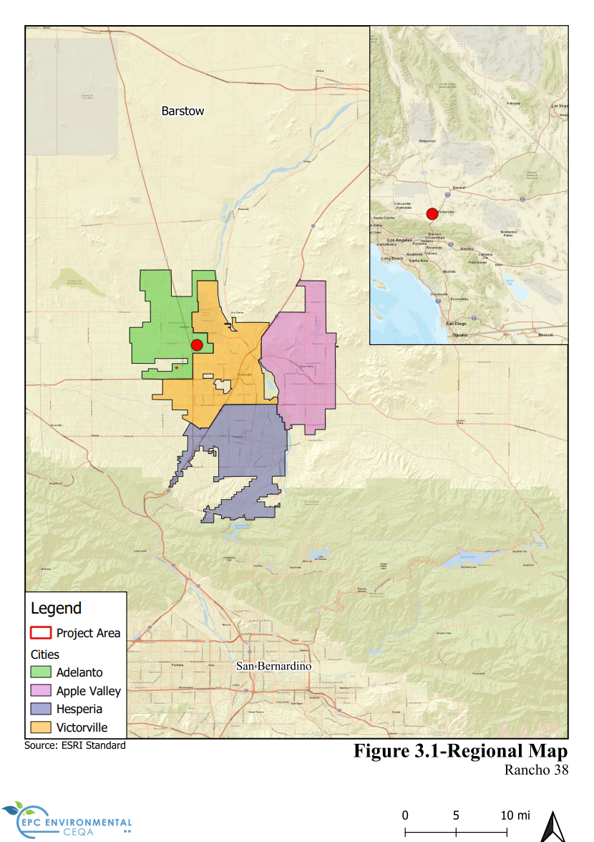

Local Area Map
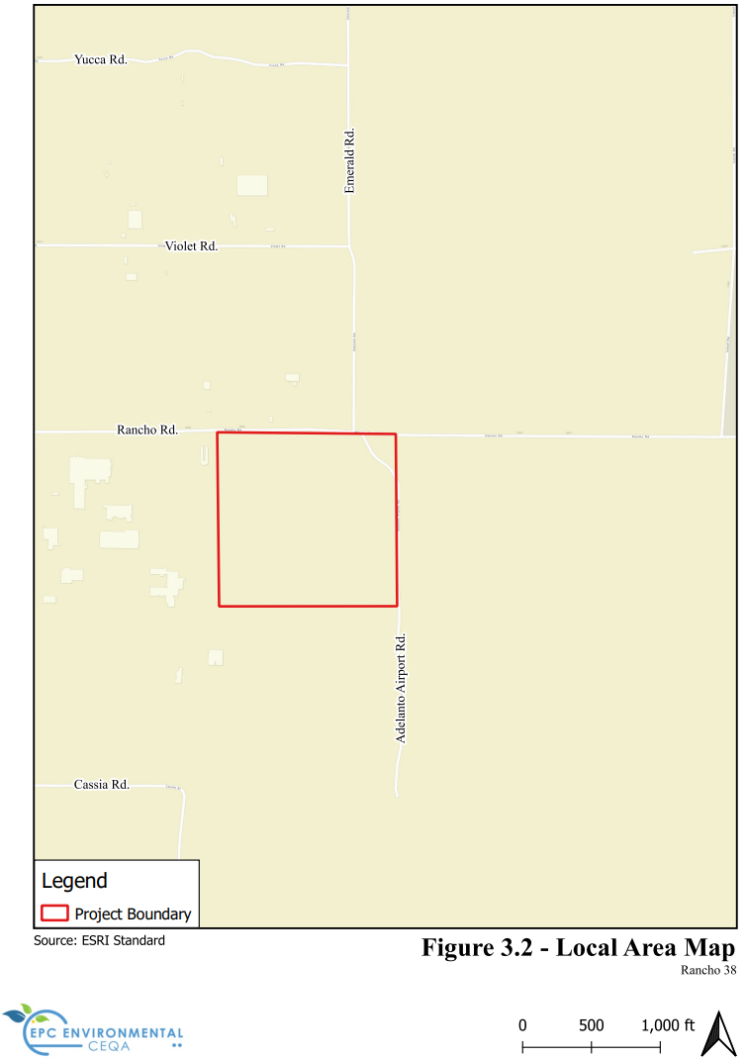

Aerial View
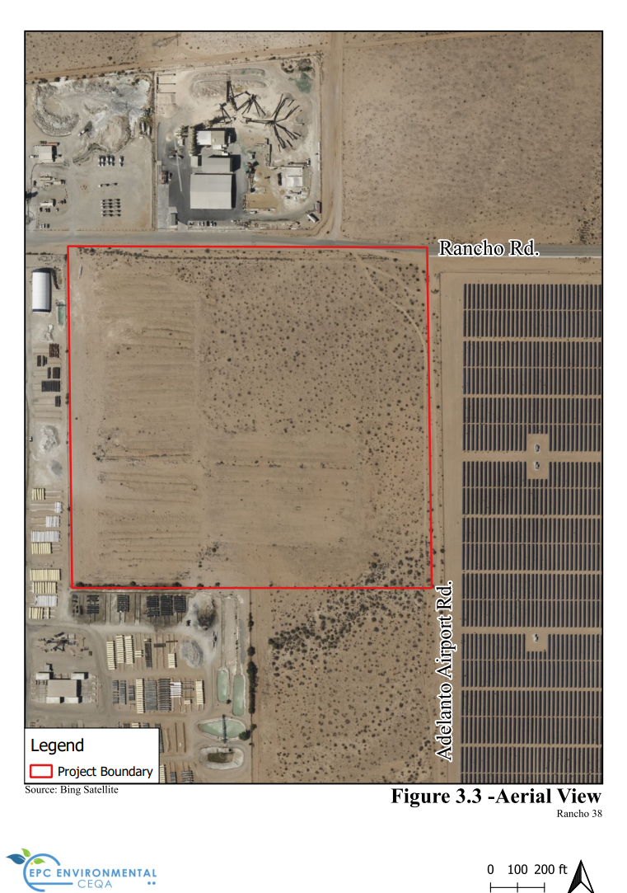

Water and Sewer Improvements
Water Service
The Project site will connect to the 12-inch public water main in Rancho Road that extends from Adelanto Road to the east and ends just before Emerald Road. The 12-inch water line will be extended to the eastern end of the property line.
Given that this project is a speculative development, and a tenant has not been identified, one 2-inch domestic water services at the west end of the building and one single domestic irrigation service are proposed . This is a standard service size for this size building/development.
Sewer Service
The Project will connect to the nearest sanitary sewer line, which is located approximately 2,400 feet west of the site within the paved area in Rancho Road. It is recommended to install a new 12-inch sewer force main line sloped at 0.41%. This line will have a capacity of 1.78 cubic feet per second (cfs) at 75% full or 1.15 million gallons per day (MGD).
Storm Drainage Improvements
The existing site is undeveloped. The existing site generally slopes from southwest to northeast. There are no existing storm drains within the Project site. The slopes within the Project site range from flat to mild slopes, ranging from 2% to 10% in some areas. With the majority of the site being type C soils, the drainage percolates into the ground, and the remaining runoff flows to Rancho Road.
In the proposed condition, the site drainage is split into two areas. The northern half of the site drains to a basin on the northeast. The flow is transferred to the basin through a combination of storm drainpipe and surface flow. The southern half of the site drains to a basin located in the southeast of the site. This basin receives the site drainage through a combination of storm drainpipe and surface flow as well.
(Refer to Figure 3-4, Site Plan.)

Site Plan
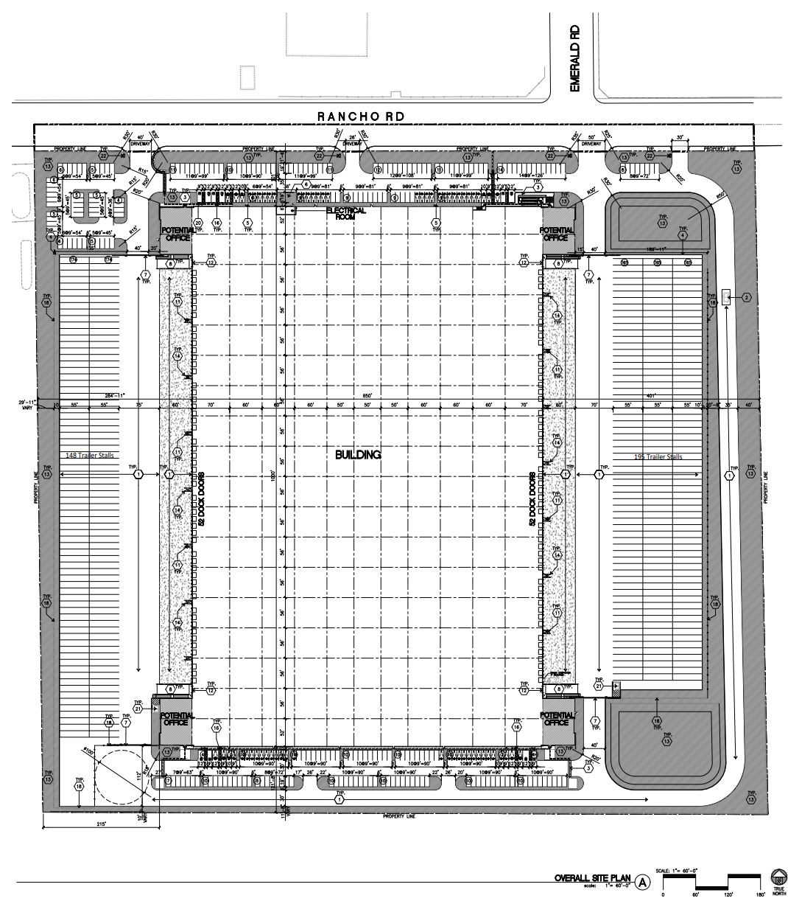

Construction and Operational Characteristics
The information from this section was taken from:
- Air Quality/GHG Assessment, KPC EHS Consultants, February 11, 2022 included as Appendix C.
Construction Schedule
Construction was estimated for a 320-day construction schedule, which includes site preparation, grading, building construction, paving, architectural coating, and paving schedules. Construction equipment and staging are to occur on-site, and construction vehicle access is planned along Rancho Road.
Operational Characteristics
The proposed Project would operate as an industrial facility. Typical operational characteristics would include employees and customers traveling to and from the site, truck loading, and truck unloading activities. It is assumed that the proposed building would be operational 24 hours per day, 365 days per year, with exterior areas lit at night. Lighting would be subject to compliance with the City of Adelanto Municipal Code or CALGreen Code, which both require that lighting fixtures be focused, directed, and arranged to prevent glare or direct illumination on streets or adjoining property.
The building is designed such that business operations would be conducted within the enclosed building, with the exception of traffic movement, parking, and the loading and unloading of tractor trailers at designated loading bays and trailer parking stalls.

Environmental Setting
CEQA Guidelines §15125 establishes requirements for defining the environmental setting to which the environmental effects of a proposed project must be compared. The environmental setting is defined as “…the physical environmental conditions in the vicinity of the project, as they exist at the time the Notice of Preparation is published, or if no Notice of Preparation is published, at the time the environmental analysis is commenced…” (CEQA Guidelines §15125[a]). Because a Notice of Preparation was not required, the environmental setting for the Project is October 2022, which is the date that the Project’s environmental analysis commenced.
The proposed Project site is located in an area that supports a variety of land uses in the City of Adelanto. The land surrounding the site comprises undeveloped vacant land and commercial development. The site is bounded immediately to the north by Rancho Road with commercial development beyond, to the west by commercial development, the south by a mix of commercial development and undeveloped vacant land, and to the east by commercial development. The site itself consists entirely of undeveloped vacant land that supports a native creosote scrub plant community. Much of the western portion of the site has been heavily disturbed and cleared of vegetation by recent grading activities and the creation of artificial berms. Additionally, anthropogenic disturbances such as illegal dumping and off-road vehicular use are heavily concentrated along the site boundaries.
Onsite and adjacent land uses, General Plan land use designations, and zoning classifications are shown in Table 3-1.

Land Uses, General Plan Land Use Designations, and Zoning Classifications
Location | Current Land Use | General Plan Land Use/Zoning Designations
Site | Vacant land | Light Manufacturing (LM)
North | Rancho Road then commercial businesses (Holliday Rock Co. located at 12750 Rancho Road and Western States Wholesale located at 12808 Rancho Road) and undeveloped land. | Business Park (BP)  Light Manufacturing (LM)
South | Northwest Pipe Company (12351 Rancho Road) borders the west half of the site while undeveloped desert land borders the east half of the southern site border. | Light Manufacturing (LM)
East | Unpaved Emerald Road (no street sign was visible) then a chain-link fence enclosing an expansive solar panel farm. | Light Manufacturing (LM)
West | Northwest Pipe Company (12351 Rancho Road). | Light Manufacturing (LM)
Source: Field inspection, City of Adelanto -General Plan Land Use & Zoning District Map, March 2022, Google Earth Pro.

Aerial View of Adjacent Land Uses
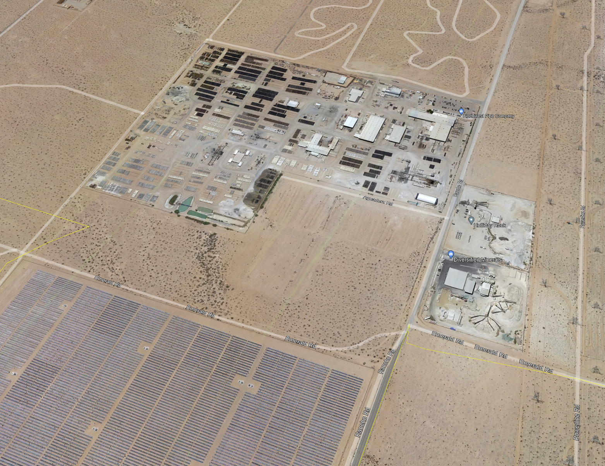
Northwest Pipe Company
Solar Farm
Diversified Minerals
Holiday Rock
Project Site

Street Views
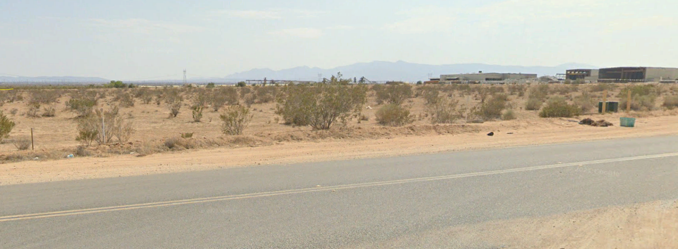
View looking southwest from the Intersection of Rancho Road and Emerald Road

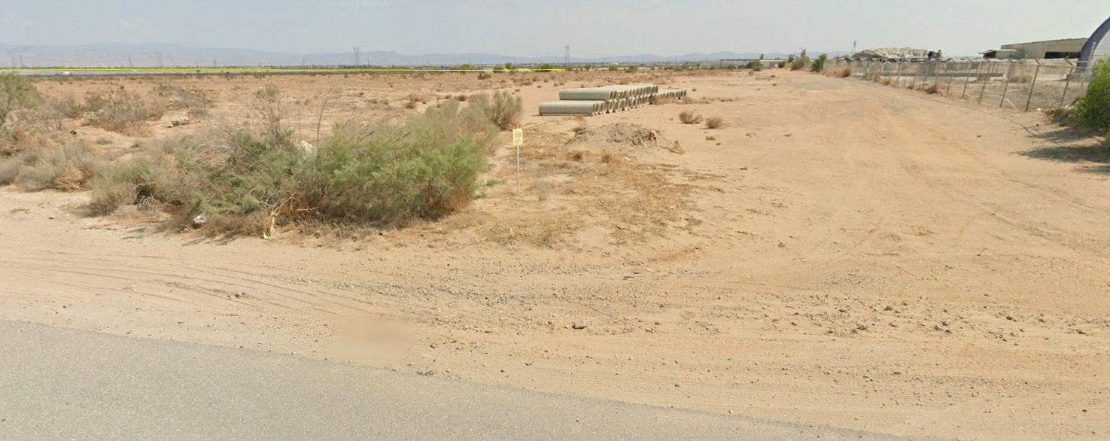
View looking southeast from Rancho Road, next to Northwest Pipe Company

Environmental Analysis
The Project is evaluated based on its potential effect on 21 environmental topics. Each of the above environmental topics is analyzed by responding to a series of questions pertaining to the impact of the Project on the topic. Based on the results of the Impact Analysis, the effects of the Project are then placed in one of the following four categories, which is followed by a summary to substantiate the factual reasons why the impact was placed in a certain category.
Potentially Significant Impact | Less Than Significant Impact with Mitigation Incorporated | Less Than  Significant Impact | No Impact
Significant or potentially significant impact(s) have been identified or anticipated that cannot be mitigated to a level of insignificance. An Environmental Impact Report must therefore be prepared. | Potentially significant impact(s) have been identified or anticipated, but mitigation is possible to reduce impact(s) to a less than significant category. Mitigation measures must then be identified. | No “significant” impact(s) identified or anticipated. Therefore, no mitigation is necessary. | No impact(s) identified or anticipated. Therefore, no mitigation is necessary.

Aesthetics
Threshold 4.1 – Aesthetics  Except as provided in Public Resources Code §21099, would the Project: | Potentially Significant Impact | Less Than Significant  with Mitigation Incorporated | Less Than  Significant Impact | No Impact
a) Have a substantial adverse effect on a scenic vista?
Impact Analysis
A scenic vista is defined as a publicly accessible vantage point that provides expansive views of a highly valued landscape. The City of Adelanto General Plan identifies Shadow Hills and the Mojave River as scenic vistas. Shadow Hills is located approximately 7 miles to the north of the Project site and the Mojave River is located approximately 5 miles east of the Project site. Impacts to scenic vistas are analyzed from points or corridors that are accessible to the public and that provide a view of a scenic vista. Potential public views and vantage points from the Project site to the Shadow Hills and Mojave River would be from the public-rights-of way of Adelanto Road, Rancho Road, and Mesa Linda Road.
Structures within a viewer’s line of sight of a scenic vista may interfere with a public view of a scenic vista, either by physically blocking or screening the scenic vista from view, or by impeding or blocking access to a formerly available viewing position. Those viewers may see the scenic areas prior to development but would have those views blocked post development. Because of distance to the Shadow Hills and Mojave River and intervening development, public views of these scenic vistas would not be blocked by the Project.
In addition, as required by Adelanto Zoning Ordinance §17.30.080, Table 30-1, the Light Manufacturing (LM) maximum building height is limited to three stories (50 feet), and there are required building setbacks for the front, rear, and side lot lines that will serve to create space between structures. As such, the proposed structures would not block or completely obstruct views from the surrounding public vantage to the Shadow Hills. The Mojave River is not visible from the Project site because of the flat topography. Impacts are less than significant, and no mitigation measures are required.

Threshold 4.1 – Aesthetics  Except as provided in Public Resources Code §21099, would the Project: | Potentially Significant Impact | Less Than Significant  with Mitigation Incorporated | Less Than  Significant Impact | No Impact
b) Substantially damage scenic resources, including, but not limited to, trees, rock outcroppings, and historic buildings within a state scenic highway?
Impact Analysis
According to the California Department of Transportation, the Project site is not located within a state scenic highway. As such, there is no impact.

Threshold 4.1 – Aesthetics  Except as provided in Public Resources Code §21099, would the Project: | Potentially Significant Impact | Less Than Significant  with Mitigation Incorporated | Less Than  Significant Impact | No Impact
c) If the project is in an urbanized area, would the project conflict with applicable zoning and other regulations governing scenic quality?
Impact Analysis
According to US Census Bureau, Adelanto is located within the Victorville-Hesperia, CA Urbanized Area. As such, the Project is subject to the City’s applicable regulations governing scenic quality. As required by Adelanto Municipal Code Chapter 17.15 Design Review, all residential, commercial and industrial development proposals are subject to the City’s Design Review process to ensure that development projects comply with all applicable local design guidelines, standards and ordinances; to minimize adverse effects on surrounding properties and the environment; and to ensure consistency with the General Plan, which promotes high aesthetics and functional standards to complement and add to the physical, economic and social character of Adelanto.
According to Municipal Code §17.15.020, Projects Requiring Design Review, a Design Review is required for all residential, commercial, and industrial projects involving the issuance of a building permit for new construction on vacant property.
In compliance with the Municipal Code, the Project Proponent filed Location and Development Permit No. LDP 23-01, which is the subject of this Initial Study document. As required by Adelanto Municipal Code §17.15.070, Industrial Design Standards, the Project’s Location and Development Plan review, included, but was not limited, to the following:
- Site Design. To ensure warehouse buildings are designed and oriented to locate the shorter width of the building toward the public rights-of-way; that the office portion of warehouse uses shall be located in the front portion of buildings; and that portions of buildings visible from public rights-of-way shall be architecturally treated to break up the box-like look of buildings.
- Building Design. To ensure the scale, character and architectural design of the Project is compatible with and shall enhance surrounding development; that the front facade of the building includes architectural features such as reveals, windows and openings, expansion joints, changes in color, texture, and material to add interest to the building elevation; and where function necessitates a basic, box-like building form, exterior articulation such as change in color, material, or plane is introduced on an outer decorative shell encompassing facades which are visible from public streets.
- Parking and Circulation. To ensure the design of parking and circulation layout provided landscape buffers between parking lots and public streets, and parking areas and buildings and to enhance the overall aesthetic quality of the site.
- Roof Equipment. To ensure all roof appurtenances including, but not limited to, air conditioning units and mechanical equipment, are fully screened by parapets, roof screens, or equipment wells.

Architectural Elevations
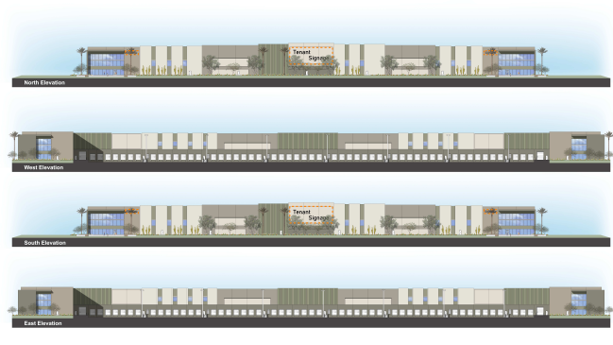

- Lighting. To ensure exterior light fixture design is compatible with the design and the use of the principal structure on the site and that exterior light fixtures are incorporated into the building design and landscape scheme of the development.
- Trash Enclosures. To ensure that the design of the trash enclosures is compatible with the design of the building.
As detailed in Location and Development Plan (LDP) No. 23-01 the Project meets all applicable development regulations scenic quality.

Threshold 4.1 – Aesthetics  Except as provided in Public Resources Code §21099, would the Project: | Potentially Significant Impact | Less Than Significant  with Mitigation Incorporated | Less Than  Significant Impact | No Impact
d) Create a new source of substantial light or glare which would adversely affect day or nighttime views in the area?
Impact Analysis
Outdoor Lighting and Glare
The Project would increase the amount of light in the area above what is being generated by the vacant site by directly adding new sources of illumination including security and decorative lighting for the proposed structures. All outdoor lighting is required to be designed and installed to comply with §17.90.040 - Lighting, of the Zoning Ordinance, which stipulates:
“Except for residential light fixtures using less than a 75-watt bulb, the following shall apply to all outdoor lighting fixtures:
(a) All on-site lighting shall be energy efficient, stationary, and directed away from adjoining properties and public rights-of-way.
(b) Light fixtures shall be shielded so no light is emitted above the horizontal plane of the bottom of the light fixture.
(c) Light fixtures shall be shielded so no light above 0.5 footcandle spills over onto adjacent properties and rights-of-way. There shall be no spillover (0.0 footcandle) onto adjacent residential used or zoned properties.”
Building Material Glare
The building will be constructed of concrete tilt-up panels that do not induce glare. The office portion of the buildings will have tinted glass that will reduce glare. As such, the Project will not adversely affect daytim or nighttime views in the area as a result of glare.

Agriculture and Forestry Resources
The information from this section was derived from:
- Title Insurer Packet Zoning Summary, PZR Report, August 30, 2022 included as Appendix A to this initial study.
Threshold 4.2 – Agriculture and Forestry Resources  Would the Project: | Potentially  Significant Impact | Less Than Significant  Impact with Mitigation | Less Than  Significant Impact | No Impact
a) Convert Prime Farmland, Unique Farmland, or Farmland of Statewide Importance (Farmland), as shown on the maps prepared pursuant to the Farmland Mapping and Monitoring Program of the California Resources Agency, to non-agricultural use?
Impact Analysis
The Project site is not designated as Prime Farmland, Unique Farmland, or Farmland of Statewide Importance as mapped by the State Department of Conservation Farmland Mapping and Monitoring Program. As such, the development of the Project will not convert any type of farmland to a non-agricultural use.

Threshold 4.2 – Agriculture and Forestry Resources  Would the Project: | Potentially  Significant Impact | Less Than Significant  Impact with Mitigation | Less Than  Significant Impact | No Impact
b) Conflict with existing zoning for agricultural use, or a Williamson Act contract?
Impact Analysis
Agricultural Zoning
The current zoning classification for the site is Light Manufacturing (LM). The Light Manufacturing (LM) district provides for a more limited range of uses, including only light industrial and manufacturing uses which benefit from separation from residential, office, and retail districts. The LM zone is not intended for agricultural use.
Williamson Act
A Williamson Act Contract enables private landowners to voluntarily enter contracts with local governments for the purpose of establishing agricultural preserves. The Project site is not under a Williamson Act Contract.
Threshold 4.2 – Agriculture and Forestry Resources  Would the Project: | Potentially  Significant Impact | Less Than Significant  Impact with Mitigation | Less Than  Significant Impact | No Impact
c) Conflict with existing zoning for, or cause rezoning of, forest land (as defined in Public Resources Code Section 12220(g)), timberland (as defined by Public Resources Code Section 4526), or timberland zoned Timberland Production (as defined by Government Code Section 51104(g))?
Impact Analysis
California Public Resources Code §12220(g) defines forest land as land that can support 10% native tree cover of any species, including hardwoods, under natural conditions, and that allows for management of one or more forest resources, including timber, aesthetics, fish and wildlife, biodiversity, water quality, recreation, and other public benefits.
Section 4526 of the Public Resources Code defines timberland as land, other than land owned by the federal government or land designated by the state as experimental forest land, that is available for, and capable of, growing a crop of trees of any commercial species used to produce lumber and other forest products, including Christmas trees.
The Project site does not contain any forest lands, timberland, or timberland zoned as Timberland Production, nor are any forest lands or timberlands located on or nearby the Project site. Because no land within the Project site is currently zoned or proposed for forestland or timberland, there is no potential to impact such zoning.

Threshold 4.2 – Agriculture and Forestry Resources  Would the Project: | Potentially  Significant Impact | Less Than Significant  Impact with Mitigation | Less Than  Significant Impact | No Impact
d) Result in the loss of forest land or conversion of forest land to non-forest use?
Impact Analysis
As noted in the response to Threshold 4.2(c) above, the Project site and surrounding properties do not contain forest lands, are not zoned for forest lands, nor are they identified as containing forest resources by the General Plan. Because forest land is not present within the Project site or in the immediate vicinity of the site, the Project has no potential to result in the loss of forest land or the conversion of forest land to a non-forest use.

Threshold 4.2 – Agriculture and Forestry Resources  Would the Project: | Potentially  Significant Impact | Less Than Significant  Impact with Mitigation | Less Than  Significant Impact | No Impact
e) Involve other changes in the existing environment which, due to their location or nature, could result in conversion of Farmland, to non-agricultural use or conversion of forest land to non-forest use?
Impact Analysis
As noted under Threshold 4.2(a), the Project site is not designated as Prime Farmland, Unique Farmland, or Farmland of Statewide Importance as mapped by the State Department of Conservation Farmland Mapping and Monitoring Program. In addition, the site is not under agricultural production and there is no land being used primarily for agricultural purposes on or in the vicinity of the site.

Air Quality
The following analysis is based in part on the following:
- Air Quality/GHG Assessment, KPC EHS Consultants, February 11, 2023, included as Appendix C to this Initial Study.
- MDAQMD California Environmental Quality Act (CEQA) and Federal Conformity Guidelines, February 2020, available at: https://www.mdaqmd.ca.gov/rules/overview.
Air Quality Setting
Topography and Climate
The Project site is located within the Mojave Desert portion of the Mojave Desert Air Basin (MDAB), bordered in the southwest by the San Bernardino Mountains, and separated from the San Gabriel Mountains by the Cajon Pass (4,200 feet). A lesser channel lies between the San Bernardino Mountains and the Little San Bernardino Mountains (the Morongo Valley). The MDAB is classified as a dry-hot desert (BWh), with portions classified as dry-very hot desert (BWhh), to indicate at least 3 months have maximum average temperatures over 100.4° F.
Air Pollutants and Health Effects
Air pollutants are the foreign and/or natural substances occurring in the atmosphere that may result in adverse effects to humans, animals, vegetation, and/or materials. The air pollutants regulated by the MDAQMD that are applicable to the Project are described below.
Carbon Monoxide (CO): A colorless, odorless gas resulting from the incomplete combustion of hydrocarbon fuels. Over 80% of the CO emitted in urban areas is contributed by motor vehicles. Carbon monoxide is harmful when breathed because it displaces oxygen in the blood and deprives the heart, brain, and other vital organs of oxygen.
Nitrogen Dioxide NOx): Nitrogen dioxide (NO₂) is a byproduct of fuel combustion. The principal form of nitrogen oxide produced by combustion is nitric oxide (NO), but NO reacts quickly to form NO₂, creating a mixture of NO and NO₂ commonly called NOx. NOx can irritate the eyes, nose, throat, and lungs, possibly leading to coughing, shortness of breath, tiredness, and nausea.
Particulate Matter (PM_{2.5} and PM₁₀): One type of particulate matter is the soot seen in vehicle exhaust. Fine particles – less than one-tenth the diameter of a human hair – pose a serious threat to human health, as they can penetrate deep into the lungs. PM can be a primary pollutant or a secondary pollutant from hydrocarbons, nitrogen oxides, and sulfur dioxides. Diesel exhaust is a major contributor to PM pollution.
Sulfur Dioxide (SO₂): A strong-smelling, colorless gas that is formed by the combustion of fossil fuels. Power plants, which may use coal or oil high in sulfur content, can be major sources of SO2. Sulfur dioxide irritates the skin and mucous membranes of the eyes, nose, throat, and lungs.
Ozone: Ozone is formed when several gaseous pollutants react in the presence of sunlight. Most of these gases are emitted from vehicle tailpipe emissions. Ozone can reduce lung function and worsen bronchitis, emphysema, and asthma.
Volatile Organic Compounds (VOCs): VOCs contribute to the formation of smog and/or may themselves be toxic. VOCs often have an odor, and some examples include gasoline, alcohol, and the solvents used in paints. Health effects may include eye, nose and throat irritation, headaches, loss of coordination, and nausea.
Non-Attainment Designations and Classification Status
The United States Environmental Protection Agency (EPA)and the California Air Resources Board (CARB) have designated portions of the district nonattainment for a variety of pollutants. An “attainment” designation for an area signifies that criteria pollutant concentrations did not exceed the established standard. In contrast to attainment, a “nonattainment” designation indicates that a criteria pollutant concentration has exceeded the established standard. Table 4.3-1 shows the attainment status of criteria pollutants in the MDAB.

Attainment Status of Criteria Pollutants in the Mojave Desert Air Basin
Criteria Pollutant | State Designation | Federal Designation
Ozone – 1-hour standard | Nonattainment | No Standard
Ozone – 8-hour standard | Nonattainment | Attainment
Respirable Particulate Matter (PM10) | Nonattainment | Nonattainment
Fine Particulate Matter (PM2.5) | Unclassified | Attainment
Carbon Monoxide (CO) | Attainment | Unclassified/Attainment
Nitrogen Dioxide (NOx) | Attainment | Unclassified/Attainment
Sulfur Dioxide (SO2) | Unclassified /Attainment | Unclassified/Attainment
Lead | Attainment | Attainment
Source: California Air Resources Board, 2015.

As shown in Table 4.3-1 above, the MDAB is classified as Nonattainment for Ozone – 1-hour standard, Ozone – 8-hour standard, Respirable Particulate Matter (PM₁₀) and Fine Particulate Matter (PM_{2.5}).

Threshold 4.3 – Air Quality  Would the Project: | Potentially  Significant Impact | Less Than Significant  Impact with Mitigation | Less Than  Significant Impact | No Impact
a) Conflict with or obstruct implementation of the applicable air quality plan?
Impact Analysis
The following analysis is consistent with the preferred analysis approach recommended by the MDAQMD California Environmental Quality Act (CEQA) and Federal Conformity Guidelines.
Conformity with Air Quality Management Plans
The Project is located within the Mojave Desert Air Basin (MDAB) and under the jurisdiction of the Mojave Desert Air Quality Management District (MDAQMD). Under the Federal Clean Air Act the MDAQMD has adopted a variety of attainment plans (i.e., Air Quality Management Plans) for a variety of non-attainment pollutants. A complete list of the various air quality management plans is available from the Mojave Desert Air Quality Management District located at 14306 Park Avenue, Victorville, CA 92392 or on their website at: https://www.mdaqmd.ca.gov/rules/overview.
The MDAQMD is responsible for maintaining and ensuring compliance with the various Air Quality Management Plans. Conformity is determined based on the following criteria:
- A project is non-conforming if it conflicts with or delays the implementation of any applicable attainment or maintenance plan. A project may also be non-conforming if it increases the gross number of dwelling units, increases the number of trips, and/or increases the overall vehicle miles traveled in an affected area (relative to the applicable land use plan).
- A project is conforming if it complies with all applicable Mojave Desert Air Quality Management District rules and regulations, complies with all proposed control measures that are not yet adopted from the applicable plan(s), and is consistent with the growth forecasts in the applicable plan(s) (or is directly included in the applicable plan).
Consistency with Emission Thresholds
As shown in Table 4.3-3 and Table 4.3-4 below, the Project would not exceed the Mojave Desert Air Quality Management District significance thresholds for any criteria pollutant during construction or during long-term operation. Accordingly, the Project’s air quality emissions are less than significant.
Consistency with Control Measures
The construction contractors are required to comply with rules, regulations, and control measures to control fugitive dust from grading (Rule 403) and the application of architectural coatings during building construction (Rule 1113).
Consistency with Growth Forecasts
The current zoning classification for the site is Light Manufacturing (LM). The Light Manufacturing (LM) district provides for a more limited range of uses, including only light industrial and manufacturing uses, which benefit from separation from residential, office, and retail districts. The LM zone is not intended for agricultural use. The minimum lot size is 20,000 square feet. Development at this density requires full urban levels of service and public improvements. The LM land use designation was used by the MDAQMD to generate the growth forecasts for the air quality plans referenced above.

Threshold 4.3 – Air Quality  Would the Project: | Potentially  Significant Impact | Less Than Significant  Impact with Mitigation | Less Than  Significant Impact | No Impact
b) Result in a cumulatively considerable net increase of any criteria pollutant for which the project region is non-attainment under an applicable federal or state ambient air quality standard?
Impact Analysis
The following provides an analysis based on the applicable regional significance thresholds established by the Mojave Desert Air Quality Management District (MDAQMD) to meet national and state air quality standards.

MDAQMD Air Quality Significance Thresholds
Criteria Pollutant | Daily Emissions Thresholds  (pounds)
Carbon Monoxide (CO) | 548
Oxides of Nitrogen (NOx) | 137
Volatile Organic Compounds (VOC) | 137
Oxides of Sulphur (SOx) | 137
Particulate Matter (PM₁₀) | 82
Particulate Matter (PM_{2.5}) | 82
Source: MDAQMD CEQA Guidelines, February 2020, Table 6
Both construction and operational emissions for the Project were modeled using the California Emissions Estimator Model (CalEEMod), which is a statewide land use emissions computer model designed to provide a uniform platform for government agencies to quantify potential criteria pollutant emissions associated with construction and operations emissions. CalEEMod is authorized for use to assess project emissions by the MDAQMD. The City uses the MDAQMD significance thresholds to determine a project’s impacts on greenhouse gas (GHG) emissions. The thresholds established by the MDAQMD for GHG emissions included an annual threshold of 100,000 short tons CO₂e per year (90,718 MTCO₂e/year) and a daily threshold of 548,000 pounds per day. The MDAQMD significance thresholds were used for determining the Project’s impacts.
Construction Emissions
Construction of the Project is assumed to begin in the year 2023 and last approximately 320 days. Construction phases are assumed to consist of site preparation, grading, building construction, paving, and architectural coating. The Project is expected to be operational in the year 2024. Construction phases are not expected to overlap. Construction activities produce combustion emissions from various sources (e.g., utility engines, tenant improvements, and motor vehicles transporting the construction crew). Exhaust emissions from construction activities envisioned on site would vary daily as construction activity levels change. The Project will be required to comply with several standard fugitive dust control measures, per MDAQMD Rule 403. The following measures were factored into CalEEMod and are based upon data provided from MDAQMD:
- Utilize soil stabilizers – 30% PM10 and PM2.5 reduction
- Replace ground cover – 15% PM10 and PM2.5 reduction
- Water exposed areas 2 times per day
Daily construction emissions based on the above-described parameters are shown in Table 4.3-3 below.

Construction Emissions
Emissions
(pounds per day)
 | NOx | VOC | CO | SOx | PM₁₀ | PM_{2.5}
Maximum Daily Emissions | 54.02 | 84.32 | 56.14 | 0.14 | 21.07 | 11.31
Regional Threshold | 137 | 137 | 548 | 137 | 82 | 65
Exceeds Regional Threshold? | No | No | No | No | No | No
Source: MDAQMD and CalEEMod 2020.4.0
Operational Emissions
The Project would be operated as a warehouse facility. Typical operational characteristics include residents and visitors traveling to and from the site, delivery of goods and services to the residents, and maintenance activities. Table 4.3-4 shows the MDAQMD thresholds for operational emissions compared to the Project’s maximum daily emissions.

Operational Emissions (Average of Summer and Winter)
Emissions
(pounds per day)
 | NOx | VOC | CO | SOx | PM₁₀ | PM_{2.5}
Maximum Daily Emissions | 23.885 | 23.525 | 45.375 | 0.14 | 9.88 | 3.05
Regional Threshold | 137 | 137 | 548 | 137 | 82 | 65
Exceeds Regional Threshold? | No | No | No | No | No | No
Source: MDAQMD and CalEEMod 2020.4.0
As shown in Table 4.3-4 above, both construction and operational-related emissions would not exceed MDAQMD thresholds. The Project will be required to comply with all applicable MDAQMD rules, and the Project must adhere to the City of Adelanto General Plan Policies and Implementing Programs. Additionally, per the California Attorney General’s Bureau of Environmental Justice, Warehouse Projects: Best Practices and Mitigation Measures to Comply with the California Environmental Quality Act, to ensure emissions impacts from the operational phases will be reduced to the extent feasible, the following Best Management Practices (BMPs) are recommended:
BMP-AQ-1 TRU Electrical Connections: Electrical hookups shall be provided as part of the tenant improvements for any tenant that requires cold storage. The electrical hookups shall be provided at loading bays for truckers to plug in any onboard auxiliary equipment and power refrigeration units while their truck is stopped.
BMP-AQ-2 Truck Access Gate Signage: All truck access gates and loading docks within the project site shall have a sign posted that states:
  - Truck drivers shall turn off engines when not in use.
  - Truck drivers shall shut down the engine after five minutes of continuous idling operation once the vehicle is stopped, the transmission is set to “neutral” or “park”, and the parking brake is engaged.
  - Telephone numbers of the building facilities manager and CARB to report Violations.

The BMPs are not mitigation measures, but will be added to the Conditions of Approval for LDP23-01.

Threshold 4.3 – Air Quality  Would the Project: | Potentially  Significant Impact | Less Than Significant  Impact with Mitigation | Less Than  Significant Impact | No Impact
c) Expose sensitive receptors to substantial pollutant concentrations?
Impact Analysis
The Project is an industrial development and may generate heavy-duty diesel truck emissions. According to the MDAQMD, residences, schools, daycare centers, playgrounds, and medical facilities are considered sensitive receptor land uses. The nearest sensitive receptors are the residential neighborhood located adjacent to the Project site to the south approximately 150 feet.
Transport Refrigeration Units
Transport Refrigeration Units (TRU) are refrigeration systems powered by diesel internal combustion engines (ICEs) designed to refrigerate or heat perishable products that are transported in various containers, including vans, trucks, semi-truck trailers, and shipping containers.
To account for the operations of potential TRUs on-site the number of refrigerated trucks/trailers was estimated using the Traffic Study and Vehicle Miles Traveled (VMT) Screening Memo from David Evans and Associates, dated November 9, 2022. According to the memo’s Trip Generation Table, the average daily trips for the Cold Storage portion of the building would be approximately 44 trucks per day. Emissions from the TRUs were estimated to be 50 horsepower (HP) units operating on diesel fuel for a period of 4 hours on-site. The 4-hour operational time is a worst-case scenario as typical TRUs range from 9 to 36 horsepower, and emissions can be substantially reduced through the implementation the installation of electrical plugs for electric transport units at each dock door servicing the Cold Storage portion of the Project.
To calculate the emissions for the TRUs the CARB EMFAC OFFROAD2021 (v1.0.3) was used to obtain emissions factors and multiplied by the daily number of trucks and the estimated hours of on-site operation.
On-Site Equipment Emissions
Industrial warehouse projects commonly require cargo handling equipment (CHE) to move empty containers and empty chassis to and from the various pieces of cargo handling equipment that receive and distribute containers. The most common type of cargo handling equipment is the yard truck, which is designed for moving cargo containers. Yard trucks are also known as yard goats, utility tractors (UTRs), hustlers, yard hostlers, and yard tractors. Yard trucks have a horsepower (hp) range of approximately 175 hp to 200 hp. Based on surveys conducted by the SCAQMD; high-cube warehouse projects typically have 3.6-yard trucks per million square feet of building space. For the Project, on-site modeled operational equipment includes four 200-hp yard tractors operating at 8 hours a day for 365 days of the year. In addition to the use of yard trucks operating at the Project site, forklifts and pallet jacks are common pieces of equipment used in warehouse operations. As part of the Project’s design, all on-site outdoor CHE (including yard trucks, hostlers, yard goats), will be powered by compressed natural gas (CNG), propane, or electric engines, while all forklift and pallet jacks will be electric powered. Using the CalEEMod program, the emissions from UTRs were calculated using the Tractor/Loader/Backhoe equipment, operating at 200 hp on CNG. The emissions estimates for the Project includes 120 forklifts/pallet jacks operating at 8 hours a day for 365 days of the year interior to the building. For purposes of the analysis, forklifts and pallet jacks are assumed to be electric consistent with industry standards.
The following project types proposed for sites within the specified distance to an existing or planned (zoned) sensitive receptor land use must be evaluated:
- Any industrial project within 1,000 feet
- A distribution center (40 or more trucks per day) within 1,000 feet
- A major transportation project (50,000 or more vehicles per day) within 1,000 feet
- A dry cleaner using perchloroethylene within 500 feet
- A gasoline dispensing facility within 300 feet
The Project proposes to construct an industrial facility. The Project is not within 1,000 feet of a sensitive receptor and does not meet the criteria listed above. As such, no impact will occur.

Threshold 4.3 – Air Quality  Would the Project: | Potentially  Significant Impact | Less Than Significant  Impact with Mitigation | Less Than  Significant Impact | No Impact
d) Result in other emissions (such as those leading to odors) adversely affecting a substantial number of people?
Impact Analysis
The potential for the Project to generate objectionable odors has been considered. Land uses generally associated with odor complaints include:
- Agricultural uses (livestock and farming)
- Wastewater treatment plants
- Food processing plants
- Chemical plants
- Composting operations
- Refineries
- Landfills
- Dairies
- Fiberglass molding facilities
The Project does not propose or require land uses that would be substantive sources of objectionable odors. Potential temporary and intermittent odors may result from construction equipment exhaust, and the application of asphalt and architectural coatings. Temporary and intermittent construction-source emissions are controlled through existing requirements and industry BMPs addressing proper storage and application of construction materials.
Over the life of the Project, odors may result from storage of municipal solid waste pending its transport to area landfills. Project-generated refuse would be stored in covered containers and removed at regular intervals in compliance with the City’s solid waste regulations.
The proposed Project would involve the use of diesel-powered construction equipment and diesel-powered vehicles pulling trailers for deliveries during operations. Diesel exhaust during construction may be noticeable temporarily at adjacent properties; however, construction activities would be temporary. During operations diesel vehicles entering the site are required to limit idling to less than 5 minutes, which will reduce the impacts of diesel odors.
The proposed Project would also be required to comply with MDAQMD Rule 402. Rule 402 provides that “[a] person shall not discharge from any source whatsoever such quantities of air contaminants or other material which cause injury, detriment, nuisance, or annoyance to any considerable number of persons or to the public, or which endanger the comfort, repose, health or safety of any such persons or the public, or which cause, or have a natural tendency to cause, injury or damage to business or property.” Based on the preceding, the potential for the Project to create objectionable odors affecting a substantial number of people is considered less-than- significant.

Biological Resources
The analysis in this section is based in part on the following technical reports:
- Phase 1 Environmental Site Assessment, WSP USA Environmental & Infrastructure Inc., October 19, 2022, included as Appendix B to this initial study.
- Biological Resources Assessment: ELMT Consulting, November 16, 2022, included as Appendix D to this Initial Study.

Threshold 4.4 – Biological Resources  Would the Project: | Potentially  Significant Impact | Less Than Significant  Impact with Mitigation Incorporated | Less Than  Significant Impact | No Impact
a) Have a substantial adverse effect, either directly or through habitat modifications, on any species identified as a candidate, sensitive, or special status species in local or regional plans, policies, or regulations, or by the California Department of Fish and Wildlife or U.S. Fish and Wildlife Service?
Impact Analysis
As part of the environmental process, California Department of Fish and Wildlife (CDFW) and U.S. Fish and Wildlife Service (USFWS) data sources were reviewed. Following the data review, surveys were performed on the site on October 6, 2022, during which the biological resources on the site and in the surrounding areas were documented by biologists from ELMT Consulting. As part of the surveys, the property and adjoining areas were evaluated for the presence of native habitats that may support populations of sensitive wildlife and plant species. The property was also evaluated for the presence of sensitive habitats including wetlands, vernal pools, riparian habitats, and jurisdictional areas. Habitat assessments were also conducted for the desert tortoise, burrowing owl, and Mohave ground squirrel based on data from USFWS, CDFW, and a search of the California Natural Diversity Database.
Plant Species
The Project site consists of vacant undeveloped land that has been subject to a variety of anthropogenic disturbances, including off-road vehicular use and illegal dumping. These disturbances occur primarily along the Project boundaries, with relatively little disturbance occurring near the center of the Project site. Additionally, most of the vegetation has been removed from the western portion of the site, and this area has been recently graded. Refer to Figure 3.3, Aerial View, and Figure 3.6, Street Views, for representative site photographs.
According to the CNDDB and CNPS, twelve (12) special-status plant species have been recorded in the Adelanto and Victorville quadrangles. No special-status plant species were observed within the proposed project footprint during the field investigation. The majority of the project site consists of vacant, undeveloped land which supports a native creosote scrub community. According to the CNDDB and CNPS, twelve (12) special-status plant species have been recorded in the Adelanto and Victorville quadrangles. No special-status plant species were observed on-site during the field investigation. The project site consists vacant, undeveloped land that has been subject to a variety of anthropogenic disturbances and is primarily surrounded by existing development. These disturbances have reduced the ability of the on-site habitat to provide suitable habitat for special-status plant species known to occur in the general vicinity. Based on habitat requirements for specific special-status plant species and the availability and quality of habitats needed by each species, it was determined that the project site does not provide suitable habitat for any of the special-status plant species known to occur in the area and all are presumed to be absent. No focused surveys are recommended.
Western Joshua Trees
Western Joshua tree became a candidate species under the California Endangered Species Act (CESA), effective October 9, 2020. The CESA prohibits the take and possession of any species, or any part or product of a species that is designated by the California Fish and Game Commission as an endangered, threatened, or candidate species. As a candidate species, western Joshua tree now has full protection under CESA, and any take of the species (including removal of western Joshua tree or similar actions) will require authorization under CESA.
At its February 2023, meeting, regarding whether to list the eastern Joshua tree as threatened or endangered under the California Endangered Species Act (CESA), the Commission continued the agenda item to its June 2023 meeting. The western Joshua tree will remain protected by CESA during this period. However, there are no Western Joshua Trees located on this project site.
Wildlife Species
Plant communities provide foraging habitat, nesting/denning sites, and shelter from adverse weather or predation. This section provides a discussion of those wildlife species that were observed or are expected to occur within the Project site. The discussion is to be used a general reference and is limited by the season, time of day, and weather conditions in which the field investigation was conducted. Wildlife detections were based on calls, songs, scat, tracks, burrows, and direct observation. The Project site provides moderate habitat for wildlife species, especially those adapted to a high degree of anthropogenic disturbance.
Fish
No fish or hydrogeomorphic features (e.g., perennial creeks, ponds, lakes, reservoirs) that would provide suitable habitat for fish were observed on or within the vicinity of the project site. Therefore, no fish are expected to occur and are presumed absent from the Project site.
Amphibians
No amphibians or hydrogeomorphic features (e.g., perennial creeks, ponds, lakes, reservoirs) that would provide suitable habitat for amphibian species were observed on or within the vicinity of the project site. Therefore, no amphibians are expected to occur on the Project site and are presumed absent.
Reptiles
The survey area provides limited foraging and cover habitat for local reptile species adapted to conditions within the Mojave Desert. The only reptilian species observed was western side-blotched lizard. Common reptilian species that could be expected to occur include Great Basin fence lizard, Great basin gopher snake, and red racer.
Birds
The Project site and surrounding area provide suitable foraging and nesting habitat for bird species adapted to conditions within the Mojave Desert. Bird species detected during the field investigation include cactus wren, American kestrel, house finch, common raven, loggerhead shrike, and mourning dove. Owl pellets were also observed on the Project site, but the contributing species is unknown.
Mammals
The survey area provides moderate foraging and cover habitat for mammalian species adapted to conditions surrounding the Mojave Desert. Mammalian species detected during the field investigation include coyote, California ground squirrel, and white-tailed antelope squirrel. Additional common mammalian species that could be expected to occur include desert cottontail.
Nesting Birds
No active nests or birds displaying nesting behavior were observed during the field survey, which was conducted outside the breeding season. The Project site provides minimal nesting opportunities for year-round and seasonal avian residents, as well as migrating songbirds that are adapted to conditions surrounding the Mojave Desert. Nesting birds are protected pursuant to the Migratory Bird Treaty Act (MBTA) and California Fish and Game Code (§3503, §3503.5, §3511, and §3513 prohibit the take, possession, or destruction of birds, their nests or eggs). If construction occurs between February 1 and August 31, a pre-construction clearance survey for nesting birds should be conducted within 3 days of the start of any vegetation removal or ground disturbing activities to ensure that no nesting birds will be disturbed during construction.

Presence of Candidate, Sensitive, or Special Status Wildlife Species
Species | Status | Presence/Absence
Desert Tortoise | Federal: Threatened  State: Threatened | Not Present: The site is located within the known distribution of the species. An evaluation of the area and property was conducted, and no tortoises or suitable habitat was observed.
Mohave Ground Squirrel | Federal: None  State: Threatened | Not Present: Site supports marginal habitat for the species. Species is not expected to observations occur on the site.
Swainson’s Hawk | Federal: None  State: Threatened | Not Present. There is no habitat that the supports the species.
Le Conte's thrasher | Federal: None  State: None  CDFW: Species of Special Concern | Not Present. Site does support suitable habitat for the species. Surveys conducted on site did not identify any thrashers.
Burrowing Owl | Federal: None  State: None  CDFW: Species of Special Concern | Not Present/Future Presence Possible. The site does support suitable habitat for the species; however, no owls or owl sign, or suitable burrows were observed during field surveys.

Wildlife Species Mitigation Measures
Although wildlife species identified as a candidate, sensitive, or special status species in local or regional plans, policies, or regulations, or by the California Department of Fish and Wildlife or the U.S. Fish and Wildlife Service were not detected on-site, the site is located within the range of the burrowing owl, the Mohave ground squirrel, the desert tortoise, and nesting birds. Therefore, the following mitigation measures have been included to ensure any impacts are less than significant to these species.
Mitigation Measure BIO-1. Burrowing Owl Pre-Construction Survey. Prior to any ground disturbance, pre-construction surveys for Burrowing Owls on the Project site and in the surrounding area in accordance with the Staff Report on Burrowing Owl Mitigation, State of California Natural Resource Agency, Department of Fish and Game, May 7, 2012, shall be conducted no more than 14 days prior to the beginning of Project activities, and a secondary survey must be conducted by a qualified biologist within 24 hours prior to the beginning of Project construction to determine if the Project site contains suitable burrowing owl or sign thereof and to avoid any potential impacts to the species. The surveys shall include 100 percent coverage of the Project site. If both surveys reveal no burrowing owls are present or sign thereof, no additional actions related to this measure are required and a letter shall be prepared by the qualified biologist documenting the results of the survey. The letter shall be submitted to CDFW prior to construction. If occupied active burrows or sign thereof are found within the development footprint during the pre-construction clearance survey, Mitigation Measure BIO-2 shall apply.
Mitigation Measure BIO-2. Burrowing Owl Avoidance/Relocation. If active burrows or signs thereof are found within the development footprint during the pre-construction clearance surveys, site-specific non-disturbance buffer zones shall be established by the qualified biologist and shall be no less than 300 feet. If determined appropriate, a smaller buffer may be established by the qualified biologist following monitoring and assessments of the Project’s effects on the burrowing owls. If it is not possible to avoid active burrows, passive relocation shall be implemented if a qualified biologist has determined there are no nesting owls and/or juvenile owls are no longer dependent on the burrows. A qualified biologist, in coordination with the applicant and the City, shall prepare and submit a passive relocation program in accordance with Appendix E (i.e., Example Components for Burrowing Owl Artificial Burrow and Exclusion Plans) of the CDFW’s Staff Report on Burrowing Owl Mitigation (CDFG 2012) for CDFW review/approval prior to the commencement of disturbance activities onsite and proposed mitigation for permanent loss of occupied burrow(s) and habitat consistent with the 2012 Staff Report on Burrowing Owl Mitigation. When a qualified biologist determines that burrowing owls are no longer occupying the Project site and passive relocation is complete, construction activities may begin. A final letter report shall be prepared by the qualified biologist documenting the results of the passive relocation. The letter shall be submitted to CDFW.
Mitigation Measure BIO-3. Mohave Ground Squirrel Pre-Construction Survey. Pre-construction surveys following the Mohave Ground Squirrel Survey Guidelines (CDFG 2010), or most recent version shall be performed by a qualified biologist authorized by a Memorandum of Understanding issued by CDFW. The pre-construction surveys shall cover the Project Area and a 50-foot buffer zone. If Mohave ground squirrel presence is confirmed during the survey, the Project Proponent should obtain an Incidental Take Permit (ITP) for Mohave ground squirrel prior to the start of Project activities. CDFW shall be notified if Mohave ground squirrel presence is confirmed during the pre-construction survey. If a Mohave ground squirrel is observed during Project activities, and the Project Proponent does not have an ITP, all work shall immediately stop, and the observation shall be immediately reported to CDFW.
Mitigation Measure BIO-4. Desert Tortoise Pre-Construction Survey. A CDFW-approved biologist shall conduct pre-construction presence/absence surveys for desert tortoise during the desert tortoise active season (April to May or September to October) 48 hours prior to initiation of Project activities and after any pause in Project activities lasting 30 days or more. Desert tortoise preconstruction surveys shall be conducted in accordance with the U.S. Fish and Wildlife Service (USFWS) 2019 desert tortoise survey methodology. Preconstruction surveys shall be completed using 100-percent visual coverage for desert tortoise and their sign and shall use perpendicular survey routes within the Project site and 50-foot buffer zone. Pre-construction surveys cannot be combined with other surveys conducted for other species while using the same personnel. Project activities cannot start until two negative results from consecutive surveys using perpendicular survey routes for desert tortoise are documented. Results of the survey shall be submitted to CDFW prior to start of Project activities. If the survey confirms desert tortoise absence, the CDFW approved biologist shall ensure that desert tortoises do not enter the Project area.
If desert tortoise presence is confirmed during the survey, the Project Proponent shall submit to CDFW for review and approval a desert tortoise specific avoidance plan detailing the protective avoidance measures to be implemented to ensure complete avoidance of take (California Fish and Game Code Section 86 defines “take” as “hunt, pursue, catch, capture, or kill, or attempt to hunt, pursue, catch, capture, or kill”) to desert tortoise. If complete avoidance of desert tortoise cannot be achieved, the Project Proponent shall not undertake Project activities, and Project activities shall be postponed until appropriate authorization (i.e., California Endangered Species Act (CESA) Incidental Take Permit (ITP) under Fish and Game Code §2081) is obtained.
If complete avoidance of desert tortoise is infeasible, CDFW recommends that the Project Proponent apply for a CESA ITP and prepare a site-specific Desert Tortoise Translocation Plan (Plan) that will provide details on the proposed recipient site, desert tortoise clearance surveys, and relocation, definitions for Authorized Biologists and qualified desert tortoise biologists, exclusion fencing guidelines, protocols for managing desert tortoise found during active versus inactive seasons, protocols for incidental tortoise death or injury, and shall be consistent with project permits and current USFWS and CDFW guidelines. The Plan shall also include a requirement for communication and coordination with the Bureau of Land Management (BLM) regarding the desert tortoise recipient site.
Prior to construction, the Plan shall be subject to the review and approval of the CDFW and the USFWS. Impacts shall be offset through acquisition of compensatory land within occupied desert tortoise habitat and/or mitigation bank credit purchase from a CDFW-approved mitigation bank mitigated at a ratio determined by CDFW after Project analysis.
Mitigation Measure BIO-5. Environmental Awareness Training: A qualified biologist must present a biological resource information training for desert tortoise, Mohave ground squirrel, and burrowing owl prior to project activities to all personnel that will be working within the project site. The same instruction shall be provided for any new workers prior to their performing any work on-site. Interpretation shall be provided for any non-English speaking workers.
Mitigation Measure BIO-6. Deceased or Injured Tortoise Within the Project Site: USFWS and CDFW shall be informed of any injured or deceased desert tortoise (and other special-status species) found on site (verbal notice within 24-hours and written notification within 5 days).
Mitigation Measure BIO-7. Species Avoidance: If during project activities a desert tortoise is discovered within the Project site, all activities shall immediately stop and the CDFW shall be immediately notified (within 24 hours). Coordination with respective state and federal resource agencies shall be required prior to restarting activities to determine appropriate avoidance, minimization, and mitigation measures.
Mitigation Measure BIO-8. Nesting Bird Pre-Construction Survey. Regardless of the time of year, a pre-construction sweep shall be performed to verify absence of nesting birds. A qualified biologist shall conduct the pre-activity sweep within the Project areas (including access routes) and a 500-foot buffer surrounding the Project areas, within 2 hours prior to initiating Project activities. Additionally, a nesting bird survey shall be conducted by a qualified biologist no more than 3 days prior to the initiation of Project activities, including, but not limited to clearing, grubbing, and/or rough grading to prevent impacts to birds and their nests.
The survey shall be conducted by a qualified biologist. Surveys shall include any potential habitat (including trees, shrubs, the ground, or nearby structures) that may be impacted by activities resulting in nest destruction or abandonment. If nesting bird activity is present, a no-disturbance buffer zone shall be established by the qualified biologist around each nest to prevent nest destruction or abandonment. If nesting bird activity is present, a no-disturbance buffer zone shall be established by the qualified biologist around each nest to prevent nest destruction and disruption of breeding or rearing behavior. The buffer shall be a minimum of 500 feet for raptors and 300 feet for songbirds, unless a smaller buffer is specifically determined by a qualified biologist familiar with the nesting phenology of the nesting species. The buffer areas shall be avoided until the nests are no longer occupied and the juvenile birds can survive independently from the nests, as confirmed by a qualified biologist. A qualified biologist shall inspect the active nest to determine whether construction activities are disturbing the nesting birds or nestlings. If the qualified biologist determines that construction activities pose a disturbance to nesting, construction work shall be stopped in the area of the nest and the 'no disturbance buffer' shall be expanded. If there is no nesting activity, then no further action is needed for this measure.
With the implementation of Mitigation Measures BIO-1 through BIO-8, impacts would be less than significant relating to candidate, sensitive, or special status plant and wildlife species.

Threshold 4.4 – Biological Resources  Would the Project: | Potentially  Significant Impact | Less Than Significant  Impact with Mitigation Incorporated | Less Than  Significant Impact | No Impact
b) Have a substantial adverse effect on any riparian habitat or other sensitive natural community identified in local or regional plans, policies, regulations or by the California Department of Fish and Wildlife or U.S. Fish and Wildlife Service?
Impact Analysis
The site is separated from identified regional wildlife corridors and linkages by existing development and roadways, and undeveloped land, and there are no riparian corridors or creeks connecting the Project site to these areas.
Threshold 4.4 – Biological Resources  Would the Project: | Potentially  Significant Impact | Less Than Significant  Impact with Mitigation Incorporated | Less Than  Significant Impact | No Impact
c) Have a substantial adverse effect on state or federally protected wetlands (including, but not limited to, marsh, vernal pool, coastal, etc.) through direct removal, filling, hydrological interruption, or other means?
Impact Analysis
The project site does not support any discernible drainage courses, inundated areas, wetland features, or hydric soils that would be considered jurisdictional by the Corps, Regional Board, or CDFW. A query of the National Wetlands Inventory (NWI) database determined that no potential blueline streams, riverine, or other aquatic resources occur within or adjacent to the Project site. Therefore, Project activities will not result in impacts to Corps, Regional Board, or CDFW jurisdictional areas and regulatory approvals will not be required.

Threshold 4.4 – Biological Resources  Would the Project: | Potentially  Significant Impact | Less Than Significant  Impact with Mitigation Incorporated | Less Than  Significant Impact | No Impact
d) Interfere substantially with the movement of any native resident or migratory fish or wildlife species or with established native resident or migratory wildlife corridors, or impede the use of native wildlife nursery sites?
Impact Analysis
Habitat linkages provide connections between larger habitat areas that are separated by development. Wildlife corridors are similar to linkages but provide specific opportunities for animals to disperse or migrate between areas. A corridor can be defined as a linear landscape feature of sufficient width to allow animal movement between two comparatively undisturbed habitat fragments. Adequate cover is essential for a corridor to function as a wildlife movement area. It is possible for a habitat corridor to be adequate for one species yet still inadequate for others. Wildlife corridors are features that allow for the dispersal, seasonal migration, breeding, and foraging of a variety of wildlife species. Additionally, open space can provide a buffer against both anthropogenic disturbance and natural fluctuations in resources.
According to the San Bernardino County General Plan, the Project site has not been identified as occurring within a Wildlife Corridor or Linkage. As designated by the San Bernardino County General Plan Open Space Element, major open space areas documented in the vicinity of the Project site include the Mojave River located approximately 4.6 miles east of the site. The site is separated from this identified regional wildlife corridors and linkages by existing development and roadways, and undeveloped land, and there are no riparian corridors or creeks connecting the project site to these areas.
The undeveloped land in the immediate vicinity of the Project site provides local wildlife movement opportunities for wildlife species moving through the immediate area; however, the Project site does not function as a major wildlife movement corridor or linkage. As such, implementation of the proposed Project is not expected to have a significant impact to wildlife movement opportunities or prevent local wildlife movement through the area since there is ample habitat adjacent to the project site to support wildlife movement opportunities.

Threshold 4.4 – Biological Resources  Would the Project: | Potentially  Significant Impact | Less Than Significant  Impact with Mitigation Incorporated | Less Than  Significant Impact | No Impact
e) Conflict with any local policies or ordinances protecting biological resources, such as a tree preservation policy or ordinance?
Impact Analysis
Please refer to the discussion under Threshold 4.4 (a) regarding Joshua trees.

Threshold 4.4 – Biological Resources  Would the Project: | Potentially  Significant Impact | Less Than Significant  Impact with Mitigation Incorporated | Less Than  Significant Impact | No Impact
f) Conflict with the provisions of an adopted Habitat Conservation Plan, Natural Community Conservation Plan, or other approved local, regional, or state habitat conservation plan?
Impact Analysis
Regional multiple species conservation plans offer long-term assurances for conservation of covered species at a landscape scale, in exchange for biologically appropriate levels of incidental take and/or habitat loss as defined in the approved plan. California’s Natural Community Conservation Planning (NCCP) Act (California Fish and Game Code §2800 et seq.) governs such plans at the state level, and was designed to conserve species, natural communities, ecosystems, and ecological processes across a jurisdiction or a collection of jurisdictions. Complementary federal Habitat Conservation Plans (HCPs) are governed by the Endangered Species Act (7 U.S.C. §136, 16 U.S.C. §1531 et seq.) (ESA). Regional conservation plans provide conservation for unlisted as well as listed species. According to the California Natural Community Conservation Plans Map maintained by the California Department of Fish and Wildlife, there are no such plans that encompass the Project site.

Cultural Resources
The analysis in this section is based in part on the following technical report:
- Historical/Archaeological Resources Survey Report, CRM TECH, January 15, 2023, included as Technical Appendix E.

Threshold 4.5 – Cultural Resources  Would the Project: | Potentially  Significant or  Significant Impact | Less Than Significant  Impact with Mitigation | Less Than  Significant Impact | No Impact
a) Cause a substantial adverse change in the significance of a historical resource pursuant to §15064.5?
Impact Analysis
Records Search
To identify such resources, CRM TECH conducted an historical/archaeological resources records search, initiated a Native American Sacred Lands File search, pursued historical background research, and carried out an intensive-level field survey. Through the various avenues of research, this study did not encounter any “historical resources” within or adjacent to the project area. Therefore, CRM TECH recommends to the City of Adelanto a finding of No Impact regarding “historical resources.”
No further cultural resources investigation is recommended for the proposed Project unless development plans undergo such changes as to include areas not covered by this study. However, if buried cultural materials are encountered during any earth-moving operations associated with the project, all work within 50 feet of the discovery should be halted or diverted until a qualified archaeologist can evaluate the nature and significance of the finds.
Field Survey
On October 21, 2022, CRM TECH archaeologists Hunter O’Donnell and Cristal Conner-Ayala carried out the field survey of the Project area. The survey was completed at an intensive level by walking a series of parallel north-south transects spaced 15 meters (approximately 50 feet) apart. In this way, the ground surface in the entire Project area was systematically and carefully examined for any evidence of human activities dating to the prehistoric or historic period. (i.e., structures 50 years or older and prehistoric artifacts). Ground visibility was excellent (95%) throughout the Project area due to the sparsity of the vegetation growth.
The field survey produced completely negative results for potential cultural resources. No surface historic cultural resources would be impacted by the Project.

Threshold 4.5 – Cultural Resources  Would the Project: | Potentially  Significant or  Significant Impact | Less Than Significant  Impact with Mitigation | Less Than  Significant Impact | No Impact
b) Cause a substantial adverse change in the significance of an archaeological resource pursuant to §15064.5?
Impact Analysis
Archaeological Setting
Although no surface cultural resources (including historic-period or prehistoric archaeological resources, or historic-period architectural resources) or cultural resource sensitivity were identified on or near the Project site, future ground-disturbing activities have the potential to reveal buried deposits not observed on the surface. Therefore, the following mitigation measure is recommended:
Mitigation Measure CR-1: Resource Discovery. In the event that cultural resources are discovered during project activities, all work in the immediate vicinity of the find (within a 60-foot buffer) shall cease and a qualified archaeologist meeting Secretary of Interior standards shall be hired to assess the find. Work on the other portions of the Project outside the buffered area may continue during this assessment period. Additionally, the Yuhaaviatam of San Manuel Nation Cultural Resources Department (YSMN) shall be contacted, as detailed within TCR-1, regarding any pre-contact and/or historic-era finds and be provided information after the archaeologist makes his/her initial assessment of the nature of the find, so as to provide Tribal input with regards to significance and treatment.
Mitigation Measure CR-2: Monitoring and Treatment Plan. If significant pre-contact and/or historic-era cultural resources, as defined by CEQA (as amended, 2015), are discovered and avoidance cannot be ensured, the archaeologist shall develop a Monitoring and Treatment Plan, the drafts of which shall be provided to YSMN for review and comment, as detailed within TCR-1. The archaeologist shall monitor the remainder of the Project and implement the Plan accordingly.

Threshold 4.5 – Cultural Resources  Would the Project: | Potentially  Significant or  Significant Impact | Less Than Significant  Impact with Mitigation | Less Than  Significant Impact | No Impact
c) Disturb any human remains, including those interred outside of dedicated cemeteries?
Impact Analysis
The Project site does not contain a cemetery and no known formal cemeteries are located within the immediate site vicinity. If human remains are discovered during Project grading or other ground-disturbing activities, the Project would be required to comply with the applicable provisions of California Health and Safety Code §7050.5 as well as Public Resources Code §5097 et. seq.

Energy
This section was informed by:
- Air Quality/GHG Assessment, KPC EHS Consultants, February 11, 2023, included as Appendix C to this initial study.
- Traffic Impact Analysis Scoping Agreement, David Evans and Associates Inc., November 9, 2022, included as Appendix K to this initial study.
- Vehicle Miles Traveled (VMT) Analysis, General Technologies and Solutions, February 24, 2023, included as Appendix L to this initial study.

Threshold 4.6 – Energy  Would the Project: | Potentially Significant Impact | Less Than Significant  Impact with Mitigation Incorporated | Less Than  Significant Impact | No Impact
a) Result in potentially significant environmental impact due to wasteful, inefficient, or unnecessary consumption of energy resources, during project construction or operation?
Impact Analysis
Electricity and Natural Gas
Construction
The Project would require the use of electric power tools. The anticipated construction schedule assumes the Project would require approximately 320 days for completion of the build-out. The consumption of electricity would be temporary in nature and would not represent a significant demand on available supplies. Use of natural gas is not anticipated used during construction.
Operations
Occupancy of the building would result in the consumption of natural gas and electricity. Energy demands are estimated at 17,143.37 kBTU/year of natural gas and 5,528,059 kWh/year of electricity. Natural gas would be supplied to the Project by Southwest Gas Corporation, and electricity would be supplied by Southern California Edison. The Project does not propose uses that are inherently energy intensive, and the energy demands in total would be comparable to other single-family land use projects of similar scale and configuration. The Project will also comply with the applicable Title 24 standards.
Motor Vehicle Fuels
Construction
Most activities would use fuel-powered equipment and vehicles that would consume gasoline or diesel fuel. Heavy construction equipment (e.g., dozers, graders, backhoes, dump trucks) would be diesel powered, while smaller construction vehicles, such as pick-up trucks and personal vehicles used by workers, would be gasoline powered.
The consumption of fuel would be temporary in nature and would not represent a significant demand on available supplies. Given the physical characteristics of the site and the type of development proposed, there are no unusual Project characteristics or construction processes that would require the use of equipment that would use more fuel than is used for comparable activities; or equipment that would not conform to current emissions standards (and related fuel efficiencies). In addition, as required by state law, idling times of construction vehicles are limited to no more than 5 minutes, thereby minimizing or eliminating unnecessary and wasteful consumption of fuel due to unproductive idling of construction equipment. Equipment employed in the construction of the Project would therefore not result in inefficient, wasteful, or unnecessary consumption of fuel.
Operations
Fuel that would be consumed by Project‐generated traffic is a function of total vehicles miles traveled (VMT) and estimated vehicle fuel economies of vehicles accessing the Project site. The Project will result in 88,527,742 annual VMT and an estimated annual fuel consumption of 3,319,236.19 gallons of fuel.
Enhanced fuel economies realized pursuant to federal and state regulatory actions, and related transition of vehicles to alternative energy sources (e.g., electricity, natural gas, biofuels, hydrogen cells) would likely decrease future gasoline fuel demands per VMT. Location of the Project proximate to regional and local roadway systems tends to reduce VMT within the region, acting to reduce regional vehicle energy demands.
Conclusion
As supported by the preceding discussions, Project transportation energy consumption would not be considered inefficient, wasteful, or otherwise unnecessary.

Threshold 4.6 – Energy  Would the Project: | Potentially Significant Impact | Less Than Significant  Impact with Mitigation Incorporated | Less Than  Significant Impact | No Impact
b) Conflict with or obstruct a state or local plan for renewable energy or energy efficiency?
Impact Analysis
The regulations directly applicable to the Project are Building Energy Efficiency Standards, Title 24, Part 6, and CALGreen Title 24, Part 11. These regulations include but are not limited to the use of energy efficient heating and cooling systems, water-conserving plumbing, and water-efficient irrigation systems. The Project is required to demonstrate compliance with these regulations as part of the building permit and inspection process.

Geology and Soils
The information from this section was taken from:
- Phase 1 Environmental Site Assessment, WSP USA Environmental & Infrastructure Inc., October 19, 2022, included as Appendix B to this initial study.
- Preliminary Geotechnical Evaluation, LGC Geotechnical, Inc., November 30, 2022 included as Appendix F to this initial study.

Threshold 4.7 – Geology and Soils  Would the Project: | Potentially  Significant Impact | Less Than Significant  Impact with Mitigation | Less Than  Significant Impact | No Impact
a) Directly or indirectly cause potential substantial adverse effects, including the risk of loss, injury, or death involving:
i) Rupture of a known earthquake fault, as delineated on the most recent Alquist-Priolo Earthquake Fault Zoning Map, issued by the State Geologist for the area or based on other substantial evidence of a known fault? Refer to Division of Mines and Geology Special Publication 42.
Impact Analysis
Alquist-Priolo earthquake fault zones are regulatory zones surrounding the surface traces of active faults in California. (A trace is a line on the earth's surface defining a fault.) Wherever an active fault exists, if it has the potential for surface rupture, a structure for human occupancy cannot be placed over the fault and must be a minimum distance from the fault (generally 50 feet). According to The California Geological Survey’s Earthquake Hazards Zone Application (EQ Zapp), the Project site is not located within an Alquist-Priolo Earthquake Fault zone.

Threshold 4.7 – Geology and Soils  Would the Project: | Potentially  Significant Impact | Less Than Significant  Impact with Mitigation | Less Than  Significant Impact | No Impact
a) Directly or indirectly cause potential substantial adverse effects, including the risk of loss, injury, or death involving:
ii) Strong seismic ground shaking?
Impact Analysis
The Project site is in a seismically active area of Southern California and is expected to experience moderate to severe ground shaking during the lifetime of the Project. This risk is not considered substantially different than that of other similar properties in the Southern California area. As a mandatory condition of Project approval, the Project would be required to construct the proposed structures in accordance with the seismic design criteria mandated by the Adelanto Municipal Code Title 14, Buildings and Construction. The purpose of this Title is, in part, to provide minimum standards to safeguard life or property by stipulating building and foundation requirements to withstand earthquakes.

Threshold 4.7 – Geology and Soils  Would the Project: | Potentially  Significant Impact | Less Than Significant  Impact with Mitigation | Less Than  Significant Impact | No Impact
a) Directly or indirectly cause potential substantial adverse effects, including the risk of loss, injury, or death involving:
iii) Seismic-related ground failure, including liquefaction?
Impact Analysis
According to the California Geological Survey’s Earthquake Hazards Zone Application (EQ Zapp), the Project site is not located in a liquefaction zone. Notwithstanding, the Project would be required to comply with Development Code §16-5.02.060(b)(2), Soils Engineering Report, which includes data regarding the nature, distribution and strength of existing soils, conclusions and recommendations for grading procedures, design criteria for corrective measures and other data required by the Building Official.

Threshold 4.7 – Geology and Soils  Would the Project: | Potentially  Significant Impact | Less Than Significant  Impact with Mitigation | Less Than  Significant Impact | No Impact
a) Directly or indirectly cause potential substantial adverse effects, including the risk of loss, injury, or death involving:
iv) Landslides?
Impact Analysis
The site is relatively flat and is not adjacent to any slopes or hillsides that could be potentially susceptible to landslides.

Threshold 4.7 – Geology and Soils  Would the Project: | Potentially  Significant Impact | Less Than Significant  Impact with Mitigation | Less Than  Significant Impact | No Impact
b) Result in substantial soil erosion or the loss of topsoil?
Impact Analysis
The Project will not result in substantial soil erosion or the loss of topsoil, because the site will be paved and landscaped after it is developed. To control soil erosion during construction, the Project proponent is required to comply with Chapter 17.93 - Erosion and Sediment Control, of the Adelanto Municipal Code, which serves to implement the National Pollutant Discharge Elimination System requirements applicable to the Project area and prepare a Storm Water Pollution Prevention Plan (SWPPP). In addition, a Water Quality Management Plan (WQMP) is required that addresses post-construction soil erosion. Preparation and implementation of these plans is a mandatory requirement.
The SWPPP will identify potential sources of erosion and sedimentation loss of topsoil during construction and identify erosion control measures to reduce or eliminate the erosion and loss of topsoil, such as the use of silt fencing, fiber rolls, or gravel bags, stabilized construction entrance/exit, and hydroseeding.
Post construction, much of the site will be covered with paving, structures, and landscaping, which will reduce soil erosion. As detailed in Threshold 4.9 (a), Hydrology and Water Quality, stormwater will be controlled using a single basin designed to implement water quality and flood control requirements. Stormwater treatment will be provided by the bottom 1 to 2 feet of the basin, where the required volume will infiltrate into the ground, and any soil erosion materials will be managed.
(Also see analysis under Issue 4.9, Hydrology and Water Quality.)

Threshold 4.7 – Geology and Soils  Would the Project: | Potentially  Significant Impact | Less Than Significant  Impact with Mitigation | Less Than  Significant Impact | No Impact
c) Be located on a geologic unit or soil that is unstable, or that would become unstable as a result of the project, and potentially result in on- or off-site landslide, lateral spreading, subsidence, liquefaction or collapse?
Impact Analysis
Landslide/Lateral Spreading
Lateral spread or flow are terms referring to landslides that commonly form on gentle slopes and that have rapid fluid-like flow movement, like water. All the land within the Project site is relatively flat and, according to the County of San Bernardino Hazard Maps, is not located in areas prone to landslides, and thus there are no slopes that may contribute to lateral spreading.
Subsidence
Subsidence is the downward movement of the ground caused by the underlying soil conditions. Certain soils, such as clay soils, are particularly vulnerable since they shrink and swell depending on their moisture content. Subsidence is an issue if buildings or structures sink, which causes damage to the building or structure. Subsidence is usually remedied by excavating the soil the depth of the underlying bedrock and then recompacting the soil so that it can support buildings and structures.
Liquefaction or Collapse
Liquefaction may occur during seismic ground shaking of relatively loose, granular soils that are saturated or submerged; this can cause soils to liquefy and temporarily behave as a dense fluid.
Collapse occurs in saturated soils in which the space between individual particles is filled with water. This water exerts a pressure on the soil particles that influences how tightly the particles themselves are pressed together. The soils lose their strength beneath buildings and other structures.
Based on the California Geological Survey, the site is not mapped within a zone of potentially liquefiable soils. Based on groundwater data (http://www.water.ca.gov/waterdatalibrary/), it is estimated that groundwater is at a depth of 235 feet below existing grade. The site is also not included within the San Bernardino County Geologic Hazards Maps as being located within an area with a liquefaction hazard. Liquefaction is not considered to be a hazard at the subject site due to the great depth to groundwater (greater than 235 feet) and the current geologic hazard mapping. As such, impacts would be less than significant, and no impacts related to subsidence, liquefaction, and collapse will occur through compliance with the California Building Standards Code also known as California Code of Regulations Title 24.

Threshold 4.7 – Geology and Soils  Would the Project: | Potentially  Significant Impact | Less Than Significant  Impact with Mitigation | Less Than  Significant Impact | No Impact
d) Be located on expansive soil, as defined in Table 18-1-B of the Uniform Building Code (1994), creating substantial direct or indirect risks to life or property?
Impact Analysis
Expansive soils generally consist of clay that tends to expand (increase in volume) as it absorbs water, and it will shrink (lessen in volume) as water is drawn away. According to the Natural Resources Conservation Service, United States Department of Agriculture, Web Soil Survey, the Project site primarily consists of soils classified as Cajon Sand (56%) and Helendale Bryman Loamy Sand (44%).
Clay soils are generally classified as “expansive.” This means that a given amount of clay will tend to expand (increase in volume) as it absorbs water, and it will shrink (lessen in volume) as water is drawn away. The Cajon and Helendale series of soils consists of very deep, moderately well drained soils that formed in mixed alluvium dominantly from granitic sources. Because they are not clay soils, they are not susceptible to expansion. Notwithstanding, the Project would be required to comply with Adelanto Municipal Code §16.04.050, which sets forth the procedures governing the requirements for soils reports, which includes data regarding the nature, distribution, and strength of existing soils, conclusions and recommendations for grading procedures, design criteria for corrective measures and other data required by the Building Official.

Threshold 4.7 – Geology and Soils  Would the Project: | Potentially  Significant Impact | Less Than Significant  Impact with Mitigation | Less Than  Significant Impact | No Impact
e) Have soils incapable of adequately supporting the use of septic tanks or alternative waste water disposal systems where sewers are not available for the disposal of waste water?
Impact Analysis
The Project does not propose the use of septic tanks or alternative wastewater disposal systems. The Project would install domestic sewer infrastructure and connect to the City of Adelanto’s sewer conveyance and treatment system.

Threshold 4.7 – Geology and Soils  Would the Project: | Potentially  Significant Impact | Less Than Significant  Impact with Mitigation | Less Than  Significant Impact | No Impact
f) Directly or indirectly destroy a unique paleontological resource or site or unique geologic feature?
Impact Analysis
Paleontological resources are the preserved fossilized remains of plants and animals. Fossils and traces of fossils are preserved in sedimentary rock units, particularly fine- to medium-grained marine, lake, and stream deposits, such as limestone, siltstone, sandstone, or shale, and in ancient soils. They are also found in coarse-grained sediments, such as conglomerates or coarse alluvium sediments. Fossils are rarely preserved in igneous or metamorphic rock units. Fossils may occur throughout a sedimentary unit and, in fact, are more likely to be preserved subsurface, where they have not been damaged or destroyed by previous ground disturbance, amateur collecting, or natural causes such as erosion.
The property is situated in the Mojave Desert geomorphic province. The Mojave Desert province is a wedge-shaped area that is enclosed on the southwest by the San Andreas fault zone, the Transverse Ranges province, and the Colorado Desert province, on the north and northeast by the Garlock fault zone, the Tehachapi Mountains and the Basin and Range province, and on the east by the Nevada and Arizona state lines, and the Colorado River. The area is dominated by broad alluvial basins that are mostly aggrading surfaces that are receiving non-marine continental deposits from the adjacent upland areas. More specific to the subject property, the site is in an area geologically mapped to be underlain by Quaternary Alluvium. Alluvium is deposited as lakes, playas, and terraces and has the potential to contain paleontological resources. Therefore, the following mitigation measures are required.
Mitigation Measures
Mitigation Measure PALEO-1: Inadvertent Discovery of Paleontological Resources. If paleontological resources are encountered during implementation of the Project, (including areas impacted by off-site street improvements, ground-disturbing activities will be temporarily redirected from the vicinity of the find. A qualified paleontologist (the “Project Paleontologist”) shall be retained by the developer to make an evaluation of the find. If the resource is significant, Mitigation Measure GEO‐2 shall apply.
Mitigation Measure PALEO-2: Paleontological Treatment Plan. If a significant paleontological resource(s) is discovered on the property,(including areas impacted by off-site street improvements), in consultation with the Project proponent and the City, the qualified paleontologist shall develop a plan of mitigation which shall include salvage excavation and removal of the find, removal of sediment from around the specimen (in the laboratory), research to identify and categorize the find, curation in the find a local qualified repository, and preparation of a report summarizing the find.
With the implementation of Mitigation Measures PALEO-1 and PALEO-2, impacts are less than significant regarding paleontological resources.
Unique Geologic Feature
The Project site is relatively flat. The site soils generally consist of Quaternary Alluvium (Cajon Sand and Helendale Bryman Loamy Sand), which are common soil types in Adelanto. As such, the Project does not contain a geologic feature that is unique or exclusive locally or regionally.

Greenhouse Gas Emissions
The following documents were used in the preparation of this analysis:
- Air Quality/GHG Assessment, KPC EHS Consultants, February 11, 2023, included as Appendix C to this initial study.
- Mojave Desert Air Quality Management District, California Environmental Quality Act (CEQA) And Federal Conformity Guidelines, February 2020.

Threshold 4.8 – Greenhouse Gas Emissions  Would the Project: | Potentially  Significant Impact | Less Than Significant  Impact with Mitigation Incorporated | Less Than  Significant Impact | No Impact
a) Generate greenhouse gas emissions, either directly or indirectly, that may have a significant impact on the environment?
Impact Analysis
Greenhouse Gas Emissions and Climate Change
Gases that trap heat in the atmosphere are called greenhouse gases (GHGs). The major concern with GHGs is that increases in their concentrations are contributing to global climate change. Global climate change is a change in the average weather on Earth that can be measured by wind patterns, storms, precipitation, and temperature. Although there is disagreement as to the rate of global climate change and the extent of the impacts attributable to human activities, most in the scientific community agree that there is a direct link between increased emissions of GHGs and long-term global temperature increases. The principal GHGs are carbon dioxide (CO₂), methane (CH₄), nitrous oxide (N₂O), sulfur hexafluoride (SF₆), perfluorocarbons (PFCs), and hydrofluorocarbons (HFCs). Because different GHGs have different warming potentials, and CO₂ is the most common reference gas for climate change, GHG emissions are often quantified and reported as CO₂ equivalents (CO₂e). No single land-use project could generate enough greenhouse gas (GHG) emissions to change the global average temperature noticeably. Cumulative GHG emissions, however, contribute to global climate change and its significant adverse environmental impacts. Thus, the primary goal in adopting GHG significance thresholds, analytical methodologies, and mitigation measures is to ensure new land use development provides its fair share of the GHG reductions needed to address cumulative environmental impacts from those emissions.
Mojave Desert Air Quality Management District Thresholds of Significance
According to CEQA Guidelines §15064.4, when making a determination of the significance of greenhouse gas emissions, the “lead agency shall have discretion to determine, in the context of a particular project, whether to use a model or methodology to quantify greenhouse gas emissions resulting from a project, and which model or methodology to use.” Moreover, CEQA Guidelines §15064.7(c) provides that “a lead agency may consider thresholds of significance previously adopted or recommended by other public agencies or recommended by experts” on the condition that “the decision of the lead agency to adopt such thresholds is supported by substantial evidence.”
The City of Adelanto has not adopted GHG thresholds of significance; therefore, the Mojave Desert Air Quality Management District (MDAQMD) threshold will be utilized. GHG emissions for the Project were estimated using the California Emissions Estimator Model (CalEEMod), which is a statewide land use emissions computer model designed to provide a uniform platform for government agencies to quantify potential criteria pollutant emissions associated with both construction and operations emissions. CalEEMod is authorized for use to assess project emissions by the MDAQMD. MDAQMD significance thresholds were used for determining the project’s impacts. The CalEEMod program outputs annual CO₂e emissions in metric tons per year (MTCO₂e/year); however, the MDAQMD threshold is in tons per year (tons/year); therefore, the emissions results in the tables are included as both MTCO₂e/year and CO₂e tons/year. Construction and operation emissions are presented in Table 4.8-1 and summarized in Table 4.8-2.

Project Greenhouse Gas Emissions (Annual)
Source | GHG Emissions  (metric tons per year)
Source | N₂O | CO₂ | CH₄ | CO₂e
Area | 0.000 | 0.012 | 0.00003 | 0.013
Energy | 0.016 | 1,314.29 | 0.089 | 1,321.33
Mobile Sources | 1.153 | 1,692.66 | 0.069 | 1,740.01
Solid Waste | 0.00 | 130.89 | 7.74 | 324.28
Water/Wastewater | 0.12 | 419.86 | 5.13 | 585.24
30-year Amortized Construction GHG |  |  |  | 28.34
Total | tons per year / metric tons per year |  |  | 4,860/4,409
MDAQMD Threshold | 100,000 tons per year / 90,718.5 metric tons per /year* |  |  | 100,000/90,718
Exceed Threshold? |  |  |  | No
*Per MDAQMD ________________________

Project Greenhouse Gas Emissions Summary
GHG Emissions Source | Daily Emissions | Daily Threshold | Annual Emissions Tons / Metric Tons | Annual Threshold Tons / Metric Tons | Exceeds Threshold?
Construction 2023 | 13,794.1 | 548,000 | 359.4/326.1 | 100,000 / 90,718.5 | No
Construction 2024 | 10,514.5 | 548,000 | 577.7/524.1 | 100,000 / 90,718.5 | No
Operations | 15,932.1 | 548,000 | 4,869.3/4,409.2 | 100,000 / 90,718.5 | No

As shown in Table 4.8-1 and Table 4.8-2, the Project’s greenhouse gas emissions on both a daily and annual basis would not exceed the MDAQMD’s significance thresholds. Thus, Project-related emissions would not have a significant direct or indirect impact on greenhouse gas emissions that could impact climate change, and no mitigation or further analysis is required.

Thresholds 8 – Greenhouse Gas Emissions  Would the Project: | Potentially  Significant Impact | Less Than Significant  Impact with Mitigation Incorporated | Less Than  Significant Impact | No Impact
b) Conflict with an applicable plan, policy or regulation adopted for the purpose of reducing the emissions of greenhouse gases?
Impact Analysis
In 2006, the California legislature passed Assembly Bill (AB) 32, the Global Warming Solutions Act of 2006. The law establishes a limit on greenhouse gas (GHG) emissions for the state of California to reduce statewide emissions to 1990 levels by 2020. In 2016, the California Assembly and Senate expanded upon AB 32 with Senate Bill (SB) 32, which mandates a 40% reduction in GHG emissions from 1990 levels by 2030. In January 2017, the California Air Resources Board (CARB) developed a plan (SB 32 Scoping Plan1) that charted a path toward the GHG reduction goal using all technologically feasible and cost-effective means.
In response to these initiatives, an informal project partnership, led by the San Bernardino Council of Governments (SBCOG), adopted the San Bernardino County Regional Greenhouse Gas Reduction Plan. The Reduction Plan summarizes the actions that 23 jurisdictions selected to reduce jurisdictional GHG emissions, as well as state-mandated actions. The Reduction Plan is not mandatory for partnership jurisdictions. Instead, it provides information that can be used by partnership jurisdictions, if they choose so, to develop individual climate action plans (CAPs).
Pursuant to the Plan, the City of Adelanto selected a goal to reduce its community GHG emissions to a level that is 40% below its 2020 GHG emissions level by 2030. The city will meet and exceed this goal subject to reduction measures that are technologically feasible and cost-effective through a combination of state (~60%) and local (~40%) efforts.
At the project level, prior to issuance of a building permit, the Project Proponent is required to submit plans showing that the Project will be constructed in compliance with the most recently adopted edition of the applicable California Energy Code, (Part 6 of Title 24 of the California Code of Regulations) and the California Green Building Standards Code, 2019 Edition (Part 11 of Title 24 of the California Code of Regulations).
Based on the analysis above, the Project will not conflict with regional or state plans to reduce greenhouse gas emissions and will support the 40% long-term reduction in greenhouse gas emissions identified in the Reduction Plan.

Hazards and Hazardous Materials
Threshold 4.9 – Hazards and Hazardous Materials  Would the Project: | Potentially  Significant Impact | Less Than Significant  Impact with Mitigation | Less Than  Significant Impact | No Impact
a) Create a significant hazard to the public or the environment through the routine transport, use, or disposal of hazardous materials?
b) Create a significant hazard to the public or the environment through reasonably foreseeable upset and accident conditions involving the release of hazardous materials into the environment?
Impact Analysis
Construction of the Project has the potential to create a hazard to the public or the environment through the routine transportation, use, and disposal of construction-related hazardous materials such as fuels, oils, solvents, and other materials.
Construction
Potential hazardous materials such as fuel, paint products, lubricants, solvents, and cleaning products may be used and/or stored on-site during construction of the proposed Project. These materials are typical of materials delivered to construction sites. The transport, use, and disposal of hazardous materials during construction would be regulated by the Hazardous Materials Division of the San Bernardino County Fire Department and the California Occupational Safety and Health Administration. Additionally, the United States Department of Transportation Office of Hazardous Materials Safety prescribes strict regulations for the safe transportation of hazardous materials by truck and rail on state highways and rail lines, as described in Title 49 of the Code of Federal Regulations and implemented by Title 13 of the CCR.
Operation
Similar to Project construction, the transport, use, and disposal of hazardous materials during Project operation would be regulated by the Hazardous Materials Division of the San Bernardino County Fire Department and the California Occupational Safety and Health Administration. Additionally, transport of hazardous materials by truck and rail on state highways and rail lines would be regulated by the United States Department of Transportation Office of Hazardous Materials Safety as described above.
Pursuant to California Health and Safety Code §25507, a business shall establish and implement a Hazardous Materials Business Emergency Plan for emergency response to a release or threatened release of a hazardous material in accordance with the standards prescribed in the regulations adopted pursuant to §25503 if the business handles a hazardous material or a mixture containing a hazardous material that has a quantity at any one time above the thresholds described in §25507(a)(1) through (8).
These regulations inherently safeguard life and property from the hazards of fire/explosion arising from the storage, handling, and disposal of hazardous substances, materials, and devices, as well as hazardous conditions due to the use or occupancy of buildings. Therefore, impacts from the routine transport, use, or disposal of hazardous materials would be less than significant. Mitigation is not required.

Threshold 4.9 – Hazards and Hazardous Materials  Would the Project: | Potentially  Significant Impact | Less Than Significant  Impact with Mitigation | Less Than  Significant Impact | No Impact
c) Emit hazardous emissions or handle hazardous or acutely hazardous materials, substances, or waste within one-quarter mile of an existing or proposed school?
Impact Analysis
Victoria Magathan Elementary School is located approximately 1.9 miles (10,028 feet) to the southwest of the Project site. As discussed in the responses to Thresholds 4.9(b) and 4.9(c) above, all hazardous or potentially hazardous materials would comply with all applicable federal, state, and local agencies and regulations with respect to hazardous materials. Therefore, regardless of the proximity of Victoria Magathan Elementary School, the Project would not emit hazardous emissions or handle hazardous or acutely hazardous materials, substances, or waste that would impact the school.

Threshold 4.9 – Hazards and Hazardous Materials  Would the Project: | Potentially  Significant Impact | Less Than Significant  Impact with Mitigation | Less Than  Significant Impact | No Impact
d) Be located on a site which is included on a list of hazardous materials sites compiled pursuant to Government Code §65962.5 and, as a result, would it create a significant hazard to the public or the environment?
Impact Analysis
The Hazardous Waste and Substances Sites (Cortese) List is a planning document used by the state and local agencies to comply with the California Environmental Quality Act requirements in providing information about the location of hazardous materials release sites pursuant to Government Code §65962.5. Below are the data resources that provide information regarding the facilities or sites identified as meeting the Cortese List requirements.
- List of Hazardous Waste and Substances sites from the Department of Toxic Substances Control (DTSC) EnviroStor database.
- List of Leaking Underground Storage Tank Sites from the State Water Board’s GeoTracker database.
- List of solid waste disposal sites identified by the Water Board with waste constituents above hazardous waste levels outside the waste management unit.
- List of “active” CDO and CAO from Water Board.
- List of hazardous waste facilities subject to corrective action pursuant to §25187.5 of the Health and Safety Code, identified by DTSC.
Based on a review of the Cortese List maintained by the California Environmental Protection Agency, the Project site is not identified on the list of hazardous materials sites compiled pursuant to Government Code §65962.5.

Threshold 4.9 – Hazards and Hazardous Materials  Would the Project: | Potentially  Significant Impact | Less Than Significant  Impact with Mitigation | Less Than  Significant Impact | No Impact
e) For a project located within an airport land use plan or, where such a plan has not been adopted, within two miles of a public airport or public use airport, would the project result in a safety hazard or excessive noise for people residing or working in the project area?
Impact Analysis
According to the Southern California Logistics Airport Compatibility Plan, (SCLA Airport Plan), the Project site is located within Review Area 2 (Figure 4.9-1, Southern California Logistics Airport Compatibility Review Areas). Zone 2 is the Inner Approach/Departure Zone. Residential use should only be allowed on large, agricultural parcels, and nonresidential use should be low intensity. Several land uses should be avoided in this area such as schools, daycare centers, hospitals, and nursing homes. Additionally, aboveground storage of fuel should be prohibited in this area. Page B-3. Policy 1.3 C. “All new projects proposed within the Airport Planning Area boundaries of this Comprehensive Land Use Plan shall be reviewed for consistency utilizing the Land Use Compatibility Noise and Safety Standards found in Table 3A, Land Use Compatibility Standards, Southern California Logistics Airport Environs Warehouses are “Normally Acceptable” provided they do not exceed an average intensity of 100 people per gross acre. The Project site is approximately 38 gross acres. As such, 3,800 persons would be allowed to occupy the property. The Project will employ an estimated 303 persons, which represents an intensity of 0.12 persons per gross acres, which is far below the 3,800-person maximum allowed.
Although building height is not a standard that is required in Review Area 2, according to the SCLA Airport Plan, “defining the height limits according to Title 14, Part 77 of the Code of Federal Regulations (CFR) provides an ample margin of safety for aircraft operations. Part 77 establishes the standards and notification requirements for objects affecting navigable airspace. Employing Part 77 regulations helps to prevent the construction of buildings or other structures that may interfere with the safe operation of aircraft near the airport. Establishing maximum height standards within airport influence areas that are tied to the Part 77 restrictions can be an effective means of avoiding airspace obstructions.

Southern California Logistics Airport Compatibility Review Areas
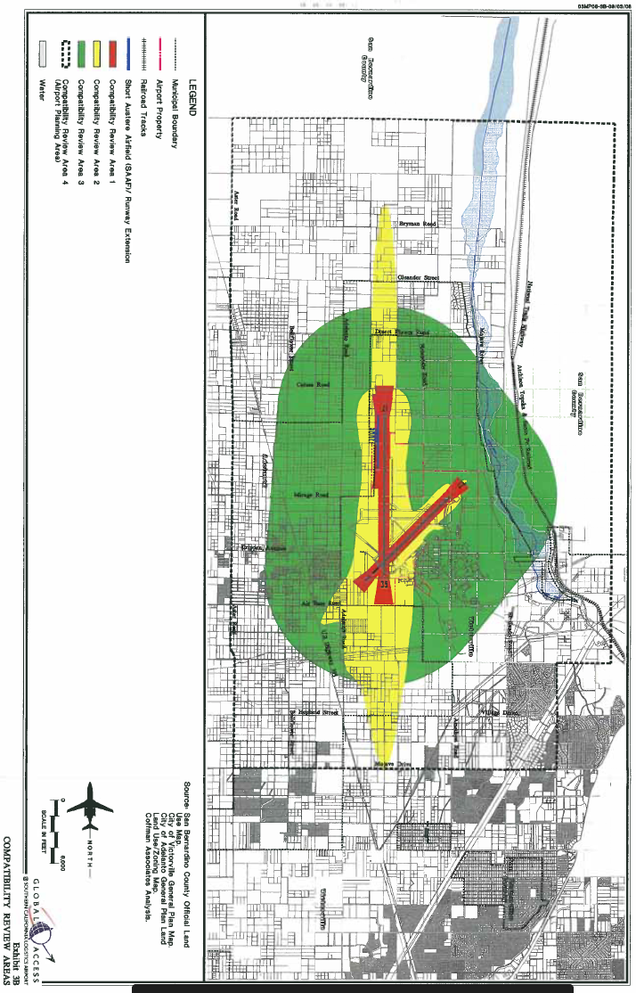
Project Site

The ADD and LM Zones are located within Review Area 2 -Future 65 CNEL Noise Contour, Review Area 3 -Part 77 Horizontal Surface (height limits), and Review Area 4-Airport Planning Area (requires disclosure notice for residential development). Pursuant to Chapter Three, Section 1.3. Types of Actions Reviewed, Paragraph B, of the Comprehensive Land Use Plan (CLUP) States 4.1 Airspace Obstructions: The proposed use or structure shall not be greater than the imaginary surfaces defined according to 14 CFR Part 77.
Part 77 Horizontal Surface (height limits), which is regulated by 14 CFR § 77.17 Obstruction standards as described below.
(a) An existing object, including a mobile object, is, and a future object would be an obstruction to air navigation if it is of greater height than any of the following heights or surfaces:
(1) A height of 499 feet above ground level (“AGL”) at the site of the object.
(2) A height that is 200 feet AGL, or above the established airport elevation, whichever is higher, within 3 nautical miles of the established reference point of an airport, excluding heliports, with its longest runway more than 3,200 feet in actual length, and that height increases in the proportion of 100 feet for each additional nautical mile from the airport up to a maximum of 499 feet.
(3) A height within a terminal obstacle clearance area, including an initial approach segment, a departure area, and a circling approach area, which would result in the vertical distance between any point on the object and an established minimum instrument flight altitude within that area or segment to be less than the required obstacle clearance.
(4) A height within an en-route obstacle clearance area, including turn and termination areas, of a Federal Airway or approved off-airway route, that would increase the minimum obstacle clearance altitude.
(5) The surface of a takeoff and landing area of an airport or any imaginary surface established under §77.19, 77.21, or 77.23. However, no part of the takeoff or landing area itself will be considered an obstruction.
The Federal Aviation Administration (FAA) conducted an aeronautical study under the provisions of 49 U.S.C., Section 44718 and if applicable Title 14 of the Code of Federal Regulations, part 77, and issued a Determination of No Hazard To Air Navigation dated December 1, 2022 (Appendix M of this Initial Study). This aeronautical study revealed that the structure does not exceed obstruction standards and would not be a hazard to air navigation. Based on this evaluation, marking and lighting are not necessary for aviation safety
The proposed building height of 55 feet is significantly below the height restrictions contained in the SCLA Airport Plan and allowed by the FAA.
Based on the preceding analysis, impacts are less than significant.
Threshold 4.9 – Hazards and Hazardous Materials  Would the Project: | Potentially  Significant Impact | Less Than Significant  Impact with Mitigation | Less Than  Significant Impact | No Impact
f) Impair implementation of or physically interfere with an adopted emergency response plan or emergency evacuation plan?
Impact Analysis
Access to the Project site is proposed from Rancho Road. The Project site does not contain any emergency facilities, nor does it serve as an emergency evacuation route. During construction and long‐term operation, the Project would be required to maintain adequate emergency access for emergency vehicles from these roadways.

Threshold 4.9 – Hazards and Hazardous Materials  Would the Project: | Potentially  Significant Impact | Less Than Significant  Impact with Mitigation | Less Than  Significant Impact | No Impact
g) Expose people or structures, either directly or indirectly, to a significant risk of loss, injury or death involving wildland fires?
Impact Analysis
According to the California Fire Hazard Severity Zone Viewer maintained by Cal Fire, the Project site is not located within a high wildfire hazard area. Also refer to analysis under Section 4.20, Wildfire.

Hydrology and Water Quality
The following document was used in the preparation of this analysis:
- Preliminary Hydrology Study, Keir + Wright, February 28, 2023, included as Appendix G to this initial study
- Water Supply Assessment, KPC EHS Consultants, LLC, January 30, 2023, included as Appendix H to this initial study
- Sewer and Water Analysis, Kier + Wright, November 18, 2022, included as Appendix I to this initial study

Threshold 4.10 – Hydrology and Water Quality  Would the Project: | Potentially  Significant Impact | Less Than Significant  Impact with Mitigation | Less Than  Significant Impact | No Impact
a) Violate any water quality standards or waste discharge requirements or otherwise substantially degrade surface or ground water quality?
Impact Analysis
Pre-Development Conditions
Currently, the existing site is undeveloped. The existing site generally slopes from southwest to northeast. There are no existing storm drains within the Project site. The slopes within the Project site range from flat to mild slopes, ranging from 2% to 10% in some areas. With the majority of the site being type C soils, the drainage percolates into the ground, and the remaining runoff flows to Rancho Road.
Construction Impacts
Construction of the Project would involve clearing, grading, paving, utility installation, building construction, and the installation of landscaping, which would result in the generation of potential water quality pollutants such as silt, debris, chemicals, paints, and other solvents with the potential to adversely affect water quality. As such, short‐term water quality impacts have the potential to occur during construction activities in the absence of any protective or avoidance measures.
Chapter 17.93.050 - Soil Erosion and Sediment Control Plan of the Adelanto Municipal Code requires the Project to obtain a National Pollutant Discharge Elimination System (NPDES) Municipal Stormwater Permit for construction activities. The permit is required for all projects that include construction activities, such as clearing, grading, and/or excavation that disturb at least one acre of total land area.
Compliance with the permit requires the preparation and implementation of a Storm Water Pollution Prevention Plan (SWPPP) to identify construction Best Management Practices (BMPs) that will be implemented to prevent soil erosion and the discharge of sediment into the local storm drains during the Project’s construction phase. Typical BMPs include, but are not limited to, preserving natural vegetation, stabilizing exposed soils, use of sandbags, and installation of temporary silt fencing.
Operational Impacts
Stormwater pollutants commonly associated with industrial land uses include sediments, nutrients, trash and debris, bacteria and viruses, oil and grease, and pesticides. City of Adelanto Municipal Code Chapter 17.93.060 requires the preparation of a Water Quality Management Plan (WQMP) for managing the quality of stormwater or urban runoff that flows from a developed site after construction is completed. The Project will comply with the City of Adelanto and the Phase II Small MS4 General Permit for the Mojave River Watershed as described below.
In the proposed condition, the site drainage is split into two areas. The northern half of the site drains to a basin on the northeast. The flow is transferred to the basin through a combination of storm drainpipe, and surface flow. The southern half of the site drains to a basin located in the southeast of the site. This basin receives the site drainage through a combination of storm drainpipe and surface flow as well.

Threshold 4.10 – Hydrology and Water Quality  Would the Project: | Potentially  Significant Impact | Less Than Significant  Impact with Mitigation | Less Than  Significant Impact | No Impact
b) Substantially decrease groundwater supplies or interfere substantially with groundwater recharge such that the project may impede sustainable groundwater management of the basin?
Impact Analysis
Ground Water Supply Discussion
The Project would be served with potable water by the Adelanto Public Utility Authority. Adelanto has groundwater wells within its distribution system that are actively used to pump groundwater from the Mojave River Groundwater Basin, which lies beneath Victor Valley. The Mojave Basin Area was the subject of a court ordered adjudication in 1993 due to the rapid growth within the area, increased withdrawals, and lowered groundwater levels. The court’s Judgment appointed Mojave Water Agency (MWA) as Watermaster of the Mojave Basin Area. The court ordered adjudication of the Mojave Basin Area allocates a variable free production allowance (FPA) to each purveyor that supplies more than 10 AFY, including Adelanto.
Each allocated FPA represents the purveyor’s share of the water supply available from the MWA Subarea. FPAs are determined as a percentage of the purveyor’s highest verified annual use from 1986 to 1990. The FPA, which is currently set at 80% of BAP for agriculture and 60% of BAP for municipal and industrial (M&I), can vary from year to year depending on the Watermaster’s safe yield projections for the Basin. If Adelanto, or another purveyor, pumps more than its allotted FPA in any year, it is required to purchase replacement water equal to the amount of production in excess of the FPA. Replacement obligations are satisfied by paying MWA and then purchasing unused FPA within the subarea.
Given the City’s total reliance on groundwater, the reliability of the City’s water supply is thus entirely dependent on the reliability of the groundwater in the Mojave River Basin managed by the Mojave Water Agency. Because almost all the water used within the Mojave Water Agency’s service area is supplied by pumped groundwater, to supplement the local groundwater supplies, the Mojave Water Agency recharges the groundwater basins with State Water Project imported water, natural surface water flows, wastewater imports from outside the Mojave Water Agency’s service area, agricultural depletion from storage, and return flow from pumped groundwater not consumptively used. The Mojave Water Agency’s sources are only used to recharge the groundwater basins and are not supplied directly to any retailers, except for two power plants, the High Desert Power Project, and the LUZ Solar Plant.
Groundwater Recharge Discussion
Groundwater was not encountered during subsurface field evaluation to the maximum explored depth of approximately 50 feet below existing ground surface. Historic high groundwater is anticipated to be greater than 50 feet below existing grade. The California Department of Water Resources Water Data Library indicates that several wells existed within approximately 1 mile of the site; however, the wells were not frequently monitored. Based on the data, it appears that groundwater between the 1950s and early 1960s was between approximately 100 to 200 feet deep, while in the mid-1990s it was over 300 feet deep.
Seasonal fluctuations of groundwater elevations should be expected over time. In general, groundwater levels fluctuate with the seasons and local zones of perched groundwater may be present within the near-surface deposits due to local seepage or during rainy seasons. Groundwater conditions below the site may be variable, depending on numerous factors including seasonal rainfall, local irrigation, and groundwater pumping, among others.
Sustainable Groundwater Management Discussion
California depends on groundwater for a major portion of its annual water supply, particularly during times of drought. This reliance on groundwater has resulted in overdraft and unsustainable groundwater usage in many of California’s basins. The Sustainable Groundwater Management Act (SGMA) was enacted to halt overdraft and bring groundwater basins into balanced levels of pumping and recharge. The City of Adelanto is located within the Upper Mojave River Valley portion of the Mojave River Basin.
The Mojave River is an adjudicated basin (i.e., water rights are determined by court order). Adjudicated basins are exempt from the SGMA because such basins already operate under a court-ordered management plan to ensure the long-term sustainability of a basin. No component of the Project would obstruct or prevent the implementation of the management plan for the Mojave River Basin. As such, the Project would not conflict with any sustainable groundwater management plan. Impacts would be less than significant.
Conclusion
Based on the analysis above, the Project is not forecast to substantially deplete groundwater supplies or interfere substantially with groundwater recharge such that there would be a net deficit in aquifer volume or a lowering of the local groundwater table level.

Threshold 4.10 – Hydrology and Water Quality  Would the Project: | Potentially  Significant Impact | Less Than Significant  Impact with Mitigation | Less Than  Significant Impact | No Impact
c) Substantially alter the existing drainage pattern of the site or area, including through the alteration of the course of a stream or river or through the addition of impervious surfaces, in a manner which would:
i) result in a substantial erosion or siltation on- or off-site;
ii) substantially increase the rate or amount of surface runoff in a manner which would result in flooding on- or offsite;
iii) create or contribute runoff water which would exceed the capacity of existing or planned stormwater drainage systems or provide substantial additional sources of polluted runoff; or
iv) impede or redirect flood flows?
Impact Analysis
Existing Condition/Pre-Development
Currently, the existing site is undeveloped. The existing site generally slopes from southwest to northeast. There are no existing storm drains within the Project site. The slopes within the Project site range from flat to mild slopes, ranging from 2% to 10% in some areas. With the majority of the site being type C soils, the drainage percolates into the ground, and the remaining runoff flows to Rancho Road. The peak flow rate is 69.57 cubic feet per second (cfs).
Proposed Condition/Post Development
In the proposed condition, the site drainage is split into two areas. The northern half of the site drains to a basin on the northeast. The flow is transferred to the basin through a combination of storm drain pipe and surface flow. The southern half of the site drains to a basin located in the southeast of the site. This basin receives the site drainage through a combination of storm drain pipe and surface flow as well. Post development, the peak flow rate would be 101.31 cfs.

Pre-Development vs. Post Development Storm Water Runoff
Description | Peak Flow Rate  (cubic feet per second)
Existing Condition | 69.57 cfs
Design Criteria (90% of 69.57 cfs). | 62.613 cfs
Post Development | 101.31 cfs
Meets Requirement? | No
Source: Preliminary Hydrology Study, Appendix D (Appendix G to this ISMND).

The required capture volume is 110,385 cubic feet (2.534 acre-feet) of stormwater per the unit hydrograph calculations. The basin has been sized to store 6.45 acre-feet of stormwater due to the increase of peak flow runoff from the post-development state compared to the pre-development state. Unit hydrograph calculations were prepared to establish the baseline Qs for the 100-year 24-hour storm for the project. To mitigate the extra runoff, the basin has been sized to prevent extra runoff from leaving the site during the storm event. The basins are located in areas that results in favorable infiltration rates based on the geotechnical report provided by LGC Geotechnical, Inc. found in Appendix 3. With a factor of safety of 3 applied to the observed infiltration rate, the native soils has a rate of 3.67” per hour. With the largest basin filled completely with a depth of 9’, the basin should drain within 30 hours at this rate.
Proposed development can be mitigated as designed to be compatible with the City of Adelanto Master Plan of Drainage. The development of the subject site will not significantly change area drainage patterns, impact any of the surrounding properties, or change any of the regional master plan facilities.

Threshold 4.10 – Hydrology and Water Quality  Would the Project: | Potentially  Significant Impact | Less Than Significant  Impact with Mitigation | Less Than  Significant Impact | No Impact
d) In flood hazard, tsunami, or seiche zones, risk release of pollutants due to project inundation?
Impact Analysis
According to the Federal Emergency Management Agency (FEMA), the Project site is not located within a flood hazard zone. According to the California Department of Conservation, California Official Tsunami Inundation Maps, the site is not located within a tsunami inundation zone. In addition, the Project would not be at risk from seiche because there is no water body around the Project site capable of producing as seiche.

Threshold 4.10 – Hydrology and Water Quality  Would the Project: | Potentially  Significant Impact | Less Than Significant  Impact with Mitigation | Less Than  Significant Impact | No Impact
e) Conflict with or obstruct implementation of a water quality control plan or sustainable groundwater management plan?
Impact Analysis
As discussed under Thresholds 4.10 (a) and 4.10 (c), with implementation of the proposed drainage system improvements and features, the Project will not conflict with or obstruct implementation of the Lahontan Basin Plan. In addition, as discussed under Threshold 4.10 (b), the Project site is not subject to a Sustainable Groundwater Water Management program and will not substantially impede sustainable groundwater management of the basin.

Land Use and Planning
Thresholds 11 – Hydrology and Water Quality  Would the Project: | Potentially  Significant Impact | Less Than Significant  Impact with Mitigation | Less Than  Significant Impact | No Impact
a) Physically divide an established community?
Impact Analysis
An example of a Project that has the potential to divide an established community includes the construction of a new freeway or highway through an established neighborhood. The Project site is in an area that consists primarily of vacant undeveloped land. The Project site is bordered on the north by Rancho Road then commercial businesses and undeveloped land; on the south by manufacturing and undeveloped land; on the east by an unpaved road and a solar farm; and on the west by manufacturing. The Project site is planned for residential development by the General Plan. The properties in the immediate area are also planned for light manufacturing. Thus, the development of the Project site is a logical continuation of the development pattern in the area as proposed by the General Plan and will not divide an established community.

Thresholds 11 – Hydrology and Water Quality  Would the Project: | Potentially  Significant Impact | Less Than Significant  Impact with Mitigation | Less Than  Significant Impact | No Impact
b) Cause a significant environmental impact due to a conflict with any land use plan, policy, or regulation adopted for the purpose of avoiding or mitigating an environmental effect?
Impact Analysis
The applicable plans and policies relating to a conflict with any applicable land use plan, policy, or regulation of an agency with jurisdiction over the Project (including, but not limited to the general plan, specific plan, or zoning ordinance) adopted for the purpose of avoiding or mitigating an environmental effect are evaluated throughout this Initial Study document as described below.
City of Adelanto General Plan
- Land Use Element: The General Plan Land Use and Zoning designation for the Project site is Light Manufacturing (LM). The Light Manufacturing (LM) district provides for a limited range of uses, including only light industrial and manufacturing uses that benefit from separation from residential, office, and retail districts. As evidenced throughout this Initial Study, all impacts have been identified as having no impact, a less than significant impact, or a less than significant impact with mitigation incorporated. As such, the Project is consistent with the new General Plan Land Use and Zoning designations.
- Circulation Element: Please refer to Section 4.17, Transportation, for the analysis.
- Conservation/Open Space Element: Please refer to Section 4.1, Aesthetics, and Section 4.4, Biological Resources, for the analysis.
- Noise Element: Please refer to Section 4.13, Noise, for the analysis.
- Safety Element: Please refer to Section 4.9, Hazards and Hazardous Materials, for the analysis.
- Community Design Element: Please refer to Section 4.1, Aesthetics, for the analysis.
City of Adelanto Zoning Ordinance
In instances where the Zoning Ordinance applies to an environmental effect, it is identified in the Impact Analysis section for each environmental topic. As detailed in such instances, impacts are less than significant.
Mojave Desert Air Quality Management District Air Quality Management Plan
Please refer to Section 4.3, Air Quality, for the analysis.
San Bernardino County Regional Greenhouse Gas Reduction Plan
Please refer to section 4.8, Greenhouse Gas Emissions, for the analysis.
Water Quality Control Plan for the Lahontan Region (Basin Plan)
Please refer to Section 4.10, Hydrology and Water Quality for the analysis.
Conclusion
As demonstrated throughout this Initial Study document, the Project would not conflict with any applicable land use plan, policy, or regulation due to a conflict with any land use plan, policy, or regulation adopted for the purpose of avoiding or mitigating an environmental effect, with compliance with mandatory regulatory requirements or mitigation measures.

Mineral Resources
Threshold 4.12 – Mineral Resources  Would the Project: | Potentially  Significant Impact | Less Than Significant  Impact with Mitigation | Less Than  Significant Impact | No Impact
a) Result in the loss of availability of a known mineral resource that would be a value to the region and the residents of the state?
Impact Analysis
The naturally occurring mineral resources within the Planning Area include sand, gravel, or stone deposits that are suitable as sources of concrete aggregate. The Project site has been designated with a Mineral Land Classification of MRZ-3A, which is an area containing known mineral occurrences of undetermined mineral resource significance. This classification was based on a report by the California Department of Conservation, Division of Mines and Geology, entitled Mineral Land Classification of Concrete Aggregate Resources in the Barstow - Victorville Area, San Bernardino County, California. A review of the California Department of Conservation interactive web mapping indicates there are no active mines on the Project site. In addition, a review of the California Division of Oil, Gas, and Geothermal Resources well finder indicates that there are no wells located in the vicinity of the Project site.
Accordingly, implementation of the Project would not result in the loss of availability of a known mineral resource that would be of value to the region or the residents of the State of California.

Thresholds 12 – Mineral Resources  Would the Project: | Potentially  Significant Impact | Less Than Significant  Impact with Mitigation | Less Than  Significant Impact | No Impact
b) Result in the loss of availability of a locally important mineral resource recovery site delineated on a local general plan, specific plan or other land use plan?
Impact Analysis
The Project site is not being used for mineral resource recovery. The Project site is designated as Light Manufacturing (LM). If the Project site were intended for mineral recovery, it would be designated as such, and not residential. As such, the Project is not delineated on the General Plan, a specific plan, or other land use plan as a locally important mineral resource recovery site.

Noise
The following analysis is based in part on the following:
- Noise Assessment. KPC EHS Consultants, LLC, dated February 14, 2023, included as Appendix J to this Initial Study.

Thresholds 4.13 – Hydrology and Water Quality  Would the Project: | Potentially  Significant Impact | Less Than Significant  Impact with Mitigation | Less Than  Significant Impact | No Impact
a) Generation of a substantial temporary or permanent increase in ambient noise levels in the vicinity of the project in excess of standards established in the local general plan or noise ordinance, or applicable standards of other agencies?
Impact Analysis
Existing Ambient Noise Levels
The primary sources for existing ambient noise in the Project area are traffic and industrial uses. Traffic generated noise is from adjacent Adelanto and Rancho Roads, and Highway 395, which is approximately 1 mile to the west. The Southern California Logistics Airport is located approximately 1.4 miles north. Industrial uses surrounding the Project area are listed in Table 4.13-1, Occupied Structures/Receptors, below with approximate distance(s) to the site.

Occupied Structures/Receptors
Business | Location | Distance
Northwest Pipe Company | West across Aguadera Road | Occupied structures approximately 600 feet from west boundary
Western States Wholesale Building Materials | North across Rancho Road | Occupied structures approximately 85 feet from north boundary
Holiday Rock | Northwest across Rancho Road | Occupied structures approximately 190 feet from northwest boundary

To assess the existing noise level environment, short-term noise measurements were obtained from six locations in the Project study area. Figure 4.13-1 provides the locations of the noise level measurements. Table 4.13-2 provides the noise measurements.

Ambient Noise Level Measurements
Location | Description | Average Noise Level  dBA (Leq)
#1 | Air Expressway & 395 | 56.2
#2 | Air Expressway & Mesa Linda | 53.8
#3 | Violet Road & Emerald Road | 50.7
#4 | Project Site | 48.7
#5 | Old Rancho Road & Adelanto Road | 57.3
#6 | 395 and Mojave | 57.0

Noise Measurement Locations
Cactus Road
Emerald Road

Air Expressway
Rancho Road
5
4
6
3
1

2

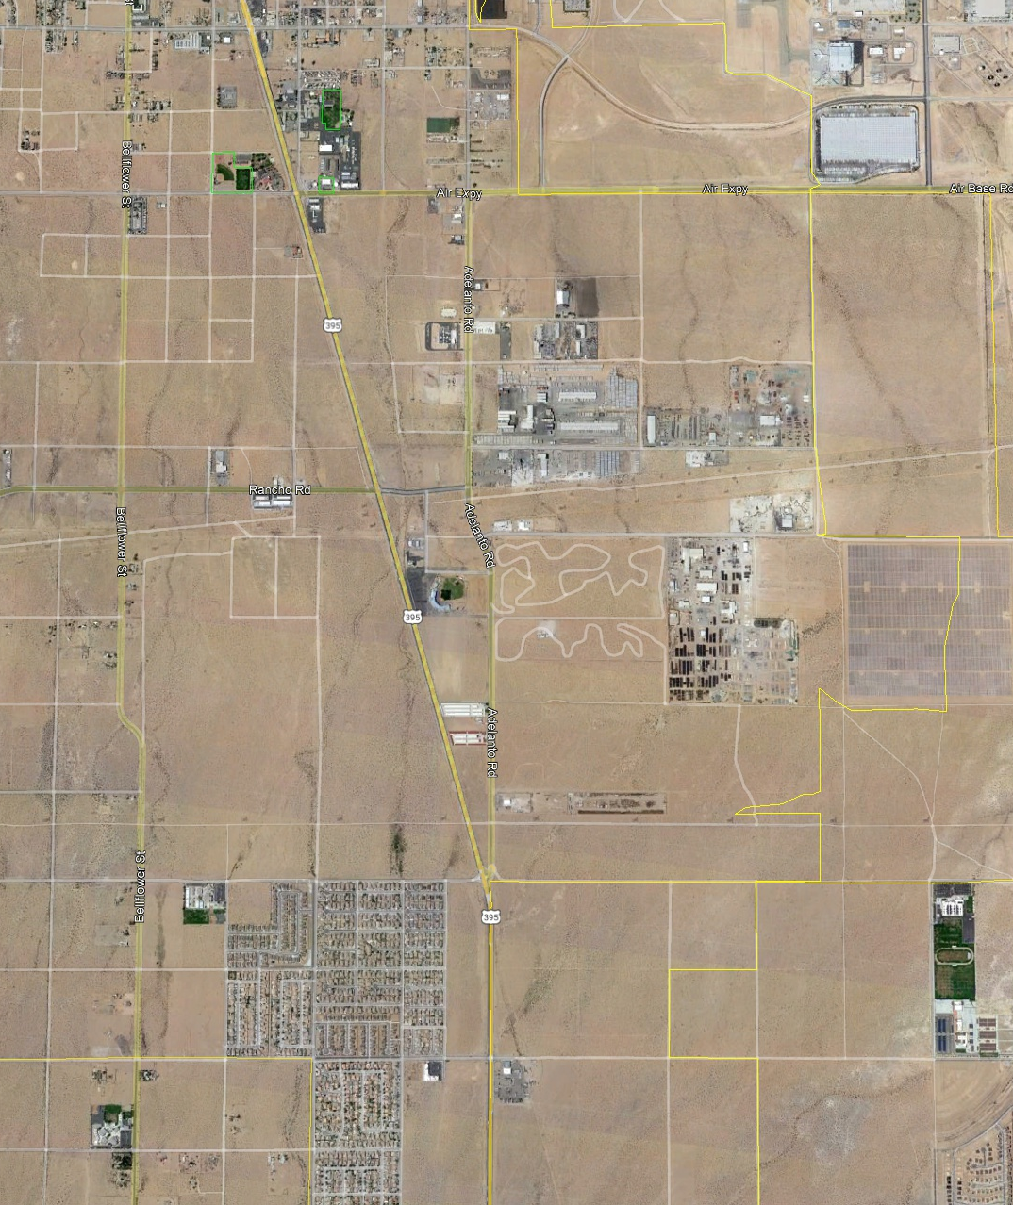
Noise-sensitive land uses are locations where people reside or where the presence of unwanted sound could adversely affect the use of the land. Residences, schools, hospitals, guest lodging, libraries, churches, nursing homes, auditoriums, concert halls, amphitheaters, playgrounds, and parks are considered noise sensitive. The nearest sensitive receptor to the Project site is the Adelanto Medical Clinic located at 11678 Rancho Road, approximately 8,239 feet or 1.56 miles northwest of the property western boundary.
The Bureau of Transportation Statistics provides the National Transportation Noise Map as a basis for understanding what-if scenarios and helping policy makers and planners to prioritize noise-related transportation investments. The data on the noise map allows for viewing the potential exposure to aviation, highway, and rail noise. The current data for the Adelanto Area is from the 2016-2018 noise map and is presented in Figure 4.13-2. The Noise Map contours are representative of the measured ambient noise measurements as presented in Table 4.13-2, Ambient Noise Level Measurements.
Short-Term Construction Noise Impact Analysis
Construction activities that would create noise include site preparation, grading, building construction, paving, and architectural coating. Noise levels associated with the construction will vary with the different types of construction equipment, the duration of the activity, and distance from the source. Construction noise will have a temporary or periodic increase in the ambient noise level above the existing levels within the Project vicinity. The nearest sensitive receptor to the Project site is the Adelanto Medical Clinic, located 8,239 feet or 1.56 miles northwest of the property western boundary. The closest commercial structure to the project site is the Western States Wholesale Building Materials store to the north approximately 85 feet from the north boundary across Rancho Road.
To estimate the potential impact of construction noise at the nearest sensitive receptor, the Adelanto Medical Clinic, as well as nearby commercial and industrial land uses (current and future), equipment that is expected to be used during construction was input into the Federal Highway Administration Roadway Construction Noise Model (RCNM) to generate anticipated noise levels. The RCNM generates the maximum noise levels (Lmax) and the equivalent continuous sound level (Leq). The Leq is a calculation of the anticipated steady sound pressure level that, over a given time period (day, evening, night), has the same total energy as the actual fluctuating noise. The RCNM also uses an acoustical use factor in the noise calculations. The acoustical use factor is the percentage of time each piece of construction equipment is assumed to be operating at the full power level and is used to estimate the Leq values from the Lmax values. For example, typical operating cycles for these types of construction equipment may involve one or two minutes of full power operation followed by three to four minutes at lower power settings. Noise levels will be loudest during the site preparation and grading phases. Table 4.13-3, Construction Equipment Noise Levels at the Nearest Receptor (Adelanto Medical Center), identifies the level of noise generated by construction equipment.
The properties immediately adjacent and surrounding the Project site are industrial uses or vacant undeveloped parcels (zoned Industrial); additionally, the nearest sensitive receptors are located over 1 mile away. The Project would be compatible with surrounding land uses and would not adversely impact sensitive receptors.
The City of Adelanto has set restrictions to control noise impacts from construction activities. Section 17.90.020(d)(1) of the Adelanto Municipal Code restricts construction activities between the hours of 7:00 a.m. and dusk on weekdays, and construction will not occur on weekends or state holidays.

National Transportation Noise Map: Adelanto Area
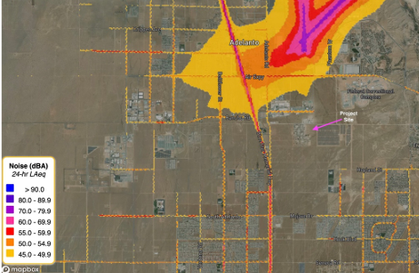
Source: Noise Assessment, Appendix J.

Construction Equipment Noise Levels at the Nearest Sensitive Receptor (Adelanto Medical Center)
Source | Approximate Distance to Nearest Receptor  (Property Line to Construction Site)  (feet) | Sound Level at Nearest Receptor
Source |  | Lmax | Acoustical Use Factor  (%) | Leq
Backhoe | 8,239 | 33.2 | 40 | 29.2
Compactor (ground) | 8,239 | 38.9 | 20 | 31.9
Compressor (air) | 8,239 | 33.3 | 40 | 29.4
Crane | 8,239 | 36.2 | 16 | 28.3
Concrete mixer truck | 8,239 | 34.5 | 40 | 30.5
Dozer | 8,239 | 37.3 | 40 | 33.4
Dump truck | 8,239 | 32.1 | 40 | 28.1
Excavator | 8,239 | 36.4 | 40 | 32.4
Front end loader | 8,239 | 34.8 | 40 | 30.8
Generator | 8,239 | 36.3 | 50 | 33.3
Grader | 8,239 | 40.7 | 40 | 36.7
Offroad forklift | 8,239 | 39.1 | 40 | 35.1
Paver | 8,239 | 32.9 | 50 | 29.9
Pickup truck | 8,239 | 30.7 | 40 | 26.7
Roller | 8,239 | 35.7 | 20 | 28.7
Scraper | 8,239 | 39.2 | 40 | 35.3
Welder/torch | 8,239 | 29.7 | 40 | 25.7
Source: FHWA – RCNM Version 1.1

Construction Equipment Noise Levels at the Nearest Sensitive Receptor (Western States Wholesale Building Materials)
Source | Approximate Distance to Nearest Receptor  (Property Line to Construction Site)  (feet) | Sound Level at Nearest Receptor
Source |  | Lmax | Acoustical Use Factor  (%) | Leq
Backhoe | 85 | 73.0 | 40 | 69.0
Compactor (ground) | 85 | 78.6 | 20 | 71.6
Compressor (air) | 85 | 73.1 | 40 | 69.1
Crane | 85 | 75.9 | 16 | 68.0
Concrete mixer truck | 85 | 74.2 | 40 | 70.2
Dozer | 85 | 77.1 | 40 | 73.1
Dump truck | 85 | 71.8 | 40 | 67.9
Excavator | 85 | 76.1 | 40 | 72.1
Front end loader | 85 | 74.5 | 40 | 70.5
Generator | 85 | 76.0 | 50 | 73.0
Grader | 85 | 80.4 | 40 | 76.4
Offroad forklift | 85 | 78.8 | 40 | 74.8
Paver | 85 | 72.6 | 50 | 69.6
Pickup truck | 85 | 70.3 | 40 | 66.3
Roller | 85 | 75.4 | 20 | 69.4
Scraper | 85 | 79.0 | 40 | 75.0
Welder/torch | 85 | 69.4 | 40 | 65.4
Source: FHWA – RCNM Version 1.1

Noise generation related to construction activities is addressed in §17.90.020(d) of the Zoning Ordinance, which requires construction projects to list general noise-reduction practices as “General Notes” on the construction drawings as part of the Project’s conditions of approval (COA). These mandatory conditions are described as follows:
17.90.020 (d) Construction Practices
To reduce potential noise and air quality nuisances, the following items shall be listed as “General Notes” on the construction drawings:
(1) Construction activity and equipment maintenance is limited to the hours between 7:00 a.m. to dusk on weekdays. Construction may not occur on weekends or State holidays, without prior consent of the Building Official. Non-noise generating activities (e.g., interior painting) are not subject to these restrictions. City and State construction projects, such as road re-building or resurfacing, and any construction activity that is in response to an emergency, shall be exempt from this requirement.
(2) Stationary construction equipment that generates noise in excess of sixty-five (65) dBA at the project boundaries must be acoustically shielded and located at least one hundred feet (100') from occupied residences. The equipment area with appropriate acoustic shielding shall be designated on building and grading plans. Equipment and shielding shall remain in the designated location throughout construction activities.
(3) Construction routes are limited to City of Adelanto designated truck routes.
(4) Water trucks or sprinkler systems shall be used during clearing, grading, earth moving, excavation, or transportation of cut or fill materials to prevent dust from leaving the site and to create a crust after each day's activities cease. At a minimum, this would include wetting down such areas in the later morning and after work is completed for the day and whenever wind exceeds fifteen (15) miles per hour.
(5) A person or persons shall be designated to monitor the dust control program and to order increased watering as necessary to prevent transport of dust off-site. The name and telephone number of such person(s) shall be provided to the City.
(6) All grading equipment shall be kept in good working order per factory specifications.
While the City establishes limits to the hours during which construction activity may take place, it does not identify specific noise level limits for construction noise levels. Therefore, to evaluate whether the Project will generate a substantial increase in the short-term noise levels at the offsite sensitive receptors (residences), the construction-related noise level threshold is based on the National Institute for Occupational Safety and Health (NIOSH) recommended exposure limit (REL) for occupation noise exposure at 85 dBA, as an 8-hour time-weighted average (85 dBA – 8-hr TWA). Using the equipment from the Air Quality GHG Technical Memorandum CalEEMod data for the Site Preparation and Grading Phases, each piece of equipment operating at the same time in the same location for a full 8-hour period was calculated with results provided in Table 4.13-5, Worst Case Construction Noise Levels (Site Preparation and Grading).

Worst Case Construction Noise Levels (Site Preparation and Grading)
Phase | Equipment Type | Number of Units | Leq dBA/Unit | Leq dBA Total
Site preparation | Tractor/loader/backhoe | 4 | 39.2 | –
Site preparation | Rubber tired dozer | 3 | 39.6 | –
 | Total noise level | – | – | 42.4
Grading | Grader | 1 | 36.7 | –
Grading | Tractor/loader/backhoe | 2 | 36.2 | –
Grading | Rubber tired dozer | 1 | 30.8 | –
Grading | Excavator | 2 | 35.4 | –
Grading | Scrapers | 2 | 38.3 | –
 | Total noise level | – | – | 43.1

The highest equipment noise level at the nearest sensitive receptor as indicated in Table 4.13-3 above will be 40.7 dBA (Lmax) and 36.7 dBA (LEQ). During the construction phase the noise levels will be the highest as heavy equipment passes along the Project site boundaries. During the site preparation and grading phases, which produce the highest noise levels, equipment will not be stationary; rather, equipment will be moving throughout the site at varying speeds and power levels and as a result not operating at the maximum noise level for the entire workday. The levels of noise at the nearest sensitive receptor as indicated in Table 4.13-4 are all below the NIOSH REL of 85 dBA 8-hour TWA and would be less than significant. Construction noise is of short-term duration and will not present any long-term impacts on the Project site or the surrounding area. Additionally, the highest noise levels at the Western States Wholesale Building Materials sales office, the closest occupied structure to the site, will be 80.4 dBA Max and 76.4 dBA Leq and construction noise will be less than significant.
Operational Noise Impact Analysis
Offsite Traffic Noise Impacts
Vehicle noise is a combination of the noises produced by the engine, exhaust, and tires. The primary source of noise generated by the Project will be from the vehicle traffic generated by the vehicle ingress and egress to the Project site. Under existing conditions, the site does not generate any traffic noise that impacts the surrounding area.
According to the Federal Highway Administration, Highway Traffic Noise Analysis and Abatement Policy and Guidance, the level of roadway traffic noise depends on three things: (1) the volume of the traffic, (2) the speed of the traffic, and (3) the number of trucks in the flow of the traffic. Generally, the loudness of traffic noise is increased by heavier traffic volumes, higher speeds, and greater numbers of trucks. These factors are discussed below.
Volume of Traffic
Upon buildout, the proposed Project is expected to generate approximately 1,046 average daily vehicle trips from passenger cars and trucks, of which 217 (20.7 %) trips will be from trucks. The morning and afternoon peak hour truck traffic is calculated to be 20 ADT and 21 ADT, respectively, which will increase the ambient traffic noise levels in the vicinity of the Project site in comparison to the existing site conditions (industrial and vacant land).
The current average daily vehicle trips (ADT) along Adelanto Drive north of Air Expressway is approximately 1,180, assuming all the Project traffic (761 ADT) takes Adelanto Drive, the results would not be a doubling of traffic volume. Additionally, noise analysis performed as part of the Southern California Logistics Airport Lot 44 Distribution Center indicate that noise levels along Adelanto Drive around Air Expressway have been calculated at 51 dBA CNEL 100 feet from the roadway centerline.
According to Caltrans, the human ear is able to begin to detect sound level increases of 3 decibels (dB) in typical noisy environments. A doubling of sound energy (e.g., doubling the volume of traffic on a highway) that would result in a 3-dBA increase in sound, would generally be barely detectable. Implementation of the Project will increase traffic volumes in the area occurring along Inland Rancho Road and Emerald Road but not to the extent that traffic volumes will be doubled creating a +3-dBA noise increase or result in a perceivable noise increase. Therefore, operational noise impacts would be less than significant.
Speed of Traffic
Adelanto Road is a 4-lane road classified as a Major Boulevard and has a speed limit of 45 miles per hour (mph). Rancho Road is generally a 2-lane road classified as a Major Arterial Highway and has a speed limit of 45 mph between Emerald and Adelanto Roads. These low levels of speeds do not result in vehicles generating high levels of noise.
Number of Trucks in the Flow of the Traffic
The Project is a warehouse development in an industrial area and, although it will generate noise from large trucks, the site is located in an industrial area with similar truck and traffic uses. The total number of daily trips from passenger cars and trucks is calculated to be 1,046 ADT, of which 217 (20.75 %) trips will be from trucks. The morning and afternoon peak hour truck traffic is calculated to be 68 ADTE and 79 ADT, respectively. Truck traffic will also be required to use the City’s designated truck routes, which include Adelanto Road and Highway 395 for north/south traffic, and Rancho Road, Holly Road, and Air Expressway for east/west traffic. The use of the truck routes will also decrease the impacts on sensitive receptors such as residential uses.
Facility Operations (Stationary Noise)
At the time the noise analysis was prepared, the future tenants of the proposed Project were unknown. The on-site Project-related noise sources are expected to include rooftop heating ventilation and air conditioning units (HVAC), refrigeration units, idling trucks, truck activities, backup alarms, as well as loading and unloading of dry goods, and parking lot vehicle movements. This noise analysis is intended to describe noise level impacts associated with the expected typical operational (stationary source) activities at the Project site.

Reference Noise Level Measurements
Noise Source | Reference Distance  (feet) | Reference Noise Level  (dBA) | Distance to Receptor  (feet) | Noise Level  (dBA)
Rooftop HVAC ¹ | 1 | 88 | 100 | 48.0
Truck Loading Dock Activity ² | 50 | 63.6 | 840 | 39.1
Truck Backup Alarm ² | 50 | 75.0 | 840 | 50.5
Parking Lot Activity ² | 25 | 54.4 | 100 | 42.4
¹ Reference Level Lennox 10-ton air handler unit (AHU) manufacturer specifications.
² Reference Level collected at Amazon Fulfillment Center ONT-6 (24208 San Michele Road, Moreno Valley)

The proposed warehouse structure would include dock doors for truck loading and unloading. To determine the noise level impacts of the Project, short-term reference noise level measurements were collected at the Amazon Fulfillment Center located at 24208 San Michele Road in the City of Moreno Valley. The noise measurements represent a typical weekday warehouse loading/unloading operation on a large single building distribution center, approximately 1.2 million square feet with 200 trailer parking spaces and 90 docks. Operations during the noise measurements included multiple trucks being loaded/unloaded, forklift and truck/trailer movement.
The loading/unloading operations noise measurements were taken over a 15-minute period from an area approximately at the center of the docking stations at 50 feet from the building. The reference noise measurement obtained was 63.6 dBA Leq and calculated attenuation for 840-foot distance at 39.1 dBA Leq. The 840-foot distance is the closest distance from the west loading dock side of the structure to the closest occupied building on the adjacent Northwest Pipe Company property. No attenuation for shielding from buildings or walls was calculated.
Trucks at the Project site would utilize backup alarms during the loading/unloading activities, which according to ECCO, the first manufacturer of backup alarms, depending on the model, typically produce a noise level of 87 to 112 dBA at 1 foot, and at 840 feet with no sound barriers (walls or buildings) the noise level would be between 28.5 and 53.5 dBA. Reference noise level measurements taken at 50 feet during truck movement and backup alarm operation were measured at 75 dBA max, which would result in a 50.5 dBA noise level at 840 feet with no perimeter walls or buildings as shielding.
Parking lot areas for passenger vehicles and trailer parking were estimated to be located on the west and east sides of the proposed structure. Traffic associated with parking lots is typically not at a sufficient level to exceed the community noise standards. The total parking estimated for the Project are fewer than 500 stalls, the reference noise levels were taken at a parking lot that can accommodate approximately 1,000 stalls. The Project’s parking lots are substantially smaller, and no significant noise impacts offsite from the parking lot use would be anticipated.
The USEPA identifies noise levels affecting health and welfare as exposure levels over 70 dBA over a 24-hour period. Noise levels for various levels are identified according to the use of the area. Levels of 45 dBA are associated with indoor residential areas, hospitals, and schools, whereas 55 dBA is identified for outdoor areas where typical residential human activity takes place. According to the USEPA, levels of 55 dBA outdoors and 45 dBA indoors are identified as levels of noise considered to permit spoken conversation and other activities such as sleeping, working, and recreation, which are part of the daily human condition. Levels exceeding 55 dBA in a residential setting are normally short in duration and not significant in affecting health and welfare of residents. As the Project site is located in an industrialized area that is zoned and planned for future industrial development, the nearest exiting sensitive receptor is over 1 mile away and the nearest potential future sensitive receptors would be in the Mixed-Use zoned properties approximately 4,770 feet (0.9 miles) to the west, and no significant noise impacts are expected at that distance.
Conclusion
Through compliance with mandatory requirements to reduce noise during construction, the Project’s construction noise impacts will not result in the generation of a substantial temporary or permanent increase in ambient noise levels in the vicinity of the project. In addition, as shown above, the Project’s operational noise would not be significant.

Thresholds 4.13 – Hydrology and Water Quality  Would the Project: | Potentially  Significant Impact | Less Than Significant  Impact with Mitigation | Less Than  Significant Impact | No Impact
b) Generation of excessive groundborne vibration or groundborne noise levels?
Impact Analysis
During construction the operation and movement of heavy equipment create seismic waves that radiate along the ground surface in all directions. These waves are felt as ground vibrations. Vibrations from construction can result in effects ranging from annoyance to people to structure damage. Vibration levels are impacted by geology, distance, and frequencies. According to the Federal Transit Administration, Transit Noise and Vibration Impact Assessment Manual, September 2018, while ground vibrations from construction activities do not often reach the levels that can damage structures, construction vibration may result in building damage or prolonged annoyance from activities such as blasting, piledriving, vibratory compaction, demolition, and drilling or excavation near sensitive structures. The Project does not require these types of construction activities. Vibration amplitude and impact decreases with distance and perceptible groundborne vibration is generally limited to areas within 1 to 200 feet of the construction activity. The vibration standard used for the City is that no ground vibration shall be allowed that can be felt without the aid of instruments at or beyond the subject property line, nor will any vibration be permitted that produces a peak particle velocity (PPV) greater than or equal to two-tenths of an inch per second measured at or beyond the lot line.

Vibration Source Levels for Construction Equipment
Equipment | PPV (inches per second)  at 25 feet
Small bulldozer | 0.003
Jackhammer | 0.035
Loaded trucks | 0.076
Large bulldozer | 0.089
Source: Federal Transit Administration, Transit Noise and Vibration Impact Assessment, September 2018

The closest sensitive receptor to the Project property line is minimally 8,239 feet from the property line. The estimated construction vibration level from a large bulldozer (worst case scenario) measured at 15 feet would create a vibration level of 0.191 in/sec, which does not exceed the 0.2 in/sec threshold. Therefore, the vibrations at the nearest sensitive receptor will remain well below the strongly perceptible annoyance criteria and potential residential vibration damage criteria thresholds listed in the City of Adelanto Municipal Code Section 17.90.030 (vibration).
This threshold requires that no vibration greater than 0.2 PPV be felt at or beyond the lot line. The proposed Project therefore is not considered to result in exposure of people to excessive ground vibration. During operations of the Project following construction, the primary source of vibration would be from vehicle traffic, primarily truck traffic. Truck vibration levels are dependent on vehicle characteristics, load, speed, and pavement conditions. Typical vibration levels from heavy truck activity at normal traffic speeds are in the order of 0.004 in/sec PPV at 25 feet based on the FTA’s Transit Noise Impact and Vibration Assessment (2018). Trucks once on site will be travelling at very low speeds and it is expected that truck vibration impacts off site would not exceed the 0.2 in/sec PPV threshold.
Groundborne vibration levels from automobile traffic are generally overshadowed by vibration generated by heavy trucks that roll over the same uneven roadway surfaces. However, due to the rapid drop-off rate of groundborne vibration and the short duration of the associated events, vehicular traffic-induced groundborne vibration is rarely perceptible beyond the roadway right-of-way, and rarely results in vibration levels that would cause annoyance to people or damage to buildings in the vicinity.
Conclusion
The Project’s construction and operations vibration impacts as well as operational noise for mobile and operational noise impacts to the environment are less than significant.

Thresholds 4.13 – Hydrology and Water Quality  Would the Project: | Potentially  Significant Impact | Less Than Significant  Impact with Mitigation | Less Than  Significant Impact | No Impact
c) For a project located within the vicinity of a private airstrip or an airport land use plan or, where such a plan has not been adopted, within two miles of a public airport or public use airport, would the project expose people residing or working in the project area to excessive noise levels?
Impact Analysis
The Project site is approximately 1.4 miles south of the Southern California Logistics Airport. According to San Bernardino Countywide Plan Policy Map HZ-9, Airport Safety and Planning Areas, the Project site is not located within an area exposed to excessive noise levels.

Long-Range Noise Contours
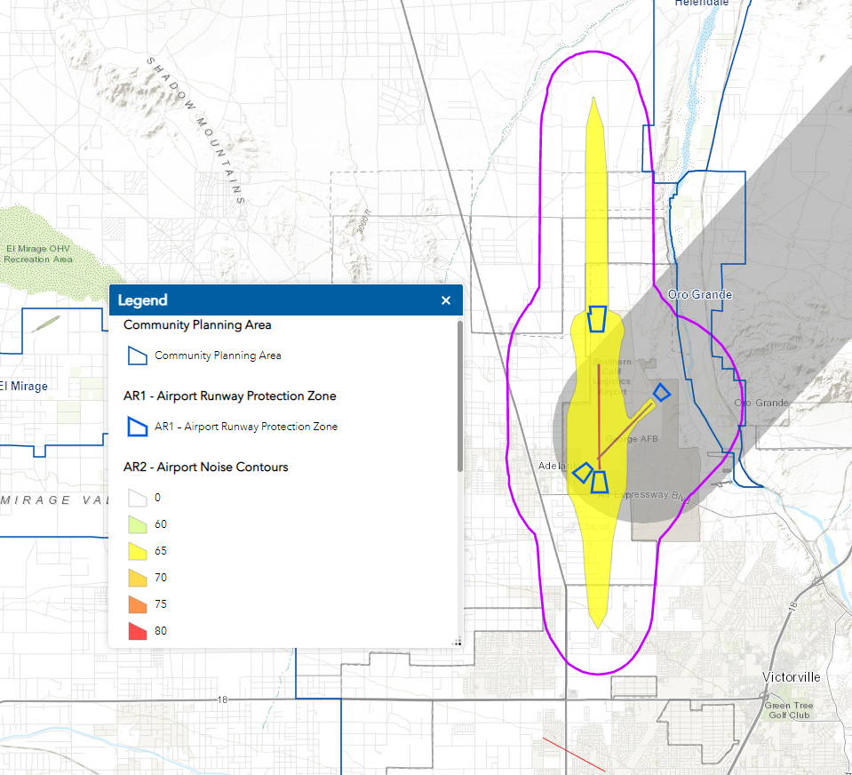
Project Site

Source: County of San Bernardino Countywide Plan, Map HZ-9, Airport Safety and Hazard Areas. https://www.arcgis.com/apps/webappviewer/index.html?id=5dc02b81369c49c9a1947aedfc300a45

Population and Housing

Threshold 4.14 – Population and Housing  Would the Project: | Potentially  Significant Impact | Less Than Significant  Impact with Mitigation | Less Than  Significant Impact | No Impact
a) Induce substantial unplanned population growth in an area, either directly (for example, by proposing new homes and businesses) or indirectly (for example, through extension of roads or other infrastructure)?
Impact Analysis
Population Growth
A project could induce population growth in an area, either directly (for example, by proposing new homes and/or businesses) or indirectly (for example, through extension of roads or other infrastructure). No residential uses would be developed as part of the Project. The Project would not result in the development of any new housing, and therefore, would not induce direct population growth in the City through new housing development. The Project would employ approximately 303 people. The addition of a new distribution center on a previously vacant site would increase employment within the City. Thus, the Project would lead to an increase in the employee population within the area. The additional employment created by the proposed Project has the potential to result in an indirect growth in the City’s population, since the potential exists that future employees (and their families) that currently reside outside of the City could choose to relocate to the City. Estimating the number of future employees who may choose to relocate to the City would be highly speculative, since many factors influence personal housing location decisions (e.g., family income levels and the cost and availability of suitable housing in the local area). Additionally, housing opportunities exist for the Project’s future employees in the communities surrounding the City. Although uncertainty exists regarding the number of new employees who may choose to relocate to the City, it is not anticipated that implementation of the proposed project would induce substantial population growth within the City either directly or indirectly.
Infrastructure Extensions
The Project site is adjacent to Rancho Road, Adelanto Road, and Mesa Linda Road. No roadway extensions are required to serve the site. The Project would connect to the existing sewer, water, storm drain, electric, gas, and communication facilities located adjacent or in close proximity to the site. No infrastructure extensions will be needed to serve the Project.

Threshold 4.14 – Population and Housing  Would the Project: | Potentially  Significant Impact | Less Than Significant  Impact with Mitigation | Less Than  Significant Impact | No Impact
b) Displace substantial numbers of existing people or housing, necessitating the construction of replacement housing elsewhere?
Impact Analysis
The Project site consists of undeveloped vacant land. Therefore, implementation of the Project would not displace a substantial number of existing housing, nor would it necessitate the construction of replacement housing elsewhere.

Public Services
Threshold 4.15 – Public Services  Would the Project: | Potentially  Significant Impact | Less Than Significant  Impact with Mitigation | Less Than  Significant Impact | No Impact
a) Result in substantial adverse physical impacts associated with the provision of new or physically altered governmental facilities, need for new or physically altered governmental facilities, the construction of which could cause significant environmental impacts, in order to maintain acceptable service ratios, response times, or other performance objectives for any of the public services:
i) Fire protection?
ii) Police protection?
iii) Schools?
iv) Parks?
v) Other public facilities?
Impact Analysis
Fire Protection: The San Bernardino County Fire Department provides fire protection services to the Project area. The Project would be primarily served by the Adelanto Station #322, an existing station located approximately 3.2 roadway miles west of the Project site at 10370 Rancho Road. Development of the Project would impact fire protection services by placing an additional demand on existing County Fire Department resources if its resources are not augmented. To offset the increased demand for fire protection services, the Project would be conditioned by the City to provide a minimum of fire safety and support fire suppression activities, including compliance with state and local fire codes, fire sprinklers, a fire hydrant system, paved access, and secondary access.
In addition, the City collects a Development Impact Fee to assist the City in providing fire protection facilities. Payment of the Development Impact Fee would be applied to fire facilities and/or equipment to offset the incremental increase in the demand for fire protection services that would be created by the Project. Therefore, the Project would not result in the need to construct new or physically altered fire facilities, the construction of which could cause significant environmental impacts, to maintain acceptable service ratios, response times or other performance objectives for fire protection.
Police Protection: The San Bernardino County Sheriff’s Department provides community policing to the Project area via the Victor Valley Sheriff Station located at 11613 Bartlett Street in Victorville, approximately 2.7 roadway miles northwest. Because the Project site is in an area near development, it would be routinely patrolled by the Sheriff’s Department. The city collects a Development Impact Fee to assist the city in providing for capital improvement costs for police protection facilities. Payment of the Development Impact Fee would be applied to police facilities and/or equipment, to offset the incremental increase in the demand for police protection services that would be created by the Project. Therefore, the Project would not result in the need to construct new or physically altered police facilities, the construction of which could cause significant environmental impacts, to maintain acceptable service ratios, response times or other performance objectives for police protection.
Schools: The Project proposes to construct a distribution facility, which would not result in a substantial direct population growth within the City. However, the Project would be subject to the requirements of AB 2926 and SB 50, which allows school districts to collect development impact fees to minimize potential impacts to school districts as a result of new development. Pursuant to SB 50, payment of fees to the applicable school district is considered full mitigation for project impacts, including impacts related to the provision of new or physically altered governmental facilities, need for new or physically altered governmental facilities, the construction of which could cause significant environmental impacts, in order to maintain acceptable service ratios, or other performance objectives for schools. Thus, upon payment of development fees by the project applicant consistent with existing state requirements, impacts in this regard would be less than significant.
Parks: The nearest public park to the Project site is Richardson Park, approximately 2 miles to the northwest. The Project does not propose residential development , so it would not directly increase population within the City and therefore would not significantly increase the demand for parkland or other recreational facilities.
Other Public Facilities: As noted above, development of the Project could result in an indirect increase in the population of persons. The current population of the City is 36,357 (assuming all new residents of the Project came from outside the City). It is not anticipated the Project would increase the demand for public services, including public health services and library services to the degree that the construction of new or expanded public facilities would be required based on this small increase in population.

Recreation
Threshold 4.16 – Recreation | Potentially  Significant Impact | Less Than Significant  Impact with Mitigation | Less Than  Significant Impact | No Impact
a) Would the project increase the use of existing neighborhood and regional parks or other recreational facilities such that substantial physical deterioration of the facility would occur or be accelerated?
Impact Analysis
The nearest public park to the Project site is Richardson Park, approximately 2 miles to the northwest. The Project would not directly increase population within the City. Any indirect increase as a result of employees moving into the City to fill the estimated 460 jobs would not increase the use of parks or recreational facilities to the degree that physical deterioration would occur or be accelerated.

Threshold 4.16 – Recreation | Potentially  Significant Impact | Less Than Significant  Impact with Mitigation | Less Than  Significant Impact | No Impact
b) Does the project include recreational facilities or require the construction or expansion of recreational facilities which might have an adverse physical effect on the environment?
Impact Analysis
The Project does not propose the construction or expansion of recreational facilities onsite or offsite.

Transportation
The analysis in this section is based in part on the following Technical Reports:
- Traffic Impact Analysis, David Evans and Associated Inc., March 5, 2023 included as Appendix K.

- Vehicle Miles Traveled (VMT) Analysis, General Technologies and Solutions, February 24, 2023 included as Appendix L.

Threshold 4.17 – Transportation  Would the Project: | Potentially  Significant or  Significant Impact | Less Than Significant  Impact with Mitigation | Less Than  Significant Impact | No Impact
a) Conflict with a program, plan, ordinance or policy addressing the circulation system, including transit, roadway, bicycle and pedestrian facilities?
Impact Analysis
A significant impact would occur if the development of the Project would conflict with programs, plans, or ordinances that support transit services, bicycle lanes, sidewalks, and trails. The Project would construct the following circulation system improvements:
Rancho Road
The Project will construct pavement for travel lanes, curbs, gutters, sidewalks, and a landscaped parkway within a 50-foot-wide portion of the right-of-way. The site can be accessed through three entrances off Rancho Road. Driveway #1 is 40’ wide, driveway #2 is 26’ wide, and driveway #3 is 60’ wide.
For CEQA purposes, roadway facilities are viewed in the context of how they reduce the amount of vehicle miles traveled and promote the use of other non-motorized modes of travel such as transit, bicycle, and pedestrian. The proposed roadway improvements will promote a reduction in VMT by constructing sidewalks to facilitate pedestrians and by improving roadway to allow access for transit service.
Bicycle and Pedestrian Facilities
In October 2020, the City adopted the Adelanto Active Transportation Plan. Adelanto in Motion, An Active Transportation Plan (“Plan”) that represents a new commitment to walking and biking in Adelanto. There are no bicycle or pedestrian projects proposed adjacent to the Project site. Thus, the Project would not interfere with proposed bicycle and pedestrian facilities planned elsewhere in the City. However, the Project would construct streets that meet City standards that provide sidewalks and pavement that would accommodate bicycle travel along Rancho Road.
Public Transit Facilities
Public transportation services within the City of Adelanto are provided by the Victor Valley Transit Authority (VVTA). There is no transit service adjacent to the site. The closet connection point to the VVTA transit system is Route No. 33 (Highway 395 & Palmdale Rd-Bartlett & Greening), located at the intersection of US Highway 395, then going westerly to Koala Road. The Project is not proposing any improvements that would conflict with Route No. 33, or any future transit route in the area.
Conclusion
As detailed above, the Project would not conflict with a program, plan, ordinance, or policy addressing the circulation system, including transit, roadway, bicycle, and pedestrian facilities.

Threshold 4.17 – Transportation  Would the Project: | Potentially  Significant or  Significant Impact | Less Than Significant  Impact with Mitigation | Less Than  Significant Impact | No Impact
b) Conflict or be inconsistent with CEQA Guidelines §15064.3, subdivision (b)?
Impact Analysis
Background
Changes to California Environmental Quality Act (CEQA) Guidelines were adopted in December 2018, which require all lead agencies to adopt Vehicle Miles Traveled (VMT) as a replacement for automobile delay-based level of service (LOS) as the new measure for identifying transportation impacts for land use projects. This statewide mandate took effect July 1, 2020. Impacts related to LOS will be evaluated through the City’s development review process apart from CEQA. The City of Adelanto City Council adopted Resolution No. 20-41 on June 24, 2020, which approved VMT thresholds for CEQA compliance purposes.
Methodology
The Project VMT analysis was conducted using the City of Adelanto’s Traffic Impact Analysis Guidelines for Vehicle Miles Traveled (VMT) and Level of Service Assessment (LOS) (Guidelines), dated July 2020. The guidelines included project screening criteria which was reviewed for the project evaluation. The project does not qualify for VMT screening under any of the established screening criteria. Hence, a full VMT analysis was conducted using the San Bernardino County Transportation Analysis Model (SBTAM) as recommended in the City’s guidelines. The SBTAM model is a socioeconomic data-based model and so the Project land use was converted into model employment categories using conversion factors from SCAG’s Employment Density Study Summary Report – dated October 31, 2001. The land use conversion yielded a total of 327 employees.

Rancho 38 Warehouse – Employment Estimates
Land Use Type | Square Footage (SF) | Square Feet per /Employee | Total Employees
Warehouse | 689,824 | 2,111 | 327
Total | 689,824 |  | 327
Source: VMT Analysis, Appendix L.
Because the Project is greater than 256,000 square feet in floor area, it is not screened out from further VMT analysis.
Both baseline (2016) and horizon year (2040) model runs were used to estimate the Project’s VMT impacts. SBTAM socioeconomic databases for the scenarios were updated with the project land use to calculate project VMT. Typically, project VMT is calculated by isolating the project in a new TAZ or multiple TAZs depending on the diversity of project land uses and project size. Because SBTAM does not allow addition of new TAZs, one TAZ was borrowed for this project. The project TAZ was utilized to calculate project specific VMT per service population. No project specific network modifications were conducted for the model scenarios.
Full model runs with feedback loops were conducted for all of the project scenarios. It should be noted that the project land use was included in the model as additional land use in the cumulative (2040) scenario and no shifting of land use from other TAZs was used. In that regard, the cumulative VMT analysis can be considered as a conservative estimate. Based on the Guidelines, either a project’s Origin/Destination (OD) VMT per service population or Production/Attraction (PA) VMT per service population can be used to evaluate project impact if the project consists of a single land use. As the proposed project consists of a single land use (warehouse), either OD VMT or PA VMT per service population can be used to evaluate the project. OD VMT per service population was used as the evaluation metric for the project. Origin-destination matrix outputs were used as trips and the trip lengths were derived from the skimming step to estimate OD VMT as recommended in the guidelines. OD matrix outputs include vehicle trips and hence no conversion for auto occupancy was applied. The trip length or distance was obtained using the model outputs from the “Skimming” step. The model skim outputs include peak and off-peak skim matrices by mode, similar to trip outputs from the model. OD VMT was estimated for both peak and off peak and added together to estimate the total daily VMT for the project.
The project OD VMT per service population for base and cumulative scenarios was compared with San Bernardino County regional average OD VMT per service population. The San Bernardino County OD VMT per service population threshold was obtained from the Guidelines (CEQA VMT Impact Thresholds section of the Guidelines). Table 4.17-2 below shows the project VMT metrics for both baseline (2016) and cumulative (2040) conditions along with the regional VMT thresholds.

Project VMT Analysis
VMT Metric | Baseline (2016) | Cumulative (2040)
Population | 0 | 0
Employment | 303 | 303
Service Population | 303 | 303
OD VMT | 8,858 | 9,149
OD VMT per Service Population | 29.2 | 30.2
San Bernardino County Threshold* | 32.7 | 32.7
Exceeds Threshold? | No | No
*Threshold value obtained from City of Adelanto “Traffic Impact Guidelines for Vehicle Miles Traveled (VMT) and Level of Service Assessment (LOS)”, July 2020

Table 4.17-3, Roadway VMT within San Bernardino County, illustrating the project’s effect on VMT, is a comparison of roadway VMT within San Bernardino County for both “With Project” and “Without Project” conditions.

Roadway VMT within San Bernardino County
2016 | With Project | Without Project
Roadway VMT | 57,497,592 | 57,484,358
Service population | 2,891,567 | 2,891,240
VMT per service population | 19.9 | 19.9
2040 | With Project | Without Project
Roadway VMT | 88,577,150 | 88,879,672
Service population | 3,699,801 | 3,699,498
VMT per service population | 23.9 | 24.0
San Bernardino County Threshold | 32.7 | 32.7
Exceeds Threshold? | No | No
Conclusion
Based on the VMT analysis shown above, the project does not constitute a significant impact for both “project generated VMT” and “project’s effect” on VMT.

Threshold 4.17 – Transportation  Would the Project: | Potentially  Significant or  Significant Impact | Less Than Significant  Impact with Mitigation | Less Than  Significant Impact | No Impact
c) Substantially increase hazards due to a geometric design feature (e.g., sharp curves or dangerous intersections) or incompatible uses (e.g., farm equipment)?
Impact Analysis
The proposed roadway improvement on Rancho Road will be designed in accordance with the City of Adelanto’s Standard Drawings and Specifications requirements. In addition, the Project is located in an area planned for light manufacturing uses. As such, the Project would not be incompatible with existing development in the surrounding area to the extent that it would create a transportation hazard because of an incompatible use.

Threshold 4.17 – Transportation  Would the Project: | Potentially  Significant or  Significant Impact | Less Than Significant  Impact with Mitigation | Less Than  Significant Impact | No Impact
d) Result in inadequate emergency access?
Impact Analysis
The Project would propose roadway improvements to Rancho Road adjacent to the Project site per City standards. Emergency access would be available from Rancho Road connecting to the citywide circulation system. During the preliminary review of the Project, the Project’s transportation design was reviewed by the City’s Engineering Department, Fire Department, and Sheriff’s Department to ensure that adequate access to and from the site would be provided for emergency vehicles.

Tribal Cultural Resources
Threshold 4.18 – Tribal Cultural Resources | Potentially  Significant Impact | Less Than Significant  Impact with Mitigation Incorporated | Less Than  Significant Impact | No Impact
a) Would the project cause a substantial adverse change in the significance of a tribal cultural resource, defined in Public Resources Code §21074 as either a site, feature, place, cultural landscape that is geographically defined in terms of the size and scope of the landscape, sacred place, or object with cultural value to a California Native American tribe, and that is:
i) Listed or eligible for listing in the California Register of Historical Resources, or in a local register of historical resources as defined in Public Resources Code §5020.1(k), or
Impact Analysis
Section 21074 of the Public Resources Code describes Tribal Cultural Resources as follows:
(a) “Tribal cultural resources” are either of the following:
(1) Sites, features, places, cultural landscapes, sacred places, and objects with cultural value to a California Native American tribe that are either of the following:
(A) Included or determined to be eligible for inclusion in the California Register of Historical Resources.
(B) Included in a local register of historical resources as defined in subdivision (k) of Section 5020.1.
(2) A resource determined by the lead agency, in its discretion and supported by substantial evidence, to be significant pursuant to criteria set forth in subdivision (c) of Section 5024.1. In applying the criteria set forth in subdivision (c) of Section 5024.1 for the purposes of this paragraph, the lead agency shall consider the significance of the resource to a California Native American tribe.
(b) A cultural landscape that meets the criteria of subdivision (a) is a tribal cultural resource to the extent that the landscape is geographically defined in terms of the size and scope of the landscape.
(c) A historical resource described in Section 21084.1, a unique archaeological resource as defined in subdivision (g) of Section 21083.2, or a “nonunique archaeological resource” as defined in subdivision (h) of Section 21083.2 may also be a tribal cultural resource if it conforms with the criteria of subdivision (a).
California Register of Historical Resources/Local Register of Historical Resources
A historical resource or archaeological resource may also be a tribal cultural resource if it conforms with the criteria described in Public Resources Code §21074(a) above. As discussed in Section 4.5 Cultural Resources, based on a records search and a pedestrian field survey, no historical or archaeological resources eligible for listing on the California Register of Historical Resources or a local register were encountered on the surface of the Project site. However, grading, utility trenching, and the construction of the water quality basin have the potential to reveal buried deposits below the surface. Therefore, Mitigation Measures CR-1 and CR-2 under Section 4.5, Cultural Resources shall apply. These measures require that the Yuhaaviatam of San Manuel Nation (YSMN) Cultural Resources Department be contacted, as detailed within CR-1, regarding any pre-contact finds and be provided information after the archaeologist makes his/her initial assessment of the nature of the discovery, to provide Tribal input with regard to significance and treatment. In addition, if significant pre-contact cultural resources, as defined by CEQA, are discovered, and avoidance cannot be ensured, the archaeologist shall develop a Monitoring and Treatment Plan, the drafts of which shall be provided to YSMN for review and comment.

Threshold 4.18 – Tribal Cultural Resources | Potentially  Significant Impact | Less Than Significant  Impact with Mitigation Incorporated | Less Than  Significant Impact | No Impact
a) Would the project cause a substantial adverse change in the significance of a tribal cultural resource, defined in Public Resources Code §21074 as either a site, feature, place, cultural landscape that is geographically defined in terms of the size and scope of the landscape, sacred place, or object with cultural value to a California Native American tribe, and that is:
ii) A resource determined by the lead agency, in its discretion and supported by substantial evidence, to be significant pursuant to criteria set forth in subdivision (c) of Public Resources Code §5024.1. In applying the criteria set forth in subdivision (c) of Public Resources Code §5024.1, the lead agency shall consider the significance of the resource to a California Native American tribe.
Impact Analysis
Sacred Lands File Search
A Sacred Lands File request was sent by CRM TECH to the State of California Native American Heritage Commission (NAHC) for a records search. The NAHC is the State of California’s trustee agency for the protection of “tribal cultural resources,” as defined by California Public Resources Code §21074 and is tasked with identifying and cataloging properties of Native American cultural value, including places of special religious, spiritual, or social significance and known graves and cemeteries throughout the state. The Sacred Lands File yielded negative results for Native American cultural resources in the vicinity of the project area.
Assembly Bill (AB) 52
The Legislature added requirements regarding tribal cultural resources for CEQA in Assembly Bill 52 (AB 52) that took effect July 1, 2015. AB 52 requires consultation with California Native American tribes and consideration of tribal cultural resources in the CEQA process. By including tribal cultural resources early in the CEQA process, the legislature intended to ensure that local and Tribal governments, public agencies, and project proponents would have information available, early in the project planning process, to identify and address potential adverse impacts to tribal cultural resources. By taking this proactive approach, the legislature also intended to reduce the potential for delay and conflicts in the environmental review process. To help determine whether a project may have such an effect, the Public Resources Code requires a lead agency to consult with any California Native American tribe that requests consultation and is traditionally and culturally affiliated with the geographic area of a Proposed Project. Because the Project site is located within the ancestorial territory of Yuhaaviatam of San Manuel Nation (YSMN), the possibility exists that Native American Tribal Cultural Resources may be discovered during ground disturbing activities. Mitigation Measures TCR-1 is made a part of the project/permit/plan conditions.
Mitigation Measure TCR-1. Contact Yuhaaviatam of San Manuel Nation
1. The Yuhaaviatam of San Manuel Nation Cultural Resources Department (YSMN) shall be contacted, as detailed in CR-1, of any pre-contact and/or historic-era cultural resources discovered during project implementation and be provided information regarding the nature of the find, so as to provide Tribal input with regards to significance and treatment. If the find is deemed significant, as defined by CEQA (as amended, 2015), a cultural resource Monitoring and Treatment Plan shall be created by the archaeologist, in coordination with YSMN, and all subsequent finds shall be subject to this Plan. This Plan shall allow for a monitor to be present that represents YSMN for the remainder of the project, should YSMN elect to place a monitor on-site.
2. Any and all archaeological/cultural documents created as a part of the project (e.g., isolate records, site records, survey reports, testing reports) shall be supplied to the applicant and Lead Agency for dissemination to YSMN. The Lead Agency and/or applicant shall, in good faith, consult with YSMN throughout the life of the project.
Note: Yuhaaviatam of San Manuel Nation realizes that there may be additional tribes claiming cultural affiliation to the area; however, Yuhaaviatam of San Manuel Nation can only speak for itself. The Tribe has no objection if the agency, developer, and/or archaeologist wishes to consult with other tribes in addition to YSMN and if the Lead Agency wishes to revise the conditions to recognize additional tribes.

Utilities and Service Systems
Threshold 4.19 – Utilities and Service Systems  Would the project: | Potentially  Significant Impact | Less Than Significant  Impact with Mitigation | Less Than  Significant Impact | No Impact
a) Require or result in the relocation or construction of new or expanded water, wastewater treatment or storm water drainage, electric power, natural gas, or telecommunications facilities, the construction or relocation of which could cause significant environmental effects?
Impact Analysis
The Project would require construction of new utility infrastructure as described below.
Water Service
The Project site will connect to the 12-inch public water main in Rancho Road that extends from Adelanto Road to the east and will end just before Emerald Road. The 12-inch water line will be extended to the eastern end of the property line.
Given that this project is a speculative development, and a tenant has not been identified, one 2-inch domestic water service connections are provided at the west end of the building and one single domestic irrigation service connection for the overall site. This is a standard service size for this size building/‌development.
Sewer Service
The Project will connect to the nearest sanitary sewer line located approximately 2,400 feet west of the site in Rancho Road. It is proposed to extend sewer service from Rancho Road approximately 2,400 feet east to service the development. It is recommended to install a new 12” sewer force main line sloped at 0.41%. This line will have a capacity of 1.78 cfs at 75% full or 1.15 MGD.
Storm Drainage Improvements
The existing site is undeveloped. The existing site generally slopes from southwest to northeast. There are no existing storm drains within the Project site. The slopes within the Project site range from flat to mild slopes, ranging from 2% to 10% in some areas. With the majority of the site being type C soils, the drainage percolates into the ground, and the remaining runoff flows to Rancho Road.
In the proposed condition, the site drainage is split into two areas. The northern half of the site drains to a basin on the northeast. The flow is transferred to the basin through a combination of storm drainpipe and surface flow. The southern half of the site drains to a basin located in the southeast of the site. This basin receives the site drainage through a combination of storm drainpipe and surface flow as well.
Electric Power Facilities
The Project will connect to the existing Southern California Edison electrical distribution facilities available in the vicinity of the Project site.
Natural Gas Facilities
The Project will connect to the existing Southwest Gas Corporation natural gas distribution facilities available in the vicinity of the Project site.
Telecommunication Facilities
Telecommunication facilities include a fixed, mobile, or transportable structure, including all installed electrical and electronic wiring, cabling, and equipment, all supporting structures, such as utility, ground network, and electrical supporting structures, and a transmission pathway and associated equipment to provide cable TV, internet, telephone, and wireless telephone services to the Project site. Services that are not provided via satellite will connect to existing facilities maintained by the various service providers.
Conclusion
Construction or installation of utilities and service systems may impact Biological Resources, Cultural Resources, Paleontological Resources, and Tribal Cultural Resources. Mitigation Measures BIO-1 through BIO-8, CR-1, CR-2, PALEO-1, PALEO-2, and TCR-1 are required.

Threshold 4.19 – Utilities and Service Systems  Would the project: | Potentially  Significant Impact | Less Than Significant  Impact with Mitigation | Less Than  Significant Impact | No Impact
b) Have sufficient water supplies available to serve the project and reasonably foreseeable future development during normal, dry and multiple dry years?
Impact Analysis
The following analysis is based in part on the Water Supply Assessment, KPC EHS Consultants, LLC, January 30, 2023 included as Appendix H.
Groundwater
The sole source of water in the City is from groundwater in the Mojave River Groundwater Basin, commonly referred to as the Mojave Basin Area (MBA). The MBA is an adjudicated basin and, pursuant to the Judgment, the Court appointed the Mojave Water Agency (MWA) as Watermaster of the MBA.
For management purposes under the Mojave Basin Judgment, MWA subdivided the Mojave River watershed and associated groundwater basins into five subareas: Alto, Baja, Centro, Este, and Oeste. The City of Adelanto lies within MWA’s Alto Subarea. Adelanto and the other purveyors in the area supply water to their customers from local groundwater. MWA replenishes the groundwater supply, primarily with imported water purchased from the State Water Project (SWP).
The court ordered adjudication of the Mojave Basin Area allocates a variable free production allowance (FPA) to each purveyor that supplies 10 acre-feet per year (AFY) or more, including Adelanto. The FPA can vary from year to year depending on the Watermaster’s safe yield projections for the Basin.
Historic Groundwater Production
The City’s potable water system is supplied by groundwater from seven active potable wells. Additionally, the City has nine wells currently inactive, one non-potable well, two emergency interties with the Victorville Water District and one with the Mojave Water Agency. The City’s seven active wells have a combined nominal capacity of 4,728 gallons per minute (gpm).
Projected Water Supply
The City will continue to use groundwater as the sole source of potable water supply combined with supplemental water through an intertie with MWA. The City’s projected supply is the available FPA, which is currently 2,851 AFY, which may be adjusted annually by the Watermaster. Transfers between MWA and the City are also from groundwater; future year projections are determined based on the difference between available FPA and forecasted demand, although more would be available as needed. Recycled water will begin delivery for irrigation uses by 2025, increasing through 2045.
Normal Year, Single Year, and Multiple Year Supply
Due to its reliance on local groundwater sources, the City has not experienced any actual supply deficiencies, even during multiple drought years. The City does not anticipate a deficit in available water supplies during a dry year or during multiple dry years. According to the 2020 Urban Water Management Plan, the City is confident that water supplies are adequate to meet demands for all weather conditions through 2045.
Groundwater Management
The Sustainable Groundwater Management Act, passed by the California Legislature in 2014, is an effort to regulate the use of groundwater in the state so that it is sustainable into the long-term future.
The majority of the Mojave IRWM Plan Region is part of an adjudicated basin pursuant to: (1) Stipulated Judgment in City of Barstow, et. al. vs. City of Adelanto, et al., Riverside County Superior Court Case No. 2018568 and (2) Hi-Desert Water District vs. Yucca Valley Water Company Ltd, San Bernardino County Court Case No. 172103. SGMA does not apply to these. adjudicated areas.
Imported Water
During normal operation there are no water transfers or exchanges of water within the City’s service area. The City water system has two available interties with the Victorville Water District (VWD) that have been utilized during the past 5-years and now has an intertie with MWA for future years.
The MWA purchases State Water Project (SWP) water for groundwater recharge. MWA’s available SWP supply has historically been greater than the demands within their service area. MWA stores excess water in various groundwater basins for future use when SWP supplies are limited or not available. To enhance the long-term reliability of the water supply, MWA continues to explore opportunities to purchase water supplies from other water agencies and sources in addition to the SWP water supply.
Recycled/Non-Potable Water
At this time there is no recycled water available for customer use in Adelanto. However, recycled water capacity is being developed and is anticipated for distribution for irrigation purposes by 2025 and increasing through 2045.
Project Water Demand
To compare the Project’s water demand to the projected supply and demands in the 2020 UWMP, the Project’s Proposed Site Plan was used to determine acreage of the Project site and multiplied by a water demand factor (WDF) to determine the total projected water demand. WDF’s are applied to development units either by acre or square-feet (sqft). The WDF was calculated using the Adelanto 2020 UWMP and Water Master Plan. The 2020 UWMP determined the actual gallons per capita per day (GPCD) to be 116 gallons per day (gpd). The City’s Water Master Plan established Equivalent Residential Dwelling Units (EDUs) for calculating nonresidential usage. The EDU for industrial project is 2 EDU per acre times GPCD. Using this method, total acres times the WDF 232 gpd times 2 EDU for a total of 9,104 gpd or 12.25 AFY. The WDF and calculated demand was compared to other WSAs performed in the region for similar land uses to validate the calculations.
Urban Water Management Plan (UWMP)
The Adelanto 2020 UWMP documented General Plan land uses, population, and proposed projects as well as projections that reflect increases in population, planned residential and commercial development at the time of the assessment. The 2020 UWMP plan determined that there would be adequate water supply for the residential, general commercial, industrial, and open space parks and resources within the City’s Public Works Water Service Area. The proposed Project zoning was part of the current General Plan and was evaluated under the 2020 UWMP.
Based on the Water Supply Assessment prepared for the Project (Appendix H), the City has adequate supplies to serve 100% of the Project’s water demands of 12.25 AFY during normal, dry year, and multiple dry year demands through 2045.
According to the 2020 UWMP: “ With continued effective water management strategies, the City is projected to have 100 percent water reliability in a single dry year or five-consecutive year drought conditions for the forecast period to 2045.” The Mojave 2014 IRWM Plan (amended 2018) replaces the 2007 GWMP as a critical source document for MWA’s groundwater management since the City relies 100% on the Alto Subarea for its drinking water supply. More specifically, MWA has expressly stated, “MWA has reliable water supplies to meet retail demands within its service area.”
Based on the analysis in this study, the water demand projections are expected to increase slightly due to the proposed project; however, these demands as indicated in the Water Supply Assessment, are not anticipated to exceed the supply capacity of the City and the ground water subbasins. Therefore, the projected water demand for the proposed Project is within the scope of the analysis contained in the 2020 UWMP, and there is an ample water supply to serve the uses planned in the proposed Project.

Threshold 4.19 – Utilities and Service Systems  Would the project: | Potentially  Significant Impact | Less Than Significant  Impact with Mitigation | Less Than  Significant Impact | No Impact
c) Result in a determination by the wastewater treatment provider, which serves or may serve the project that it has adequate capacity to serve the project’s projected demand in addition to the provider’s existing commitments?
Impact Analysis
The Adelanto Public Utilities Authority is the sole agency for collecting, treating, and discharging wastewater within its service area through the Adelanto Wastewater Treatment Facility. Wastewater from Adelanto’s water service area is collected and treated at the City-owned 4.0 MGD activated sludge wastewater treatment facility through an operations and maintenance contract with the PERC Water Corporation.
Municipal wastewater is generated in Adelanto’s service area from a combination of residential, commercial, and industrial sources. The quantities of wastewater generated are generally proportional to the population and water usage in the service area. It is estimated that Adelanto’s customers generate wastewater roughly proportional to 60 to 70 percent of the City’s water demand. Based on the Projects water demand of 12.25 AFY, and based on a 70% wastewater-to-water calculation, the Project is estimated to generate 8.57 AFY (7,650 gallons per day). The Project’s wastewater represents only r 0.026 MGD of wastewater per day of the 4.0 MGD treatment capacity available at the Adelanto Wastewater Treatment Facility. The City would have adequate capacity to serve the Project’s wastewater needs and would not significantly impact existing commitments. Therefore, no significant adverse impacts are identified or anticipated, and no mitigation measures are required.

Threshold 4.19 – Utilities and Service Systems  Would the project: | Potentially  Significant Impact | Less Than Significant  Impact with Mitigation | Less Than  Significant Impact | No Impact
d) Generate solid waste in excess of state or local standards, or in excess of the capacity of local infrastructure, or otherwise impair the attainment of solid waste reduction goals?
Impact Analysis
Construction Related Impacts
The California Green Building Standards Code (CALGreen) requires all newly constructed buildings to prepare a Waste Management Plan and divert construction waste through recycling and source reduction methods. The City of Victorville Building and Safety Department reviews and approves all new construction projects required to submit a Waste Management Plan. Mandatory compliance with CALGreen solid waste requirements will ensure that impacts are less than significant.
Operational Related Impacts
The Project is estimated to generate 644.81 tons of solid waste per year. The amount of estimated solid waste generated by the Project is derived from the California Emissions Estimator Model, which is a statewide land use emissions computer model designed to provide a uniform platform for government agencies, land use planners, and environmental professionals to quantify potential criteria pollutant and greenhouse gas (GHG) emissions associated with construction and operations from a variety of land use projects. The model also quantifies the amount of solid waste generated by a project. The program uses annual waste disposal rates from the California Department of Resources Recycling and Recovery (CalRecycle) data for individual land uses.
Although solid waste may ultimately be disposed of at various landfills, the closest landfill to the Project site is the Victorville Sanitary Landfill located at 18600 Stoddard Wells Road. According to the CalRecycle website, the Victorville Sanitary Landfill has a daily throughput of 3,000 tons per day and a remaining capacity of 93,400,000 cubic yards. The expected closure is October 1, 2047. As such, there is adequate landfill capacity to serve the Project.

Threshold 4.19 – Utilities and Service Systems  Would the project: | Potentially  Significant Impact | Less Than Significant  Impact with Mitigation | Less Than  Significant Impact | No Impact
e) Comply with federal, state, and local management and reduction statutes and regulations related to solid waste?
Impact Analysis
Avco Disposal (Burrtec) currently provides solid waste collection services to the City. Avco is required to provide these services in compliance with federal, state, and local management and reduction statutes and regulations related to solid waste.

Wildfire
Threshold 4.20 – Wildfire  If located in or near state responsibility areas or lands classified as very high fire hazard severity zones, would the project: | Potentially  Significant Impact | Less Than Significant  Impact with Mitigation Incorporated | Less Than  Significant Impact | No Impact
a) Substantially impair an adopted emergency response plan or emergency evacuation plan?
b) Due to slope, prevailing winds, and other factors, exacerbate wildfire risks, and thereby expose project occupants to pollutant concentrations from a wildfire or the uncontrolled spread of a wildfire?
c) Require the installation or maintenance of associated infrastructure (such as roads, fuel breaks, emergency water sources, power lines or other utilities) that may exacerbate fire risk or that may result in temporary or ongoing impacts to the environment?
d) Expose people or structures to significant risks, including downslope or downstream flooding or landslides, as a result of runoff, post-fire slope instability, or drainage changes?
Impact Analysis
A wildfire is a nonstructural fire that occurs in vegetative fuels, excluding prescribed fire. Wildfires can occur in undeveloped areas and spread to urban areas where the landscape and structures are not designed and maintained to be ignition resistant. As stated in the State of California’s General Plan Guidelines: “California’s increasing population and expansion of development into previously undeveloped areas is creating more ‘wildland-urban interface’ issues with a corresponding increased risk of loss to human life, natural resources, and economic assets associated with wildland fires.” To address this issue, the state passed Senate Bill 1241 to require that General Plan Safety Elements address the fire severity risks in State Responsibility Areas (SRAs) and Local Responsibility Areas (LRAs).
According to the California Fire Hazard Severity Zone Viewer maintained by CAL FIRE, the Project site is not located within a high wildfire hazard area. The Project site is not located in or near state responsibility areas or lands classified as very high fire hazard severity zones. As such, Thresholds 4.20 (a) through 4.20 (d) require no response.

Mandatory Findings of Significance
Threshold 4.21 – Mandatory Findings of Significance | Potentially  Significant Impact | Less Than Significant  Impact with Mitigation Incorporated | Less Than  Significant Impact | No Impact
a) Does the project have the potential to substantially degrade the quality of the environment, substantially reduce the habitat of a fish or wildlife species, cause a fish or wildlife population to drop below self-sustaining levels, threaten to eliminate a plant or animal community, substantially reduce the number or restrict the range of a rare or endangered plant or animal or eliminate important examples of the major periods of California history or prehistory?
Impact Analysis
As indicated in this Initial Study, Biological Resources, Cultural Resources, Soils and Geology, and Tribal Cultural Resources may be adversely impacted by Project development. The following mitigation measures are required to reduce impacts to less than significant levels:
- BIO-1: Burrowing Owl Pre-Construction Survey.
- BIO-2: Burrowing Owl Avoidance/Relocation.
- BIO-3: Mohave Ground Squirrel Pre-Construction Survey.
- BIO-4: Desert Tortoise Pre-Construction Survey.
- BIO-5: Worker Environmental Awareness Training
- BIO-6: Deceased or Injured Tortoise Within the Project Site
- BIO-7: Species Avoidance
- BIO-8: Nesting Bird Pre-Construction Survey

- CR-1: Resource Discovery
- CR-2: Monitoring and Treatment Plan

- PALEO-1: Inadvertent Discovery of Paleontological Resources
- PALEO-2: Paleontological Treatment Plan

- TCR-1: Contact Yuhaaviatam of San Manuel Nation
- TCR-2: Tribal Cultural Documents

Threshold 4.21 – Mandatory Findings of Significance | Potentially  Significant Impact | Less Than Significant  Impact with Mitigation Incorporated | Less Than  Significant Impact | No Impact
b) Does the project have impacts that are individually limited, but cumulatively considerable? (“Cumulatively considerable” means that the incremental effects of a project are considerable when viewed in connection with the effects of past projects, the effects of other current projects, and the effects of probable future projects.)
Impact Analysis
The cumulative impacts analysis provided here is consistent with Section 15130(a) of the CEQA Guidelines in which the analysis of the cumulative effects of a project is based on two determinations: Is the combined impact of this project and other projects significant? If so, is the project’s incremental effect cumulatively considerable, causing the combined impact of the projects evaluated to become significant? The cumulative impact must be analyzed only if the combined impact is significant, and the project’s incremental effect is found to be cumulatively considerable (CEQA Guidelines §15130(a)(2) and (3)).
The analysis of potential environmental impacts in Section 4.0, Environmental Analysis, of this Initial Study concluded that the Project would have no impact or a less than significant impact for all environmental topics, apart from Biological Resources, Cultural Resources, Geology and Soils (Paleontological Resources), Tribal Cultural Resources, and Utilities and Service Systems (installation of facilities that involves disturbance of previously undisturbed land). For these resources, Mitigation Measures are required to reduce impacts to less than significant levels as discussed below.
Biological Resources
As discussed in Section 4.4, Biological Resources, of this Initial Study, future development of the site will impact the general biological resources present on the site, and most of the vegetation will likely be removed during future construction activities. Wildlife will also be impacted by development activities and those species with limited mobility (i.e., small mammals and reptiles) will experience increases in mortality during the construction phase. More mobile species (i.e., birds and large mammals) will be displaced into adjacent areas and will likely experience minimal impacts.
Although wildlife species identified as a candidate, sensitive, or special status species in local or regional plans, policies, or regulations, or by the California Department of Fish and Wildlife or the U.S. Fish and Wildlife Service were not detected, the Project site is located within the range of the Burrowing Owl, Mohave Ground Squirrel, Desert Tortoise, and Nesting Birds. Therefore, the Mitigation Measures BIO-1 through BIO-8 are included to ensure any impacts are less than significant to these species.
Overall, the loss of about 37 acres of disturbed desert vegetation is not expected to have a significant cumulative impact on the overall biological resources in the region given the presence of similar habitats throughout the surrounding desert region. Based on the preceding analysis, the Project’s impacts would not be cumulatively considerable.
Cultural Resources
As discussed in Section 4.5, Cultural Resources, of this Initial Study, the records search and field survey did not identify any historical resources or unique archaeological resources within the Project site boundaries. Research results combined with surface conditions have failed to indicate sensitivity for buried cultural resources. No additional cultural resources work or monitoring is necessary during the proposed activities associated with the development of the earthmoving activities. If previously undocumented cultural resources are identified during earthmoving activities, a qualified archaeologist should be contacted to assess the nature and significance of the find, diverting construction excavation, if necessary, as required by Mitigation Measures CR-1 and CR-2. Based on the preceding analysis, the Project’s impacts would not be cumulatively considerable.
Geology and Soils (Paleontological Resources)
As discussed in Section 4.7, Geology and Soils, of this Initial Study, the property is situated in the Mojave Desert geomorphic province. The Mojave Desert province is a wedge-shaped area that is enclosed on the southwest by the San Andreas fault zone, the Transverse Ranges province, and the Colorado Desert province, on the north and northeast by the Garlock fault zone, the Tehachapi Mountains and the Basin and Range province, and on the east by the Nevada and Arizona state lines, and the Colorado River. The area is dominated by broad alluvial basins that are mostly aggrading surfaces that are receiving non-marine continental deposits from the adjacent upland areas. More specific to the subject property, the site is in an area geologically mapped to be underlain by alluvium. Alluvium has the potential to contain paleontological resources. Therefore, Mitigation Measures PALEO-1 and PALEO-2 are required. Based on the preceding analysis, the Project’s impacts would not be cumulatively considerable.
Tribal Cultural Resources
As discussed in Section 4.18, Tribal Cultural Resources, of this Initial Study, the construction and operation of the Project could potentially impact tribal cultural resources. Pending results of the AB 52 tribal consultation process, Mitigation Measures TCR-1 and TCR-2 are required. Based on the preceding analysis, the Project’s impacts would not be cumulatively considerable.
Utilities and Service Systems
As discussed in Section 4.19 Utilities and Service Systems, of this Initial Study, the installation and construction of the sewer, water, and storm drainage facilities described below will result in earth moving that may impact Biological Resources, Cultural Resources, Geology and Soils (Paleontological Resources), and Tribal Cultural Resources. Potential impacts to these resources are mitigated by Mitigation Measures BIO-1 through BIO-8, CR-1 CR-2, PALEO-1, PALEO-2, and TCR-1 and TCR-2. Based on the preceding analysis, the Project’s impacts would not be cumulatively considerable.

Threshold 4.21 – Mandatory Findings of Significance | Potentially  Significant Impact | Less Than Significant  Impact with Mitigation Incorporated | Less Than  Significant Impact | No Impact
c) Does the project have environmental effects which will cause substantial adverse effects on human beings, either directly or indirectly?
Impact Analysis
As indicated by this Initial Study, the Project will not result in potentially significant environmental impacts that directly affect human beings (i.e., Air Quality, Agriculture and Forestry Resources, Energy, Geology and Soils, Hazards and Hazardous Materials, Hydrology and Water Quality, Land Use and Planning, Noise, Public Services, Recreation, Transportation, and Utilities and Service Systems). Although air quality emissions do not exceed MDAQMD significance thresholds, to ensure that air quality impacts are reduced to the maximum extent feasible, the Project will comply with mandatory rules of the CARB or the MDAQMD through implementation of the following Best Management Practices (BMPs):
BMP-AQ-1 TRU Electrical Connections: Electrical hookups shall be provided as part of the tenant improvements for any tenant that requires cold storage. The electrical hookups shall be provided at loading bays for truckers to plug in any onboard auxiliary equipment and power refrigeration units while their truck is stopped.
BMP-AQ-2 Truck Access Gate Signage: All truck access gates and loading docks within the project site shall have a sign posted that states:
- Truck drivers shall turn off engines when not in use.
- Truck drivers shall shut down the engine after five minutes of continuous idling operation once the vehicle is stopped, the transmission is set to “neutral” or “park”, and the parking brake is engaged.
- Telephone numbers of the building facilities manager and CARB to report Violations.

California Department of Transportation, State Scenic Highway Program, https://dot.ca.gov/programs/design/lap-landscape-architecture-and-community-livability/lap-liv-i-scenic-highways, accessed June 9, 2022.
United States Census Bureau, 2010 Census Urban Area Reference Maps, https://www2.census.gov/geo/maps/dc10map/UAUC_RefMap/ua/ua90541_victorville--hesperia_ca/DC10UA90541_001.pdf; Accessed June 9, 2022.
Zoning Ordinance.
https://databasin.org/maps/new/#datasets=b83ea1952fea44ac9fc62c60dd57fe48, accessed on June 9, 2022.
https://sbcountyarc.org/wp-content/uploads/arcforms/NPP874-WilliamsonActParcels.pdf, accessed June 9, 2022.
MDAQMD CEQA Guidelines, February 2020, Page 6-7.
http://www.aqmd.gov/home/air-quality
Appendix C, Rancho 38 CalEEMod Datasheets.
California Code of Regulations Title 13, Motor Vehicles, §2449(d)(3) Idling.
Rancho 38 CalEEMod Datasheets.
EPA, 2020 Automotive Trend Report, https://www.epa.gov/automotive-trends/explore-automotive-trends-data, accessed June 11, 2022.
https://www.conservation.ca.gov/cgs/alquist-priolo
https://maps.conservation.ca.gov/geologichazards/#dataviewer, accessed June 10, 2022.
https://maps.conservation.ca.gov/geologichazards/#dataviewer, accessed June 10, 2022.
Natural Resources Conservation Service, United States Department of Agriculture. Web Soil Survey. Available online at the following link: http://websoilsurvey.sc.egov.usda.gov/. Accessed June 15, 2022.
San Bernardino County Regional Greenhouse Gas Reduction Plan , available at: https://www.gosbcta.com/wp-content/uploads/2019/09/San_Bernardino_Regional_GHG_Reduction_Plan_Main_Text_Mar_2021.pdf, accessed on June 10, 2022.
California Environmental Protection Agency, Cortese List Data Resources, https://calepa.ca.gov/sitecleanup/corteselist/ , accessed June 10, 2022.
Source: SCAG Employment Density Study Summary Report, October 31, 2001
https://gis.data.ca.gov/datasets/789d5286736248f69c4515c04f58f414, accessed on June 10, 2022.
2020 Urban Water Management Plan, Victorville Water District, June 1, 2021, p. 6-3, accessed on June 10, 2022.
https://www.waterboards.ca.gov/water_issues/programs/gmp/, accessed on June 10, 2022.
https://gis.water.ca.gov/app/bp-dashboard/final/, accessed on June 10, 2022.
https://www.fema.gov/flood-maps, accessed on June 10, 2022.
California Department of Conservation, California Official Tsunami Inundation Maps, ,accessed June 10, 2022.
https://maps.conservation.ca.gov/mineralresources/, accessed on June 10, 2022.
California, State of, Department of Conservation. California Oil, Gas, and Geothermal Resources Well Finder. https://maps.conservation.ca.gov/doggr/wellfinder/#openModal/-117.41448/34.56284/14, accessed on June 10, 2022.
Traffic Impact Assessment, Table 5-1, Appendix K.
Traffic Impact Assessment, Table 5-1, Appendix K.
USEPA “EPA Identifies Noise Levels Affecting Health and Welfare” https://archive.epa.gov/epa/aboutepa/epa-identifies-noiselevels-affecting-health-and-welfare.html accessed February 7, 2023.
https://www.transit.dot.gov/research-innovation/transit-noise-and-vibration-impact-assessment-manual-report-0123.
City of Adelanto Municipal Code Section 17.90.030 (vibration).
https://cms.sbcounty.gov/lus/Planning/AirportLandUse.aspx, accessed on June 18, 2022.
Vehicle Miles Traveled (VMT) Analysis, General Technologies and Solutions, February 24, 2023, Appendix L.
Appendix C Rancho 38 CalEEMod Datasheets.
https://www.calrecycle.ca.gov/SolidWaste/SiteActivity/Details/1870?siteID=2652, accessed on June 11, 2022.
https://egis.fire.ca.gov/FHSZ/, accessed on June 10, 2022.

