NOTICE OF INTENT TO ADOPT MITIGATED NEGATIVE DECLARATION

This notice is to inform the public and interested agencies that in accordance with the California Environmental Quality Act (CEQA), the Alameda County Flood Control & Water Conservation District (District) is circulating an Initial Study/Mitigated Negative Declaration (IS/MND) for public comment.
Project Title and Location:
Phases 2 and 3 of Ardenwood Creek (Zone 5 Line P) Flood Control Channel Improvement Project Fremont, California.
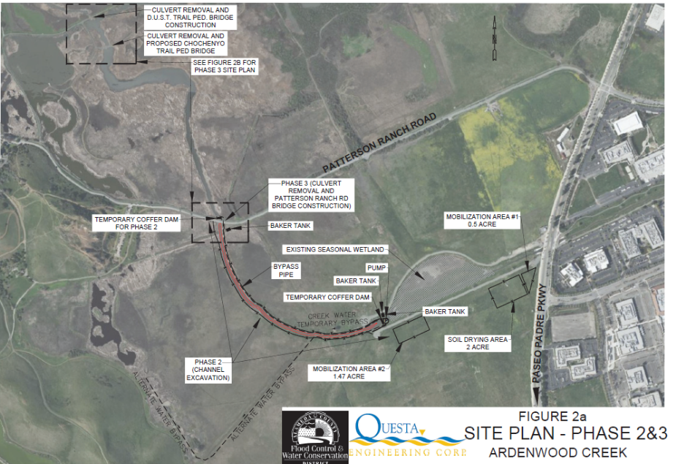

Project Description: The Alameda County Flood Control and Water Conservation District (District) is proposing to increase flood conveyance and restore and enhance aquatic habitats along Ardenwood Creek (Zone 5 Line P flood control channel) downstream of Paseo Padre Parkway in Fremont. The project's objectives are to increase channel flood conveyance improve habitat function. The project will include channel excavation and revegetation from 0.4 miles downstream of Paseo Padre Parkway to Patterson Ranch Road. Additional work includes replacement of three existing culvert structures with clear span bridges. The existing culverts contribute to flow blockage at, and north of Patterson Ranch Road.

Document Availability: The draft IS/MND is available for review at Alameda County Public Works Agency office at 399 Elmhurst Street, Hayward, CA 94544, and on the Agency website under Environmental Documents at https://www.acpwa.org/document-library.page.

Project Impacts: The IS/MND describes the Proposed Project, analyzes whether the Project would result in any potentially significant impacts on the environment, and provides avoidance and minimizations measures that would be implemented to reduce any potential impacts to the environment. Based on the findings of the Initial Study, it has been determined that the project will not have a significant adverse effect upon the environment.

Public Review Period: The 30-day public review period for the Draft Initial Study/Mitigated Negative Declaration is from November 1, 2022 to December 1, 2022.

Send Comments to: Any person who wishes to comment on the District’s intent to adopt the MND must submit comments no later than 3:00 p.m. on December 1, 2022. The Alameda County Board of Supervisors will consider the Mitigated Negative Declaration, all comments received, and responses to those comments prior to approval of the project. Written comments may be sent to: Alameda County Flood Control & Water Conservation District, Attention: James Yoo, 399 Elmhurst Street, Hayward, CA 94544. Comments may also be sent by email to: jamesy@acpwa.org

