ORIGINAL - PROJECT APPLICANT COPY - CDFW/ASB COPY-LEADAGENCY COPY - COUNTY CLERK DFW 753.5a (Rev. 01012022)
 | State of California - Department of Fish and Wildlife  2022 ENVIRONMENTAL DOCUMENT FILING FEE CASH RECEIPT  DFW 753.5a (REV. 01/01/22) Previously DFG 753.5a | 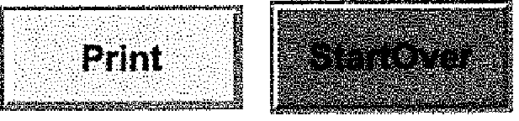
I,:: Save .
....,. "'',.,^. 4...3,......5:145.1

RECEIPT NUMBER:
42 — 07/19/2022 — 152
STATE CLEARINGHOUSE NUMBER (If applicable)
SEE INSTRUCTIONS ON REVERSE. TYPE OR PRINT CLEARLY.
LEAD AGENCY LEADAGENCY EMAIL DATE
Goleta Water District dbrooks@goietawatereorn 07/19/2022
COUNTY/STATE AGENCY OF FILING DOCUMENT NUMBER
'Santa Barbara
PROJECT TITLE
Goleta Water District Headquaters Solar and EV Charger Power Systems
PROJECT APPLICANT (Check appropriate box)

ZIP CODE
93110
CITY STATE
Goleta CA
PROJECT APPLICANT ADDRESS
4699 Hollister Ave
PROJECT APPLICANT NAME
Daniel Brooks
PROJECT APPLICANT EMAIL
dbrooks@goletawater.com
PHONE NUMBER
(805)964-6761
Local Public Agency ❑ School District 0 Other Special District ❑ State Agency 0 Private Entity
CHECK APPLICABLE FEES:
- Environmental Impact Report (EIR) $3,539.25 $ 0.00
- Mitigated/Negative Declaration (MND)(ND) $2,548.00 $ 0.00
- Certified Regulatory Program (CRP) document - payment due directly to CDFW $1,203.25 $ 0.00
Exempt from fee
E] Notice of Exemption (attach)
- CDFW No Effect Determination (attach)
- Fee previously paid (attach previously issued cash receipt copy)
0.00
50.00
Check ❑ Other
121
$850.00 $
$
$
- Other
PAYMENT METHOD:
- Cash ❑ Credit
County documentary handling fee
- Water Right Application or Petition Fee (State Water Resources Control Board only)
TOTAL RECEIVED $ 50.00
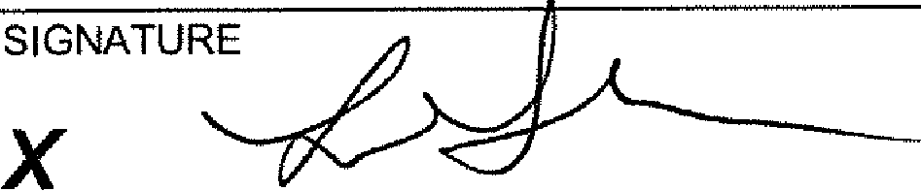 |  | AGENCY OF FILING PRINTED NAME AND TITLE  Lia Graham, Deputy Clerk

ORIGINAL - PROJECT APPLICANT COPY - CDFWIASB COPY - LEAD AGENCY COPY - COUNTY CLERK DFW 7515a (Rev. 01012022)
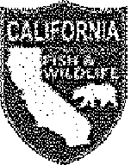 | State of California - Department of Fish and Wildlife 2022 ENVIRONMENTAL DOCUMENT FILING FEE CASH RECEIPT  DFW 753.5a (REV. 01/01/22) Previously DFG 753.5a

NOTICE
Each project applicant shall remit to the county clerk the environmental filing fee before or at the time of filing a Notice of Determination (Pub. Resources Code, § 21152; Fish & G. Code, § 711.4, subdivision (d); Cal. Code Regs., tit. 14, § 753.5). Without the appropriate fee, statutory or categorical exemption, or a valid No Effect Determination issued by the California Department of Fish and Wildlife (CDFW), the Notice of Determination is not operative, vested, or final, and shall not be accepted by the county clerk.
COUNTY DOCUMENTARY HANDLING FEE
The county clerk may charge a documentary handling fee of fifty dollars ($50) per filing in addition to the environmental filing fee (Fish & G. Code, § 711.4, subd. (e); Cal. Code Regs., tit. 14, § 753.5, subd. (g)(1)). A county board of supervisors shall have the authority to increase or decrease the fee or charge, that is otherwise authorized to be levied by another provision of law, in the amount reasonably necessary to recover the cost of providing any product or service or the cost of enforcing any regulation for which the fee or charge is levied (Gov. Code, § 54985, subd. (a)).
COLLECTION PROCEDURES FOR COUNTY GOVERNMENTS
Filing Notice of Determination (NOD):
- Collect environmental filing fee or copy of previously issued cash receipt. (Do not collect fee if project applicant presents a No Effect Determination signed by CDFW. An additional fee is required for each separate environmental document. An addendum is not considered a separate environmental document. Checks should be made payable to the county.)
- Issue cash receipt to project applicant.
- Attach copy of cash receipt and, if applicable, previously issued cash receipt, to NOD.
- Mail filing fees for CRP document to CDFW prior to filing the NOD or equivalent final approval (Cal. Code Regs. Tit. 14, § 753.5 (b)(5)). The CRP should request receipt from CDFW to show proof of payment for filing the NOD or equivalent approval. Please mail payment to address below made attention to the Cash Receipts Unit of the Accounting Services Branch.
If the project applicant presents a No Effect Determination signed by CDFW, also:
- Attach No Effect Determination to NOD (no environmental filing fee is due).
Filing Notice of Exemption (NOE) (Statutorily or categorically exempt project (Cal. Code Regs., tit. 14, §§ 15260-15285, 15300-15333))
- Issue cash receipt to project applicant.
- Attach copy of cash receipt to NOE (no environmental filing fee is due).
Within 30 days after the end of each month in which the environmental filing fees are collected, each county shall summarize and record the amount collected on the monthly State of California Form No. CA25 (TC31) and remit the amount collected to the State Treasurer. Identify the remittance on Form No. CA25 as "Environmental Document Filing Fees" per Fish and Game Code section 711.4.
The county clerk shall mail the following documents to CDFW on a monthly basis:
- A photocopy of the monthly State of California Form No. CA25 (TC31)
- CDFW/ASB copies of all cash receipts (including all voided receipts)
- A copy of all CDFW No Effect Determinations filed in lieu of fee payment
- A copy of all NODs filed with the county during the preceding month
- A list of the name, address and telephone number of all project applicants for which an NOD has been filed. If this information is contained on the cash receipt filed with CDFW under California Code of Regulations, title 14, section 753.5, subdivision (e)(6), no additional information is required.
DOCUMENT RETENTION
The county shall retain two copies of the cash receipt (for lead agency and county clerk) and a copy of all documents described above for at least 12 months.
RECEIPT NUMBER
# The first two digits automatically populate by making the appropriate selection in the County/State Agency of Filing drop down menu.
- The next eight digits automatically populate when a date is entered.
- The last three digits correspond with the sequential order of issuance for each calendar year. For example, the first receipt number issued on January 1 should end in 001. If a county issued 252 receipts for the year ending on December 31, the last receipt number should end in 252. CDFW recommends that counties and state agencies 1) save a local copy of this form, and 2) track receipt numbers on a spreadsheet tabbed by month to ensure accuracy.
DO NOT COMBINE THE ENVIRONMENTAL FEES WITH THE STATE SHARE OF FISH AND WILDLIFE FEES.
Mail to:
California Department of Fish and Wildlife Accounting Services Branch
P.O. Box 944209
Sacramento, California 94244-2090

78504
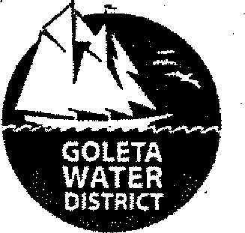 | 'GOLETA WATER DISTRICT  4699 Hollister Avenue Goleta, CA 93110 | Wells Fargo Bank, N.A.  420 Montgomery Street  San Francisco, CA 94104  11.24/1210

DATE CONTROL NO. AMOUNT
7/14/2022 078504 $50.00
Fifty Dollars and 00 Cents
PAY  TO THE ORDER OF | COUNTY OF SANTA BARBARA CLERK OF BOARD 105 E Anapamu St. Rrn 407  Santa Barbara CA 93101 |  |  | VOID AFTER 180 DAYS
 |  |  | 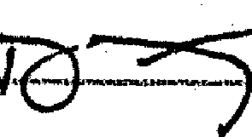 | AUTHODSIGNATuRE | PIP
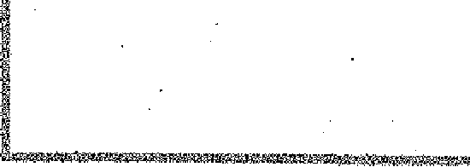 |  | ₁₁.0 ?,6 2 1,000 2481: L. L 245069 S rhin  .WMVWM,VOWWqngW,u,,ns,m,..AWWW,,'

GOLETA WATER DISTRICT 78504
Goleta Water District 7/14/2022
VCH0083191 D22 CEQA HDQTR 6/29/2022 $50.00 $50.00 $0.00 $50.00

COUNTY OF SANTA BARBARA
Co6
Date *7- Iq.
Gok-VA \Q(Altv
X2159229
Department

Received from

 |  |  |  |  |  | 100
 | Received original of the above numbered receipt | CREDIT CARD CASH CHECK |  |  |  | 100
 | Received original of the above numbered receipt |  |  |  |  | 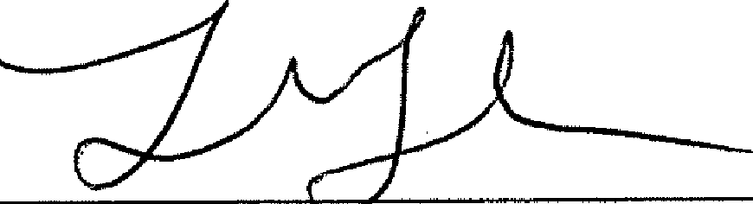
 | 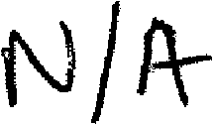
 |  |  | 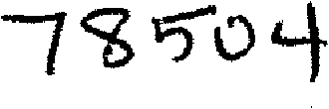
 |  |  |  |  |  | AUT i IZED SIGNATURE
AC-147 SIGNATURE OF PAYOR |  |  |  |  |  | AUT i IZED SIGNATURE

In Payment of | NOG ^{9{0I}CC5kr'

and ⁴⁻Dollars $ 5⁻0

 | 2022 CEQA Transizittal Memorandum  County of Santa Barbara - Clerk of the Board of Supervisors  105 E. Anapamu St. Room 407 • Santa Barbara * CA • 93101  (805) 568-2240

Complete this form when filing a Negative Declaration, Mitigated Negative Declaration, Environmental Impact Report or Notice of Exemption.
You will need to submit one original for posting plus one copy for the Department of Fish & Wildlife. A scanned copy including the date/time of posting will be emailed to the Lead Agency and Project Applicant. If you would like a return copy, please submit an extra copy along with a pre-addressed, stamped envelope.
Contact Person  Daniel Brooks |  | Phone  805-964-6761
Lead Agency  Goleta Water District |  | Lead Agency Email dbrooks@goletawater.com
Project Title
Goleta Water District Headquarters Solar and EV Charger Power Systems
Project Applicant  Goleta Water District | Email  dbrooks@goletawatercom | Phone  805-964-6761
Project Applicant Address  4699 Hollister Ave | City  Goleta | State  CA | Zip  93110

DOCUMENT BEING FILED:
- Environmental Impact Report (EIR)
- 2022 Filing Fee  - Previously Paid (must attach receipt)  - No Effect Determination (must be attached) | $3,539.25 $0.00 $0.00
- Negative Declaration or Mitigated Negative Declaration
- 2022 Filing Fee | $2,548.00
- Previously Paid (must attach receipt) | $0.00
- No Effect Determination (must be attached) | $0.00
- Notice of Exemption | $0.00
a County Administrative Handling Fee (required for all filings, effective 7/19/18) | $50.00

TOTAL: $ 50.00
PAYMENT METHOD: ALL APPLICABLE FEES MUST BE PAID AT THE TIME OF FILING
- Cash ❑ Credit Card 0 Check # q?³'S⁻⁰¹1— ❑ Journal Entry #
(in person only)

Date Received for Filing:
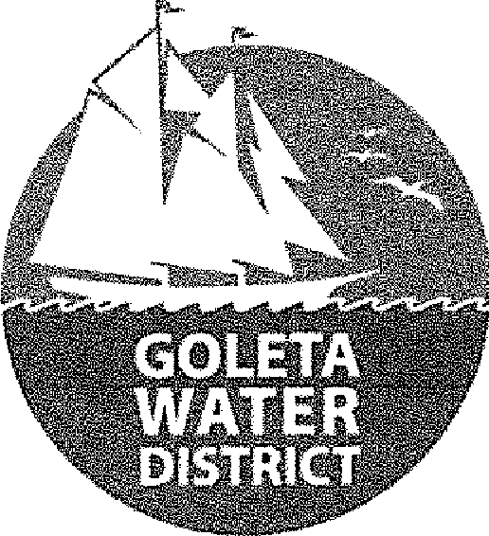
 | 4699 HOLLISTER AVENUE  GOLETA, CALIFORNIA 93110-1999 TELEPHONE 805/964-6761  FAX 805/964-7002 | NOTICE OF EXEMPTION

To: El Office of Planning and Research Post Office Box 3044, Room 113 Sacramento, CA 95812-3044
County Clerk
County of Santa Barbara From: Goleta Water District
105 Anapamu Street 4699 Hollister Avenue
Santa Barbara, CA 93101 Goleta, CA 93110-1999
Project Title: Goleta Water District Headquarters Solar and EV Charger Power Systems
Project Applicant: N/A GWD Project No. P-132 & 21-4656
Project Location - Specific: Goleta Water District Headquarters:
Goleta Water District 4699 Hollister Avenue Goleta, CA 93110
Project Location — City: 1 Goleta El Santa Barbara 0 Unincorporated Area Project Location — County: Santa Barbara
Description of Nature & Purpose of Project: Goleta Water District (District) owns and operates the Headquarter office buildings. The District proposes to install solar energy arrays on four carport structures and on three building rooftops to mitigate potential public safety power shutdowns and emergency impacts, as well as offset energy costs incurred by the District.
Name of Public Agency Approving and Carrying Out Project: Goleta Water District
Exempt Status: | EMinisterial (§21080(b)(1); 15268);  ElDeclared Emergency (§21080(b); 15269(a));  DEmergency Project (§21080(b)(3); 15269(b)(c));  Categorical Exemption. Article 19, Section 15301 — Existing Facilities Statutory Exemption (PRC §21080(b)(3)) — Existing Facilities

Reasons Why Project is Exempt: California Public Resources Code section 21080.35 was modified in 2011 pursuant to SB 226 to provide statutory exemption from the requirements of CEQA for the installation of solar energy systems associated with building rooftops and parking lots. This project will install solar energy systems that meet the criteria of PRC 21080.35.
Contact Person: Daniel Brooks, Engineering & Infrastructure Manager
Telephone: (805) 879-4625

Signature: | 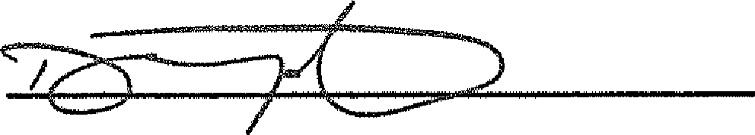 | Date:

David Matson, Assistant General Manager Goleta Water District

