Public Notice
Notice of Intent to Adopt a Mitigated Negative Declaration and Opportunity for a Public Hearing
(Study Results Available)
Do you want a public hearing on changes proposed for U.S. Route 101 in Santa Barbara County?
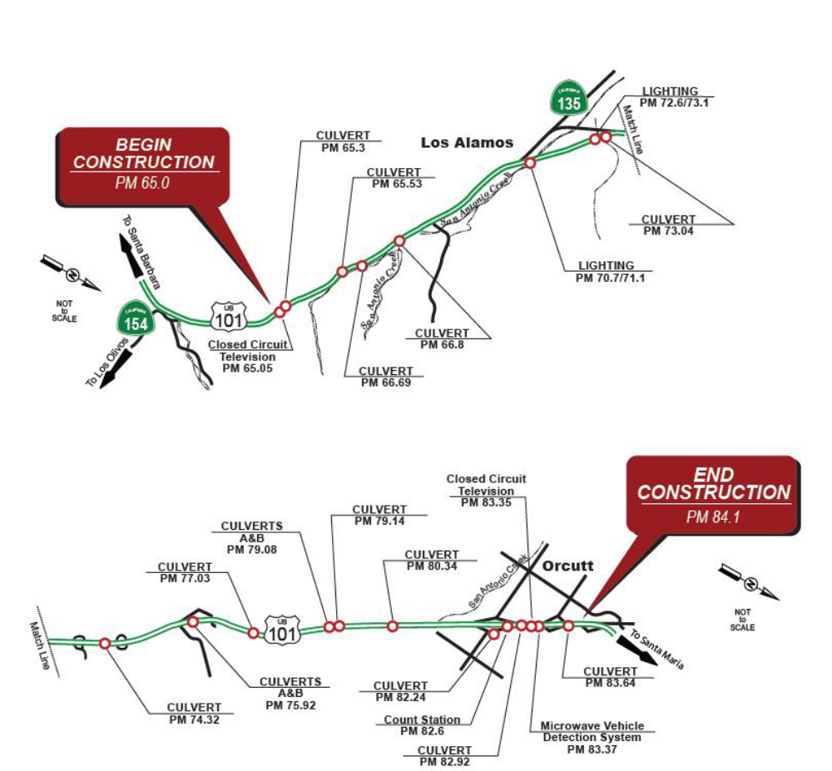
PUBLIC COMMENT PERIOD
Comments will be accepted up to June 15, 2022. If there are no major comments or requests for a public hearing, Caltrans will proceed with the project’s design.
WHAT’S BEING PLANNED?
The California Department of Transportation (Caltrans) proposes to replace and modify 13 drainage culverts, 16 lighting elements, and five Transportation Management System elements on U.S. Route 101 in Santa Barbara County, from Zaca Station Road near Los Alamos to 0.2 mile south of the Santa Maria Undercrossing in Orcutt.
WHY THIS PUBLIC NOTICE?
Caltrans has studied the effects this project may have on the environment. Our studies show the project will not significantly affect the quality of the environment. The report that explains why is called an Initial Study with Proposed Mitigated Negative Declaration. This notice is to inform you of the preparation of the Initial Study with Proposed Mitigated Negative Declaration and of its availability for you to read and comment on. This notice also offers you an opportunity to request a public hearing.
WHAT’S AVAILABLE?
The Initial Study with Proposed Mitigated Negative Declaration and
other project information is available for review at:
- Caltrans District 5 Office at 50 South Higuera Street, San Luis
Obispo, California 93401 on weekdays from 8:00 a.m. to 5:00 p.m.
- The document can also be viewed online at: http://www.dot.ca.gov/d5
WHERE YOU COME IN?
Do you have any comments about processing the project with an Initial Study with Proposed Mitigated Negative Declaration? Do you disagree with the findings of our study as set forth in the Proposed Mitigated Negative Declaration? Would you care to make any other comments on the project? Would you like a public hearing? Please submit your comments or requests for a public hearing in writing by U.S. Mail or email no later than June 15, 2022, to Caltrans, Attention: Jason Wilkinson, District 5 Office at 50 Higuera Street, San Luis Obispo, California 93401, or by email to jason.wilkinson@dot.ca.gov. If there are no major comments or requests for a public hearing, Caltrans will proceed with the project’s design.
CONTACT
For more information about this project, please contact Jason Wilkinson, Senior Environmental Planner, at 805-540-9165 or by email at jason.wilkinson@dot.ca.gov. For all other state highway matters in the area, please contact the District 5 Public Information Office at 805-549-3318 or by email at info-d5@dot.ca.gov.
SPECIAL ACCOMMODATIONS
Under the Americans with Disabilities Act of 1990, individuals who require accommodation (American Sign Language Interpreter, accessible seating, documents in alternative formats, etc.) are requested to contact the Caltrans District 5 Public Information Office at 805-549-3318 or by email at info-d5@dot.ca.gov. Telecommunication Devices for the Deaf (TDD) users may contact the California Relay Service line at 1-800-735-2929, Voice Line at 1-800-735-2922, or contact the California Relay Service Teletype Voice Line by dialing 711.

