

NOTICE OF PUBLIC HEARING

Notice is hereby given the Planning Commission of the County of Amador, State of California, has received an application for the project described in this notice.

PROJECT NAME AND DESCRIPTION: Request for a Use Permit (UP-21;10-1) to allow for up to five dwellings on a single property, and Zone Change (ZC-21;10-1) from RE, Residential Estates District to PD, Planned Development District in conjunction with a General Plan Amendment (GPA -21;10-1) from AT, Agricultural Transition to SPA, Special Planning Area. APN: 030-090-063.

PROPERTY OWNERS: Orion Fowler
SUPERVISORIAL DISTRICT: 5
LOCATION: 14674 Tanyard Hill Road, Pine Grove, CA 95665

NOTE: SEE MAP ON REVERSE. The Staff Report will be available online (typically the Tuesday prior to the meeting) for viewing at http://www.amadorgov.org in the “Agendas and Minutes” section.

ENVIRONMENTAL REVIEW PROCESS: In accordance with the California Environmental Quality Act (CEQA), the lead agency, the Amador County Planning Commission, intends to consider the adoption of a Negative Declaration, as the project is consistent with the Amador County General Plan and zoning codes. The environmental assessment and application materials appear to be complete and indicate there are no extraordinary or unique environmental issues not normally mitigated for with the County's standard conditions which would be applied to this type of project. If, during the processing of this application, it is determined that there are state or local issues which cannot be found to be insignificant or adequately mitigated through standard conditions, it may be found by the Planning Commission or Board of Supervisors an Environmental Impact Report (EIR) shall be prepared. The Technical Advisory Committee (TAC) has reviewed this project and has found no technical objection to the approval of this project with the adoption of a Negative Declaration. The required environmental review and comment period for this project will commence on February 16, 2022 and ends on March 8, 2022.

PUBLIC HEARING: Notice is hereby given said Planning Commission will hold a public hearing on this project at the County Administration Center, Board of Supervisors Chambers, 810 Court Street, Jackson, California, on March 8, 2022 at 7:00 p.m. or as soon thereafter as can be heard. Anyone having comments on the project may attend and be heard.

THE AMADOR COUNTY PLANNING COMMISSION WILL BE CONDUCTING ITS MEETING VIA TELECONFERENCE. WHILE THIS MEETING WILL STILL BE CONDUCTED IN-PERSON AT THE ABOVE ADDRESS, WE STRONGLY ENCOURAGE THE PUBLIC TO PARTICIPATE FROM HOME BY CALLING IN USING ANY OF THE FOLLOWING NUMBERS:

+1 669 900 6833 US
+1 346 248 7799 US
+1 301 715 8592 US
+1 312 626 6799 US
+1 929 205 6099 US
+1 253 215 8782 US

Meeting ID: 537 512 8983

YOU MAY ALSO VIEW AND PARTICIPATE IN THE MEETING USING THIS LINK:

https://us02web.zoom.us/j/5375128983

The Chairperson will invite the public to comment via phone/online. Public comment will also be accepted by email at planning@amadorgov.org. All emails must be received prior to the start of the meeting and will be included in the record of the meeting. Emails received after those already included in the meeting materials will be printed and distributed to the Commissioners and available to the public, and shall be subject to the same rules as would otherwise govern speaker comments at the Commission meeting.
Letters of comment regarding this matter received by the County prior to the publication of the Staff Report will be sent to each Planning Commissioner as part of the agenda packet (generally the Tuesday prior to the meeting). Letters received after the Staff Report has been published will be copied and circulated to each Commissioner just prior to the public hearing. Be advised that due to time constraints, the Commissioners may not be able to give letters submitted after the Staff Report is published, as detailed a review as those received earlier. Therefore, it may be to your benefit to attend the hearing and summarize your concerns orally. Letters will not be read aloud at the public hearing. If you have any questions or desire more information, please contact this office.

In compliance with the Americans with Disabilities Act, if you are a person with a disability and require special modification or accommodation to participate in this meeting, please contact the Amador County Planning Department, at (209) 223-6380, by email to planning@amadorgov.org. Requests must be made as early as possible, and at least two business days before the start of the meeting.

NOTE: If you do not comment at the public hearing or send in written comments and later decide to challenge the nature of this proposed action in court, you may be limited to raising only those issues you raised at the public hearing or have given in written correspondence delivered to the public entity conducting the hearing at, or prior to, the Public Hearing.

AMADOR COUNTY PLANNING COMMISSION
Date of this notice: February 15, 2022

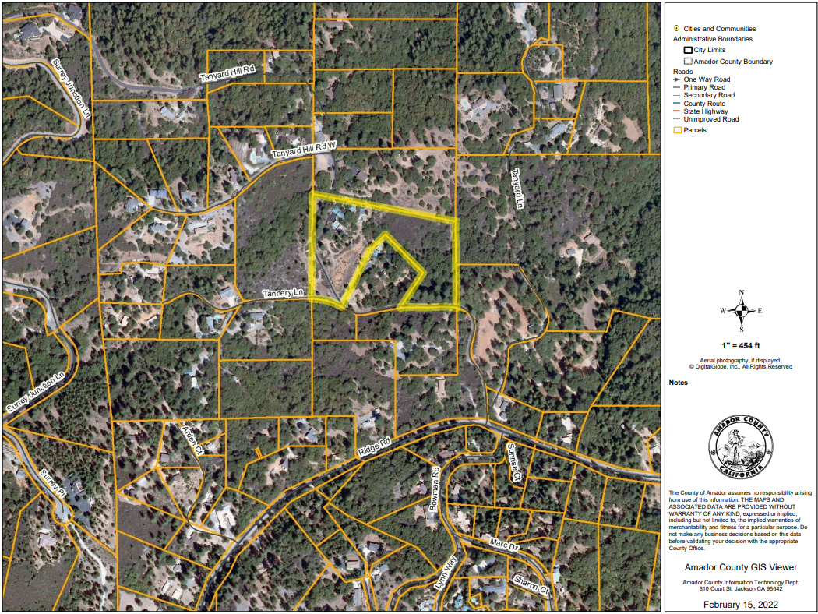
SUBJECT AREA HIGHLIGHTED IN YELLOW

