
COUNTY OF LAKE Scott De Leon
COMMUNITY DEVELOPMENT DEPARTMENT Interim Community Development Director
Courthouse - 255 N. Forbes Street
Lakeport, California 95453
Planning Department · Building Department · Code Enforcement
707/263-2221 · FAX 707/263-2225

Dated: June 2, 2021

CALIFORNIA ENVIRONMENTAL QUALITY ACT

ENVIRONMENTAL CHECKLIST FORM

INITIAL STUDY IS 20-26

- Project Title: Bar X Ranch

- Permit Number: Major Use Permit, UP 20-92
Initial Study, IS 20-111
Early Activation, EA 20-108

- Lead Agency Name and Address: County of Lake
Community Development Department
Courthouse – 255 North Forbes Street
Lakeport CA 95453

- Contact Person: Eric Porter, Associate Planner
(707) 263-2221

- Project Location(s): 18655, 19395, 20103, and 20333 S Hwy 29
Middletown, California 95461
Cultivation APNs: 014-250-07 and 14
Non-cultivation APNs: 014-250-05 and 10

- Project Sponsor’s Name/Address: Bar X Farms LLC
20333 S. Highway 29
Middletown, CA 95461

7. General Plan Designation: Rural Lands (RL)/Resource Conservation (RC)/Agriculture (A)

- Zoning: “RL-FF-FW-SC-WW”; Rural Lands-Floodway Fringe-Floodway-Scenic-Waterway Combining Districts

- Supervisor District: District One (1)
- Flood Zone: Zone A, AE (western portion of APN 14); and Zone D
- Slope: Varied; cultivation sites are less than 10%
- Fire Hazard Severity Zone: SRA – Moderate and Very High Fire Risk
- Earthquake Fault Zone: Not located within an Earthquake Fault Zone
- Dam Failure Inundation Area: Not located within Dam Failure Inundation Area
- Parcel Sizes: APN 014-250-05 (2.8 acres), APN 014-250-10 (511.0 acres), APN 014-250-07 (564.9 acres), APN 014-250-14 (515.9 acres) – Total Acreage is 1,594.6 acres

- Environmental Setting and Existing Conditions
The Bar X Ranch (Ranch) is located at 18655 and 20333 S State Highway 29 approximately 1.8 miles northeast of Middletown and approximately 2.3 miles southwest of the Hidden Valley Lake community (Township 11N, Range 6W, 7W, Unsectioned Guenoc, in the Middletown 1993 USGS quadrangle). The cumulative parcel acreage of the Bar X Ranch is 1594.6 acres. The proposed project is located in the Middletown Planning Area.
Bar X Ranch is an existing cattle ranch that has been actively farmed for over 100-years for cattle grazing and hay production. The Ranch is bounded by Putah Creek to the west and State Highway 29 to the east. The surrounding land uses are rural land, residential, and agriculture with existing ranches and vineyards to the north and west and an existing heavy industrial area adjacent to the Ranch to the northeast. The topography of the Ranch is rolling and consists of mountain ridges and valleys ranging from 1,000 feet to 1,500 feet above sea level. The Ranch is located within the Upper Putah Creek watershed (HUC-1802016203). Putah Creek, a Class I watercourse, bounds the western edge of the property and flows in the northerly direction and then turns east approximately 1.7 miles north of the Ranch. Crazy Creek, a Class II watercourse that is tributary to Putah Creek, flows east towards its confluence with Putah Creek located approximately 3.5 miles east of Bar X Ranch. Several Class III watercourses are located throughout Bar X Ranch, draining to Putah Creek or Crazy Creek (Figure 1). The climate of the site is characterized by a Mediterranean-type climate, with distinct seasons of hot, dry summers and wet, moderately cold winters. The wet season is typically October through May.
The Ranch’s vegetation is comprised of annual grasses and weeds, with scattered oak trees, shrubs, star thistle, and blackberry brambles. Much of the vegetation and trees were burned during the 2015 Valley Fire.
Existing conditions at the Ranch include a number of internal compacted dirt and gravel roads, fenced and cross fenced pastures, trenched irrigation system, an approximately 16,250 sq. ft. (65 ft x 250 ft) pole barn, two groundwater wells (one for domestic, one for irrigation), and a residential area with houses, barns, garages, shops, storage buildings, and septic systems. The residential area would not be utilized by the proposed project and would remain as is. The Ranch is accessed off of State Highway 29 via three (3) existing driveways (north, center, and south [Figure 2]). The center driveway is used to access the residential area.

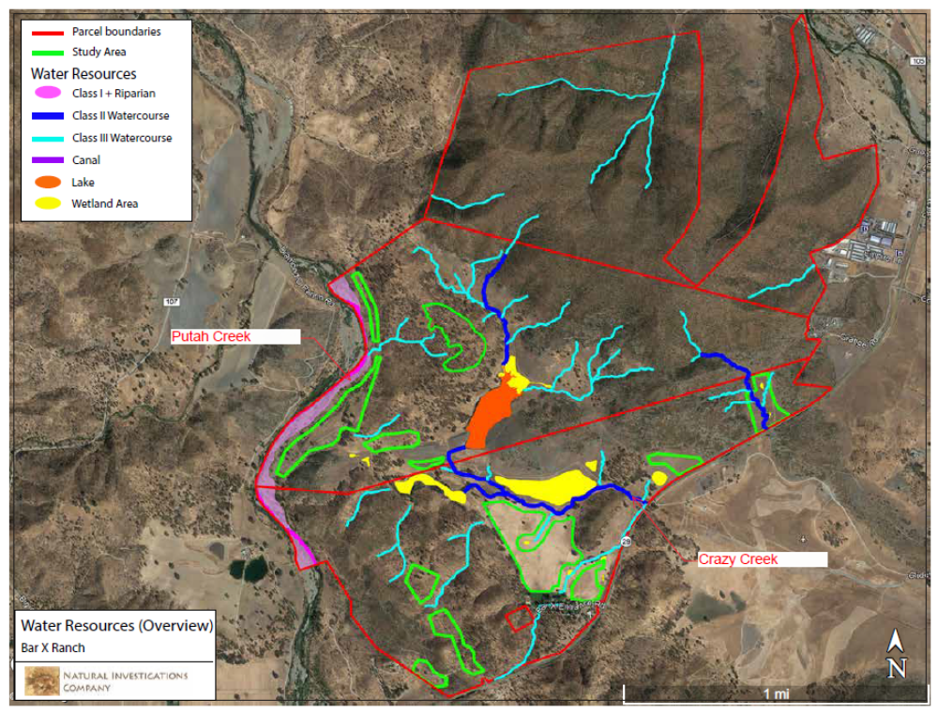
Figure 1. Bar X Ranch Water Resources (Source: Biological Resources Assessment, dated February 1, 2021)
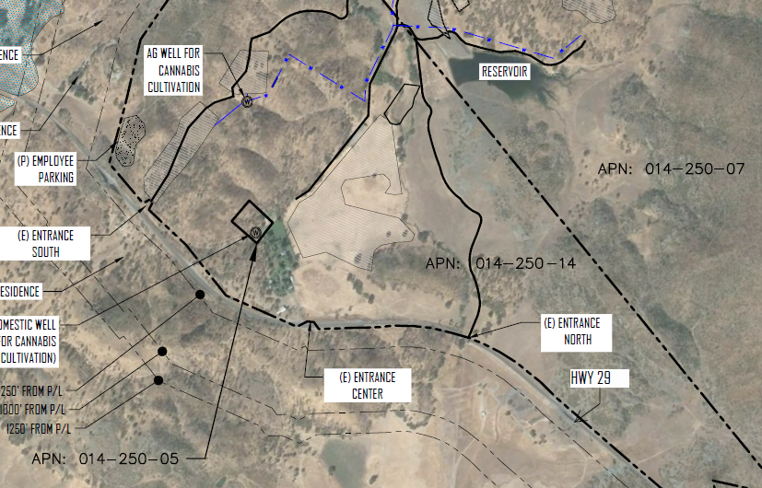
Figure 2. North, Center, and South Entrances off of State Highway 29
- Description of Project: (Describe the whole action involved, including but not limited to later phases of the project, and any secondary, support, or off-site features necessary for its implementation. Attach additional sheets if necessary).
Description of Project: Bar X Farms LLC, is seeking discretionary approval from Lake County for a Major Use Permit, UP 20-92, for commercial cannabis operations at 18655 and 20333 S State Highway 29, Middletown (APNs 014-250-07 and 14, respectively), in two phases as follows:

Phase 1
Sixty-Three (63) A-Type 3: "Outdoor" licenses: Outdoor cultivation for adult-use cannabis without the use of light deprivation and/or artificial lighting in the canopy area at any point in time. The applicant proposes 1,545,000 sq. ft. (35.5 acres) of commercial cannabis canopy area on APN 014-250-07 and 1,160,000 sq. ft. (26.6 acres) of commercial cannabis canopy area on APN 014-250-14, for a total of 62.1 acres of canopy within a cultivation area of approximately 75.6 acres (3,293,136 sq. ft.). The proposed project would include retrofitting an existing 16,250 sf (65 ft x 250 ft) barn for drying and curing of cannabis grown onsite.
A-Type 13 Self Distribution license

The proposed project would include the retrofitted 16,250 sf pole barn for drying and curing. Retrofitting of the existing barn would not occur until the appropriate grading and building permits have been obtained from Lake County.
Phase 2
Forty-Three (43) A-Type 3: "Outdoor" licenses: Outdoor cultivation for adult-use cannabis would be reduced from sixty-three (63) outdoor licenses to forty-three (43) outdoor licenses by reducing the outdoor cultivation canopy area on APN 014-250-14 to 315,000 sq. ft. (7.2 acres) of commercial cannabis canopy, for a total of four 42.7 acres (1,860,000 sq. ft.) of canopy within a cultivation area of approximately 49.8 acres (2,169,288 sq. ft.).
Thirty-Four (34) A-Type-3B: “Mixed-Light” licenses: Greenhouse cultivation for adult-use cannabis with the use of artificial lighting in the canopy area from 10,001 sq. ft. to 22,000 sq. ft. The applicant proposes 296, 25’ x 100’ or 740,000 sq. ft. of mixed-light greenhouses within a cultivation area of approximately 25.8 acres (1,123,848 sq. ft.). The greenhouse cultivation would be operated as “Mixed-Light Tier 1” without the use of artificial light or the use of artificial light at a rate above zero, but no more than six watts per square foot. The total canopy area, less space for 4-foot of aisle ways along the length of the greenhouses, would be approximately 621,600 sq. ft.
The total canopy area would be approximately 2,481,600 sq. ft. within a cultivation area of approximately 75.6 acres (3,293,136 sq. ft.).
One (1) Cannabis Processor License: Processing for adult-use cannabis within a new 60,000 sq. ft. (200 ft x 300 ft) commercial processing building.

The proposed project would include the retrofitted 16,250 sf pole barn for drying and curing. Construction of the proposed greenhouses and processing building would not occur until the appropriate grading and building permits have been obtained from Lake County.

At full buildout, the proposed cannabis operation would utilize approximately 80 acres (5%) of the 1594.6 acre Ranch. The remainder of the Ranch would continue to operate as it has operated in the past, including cattle ranching and hay production.

A Biological Resources Assessment for the Ranch, dated February 1, 2021, and Botanical Survey Report, dated April 16, 2021, were prepared by Natural Investigations Co. (Natural Investigations Co., 2021). Natural Investigations Co. identified 87.6-acres, represented by ten (10) distinct sites, that are suited for the proposed project. These sites, referred to as “gardens”, were selected to occur within active agricultural areas and to avoid all wetlands and channels, setbacks from watercourses and other natural resources, sensitive terrestrial habitats (serpentine soils, riparian, chaparral habitats), sensitive plant areas, steep slopes, and dense oak stands. The proposed cannabis cultivation would be setback a minimum 150 ft. from Class I watercourses and a minimum of 100 ft. from wetlands and from the top of bank all Class II, and Class III watercourses. The project is proposed in two phases. Phase 1 would consist of development of outdoor cannabis gardens for cultivation of 62.1 acres of outdoor canopy at eight (8) of the garden areas. Phase 2 would consist of converting one of the outdoor cultivation areas into permanent greenhouses for mixed-light cultivation and constructing a 60,000 sq. ft. commercial processing building. The proposed cannabis activities are to be co-located on the subject parcels in compliance with Lake County regulations. Details are summarized in Table 1 and Table 2 and Figure 3.
Table 1. Summary of cannabis cultivation canopy areas for each garden (Phase 1)
Site Plan  Sheet # | APN | Name | Cultivation Type | Canopy Area  (sq. ft.) | Cultivation Area  (acres)
7 | 014-250-07 | Center Garden | Outdoor | 60,000 | 1.2
7 | 014-250-07 | West Center Garden | Outdoor | 110,000 | 3.4
8 | 014-250-07 | Riverside Garden | Outdoor | 835,000 | 20.1
9 | 014-250-07 | Northwest Garden | Outdoor | 85,000 | 2.9
11 | 014-250-07 | East Center Garden | Outdoor | 455,000 | 11.4
10 | 014-250-14 | Pasture Garden | Outdoor | 845,000 | 25.8
5 | 014-250-14 | Employee Parking | N/A | N/A | N/A
5 | 014-250-14 | Southwest Garden #1 | Outdoor | 150,000 | 5.7
6 | 014-250-14 | Southwest Garden #2 | Outdoor | 165,000 | 5.1
 |  |  | Total | 2,705,000 | 75.6

Table 2. Summary of cannabis cultivation canopy areas for each garden (Phase 2)
Site Plan  Sheet # | APN | Name | Cultivation Type | Canopy Area  (sq. ft.) | Cultivation Area (acres)
7 | 014-250-07 | Center Garden | Outdoor | 60,000 | 1.2
7 | 014-250-07 | West Center Garden | Outdoor | 110,000 | 3.4
8 | 014-250-07 | Riverside Garden | Outdoor | 835,000 | 20.1
9 | 014-250-07 | Northwest Garden | Outdoor | 85,000 | 2.9
11 | 014-250-07 | East Center Garden | Outdoor | 455,000 | 11.4
10.1 | 014-250-14 | Pasture Garden | Mixed-Light | 621,600¹ | 25.8
5 | 014-250-14 | Employee Parking | N/A | N/A | N/A
5 | 014-250-14 | Southwest Garden #1 | Outdoor | 150,000 | 5.7
6 | 014-250-14 | Southwest Garden #2 | Outdoor | 165,000 | 5.1
10.1 | 014-250-14 | Commercial Processing Building (East Garden) | N/A | N/A | N/A
 |  |  | Total | 2,481,600 | 75.6
¹Mixed-Light cultivation would occur within a greenhouse footprint of 740,000 sq. ft., canopy area would cover up to approximately 621,600 sq. ft. when accounting for aisle space.

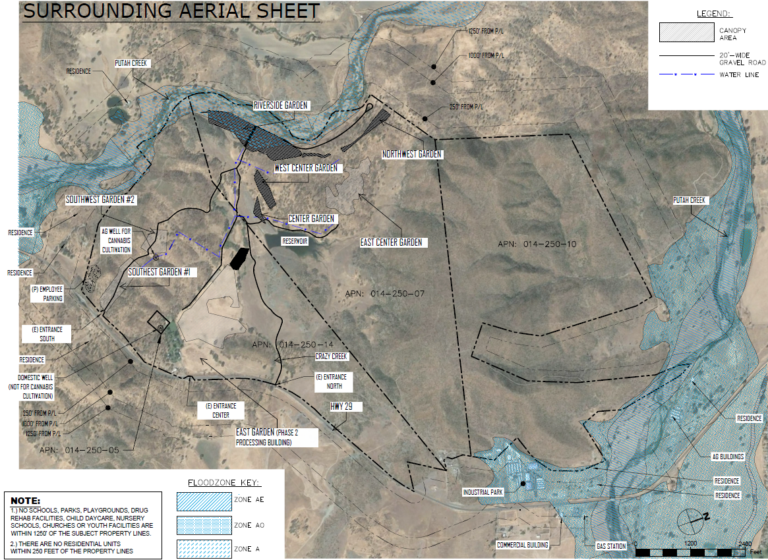
Figure 3. Proposed project garden areas and surrounding area
Outdoor cultivation would occur in full sun, with imported soil and amendments, in planter boxes or smart pots (grow bags) placed on top of the existing grade utilizing natural contours in open areas. During Phase 1, some vegetation clearing and minor grading (clearing and grubbing) is proposed for the outdoor cultivation activities to create level areas, on contour, for the planter boxes or smart pots, the cultivation employee parking area, and a flat for the water tanks near the Southwest Garden #2. No removal of living trees with a diameter greater than 5-inches measured at breast height (5-inch DBA) is proposed. An existing 16,250 sf barn would be retrofitted and used for storage, drying, and curing of cannabis; no cultivation would occur in this building. Employees would use the main parking area and the existing onsite access roads for parking and staging and accessing cultivation areas. Employees would have access to portable chemical toilets located at the main employee parking area and at each of the cultivation areas.

During Phase 2, the Pasture Garden would be converted from outdoor cultivation to mixed-light cultivation by installing approximately 296, 25-ft x 100-ft greenhouses to cultivate two harvests per year. Grading would be required to create greenhouse building pads. The area is relatively flat, so grading would be minor. Cultivation in each greenhouse would be conducted with the use of low wattage artificial light, fans for cooling, and two small motors to open and close blackout fabric covers. The artificial light would consist of a string of LED, low wattage lights (less than approximately 100 watts per greenhouse) to provide the minimal light required to prevent flowering, 3 to 4-hours per night for 8 to 12 weeks each year.

Phase 2 also includes a new 60,000 sq. ft. commercial processing building, with parking, that would be constructed at the East Garden. The processing building would include ADA accessible restrooms. Wastewater would be treated via a new, onsite septic system. No cultivation would occur at the East Garden. Grading would be required to create processing building pad. The area is relatively flat, so grading would be minor.
Since both phases require grading, the applicant has submitted, to Lake County, an application for a Grading Permit. The application includes a Grading Plan that demonstrate the areas of vegetation removal and grading, including earthwork quantities. No grading or building would occur until the appropriate grading and building permits have been obtained from the County.
Construction: Proposed grading activities would include vegetation removal and minor grading (clearing and grubbing) to prepare the outdoor cultivation areas, grading of the cultivation employee parking area, grading the building pads for the greenhouses, and grading the building pad for the commercial processing building and parking. A grading permit application, Grading Plan and Dust Mitigation Plan have been submitted to Lake County. No grading would occur until an approved grading permit has been obtained from the County. Normal means and methods would be used to retrofit the barn and construct the greenhouses and processing building.
Phase 1 construction is expected to begin in the spring of 2022, with the exact start date dependent on permits, dry weather, and suitable soil conditions. Construction would include building fences, preparing the cultivation areas, installing the above ground irrigation system, retrofitting the existing barn, developing the employee parking area, and preparing flats for the water tanks. Activities would include some vegetation clearing and minor grading to create level areas, on contour, for the planter boxes or smart pots, to develop the cultivation employee parking area, and the water tank area. No removal of living trees greater than 5-inch DBA is proposed. The existing 16,250 sf barn would be retrofitted and used for storage, drying, and curing of cannabis; no cultivation would occur in this building. A building permits is required and would be obtained from Lake County prior to retrofitting the barn. Phase 1 construction is expected to take approximately 4 to 8 weeks. During construction, there would be approximately 15 to 30 workers. Truck deliveries would be expected to occur, on average, every two days throughout the construction season. Construction staging would occur in the proposed employee parking area and existing onsite access roads.
Phase 2 construction is expected to begin in spring of 2023, with the exact start date dependent on permits, dry weather, and suitable soil conditions. Construction of the greenhouses and processing building would include grading to create building pads. Building permits are required and would be obtained from Lake County prior to construction. A permit from the Lake County Environmental Health Department would be obtained prior to developing the onsite septic system for the processing building. Activities would include vegetation clearing and grading to create building pads, parking, and the septic system. Phase 2 construction is expected to take approximately 3 to 6 months. During construction, there would be approximately 10 to 15 workers. Truck deliveries would be expected to occur, on average, every 1 to 2 days throughout the construction season. Construction staging would occur in the proposed processing building parking area.
During construction, Best Management Practices (BMPs) would be used to minimize erosion and control dust: within a cultivation area of approximately 75.6 acres (3,293,136 sq. ft.). These are detailed in the Property Management Plan for the proposed project.
- BMPs for erosion control during construction include preserving natural vegetation whenever possible, stabilize loose soil. Sediment control BMPs include vegetated swales, buffer strips, sediment traps, straw wattles, silt fences, or fiber rolls.
- Dust control measures include installing weed barriers, maintain existing vegetation outside cultivation areas, watering exposed surfaces (e.g. parking areas, staging areas, soil piles, graded areas, and unpaved access roads), and restrict onsite speeds to 15 mph or less.
Power Source and Generator Use: During Phase 1, power for security cameras, security lights, and the dry barn would be powered using small, localized solar power at each cultivation area and on/or adjacent to the barn.

During Phase 2, power to each greenhouse needed to operate the low wattage lights, fans, and motors to open and close the blackout covers, would be powered using solar power on each greenhouse with battery backup storage. Each greenhouse would be equipped with its own solar panels sufficient to power the lights, fans, and motors (small motors, 0.25 horsepower) within the greenhouse. No “on grid” power is proposed to operate the mixed-light cultivation. No generators are proposed to operate the greenhouses at any time.
The processing building would be powered using “on grid” power provided by PG&E. An existing PG&E power service exists at the residential area near the proposed processing building.
During both Phase 1 and Phase 2, water from the irrigation well would be pumped to approximately 27, 5,000 gallon water storage tanks using a 75 Horse Power (HP) pump. The tanks are located at a high point on the property so that water from the tanks would gravity feed through an above ground pipe system (aka, irrigation lines) to each cultivation area. The pump would be powered by a 120kW diesel generator that would be housed in a sound dampening enclosure.
Article 27, Section (at)1.iii lists prohibited activities associated with commercial cannabis cultivation and does not prohibit the use of generators for irrigation or outdoor cultivation, specifically, the section states, for electrical generators, that, “The indoor or mixed-light cultivation of cannabis shall not rely on a personal gasoline, diesel, propane, or similar fuels, powered generator as a primary source of power and shall only allow properly permitted (when applicable) generators for temporary use in the event of a power outage or emergency that is beyond the permittee’s control”.
The generator use proposed here is solely to operate the 75 HP well pump and for backup power to the commercial processing building in case of power outages. The cultivation of cannabis, outdoor and mixed-light, would not rely on the use of a generator.
Water Use: Plants would be watered using an above ground, drip-irrigation system. Water for cultivation activities would be supplied from an existing groundwater well on APN 014-250-14 (a Well Completion Report was submitted to Lake County Department of Environmental Health on January 15, 2021). The well was drilled in January 2021, is approximately 215 feet in depth, and has an approximate yield of 800 gallons per minute (GPM). Water would be pumped from the well to approximately twenty-seven (27), 5,000-gallon water tanks adjacent to Southwest Garden #2 on APN 014-250-14, where it would gravity feed through, new, above ground irrigation lines to each of the proposed garden areas. Fertigation (addition of liquid fertilizers and other amendments to the irrigation water) at each garden would be done using a mobile mixing tank and injected directly into the drip-irrigation system.

A Groundwater Availability Analysis was prepared for the project by Chico Environmental on April 21, 2021. According to this study, the expected annual water use would be 3,000 gallons per day per acre. This would equate to approximately 22,356,000 gallons (68.6 acre-feet) for 62.1 acres of outdoor canopy over an approximately 120 day cultivation season. During Phase 2, the canopy area would be approximately 57.0 acres of cultivation (approximately 42.7 acres of outdoor and 14.3 acres of mixed-light cultivation), resulting in approximately 20,520,000 gallons (63.0 acre-feet) at full buildout. The daily demand would be approximately 186,300 gallons during Phase 1 and 171,000 gallons during Phase 2. The total water storage would be approximately 135,000 gallons. The well yield is approximately 800 GPM. The proposed well pump would be a variable speed pump that would pump from 350 to 750 GPM; which would have the capacity to supply 190,000 gallons of water in less than 5 hours; meeting the average daily demand for both phases.

Hours/Days of Operation and Number of Employees: Operations would occur up to seven days per week with cultivation operations occurring approximately from April to November every year. Once operational, the commercial processing facility would operate up to seven days per week, with peak operations occurring after harvest. Hours of operation for the proposed activities would typically be between approximately 7 am and 8 pm daily. The Lake County Zoning Ordinance restricts deliveries and pickups for cannabis cultivation operations from 9 am to 7pm Monday through Saturday and Sunday from 12 pm to 5 pm.

The approximate number of employees for the proposed project, which are based on employee numbers from similar operations, are summarized in Table 3. Seasonal employees would be contracted through a local company during planting, harvesting, and processing.

Table 3. Employee counts for the proposed project
Employees | Phase 1 | Phase 2
Fulltime Cultivation | 10 | 10
Seasonal Cultivation | 120 | 120
Fulltime Processing | N/A | 10
Seasonal Processing | N/A | 75
Total Fulltime | 10 | 20
Total Seasonal | 120 | 195

Access, Parking, and Traffic: The Ranch is accessed off of State Highway 29 via three (3) existing driveways (north, center, and south [Figure 2]). The center driveway is currently used to access the residential area and would not be used for access by traffic associated with the outdoor or mixed-light cultivation operations. During Phase 2, once the commercial processing building is constructed, access to the building would be via the center driveway. The main access for the cultivation operations would be the south driveway, which is closest to the cultivation employee parking area. The north driveway would be used as a secondary access for employees and deliveries. Existing, internal ranch roads would be used to access all cultivation areas. The cultivation parking area would have approximately 152 parking spaces, which includes 2 ADA spaces. The commercial processing building parking area would have approximately 48 parking spaces and include ADA parking.

Construction traffic would occur over approximately 4 to 8 weeks during Phase 1 and 3 to 6 months during Phase 2. Larger equipment would be mobilized once at the beginning of the construction season, and out and the end of the construction season for each phase. During construction, it is expected that there would be approximately 10 to 15 construction employees, with up to approximately 30 round trips per day. Assuming an average of one (1) delivery per day, the total construction trips would be approximately 31 trips per day.

During Phase 1 operations, there would be about 20 round trips for fulltime employees. Seasonal employees would be contracted through a local company during planting, harvesting, and processing and would be encouraged to carpool or be brought in by van. It is assumed that 240 trips (round-trip) would be required to bring in seasonal employees. Deliveries are expected to occur every two days. The total trips, including deliveries, during operation of Phase 1 are expected to up to 262 trips per day, assuming an average of one (1) delivery round trip per day.

During Phase 2 operations, there would be about the same number of trips for the cultivation activities as during Phase 1, with an additional 20 roundtrips for fulltime processing employees and 150 trips for seasonal processing employees. Deliveries are expected to occur every 1 to 2 days. The total trips, including deliveries, during operation of Phase 2, which is full buildout, are expected to be up to 434 trips per day, assuming an average of one (1) delivery round trip per day for processing operations.

Seasonal employees would be encouraged to carpool or vanpool to the site. In addition, the proposed project would offer onsite food service in the form of a food catering truck (or similar) to reduce daily trips.

Operation Details: According to the Property Management Plan, fertilizers, pesticides, and petroleum products would be stored with compatible chemicals and outside of riparian setbacks in the existing barn or stormproof sheds or, as needed, storage containers installed at each cultivation area. All waste would be kept in secured areas, located at each cultivation site, and regularly hauled off-site to be disposed of properly at an appropriate waste disposal facility. Any plant waste would be chipped/mulched and spread around the cultivation areas. A trash enclosure, soil stockpile, and compost pile would be established at each cultivation area.

Each cultivation area would be fully secured with 8-foot wire deer fencing and a minimum 14-foot wide locked gate that is wide enough to allow access for emergency vehicles.

According to the Property Management Plan, the following erosion control measures would be followed:
- Preserve existing vegetation where required and when feasible;
- Apply temporary erosion control to exposed areas. Reapply as necessary to maintain effectiveness;
- Implement temporary erosion control measures at regular intervals throughout the defined rainy season to achieve and maintain stability. Implement erosion control prior to the defined rainy season; and
- Control erosion in concentrated flow paths by applying erosion control devices.

Bar X Ranch is enrolled with the State Water Resources Control Board (SWRCB) for Tier 2, Low Risk coverage under Order No. WQ 2019-001-DWQ (Cannabis Cultivation General Order). The Cannabis Cultivation General Order implements Cannabis Policy requirements with the purpose of ensuring that the diversion of water and discharge of waste associated with cannabis cultivation does not have a negative impact on water quality, aquatic habitat, riparian habitat, wetlands, or springs. The site was assigned WDID No. 5S17CC429135. The Cannabis Cultivation General Order requires the preparation of a Site Management Plan (SMP), a Nitrogen Management Plan (NMP), and the submittal of annual technical and monitoring reports demonstrating compliance. The purpose of the SMP is to identify Best Practicable Treatment or Control (BPTC) measures that the site intends to follow for erosion control purposes and to prevent stormwater pollution. The purpose of the NMP is to identify how nitrogen is stored, used, and applied to crops in a way that is protective to water quality. The SMP and NMP are required prior to commencing cultivation activities and were submitted with the application materials.

Since, the project would disturb more than one acre in preparing the cultivation areas, constructing the parking areas, greenhouses, and processing building, the project would be subject to the requirements State Water Resources Control Board (SWRCB) Construction General Permit (CGP, 2009-009-DWQ). The SWRCB CGP would require the preparation of a Stormwater Pollution Prevention Plan (SWPPP) and Erosion Control Plan which documents the stormwater dynamics at the site, the Best Management Practices (BMPs), and water quality protection measures that are used, and the frequency of inspections. BMPs are activities or measures determined to be practicable, acceptable to the public, and cost effective in preventing water pollution or reducing the amount of pollution generated by non-point sources. Obtainment of a CGP is also a BPTC Measure for compliance with the SWRCB General Order. The Construction General Permit does not cover disturbances of land surfaces solely related to agricultural operations such as disking, harrowing, terracing and leveling, and soil preparation.

- Surrounding Land Uses and Setting: Briefly describe the project’s surroundings:

North: Rural Lands (RL), Rural Residential (RR), and Agricultural (A) zoned properties
South: Rural Lands (RL), Agricultural (A), Open Space (O), and Timberland Protection Zone (TPZ) zoned properties
East: Rural Lands (RL), Rural Residential (RR), Heavy Industrial (M2), Suburban Reserve (SR), and Service Commercial (C3) zoned properties
West: Rural Lands (RL) zoned properties
The nearest offsite residence is located on APN 014-480-03 approximately 1,000 feet west of Southwest Garden #1.
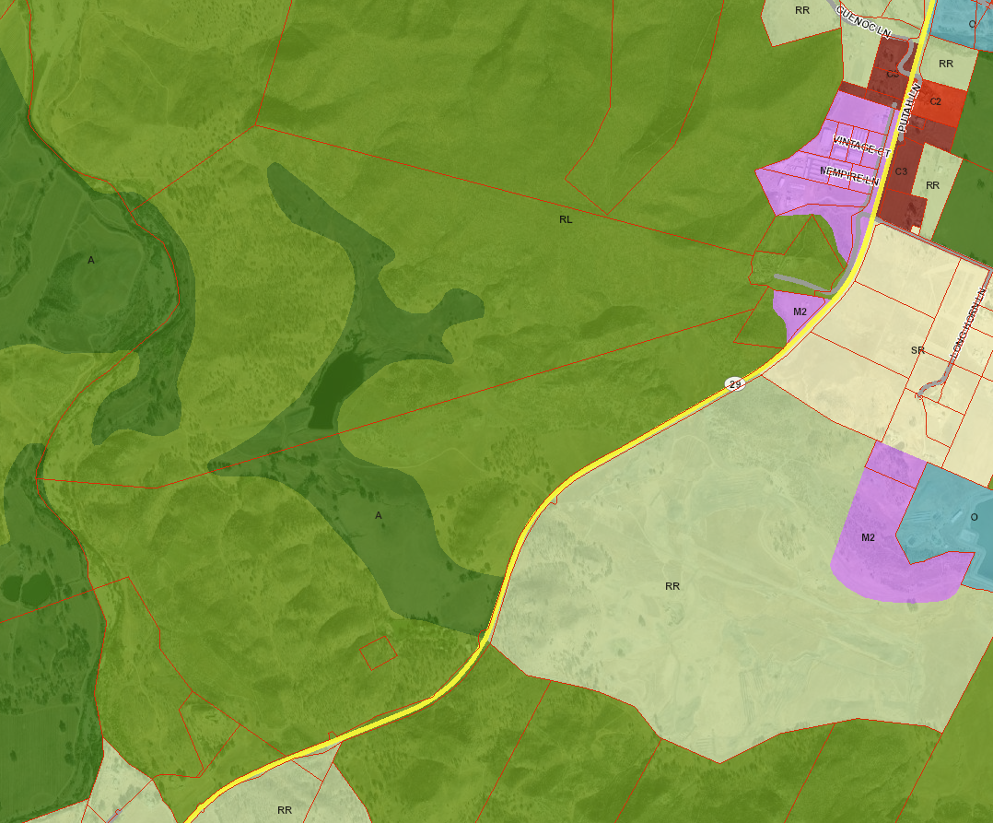
Nearest Offsite Residence
014-250-14
014-250-07
Figure 4. Zoning of project area and surrounding parcels

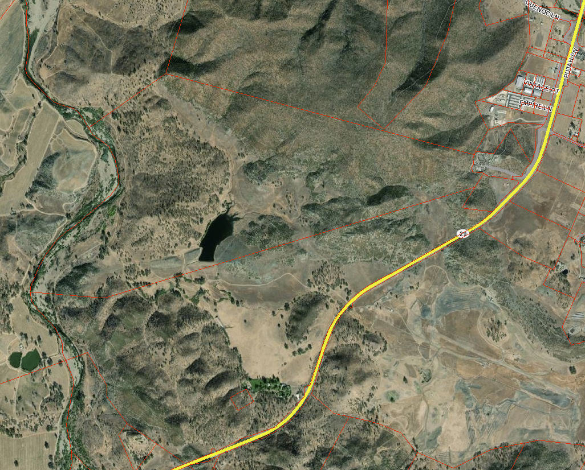
014-250-14
014-250-07
Figure 5. Aerial photo of project area and surrounding parcels

Other public agencies whose approval may be required (e.g., Permits, financing approval, or participation agreement.)

Lake County Department of Environmental Health
Lake County Air Quality Management District
Lake County Department of Public Works
Lake County Department of Public Services
Lake County Agricultural Commissioner
Lake County Sheriff Department
South Lake County Fire Protection District
Central Valley Regional Water Quality Control Board
CalCannabis (via Dept. of Food and Agriculture)
California Water Resources Control Board
California Department of Forestry & Fire Protection (CALFIRE)
California Department of Fish & Wildlife (CDFW)
California Department of Food and Agriculture
California Department of Pesticides Regulations
California Department of Public Health
California Bureau of Cannabis Control
California Department of Consumer Affairs

- Have California Native American tribes traditionally and culturally affiliated with the project area requested consultation pursuant to Public Resources Code section 21080.3.1? If so, is there a plan for consultation that includes, for example, the determination of significance of impacts to tribal cultural resources, procedures regarding confidentiality, etc.? Note: Conducting consultation early in the CEQA process allows tribal governments, lead agencies, and project proponents to discuss the level of environmental review, identify and address potential adverse impacts to tribal cultural resources, and reduce the potential for delay and conflict in the environmental review process. (See Public Resources Code section 21080.3.2.) Information may also be available from the California Native American Heritage Commission’s Sacred Lands File per Public Resources Code section 5097.96 and the California Historical Resources Information System administered by the California Office of Historic Preservation. Please also note that Public Resources Code section 21082.3 (c) contains provisions specific to confidentiality.
Notification of the project was sent to the local tribes on December 18, 2020. The Middletown Rancheria Tribal Historic Preservation Department (Middletown Rancheria THPD) responded with an email dated January 4, 2021, and determined that, the Ranch is within the aboriginal territories of the Middletown Rancheria. The Middletown Rancheria THPD requested additional information regarding the project as well as a consultation regarding the project. In an email dated April 21, 2021, to Mr. Eric Porter from the County Community Development Department, the Middletown Rancheria THPD informed the County that Middletown Rancheria THPD and Bar X Farms, LLC were in the process of finalizing a Cultural Resources Monitoring (CRM) agreement for the proposed project.

ENVIRONMENTAL FACTORS POTENTIALLY AFFECTED:
The environmental factors checked below would be potentially affected by this project, involving at least one impact that is a “Potentially Significant Impact” as indicated by the checklist on the following pages.

 | Aesthetics |  | Greenhouse Gas Emissions |  | Population / Housing
 | Agriculture & Forestry |  | Hazards & Hazardous Materials |  | Public Services
 | Air Quality |  | Hydrology / Water Quality |  | Recreation
 | Biological Resources |  | Land Use / Planning |  | Transportation
 | Cultural Resources |  | Mineral Resources |  | Tribal Cultural Resources
 | Geology / Soils |  | Noise |  | Utilities / Service Systems
 | Wildfire Energy |  |  |  | Mandatory Findings of Significance

DETERMINATION: (To be completed by the lead Agency)
On the basis of this initial evaluation:

I find that the proposed project COULD NOT have a significant effect on the environment, and a NEGATIVE DECLARATION will be prepared.

I find that although the proposed project could have a significant effect on the environment, there will not be a significant effect in this case because revisions in the project have been made by or agreed to by the project proponent. A MITIGATED NEGATIVE DECLARATION will be prepared.

I find that the proposed project MAY have a significant effect on the environment, and an ENVIRONMENTAL IMPACT REPORT is required.

I find that the proposed project MAY have a “potentially significant impact” or “potentially significant unless mitigated” impact on the environment, but at least one effect 1) has been adequately analyzed in an earlier document pursuant to applicable legal standards, and 2) has been addressed by mitigation measures based on the earlier analysis as described on attached sheets. An ENVIRONMENTAL IMPACT REPORT is required, but it must analyze only the effects that remain to be addressed.

I find that although the proposed project could have a significant effect on the environment, because all potentially significant effects (a) have been analyzed adequately in an earlier EIR or NEGATIVE DECLARATION pursuant to applicable standards and (b) have been avoided or mitigated pursuant to that earlier EIR or NEGATIVE DECLARATION, including revisions or mitigation measures that are imposed upon the proposed project, nothing further is required.

Initial Study Prepared By: NorthPoint Consulting Group, Inc.
Reviewed by: Eric Porter, Associate Planner, County of Lake

Date:
SIGNATURE

Scott DeLeon – Interim Community Development Director
Community Development Department

Section 1 - EVALUATION OF ENVIRONMENTAL IMPACTS:

1) A brief explanation is required for all answers except "No Impact" answers that are adequately supported by the information sources a lead agency cites in the parentheses following each question. A "No Impact" answer is adequately supported if the referenced information sources show that the impact simply does not apply to projects like the one involved (e.g., the project falls outside a fault rupture zone). A "No Impact" answer should be explained where it is based on project-specific factors as well as general standards (e.g., the project will not expose sensitive receptors to pollutants, based on a project-specific screening analysis).

2) All answers must take account of the whole action involved, including off-site as well as on-site, cumulative as well as project-level, indirect as well as direct, and construction as well as operational impacts.

- Once the lead agency has determined that a particular physical impact may occur, and then the checklist answers must indicate whether the impact is potentially significant, less than significant with mitigation, or less than significant. "Potentially Significant Impact" is appropriate if there is substantial evidence that an effect may be significant. If there are one or more "Potentially Significant Impact" entries when the determination is made, an EIR is required.

- "Negative Declaration: Less Than Significant With Mitigation Incorporated" applies where the incorporation of mitigation measures has reduced an effect from "Potentially Significant Impact" to a "Less Than Significant Impact." The lead agency must describe the mitigation measures, and briefly explain how they reduce the effect to a less than significant level (mitigation measures from Section XVII, "Earlier Analyses," may be cross-referenced).

5) Earlier analyses may be used where, pursuant to the tiering, program EIR, or other CEQA process, an effect has been adequately analyzed in an earlier EIR or negative declaration. Section 15063(c)(3)(D). In this case, a brief discussion should identify the following:
a) Earlier Analysis Used. Identify and state where they are available for review.
b) Impacts Adequately Addressed. Identify which effects from the above checklist were within the scope of and adequately analyzed in an earlier document pursuant to applicable legal standards, and state whether such effects were addressed by mitigation measures based on the earlier analysis.
c) Mitigation Measures. For effects that are "Less than Significant with Mitigation Measures Incorporated," describe the mitigation measures, which were incorporated or refined from the earlier document and the extent to which they address site-specific conditions for the project.

6) Lead agencies are encouraged to incorporate into the checklist references to information sources for potential impacts (e.g., general plans, zoning ordinances). Reference to a previously prepared or outside document should, where appropriate, include a reference to the page or pages where the statement is substantiated.

- Supporting Information Sources: A source list should be attached, and other sources used or individuals contacted should be cited in the discussion.

- This is only a suggested form, and lead agencies are free to use different formats; however, lead agencies should normally address the questions from this checklist that are relevant to a project's environmental effects in whatever format is selected.

9) The explanation of each issue should identify:
a) the significance criteria or threshold, if any, used to evaluate each question; and
b) the mitigation measure identified, if any, to reduce the impact to less than significance

KEY: 1 = Potentially Significant Impact
2 = Less Than Significant with Mitigation Incorporation
3 = Less Than Significant Impact
4 = No Impact

IMPACT  CATEGORIES* | 1 | 2 | 3 | 4 |  | All determinations need explanation.  Reference to documentation, sources, notes and correspondence. | Source Number**
I. AESTHETICS
Would the project:
a) Have a substantial adverse effect on a scenic vista? |  | X |  |  |  | The Ranch is accessed off of State Route 29, approximately 1.3 miles northeast of Middletown. In addition to natural features, the cultural landscape includes agricultural activities such as grazing lands, walnut orchards and vineyards that provide scenic vistas for those traveling State Route 29, which is a gateway to Lake County from the Bay Area. State Route 29 is a State Scenic Highway. In the vicinity of the Ranch, State Route 29 is designated scenic through the use of the “SC”, Scenic Combining District. The “SC” Combining District provides viewshed protection for scenic vistas visible from designated roadways. Agricultural activities, including greenhouses and processing, are permitted uses within the SC zone.  According to the Middletown Area Plan, the concentration of agricultural lands and their distribution in the County, especially large ranches, is a major contributing element to its rural character and scenic quality.  Bar X Ranch is a 1594.6 acre cattle ranch. The proposed cannabis activities would utilize approximately 80 acres (5%) of the Ranch. The remainder of the Ranch would continue to operate as it has in the past, including cattle ranching and hay production. The proposed activities are agricultural in nature and are consistent with the current and past use of the property, the surrounding existing uses, and existing zoning.  The proposed Phase 2 greenhouses and processing building have the potential of having an adverse impact on the area related to light migration. Visual distance would help with the overall visual impact of the project, along with mitigation measures to further reduce potential visual impacts.  Impacts would be Less than Significant with Mitigation Measure AES-1.  AES-1: All greenhouses shall incorporate blackout screening so that no light is visible from outside each greenhouse. | 1, 2, 3, 4, 5, 6, 9
b) Substantially damage scenic resources, including, but not limited to, trees, rock outcroppings, and historic buildings within a state scenic highway? |  | X |  |  |  | The Ranch is accessed off of State Route 29, approximately 1.3 miles northeast of Middletown. In addition to natural features, the cultural landscape includes agricultural activities such as grazing lands, walnut orchards and vineyards that provide scenic vistas for those traveling State Route 29, which is a gateway to Lake County from the Bay Area. The “SC” Combining District provides viewshed protection for scenic vistas visible from designated roadways. Agricultural activities, including greenhouses and processing, are permitted uses within the SC zone.  Impacts would be Less than Significant with Mitigation Measure AES-1. | 2, 3, 4, 9
c) Substantially degrade the existing visual character or quality of public views the site and its surroundings? If the project is in an urbanized area, would the project conflict with applicable zoning and other regulations governing scenic quality? |  | X |  |  |  | The Ranch is located in a rural, unincorporated area of Lake County northeast of Middletown. Large ranches are of great value to the rural character and scenic quality of the County. The proposed activities are agricultural in nature and are consistent with the current and past use of the property, the surrounding existing uses, and existing zoning.  Impacts would be Less than Significant with Mitigation Measure AES-1. | 1, 2, 3, 4, 6, 9
d) Create a new source of substantial light or glare which would adversely affect day or nighttime views in the area? |  | X |  |  |  | The project has some potential to create additional light and/or glare through exterior security lighting. The following mitigation measures have been implemented that would reduce the impacts to less than significant:  Less than Significant Impact with Mitigation Measures AES-1 through AES-3.  AES-2: A Lighting Plan that meets the darksky.org lighting recommendations shall be submitted for review and acceptance, or review and revision prior to building permit issuance.  AES-3: Prior to construction of the greenhouses and the processing building during Phase II, the applicant shall provide a vegetation screening plan, to screen the greenhouses and processing building from public traveling on State Route 29, to the Lake County Community Development Department for review and acceptance, or review and revision prior to building permit issuance. The vegetation screening shall consist of woody vegetation or trees that grow to no less than 20 feet tall. The species of woody vegetation or trees to be used may be chosen by the applicant but should be suited to localized soil and site conditions. Native plant species are encouraged as are plantings which shall benefit local fauna. Plantings must be perennial and hardy in the local climate zone as specified in scientific literature or garden catalogs. The plan shall detail the woody vegetation or tree type, quantity, and placement as well as a maintenance and monitoring program to ensure the screen shall be maintained through the life of the project | 1, 2, 3, 4, 5, 6, 9
- AGRICULTURE AND FORESTRY RESOURCES
In determining whether impacts to agricultural resources are significant environmental effects, lead agencies may refer to the California Agricultural Land Evaluation and Site Assessment Model (1997) prepared by the California Dept. of Conservation as an optional model to use in assessing impacts on agriculture and farmland. In determining whether impacts to forest resources, including timberland, are significant environmental effects, lead agencies may refer to information compiled by the California Department of Forestry and Fire Protection regarding the state’s inventory of forest land, including the Forest and Range Assessment Project and the Forest Legacy Assessment Project; and forest carbon measurement methodology provided in Forest protocols adopted by the California Air Resources Board.
Would the project:
a) Convert Prime Farmland, Unique Farmland, or Farmland of Statewide Importance (Farmland), as shown on the maps prepared pursuant to the Farmland Mapping and Monitoring Program of the California Resources Agency, to non-agricultural use? |  |  |  | X |  | Per the Farmland Mapping and Monitoring Program, the Ranch is mostly classified as Grazing Land with isolated pockets of land designated as Farmland of Local Importance. The Ranch is not located within a Farmland Protection Zone. The proposed activities are agricultural in nature and are consistent with the current and past use of the property, the surrounding existing uses, and existing zoning. Therefore, this proposed project would not convert farmland that is high quality farmland to a non-agricultural use.  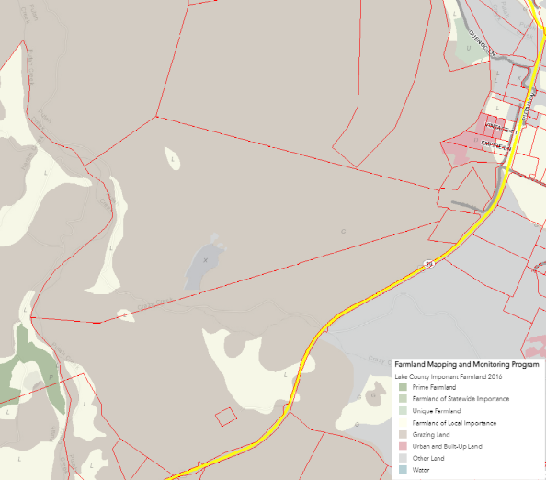  Figure 6. Farmland Mapping and Monitoring Program designation  No Impact | 1, 2, 3, 4, 7, 8, 11, 13, 39
b) Conflict with existing zoning for agricultural use, or a Williamson Act contract? |  |  |  | X |  | The site is not under a Williamson Act contract. The cultivation site is not located within a Lake County Farmland Protection Zone and is not within 1-mile of the Farmland Protection Zone. The cultivation portion of the site would not interfere with the ability of the owner or neighbors to use the non-cannabis land for more traditional crop production. The site is zoned Rural Land (RL) and Agriculture (A), which is a designated zone for agriculture, including cannabis cultivation.  Less than Significant Impact | 1, 2, 3, 4, 5, 7, 8, 11, 13
c) Conflict with existing zoning for, or cause rezoning of, forest land (as defined in Public Resources Code section 12220(g)), timberland (as defined by Public Resources Code section 4526), or timberland zoned Timberland Production (as defined by Government Code section 51104(g))? |  |  |  | X |  | The property is zoned Rural Lands (RL) and Agriculture (A) and does not contain forest land. Therefore, the proposed project would not conflict with existing zoning and/or cause the rezoning of forest land as defined by Public Resource Code section 4526, or of timberland as defined by Government Code section 51104(g).  No Impact | 1, 2, 3, 4, 5, 7, 8, 11, 13
d) Result in the loss of forest land or conversion of forest land to non-forest use? |  |  |  | X |  | The property is zoned Rural Lands (RL) and Agriculture (A) and does not contain forest land. Therefore, the project would not result in the loss or conversion of forest land to a non-forest use.  No Impact | 1, 2, 3, 4, 5, 7, 8, 11, 13
e) Involve other changes in the existing environment which, due to their location or nature, could result in conversion of Farmland, to non-agricultural use or conversion of forest land to non-forest use? |  |  |  | X |  | As proposed, this project would not induce changes to existing farmland that would result in its conversion to non-agricultural use.  No Impact | 1, 2, 3, 4, 5, 7, 8, 11, 13
III. AIR QUALITY
Where available, the significance criteria established by the applicable air quality management or air pollution control district may be relied upon to make the following determinations.
Would the project:
a) Conflict with or obstruct implementation of the applicable air quality plan? |  | X |  |  |  | The project site is located within the Lake County Air Basin, which is under the jurisdiction of the Lake County Air Quality Management District (LCAQMD). The LCAQMD applies air pollution regulations to all major stationary pollution sources and monitors air quality. The Lake County Air Basin is in attainment with both state and federal air quality standards. According to the USDA Soil Survey and the Ultramafic, ultrabasic, serpentine rock and soils map of Lake County, serpentine soils exist on the large Ranch, but the cultivation operations have been located in areas not designated as serpentine soils.  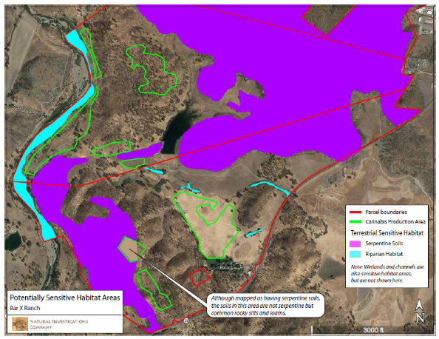  Figure 7. Map of Serpentine Soils (Source: Botanical Survey Report, 2021)  Since the Lake County Air Basin is in attainment for all air pollutants, air quality plans are not required in Lake County.  Although the Lake County Air Basin is not required to have an air quality plan, the proposed project has the potential to result in short- and long-term air quality impacts from construction and operation of the proposed project.  Potential construction impacts, which, under Phase 1, are limited to some vegetation clearing and minor grading to create level areas, on contour, for the planter boxes or smart pots, grading the cultivation employee parking area, and a flat area for the water tanks. Under Phase 2, potential construction impacts would be from grading to develop flats for proposed greenhouses and the processing building. During both phases, these impacts, would be temporary in nature and would occur over about a 4 to 6 week period during Phase 1 and a 2 to 4 month period during Phase 2. Ongoing field management is considered an operational, not construction, activity.  Operational impacts would include dust and fumes from site preparation of the cultivation areas, cultivation employee parking area, water tank area, greenhouses, processing building, and vehicular traffic, including delivery vehicles that would be contributors during and after site preparation/construction. Odors generated by the plants, particularly during harvest season, would be mitigated through passive means (separation distance), and other measures such as planting native flowering vegetation surrounding the cultivation area. Implementation of mitigation measures would reduce air quality impacts to less than significant.  The project proposes the use of a gasoline-powered generator to operate the well pump and for backup power to the commercial processing building in the case of power outages.  The use of generators for mixed-light cultivation are only allowed in the event of a power outage or emergency that is beyond the applicants control. No generator use is not proposed as part of the outdoor or mixed-light cultivation activities.  The diesel-powered equipment (tillers, weed-eaters, etc.) would be used for maintenance.  Dust during site preparation would be limited during periods of high winds (over 15 mph). All visibly dry, disturbed soil and road surfaces would be watered to minimize fugitive dust emissions.  Dust and fumes may be released as a result of vehicular traffic, including delivery vehicles. Minor grading is proposed during both phases. Additionally, implementation of mitigation measures below would further reduce air quality impacts to less than significant.  Impacts would be Less than Significant with Mitigation Measures AQ-1 through AQ-7 incorporated.  AQ-1: Prior to obtaining the necessary permits and/or approvals for any phase, applicant shall contact the Lake County Air Quality Management District and obtain an Authority to Construct (A/C) Permit for all operations and for any diesel-powered equipment and/or other equipment with potential for air emissions. Or provide proof that a permit is not needed.  AQ-2: All mobile diesel equipment used must be in compliance with State registration requirements. Portable and stationary diesel powered equipment must meet all Federal, State, and local requirements, including the requirements of the State Air Toxic Control Measures for CI engines. Additionally, all engines must notify LCAQMD prior to beginning construction activities and prior to engine Use.  AQ-3: The applicant shall maintain records of all hazardous or toxic materials used, including a Material Safety Data Sheet (MSDS) for all volatile organic compounds utilized, including cleaning materials. Said information shall be made available upon request and/or the ability to provide the Lake County Air Quality Management District such information in order to complete an updated Air Toxic emission Inventory.  AQ-4: All vegetation during site development shall be chipped and spread for ground cover and/or erosion control. The burning of vegetation, construction debris, including waste material is prohibited.  AQ-5: The applicant shall have the primary access and parking areas surfaced with chip seal, asphalt or an equivalent all weather surfacing to reduce fugitive dust generation. The use of white rock as a road base or surface material for travel routes and/or parking areas is prohibited.  AQ-6: All areas subject infrequent use of driveways, over flow parking, etc., shall be surfaced with gravel. Applicant shall regularly use and/or maintain graveled area to reduce fugitive dust generations.  AQ-7: Due to the presence of serpentine soil on the property, prior to any cultivation activities, the applicant shall prepare a Dust Mitigation and Control Plan to show how the applicant shall keep serpentine soil from migrating during site disturbance. This shall occur prior to early activation being issued for this property, and is subject to review and acceptance by the Lake County Building Official and/or Air Quality Control Department. | 1, 3, 4, 5, 13, 21, 24, 31, 36
b) Violate any air quality standard or result in a cumulatively considerable net increase in an existing or projected air quality violation? |  |  | X |  |  | The County of Lake is in attainment of state and federal ambient air quality standards. Burning cannabis waste is prohibited within the commercial cannabis ordinance for Lake County.  The project proposes the use of a gasoline-powered generator to operate the well pump and for backup power to the commercial processing building in the case of power outages.  The use of generators for mixed-light cultivation are only allowed in the event of a power outage or emergency that is beyond the applicants control. No generator use is not proposed as part of the outdoor or mixed-light cultivation activities.  The diesel-powered equipment (tillers, weed-eaters, etc.) would be used for maintenance.  On-site construction is likely to occur over a relatively short period of time (approximately 4 to 6 weeks for Phase 1 and approximately 2 to 4 months for Phase 2) with vegetation removal and grading. Potential particulate matter could be generated during construction activities and build-out of the site, however, in general, construction activities that last for less than one year, and use standard quantities and types of construction equipment, are not required to be quantified and are assumed to have a less than significant impact. It is unlikely that this use would generate enough particulates during and after construction to violate any air quality standards.  Less than Significant Impact | 1, 2, 3, 4, 5, 21, 24, 31, 36
c) Expose sensitive receptors to substantial pollutant concentrations? |  |  | X |  |  | Land uses that are considered sensitive receptors typically include residences, schools, parks, childcare centers, hospitals, convalescent homes, and retirement homes. There are no schools, parks, childcare centers, convalescent homes, or retirement homes located near the project. The nearest off-site residence appears to be located approximately 1,000 feet southwest of the cultivation activities. Article 27 of the Lake County Zoning Ordinance requires that the minimum setback requirement for commercial cannabis cultivation be 200 feet from off-site residences. Pesticide application would only be applied during the growing months and applied carefully to individual plants to prevent off-site drift of pesticides. As such, sensitive receptors would not likely be exposed to substantial pollutant concentrations from pesticides. Additionally, no demolition or renovation is proposed that could expose sensitive receptors to asbestos. No serpentine soils are mapped within the proposed cultivation areas, parking area, or processing building area.  Less than Significant Impact | 1, 2, 3, 4, 5, 10, 21, 24, 31, 36
d) Result in substantial emissions (such as odors or dust) adversely affecting a substantial number of people? |  | X |  |  |  | Odors generated by the plants, particularly during harvest season, would be mitigated through passive means (separation distance), and other measures such as planting native flowering vegetation surrounding the cultivation area. An air quality assessment is provided in the Property Management Plan. Construction emissions and operational emissions were calculated using the California Emissions Estimator Model (CalEEMod®), Version 2016.3.2. Construction and operational emissions are summarized in the following tables. The results are expressed as a range of potential emissions. To magnify any air quality impacts, the model was run using the worst-case scenarios, and emissions estimates are reported here using the unmitigated emissions values. The main sources of construction emissions are exhaust from heavy equipment and tailpipe emissions from cars and trucks. In the operational phase, no direct emissions would occur. Electrical consumption would contribute incrementally, but not significantly, to greenhouse gas generation.  Lake County has adopted the Bay Area Air Quality Management District (BAAQMD) thresholds of significance as a basis for determining the significance of air quality and GHG impacts. Air emissions modeling performed for this project demonstrates that the project, in both the construction phase and the operational phase, would not generate significant quantities of ozone or particulate matter and does not exceed the project-level thresholds established by BAAQMD.  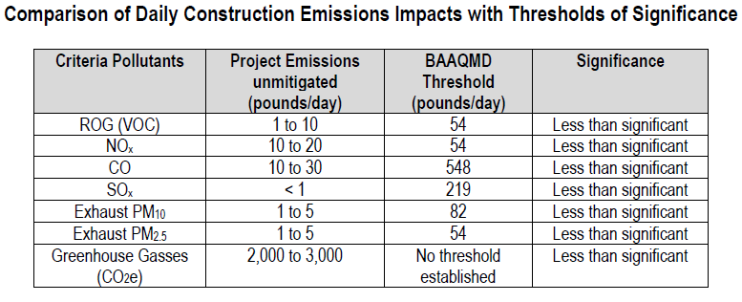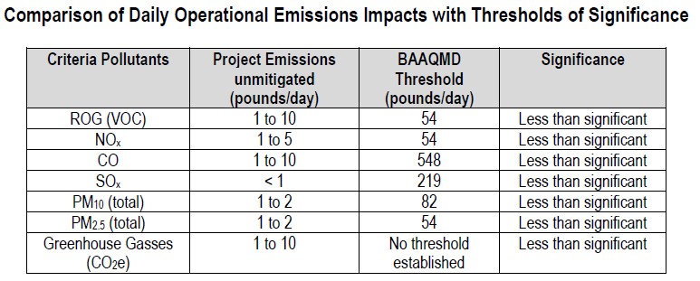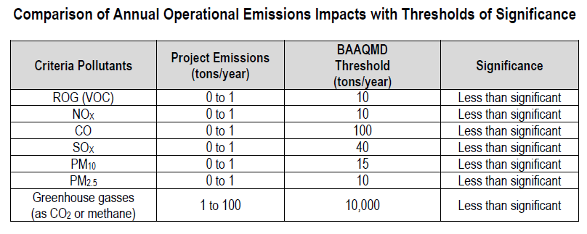  Some site disturbance is needed to implement the project as proposed. Additionally, the applicant would be required to submit an Odor Control Plan as Mitigation Measure AQ-8.  The proposed cultivation would generate minimal amounts of carbon dioxide from operation of small gasoline engines (tillers, weed eaters, lawn mowers, etc.) and from vehicular traffic associated with staff communicating and delivery / pickups. Additionally, Mitigation Measures AQ-1 and AQ-8 would reduce impacts of dust generation from on-site roads and parking areas.  Less than Significant Impact with Mitigation Measures AQ-1 and AQ-8.  AQ-8: Each greenhouse and the processing building shall contain an air and odor filtration system. An Odor Control Plan identifying the method of filtration shall be provided to the Lake County Planning Department for review prior to any construction of greenhouses or the processing building occurring on site. | 1, 2, 3, 4, 5, 21, 24, 31, 36
IV. BIOLOGICAL RESOURCES
Would the project:
a) Have a substantial adverse effect, either directly or through habitat modifications, on any species identified as a candidate, sensitive, or special status species in local or regional plans, policies, or regulations, or by the California Department of Fish and Game or U.S. Fish and Wildlife Service? |  | X |  |  |  | A Biological Resources Assessment (BA) and Botanical Survey Report (BSR) were prepared by Natural Investigations Company, February 1, 2021, and April 16, 2021, respectively. The BSR included a formal wetland delineation. Field surveys were conducted on June 25, 2020, August 21, 2020, January 4, 2021, February 24, 2021, and April 1, 2021. The purpose of the BA and the BSR were to provide information as to whether the proposed cultivation and cannabis operation areas contain sensitive plants or potentially contain sensitive wildlife requiring mitigation under CEQA. The BA and BSR refer to the combined parcels APN 014-250-07 and 14 as the Study Area.  The Ranch is located within the Upper Putah Creek watershed (HUC-1802016203). Putah Creek, a Class I watercourse, bounds the western edge of the property and flows in the northerly direction and then turns east approximately 1.7 miles north of the Ranch. Crazy Creek, a Class II watercourse that is tributary to Putah Creek, flows east towards its confluence with Putah Creek located approximately 3.5 miles east of Bar X Ranch. Several Class III watercourses are located throughout Bar X Ranch, draining to Putah Creek or Crazy Creek (Figure 1). No development is proposed within 150-feet of the Class I watercourse or within 100-feet of any Class II or Class III watercourses.  The BSR identified wetland areas on the Ranch, but the proposed project areas were designed with setbacks of at least 100-feet from these wetlands.  Although there are no designated wildlife corridors in the Study Area, the open space within the Study Area allows for unrestricted animal movement, and the Putah Creek corridor functions as a wildlife movement corridor. Putah Creek also contains fishery resources.  The Study Area is not located within any adopted Habitat Conservation Plan or Natural Community Conservation Plan.  Special-Status Plant Populations  Special-status plants have a moderate potential to occur in the Study Area in wetlands areas, and a moderate to high potential to occur in areas that have serpentine soils. No special-status plant species were detected in the project area during numerous botanical field surveys that were conducted over the entire blooming season over a span of 2 years (2020 and 2021).  Indirect impacts could occur from the loss of suitable habitat for regionally-occurring special-status species. The project area contains the following general habitat types: non-native annual grassland; oak woodland; pasture; and urbanized. Cattle grazing has degraded the habitat quality in the project area. The project area contains no aquatic habitats such as wetlands or channels. The surrounding property (Bar X Ranch) contains these habitat types plus riparian, open water, chaparral, serpentine soils, and wetlands sensitive habitats. Note that although Southwest Garden #2 is generally mapped as having a soil type that contains serpentine materials (Henneke-Montara-rock outcrop complex), serpentine materials were not observed in Southwest Garden #2. The majority of regionally-occurring special-status species occur in these sensitive habitat types. The proposed project has been designed to avoid these sensitive habitat types.  Some regionally-occurring special-status plant species have the potential to utilize the habitat types in the project area. However, project implementation would have a less-than significant impact upon habitat loss for regionally occurring special-status plant species for numerous reasons. Outdoor cultivation would involve some vegetation removal and minor grading to create level areas, on contour, to place the wooden planters or smart pots, and grading is required to develop the cultivation employee parking area and flats for the mixed-light greenhouses and processing building. So, natural habitats may be disturbed, but not totally eradicated. Furthermore, the proposed project activities would occur on only 5% of the Property (80 acres out of 1,594.6 acres), which leaves the vast majority of the natural habitats undisturbed on the Ranch. Cattle grazing has degraded the habitat quality in the project area, making it less suitable for special-status plant species. Finally, the majority of regionally-occurring special-status plant species require habitat types that would not be disturbed, such as riparian, wetland, chaparral, and serpentine soil. For these reasons, project implementation would have a less than significant indirect or cumulative impact upon special-status plant species.  Sensitive Natural Communities  The project area does contain one general sensitive natural community type, Oak Woodlands and Forests, and specifically, Blue Oak Woodland And Forest or Valley Oak Woodland and Forest, depending upon location. Project implementation would have a less-than significant impact upon sensitive natural communities for numerous reasons. The majority of sensitive natural communities on the Ranch (riparian, open water, chaparral, serpentine soils, channels and wetlands) were avoided in project design, including aquatic buffers of at least 100 feet.  Construction of Phase 1 would include building fences, preparing the cultivation areas, installing the above ground irrigation system, retrofitting the existing barn, developing the employee parking area, and preparing flats for the water tanks. Activities would include some vegetation clearing and minor grading to create level areas, on contour, to place the planter boxes or smart pots, to develop the cultivation employee parking area, and the water tank area. No removal of living trees greater than 5-inch DBA is proposed and disturbance would occur outside of oak canopies, so Oak Woodland habitats may be disturbed, but not eradicated.  During Phase 2, minor grading would occur to build greenhouses and the processing building; which have been sited outside of the sensitive natural communities identified on the Ranch.  Although project implementation would disturb some Oak Woodland communities, the majority of Oak Woodland communities on the Ranch would not be disturbed or involved in the project. For these reasons, project implementation would have a less than significant impact (direct, indirect, and cumulative) upon sensitive natural communities.  Special-Status Animal Species  Special-status animals are considered to be moderately likely in potential project areas, and highly likely to occur in other portions of the Study Area, especially near Putah Creek, and also smaller watercourses and wetlands.  Special-status animals (amphibians, mammals, fish, and birds) have been reported to occur on the Ranch. Areas near channels and wetlands should be avoided, as these areas are more likely to contain special-status animal species. The buffers required by the Cannabis Cultivation General Order may be sufficient to avoid special-status animal species. However, special-status species could migrate into project areas between the time that the field survey was completed and the start of construction. Mitigation Measure BIO-1 is recommended to mitigate this impact to less than significant.  Special-status bird species were reported in databases (CNDDB and USFWS) in the vicinity of the project area. The project area, and adjacent trees and utility poles, contain suitable nesting habitat for various bird species. However, no nests were observed during the field survey. If construction activities are conducted during the nesting season, nesting birds could be directly impacted by tree removal and indirectly impacted by noise, vibration, and other construction-related disturbance. Therefore, Project construction is considered a potentially significant adverse impact to nesting birds before mitigation. Mitigation Measure BIO-2 is recommended to mitigate this impact to less than significant.  Impacts would be Less than Significant with Mitigation Measures BIO-1 and BIO-2 incorporated.  BIO-1: Because special-status species that occur in the vicinity could migrate onto the Study Area between the time that the field survey was completed and the start of construction, a pre-construction survey for special-status species shall be performed by a qualified biologist prior to activation of this use permit to ensure that special-status species are not present. If any listed species are detected, construction should be delayed, and the appropriate wildlife agency (CDFW and/or USFWS) should be consulted and project impacts and mitigation reassessed. With the implementation of this mitigation measure, adverse impacts upon special-status species would be reduced to a less-than-significant level.  BIO-2: If construction activities would occur during the nesting season (typically February through August), a pre-construction survey for the presence of special-status bird species or any nesting bird species shall be conducted by a qualified biologist within 500 feet of proposed construction areas. If active nests are identified in these areas, CDFW and/or USFWS should be consulted to develop measures to avoid “take” of active nests prior to the initiation of any construction activities. Avoidance measures may include establishment of a buffer zone using construction fencing or the postponement of vegetation removal until after the nesting season, or until after a qualified biologist has determined the young have fledged and are independent of the nest site. | 2, 5, 11, 12, 13, 16, 24, 29, 30, 31, 32, 33, 34
b) Have a substantial adverse effect on any riparian habitat or other sensitive natural community identified in local or regional plans, policies, and regulations or by the California Department of Fish and Game or U.S. Fish and Wildlife Service? |  | X |  |  |  | A Biological Resources Assessment (BA) and Botanical Survey Report (BSR) were prepared by Natural Investigations Company, February 1, 2021, and April 16, 2021, respectively. The BSR included a formal wetland delineation. The BA and BSR refer to the combined parcels APN 014-250-07 and 14 as the Study Area.  The Ranch is located within the Upper Putah Creek watershed (HUC-1802016203). Putah Creek, a Class I watercourse, bounds the western edge of the property and flows in the northerly direction and then turns east approximately 1.7 miles north of the Ranch. Crazy Creek, a Class II watercourse that is tributary to Putah Creek, flows east towards its confluence with Putah Creek located approximately 3.5 miles east of Bar X Ranch. Several Class III watercourses are located throughout Bar X Ranch, draining to Putah Creek or Crazy Creek (Figure 1). No development is proposed within 150-feet of the Class I watercourse or within 100-feet of any Class II or Class III watercourses.  The BSR identified wetland areas on the Ranch, but the proposed project areas were designed with setbacks of at least 100-feet from these wetlands.  The Ranch contains wetlands and Class I, II, and III watercourses. No development is proposed within 100-feet of wetlands or watercourses, which is consistent with Article 27 of the Lake County Zoning Ordinance that regulates commercial cannabis cultivation. The applicant has provided a Property Management Plan, which addresses controlled water runoff in a manner that reduces impacts to this stream. No development would occur within the drainage buffers and setbacks.  Erosion control measures to control erosion and sedimentation during construction and operation have been identified in the Property Management Plan. Measures that could be implemented include vegetated swales, buffer strips, sediment traps, straw wattles, silt fences, or fiber rolls.  Bar X Ranch is enrolled with the State Water Resources Control Board (SWRCB) for Tier 2, Low Risk coverage under Order No. WQ 2019-001-DWQ (Cannabis Cultivation General Order). The Cannabis Cultivation General Order implements Cannabis Policy requirements with the purpose of ensuring that the diversion of water and discharge of waste associated with cannabis cultivation does not have a negative impact on water quality, aquatic habitat, riparian habitat, wetlands, or springs. The Cannabis Cultivation General Order requires the preparation of a Site Management Plan (SMP), a Nitrogen Management Plan (NMP), and the submittal of annual technical and monitoring reports demonstrating compliance. The purpose of the SMP is to identify Best Practicable Treatment or Control (BPTC) measures that the site intends to follow for erosion control purposes and to prevent stormwater pollution. The purpose of the NMP is to identify how nitrogen is stored, used, and applied to crops in a way that is protective to water quality. The SMP and NMP are required prior to commencing cultivation activities and were submitted with the application materials.  Since, the project would disturb more than one acre in preparing the cultivation areas, constructing the parking areas, greenhouses, and processing building, the project would be subject to the requirements State Water Resources Control Board (SWRCB) Construction General Permit (CGP, 2009-009-DWQ). The SWRCB CGP would require the preparation of a Stormwater Pollution Prevention Plan (SWPPP) and Erosion Control Plan which documents the stormwater dynamics at the site, the Best Management Practices (BMPs), and water quality protection measures that are used, and the frequency of inspections. BMPs are activities or measures determined to be practicable, acceptable to the public, and cost effective in preventing water pollution or reducing the amount of pollution generated by non-point sources. Obtainment of a CGP is also a BPTC Measure for compliance with the SWRCB General Order.  In addition, the BA concludes that the project area and surrounding Study Area are not within any designated listed species’ critical habitat. The project areas do not contain special-status habitats, because they were designed to avoid all special-status habitats. The surrounding Study Area does contain special-status habitat: Putah Creek and its riparian corridor, and smaller watercourses and wetlands. There is no evidence that project implementation would impact any special-status habitat with Mitigation Measure BIO-3 incorporated.  Impacts would be Less than Significant with Mitigation Measure BIO-3 incorporated.  BIO-3: All work should incorporate erosion control measures consistent with the engineered Grading and Erosion Control Plans submitted; the Lake County Grading Regulations, and the State Water Resources Control Board Order No. WQ 2019-001-DWQ and Construction General Permit 2009-009-DWQ. | 1, 2, 3, 4, 5, 11, 12, 13, 16, 17, 29, 30, 31, 32, 33, 34
c) Have a substantial adverse effect on state or federally protected wetlands (including, but not limited to, marsh, vernal pool, coastal, etc.) through direct removal, filling, hydrological interruption, or other means? |  | X |  |  |  | A Biological Resources Assessment (BA) and Botanical Survey Report (BSR) were prepared by Natural Investigations Company, February 1, 2021, and April 16, 2021, respectively. The BSR included a formal wetland delineation. The BA and BSR refer to the combined parcels APN 014-250-07 and 14 as the Study Area.  The Ranch is located within the Upper Putah Creek watershed (HUC-1802016203). Putah Creek, a Class I watercourse, bounds the western edge of the property and flows in the northerly direction and then turns east approximately 1.7 miles north of the Ranch. Crazy Creek, a Class II watercourse that is tributary to Putah Creek, flows east towards its confluence with Putah Creek located approximately 3.5 miles east of Bar X Ranch. Several Class III watercourses are located throughout Bar X Ranch, draining to Putah Creek or Crazy Creek (Figure 1). No development is proposed within 150-feet of the Class I watercourse or within 100-feet of any Class II or Class III watercourses.  The Ranch contains wetlands and Class I, II, and III watercourses. No development is proposed within 100-feet of wetlands or watercourses, which is consistent with Article 27 of the Lake County Zoning Ordinance that regulates commercial cannabis cultivation. The applicant has provided a Property Management Plan, which addresses controlled water runoff in a manner that reduces impacts to this stream. No development would occur within the drainage buffers and setbacks.  Erosion control measures to control erosion and sedimentation during construction and operation have been identified in the Property Management Plan. Measures that could be implemented include vegetated swales, buffer strips, sediment traps, straw wattles, silt fences, or fiber rolls.  Potential indirect impacts to water resources could occur during construction by increased erosion and sedimentation in receiving water bodies due to soil disturbance. If the total ground disturbance is greater than 1-acre, the applicant must enroll for coverage under the General Permit for Discharges of Storm Water Associated with Construction Activity (Construction General Permit, 2009-0009-DWQ). Implementation of a stormwater pollution prevention plan, and erosion control plan, along with regular inspections, would ensure that construction activities do not pollute receiving waterbodies.  Potential adverse impacts to water resources could occur during operation of cultivation activities resources by discharge of sediment or other pollutants (fertilizers, pesticides, human waste, etc.) into receiving waterbodies. However, the project proponent has enrolled in Cannabis Cultivation General Order. Compliance with this Order would ensure that cultivation operations would not significantly impact water resources by using a combination of Best Management Practices (BMPs), buffer zones, sediment and erosion controls, site management plans, inspections and reporting, and regulatory oversight.  Impacts would be Less than Significant with Mitigation Measure BIO-3 incorporated. | 1, 2, 3, 4, 5, 11, 12, 13, 16, 17, 21, 24, 29, 30, 31, 32, 33, 34
d) Interfere substantially with the movement of any native resident or migratory fish or wildlife species or with established native resident or migratory wildlife corridors, or impede the use of native wildlife nursery sites? |  |  | X |  |  | A Biological Resources Assessment (BA) and Botanical Survey Report (BSR) were prepared by Natural Investigations Company, February 1, 2021, and April 16, 2021, respectively. The BSR included a formal wetland delineation. The BA and BSR refer to the combined parcels APN 014-250-07 and 14 as the Study Area.  Although the BA did not identify designated wildlife corridors in the Study Area, the open space within the Study Area allows for unrestricted animal movement, and the Putah Creek river corridor functions as a wildlife movement corridor. Putah Creek also contains fishery resources. Implementation of the proposed project would not have a significant impact on wildlife movement and fisheries because it would not completely block wildlife movement, Putah Creek would not be affected, and the majority of the open space in the Study Area would still be available. Implementation of the proposed project would necessitate erection of security fences around the cultivation compounds. These fences would restrict animal movement and may act as a local barrier to wildlife movement. However, the fenced cultivation areas are surrounded by open space, allowing wildlife to move around these fenced areas. Thus, implementation of the proposed project is a less than significant impact upon wildlife movement. Implementation of the project would not interfere substantially with the movement of any native resident or migratory fish or wildlife species or with established native resident or migratory wildlife corridors, or impede the use of native wildlife nursery sites.  Less than Significant Impact | 13
e) Conflict with any local policies or ordinances protecting biological resources, such as a tree preservation policy or ordinance? |  | X |  |  |  | This project does not conflict with any local policies or ordinances protecting biological resources. The project does not propose to remove living trees greater than 5-inch DBA. The Study Area is not within the coverage area of any adopted Habitat Conservation Plan or Natural Community Conservation Plan.  Removal of trees is to be avoided, except as required by CALFIRE to create defensible space and removal of dead or dying trees burned during prior wildland fires. Implementation of the project does not conflict with any county or municipal policies or ordinances protecting biological resources, such as a tree preservation policy or ordinance. If it is necessary to remove trees, Mitigation Measure BIO-4 and BIO-5 are recommended.  Impacts would be Less than Significant with Mitigation Measures BIO-4 and BIO-5 incorporated.  BIO-4: If development requires the removal of live, native oak tree species greater than 5-inches in diameter, measured at breast height (DBH), a Tree Removal and Mitigation Plan shall be submitted for review and acceptance prior to activation of the use permit. The Tree Removal and Mitigation Plan shall demonstrate a 3:1 replacement ratio for any live oak tree greater than 5-inches DBH removed.  BIO-5: If development of the project would result in the removal of commercial tree species or native oak species, one of the following permits shall be obtained: Less than 3 Acre Conversion Exemption; Christmas Tree; Dead, Dying or Diseased, Fuelwood, or Split Products Exemption; a Public Agency, Public and Private Utility Right of Way Exemption; a Notice of Exemption from Timberland Conversion Permit for Subdivision; or an Application for Timberland Conversion Permit. | 1, 2, 3, 4, 5, 11, 12, 13
f) Conflict with the provisions of an adopted Habitat Conservation Plan, Natural Community Conservation Plan, or other approved local, regional, or state habitat conservation plan? |  |  |  | X |  | No special conservation plans have been adopted for this site and no impacts are anticipated.  No Impact | 1, 2, 3, 4, 5, 13
V. CULTURAL RESOURCES
Would the project:
a) Cause a substantial adverse change in the significance of a historical resource pursuant to §15064.5? |  | X |  |  |  | A Cultural Resources Assessment was conducted by Natural Investigations Company dated September 2020. A California Historical Resources Information System (CHRIS) records search was completed by the Northwest Information Center (NWIC) on September 9, 2019. The results of the California Historical Resources Information System (CHRIS) records search were received from the Northwest Information Center (NWIC) on September 16, 2020. The Native American Heritage Commission (NAHC) returned the results of the SLF search on August 19, 2020. Finally, Natural Investigations conducted an intensive pedestrian survey of the project area on August 27 and 28, 2020.  The CHRIS records search indicates that six prior cultural resource studies have been completed which included all or portions of the project area, and 23 additional studies have been completed outside the project area but within the 0.25-mile record search radius. The CHRIS records search also indicated that one cultural resource has been previously recorded within the project area, and 23 additional resources have been recorded within the 0.25-mile search radius. The SLF search returned negative results for Native American resources in the vicinity of the Project. One isolated prehistoric artifact was identified within the project area during the field survey.  One isolated lithic flake was identified during the field survey. Isolated artifacts are by definition found outside of an interpretable archaeological context which is constituted of groups of contemporary and associated artifacts, ecofacts, features, and/or sites. Without this context, isolates typically lack the potential to yield information important in prehistory, the California Register of Historical Resources (CRHR) criterion (Criterion 4) under which archaeological resources are most often found to be significant. As such, the isolate identified during this assessment is not eligible for listing on the CRHR and no further consideration is needed.  Additionally, one partially destroyed historical foundation feature is located on the southeastern edge of the project area. This resource does not appear to meet CRHR eligibility criteria given the extent of past impacts sustained and the thoroughness of existing documentation which appears to have exhausted its informational potential. Nevertheless, given its location no further disturbance of the resource is expected to result from cultivation related activities. For these reasons, no additional cultural resources work is recommended at this time.  It is possible, but unlikely, that significant artifacts or human remains could be discovered during project construction. If, however, significant artifacts or human remains of any type are encountered it is recommended that the project sponsor contact the culturally affiliated tribe and a qualified archaeologist to assess the situation. The Sheriff’s Department must also be contacted if any human remains are encountered.  Impacts would be than Significant with Mitigation Measures CUL-1 and CUL-2 incorporated:  CUL-1: Should any archaeological, paleontological, or cultural materials be discovered during site development, all activity shall be halted in the vicinity of the find(s), the applicant shall notify the culturally affiliated Tribe, and a qualified archaeologist to evaluate the find(s) and recommend mitigation procedures, if necessary, subject to the approval of the Community Development Director. Should any human remains be encountered, the applicant shall notify the Sheriff’s Department, the culturally affiliated Tribe, and a qualified archaeologist for proper internment and Tribal rituals per Public Resources Code Section 5097.98 and Health and Safety Code 7050.5.  CUL-2: All employees shall be trained in recognizing potentially significant artifacts that may be discovered during ground disturbance. If any artifacts or remains are found, the culturally affiliated Tribe shall immediately be notified; a licensed archaeologist shall be notified, and the Lake County Community Development Director shall be notified of such finds. | 1, 3, 4, 5, 11, 14c, 15
b) Cause a substantial adverse change in the significance of an archeological resource pursuant to §15064.5? |  | X |  |  |  | A Cultural Resources Assessment was conducted by Natural Investigations Company dated September 2020. A California Historical Resources Information System (CHRIS) records search was completed by the Northwest Information Center (NWIC) on September 9, 2019. The results of the California Historical Resources Information System (CHRIS) records search were received from the Northwest Information Center (NWIC) on September 16, 2020. The Native American Heritage Commission (NAHC) returned the results of the SLF search on August 19, 2020. Finally, Natural Investigations conducted an intensive pedestrian survey of the project area on August 27 and 28, 2020.  The CHRIS records search indicates that six prior cultural resource studies have been completed which included all or portions of the project area, and 23 additional studies have been completed outside the project area but within the 0.25-mile record search radius. The CHRIS records search also indicated that one cultural resource has been previously recorded within the project area, and 23 additional resources have been recorded within the 0.25-mile search radius. The SLF search returned negative results for Native American resources in the vicinity of the Project. One isolated prehistoric artifact was identified within the project area during the field survey.  One isolated lithic flake was identified during the field survey. Isolated artifacts are by definition found outside of an interpretable archaeological context which is constituted of groups of contemporary and associated artifacts, ecofacts, features, and/or sites. Without this context, isolates typically lack the potential to yield information important in prehistory, the California Register of Historical Resources (CRHR) criterion (Criterion 4) under which archaeological resources are most often found to be significant. As such, the isolate identified during this assessment is not eligible for listing on the CRHR and no further consideration is needed.  Additionally, one partially destroyed historical foundation feature is located on the southeastern edge of the project area. This resource does not appear to meet CRHR eligibility criteria given the extent of past impacts sustained and the thoroughness of existing documentation which appears to have exhausted its informational potential. Nevertheless, given its location no further disturbance of the resource is expected to result from cultivation related activities. For these reasons, no additional cultural resources work is recommended at this time.  It is possible, but unlikely, that significant artifacts or human remains could be discovered during project construction. If, however, significant artifacts or human remains of any type are encountered it is recommended that the project sponsor contact the culturally affiliated tribe and a qualified archaeologist to assess the situation. The Sheriff’s Department must also be contacted if any human remains are encountered.  Less than Significant Impact with Mitigation Measures CUL-1 and CUL-2 incorporated. | 1, 3, 4, 5, 11, 14, 15
c) Disturb any human remains, including those interred outside of formal cemeteries? |  | X |  |  |  | A Cultural Resources Assessment was conducted by Natural Investigations Company dated September 2020. A California Historical Resources Information System (CHRIS) records search was completed by the Northwest Information Center (NWIC) on September 9, 2019. The results of the California Historical Resources Information System (CHRIS) records search were received from the Northwest Information Center (NWIC) on September 16, 2020. The Native American Heritage Commission (NAHC) returned the results of the SLF search on August 19, 2020. Finally, Natural Investigations conducted an intensive pedestrian survey of the project area on August 27 and 28, 2020.  The CHRIS records search indicates that six prior cultural resource studies have been completed which included all or portions of the project area, and 23 additional studies have been completed outside the project area but within the 0.25-mile record search radius. The CHRIS records search also indicated that one cultural resource has been previously recorded within the project area, and 23 additional resources have been recorded within the 0.25-mile search radius. The SLF search returned negative results for Native American resources in the vicinity of the Project. One isolated prehistoric artifact was identified within the project area during the field survey.  One isolated lithic flake was identified during the field survey. Isolated artifacts are by definition found outside of an interpretable archaeological context which is constituted of groups of contemporary and associated artifacts, ecofacts, features, and/or sites. Without this context, isolates typically lack the potential to yield information important in prehistory, the California Register of Historical Resources (CRHR) criterion (Criterion 4) under which archaeological resources are most often found to be significant. As such, the isolate identified during this assessment is not eligible for listing on the CRHR and no further consideration is needed.  Additionally, one partially destroyed historical foundation feature is located on the southeastern edge of the project area. This resource does not appear to meet CRHR eligibility criteria given the extent of past impacts sustained and the thoroughness of existing documentation which appears to have exhausted its informational potential. Nevertheless, given its location no further disturbance of the resource is expected to result from cultivation related activities. For these reasons, no additional cultural resources work is recommended at this time.  It is possible, but unlikely, that significant artifacts or human remains could be discovered during project construction. If, however, significant artifacts or human remains of any type are encountered it is recommended that the project sponsor contact the culturally affiliated tribe and a qualified archaeologist to assess the situation. The Sheriff’s Department must also be contacted if any human remains are encountered.  Impacts would be Less than Significant with Mitigation Measure CUL-2 Incorporated. | 1, 3, 4, 5, 11, 14, 15
VI. ENERGY
Would the project:
a) Result in a potentially significant environmental impact due to wasteful, inefficient, or unnecessary consumption of energy, or wasteful use of energy resources, during project construction or operation? |  |  | X |  |  | During Phase 1, power for security cameras, security lights, and the dry barn would be powered using small, localized solar power at each cultivation area and on/or adjacent to the barn.  During Phase 2, power to each greenhouse needed to operate the low wattage lights, fans, and motors to open and close the blackout covers, would be powered using solar power on each greenhouse with battery backup storage. Each greenhouse would be equipped with its own solar panels sufficient to power the lights, fans, and motors within the greenhouse. No “on grid” power is proposed to operate the mixed-light cultivation. No generators are proposed to operate the greenhouses at any time.  The processing building would be powered using “on grid” power provided by PG&E. An existing PG&E power service exists at the residential area near the proposed processing building.  During both Phase 1 and Phase 2, water from the irrigation well would be pumped to approximately 27, 5,000 gallon water storage tanks using a 75 Horse Power (HP) pump. The tanks are located at a high point on the property so that water from the tanks would gravity feed through an above ground pipe system (aka, irrigation lines) to each cultivation area. The pump would be powered by a 120kW diesel generator.  The generator use proposed here is solely to operate the 75 HP well pump and for backup power to the commercial processing building in case of power outages. The cultivation of cannabis, outdoor and mixed-light, would not rely on the use of a generator.  Less than significant impact. | 5
b) Conflict with or obstruct a state or local plan for renewable energy or energy efficiency? |  |  | X |  |  | There are no mandatory energy reductions for cultivation activities within Article 27 of the Lake County Zoning Ordinance unless the applicant proposes ‘indoor cultivation’ (not proposed with this application).  Less than Significant Impact. | 1, 3, 4, 5
VII. GEOLOGY AND SOILS
Would the project:
a) Directly or indirectly cause potential substantial adverse effects, including the risk of loss, injury, or death involving:  - Rupture of a known earthquake fault, as delineated on the most recent Alquist-Priolo Earthquake Fault Zoning Map issued by the State Geologist for the area or based on other substantial evidence of a known fault? Refer to Division of Mines and Geology Special Publication 42.  - Strong seismic ground shaking?  - Seismic-related ground failure, including liquefaction?  - Landslides? |  |  | X |  |  | Earthquake Faults  Lake County contains numerous known active faults, however, there are no mapped earthquake faults on or adjacent to the Ranch. Future seismic events in the Northern California region can be expected to produce seismic ground shaking at the site. All proposed construction is required to be built consistent with current California Building Code construction standards.  Seismic Ground Shaking and Seismic–Related Ground Failure, including liquefaction.  The mapping of the site’s soil indicates that the soil is stable and not prone to liquefaction.  Landslides  According to the Landslide Hazard Identification Map prepared by the California Department of Conservation, Division of Mines and Geology, the area is considered generally stable.  Less Than Significant Impact | 1, 2, 3, 4, 5, 18, 19
b) Result in substantial soil erosion or the loss of topsoil? |  | X |  |  |  | Proposed grading activities would include vegetation removal and minor grading (clearing and grubbing) to prepare the outdoor cultivation areas, grading of the cultivation employee parking area, grading the building pads for the greenhouses, and grading the building pad for the commercial processing building and parking. A grading permit application, Grading Plan, and Dust Mitigation Plan have been submitted to Lake County. No grading would occur until an approved grading permit has been obtained from the County. Normal means and methods would be used to retrofit the barn and construct the greenhouses and processing building.  After the cultivation areas are prepared, all cultivation would occur in full sun, with imported soil and amendments, in planter boxes or smart pots (grow bags) placed on top of the existing grade utilizing natural contours in open areas. No additional disturbance of top soil is proposed.  In addition to obtaining a grading permit from the County, which would require measures to minimize erosion during construction, the project would be subject to the requirements State Water Resources Control Board (SWRCB) Construction General Permit (CGP, 2009-009-DWQ). The SWRCB CGP would require the preparation of a Stormwater Pollution Prevention Plan (SWPPP) and Erosion Control Plan which documents the stormwater dynamics at the site, the Best Management Practices (BMPs), and water quality protection measures that are used, and the frequency of inspections. BMPs are activities or measures determined to be practicable, acceptable to the public, and cost effective in preventing water pollution or reducing the amount of pollution generated by non-point sources. Obtainment of a CGP is also a BPTC Measure for compliance with the SWRCB General Order.  Potential erosion and loss of topsoil could occur during operation of cultivation activities. However, Bar X Ranch is enrolled with the State Water Resources Control Board (SWRCB) for Tier 2, Low Risk coverage under Order No. WQ 2019-001-DWQ (Cannabis Cultivation General Order). The Cannabis Cultivation General Order implements Cannabis Policy requirements with the purpose of ensuring that the diversion of water and discharge of waste associated with cannabis cultivation does not have a negative impact on water quality, aquatic habitat, riparian habitat, wetlands, or springs. The Cannabis Cultivation General Order requires the preparation of a Site Management Plan (SMP), a Nitrogen Management Plan (NMP), and the submittal of annual technical and monitoring reports demonstrating compliance. The purpose of the SMP is to identify Best Practicable Treatment or Control (BPTC) measures that the site intends to follow for erosion control purposes and to prevent stormwater pollution. The purpose of the NMP is to identify how nitrogen is stored, used, and applied to crops in a way that is protective to water quality. The SMP and NMP are required prior to commencing cultivation activities and were submitted with the application materials.  Compliance with the Lake County Ordinance, the Construction General Order, and the Cannabis General Order would ensure that the proposed project would not result in substantial soil erosion or the loss of topsoil.  Impacts would be Less Than Significant with Mitigation Measures BIO-3 and GIO-1 through GEO-4 Incorporated.  GEO-1: Prior to any ground disturbance for building construction, the permittee shall submit engineered erosion control and sediment plans to the Lake County Water Resource Department and the Lake County Community Development Department for review and approval. Said engineered erosion control and sediment plans shall show all earth being imported, exported or moved within the site, and shall show the method(s) used to protect the local watershed from runoff pollution through the implementation of appropriate Best Management Practices (BMPs) in accordance with the Grading Ordinance. Typical BMPs include the placement of straw, mulch, seeding, straw wattles, silt fencing, and the planting of native vegetation on all disturbed areas. No silt, sediment, or other materials exceeding natural background levels shall be allowed to flow from the project area. The natural background level is the level of erosion that currently occurs from the area in a natural, undisturbed state. Vegetative cover and water bars shall be used as permanent erosion control after project installation.  GEO-2: Excavation, filling, vegetation clearing, or other disturbance of the soil shall not occur between October 15 and April 15 unless authorized by the Lake County Community Development Department Director. The actual dates of this defined grading period may be adjusted according to weather and soil conditions at the discretion of the Community Development Director.  GEO-3: The permit holder shall monitor the site during the rainy season (October 15 – May 15), including post-installation, application of BMPs, erosion control maintenance, and other improvements as needed.  GEO-4: The project design shall incorporate Best Management Practices (BMPs) to the maximum extent practicable to prevent or reduce the discharge of all construction or post-construction pollutants into the County storm drainage system. BMPs typically include scheduling of activities, erosion and sediment control, operation and maintenance procedures, and other measures in accordance with Chapters 29 and 30 of the Lake County Code. | 1, 3, 4, 5, 19, 21, 24, 25, 30
c) Be located on a geologic unit or soil that is unstable, or that would become unstable as a result of the project, and potentially result in on-site or off-site landslide, lateral spreading, subsidence, liquefaction or collapse? |  |  | X |  |  | The project site is not identified as containing landslides or other unstable geologic conditions. The proposed cultivation sites are located within areas with less than 20 percent slopes. There is a less than significant chance of landslide, subsidence, liquefaction or collapse as a result of the proposed project.  Less Than Significant Impact | 1, 3, 4, 5, 6, 7, 10, 16, 17, 18, 19
d) Be located on expansive soil, as defined in Table 18-1-B of the Uniform Building Code (1994), creating substantial direct or indirect risks to life or property? |  | X |  |  |  | The Uniform Building Code (1994) is a set of rules that specify standards for structures. Structures proposed are greenhouses and the processing building, to be built during Phase 2.  Expansive soils possess a “shrink-swell” characteristic. Shrink-swell is the cyclic change in volume (expansion and contraction) that occurs in fine-grained clay sediments from the process of wetting and drying. Structural damage may occur over a long period of time due to expansive soils, usually the result of inadequate soil and foundation engineering or the placement of structures directly on expansive soils.  The Middletown Area Plan Policy 4.1.1a requires site specific soils analysis of lands identified as having high shrink-swell characteristics before development is allowed to determine which soils can adequately support structures and that foundations are designed to withstand expansive soils. The Phase 2 greenhouses and processing building would occur on Cole clay loam, drained (Soil type 123). Soil Type 123 is comprised of clay loam, silty clay, and silty clay loam soils which are deep, somewhat poorly drained soils with moderate shrink-swell potential.  Any new construction requiring a building permit, such as the proposed greenhouses and processing building, would be subject to the California Building Code (which incorporates the Uniform Building Code) for foundation design. A site specific soils study would be required and the foundation design would be required to meet the requirements associated with expansive soils if they are found to exist as part of the site specific study.  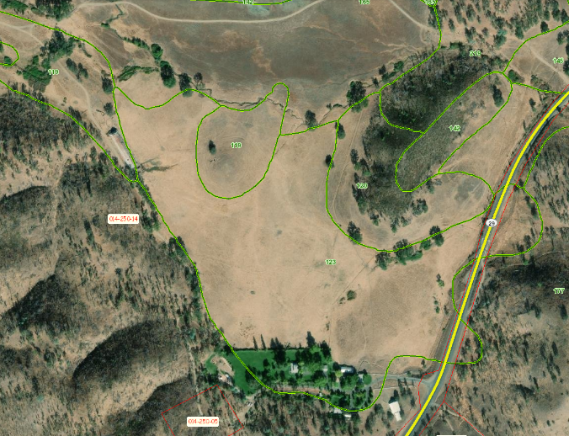  Figure 8. Soil Types  Less Than Significant Impact with Mitigation Measures GEO-1 through GEO-6 incorporated.  GEO-5: Prior to operation, all buildings, accessible compliant parking areas, routes of travel, building access, and bathrooms shall meet all California Building Code Requirements.  GEO-6: Prior to operation of Phase 2, all structure(s) used for commercial cultivation shall meet accessibility and CALFIRE standards. Please contact the Lake County Community Development Department’s Building Division for more information. | 5, 7, 39
e) Have soils incapable of adequately supporting the use of septic tanks or alternative wastewater disposal systems where sewers are not available for the disposal of waste water? |  |  | X |  |  | The proposed project would be served by portable toilets located at each of the cultivation sites. If a new ADA restroom is required to be installed in the proposed processing building, this restroom would require a new onsite wastewater treatment septic system.  State law requires permits for onsite systems to ensure that they are constructed and sited in a manner that protects human health and the environment. Prior to applying for a permit, the Lake County Division of Environmental Health requires a Site Evaluation to determine suitability of the site for a septic system. The septic system would be located, designed, and installed appropriately, following all applicable State and County guidelines and requirements.  The proposed system would be located in an area of Type 123 soils; which is the same soil type as the onsite residential area septic system. Thus, it is likely the soils could support a septic system.  Therefore, the proposed project would not have soils incapable of adequately supporting the use of septic tanks for the disposal of wastewater. In addition, the system would be reviewed and approved by the County Division of Environmental Health.  Less Than Significant Impact | 2, 4, 5, 7, 13, 39
f) Directly or indirectly destroy a unique paleontological resource or site or unique geologic feature? |  |  |  | X |  | The project site does not contain any known unique geologic feature or paleontological resources. Disturbance of these resources is not anticipated.  No Impact | 1, 2, 3, 4, 5, 14, 15
VIII. GREENHOUSE GAS EMISSIONS
Would the project:
a) Generate greenhouse gas emissions, either directly or indirectly, that may have a significant impact on the environment? |  |  | X |  |  | The project site is located within the Lake County Air Basin, which is under the jurisdiction of the LCAQMD. The LCAQMD applies air pollution regulations to all major stationary pollution sources and monitors air quality. Climate change is caused by greenhouse gases (GHGs) emitted into the atmosphere around the world from a variety of sources, including the combustion of fuel for energy and transportation, cement manufacturing, and refrigerant emissions. GHGs are those gases that have the ability to trap heat in the atmosphere, a process that is analogous to the way a greenhouse traps heat. GHGs may be emitted as a result of human activities, as well as through natural processes. Increasing GHG concentrations in the atmosphere are leading to global climate change. The Lake County Air Basin is in attainment for all air pollutants and has therefore not adopted thresholds of significance for GHG emissions.  The primary GHGs that are of concern for development projects include Carbon dioxide (CO₂), methane (CH₄), and nitrous oxide (N₂O). CO₂, CH₄, and N₂O occur naturally, and through human activity. Emissions of CO₂ are largely by-products of fossil fuel combustion and CH₄ results from off-gassing associated with agricultural practices and landfills. CO₂ is the most common GHG emitted by human activities.  In general, greenhouse gas emissions come from construction activities (vehicles) and from post-construction activities (vehicles primarily). An air quality assessment is provided in the Property Management Plan. Construction emissions and operational emissions were calculated using the California Emissions Estimator Model (CalEEMod®), Version 2016.3.2. Construction and operational emissions are summarized in the following tables. The results are expressed as a range of potential emissions. To magnify any air quality impacts, the model was run using the worst-case scenarios, and emissions estimates are reported here using the unmitigated emissions values. The main sources of construction emissions are exhaust from heavy equipment and tailpipe emissions from cars and trucks. In the operational phase, no direct emissions would occur. Electrical consumption would contribute incrementally, but not significantly, to greenhouse gas generation.  Lake County has adopted the Bay Area Air Quality Management District (BAAQMD) thresholds of significance as a basis for determining the significance of air quality and GHG impacts. Air emissions modeling performed for this project demonstrates that the project, in both the construction phase and the operational phase, would not generate significant quantities of greenhouse gases and does not exceed the project-level thresholds established by BAAQMD.  Less than Significant Impact | 1, 3, 4, 5, 36
b) Conflict with an applicable plan, policy or regulation adopted for the purpose of reducing the emissions of greenhouse gases? |  |  | X |  |  | Lake County has not adopted any specific GHG reduction strategies or climate action plans. Therefore, this project would not conflict with any adopted plans or policies for the reduction of greenhouse gas emissions.  Less than Significant Impact. | 1, 3, 4, 5, 36
IX. HAZARDS AND HAZARDOUS MATERIALS
Would the project:
a) Create a significant hazard to the public or the environment through the routine transport, use, or disposal of hazardous materials? |  | X |  |  |  | Materials associated with the proposed Cultivation of Commercial Cannabis, such as gasoline, pesticides, fertilizers, alcohol, hydrogen peroxide, and the equipment emissions may be considered hazardous if released into the environment. The applicant has stated that all potentially harmful chemicals would be stored and locked in a secured building on site.  Bulk fertilizers would be incorporated into the soil shortly after delivery and would not typically be stockpiled/stored on site. Should bulk fertilizers need to be stockpiled, they would be covered with a tarp and secured with ropes and weights. Dry and liquid fertilizers would be stored in a stormproof shed inside each cultivation compound.  Additionally, according to the applicant, pesticides and fertilizers would be stored in the retrofitted barn or stormproof storage sheds or storage containers, in their original containers with labels intact, and according to the product labeling. Agricultural chemicals and petroleum products would be stored in secondary containment, within separate storage structures, with compatible chemicals and to promote chemical compatibility. The pesticide, fertilizer, chemical, and petroleum product storage buildings would have impermeable floors. The storage buildings would be located 150-feet from the Class I watercourse and 100-feet from wetlands, riparian areas, Class II, and Class III watercourses.  The project would comply with Section 41.7 of the Lake County Zoning Ordinance that specifies that all uses involving the use or storage of combustible, explosive, caustic, or otherwise hazardous materials shall comply with all applicable local, state, and federal safety standards and shall be provided with adequate safety devices against the hazard of fire and explosion, and adequate firefighting and fire suppression equipment.  Any petroleum products brought to the site, such as gasoline or diesel to fuel construction equipment, would be stored under cover and in State of California-approved containers. All pesticides, fertilizers, or petroleum products would be stored a minimum of 100 feet from all potential sensitive areas and watercourses.  Cannabis waste, as appropriate, would be chipped and spread on site; burning cannabis waste is prohibited in Lake County.  A spill containment and cleanup kit would be kept on site in the unlikely event of a spill. All employees would be trained to properly use all cultivation equipment, including pesticides. Proposed site activities would not generate hazardous waste.  All equipment shall be maintained and operated in a manner that minimizes any spill or leak of hazardous materials. Hazardous materials and contaminated soil shall be stored, transported, and disposed of consistent with applicable local, state, and federal regulations.  Impacts would be than Significant with Mitigation Measures HAZ-1 and HAZ-2:  HAZ-1: All equipment shall be maintained and operated to minimize spillage or leakage of hazardous materials. All equipment shall be refueled in locations more than 100 feet from surface water bodies. Servicing of equipment shall occur on an impermeable surface. In an event of a spill or leak, the contaminated soil shall be stored, transported, and disposed of consistent with applicable local, state, and federal regulations.  HAZ-2: The storage of hazardous materials equal to or greater than fifty-five (55) gallons of a liquid, 500 pounds of a solid, or 200 cubic feet of compressed gas, then a Hazardous Materials Inventory Disclosure Statement/Business Plan shall be submitted and maintained in compliance with requirements of Lake County Environmental Health Division. Industrial waste shall not be disposed of on site without review or permit from Lake County Environmental Health Division or the California Regional Water Quality Control Board. The permit holder shall comply with petroleum fuel storage tank regulations if fuel is to be stored on site. | 1, 3, 5, 13, 21, 24, 29, 31, 32, 33, 34
b) Create a significant hazard to the public or the environment through reasonable foreseeable upset and accident conditions involving the release of hazardous materials into the environment? |  |  | X |  |  | The pesticides and fertilizers proposed would be stored in secure buildings. The site preparation would require some construction equipment and would last for about 4 to 6 weeks during Phase 1 and 2 to 4 months during Phase 2. All equipment staging would occur on previously disturbed areas on the Ranch. As stated above, a spill kit would be kept on site in the unlikely event of a spill. All equipment shall be maintained and operated in a manner that minimizes any spill or leak of hazardous materials. Hazardous materials and contaminated soil shall be stored, transported, and disposed of consistent with applicable local, State, and Federal regulations.  Less than Significant Impact with Mitigation Measures HAZ-1 through HAZ-7 Incorporated.  HAZ-3: Prior to operation, the applicant shall schedule an inspection with the Lake County Code Enforcement Division within the Community Development Department to verify adherence to all requirements of Chapter 13 of the Lake County Code, including but not limited to adherence with the Hazardous Vegetation requirements.  HAZ-4: Prior to operation, all employees shall have access to restrooms and hand-wash stations. The restrooms and hand wash stations shall meet all accessibility requirements.  HAZ-5: The proper storage of equipment, removal of litter and waste, and cutting of weeds or grass shall not constitute an attractant, breeding place, or harborage for pests.  HAZ-6: All food scraps, wrappers, food containers, cans, bottles, and other trash from the project area should be deposited in trash containers with an adequate lid or cover to contain trash. All food waste should be placed in a securely covered bin and removed from the site weekly to avoid attracting animals.  HAZ-7: The applicant shall maintain records of all hazardous or toxic materials used, including a Material Safety Data Sheet (MSDS) for all volatile organic compounds utilized, including cleaning materials. Said information shall be made available upon request and/or the ability to provide the Lake County Air Quality Management District such information to complete an updated Air Toxic Emission Inventory. | 1, 3, 5, 13, 21, 24, 29, 31, 32, 33, 34
c) Emit hazardous emissions or handle hazardous or acutely hazardous materials, substances, or waste within one-quarter mile of an existing or proposed school? |  |  |  | X |  | The proposed project is not located within one-quarter mile of an existing or proposed school.  No Impact | 1, 2, 5
d) Be located on a site which is included on a list of hazardous materials sites compiled pursuant to Government Code Section 65962.5 and, as a result, would it create a significant hazard to the public or the environment? |  |  |  | X |  | The California Environmental Protection Agency (CALEPA) has the responsibility for compiling information about sites that may contain hazardous materials, such as hazardous waste facilities, solid waste facilities where hazardous materials have been reported, leaking underground storage tanks and other sites where hazardous materials have been detected. Hazardous materials include all flammable, reactive, corrosive, or toxic substances that pose potential harm to the public or environment. The following databases compiled pursuant to Government Code §65962.5 were checked for known hazardous materials contamination within ¼-mile of the project site:  - State Water Resources Control Board (SWRCB) GeoTracker database  - Department of Toxic Substances Control EnviroStor database  - SWRCB list of solid waste disposal sites with waste constituents above hazardous waste levels outside the waste management unit.  The project site is not listed in any of these databases as a site containing hazardous materials as described above.  No Impact | 2, 40
e) For a project located within an airport land use plan or, where such a plan has not been adopted, within two miles of a public airport or public use airport, would the project result in a safety hazard or excessive noise for people residing or working in the project area? |  |  |  | X |  | The project is not located within two (2) miles of an airport and/or within an Airport Land Use Plan.  No Impact | 1, 3, 4, 5, 20, 22
f) Impair implementation of or physically interfere with an adopted emergency response plan or emergency evacuation plan? |  |  |  | X |  | The project would not impair or interfere with an adopted emergency response or evacuation plan.  No Impact | 1, 3, 4, 5, 20, 22, 35, 37
g) Expose people or structures, either directly or indirectly, to a significant risk of loss, injury or death involving wildland fires? |  |  | X |  |  | The Ranch is mapped as both moderate and very high fire risk. The proposed project areas are within the areas mapped as moderate fire risk and the project would not further heighten fire risks on the site. The project is located on flatter areas throughout the Ranch and requires minor vegetation clearing for planting and defensible space as required by CALFIRE, thus reducing the fuel load. Additionally, the project proposes approximately twenty-seven (27, 5,000 gallon water tanks for water storage.  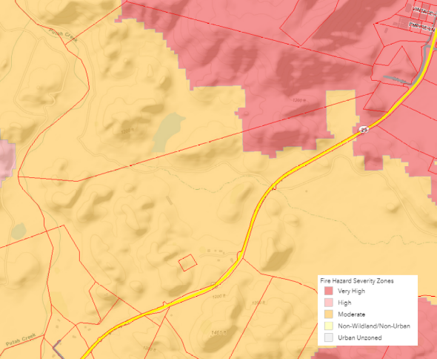  Figure 9. Fire Hazard Severity Zones  The applicant would adhere to all Federal, State, and local fire requirements/regulations for setbacks and defensible space required for any new buildings that require a building permit. All proposed construction is required to be built consistent with current county and State of California Building Code construction standards. To construct the proposed greenhouses and processing building, the applicant would be required to obtain a building permit with Lake County to demonstrate conformance with local and state building codes and fire safety requirements.  Refer to Section XX, Wildfire, for additional details.  Less than Significant Impact | 1, 3, 4, 5, 20, 35, 37
X. HYDROLOGY AND WATER QUALITY
Would the project:
a) Violate any water quality standards or waste discharge requirements or otherwise substantially degrade surface or ground water quality? |  | X |  |  |  | The Ranch is located within the Upper Putah Creek watershed (HUC-1802016203). Putah Creek, a Class I watercourse, bounds the western edge of the property and flows in the northerly direction and then turns east approximately 1.7 miles north of the Ranch. Crazy Creek, a Class II watercourse that is tributary to Putah Creek, flows east towards its confluence with Putah Creek located approximately 3.5 miles east of Bar X Ranch. Several Class III watercourses are located throughout Bar X Ranch, draining to Putah Creek or Crazy Creek (Figure 1). No development is proposed within 150-feet of the Class I watercourse or within 100-feet of any Class II or Class III watercourses. Putah Creek is not listed on the California Clean Water Act Section 303(d) List.  The Property Management Plan submitted with the application materials address runoff, and certain BMPs during and after construction to reduce impacts associated with water quality.  All equipment shall be maintained and operated in a manner that minimizes any spill or leak of pollutants.  Since, the project would disturb more than one acre in preparing the cultivation areas, constructing the parking areas, greenhouses, and processing building, the project would be subject to the requirements State Water Resources Control Board (SWRCB) Construction General Permit (CGP, 2009-009-DWQ). The SWRCB CGP would require the preparation of a Stormwater Pollution Prevention Plan (SWPPP) and Erosion Control Plan which documents the stormwater dynamics at the site, the Best Management Practices (BMPs), and water quality protection measures that are used, and the frequency of inspections. BMPs are activities or measures determined to be practicable, acceptable to the public, and cost effective in preventing water pollution or reducing the amount of pollution generated by non-point sources. Obtainment of a CGP is also a BPTC Measure for compliance with the SWRCB General Order.  In addition, Bar X Ranch is enrolled with the State Water Resources Control Board (SWRCB) for Tier 2, Low Risk coverage under Order No. WQ 2019-001-DWQ (Cannabis Cultivation General Order). The Cannabis Cultivation General Order implements Cannabis Policy requirements with the purpose of ensuring that the diversion of water and discharge of waste associated with cannabis cultivation does not have a negative impact on water quality, aquatic habitat, riparian habitat, wetlands, or springs. The Cannabis Cultivation General Order requires the preparation of a Site Management Plan (SMP), a Nitrogen Management Plan (NMP), and the submittal of annual technical and monitoring reports demonstrating compliance. The purpose of the SMP is to identify Best Practicable Treatment or Control (BPTC) measures that the site intends to follow for erosion control purposes and to prevent stormwater pollution. The purpose of the NMP is to identify how nitrogen is stored, used, and applied to crops in a way that is protective to water quality. The SMP and NMP are required prior to commencing cultivation activities and were submitted with the application materials.  The proposed project has been designed to maintain riparian buffers and grading setbacks of 100 feet. No development would occur within the drainage buffers and setbacks. Additionally, straw wattles would be staked around the cultivation areas to provide an additional buffer between the cultivation area and surface waters.  The proposed project would be served by a portable toilets located at each of the cultivation sites. If a new ADA restroom is required to be installed in the Phase 2 proposed processing building, this restroom would require a new onsite wastewater treatment septic system. If a new septic system is proposed it must adhere to all federal, state, and local regulations regarding wastewater treatment and water usage requirements.  State law requires permits for onsite systems to ensure that they are constructed and sited in a manner that protects human health and the environment. A permit from Lake County is required to install a new septic system. Prior to applying for a permit, Lake County Division of Environmental Health requires a Site Evaluation to determine suitability of the site for a septic system. A percolation test would be conducted to determine the water absorption rate of the soil, and the septic system would be located, designed, and installed appropriately, following all applicable State and County guidelines and requirements.  Impacts would be Less than Significant with Mitigation Measures BIO-3 and GEO-1 through GEO-4 incorporated. | 1, 2, 3, 4, 5, 13, 21, 23, 24, 33, 34, 41, 42
b) Substantially decrease groundwater supplies or interfere substantially with groundwater recharge such that the project may impede sustainable groundwater management of the basin? |  |  | X |  |  | The project site does not have a municipal water supply service, and relies on well water. The proposed project would use water from an existing, onsite well.  The well is located in the proximity of the Collayomi Valley Groundwater Basin and the Coyote Valley Groundwater Basin (Figure 10), both of which are discussed in the Lake County Groundwater Management Plan (GMP) and the Lake County Water Inventory and Analysis (WIA). These basins are similar in size and storage and are the source of water supply for Middletown and adjacent agricultural areas. The total storage in the Collayomi Valley Basin is approximately 29,000 acre-feet with a usable storage capacity of approximately 7,000 acre-feet. The total storage in the Coyote Valley Basin is approximately 29,000 acre-feet with a usable storage capacity of approximately 7,000 acre-feet. The total annual average agricultural demand in these basins is approximately 4,485 acre-feet; of this, the groundwater demand is 937 acre-feet. At the time of the BMP, there were a total of 341 wells in these basins, of which 51 are irrigation wells with the majority ranging in depth between 100 and 250 feet. According to the WIA, the two basins are located in the Upper Putah Inventory Unit. In this unit, the total groundwater supply during a dry year was estimated to be 2,452 acre-feet.  Basin Management Objectives outlined in the GMP for the Collayomi and Coyote Valley Basins primarily focus on preventing long-term declines in groundwater levels, increased monitoring and information gathering and maintaining groundwater quality and land subsidence.  The well to be used for cultivation activities is approximately 215 feet deep and was drilled in 2021. A Groundwater Availability Analysis was prepared for the project by Chico Environmental on April 21, 2021. According to this study, the expected annual water use would be 3,000 gallons per day per acre. During Phase 1, this would equate to approximately 22,356,000 gallons (68.6 acre-feet) for 62.1 acres of outdoor canopy over an approximately 120 day cultivation season. During Phase 2, the canopy area would be approximately 57.0 acres of cultivation (approximately 42.7 acres of outdoor and 14.3 acres of mixed-light cultivation), resulting in approximately 20,520,000 gallons (63.0 acre-feet) at full buildout. The daily demand would be approximately 186,300 gallons during Phase 1 and 171,000 gallons during Phase 2. The total water storage would be approximately 135,000 gallons. The well yield is approximately 800 GPM. The proposed well pump would be a variable speed pump that would pump from 350 to 750 GPM; which would have the capacity to supply 190,000 gallons of water in less than 5 hours; meeting the average daily demand for both phases.  Based on the Groundwater Availability Analysis, the well has sufficient yield to irrigate the 62.1 acres of canopy. Additionally, Groundwater Availability Analysis states that the overlying property possesses a sufficient quantity of groundwater for seasonal irrigation that would not adversely overdraft the local groundwater basins, affect downgradient groundwater users or other well users in the vicinity.  The site demand would be approximately 68.6 acre-feet/year during Phase 1 and 63.0 acre-feet/year at full buildout. This represents about 7% of the average annual agricultural demand in the two basins and less than 1% of the usable capacity of the two basins and 3% of the estimated groundwater supply during a dry year. Additionally, the depth of the well (215-feet) proposed for cannabis use in this project is consistent with other depths of irrigation wells in the basin.  If needed, the project could offset the amount of groundwater used with rainwater catchment. The project proposes 740,000 sq. ft. of greenhouses and a 60,000 sq. ft. processing building, creating 800,000 sq. ft. of surface area to capture rainfall. According to the WIA, the average annual rainfall at the project site is 35 inches. With the new impervious surface area created during Phase 2, the project would have the potential of capturing up to 53.4 acre-feet per year of rainfall, during an average year. The minimum annual rainfall recorded is about one-third the average, which would result in the potential of capturing up to 17.9 acre-feet of rainwater during a dry year.  Therefore, the proposed cannabis development is consistent with local plans and would likely not impede sustainable management of the local groundwater basin.  Less than Significant Impact | 1, 2, 3, 4, 5, 13, 21, 23, 24, 33, 34, 41, 42, 47, 48
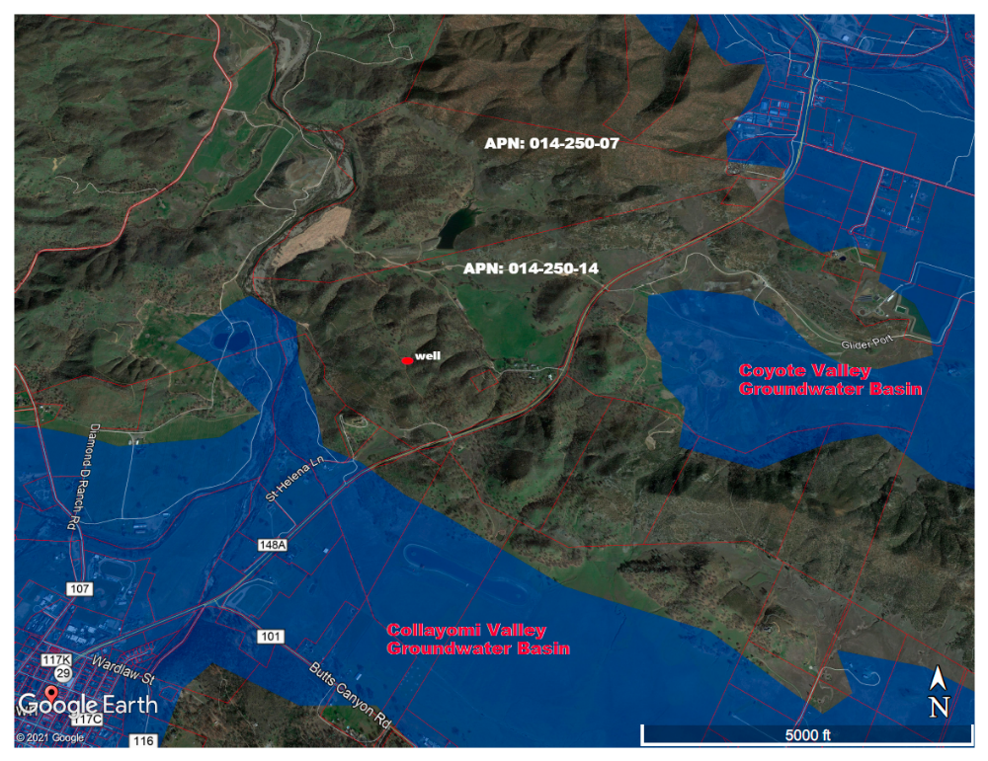
Figure 10. Groundwater Basins (Source: California Department of Water Resources)

c) Substantially alter the existing drainage pattern of the site or area, including through the alteration of the course of a stream or river or through the addition of impervious surfaces, in a manner which would:  - Result in substantial erosion or siltation on- or off-site;  - Substantially increase the rate or amount of surface runoff in a manner which would result in flooding on- or off-site;  - Create or contribute to runoff water which would exceed the capacity of existing or planned stormwater drainage systems or provide substantial additional sources of polluted runoff;  - Impede or redirect flood flows? |  | X |  |  |  | During Phase 1, some vegetation clearing and minor grading (clearing and grubbing) is proposed for the outdoor cultivation activities to create level areas, on contour, for the planter boxes or smart pots, the cultivation employee parking area, and a flat for the water tanks near the Southwest Garden #2. No removal of living trees with a diameter greater than 5-inches measured at breast height (5-inch DBA) is proposed. Cultivation would occur in full sun, with imported soil and amendments, in planter boxes and grow bags placed on top of the existing grade utilizing natural contours in open areas. An existing 16,250 sf barn would be retrofitted and used for storage, drying, and curing of cannabis. No cultivation would occur in this building. Minor grading would be required for the proposed employee parking area at the southern corner of APN 014-250-14. Construction of the employee parking area would not occur until the appropriate grading permit is obtained from Lake County.  During Phase 2, the Pasture Garden would be converted from outdoor cultivation to mixed light cultivation by installing approximately 296, 25’ x 100’ greenhouses and a 60,000 sq. ft. processing building with parking would be constructed at the East Garden. No cultivation would occur at the East Garden.  Since both phases require grading, the applicant has submitted, to Lake County, an application for a Grading Permit. The application includes a Grading Plan that demonstrate the areas of vegetation removal and grading, including earthwork quantities. No grading or building would occur until the appropriate grading and building permits have been obtained from the County.  The proposed cannabis sites were selected to occur within active agricultural areas and to avoid all wetlands and channels, setbacks from watercourses and other natural resources, sensitive terrestrial habitats (serpentine soils, riparian, chaparral habits), sensitive plant areas, steep slopes, and dense oak stands. The proposed cannabis cultivation would be setback a minimum 150 ft. from Class I watercourses and a minimum of 100 ft. from wetlands and from the top of bank all Class II, and Class III watercourses.  No development would occur within the drainage buffers and setbacks. The proposed project has been designed to maintain existing flow paths.  (i) Construction activities and operation of the proposed project would not result in substantial erosion or siltation, with compliance with the erosion control plan, SWRCB Construction General Order, and SWRCB Cannabis General Order. Less than significant impact with Mitigation Measures BIO-3 and GEO-1 through GEO-4 incorporated.  (ii)&(iii) At full buildout, the proposed cannabis operation would utilize approximately 80 acres (5%) of the 1594.6 acre Ranch. During Phase 1, no new impervious area is proposed. Under Phase 2, approximately 800,000 sq. ft. (18.4 acres) of new impervious area is proposed for greenhouses and the processing building within the headwaters of the Crazy Creek watershed. Crazy Creek flows towards the southeast and under State Route 29. According to USGS StreamStats, the Crazy Creek watershed contributing area draining to the culvert under State Route 29 is approximately 1.4 square miles. The new impervious surface represents only 2% of this total area, thus, the project would not significantly increase the rate or amount of surface runoff or create or contribute to runoff water which would exceed the capacity of an existing drainage system.  (iv) The majority of proposed outdoor cultivation area is within a FEMA Zone D, areas of possible but undetermined flood hazards, or not within a FEMA flood zone. A portion of the Riverside Garden (Figure 3) is located in FEMA Zone A, Areas subject to inundation by the 1-percent-annual-chance flood event. However, this is outdoor cultivation that would generally occur April through November, outside of the normal wet season and would not impede flood flows. In addition, no new structures are proposed in the FEMA floodplain under Phase 1 or Phase 2.  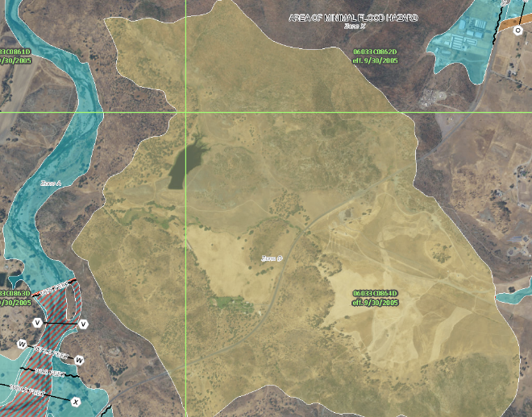  Figure 11. FEMA Flood Zones  Less than significant impact with Mitigation Measures BIO-3 and GEO-1 through GEO-4 incorporated. | 1, 3, 4, 5, 13, 21, 23, 24, 25, 29, 31, 32, 33, 34
d) In flood hazard, tsunami, or seiche zones, risk release of pollutants due to project inundation? |  |  | X |  |  | A portion of the Riverside Garden is located in the floodplain created by Putah Creek.  Bar X Ranch is enrolled with the State Water Resources Control Board (SWRCB) for Tier 2, Low Risk coverage under Order No. WQ 2019-001-DWQ (Cannabis Cultivation General Order). The Cannabis Cultivation General Order implements Cannabis Policy requirements with the purpose of ensuring that the diversion of water and discharge of waste associated with cannabis cultivation does not have a negative impact on water quality, aquatic habitat, riparian habitat, wetlands, or springs. The Cannabis Cultivation General Order requires the preparation of a Site Management Plan (SMP), a Nitrogen Management Plan (NMP), and the submittal of annual technical and monitoring reports demonstrating compliance. The purpose of the SMP is to identify Best Practicable Treatment or Control (BPTC) measures that the site intends to follow for erosion control purposes and to prevent stormwater pollution. The purpose of the NMP is to identify how nitrogen is stored, used, and applied to crops in a way that is protective to water quality. The SMP and NMP are required prior to commencing cultivation activities and were submitted with the application materials.  In addition, the outdoor cultivation would generally occur April through November, outside of the normal wet season. The Cannabis Cultivation General Order requires winterization measures to protect water quality outside of the cultivation season.  The proposed project is not located in a tsunami or seiche zone.  Less than Significant Impact | 1
e) Conflict with or obstruct implementation of a water quality control plan or sustainable groundwater management plan? |  |  | X |  |  | The proposed project area and vicinity is not subject to a water quality control plan, thus the proposed project would not conflict with or obstruct the implementation of water quality control plan as all hazardous materials including pesticides and fertilizers would be stored in a locked / secured building or shed, and would meet all Federal, State and Local agency requirements for hazardous material storage and handling.  The well is located in the proximity of the Collayomi Valley Groundwater Basin and the Coyote Valley Groundwater Basin (Figure 10), According to the California Department of Water Resources, these basins are Very Low priority groundwater basins and do not require sustainable groundwater management plans. Therefore, the proposed project would not conflict with or obstruct the implementation of a sustainable groundwater management plan.  Less than Significant Impact | 1, 3, 4, 5, 10, 13, 21, 23, 24, 25, 29, 31, 32, 33, 34, 41, 42, 47, 48, 49
XI. LAND USE AND PLANNING
Would the project:
a) Physically divide an established community? |  |  |  | X |  | The proposed project site would not physically divide an established community.  No Impact | 1, 3, 4, 5, 6
b) Cause a significant environmental impact due to a conflict with any land use plan, policy, or regulation adopted for the purpose of avoiding or mitigating an environmental effect? |  |  | X |  |  | This project is consistent with the Lake County General Plan, the Middletown Area Plan, and the Lake County Zoning Ordinance.  Less than Significant Impact | 1, 3, 4, 5, 20, 21, 22, 27
XII. MINERAL RESOURCES
Would the project:
a) Result in the loss of availability of a known mineral resource that would be of value to the region and the residents of the state? |  |  |  | X |  | The Aggregate Resource Management Plan (ARMP) does not identify this project as having an important source of aggregate. Additionally, according to the California Department of Conservation, Mineral Land Classification, there are no known mineral resources on the project site.  No Impact | 1, 3, 4, 5, 26
b) Result in the loss of availability of a locally important mineral resource recovery site delineated on a local general plan, specific plan, or other land use plan? |  |  |  | X |  | The County of Lake’s General Plan, the Middletown Area Plan nor the Lake County Aggregate Resource Management Plan designates the project site as being a locally important mineral resource recovery site.  No Impact | 1, 3, 4, 5, 26
XIII. NOISE
Would the project result in:
a) Generation of a substantial temporary or permanent increase in ambient noise levels in the vicinity of the project in excess of standards established in the local general plan or noise ordinance, or applicable standards of other agencies? |  | X |  |  |  | County noise standards require noise levels at the property line adjacent to residential and agricultural uses not to exceed 55dBA between the hours of 7:00 a.m. and 10:00 p.m. and 45 dBA between the hours of 10:00 p.m. and 7:00 a.m. Where adjacent uses are industrial (northeast) noise levels must not exceed 65dBA during daytime hours and 60dBA during nighttime hours. “dBA” is an overall frequency-weighted sound level in decibels that approximates the frequency response of the human ear.  Noise related to outdoor cannabis cultivation typically occurs either during construction, or as the result of machinery related to post construction equipment such as generator to operate the well pump, greenhouse fans, and small motors used to open and close the greenhouse blackout covers.  During both Phase 1 and Phase 2, water from the irrigation well would be pumped to storage tanks using a 75 Horse Power (HP) pump. The tanks are located at a high point on the property so that water from the tanks would gravity feed through an above ground pipe system (aka, irrigation lines) to each cultivation area. The pump would be powered by a 120kW diesel generator.  Article 27, Section (at)1.iii lists prohibited activities associated with commercial cannabis cultivation and does not prohibit the use of generators for irrigation or outdoor cultivation, specifically, the section states, for electrical generators, that, “The indoor or mixed-light cultivation of cannabis shall not rely on a personal gasoline, diesel, propane, or similar fuels, powered generator as a primary source of power and shall only allow properly permitted (when applicable) generators for temporary use in the event of a power outage or emergency that is beyond the permittee’s control”.  The generator use proposed here is solely to operate the 75 HP well pump and for backup power to the commercial processing building in case of power outages. These generators would be housed within sound dampening enclosure to reduce noise levels at or below the County noise standards at property lines.  The cultivation of cannabis, outdoor and mixed-light, would not rely on the use of a generator.  Short-term noise levels would be increased during the construction of the proposed project. Phase 1 construction is expected to begin in spring 2022 and take 4 to 8 weeks. Phase 2 construction is expected to begin in spring 2023 and take approximately 3 to 6 months. Construction-related noise may involve the use of heavy equipment, employee and delivery traffic, and human voices. Compliance with NOI-1 and NOI-2 would ensure that the proposed project activities would not exceed County noise standards. Less Than Significant with Mitigation Incorporated.  Operation of the proposed project would result in some increases in ambient noise levels in the project vicinity due to the greenhouse fans and motors, the water pump generator, and light vehicle traffic. The greenhouse fans would be selected based on the ability to meet the County noise standards at property lines. The motors would be used to open and close the greenhouse blackout covers. These are small motors, 0.25 horsepower, that emit low noise, approximately 10 dBA.  Compliance with NOI-1 and NOI-2 would ensure that the proposed project activities would not exceed County noise standards. Less Than Significant with Mitigation Incorporated.  Impacts would be Less than Significant with Mitigation Measures NOI-1 and NOI-2 Incorporated.  - NOI-1: All construction activities including engine warm-up shall be limited Monday Through Friday, between the hours of 7:00am and 7:00pm, and Saturdays from 12:00 noon to 5:00 pm to minimize noise impacts on nearby residents. Back-up beepers shall be adjusted to the lowest allowable levels. This mitigation does not apply to night work.  NOI-2: The proposed project shall comply with the noise standards identified in Section 41.11 of the Zoning Ordinance, including, but not limited to: maximum non-construction project-related noise levels shall not exceed: (a) 55 dBA between the hours of 7:00 a.m. to 10:00 p.m. and 45 dBA between the hours of 10:00 p.m. to 7:00 a.m. adjacent to residential districts; and (b) 65 dBA between the hours of 7:00 a.m. to 10:00 p.m. and 50 dBA between the hours of 10:00 p.m. to 7:00 a.m. adjacent to industrial districts at the property lines as outlined in Table 11.1. Should the proposed project exceed these noise standards during construction or operational phases, noise-generating activities shall cease until noise attenuation measures are implemented such that the proposed project is compliant with noise standards. | 1, 3, 4, 5, 13
b) Generation of excessive groundborne vibration or groundborne noise levels? |  |  | X |  |  | The project is not expected to create significant groundborne vibration due to construction or to post-construction facility operation. During Phase 1, some vegetation clearing and minor grading (clearing and grubbing) is proposed for the outdoor cultivation activities to create level areas, on contour, for the planter boxes or smart pots, the cultivation employee parking area, and a flat for the water tanks near the Southwest Garden #2. During Phase 2 grading would be required to create the greenhouse and processing building pads. However, earth movement is not expected to generate groundborne vibration or noise levels. The low-level truck traffic during construction and for deliveries would create a minimal amount of groundborne vibration.  Less Than Significant Impact | 1, 3, 4, 5, 13
XIV. POPULATION AND HOUSING
Would the project:
a) Induce substantial unplanned population growth in an area, either directly (for example, by proposing new homes and businesses) or indirectly (for example, through extension of roads or other infrastructure)? |  |  |  | X |  | The project does not involve the construction of new homes or businesses, or the extension of roads or other infrastructure that would induce a permanent growth in population.  No Impact | 1, 3, 4, 5
b) Displace substantial numbers of existing people or housing, necessitating the construction of replacement housing elsewhere? |  |  |  | X |  | No housing would be displaced as a result of the project.  No Impact | 1, 3, 4, 5
XV. PUBLIC SERVICES
Would the project:
a) Would the project result in substantial adverse physical impacts associated with the provision of new or physically altered governmental facilities, need for new or physically altered governmental facilities, the construction of which could cause significant environmental impacts, in order to maintain acceptable service ratios, response times or other performance objectives for any of the public services:  - Fire Protection?  - Police Protection?  - Schools?  - Parks?  - Other Public Facilities? |  |  | X |  |  | The project does not propose housing or other uses that would necessitate the need for new or altered government facilities. No new roads are proposed.  The project would be required to comply with all applicable local and state fire code requirements related to design and emergency access.  Construction and operation of the proposed project may result in accidents or crime emergency incidents that would require police services. Construction activities would be temporary and limited in scope. Accidents or crime emergency incidents during operation are expected to be infrequent and minor in nature. The Lake County Sheriff’s Department and other law enforcement agencies were notified of the proposed project.  There would not be a need to increase fire or police protection, schools, parks or other public facilities as a result of the project’s implementation.  Less than Significant Impact | 1, 2, 3, 4, 5, 20, 21, 22, 23, 27, 28, 29, 32, 33, 34, 36, 37
XVI. RECREATION
Would the project:
a) Increase the use of existing neighborhood and regional parks or other recreational facilities such that substantial physical deterioration of the facility would occur or be accelerated? |  |  |  | X |  | The project would generate business income, an increase in local employment opportunities, and increase public fee and tax revenue which may result in slight increases in population growth, which could lead to increased use of park and recreation facilities. However, the increased use of park and recreation, would occur over a large area and in multiple sites and therefore be diminished and would not substantially deteriorate existing parks or other recreational facilities. The project would not have any impacts on existing parks or other recreational facilities.  No Impact | 1, 2, 3, 4, 5
b) Does the project include recreational facilities or require the construction or expansion of recreational facilities which might have an adverse physical effect on the environment? |  |  |  | X |  | This project would not necessitate the construction or expansion of any recreational facilities.  No Impact | 1, 3, 4, 5
XVII. TRANSPORTATION
Would the project:
a) Conflict with a plan, ordinance or policy addressing the circulation system, including transit, roadways, bicycle lanes and pedestrian paths? |  |  | X |  |  | The Ranch is accessed off of State Highway 29 via three (3) existing driveways (north, center, and south [Figure 2]). The cultivation areas would mainly be accessed by the southern entrance and existing, internal ranch roads. The center driveway is used to access the residential area. During Phase 2, access to the processing building would use the center driveway.  There are no bicycle or pedestrian facilities on State Route 29 in the vicinity of the project.  The proposed project does not conflict with an ordinance or policy addressing the circulation along State Route 29.  Less than Significant Impact | 1, 3, 4, 5, 9, 20, 22, 27, 28, 35
b) For a land use project, would the project conflict with or be inconsistent with CEQA guidelines section 15064.3, subdivision (b)(1)? |  |  | X |  |  | State CEQA Guidelines Section 15064.3, Subdivision (b) states that for land use projects, transportation impacts are to be measured by evaluating the proposed project’s vehicle miles traveled (VMT). VMT refers to the amount and distance of automobile travel attributable to a project.  To date, the County has not yet formally adopted its transportation significance thresholds or its transportation impact analysis procedures for determining VMT or evaluating VMT impacts.  During construction, the project is expected to generate approximately 31 trips per day. Construction trips are temporary in nature and would occur only during construction, which is approximately 4 to 8 weeks during Phase 1 and approximately 3 to 6 months during Phase 2.  During operation, after full buildout, the proposed project would generate approximately 262 trips per day for the cultivation operations (20 trips for fulltime employees, 240 trips for seasonal employees, and 2 trips for delivery vehicles) and 172 trips per day for the processing operations (20 trips for fulltime employees, 150 trips for seasonal employees, and 2 trips for delivery vehicles).  Guidance regarding project-related VMT impacts is provided by the California Governor’s Office of Planning and Research (OPR) in the publication Transportation Impacts (SB 743) CEQA Guidelines Update and Technical Advisory, 2018. The OPR Technical Advisory identifies several criteria that may be used to identify certain types of projects that are unlikely to have a significant VMT impact and can be “screened” from further analysis. One of these screening criteria pertains to small projects, which OPR defines as generating fewer than 110 new vehicle trips per day on average. OPR specifies that VMT should be based on a typical weekday and averaged over the course of the year to take into consideration seasonal fluctuations.  The proposed cultivation operations are seasonal in nature. Cultivation would generally occur approximately from April through October, with seasonal peak activity occurring during planting and harvesting. Seasonal cultivation employee trips (approximately 240 trips per day) would occur approximately two (2) months of the year. Fulltime cultivation employee trips (approximately 20 trips per day) would travel to and from the site approximately seven (7) months of the year. On average, this would equate to approximately 53 average trips per day per year for cultivation operations, including two daily delivery trips for seven (7) months.  Processing is also seasonal in nature, and would occur after harvest, approximately October through March, with peak activity occurring for two to three months after harvest. Seasonal processing employee trips (approximately 150 trips per day) would occur approximately three (3) months of the year. Fulltime processing employee trips (approximately 20 trips per day) would occur approximately six (6) months of the year. On average, this would equate to approximately 49 average trips per day per year for processing operations, including two daily delivery trips for six (6) months.  The total vehicle trips per day on average for the proposed project would be approximately 102 average trips per day per year. In addition, there would be a reduction in daily trips associated with the Ranch due to the reduced ranch activities to accommodate the cultivation areas.  The Average Daily Traffic (ADT) on State Highway 29 in this area is approximately 13,000, the proposed project trips represent less than 0.1% of the ADT on State Highway 29.  Therefore, the proposed project would not generate or attract more than 110 trips per day on average; therefore, it is not expected for the project to have a potentially significant level of VMT, therefore, impacts related to CEQA Guidelines section 15064.3. subdivision (b) would be less than significant.  Less than Significant Impact. | 1, 3, 4, 5, 9, 20, 22, 27, 28, 35, 45
c) For a transportation project, would the project conflict with or be inconsistent with CEQA Guidelines section 15064.3, subdivision (b)(2)? |  |  |  | X |  | The project is not a transportation project. The proposed use would not conflict with and/or be inconsistent with CEQA Guidelines Section 15064.3, subdivision (b)(2).  No Impact. | 1, 3, 4, 5, 9, 20, 22, 27, 28, 35, 46
d) Substantially increase hazards due to a geometric design feature (e.g., sharp curves or dangerous intersections) or incompatible uses (e.g., farm equipment)? |  |  | X |  |  | The proposed project would be accessed off of State Highway 29 via three (3) existing driveways (north, center, and south [Figure 2]). The center driveway is currently used to access the residential area and would not be used for access by traffic associated with the outdoor or mixed-light cultivation operations. During Phase 2, once the commercial processing building is constructed, access to the building would be via the center driveway.  The main access for the cultivation operations would be the south driveway, which is closest to the cultivation employee parking area. The north driveway would be used as a secondary access for employees and deliveries.  The site distance along State Highway 29, from each driveway, is approximately 500 feet or more (estimated using Google Earth Street View). There are no sharp curves along this stretch of Highway 29. The posted speed limit is 55 miles per hour. The shoulders on this section of State Highway 29 are approximately 10-feet wide. According to the California Department of Transportation Highway Design Manual, Chapter 200, the minimum Sight Distance Standard for stopping, at a design speed of 55 MPH, is 500 feet. Thus, there are no design features that would cause a substantial increase in hazards.  The existing entrances are used to operate the existing Ranch activities. The proposed project would not add additional or incompatible farm equipment entering and existing the ranch. The proposed project is agricultural in nature. Therefore, the proposed project would not increase hazards due to incompatible uses.  Less than Significant Impact | 1, 3, 4, 5, 9, 20, 22, 27, 28, 35
e) Result in inadequate emergency access? |  |  | X |  |  | The proposed project would not alter the physical configuration of the existing roadway network serving the area, and would have no effect on access to local streets or adjacent uses (including access for emergency vehicles). Conditions of Approval would require that internal roadways would meet CALFIRE requirements for vehicle access. Furthermore, as noted above under impact discussion (a), increased project-related operational traffic would be minimal. The proposed project would not inhibit the ability of local roadways to continue to accommodate emergency response and evacuation activities. The proposed project would not interfere with the City’s adopted emergency response plan.  Less than Significant Impact | 1, 3, 4, 5, 9, 20, 22, 27, 28, 35
- TRIBAL CULTURAL RESOURCES
Would the project cause a substantial adverse change in the significance of a tribal cultural resource, defined in Public Resources Code section 21074 as either a site, feature, place, cultural landscape that is geographically defined in terms of the size and scope of the landscape, sacred place, or object with cultural value to a California Native American tribe, and that is:
a) Listed or eligible for listing in the California Register of Historical Resources, or in a local register of historical resources as defined in Public Resources Code section 5020.1(k), or |  |  | X |  | A Cultural Resources Assessment was conducted by Natural Investigations Company dated September 2020. A California Historical Resources Information System (CHRIS) records search was completed by the Northwest Information Center (NWIC) on September 9, 2019. The results of the California Historical Resources Information System (CHRIS) records search were received from the Northwest Information Center (NWIC) on September 16, 2020. The Native American Heritage Commission (NAHC) returned the results of the SLF search on August 19, 2020. Finally, Natural Investigations conducted an intensive pedestrian survey of the project area on August 27 and 28, 2020.  The project area is not eligible for listing in the California Register of Historical Resources, or in a local register of historical resources as defined in Public Resources Code section 5020.1(k).  Less than Significant Impact |  | 1, 3, 4, 5, 11, 14, 15
b) A resource determined by the lead agency, in its discretion and supported by substantial evidence, to be significant pursuant to criteria set forth in subdivision (c) of Public Resources Code section 5024.1. In applying the criteria set forth in subdivision (c) of Public Resources Code 5024.1, the lead agency shall consider the significance of the resource to a California Native American tribe. |  | X |  |  | A Cultural Resources Assessment was conducted by Natural Investigations Company dated September 2020. A California Historical Resources Information System (CHRIS) records search was completed by the Northwest Information Center (NWIC) on September 9, 2019. The results of the California Historical Resources Information System (CHRIS) records search were received from the Northwest Information Center (NWIC) on September 16, 2020. The Native American Heritage Commission (NAHC) returned the results of the SLF search on August 19, 2020. Finally, Natural Investigations conducted an intensive pedestrian survey of the project area on August 27 and 28, 2020.  The CHRIS records search indicates that six prior cultural resource studies have been completed which included all or portions of the project area, and 23 additional studies have been completed outside the project area but within the 0.25-mile record search radius. The CHRIS records search also indicated that one cultural resource has been previously recorded within the project area, and 23 additional resources have been recorded within the 0.25-mile search radius. The SLF search returned negative results for Native American resources in the vicinity of the Project. One isolated prehistoric artifact was identified within the project area during the field survey.  One isolated lithic flake was identified during the field survey. Isolated artifacts are by definition found outside of an interpretable archaeological context which is constituted of groups of contemporary and associated artifacts, ecofacts, features, and/or sites. Without this context, isolates typically lack the potential to yield information important in prehistory, the California Register of Historical Resources (CRHR) criterion (Criterion 4) under which archaeological resources are most often found to be significant. As such, the isolate identified during this assessment is not eligible for listing on the CRHR and no further consideration is needed.  Additionally, one partially destroyed historical foundation feature is located on the southeastern edge of the project area. This resource does not appear to meet CRHR eligibility criteria given the extent of past impacts sustained and the thoroughness of existing documentation which appears to have exhausted its informational potential. Nevertheless, given its location no further disturbance of the resource is expected to result from cultivation related activities. For these reasons, no additional cultural resources work is recommended at this time.  It is possible, but unlikely, that significant artifacts or human remains could be discovered during project construction. If, however, significant artifacts or human remains of any type are encountered it is recommended that the project sponsor contact the culturally affiliated tribe and a qualified archaeologist to assess the situation. The Sheriff’s Department must also be contacted if any human remains are encountered.  In addition, notification of the project was sent to the local tribes on December 18, 2020. The Middletown Rancheria Tribal Historic Preservation Department (Middletown Rancheria THPD) responded with an email dated January 4, 2021, and determined that, the Ranch is within the aboriginal territories of the Middletown Rancheria. The Middletown Rancheria THPD requested additional information regarding the project as well as a consultation regarding the project. In an email dated April 21, 2021, to Mr. Eric Porter from the County Community Development Department, the Middletown Rancheria THPD informed the County that Middletown Rancheria THPD and Bar X Farms, LLC were in the process of finalizing a Cultural Resources Monitoring (CRM) agreement for the proposed project.  Impacts would be Less than Significant with Mitigation Measures CUL-1 and CUL-2 Incorporated. |  | 1, 3, 4, 5, 11, 14, 15
- UTILITIES AND SERVICE SYSTEMS
Would the project:
a) Require or result in the relocation or construction of new or expanded water, wastewater treatment or storm water drainage, electric power, natural gas, or telecommunications facilities, the construction or relocation of which could cause significant environmental effects? |  |  | X |  |  | The proposed project would be served by an existing onsite irrigation well. The proposed project would be served by portable toilets located at each of the cultivation sites and, if required, a new ADA restroom in the proposed processing building, this restroom would require a new onsite wastewater treatment septic system.  At full buildout, the proposed cannabis operation would utilize approximately 80 acres (5%) of the 1594.6 acre Ranch. During Phase 1, no new impervious area is proposed. Under Phase 2, approximately 800,000 sq. ft. (18.4 acres) of new impervious area is proposed for greenhouses and the processing building within the headwaters of the Crazy Creek watershed. Crazy Creek flows towards the southeast and under State Route 29. According to USGS StreamStats, the Crazy Creek watershed contributing area draining to the culvert under State Route 29 is approximately 1.4 square miles. The new impervious surface represents 2% of this total area, thus, the project would not significantly increase the rate or amount of surface runoff or create or contribute to runoff water which would exceed the capacity of an existing drainage system.  Power for the cultivation operations under both Phase 1 and Phase 2 would be powered using small, localized solar power with backup battery storage. The processing building would be powered using “on grid” power provided by PG&E. An existing PG&E power service exists at the residential area near the proposed processing building.  Therefore, the proposed project would not result in the relocation or construction of new or expanded water, wastewater treatment or storm water drainage, electric power, natural gas, or telecommunications facilities,  Less than Significant Impact | 1, 3, 4, 5, 29, 32, 33, 34, 37
b) Have sufficient water supplies available to serve the project and reasonably foreseeable future development during normal, dry and multiple dry years? |  |  | X |  |  | The well is located in the proximity of the Collayomi Valley Groundwater Basin and the Coyote Valley Groundwater Basin (Figure 10), both of which are discussed in the Lake County Groundwater Management Plan (GMP) and the Lake County Water Inventory and Analysis (WIA). These basins are similar in size and storage and are the source of water supply for Middletown and adjacent agricultural areas. The total storage in the Collayomi Valley Basin is approximately 29,000 acre-feet with a usable storage capacity of approximately 7,000 acre-feet. The total storage in the Coyote Valley Basin is approximately 29,000 acre-feet with a usable storage capacity of approximately 7,000 acre-feet. The total annual average agricultural demand in these basins is approximately 4,485 acre-feet; of this, the groundwater demand is 937 acre-feet. At the time of the BMP, there were a total of 341 wells in these basins, of which 51 are irrigation wells with the majority ranging in depth between 100 and 250 feet. According to the WIA, the two basins are located in the Upper Putah Inventory Unit. In this unit, the total groundwater supply during a dry year was estimated to be 2,452 acre-feet.  Basin Management Objectives outlined in the GMP for the Collayomi and Coyote Valley Basins primarily focus on preventing long-term declines in groundwater levels, increased monitoring and information gathering and maintaining groundwater quality and land subsidence.  The well to be used for cultivation activities is approximately 215 feet deep and was drilled in 2021. A Groundwater Availability Analysis was prepared for the project by Chico Environmental on April 21, 2021. According to this study, the expected annual water use would be 3,000 gallons per day per acre. During Phase 1, this would equate to approximately 22,356,000 gallons (68.6 acre-feet) for 62.1 acres of outdoor canopy over an approximately 120 day cultivation season. During Phase 2, the canopy area would be approximately 57.0 acres of cultivation (approximately 42.7 acres of outdoor and 14.3 acres of mixed-light cultivation), resulting in approximately 20,520,000 gallons (63.0 acre-feet) at full buildout. The daily demand would be approximately 186,300 gallons during Phase 1 and 171,000 gallons during Phase 2. The total water storage would be approximately 135,000 gallons. The well yield is approximately 800 GPM. The proposed well pump would be a variable speed pump that would pump from 350 to 750 GPM; which would have the capacity to supply 190,000 gallons of water in less than 5 hours; meeting the average daily demand for both phases.  Based on the Groundwater Availability Analysis, the well has sufficient yield to irrigate the 62.1 acres of canopy. Additionally, Groundwater Availability Analysis states that the overlying property possesses a sufficient quantity of groundwater for seasonal irrigation that would not adversely overdraft the local groundwater basins, affect downgradient groundwater users or other well users in the vicinity.  The site demand would be approximately 68.6 acre-feet/year during Phase 1 and 63.0 acre-feet/year at full buildout. This represents about 7% of the average annual agricultural demand in the two basins and less than 1% of the usable capacity of the two basins and 3% of the estimated groundwater supply during a dry year. Additionally, the depth of the well (215-feet) proposed for cannabis use in this project is consistent with other depths of irrigation wells in the basin.  If needed, the project could offset the amount of groundwater used with rainwater catchment. The project proposes 740,000 sq. ft. of greenhouses and a 60,000 sq. ft. processing building, creating 800,000 sq. ft. of surface area to capture rainfall. According to the WIA, the average annual rainfall at the project site is 35 inches. With the new impervious surface area created during Phase 2, the project would have the potential of capturing up to 53.4 acre-feet per year of rainfall, during an average year. The minimum annual rainfall recorded is about one-third the average, which would result in the potential of capturing up to 17.9 acre-feet of rainwater during a dry year.  The applicant is prohibited from trucking in water other than a one-time emergency delivery and only with written permission from the Community Development Department Director or designee.  Less Than Significant Impact | 1, 3, 4, 5, 29, 32, 33, 34, 36, 37
c) Result in a determination by the wastewater treatment provider, which serves or may serve the project that it has adequate capacity to serve the project’s projected demand in addition to the provider’s existing commitments? |  |  | X |  |  | The proposed project would be served by portable toilets located at each of the cultivation sites and, if required, a new ADA restroom in the proposed processing building, this restroom would require a new onsite wastewater treatment septic system. The portable toilets would be serviced regularly by a local, licensed service provider.  Less Than Significant Impact | 2, 5
d) Generate solid waste in excess of State or local standards or in excess of the capacity of local infrastructure? |  |  | X |  |  | According to the Property Management Plan, the volume of solid waste per year per acre of cultivation would generate approximately 5,000 to 10,000 pounds (17 to 34 cubic yards) of solid waste and about 60,000 to 120,000 pounds of organic waste. The majority of organic waste would be composted or mulched on site. All recyclable waste would be collected separately from non-recyclable waste. All waste and recycling would be hauled to the Lake County Transfer and Recycling Facility where it would be sorted and deposited at the Eastlake Sanitary Landfill (Landfill). The Landfill is well below its current capacity of 6,050,000 cubic yards, with 2,859,962 cubic yards (47%) remaining capacity. In addition, the Lake County Public Services Department is proposing an expansion of the Landfill to extend the landfill’s life to about the year 2046; increasing the landfill footprint from 35 acres to 56.6 acres. Therefore, the Landfill would have sufficient capacity accommodate the solid waste generated by the project.  Less than Significant Impact | 1, 2, 3, 34, 36
e) Negatively impact the provision of solid waste services or impair the attainment of solid waste reduction goals? |  |  | X |  |  | The applicant would compost or chip / mulch, and spread the cannabis waste onsite, and the estimated total amount of solid waste from this project would be approximately 60,000 to 120,000 pounds annually.  Less than Significant Impact | 1, 3, 4, 5, 29, 32, 33, 34, 36
f) Comply with federal, state, and local management and reduction statutes and regulations related to solid waste? |  |  | X |  |  | The County uses a standard condition of approval regarding compliance with all Federal, State and Local management for solid waste. The cultivator would be required to chip and spread any vegetative waste on-site, and the estimated total amount of solid waste from this project is 60,000 to 120,000 pounds annually.  Less than Significant Impact | 1, 3, 4, 5, 29, 32, 33, 34, 36
- WILDFIRE
If located in or near state responsibility areas or lands classified as very high fire hazard severity zones, would the project:
a) Impair an adopted emergency response plan or emergency evacuation plan? |  | X |  |  |  | The mapped fire risk on the site is moderate high. The project site is located in the CALFIRE State Responsibility Area (SRA) and is subject to all state fire safe related codes.  Access to the sites are taken from on-site driveways accessed from State Route 29. On-site driveways would be required to meet PRC 4290 and 4291 CALFIRE Standards through the Conditions of Approval. The project proposes approximately twenty-seven (27) 5,000 gallon water storage tanks.  Should this site need to evacuate, State Route 29 would be the evacuation route.  Like much of Lake County, this area is prone to wildfire. This site is no more prone to excessive fire risk than other sites in Lake County. The applicant would adhere to all regulations of California Code Regulations Title 14, Division 1.5, Chapter 7, Subchapter 2, and Article 1 through 5 shall apply to this project; and all regulations of California Building Code, Chapter 7A, Section 701A, 701A.3.2.A  Approval of this permit would not further exacerbate the risk of wildfire, nor would it interfere with emergency evacuation should this be necessary.  Less than Significant Impact with GEO-5 and GEO-6 incorporated. | 1, 2, 4, 5, 6, 20, 23, 31, 35, 37, 38
b) Due to slope, prevailing winds, and other factors, exacerbate wildfire risks, and thereby expose project occupants to pollutant concentrations from a wildfire or the uncontrolled spread of a wildfire? |  |  | X |  |  | The project proposes to clear some vegetation, as required, to create defensible space and to construct the proposed greenhouses and processing building during Phase 2, which would reduce fuel for fire. The site driveway allows for fire access. Approval of this project would not increase the fire risk in this area. The Ranch has moderate and very high fire risk areas. The proposed project areas are located within the moderate fire risk areas. In addition, the cultivation areas would help to act as a fire break should one be needed.  Less than Significant Impact | 1, 2, 4, 5, 6, 20, 23, 31, 35, 37, 38
c) Require the installation or maintenance of associated infrastructure (such as roads, fuel breaks, emergency water sources, power lines or other utilities) that may exacerbate fire risk or that may result in temporary or ongoing impacts to the environment? |  |  | X |  |  | The site is served by State Route 29, a State maintained highway. Access to the cultivation areas would be via existing ranch roads ranging between 14-feet and 20-feet with gravel and native material, and turnouts no more than 400-feet apart. No other infrastructural improvements appear to be necessary for this project.  On-site driveways would be required to meet PRC 4290 and 4291 CALFIRE Standards through the Conditions of Approval.  Less than Significant Impact | 1, 2, 4, 5, 6, 20, 23, 31, 35, 37, 38
d) Expose people or structures to significant risks, including downslope or downstream flooding or landslides, as a result of runoff, post-fire slope instability, or drainage changes? |  |  | X |  |  | The site is generally flat near the cultivation areas; there is little chance of risks associated with post-fire slope runoff, instability or drainage changes based on the lack of site changes that would occur by this project.  Less than Significant Impact | 1, 2, 4, 5, 6, 20, 23, 31, 35, 37, 38
- MANDATORY FINDINGS OF SIGNIFICANCE
a) Does the project have the potential to substantially degrade the quality of the environment, substantially reduce the habitat of a fish or wildlife species, cause a fish or wildlife population to drop below self-sustaining levels, threaten to eliminate a plant or animal community, substantially reduce the number or restrict the range of a rare or endangered plant or animal or eliminate important examples of the major periods of California history or prehistory? |  | X |  |  |  | Per the impact discussions above, the potential of the proposed project to substantially degrade the environment is less than significant with incorporated mitigation measures. As described in this Initial Study, the proposed project has the potential for impacts related to Aesthetics, Air Quality, Biological Resources, Cultural Resources, Geology and Soils, Hazards & Hazardous Materials, Hydrology and Water Quality, Noise, Tribal Cultural Resources, and Wildfire. However, these impacts would be avoided or reduced to a less-than-significant level with the incorporation of avoidance and mitigation measures discussed in each impact section.  Impacts would be Less than Significant with Mitigation Incorporated. | All
b) Does the project have impacts that are individually limited, but cumulatively considerable? (“Cumulatively considerable” means that the incremental effects of a project are considerable when viewed in connection with the effects of past projects, the effects of other current projects, and the effects of probable future projects)? |  | X |  |  |  | Potentially significant impacts have been identified related to Aesthetics, Air Quality, Biological Resources, Cultural Resources, Geology and Soils, Hazards & Hazardous Materials, Hydrology and Water Quality, Noise, Tribal Cultural Resources, and Wildfire. These impacts in combination with the impacts of other past, present and reasonably foreseeable future projects could cumulatively contribute to significant effects on the environment. However, implementation of and compliance with mitigation measures identified in each section as project conditions of approval would avoid or reduce potential impacts to less than significant levels and would not result in cumulatively considerable environmental impacts.  Impacts would be Less than Significant with Mitigation Measures Incorporated. | All
c) Does the project have environmental effects which will cause substantial adverse effects on human beings, either directly or indirectly? |  | X |  |  |  | The proposed project has potential to result in adverse indirect or direct effects on human beings in the areas of Aesthetics, Air Quality, Biological Resources, Cultural Resources, Geology and Soils, Hazards & Hazardous Materials, Hydrology and Water Quality, Noise, Tribal Cultural Resources, and Wildfire. Implementation of and compliance with mitigation measures identified in each section as conditions of approval would not result in substantial adverse indirect or direct effects on human beings and impacts would be considered less than significant.  Impacts would be Less than Significant with Mitigation Measures Incorporated. | All

* Impact Categories defined by CEQA.

**Source List
- Lake County General Plan
- Lake County GIS Database
- Lake County Zoning Ordinance
- Middletown Area Plan
- Bar X Farms Cannabis Cultivation Application – Major Use Permit
- U.S.G.S. Topographic Maps
- U.S.D.A. Lake County Soil Survey
- Lake County Important Farmland Map, California Department of Conservation Farmland Mapping and Monitoring Program
- Department of Transportation’s Scenic Highway Mapping Program, (http://www.dot.ca.gov/hq/LandArch/16_livability/scenic_highways/index.htm)
- Lake County Serpentine Soil Mapping
- California Natural Diversity Database (https://www.wildlife.ca.gov/Data/CNDDB)
- U.S. Fish and Wildlife Service National Wetlands Inventory
- Biological Resources Assessment for the Cannabis Cultivation Operation at Bar X Ranch, Middletown California dated February 1, 2021 and Botanical Survey Report for the Cannabis Cultivation Operation at Bar X Ranch, Middletown, California dated April 16, 2021, both prepared by Natural Investigations, Co.
- Cultural Resources Assessment for the Cannabis Cultivation Operation at 20103 South State Highway 29, Middletown, CA, prepared by Natural Investigations Company, September 2020.
- California Historical Resource Information Systems (CHRIS); Northwest Information Center, Sonoma State University; Rohnert Park, CA.
- Water Resources Division, Lake County Department of Public Works Wetlands Mapping.
- U.S.G.S. Geologic Map and Structure Sections of the Clear Lake Volcanic, Northern California, Miscellaneous Investigation Series, 1995
- Official Alquist-Priolo Earthquake Fault Zone maps for Lake County
- Landslide Hazards in the Eastern Clear Lake Area, Lake County, California, Landslide Hazard Identification Map No. 16, California Department of Conservation, Division of Mines and Geology, DMG Open –File Report 89-27, 1990
- Lake County Emergency Management Plan
- Lake County Hazardous Waste Management Plan, adopted 1989
- Lake County Airport Land Use Compatibility Plan, adopted 1992
- California Department of Forestry and Fire Protection - Fire Hazard Mapping
- National Pollution Discharge Elimination System (NPDES)
- FEMA Flood Hazard Maps
- Lake County Aggregate Resource Management Plan
- Lake County Bicycle Plan
- Lake County Transit for Bus Routes
- Lake County Environmental Health Division
- Lake County Grading Ordinance
- Lake County Natural Hazard database
- Lake County Countywide Integrated Waste Management Plan and Siting Element, 1996
- Lake County Water Resources
- Lake County Waste Management Department
- California Department of Transportation (CALTRANS)
- Lake County Air Quality Management District website
- South Lake County Fire Protection District
- Site Visit – May 18, 2020
- United States Department of Agriculture – Natural Resources Conservation Service Web Soil Survey
- Hazardous Waste and Substances Sites List, www.envirostor.dtsc.ca.gov/public
- State Water Resources Control Board (SWRCB) Cannabis Policy and General Order (https://www.waterboards.ca.gov/board_decisions/adopted_orders/water_quality/2019/wqo2019_0001_dwq.pdf)
- Lake County Groundwater Management Plan, March 31st, 2006, and Lake County Water Inventory Analysis, March 2006. http://www.lakecountyca.gov/Government/Directory/WaterResources/Programs___Projects/Groundwater_Management.htm
- Lake County Rules and Regulations (LCF) for On-Site Sewage Disposal
- Lake County Municipal Code: Sanitary Disposal of Sewage (Chapter 9: Health and Sanitation, Article III)
- California Department of Transportation, Traffic Census Program. https://dot.ca.gov/programs/traffic-operations/census
- California Department of Transportation Highway Design Manual, Section 200
- Bulletin 118 – Coyote Valley Groundwater Basin https://water.ca.gov/-/media/DWR-Website/Web-Pages/Programs/Groundwater-Management/Bulletin-118/Files/2003-Basin-Descriptions/5_018_CoyoteValley.pdf
- Bulletin 118 – Collayomi Valley Groundwater Basin https://water.ca.gov/-/media/DWR-Website/Web-Pages/Programs/Groundwater-Management/Bulletin-118/Files/2003-Basin-Descriptions/5_019_CollayomiValley.pdf
- California Department of Water Resources SGMA Basin Prioritization Dashboard https://gis.water.ca.gov/app/bp-dashboard/final/

