NOTICE OF PUBLIC HEARING
AND
INTENT TO ADOPT A MITIGATED NEGATIVE DECLARATION


TIME OF HEARING: 6:00 p.m. or as soon as possible thereafter.
DATE OF HEARING: July 22, 2020
PLACE OF HEARING: MENIFEE CITY COUNCIL CHAMBERS
29844 Haun Road, Menifee, CA 92586
Note: To confirm means and methods for participation, see the agenda, which will be posted at least 72 hours prior to the meeting at: http://menifeeca.iqm2.com/Citizens/Board/1008-Planning-Commission

Note: The Draft MND was previously circulated for public review from June 1, 2020 to June 22, 2020. Since the previous circulation and noticing, the Draft MND has been revised pertaining to Traffic and Biological Resources. In addition, a new 30-day review period will be provided for public review as described below.

A PUBLIC HEARING has been scheduled, pursuant to the City of Menifee Municipal Code, before the CITY OF MENIFEE PLANNING COMMISSION to consider the project shown below:

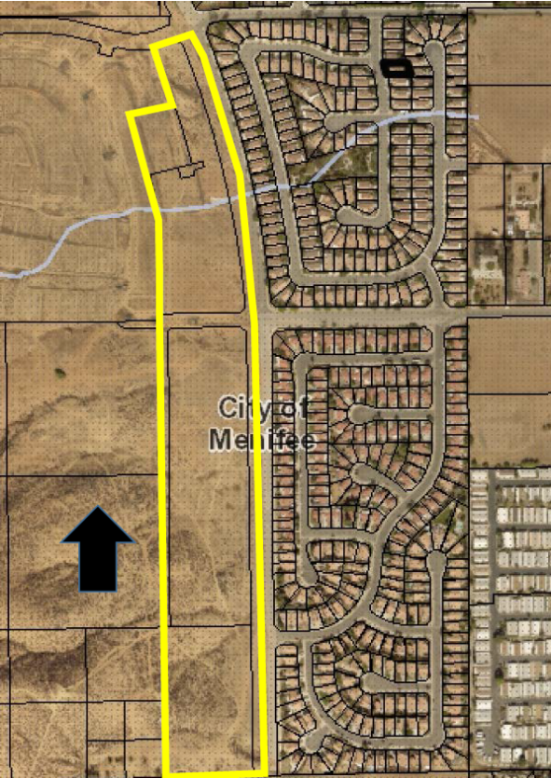
Project Title: “Valley Boulevard” Tentative Tract Map No. 36911 (Planning Application No. 2015-211)

Project Location: The project site is located on the west side of Valley Boulevard north and south of Chambers Avenue (APNs 335-080-56, 335-080-066, 335-080-067 and a portion of 335-070-054), within the City of Menifee, County of Riverside, State of California.

The Planning Commission will consider the following project at a public hearing: Tentative Tract Map No. 36911 (Planning Application 2015-211) proposes to subdivide 26.95 gross acres into 68 single family residential lots with a minimum lot size of 7,200 square feet and ten (10) common area lots including three (3) lots for water quality basins. The project site is currently vacant.

Environmental Information: The City of Menifee Community Development Department has determined that the above project will not have a significant effect on the environment and has recommended adoption of a Mitigated Negative Declaration. The Menifee Planning Commission will consider the proposed project and the proposed Mitigated Negative Declaration, at the public hearing. In addition, the project site is not included on a list of hazardous materials sites compiled pursuant to Government Code Section 65962.5 (California Department of Toxic Substances Control list of various hazardous sites).

Public Review Period: The IS/MND is being circulated for a 30-day review period pursuant to State law. The public review period will start on June 17, 2020 and close on July 16, 2020. All comments on the IS/MND must be submitted in writing to the address or e-mail provided below and received no later than 5:00 PM Thursday, July 16, 2020. The IS/MND can be found at the following web address: http://www.cityofmenifee.us/325/Environmental-Notices-Documents.

Any person wishing to comment on the proposed project may do so in writing between the date of this notice and the public hearing; or, may appear and be heard at the time and place noted above. All comments must be received prior to the time of public hearing. All such comments will be submitted to the Planning Commission, and the Planning Commission will consider such comments, in addition to any oral testimony, before making a decision on the proposed project.

If this project is challenged in court, the issues may be limited to those raised at the public hearing, described in this notice, or in written correspondence delivered to the Planning Commission at, or prior to, the public hearing. Be advised that as a result of public hearings and comment, the Planning Commission may amend, in whole or in part, the proposed project. Accordingly, the designations, development standards, design or improvements, or any properties or lands within the boundaries of the proposed project, may be changed in a way other than specifically proposed.

For further information regarding this project, please contact Manny Baeza, at (951) 723-3742 or via e-mail at mbaeza@cityofmenifee.us, or go to the City of Menifee’s agenda web page at http://www.cityofmenifee.us. To view the case file information electronically for the proposed project contact the Community Development Department office at (951) 672-6777 Monday through Friday, from 8:00 A.M. to 5:00 P.M. Please send all written correspondence to:

CITY OF MENIFEE COMMUNITY DEVELOPMENT DEPARTMENT
Attn: Manny Baeza, Senior Planner
29844 Haun Road
Menifee, CA 92586

