

NOTICE OF DETERMINATION
TO: | ☒ Riverside County Clerk  Address: 2724 Gateway Drive  Riverside, CA 92507 | FROM: | Public Agency/Lead Agency:  March Joint Powers Authority
TO: |  | FROM: | Address:  14205 Meridian Parkway, Suite 140 Riverside, CA 92518
TO: |  | FROM: | Contact: | Lauren Sotelo
TO: |  | FROM: | Phone: | 951-656-7000

TO: | ☒ Office of Planning and Research  1400 Tenth Street, Rm. 113  Sacramento, CA 95814 | Lead Agency (if different from above)  Click to enter Agency
TO: |  | Address:  Click enter address
TO: |  | Contact: | Click to enter contact
TO: |  | Phone: | Click to enter phone no.
SUBJECT: Filing of Notice of Determination in compliance with Section 21108 or 21152 of the Public Resources Code.
State Clearinghouse Number
(If submitted to SCH):
South Campus Specific Plan and Village West Drive Extension Project Subsequent Environmental Impact Report (SCH# 202000059028)
Project Title: 2021 March JPA Truck Route Ordinance (Ordinance #JPA 21-02)
Project Applicant (include address and telephone number):
March Joint Powers Authority
14205 Meridian Parkway, Suite 140
Riverside, CA 92506
(951) 656-7000
Specific Project Location – Identify Street address and cross street or attach a map showing project site (preferably a USGS 15’ or 7 ½’ topographical map identified by quadrangle name):
Jurisdiction-wide
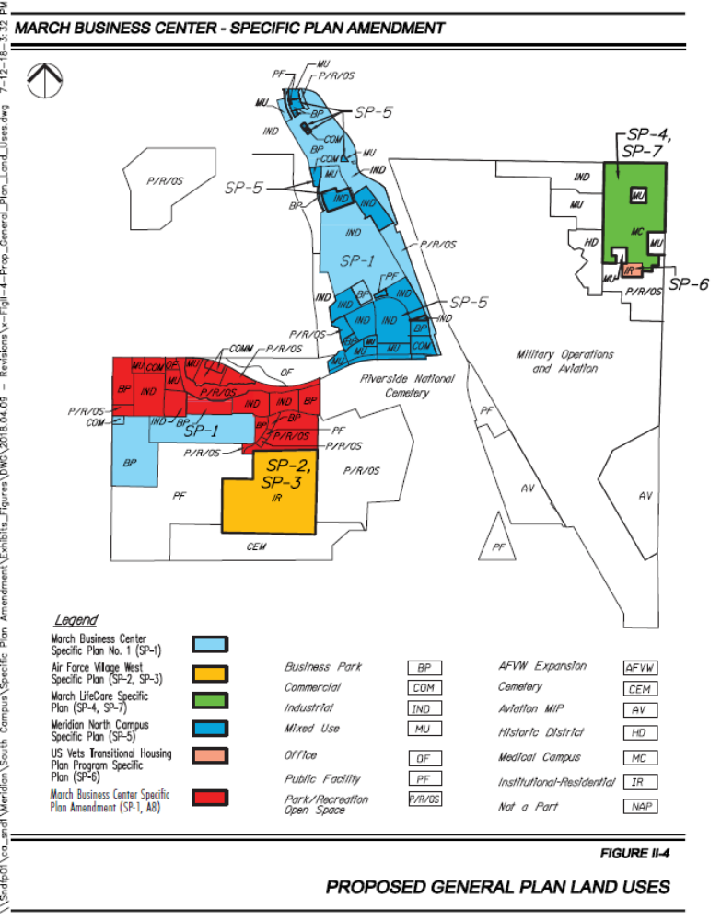
General Project Location (City and/or County): March Joint Powers Authority/ Unincorporated County of Riverside
Project Description: On January 27, 2021, the March Joint Powers Commission adopted a Mitigation Monitoring and Reporting Program for the South Campus Specific Plan and Village West Drive Extension Project and certified the Subsequent Environmental Impact Report. Then on February 10, 2021, the Joint Powers Commission approved Amendment No. 8 to the March Business Center Specific Plan (SP-1) which added a street network and truck route to the northwest corner of the South Campus. The addition of the new street network and truck route requires an update to March JPA’s existing Truck Route Ordinance #JPA 17-06. On September 22, 2021, a public hearing and first reading was held for Ordinance #JPA 20-02, an Ordinance to update and supersede March JPA’s Truck Route Ordinance (Ordinance #JPA 17-06) to include the new street network and truck route approved as part of the March Business Center Specific Plan Amendment (SP-1, Amendment #8) and the South Campus Specific Plan and Village West Drive Extension Project Subsequent Environmental Impact Report (SCH# 202000059028). Ordinance #JPA 20-02would be applicable within the boundary of the March Joint Powers Authority. Pursuant to Public Resources Code Section 21166 and State CEQA Guidelines section 15162, no further environmental review is required for the Project.
Identify the person or entity undertaking the project, including any private applicant, any other person undertaking an activity that receives financial assistance from the Public Agency as part of the project, and any person receiving a lease, permit, license, certificate, or other entitlement of use from the Public Agency as part of the project.

March Joint Powers Authority
14205 Meridian Parkway, Suite 140
Riverside, CA 92518
This is to advise that the (☒ Lead Agency or ☐ Responsible Agency) has approved the above-described project on September 22, 2021 and has made the following determinations regarding the above-described project:
 |  | The project [ ☐ will ☒ will not] have a significant effect on the environment.
 | ☒ | An Environmental Impact Report was previously prepared and certified for this project pursuant to the provisions of CEQA and reflects the independent judgment of the Lead Agency.
 | ☐ | A Negative Declaration was prepared for this project pursuant to the provisions of CEQA and reflects the independent judgment of the Lead Agency.
 | ☐ | A Mitigated Negative Declaration was prepared for this project pursuant to the provisions of CEQA and reflects the independent judgment of the Lead Agency.
 | ☐ | Mitigation measures [ ☐were ☒ were not] made a condition of the approval of the project.
 | ☐ | A Mitigation Monitoring or Reporting Plan [ ☒ was ☐ was not] adopted for this project.
 | ☐ | A Statement of Overriding Considerations [ ☒ was ☐ was not] adopted for this project.
 | ☐ | Findings [ ☒ were ☐ were not] made pursuant to the provisions of CEQA.
 |  | This is to certify that the Final EIR with comments and responses and record of project approval, or the Negative Declaration, is available to General Public at:
 |  | Custodian:  March Joint Powers Authority | Location:  14205 Meridian Parkway, Suite 140  Riverside, CA 92506

Date: September 23, 2021 | 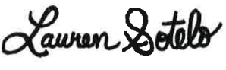________________________________________  Signature
Date: September 23, 2021 | Name: Lauren Sotelo
Date: September 23, 2021 | Title: Senior Planner
Date Received for Filing: Click or tap to enter a date.
Authority cited: Sections 21083, Public Resources Code.
Reference Section 21000-21174, Public Resources Code.

