Omega Curves Project
Nevada County, California
District 3 – Nevada – 20 – Post Miles 29.7/39.8
EA 03-2H62U EFIS 0319000021

Initial Study with Proposed Mitigated Negative Declaration/
Environmental Assessment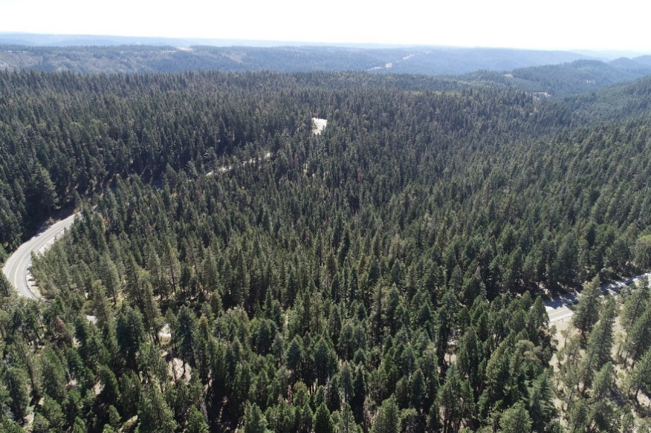
Prepared by the
State of California, Department of Transportation
The environmental review, consultation, and any other actions required by applicable Federal environmental laws for this project are being, or have been, carried out by Caltrans pursuant to 23 U.S.C. 327 and the Memorandum of Understanding dated December 23, 2016 and executed by the Federal Highway Administration (FHWA) and Caltrans.
February 2020
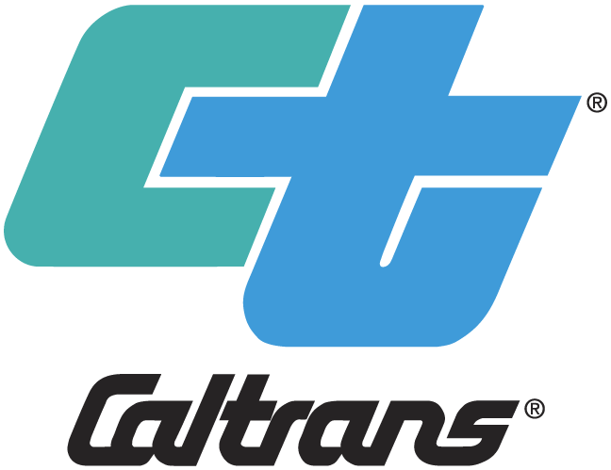
General Information About This Document
What’s in this document:
The California Department of Transportation (Caltrans), as assigned by the Federal Highway Administration (FHWA), has prepared this Initial Study/Environmental Assessment, which examines the potential environmental impacts of alternatives being considered for the proposed project in Nevada in California. The document explains why the project is being proposed, the alternatives being considered for the project, the existing environment that could be affected by the project, potential impacts of each of the alternatives, and proposed avoidance, minimization, and/or mitigation measures.
What you should do:
- Please read the document. Additional copies of the document and the related technical studies are available by appointment for review at the Caltrans district office at 703 B Street, Marysville, CA 95501.
- Attend the public information meeting on February 10, 2020 at:
Eric Rood Administrative Center
950 Maidu Avenue
Board of Supervisors' Chambers
Nevada City, CA 95959
- Tell us what you think. If you have any comments regarding the proposed project, please attend the public information meeting, and/or send your written comments to Caltrans by the deadline. Submit comments via U.S. mail to: Erin Damm, Associate Environmental Coordinator, California Department of Transportation, 703 B Street, Marysville, California, 95901. Submit comments via email to: erin.damm@dot.ca.gov Comments on social media or other platforms will not be responded to.
- Submit comments by 5:00 PM on March 13, 2020.
What happens next:
After comments are received from the public and reviewing agencies, Caltrans, as assigned by the Federal Highway Administration (FHWA), may 1) give environmental approval to the proposed project, 2) do additional environmental studies, or 3) abandon the project. If the project is given environmental approval and funding is appropriated, Caltrans could design and construct all or part of the project.
Printing this document: To save paper, this document has been set up for two-sided printing (to print the front and back of a page). Blank pages occur where needed throughout the document to maintain proper layout of the chapters and appendices.

Alternative Formats:
For individuals with sensory disabilities, this document can be made available in Braille, in large print, on audiocassette, or on computer disk. To obtain a copy in one of these alternate formats, please write to or call Caltrans, Attention: Raquel Borrayo, Public Information Officer, 703 B Street, Marysville, California, 95901; phone number 530-634-7640 (Voice), or use the California Relay Service 1-800-735-2929 (TTY), 1-800-735-2929 (Voice), or 711.

3-NEV-20-PM 29.7/39.8
EA 03-2H62U and Project ID# 0319000021
Correct curve alignment and add pull outs on State Route 20 in Nevada County at non-contiguous locations from post miles 29.7 to 39.8.
INITIAL STUDY with Proposed Mitigated Negative Declaration and ENVIRONMENTAL ASSESSMENT
Submitted Pursuant to: (State) Division 13, California Public Resources Code (Federal) 42 USC 4332(2)(C) and 49 USC 303
THE STATE OF CALIFORNIA
Department of Transportation
Cooperating Agencies: United States Forest Service, United States Fish and Wildlife Service, U.S. Army Corps of Engineers, Central Valley Regional Water Quality Control Board, State Water Resources Control Board, California Department of Fish and Wildlife, State Historic Preservation Office
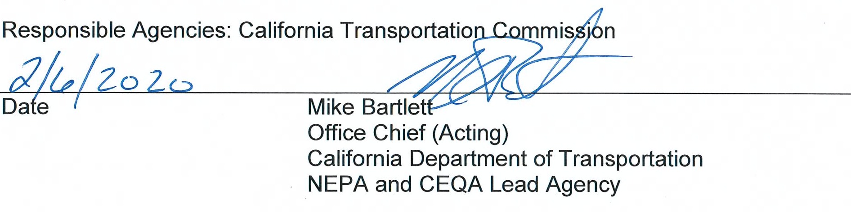
The following persons may be contacted for more information about this document:
Sam Vandell via written comment at 703 B Street, Marysville, CA 95501. Telephone number: 530-741-4593.
Erin Damm via written comment at 703 B Street, Marysville, CA 95501. Telephone number: 530-741-5387.
Comments on this document should be returned by 5:00 PM on March 4, 2020.
Pursuant to: Division 13, Public Resources Code
Project Description
The California Department of Transportation (Caltrans) proposes to improve two non-contiguous segments of the alignment of State Route (SR) 20 in Nevada County between post miles (PM) 29.7-30.9 and 36.8-39.8 by modifying the existing horizontal and vertical curves of the roadway and adding turnouts. This project will update the roadway to current standards by increasing the curve radii, widening shoulders to 8 feet, adding turnouts for both directions, and improving the vertical profile grade. Additionally, this project will improve the clear recovery zone (CRZ) by removing obstacles and flattening slopes close to the traveled way. Two main project segments occur between PM 29.7-30.9 and 36.8-39.8 are referred to as White Cloud and Lowell Hill segments respectively.

For this project, Caltrans right of way will be acquired from the United States Forest Service (USFS) through a Department of Transportation Easement (DOTE). Before construction begins on USFS property the appropriate right-of-way agreements will be obtained from the Forest Service. Potholing and utility verification will be required to identify conflicts and potential relocations. The relocation of the AT&T underground facility within the White Cloud Segment is likely.

There is one build alternative considered for White Cloud and Lowell Hill Segments, each, and one no-build alternative.

Cut slopes of 1:1 (H:V) and fill slopes of 1.5:1 are used on the project. Cut slopes may vary between 1:1 and 2:1 to balance the earthwork where feasible. However, final slopes will be determined by geotechnical recommendations. Vegetation and tree removal will be required for the realignment as well as to facilitate the access by construction equipment and personnel. One-way reversing traffic control will also be required during construction. Temporary roadway closure and detour may be needed. Night work is not anticipated, however it is not excluded. A staging area has not been identified. Construction will have a duration of approximately two years.

A 54” culvert with a maximum cover of 100’ will be constructed near White Cloud Spring and an 84” culvert with a maximum cover of 80’ will be constructed at “Steephollow Creek.” Further investigation and studies will be required to determine if a bridge or special structure design is needed at the crossings.

These elements of the project described have been considered prior to any significance determinations.
Determination
This proposed Mitigated Negative Declaration is included to give notice to interested agencies and the public that it is Caltrans’ intent to adopt a Mitigated Negative Declaration for this project. This does not mean that Caltrans’ decision on the project is final. This Mitigated Negative Declaration is subject to change based on comments received from interested agencies and the public.
Caltrans has prepared an Initial Study for this project and, pending public review, expects to determine from this study that the proposed project would not have a significant effect on the environment for the following reasons:
The proposed project would have no effect on agricultural resources, air quality, archeological resources or human remains, tribal cultural resource, geology and soils, hazardous materials, hydrology and water quality, land use and planning, mineral resources, noise, or population and housing.
The proposed project would have less than significant effect on forest resources, greenhouse gas emissions, historical linear resources, transportation and traffic, and public services and utilities.
With the following avoidance, minimization and mitigation measures incorporated, the proposed project would have less than significant effects to aesthetics, biological resources or recreation:
- AES 1: Screen Decommissioned Alignment.
- AES 2: Native Planting.
- AES 3: Aesthetic Treatments
- BIO 4: Compensatory Mitigation for Permanent Impacts on Aquatic Resources
- PRF-1: Compensatory trail reconstruction
______________________________ _______________
Mike Bartlett Date
Office Chief (Acting)
District 03
California Department of Transportation

Table of Contents

Table of Contents iv
List of Figures ix
List of Tables ix
Chapter 1 Proposed Project 1
1.1 Introduction 1
NEPA Assignment 1
1.2 Purpose and Need 2
1.2.1 Purpose 2
1.2.2 Need 2
1.3 Independent Utility and Logical Termini 4
1.4 Project Description 5
1.5 Project Alternatives 11
1.5.1 Proposed Build Alternative 11
1.5.2 No-Build (No-Action) Alternative 12
1.6 Alternatives Considered but Eliminated from Further Discussion 12
1.7 Permits and Approvals Needed 12
Chapter 2 Affected Environment, Environmental Consequences, and Avoidance, Minimization, and/or Mitigation Measures 14
2.1 Human Environment 15
2.1.1 Existing and Future Land Use 15
Affected Environment 15
Environmental Consequences 16
Avoidance, Minimization, and/or Mitigation Measures 16
2.1.2 Consistency with State, Regional, and Local Plans and Programs 16
Affected Environment 16
Environmental Consequences 17
Avoidance, Minimization, and/or Mitigation Measures 17
2.1.3 Parks and Recreational Facilities 17
Regulatory Setting 17
Affected Environment 17
Environmental Consequences 22
Avoidance, Minimization, and/or Mitigation Measures 23
2.1.4 Community Character and Cohesion 23
Regulatory Setting 23
Affected Environment 24
Environmental Consequences 25
Avoidance, Minimization, and/or Mitigation Measures 25
2.1.5 Utilities and Emergency Services 26
Affected Environment 26
Environmental Consequences 26
Avoidance, Minimization, and/or Mitigation Measures 27
2.1.6 Traffic and Transportation/Pedestrian and Bicycle Facilities 27
Regulatory Setting 27
Affected Environment 27
Environmental Consequences 28
Avoidance, Minimization, and/or Mitigation Measures 29
2.1.7 Visual/Aesthetics 29
Regulatory Setting 29
Affected Environment 29
Environmental Consequences 30
Avoidance, Minimization, and/or Mitigation Measures 34
2.1.8 Cultural Resources 35
Regulatory Setting 35
Affected Environment 36
Environmental Consequences 37
Avoidance, Minimization, and/or Mitigation Measures 38
2.2 Physical Environment 39
2.2.1 Water Quality and Storm Water Runoff 39
Regulatory Setting 39
Affected Environment 43
Environmental Consequences 44
Avoidance, Minimization, and/or Mitigation Measures 44
2.2.2 Air Quality 46
Regulatory Setting 46
Affected Environment 47
Environmental Consequences- Long Term 49
Environmental Consequences- Construction 49
Avoidance, Minimization, and/or Mitigation Measures 52
Climate Change 53
2.2.3 Energy 54
Regulatory Setting 54
Affected Environment 54
Environmental Consequences 54
Avoidance, Minimization, and/or Mitigation Measures 55
2.3 Biological Environment 56
2.3.1 Natural Communities 56
Affected Environment 56
Environmental Consequences 59
Avoidance, Minimization, and/or Mitigation Measures 60
2.3.2 Wetlands and Other Waters 61
Regulatory Setting 61
Affected Environment 63
Environmental Consequences 63
Avoidance, Minimization, and/or Mitigation Measures 64
2.3.3 Plant Species 66
Regulatory Setting 66
Affected Environment 67
Environmental Consequences 67
Avoidance, Minimization, and/or Mitigation Measures 67
2.3.4 Animal Species 68
Regulatory Setting 68
Affected Environment 68
Environmental Consequences 70
Avoidance, Minimization, and/or Mitigation Measures 71
2.3.5 Threatened and Endangered Species 73
Regulatory Setting 73
Affected Environment 74
Environmental Consequences 75
Avoidance, Minimization, and/or Mitigation Measures 75
2.3.6 Invasive Species 76
Regulatory Setting 76
Affected Environment 76
Environmental Consequences 76
Avoidance, Minimization, and/or Mitigation Measures 76
2.4 Construction Impacts 77
2.5 Cumulative Impacts 77
Regulatory Setting 77
Affected Environment 78
Avoidance, Minimization, and/or Mitigation Measures 84
Chapter 3 CEQA Evaluation 85
3.1 Determining Significance under CEQA 85
3.2 CEQA Environmental Checklist 86
3.2.1 Aesthetics 86
CEQA Significance Determinations for Aesthetics 86
3.2.2 Agriculture and Forest Resources 87
CEQA Significance Determinations for Agriculture and Forest Resources 87
3.2.3 Air Quality 88
CEQA Significance Determinations for Air Quality 88
3.2.4 Biological Resources 89
CEQA Significance Determinations for Biological Resources 89
3.2.5 Cultural Resources 91
CEQA Significance Determinations for Cultural Resources 91
3.2.6 Energy 91
CEQA Significance Determinations for Energy 91
3.2.7 Geology and Soils 92
CEQA Significance Determinations for Geology and Soils 92
3.2.8 Greenhouse Gas Emissions 93
CEQA Significance Determinations for Greenhouse Gas Emissions 93
3.2.9 Hazards and Hazardous Materials 93
CEQA Significance Determinations for Hazards and Hazardous Materials 93
3.2.10 Hydrology and Water Quality 95
CEQA Significance Determinations for Hydrology and Water Quality 95
3.2.11 Land Use and Planning 96
CEQA Significance Determinations for Land Use and Planning 96
3.2.12 Mineral Resources 97
CEQA Significance Determinations for Mineral Resources 97
3.2.13 Noise 97
CEQA Significance Determinations for Noise 97
3.2.14 Population and Housing 98
CEQA Significance Determinations for Population and Housing 98
3.2.15 Public Services 98
CEQA Significance Determinations for Public Services 98
3.2.16 Recreation 99
CEQA Significance Determinations for Recreation 99
CEQA Significance Determinations for Transportation 99
3.2.17 Tribal Cultural Resources 100
CEQA Significance Determinations for Tribal Cultural Resources 100
3.2.18 Utilities and Service Systems 100
CEQA Significance Determinations for Utilities and Service Systems 100
3.2.19 Wildfire 101
CEQA Significance Determinations for Wildfire 101
3.2.20 Mandatory Findings of Significance 102
CEQA Significance Determinations for Mandatory Findings of Significance 102
3.3 Wildfire 103
Regulatory Setting 103
Affected Environment 103
Environmental Consequences 103
Avoidance, Minimization, and/or Mitigation Measures 104
3.4 Climate Change 104
Regulatory Setting 105
Environmental Setting 108
Project Analysis 110
Greenhouse Gas Reduction Strategies 112
Adaptation 115
Chapter 4 Comments and Coordination 122
4.1 Agency Coordination 122
4.2 Tribal Consultation 122
4.3 Public Coordination 123
Chapter 5 List of Preparers 124
Department Staff 124
ICF Jones & Stokes, Inc. 124
Pacific Legacy, Inc. 125
JRP Historical Consulting, LLC 125
Chapter 6 Distribution List 126
Appendix A Section 4(f) Analysis 127
A.1 Introduction 127
A.2 Description of Proposed Project 127
A.3 Section 4(f) Properties 127
A.3.1 Study Areas 127
Tahoe National Forest 128
A.3.2 Resources Evaluated Relative to the Requirements of Section 4(f): No Use Determinations 133
A.4 Section 6(f) 137
Appendix B Title VI Policy Statement 139
Appendix C Avoidance, Minimization and/or Mitigation Summary 140
Appendix D Species List by Resource Agency 158
California Native Plant Society 158
California Department of Fish and Wildlife 160
United States Department of the Interior, Fish And Wildlife Service 163
National Oceanic and Atmospheric Administration, National Marine Fisheries Service 165
List of Technical Studies 166

List of Figures
Figure 1 Project Vicinity Map 8
Figure 2 White Cloud Project Segment Location Map 9
Figure 3 Lowell Hill Project Segment Location Map 10
Figure 4 White Cloud Segment Existing and Proposed Trail Locations 20
Figure 5 Lowell Hill Segment Existing and Proposed Trail Locations 21
Figure 6 U.S. Census Tracts 7.01, 8.01 and 9 (shaded area) 24
Figure 7 White Cloud Aerial Simulation, looking east at the intersection with Jefferson Creek Road 32
Figure 8 Lowell Hill Aerial Simulation, looking south-southeast, east of the intersections with Excelsior Point Road and Last Chance Mine Road. 33
Figure 9 Cumulative Impacts Project Locations 80
Figure 10 U. S. 2016 Greenhouse Gas Emissions 109
Figure 11 California Climate Strategy 113
Figure 12 Project Segments in Relation to Section 4(f) Properties 129
Figure 13 Section 4(f) Resources at Project Segments 130

List of Tables
Table 1 Nevada County, State Route 20, Traffic Collision Rates. 3
Table 2 Nevada County, State Route 20, Traffic Collision Type 4
Table 3 U.S. Census Data 25
Table 4 Status of SIPs Relevant to the Project Area. 48
Table 5 Habitat Types Within the Project Study Limits 58
Table 6 Estimates (US tons) of GHG Emissions During Construction 111

- Proposed Project
  - Introduction
NEPA Assignment
California participated in the “Surface Transportation Project Delivery Pilot Program” (Pilot Program) pursuant to 23 USC 327, for more than five years, beginning July 1, 2007, and ending September 30, 2012. MAP-21 (P.L. 112-141), signed by President Obama on July 6, 2012, amended 23 USC 327 to establish a permanent Surface Transportation Project Delivery Program. As a result, Caltrans entered into a Memorandum of Understanding pursuant to 23 USC 327 (NEPA Assignment MOU) with FHWA. The NEPA Assignment MOU became effective October 1, 2012, and was renewed on December 23, 2016, for a term of five years. In summary, Caltrans continues to assume FHWA responsibilities under NEPA and other federal environmental laws in the same manner as was assigned under the Pilot Program, with minor changes. With NEPA Assignment, FHWA assigned and Caltrans assumed all of the United States Department of Transportation (USDOT) Secretary's responsibilities under NEPA. This assignment includes projects on the State Highway System and Local Assistance Projects off of the State Highway System within the State of California, except for certain categorical exclusions that FHWA assigned to Caltrans under the 23 USC 326 CE Assignment MOU, projects excluded by definition, and specific project exclusions.
The California Department of Transportation (Department), as assigned by the Federal Highway Administration (FHWA), is the lead agency under the National Environmental Policy Act (NEPA). Caltrans is the lead agency under the California Environmental Quality Act (CEQA).
Caltrans proposes to improve two non-contiguous segments of the alignment of State Route (SR) 20 in Nevada County by modifying the existing horizontal and vertical curves of the roadway, increase the curve radii, widen shoulders, improve the clear recover zone, and improve operational movement by standardizing existing roadway turnout widths with shoulders. Two main project segments will occur between post miles 29.7/ 30.9 and 36.8/ 39.8, referred to as White Cloud and Lowell Hill respectively. Figures 1 and 2 are project location and vicinity maps.
This project is comprised of three State Highway Operation and Protection Program (SHOPP) projects. Two of the SHOPP projects are curve improvement projects intended to reduce collisions (EA 03-0H240 and 03-2H620) while the third project (EA 03-1H810) is an operational improvement to widen the turnout and allow slow moving vehicles a place to safely turn off the road so faster vehicles can pass. All three projects are included in the 2019 through 2022 Federal Statewide Transportation Improvement Program (FSTIP).
It has been determined that this project is eligible for Federal-aid funding and is consistent with the 2018 Nevada County Transportation Plan. The current programming utilizes the SHOPP Safety Improvement (20.XX.210.010, and 20.XX.201.310) funds. The current estimate is within the programed amount. The combined escalated estimate for the preferred alternative is $51,328,415 for construction capital and $1,039,000 for Right of Way capital. An escalation rate of 1.10% was used. The support cost ratio is 34% for EA 0H240, 62% for EA 1H810, and 27% for EA 2H620.
  - Purpose and Need
    - Purpose
The purpose of this project is to improve safety and reduce the number and severity of collisions, as well as improve highway operations by increasing the curve radii, widening shoulders, improving opportunities to turnout, improving the vertical profile, and improving the clear recovery zone.
    - Need
This project is needed because there are safety and operational concerns along this segment of mountainous two-lane highway. There are no passing lanes, little-to-no recovery area for errant drivers, limited sight distances to see oncoming errant drivers or wildlife in the travel lanes, bicyclists must share the travel lane with passenger and commercial vehicles, and over winter months, the roads stay icy when sunlight cannot penetrate the roadside vegetation shade. These conditions can- individually, or combined, contribute to collisions in the project segments.
Between January 1, 2015 and December 31, 2017, there were 39 total collisions between the two project segments, 19 of which involved injuries. The resulting total accident collision rate is 219% of the statewide average at the White Cloud segment, and 269% of the statewide average at the Lowell Hill segment. Earlier collision data at the Lowell Hill segment show that the actual collision rate was 181% of the statewide average between July 1, 2009 and June 30, 2014, and that the rate of collisions in this project segment has increased over the past 8 years. Table 1 and Table 2 below summarize traffic collision data on SR-20 through the White Cloud and Lowell Hill segments between, showing the number and types of collisions that have occurred at each project segment. The data is reported from the Traffic Accident Surveillance and Analysis System (TASAS)- Transportation System Network (TSN) database managed by Caltrans.
The project is intended to reduce vehicle versus vehicle collisions, vehicle versus object collisions, and vehicles overturning. The curve radii are tight, and the road fishtails through the dense forest. There is limited sight distance for drivers to see conditions ahead or oncoming vehicles that may be traveling over the center lane around a curve. Over correction to avoid collisions with other vehicles cause impacts with rocks, slopes and trees, or vehicles overturning as they leave the paved roadway.
The project is also intended to improve traffic operations by realigning the roadway to increase the curve radii, improve the vertical profile of the highway elevation, widen shoulders to a class-III/ multi-use width, standardize turnout widths, and increase sight lines. Variable speeds ranging between 30 mph to 55 mph result in travel trailers and commercial trucks slowing overall traffic down because it takes them longer to regain speeds that smaller, lighter vehicles can achieve. Unsafe passing maneuvers occur when slow moving vehicles don’t have enough distance to pull over in a safe turnout lane, let other vehicles pass, and then feel confident in re-entering the travel lane to regain highway speeds. Currently, the slow-moving vehicles stay on the road, slowing all traffic down behind them, or impatient drivers take risks in unsafe passing maneuvers.
Maintenance clears snow during the winter and spring, or even later at high elevations in wet years. This road clearing maintenance work is hampered by the tight curves, narrow shoulders and dense vegetation that limits snow plowing and blowing snow past the immediate shoulders, particularly when snow accumulation surpasses the blower height. The distance from regional maintenance field stations to this segment of SR-20 means equipment and materials need to be brought in from other areas, decreasing the time that can be otherwise used to clear the roads of snow or debris. This can cause delays for through traffic waiting for roads to be opened.
In addition to the safety and operational needs present on this highway segment, travelers are likely to encounter wildlife on the roadway which can result in property damage, although few such instances are documented with CHP due to limited cell phone connectivity. Caltrans Maintenance staff are tasked with keeping the highway cleared of debris, which includes animal carcasses that have been struck by vehicles.
Table 1 Nevada County, State Route 20, Traffic Collision Rates.
Location  (Post Miles) and Dates | Total Collisions | Actual Fatal | Actual Fatal + Injury | Actual Total | State Average Fatal | State Average Fatal + Injury | State Average Total
White Cloud  29.7- 30.9  01/ 01/ 2015- 12/ 31/ 2017 | 10 | 0 | 1.30 | 2.17 | 0.024 | 0.46 | 0.99
Lowell Hill 36.7- 39.8  01/ 01/ 2015- 12/ 31/ 2017 | 29 | 0 | 1.22 | 2.72 | 0.024 | 0.46 | 1.01
Lowell Hill  37.1- 39.8  07/ 01/ 2009- 06/ 30/ 2014 | 29 | 0 | 1.16 | 1.76 | 0.06 | 0.79 | 0.97
Table 2 Nevada County, State Route 20, Traffic Collision Type
Location  (Post Miles) | Head-on | Sideswipe | Rear End | Broadside | Hit Object | Overturn | Other
White Cloud 29.7-30.9 | 0 | 3 | 0 | 0 | 4 | 3 | 0
Lowell Hill 36.7-39.8 | 3 | 3 | 2 | 3 | 13 | 3 | 2
  - Independent Utility and Logical Termini
Logical termini for project development are defined as (1) rational end points for a transportation improvement, and (2) rational end points for a review of the environmental impacts. The environmental impact review frequently covers a broader geographic area than the strict limits of the transportation improvements. In the past, the most common termini have been points of major traffic generation, especially intersecting roadways. This is because in most cases traffic generators determine the size and type of facility being proposed. However, there are also instances where the project improvement is not primarily related to congestion due to traffic generators, and the choice of termini based on these generators may not be appropriate. This is the case with the proposed project; the choice of termini is based on areas of the roadway where accidents are clustered.
Choosing a corridor of sufficient length to look at all impacts need not preclude staged construction. Therefore, related improvements within a transportation facility should be evaluated as one project, rather than selecting termini based on what is programmed as short-range improvements. Construction may then be "staged," or programmed for shorter sections or discrete construction elements as funding permits. The proposed project aims to achieve this goal. The short-range, individual projects can be combined and evaluated as one project because they are similar in the type of work that needs to be conducted. Furthermore, they are in the same rural area and combining the projects during impacts evaluation and construction will reduce redundant efforts and are anticipated to lower costs.
When developing a transportation project, project sponsors should consider how the end points of the action are determined, both for the improvement itself and for the scope of the environmental analysis. Whether the action has "logical termini" or not is also a concern. Logical termini for project development are defined as rational end points for both a transportation improvement and a review of the environmental impacts. In the case of Omega Curves, there is logical termini by maintaining two project segments because traffic accident data does not indicate that improvements are needed in the miles between the two segments.
Segmentation may occur when a transportation need extends throughout an entire corridor, but project sponsors discuss the environmental issues and transportation need of only a segment of the corridor. In review of the traffic accident data, the SR-20 corridor between I-80 and Nevada City reveals only clustered accident reports at the two proposed project segments, not through the entire corridor. The following discussion of the proposed project incorporates segments of the SR-20 corridor as one project.
  - Project Description
This section describes the proposed action and the project alternative developed to meet the purpose and need of the project, while avoiding or minimizing environmental impacts.
The California Department of Transportation (Caltrans) proposes to improve two non-contiguous segments of the alignment of State Route (SR) 20 in Nevada County between post miles (PM) 29.7-30.9 and 36.8-39.8 by modifying the existing horizontal and vertical curves of the roadway and adding turnouts. This project will update the roadway to current standards by increasing the curve radii, widening shoulders to 8 feet, adding turnouts for both directions, and improving the vertical profile grade. Additionally, this project will improve the clear recovery zone (CRZ) by removing obstacles and flattening slopes close to the traveled way. Two main project segments occur between PM 29.7-30.9 and 36.8-30.9 are referred to as White Cloud and Lowell Hill segments respectively.
For this project, Caltrans right of way will be acquired from the United States Forest Service (USFS) through a Department of Transportation Easement (DOTE). Any work will require USFS project concurrence prior to project certification. Potholing and utility verification will be required to identify conflicts and potential relocations. The relocation of the AT&T underground facility within the White Cloud Segment is likely possible.
Average cut slopes of 1:1 (H:V) and fill slopes of 1.5:1 are used on the project. Cut slopes may vary between 1:1 and 2:1 to balance the earthwork where feasible. However, final slopes will be determined by geotechnical study recommendations. Vegetation and tree removal will be required for areas of realignment as well as to facilitate access to safe work areas for construction equipment and personnel. One-way reversing traffic control will also be required during construction to keep the segment open to through traffic. Temporary roadway closures and detours may be needed. Night work is not anticipated. A staging area has not been identified. Construction will have a duration of approximately two years. There is one build alternative considered for each the White Cloud and Lowell Hill Segments.
Scope of Work at White Cloud Segment:
- Construct two 12-foot lanes and 8-foot shoulders on both sides
- Designed for 40 miles per hour (MPH) vehicle speed
- Reconstruct roadway connections
- Construct Midwest Guardrails System (MGS)
- Provide storage areas requested by Maintenance near White Cloud Spring
- Construct new drainage systems and remove or maintain existing drainage systems where appropriate
- Place rock slope protection at culvert outlets, if needed
- Apply erosion control measures to disturbed soil areas
- Place new roadway signs
- Place new traffic striping and delineation
- Provide traffic handling and stage construction plans
- Relocate conflicting utilities
Scope of Work at Lowell Hill Segment
- Construct two 12-foot lanes and 8-foot shoulders on both sides
- Designed for 45 miles per hour (MPH) vehicle speed
- Reconstruct roadway connections
- Construct guardrails
- Construct screening to prevent access to existing abandoned road
- Construct new drainage systems and remove or maintain existing drainage systems where appropriate
- Place rock slope protection at culvert outlets, if needed
- Apply erosion control measures to disturbed soil areas
- Place new roadway signs
- Place new traffic striping and delineation
- Provide traffic handling and stage construction plans

A 54” culvert with a maximum cover of 100’ will be constructed near White Cloud Spring and an 84” culvert with a maximum cover of 80’ will be constructed at “Steephollow Creek.” Further investigation and studies will be required to determine if a bridge or special structure design is needed at the crossings.

The following features are included in both segments as measures to minimize the magnitude of the project impacts.

- Remove hot mix asphalt (HMA) and aggregate base (AB) of the existing pavement to be abandoned
- Construct screening to prevent access to existing abandoned road
- Provide bench in fill slopes to reconnect trails
- Compliance with 2018 Caltrans Standard Specifications particularly Sections 7, 13 and 14 which contain measures to provide protection of environmental resources.
The following features are included as enhancement measures, intended to create a net benefit as compared to the existing conditions or the finished project without these features.
- Regrade abandoned road bed with outward sloping to fill inside ditches and adding rolling dips
- Construct animal crossing with fence installed on both sides of the highway to funnel animals toward the crossing instead of on the roadway
The project is in Nevada County on SR-20, an east-west connector to Interstate 5 and SR 99, and interconnects with major routes including SR 70 and Interstate 80. This section of SR-20 is near Emigrant Gap, within the Tahoe National Forest. The U.S. Forest Service has designated the section of SR-20 as a Scenic Byway Highway, from Skillman Flat Campground to one half mile east of Lowell Hill Road. This designation is attributed to driving through pine forest and views of the dramatic results of Gold Rush Era hydraulic mining. A portion of SR-20 is officially designated a State Scenic Highway between PM 33.0 and 39.5. The County of Nevada has designated the highway as a scenic corridor and it is eligible for State Scenic Highway designation.
The project covers approximately 4 miles of the existing roadway and is broken into 2 non-contiguous segments. The White Cloud segment is approximately located between 0.1 miles east of the White Cloud campground and 0.2 miles west of the intersection with Shake Hill Road. The Lowell Hill segment is approximately located between 0.4 miles west of Excelsior Road to 1.3 miles west of Zeibright Road.
Refer to Figure 1, Figure 2, and Figure 3 to visualize the locations.

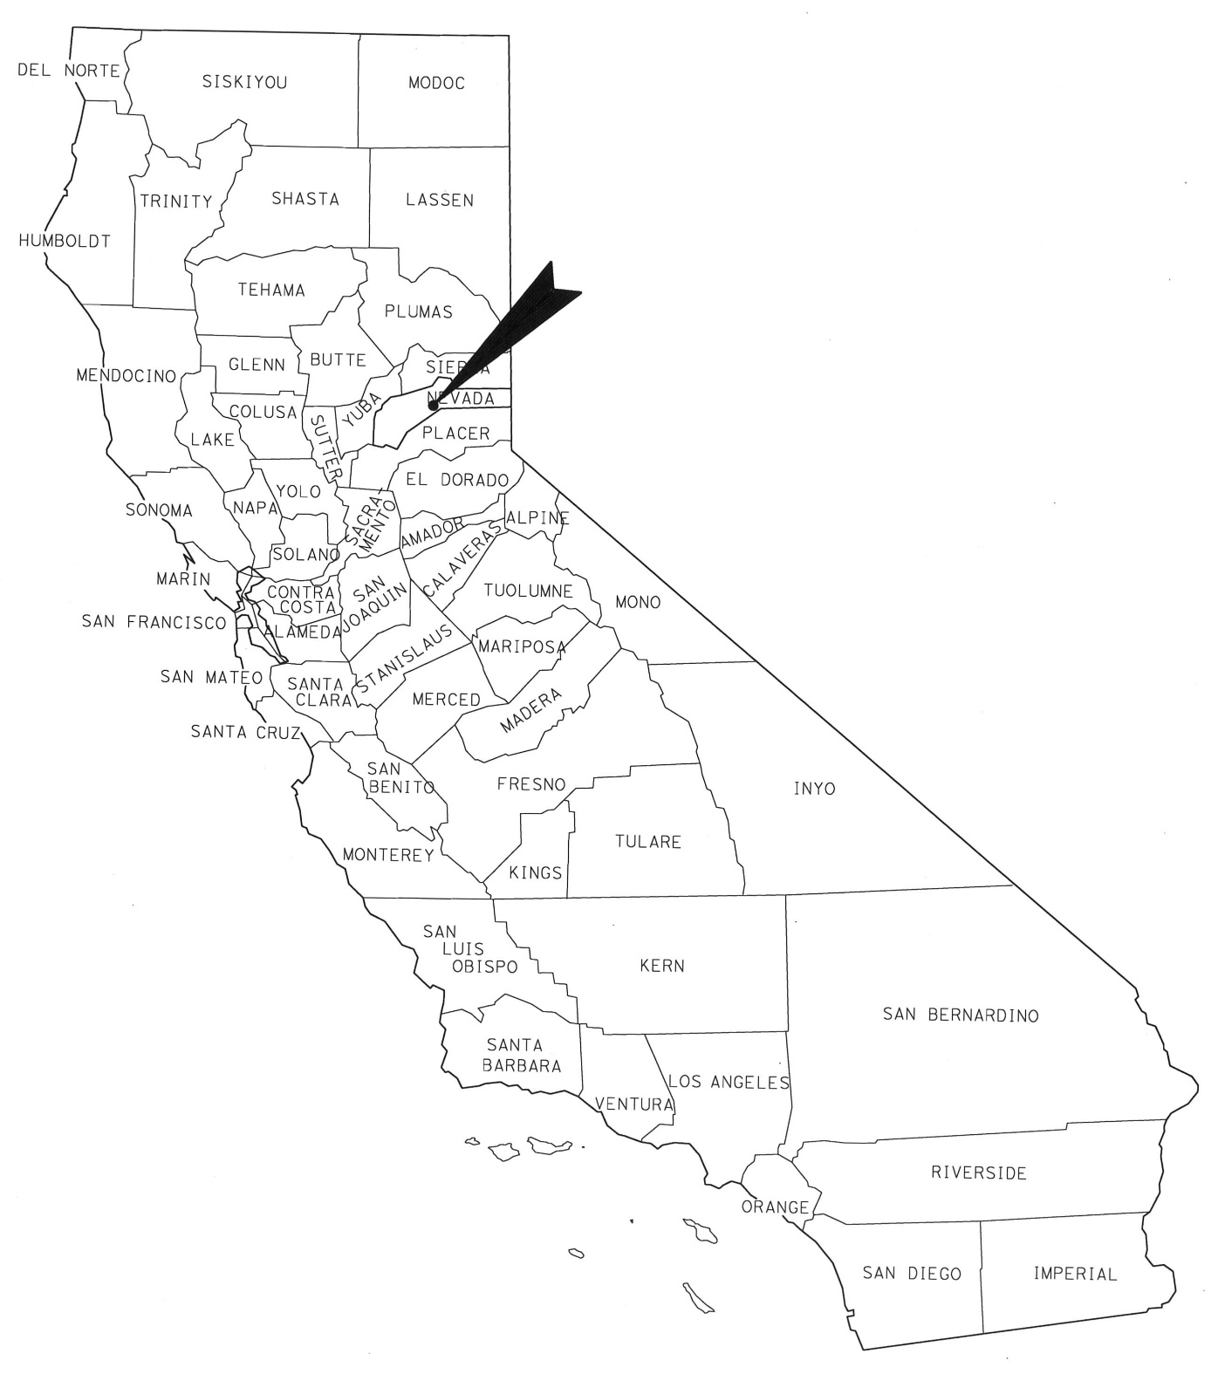
Figure 1 Project Vicinity Map

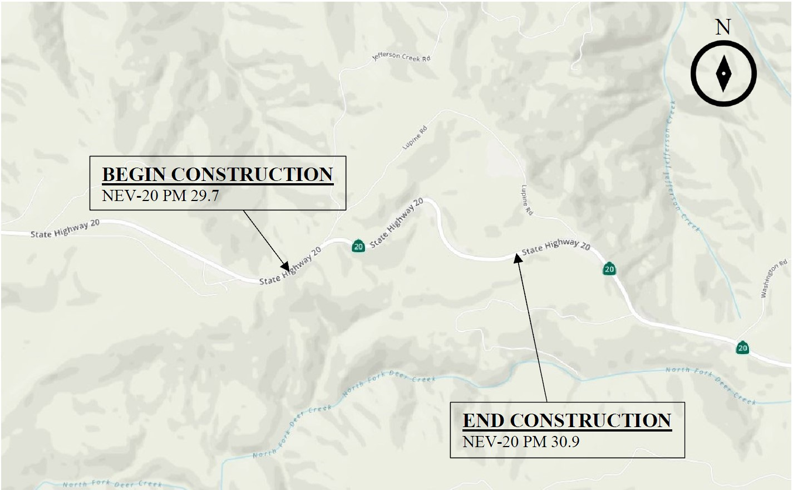
Figure 2 White Cloud Project Segment Location Map

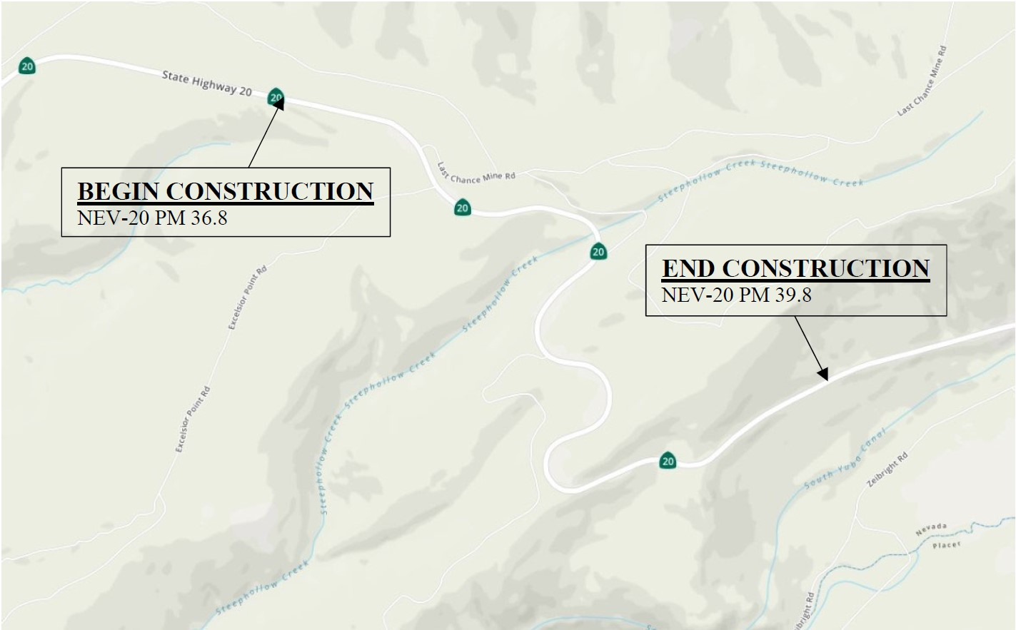
Figure 3 Lowell Hill Project Segment Location Map
  - Project Alternatives
Each project alternative includes the following standardized measures that are included as part of the project description. Standardized measures (such as Best Management Practices [BMPs]) are those measures that are generally applied to most or all Department projects. These standardized or pre-existing measures allow little discretion regarding their implementation and are not specific to the circumstances of a particular project. More information on each measure can be found in the applicable sections of Chapter 2.
- TT-1: A Transportation Management Plan (TMP) will be prepared for the project.
- CR1: Standard provisions dealing with the discovery of unanticipated cultural materials or human remains will be included in the project plans and specifications
- AQ1: The construction contractor must comply with Caltrans’ Standard Specifications in Section 14.
After the public circulation period, all comments will be considered, and the Department will select a preferred alternative and make the final determination of the project’s effect on the environment. Under the California Environmental Quality Act (CEQA), if no unmitigable significant adverse impacts are identified, the Department will prepare a Negative Declaration (ND) or Mitigated ND.
Similarly, if the Department, as assigned by the Federal Highway Administration (FHWA), determines the National Environmental Policy Act (NEPA) action does not significantly impact the environment, the Department will issue a Finding of No Significant Impact (FONSI).
    - Proposed Build Alternative
This project proposes curve realignment, shoulder widening, vertical profile realignment, and local road reconnections in each, the White Cloud and the Lowell Hill segments. Currently, Caltrans has a Special Use Permit for the highway in Tahoe National Forest. Approximately 40 acres of the current highway land area will be vacated under the proposed project. The new alignment will be part of a new Department of Transportation Easement through TNF for SR-20, totaling approximately 236 acres. Utility relocation is expected in the White Cloud segment where an AT&T underground line is located in a portion of the project limits. There are no known utilities in the Lowell Hill segment. Anticipated order of work would result in transporting fill from the Lowell Hill segment to the White Cloud segment, minimizing the need for additional storage sites. USFS is interested in retaining valuable forest top soil to promote revegetation after construction is completed and may be able to identify temporary storage locations once design details are further developed in the Plans, Specifications, and Estimates phase. Any areas not within the environmental study limit of this document would be evaluated for potential impacts to resources prior to their use. This project contains several standardized project measures that are used on most, if not all, Caltrans projects and were not developed in response to any specific environmental impact resulting from the proposed project. These measures are addressed in more detail in the Environmental Consequences sections found in Chapter 2.
    - No-Build (No-Action) Alternative
The no-build option which would make no changes to the existing roadway in either the White Cloud or Lowell Hill project segments, nor provide turnouts to allow slower traffic to pull safely off the roadway and allow other vehicles to pass. This is would not achieve the purpose and need for the project; safety would remain a concern in these areas.
  - Alternatives Considered but Eliminated from Further Discussion
The level of service (LOS) for this segment of roadway is LOS E, in a range between A (free flowing traffic) and F (a forced or a breakdown in traffic flow.) While the County’s population is forecast to increase 12 percent over the next 20 years, the traffic demands of this segment of SR-20 are not forecast to change over the same time frame. As such, Transportation System Management efficiencies and Reversible Lanes have been withdrawn from consideration. This project would not include construction of a bridge over any navigable rivers, and therefore no further consideration of providing public access to the navigable river is given.
  - Permits and Approvals Needed
The following permits, licenses, agreements, and certifications (PLACs) are required for project construction:
Agency | Permit/ Approval | Status
U.S. Army Corps of Engineers) | Clean Water Act Section 404: Permit for Placement of Fill Material into Waters of the United States | Permit application will be submitted after environmental document approval
Central Valley Regional Water Quality Control Board | Clean Water Act Section 401: Water Quality Certification | Application will be submitted after environmental document approval
State Water Resources Control Board | Section 402 coverage under the NPDES Construction General Permit (Order number 2009-0009-DWQ) | Included in construction contract
California Department of Fish and Wildlife | California Fish and Game Code Section 1602: Streambed Alteration Agreement | Permit application will be submitted after environmental document approval
United States Forest Service, Tahoe National Forest | Concurrence on Department of Transportation Act Section 4(f) | Request will be submitted following public comment of the Draft Environmental Document
State Historic Preservation Office | Concurrence on Caltrans Finding of Effects | Finding of No Adverse Effect has been submitted to SHPO and we are awaiting comments/concurrence

- Affected Environment, Environmental Consequences, and Avoidance, Minimization, and/or Mitigation Measures
As part of the scoping and environmental analysis done for the project, the following environmental issues were considered, but no adverse impacts were identified. So, there is no further discussion of these issues in this document. All documents used to make these determinations are listed at the end of this document and are incorporated to this document by reference.
- Coastal Zone: The project is not in the Coastal Zone.
- Wild and Scenic Rivers: The project does not occur near or affect a river with Wild and Scenic designation.
- Farmlands/ Timberlands: There are no lands affected by the project which are under Williamson Act contract or that have farmland designation. There are no Timber Production Zone parcels within the project limits. County of Nevada Assessor’s Parcel number 014-160-018 is zoned as TPZ-160 however it is not being affected by the proposed project, as it is east of the White Cloud project segment limits. Timber removed as part of vegetation clearing for construction of the proposed alignment will occur under the Build Alternative, and a timber harvest permit will be issued to Caltrans by the U.S. Forest Service prior to construction.
- Growth: The proposed project is in the Tahoe National Forest (TNF) and is also zoned as Forest type land by the County of Nevada. Community growth development is not included in the TNF land management or County zoning designations. The geographic constraints near the project limit growth. The project is not capacity increasing and would not induce growth.
- Relocations and Real Property Acquisitions: The proposed project will not displace any persons or businesses. Caltrans is not acquiring fee ownership of any real property.
- Environmental Justice: No minority or low-income populations that would be adversely affected by the proposed project have been identified as determined above. Therefore, this project is not subject to the provisions of Executive Order 12898.
- Hydrology and Floodplain: The project segments of the existing highway cover 14.3 acres of impervious area. The build alternative proposes 11.9 acres of impervious surface, a reduction of 2.4 acres. Permanent BMP treatment will be implemented into the proposed alignment where drainage facilities are planned. The project segments are not located in a floodplain.
- Water Quality and Storm Water Runoff: Caltrans’ standard construction provisions and use of Best Management Practices will result in compliance with requirements of the Clean Water Act, State and regional water quality objectives.
- Geology, soils, seismic and topography: The project is not located in any geologically active areas which may pose a risk for the construction or finished project. Standard erosion control measures will be employed during construction.
- Paleontological: The proposed project location is largely passing through Miocene- Pliocene age volcanic geologic formations, not likely to encounter paleontological resources.
- Hazardous Waste/ Materials: the project locations are not on any Cortese list, nor is it in any area of naturally occurring asbestos. Standard construction provisions will be employed during construction to deal with any treated wood waste, lead-containing paint or soils containing aerially deposited lead identified in a Preliminary Site Inspection conducted during the Plans, Specification and Estimate phase.
- Air Quality: The proposed project comprised of EA’s 03-1H810, 03-2H260 and 03-0H240 are exempt from air quality conformity analysis requirements per 40 CFR 93.126, however air quality during construction is discussed in section 2.2.2.
- Noise: The proposed project is not a Type I project as defined by Caltrans’ Traffic Noise Analysis Protocol. Therefore, a traffic noise analysis is not required.
  - Human Environment
    - Existing and Future Land Use
Affected Environment
Tahoe National Forest (TNF) divides the forest into forest management areas (FMA) under its Land and Resource Management Plan (1990) with the intent of managing resources in each FMA over an approximately ten year span. The project and study area is in FMA #061 “Twenty” and #058 “Steephollow.” Both forest management area plans focus on timber management, visual quality and fuel breaks along SR-20 with removal of brush and trees within 20 to 40 feet of the road edge to improve sight distances that compliment timber and visual objectives.
FMA #061 resource management emphases also include: future variation of age and size of conifers and hardwoods to the landscape while maintaining natural appearing foreground; retaining black oak throughout the FMA to provide both vegetation cover for wildlife and retain visual quality; coordinate with Caltrans and Nevada County during project planning and development that could affect aesthetics or safety along SR-20; and propose withdrawal from mineral entry and leasing for 200 feet along SR-20.
FMA #058 resource management emphases also include: winter recreation opportunities particularly non-motorized winter recreation during times of snow cover; deer, in coordination with timber management and manipulation of brush and hardwoods to improve deer habitat.
The Forest is a multiple use lands, and as such is peppered with parcels of private ownership or long-term leases for various use, such as timber harvest. There are some forest roads within the project limits that provide ingress and egress for residences deeper in the forest, however no residential parcels are directly within the proposed project limits.
The proposed project is also located in the unincorporated area of County of Nevada, zoned as Forest type land, combined with Rural-160 (160 acre minimum parcel size) and Service Commercial designations.
Environmental Consequences
The management themes within the FMA’s would not require changes due to the project. During construction and for some the time after as forest vegetation becomes re-established, the immediate foreground will be disrupted by the vegetation removal required for earthwork. Views of the forest will remain beyond the earthwork areas and allow for expanded views of the overall forest from the travel route. At the discretion of TNF staff, aligning the management boundaries of the FMA’s with the Department of Transportation Easement may occur in future management plan updates.
The phased construction work will support the management theme of allowing regulated timber harvest. Caltrans will be transferred ownership of the timber within the vegetation removal areas of the project prior to soliciting contract bidders. The contractors will be required to assume any permit conditions for timber removal from the forest.
The proposed project does not modify the surrounding land use designations. The build alternative for each segment does not require changes to the County of Nevada zoning or combination zoning designations.
Avoidance, Minimization, and/or Mitigation Measures
Section 2.1.7 includes discussion about minimization and mitigation measures to balance the effects of the project on the visual qualities of the travel route within TNF.
    - Consistency with State, Regional, and Local Plans and Programs
Affected Environment
The 2015- 2025 Nevada County Regional Transportation Plan (NCRTP) supports the goals of the California Transportation Plan 2040, including goals and plans to sustain a prosperous economy, human and environmental health, and social equity. The NCRTP identifies 16 key challenges to meet the goal of less than one roadway fatality per 100 million vehicle miles traveled. Four of those challenges relevant to projects on highway 20 in Nevada County are:
- Reduce the occurrence and consequence of leaving the roadway and head-on collision;
- Improve intersection and interchange safety for roadway users;
- Make walking and street crossing safer; and
- Improve bicycling safety.
The project limits are located within unincorporated portions of the County of Nevada. The County’s General Plan for this region of the county is to retain the forest and the visual quality of the highway corridor, as well as limit development in this area.
Environmental Consequences
In coordination with TNF environmental resource specialists, Caltrans determined the proposed project supports the goals and objectives outlined within the Forest Service’s management plan. The results of the technical studies determined that the proposed project supports the management objectives of both FMA in the project study areas.
This project addresses the four Nevada County-relevant challenges identified by NCRTP and contributes to meeting the goal of fatality reduction.
The proposed project supports the goals and objectives of the adopted and proposed updated County of Nevada Land Use General Plan Elements.
Avoidance, Minimization, and/or Mitigation Measures
Coordination with stakeholders will continue through the development and construction phases of the proposed project to avoid project conflicts with forest management plans or county transportation plans, General Plans or zoning.
    - Parks and Recreational Facilities
Regulatory Setting
The Park Preservation Act (California Public Resources Code [PRC] Sections 5400-5409) prohibits local and state agencies from acquiring any property which is in use as a public park at the time of acquisition unless the acquiring agency pays sufficient compensation or land, or both, to enable the operator of the park to replace the park land and any park facilities on that land.
Affected Environment
The proposed project is located within Tahoe National Forest (TNF), a publicly owned multiple use national forest. TNF has opportunities for multiple recreational opportunities including camping, off-highway vehicles, hiking, bicycling and equestrian trails as well as winter recreation including Nordic or Alpine skiing. According to the 1990 United States Department of Agriculture Forest Service Region 5 Land and Resource Management Plan for Tahoe National Forest Management Plan, the resource management emphasis for these tracks of land are timber management practices, winter recreation, and visual quality. The project segments White Cloud and Lowell Hill are respectively in TNF management areas (FMA) #061 “Twenty” and #058 “Steephollow.”
Both management areas identify recreational opportunities and include recreation as an emphasized activity in their resource management plan. Although there are recreational facilities within the project’s environmental study area, the land is not designated as parkland, and therefore, not protected by the Park Preservation Act as a public park.
The Pioneer Trail is a multiple use trail traversing through TNF, roughly parallel with SR-20, accessed at multiple locations throughout the corridor between I-80 and Nevada City. The Pioneer Trail would be affected by the build alternative at both project segments as it is intersected at multiple locations by either the cut or fill earthwork needed for the proposed highway alignment, or the proposed highway alignment itself. The Pioneer Trail was designated under the National Recreation Trails Program (NRTP) in 2003.
Within the FMA #058, the Steephollow Snow Trail System meanders on the north side of SR-20 with approximately 8 miles of varying difficulty trail segments. Access to the Snow Trail System is at the Alpha-Omega rest stop, 2 miles west of the Lowell Hill project segment, as well as from trail junction marker 25 at the Ridge Run Nordic turn-off from SR-20, north of Lowell Hill Road.
There are no specified winter recreation areas near the White Cloud project segment, although informal, ad-hoc winter recreation may occur anywhere along the highway.
There is one designated campground within 0.5 miles of the project. White Cloud Campground is approximately 0.1 miles west of the westerly project limits. Authorized dispersed camping locations are north and east of the Lowell Hill segment, well outside of the project limits. Dispersed campers must be identified by individuals at the time of camping with the local Ranger District for available camping locations, are limited to 14 days per District and current fire restrictions must be observed. Skillman Equestrian Camp is between the two project segments and not directly impacted by proposed construction activities.
Through a Cooperative Agreement with Caltrans, TNF will reconstruct trail segments cut off by the project after the proposed alignment is constructed. Caltrans Engineering, Division of Right of Way and Land Surveys staff will coordinate with TNF to assist with the relocation planning efforts, determine compensation for the trail relocation efforts, for reference of the trail within the right of way as needed for the Transportation Easement, and will provide a legal description and mapping for the proposed right of way. Resource specialists studying the potential impacts of the proposed project (will) have examined the relocation areas as part of their studies for determinations made in this document. Existing and proposed trail locations are shown in Figure 5 and Figure 5.

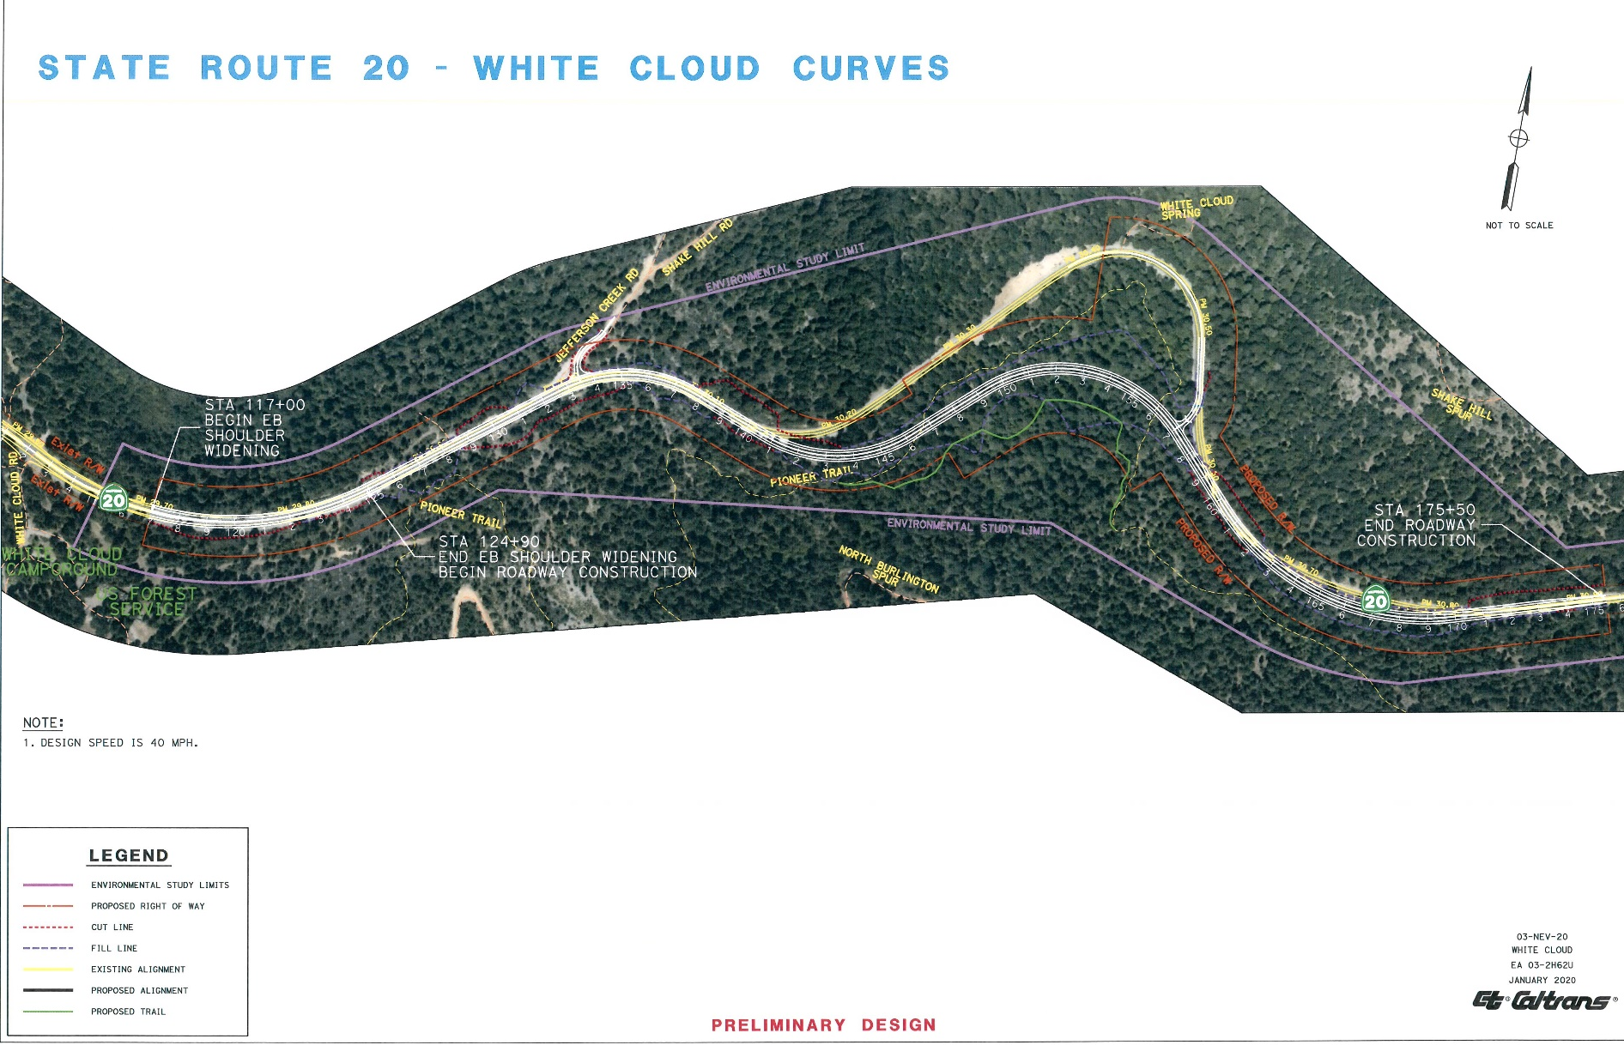
Figure 4 White Cloud Segment Existing and Proposed Trail Locations
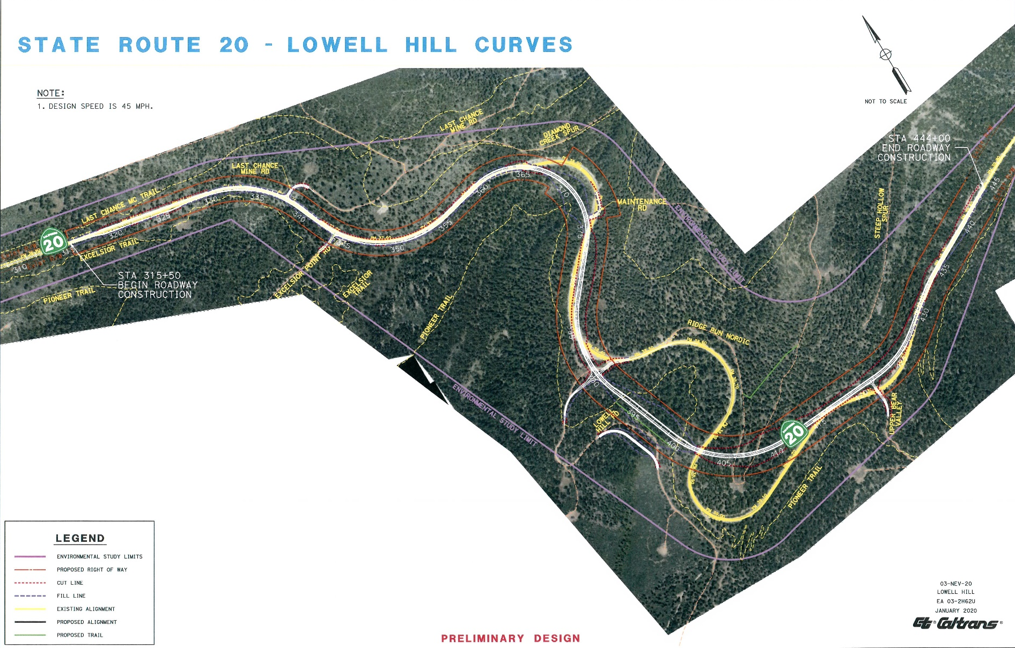

Figure 5 Lowell Hill Segment Existing and Proposed Trail Locations

Environmental Consequences
Caltrans will be abandoning its right of way along the portions of roadway being removed and acquiring right of way along the proposed right of way. Right of way is granted through a Transportation Easement from the United States Department of Agriculture Forest Service. The recreation trails will be relocated where their current paths intersect with the proposed alignment or necessary earthwork. Caltrans has determined that the California Park Preservation Act is not applicable because Caltrans is acquiring right of way as an easement from a Federal agency, rather than fee ownership with title transfer; is relinquishing abandoned right of way to the Forest Service; and Caltrans will allocate compensatory funds for trail relocation efforts to be conducted by the Forest Service following construction. Areas of trail relocation are illustrated in Figure 4 and Figure 5.
A segment of the Nordic/ Alpine ski routes in the Lowell Hill segment will require detours via replacement of tree markers both during construction and once the proposed Lowell Hill segment is operational due to approximately 1,650 linear feet of the existing trail bisected by earthwork cuts for the proposed alignment. Local roads intersecting with SR-20 will need to be reconnected with the proposed alignment.
Construction of the proposed project is anticipated to occur over two years, which would result in two Nordic ski trailhead parking locations and a portion of the Ridge Run Nordic trail within the Lowell Hill project segment being closed over the winter season between construction windows. Approximately 1,000 feet of the trail segment between trail markers number 19 and 25 would be permanently relocated due to earthwork required for the proposed alignment right of way. Access to approximately 7.25 miles of the marked cross-country ski trails at Steephollow Snow Trail System would remain unaffected by the project construction activities with access to them from the Alpha Omega Rest Stop, located west of the Lowell Hill project segment. In addition to the Steephollow Snow Trail System, TNF trails marked exclusively for cross-country ski are located off State Route 80 near Donner Summit and Truckee, off State Route 89 between Tahoe City and Sierraville, and off State Route 49 between Downieville and Sierraville, near the Yuba Pass.
There are parks and recreational facilities within the project vicinity that are protected by Section 4(f) of the Department of Transportation Act of 1966. This project will result in a “use” of some of those facilities as defined by Section 4(f). Please see Appendix A, Section 4(f), for additional details. It has also been determined that this project will not “use” other facilities as defined by Section 4(f) and some facilities within the project vicinity do not meet the definition of a Section 4(f) resource. Please see Appendix A under the heading “Resources Evaluated Relative to the Requirements of Section 4(f)” for additional details.
Avoidance, Minimization, and/or Mitigation Measures
Night work noise associated with construction near the White Cloud Campground will be minimized by monitoring and controlling noise from exceeding 86 decibels at 50 feet from the job site from 9 p.m. until 6 a.m.
The proposed roadway alignment will intersect with forest roads, some trail parking entrances and trails that currently run along topographic features near the existing roadway. During construction, forest road and trail closures or detours may be used to prevent undue accidents resulting from any conflicting activities between construction and recreationists. The Traffic Management Plan will detail temporary closures or detours including for forest road and trail parking entrances from SR-20, as well as trails. The TMP is developed in later stages of the project development.
Reconstruction and/ or replacement of road connections and existing gates modified by construction is included in the project scope. Forest road intersections with SR-20 will be realigned as part of the construction activities at Jefferson Creek Road, White Cloud Spring Road, Last Chance Mine Road, Excelsior Point Road, Lowell Hill Road, Ridge Run Nordic and Upper Bear Valley.
PRF-1 Compensatory trail reconstruction
Caltrans staff have and will continue to work with the TNF staff to include trail benches within the earthwork where feasible to graft trail segments intersected by the proposed roadway alignment. In areas where it is impractical for road construction equipment to rebuild trail segments, compensatory funding for TNF staff to oversee rebuilding the trail segments will be paid by Caltrans.
    - Community Character and Cohesion
Regulatory Setting
The National Environmental Policy Act (NEPA) of 1969, as amended, established that the federal government use all practicable means to ensure for all Americans safe, healthful, productive, and aesthetically and culturally pleasing surroundings (42 United States Code [USC] 4331[b][2]). The Federal Highway Administration (FHWA) in its implementation of NEPA (23 USC 109[h]) directs that final decisions on projects are to be made in the best overall public interest. This requires taking into account adverse environmental impacts, such as destruction or disruption of human-made resources, community cohesion, and the availability of public facilities and services.
Under the California Environmental Quality Act (CEQA), an economic or social change by itself is not to be considered a significant effect on the environment. However, if a social or economic change is related to a physical change, then social or economic change may be considered in determining whether the physical change is significant. Since this project would result in physical change to the environment, it is appropriate to consider changes to community character and cohesion in assessing the significance of the project’s effects.
Affected Environment
The community surrounding the project can be characterized as rural, forested and an unincorporated area of the County of Nevada. The project is situated in the Tahoe National Forest, between the communities of Nevada City approximately 16 miles to the west, and Emigrant Gap approximately 10 miles to the east. The town of Washington is approximately 6.5 miles northeast of the White Cloud segment. Private residences are sparsely located along, and off forest and county roads that intersect with SR-20. Within the project segments there are no residences immediately adjacent to the project. The parcels immediately adjacent to the project are owned by the USFS. Timber harvest, mining and public service-related jobs are the main sources of employment along the SR-20 corridor within TNF. There are no commercial accommodations or services businesses within the project limits or beyond for several miles in both directions. The White Cloud campground is immediately west of the project limits, and Skillman Horse Camp is approximately 2.5 miles east of the White Cloud segment. Both are USFS campgrounds.
The project segments run through three U.S. Census Bureau census tracts, numbered 7.01, 8.01 and 9, locations shown in Figure 6. Census tracts are relatively stable geographic units used for decennial updates of statistical data that reflects the participants of each tract. Comparisons of the three tracts with Nevada County is shown in Table 3. While there may be a common sense of independence shared by residents in the region surrounding the project, there is not a formal community affected by the project.
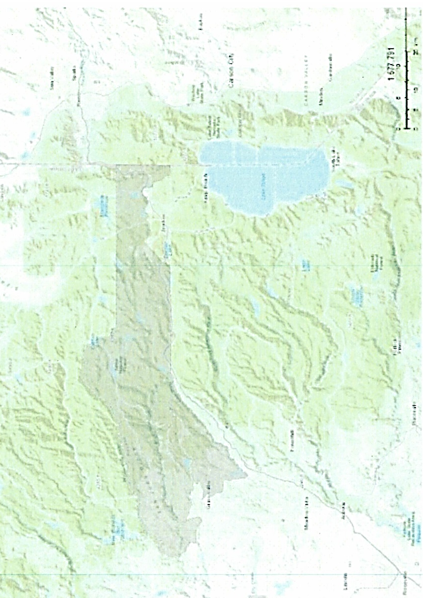
Figure 6 U.S. Census Tracts 7.01, 8.01 and 9 (shaded area)

Table 3 U.S. Census Data
Fact | Tract 7.01 | Tract 8.01 | Tract 9 | Nevada County, California
Population, Census, April 1, 2010 | 7,278 | 5,203 | 1,554 | 98,764
Persons under 18 years, percent | 14.30% | 12.20% | 14.20% | 17.30%
Persons 65 years and over, percent | 28.50% | 26.40% | 20.40% | 26.50%
Female persons, percent | 49.90% | 45.10% | 63.90% | 50.90%
Owner-occupied housing unit rate, 2013-2017 | 87.00% | 85.70% | 73.40% | 74.20%
Median gross rent, 2013-2017 | $1,411 | $1,186 | $959 | $1,217
Living in same house 1 year ago, percent of persons age 1 year+, 2013-2017 | 92.20% | 89.90% | 87.80% | 87.90%
Mean travel time to work (minutes), workers age 16 years+, 2013-2017 | 28.3 | 22.4 | 2570.00% | 24.5
Median household income (in 2017 dollars), 2013-2017 | $64,935 | $80,346 | $53,409 | $60,610
Persons in poverty, percent | 5.50% | 7.70% | 20.30% | 11.00%

Environmental Consequences
The proposed project does not divide any community, as the land being disturbed for the project construction is not used for residential, services or businesses. County residents of any income or ethnicity who commute in the highway corridor to work or community areas for goods and services may experience construction-related delays. Likewise, commercial vehicles delivering goods through the corridor will likely experience construction-related delays. Upon completion of the project, travel would be improved for all residents and area commuters.
Avoidance, Minimization, and/or Mitigation Measures
Staged construction planning will be used to minimize road closures that would cause delays. Residents in the region who require access to their property via SR-20 will be provided access including when through traffic road closures are enacted. Public notices, in coordination with the County of Nevada and TNF, will be used to help travelers be aware of and plan for construction related delays. No low-income populations have been identified to be adversely affected by the proposed project, so the project is not subject to provision of community mitigation.
    - Utilities and Emergency Services
Affected Environment
Utilities
A Right-of-Way utility report was conducted February 2018. AT&T owns one underground telecommunication transmission line which was identified in a portion of the White Cloud project location. There are no other identified utilities in the project area.
Emergency Services
Law enforcement in the area is provided by the Nevada County Sheriff’s Department, and the USFS law enforcement personnel. Fire response is provided by the USFS, from its county fire station immediately adjacent to the westerly limits of the White Cloud project segment. Emergency ground ambulance services in the region is provided by the Penn Valley Fire Protection District, Sierra Nevada Memorial Hospital Ambulance and the Truckee Fire Protection District.
Environmental Consequences
Utilities
The underground transmission line will be affected by the project because construction of the proposed alignment and removal of the abandoned roadway surface and decompaction of the road base will disrupt the earth surrounding the transmission line. Upon project approval and finalization of the environmental document, Caltrans will be authorized to notify the owner of the utility that there is a conflict between the utility and Caltrans’ proposed project. Utility Conflict Mapping will be sent along with the anticipated schedule of the proposed project. It is expected that once notice of the conflict is given, coordination will commence between the utility owner and Caltrans to develop a utility relocation plan.
Emergency Services
During construction, emergency service response times would be delayed during times of temporary road closures or detours. Section 2.5, Traffic And Transportation/ Pedestrian And Bicycle Facilities addresses managing traffic related concerns including coordinating with emergency services providers during construction. Following completion of the Build Alternative, the emergency service providers would benefit from the same road improvements as other roadway users. The road will have less drastic curves, so vehicles will not have to slow as much to navigate through the area, resulting in a benefit to the community through reduced emergency response times.
Avoidance, Minimization, and/or Mitigation Measures
Utilities
Caltrans will coordinate with AT&T during the Right of Way phase to notify them of a conflict and necessary relocation of their utilities prior to construction. The coordination will provide ample time for affected utility customers to be notified by AT&T of potential service disruptions. A coordinated relocation plan will be developed with AT&T to relocate the underground transmission line.
Emergency Services
All emergency service providers will be notified of the construction schedule and an emergency action plan will be developed for times when a coordinated emergency services response is required during a temporary road closure. See section 2.1.6 for development of the traffic management plan, which includes continuity of emergency services and emergency action planning.
    - Traffic and Transportation/Pedestrian and Bicycle Facilities
Regulatory Setting
Caltrans, as assigned by the Federal Highway Administration (FHWA), directs that full consideration should be given to the safe accommodation of pedestrians and bicyclists during the development of Federal-aid highway projects (see 23 Code of Federal Regulations [CFR] 652). It further directs that the special needs of the elderly and the disabled must be considered in all Federal-aid projects that include pedestrian facilities. When current or anticipated pedestrian and/or bicycle traffic presents a potential conflict with motor vehicle traffic, every effort must be made to minimize the detrimental effects on all highway users who share the facility.
In July 1999, the U.S. Department of Transportation (USDOT) issued an Accessibility Policy Statement pledging a fully accessible multimodal transportation system. Accessibility in federally assisted programs is governed by the USDOT regulations (49 CFR 27) implementing Section 504 of the Rehabilitation Act (29 United States Code [USC] 794). The FHWA has enacted regulations for the implementation of the 1990 Americans with Disabilities Act (ADA), including a commitment to build transportation facilities that provide equal access for all persons. These regulations require application of the ADA requirements to federal-aid projects, including Transportation Enhancement Activities.
Affected Environment
Caltrans conducted an updated Traffic Safety Accident Report on November 29, 2018 for both segments of the Build Alternative. The report was consistent with reports conducted during the planning and project initiation phases, as discussed previously in Section 1.2.2, Project Need. Caltrans approved the Transportation Concept Report for SR-20 on March 13, 2013. The Report addresses traffic analysis data and lists future programmed, planned and conceptual projects within segments of the highway. This project is in segment 17 of the Report and begins at the junction of SR 49 at Uren Street in Nevada City, ending at the SR-20 junction with Interstate 80. There are currently no pedestrian facilities within the proposed project segments.
The County of Nevada updated its Bicycle Master Plan in December 2016. The Plan does not identify SR-20 in the project area as part of its inventory of bicycle facilities. The Plan does propose that all state routes within the county where bicycle travel is permitted to be upgraded to Class III bike routes with multi-use shoulders. SR-20 is not specifically identified by the County for planned projects to improve bicycle lanes or paths. The project will provide shoulders widened to 8 feet where possible, providing sections of the highway that accomplish the segment goal of a Class III bike route.
Environmental Consequences
Caltrans uses Concept Level of Service (LOS) to reflect the minimum level or quality of acceptable operations for each route. In rural areas of Caltrans District 3, LOS D is typical. The SR-20 segment where the project is located operates a LOS E and is expected to remain LOS E throughout the 20-year period following approval of the Report. Mountainous terrain in this segment is a limiting factor to widening shoulders, adding passing lanes and making operational and safety improvements that would improve the LOS.
The project will impact local (forest) roads and intersections due to changes in the elevation of the proposed road surface at their intersections with SR-20. Impacted roads are (from west to east): Jefferson Creek Road, White Cloud Spring, Last Chance Mine Road, Excelsior Point Road, Lowell Hill Road and Upper Bear Valley Road. Temporary detours and/or closures may be required at times during construction to conform the proposed alignment with the existing local roads.
There are no public pedestrian sidewalks along or intersecting with SR-20 in the project limits; there would not be construction related impacts to non-existing facilities. The proposed project does not include any Transportation Enhancement Activities which would require application of ADA requirements.
During construction, bicyclists may encounter the same temporary detours and road closures that vehicular travelers will also encounter. Caltrans Traffic Operations staff in coordination with USFS and County of Nevada staff, will develop a final Traffic Management Plan (TMP). Temporary detours and road closures during construction that will affect both traffic, bicyclists and pedestrians will be managed through the TMP.
TMP’s may include public information planning, methods of informing motorist, incident management, construction staging and lane requirements, lane modifications, nightwork, alternate routes and/or detours and any agreements with local agencies for dealing with detoured traffic onto roadways not part of the state highway system. The TMP will also reflect public input to ensure inclusion for bicyclists, pedestrians including recreational hikers and other recreational trail users.
Once the Build Alternative construction is complete, shoulders will be widened throughout the project segments providing non-contiguous portions of the highway where bicyclist may safely ride out of the vehicular travel lane.
Avoidance, Minimization, and/or Mitigation Measures
Standard design elements and measures would be utilized to minimize any impacts to traffic and pedestrian/bicycle users as a result of the proposed project. No additional measures are proposed.
    - Visual/Aesthetics
Regulatory Setting
The National Environmental Policy Act (NEPA) of 1969, as amended, establishes that the federal government use all practicable means to ensure all Americans safe, healthful, productive, and aesthetically and culturally pleasing surroundings (42 United States Code [USC] 4331[b][2]). To further emphasize this point, the Federal Highway Administration (FHWA), in its implementation of NEPA (23 USC 109[h]), directs that final decisions on projects are to be made in the best overall public interest taking into account adverse environmental impacts, including among others, the destruction or disruption of aesthetic values.
The California Environmental Quality Act (CEQA) establishes that it is the policy of the state to take all action necessary to provide the people of the state “with…enjoyment of aesthetic, natural, scenic and historic environmental qualities” (CA Public Resources Code [PRC] Section 21001[b]).
Affected Environment
Following guidance from the FHWA Visual Impact Assessment for Highway Projects, a Visual Impact Analysis (VIA) was completed March 2019 based on preliminary design for the proposed project. The VIA analyzed existing visual resources, changes to the resources under the Build Alternative and viewer response to resource features such as scale, color and continuity, as well as characteristics that are used to describe visual quality. Graphic simulations were prepared to assist with comparisons of the “before and after” conditions at 4 roadside locations along the White Cloud segment, and 5 roadside locations along the Lowell Hill segment. These locations are termed key views in the VIA. To assist with orienting the key views in relation to the overall segments, additional aerial simulations were prepared. These offer a birds-eye view of existing and proposed changes. The simulations are shown without any treatments that are recommended as minimization measures in the VIA.

The immediate project area is characterized by mountainous terrain with steep, generally upward slopes to the north of SR-20 and downward slopes to the south of SR-20. The lands surrounding the project area are forested with local roads and trails for off-highway vehicles, horseback riding, mountain biking, hiking and winter recreation. USFS manages timber harvest throughout the Tahoe National Forest along the highway corridor screened by mature trees and understory vegetation. Visual character is described as a dense conifer forest with minor variation from deciduous trees such as oaks. The understory is made up of herbaceous shrubs and manzanita with rock outcroppings and exposed soils. The traveled highway is characterized as a narrow, enclosed corridor with views shortened by curves in the roadway and dense vegetation. Road cuts are common on both sides of the roadway and range in height. Colors are generally light to dark tans, browns, reds and grays, but predominantly green, unless there is snow cover.
The visual quality present in the existing project segments of SR-20 has high vividness due to the forested landscape and dynamic terrain. There are few visual interruptions due to the dense vegetation and lack of human built structures, so there is a very high rating for intactness. Likewise, unity is rated very high for most of the project, with a slightly lower rating of high at the key view number 1. Each simulated key view is individually evaluated for visual quality of the existing condition.
Within TNF, SR-20 is federally designated as a scenic byway. The project’s Lowell Hill segment intersects with State Scenic Highway designation between post miles 36.7-39.5. The rest of SR-20 is eligible, but not officially designated as a State Scenic Highway. The segments of SR-20 where the proposed project is located is a ridgetop highway corridor. Natural scenic resources can be viewed including Sierran mixed conifer forest and Ponderosa Pines both in the foreground and off in the distance which is complimented by intermittent views of steep mountainous terrain and granite ridgetops. The VIA did not identify outstanding features of form or age, unique or massive rock formations or any built structure that is a rare example of its period, style or design.
Environmental Consequences
The VIA evaluations of changes to the visual appearance of the finished highway under the Build Alternative would vary from other segments of SR-20 in TNF. The proposed project would result in widened canopies and longer views of the roadway where curve corrections would be replaced by straightened road segments. Traffic stopped at intersections with local roads will be visible sooner by highway travelers and highway cross-traffic will be observed sooner by motorists turning onto SR-20. In the first few year period following construction, manipulated soils and cuts in the hill sides will be contrasts to the rest of the corridor. Figure 7 shows simulations of what these conditions may look like in the White Cloud segment.
Figure 8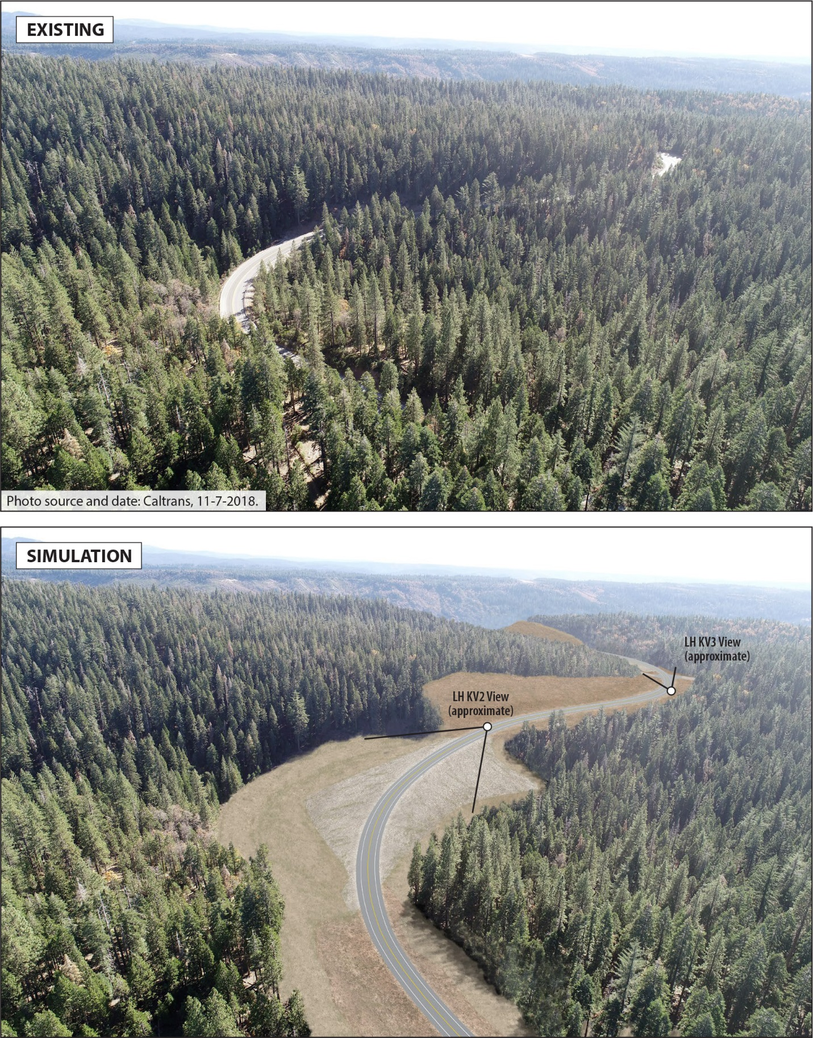
Figure 8 Lowell Hill Aerial Simulation, looking south-southeast, east of the intersections with Excelsior Point Road and Last Chance Mine Road.
shows the simulations of similar conditions in the Lowell Hill segment. The simulations do not reflect presumed conditions in the years following construction when natural succession of understory vegetation will return to the area affected by construction activities and abandoned highway right of way.
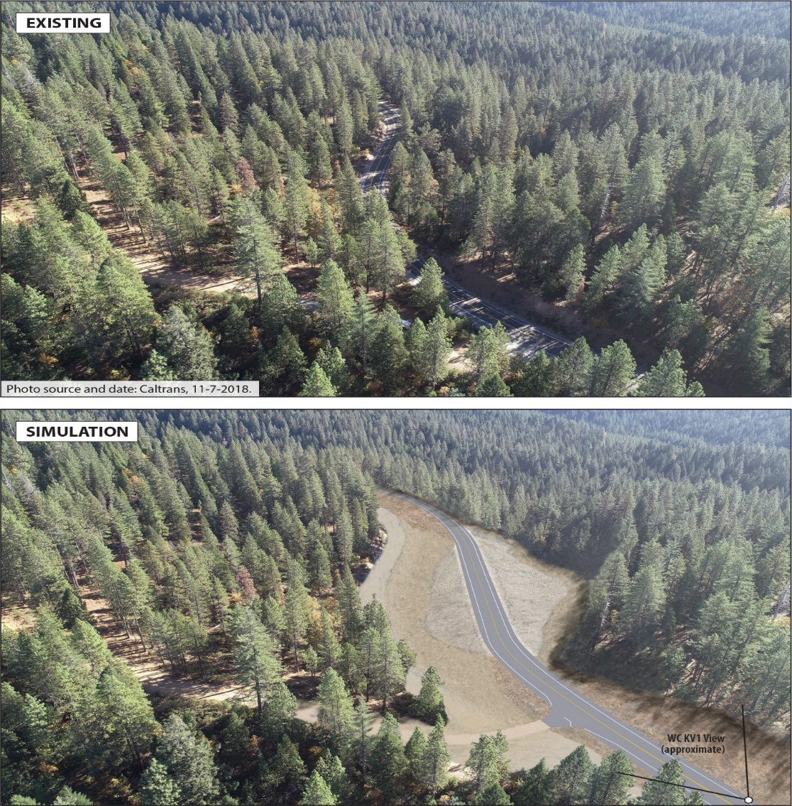
Figure 7 White Cloud Aerial Simulation, looking east at the intersection with Jefferson Creek Road
Figure 8 Lowell Hill Aerial Simulation, looking south-southeast, east of the intersections with Excelsior Point Road and Last Chance Mine Road.
During construction, the project limits will look different from the non-construction areas of SR-20. Marketable timber removed from the areas of earthwork will be processed in the United States, pursuant to TNF timber harvest permit conditions. Additional vegetation removal followed by clearing and grubbing will occur in the areas of the proposed alignment and where slopes are cut away from higher terrain or fill is placed to raise the ground for smooth vertical alignments. Perimeters of the construction areas may have high visibility fencing to protect resources in place, and stormwater run-off protections in place to minimize loose soils from traveling downhill. Due to stages of construction activities, travelers will see different aspects of the developing project as construction proceeds. The traveled roadway will have traffic calming measures in place while materials, machinery and workers are adjacent. Nighttime work would require lighting, which would create illuminated night views in an otherwise headlamp-only lit roadway.
Coordination with the TNF staff have resulted in contextually sensitive elements being considered for implementation in the final design, including tinted or painted metal beam guard rail, and natural material screening or barriers at areas where the decommissioned roadway would be visible or accessible from the proposed roadway.
Avoidance, Minimization, and/or Mitigation Measures
This section describes avoidance, minimization and/or mitigation measures that have been identified to lessen visual impacts caused by the proposed project. These measures will be designed by the District Landscape Architect (DLA) and incorporated into the project with concurrence of the project development team.
AES 1: Screen Decommissioned Alignment.
Views to the decommissioned roadbed from the proposed alignment will be screened with natural materials and native vegetation up to 200 feet back from the edges of the new roadway, depending on the angle of the configuration between the decommissioned roadbed and proposed alignment.
AES 2: Native Plant Recolonization.
Caltrans District Landscape Architect will at their discretion, apply best management practices in the Landscape Plan, Roadside Restoration, and Planting Plan. Species native to the Tahoe National Forest will be replanted, in patterns mimicking the existing vegetation. Live and downed trees salvaged from the site preparation will be placed to mimic natural patterns of fallen trees.
AES 3: Aesthetic Treatments
Aesthetic and scenic enhancements will be applied at the discretion of the District Landscape Architect, to softscape and hardscape treatments. Softscape aesthetic treatments may include landform or contour grading enhancement, minimize mature vegetation removal, especially downhill trees, or retention of rocks and trees removed during construction to be utilized on slopes and in areas of revegetation to mimic natural features in the landscape after slopes are finalized. Use of a native grass and wildflower seed mix for erosion control measures on exposed slopes will be included. Hardscape aesthetic treatments may include such treatments as using stain or texture consistent with TNF colors and patterns on structures such as metal beam guard rail, signs, rock slope protection or concrete.
    - Cultural Resources
Regulatory Setting
The term “cultural resources,” as used in this document, refers to the “built environment” (e.g., structures, bridges, railroads, water conveyance systems, etc.), places of traditional or cultural importance, and archaeological sites (both prehistoric and historic), regardless of significance. Under federal and state laws, cultural resources that meet certain criteria of significance are referred to by various terms including “historic properties,” “historic sites,” “historical resources,” and “tribal cultural resources.” Laws and regulations dealing with cultural resources include:
The National Historic Preservation Act (NHPA) of 1966, as amended, sets forth national policy and procedures for historic properties, defined as districts, sites, buildings, structures, and objects included in or eligible for listing in the National Register of Historic Places (NRHP). Section 106 of the NHPA requires federal agencies to take into account the effects of their undertakings on historic properties and to allow the Advisory Council on Historic Preservation (ACHP) the opportunity to comment on those undertakings, following regulations issued by the ACHP (36 Code of Federal Regulations [CFR] 800). On January 1, 2014, the First Amended Section 106 Programmatic Agreement (PA) among the Federal Highway Administration (FHWA), the ACHP, the California State Historic Preservation Officer (SHPO), and Caltrans went into effect for Caltrans projects, both state and local, with FHWA involvement. The PA implements the ACHP’s regulations, 36 CFR 800, streamlining the Section 106 process and delegating certain responsibilities to Caltrans. The FHWA’s responsibilities under the PA have been assigned to Caltrans as part of the Surface Transportation Project Delivery Program (23 United States Code [USC] 327).
The Archaeological Resources Protection Act (ARPA) applies when a project may involve archaeological resources located on federal or tribal land. The ARPA requires that a permit be obtained before excavation of an archaeological resource on such land can take place.
Historic properties may also be covered under Section 4(f) of the U.S. Department of Transportation Act, which regulates the “use” of land from historic properties (in Section 4(f) terminology—historic sites). See Appendix A for specific information about applicability of Section 4(f) toward historic properties.
The California Environmental Quality Act (CEQA) requires the consideration of cultural resources that are historical resources and tribal cultural resources, as well as “unique” archaeological resources. California Public Resources Code (PRC) Section 5024.1 established the California Register of Historical Resources (CRHR) and outlined the necessary criteria for a cultural resource to be considered eligible for listing in the CRHR and, therefore, a historical resource. Historical resources are defined in PRC Section 5020.1(j). In 2014, Assembly Bill 52 (AB 52) added the term “tribal cultural resources” to CEQA, and AB 52 is commonly referenced instead of CEQA when discussing the process to identify tribal cultural resources (as well as identifying measures to avoid, preserve, or mitigate effects to them). Defined in PRC Section 21074(a), a tribal cultural resource is a CRHR or local register eligible site, feature, place, cultural landscape, or object which has a cultural value to a California Native American tribe. Tribal cultural resources must also meet the definition of a historical resource. Unique archaeological resources are referenced in PRC Section 21083.2.
PRC Section 5024 requires state agencies to identify and protect state-owned historical resources that meet the NRHP listing criteria. It further requires Caltrans to inventory state-owned structures in its rights-of-way. Include the following sentence as applicable. Sections 5024(f) and 5024.5 require state agencies to provide notice to and consult with the State Historic Preservation Officer (SHPO) before altering, transferring, relocating, or demolishing state-owned historical resources that are listed on or are eligible for inclusion in the NRHP or are registered or eligible for registration as California Historical Landmarks. Procedures for compliance with PRC Section 5024 are outlined in a Memorandum of Understanding (MOU) between Caltrans and SHPO, effective January 1, 2015. For most Federal-aid projects on the State Highway System, compliance with the Section 106 PA will satisfy the requirements of PRC Section 5024.
Affected Environment
Analysis of the cultural resources for the proposed project include a Historic Property Survey Report and Historical Resource Evaluation Report, both completed in December 2019. A Finding of Effects has been submitted to the Office of Historic Preservation and Caltrans is awaiting the SHPO’s response to the proposed findings. Methods used to support the studies for the analysis include records searches, field surveys including Phase I pedestrian surveys and Extended Phase I testing, field testing and Native American consultation with the United Auburn Indian Community.
The Area of Potential Effects (APE) is the area studied for the cultural resources present in the general project area and which may extend beyond the boundary of the project study area. The APE is defined to avoid impacts to cultural resources when feasible, and where avoidance did not conflict with the purpose and need of the proposed project. The APE aligns with the cultural resource study area and project study area. It consists of a broad corridor that encompasses existing and proposed new right-of-way (ROW) as well as lands that may be used during construction but not included in the final ROW. As defined by Caltrans for the project, the project study area comprises two non-contiguous areas along SR-20 that total 565.3 acres. The western study area is the White Cloud project segment (97.4 acres) and the eastern study area is the Lowell Hill project segment (467.9 acres).
Cultural resources identified within the APE include several resources that are exempt from evaluation pursuant to Attachment 4 of the Section 106 Programmatic Agreement (Properties Exempt from Evaluation) and as applicable PRC 5024 MOU Stipulation VIII.C.1 and Attachment 4. Caltrans has evaluated one resource (Spring Box) as a result of this project and determined that it is not eligible for inclusion in the NRHP/CHL. Caltrans received concurrence on this determination from the SHPO in a letter dated January 14, 2020.
Two archaeological sites within the APE, a Native American bedrock milling station and flaked stone scatter (PLI-12) and a Native American flaked stone scatter (PLI-45), are assumed eligible for inclusion in the NRHP/CHL for the purposes of this project only because they will be protected in their entirety from any potential effects through the establishment of an Environmentally Sensitive Area (ESA), in accordance with Section 106 PA Stipulation VIII.C.3 and as applicable PRC 5024 MOU Stipulation VIII.C.3.
In accordance with Section 106 PA Stipulation VII.C.4 and as applicable PRC 5024 MOU Stipulation VII.C.4, the following properties within the APE are assumed eligible for inclusion in the NRHP and/or CHL for the purposes of this project only because evaluation was not possible: Ridge Ditch (P-29-001594), Blue Tent Ditch (P-29-00032), White Cloud Ditch (FS 05-17-53-01047), Towle Brothers Railroad Grade (P-29-001651-H), and Nevada City Route of the Emigrant Trail (NCRET) / Washington Ridge Wagon Roads (WRWR) (P-29-00732).
Environmental Consequences
Within the project APE, there are seven cultural resources that are assumed eligible for inclusion to the NRHP. Two of the historic properties are prehistoric archaeological sites and the other five are built environment linear resources. The first prehistoric archaeological sites will be avoided by a redesigned alignment that will not intersect with it, and the second prehistoric archeological site will be protected by using an ESA fenced area to restrict construction activities from happening on it. Thus, the project will have a “no adverse effect” to the two prehistoric historic properties.
The five linear resources include features which extend beyond the project study area, in some cases across state lines. These linear resources extend far outside the APE therefore it is beyond the scope of the proposed project to fully evaluate and records them. Because of this limitation, the resources are assumed eligible for the purposes of this undertaking. Caltrans has proposed that the project will not have an adverse effect on the linear resources and is currently consulting with SHPO regarding project effects. The proposed finding is based on a general lack of integrity of the resources and/or project impacts to a very small segment of a resource that stretches for miles.
If cultural materials are discovered during construction, all earth-moving activity within and around the immediate discovery area will be diverted until a qualified archaeologist can assess the nature and significance of the find.
If human remains are discovered, California Health and Safety Code (H&SC) Section 7050.5 states that further disturbances and activities shall stop in any area or nearby area suspected to overlie remains, and the County Coroner contacted. If the remains are thought by the coroner to be Native American, the coroner will notify the Native American Heritage Commission (NAHC), who, pursuant to PRC Section 5097.98, will then notify the Most Likely Descendent (MLD). At this time, the person who discovered the remains will contact the project archeologist so that they may work with the MLD on the respectful treatment and disposition of the remains. Further provisions of PRC 5097.98 are to be followed as applicable.
Consultation with the SHPO and the Tribal Historic Preservation Officer (THPO) was conducted during studies and will continue for the duration of the project. See Chapter 4 for additional information.
Properties eligible for protection under the Department of Transportation Act of 1966, Section 4(f) include the five linear resources. The proposed project would not result in a “use” of those historic sites as defined by Section 4(f). The two prehistoric archaeological sites were considered but do not warrant Section 4(f) protections. See Appendix A for additional details.
Avoidance, Minimization, and/or Mitigation Measures
A segment of the proposed alignment was initially identified to be in direct conflict with the first prehistoric archeological site. To avoid any impacts to this site and comply with the intention of the Department of Transportation Act of 1966, Section 4(f), the proposed alignment was re-routed. See Appendix A for more information on Section 4(f) properties.
The second prehistoric archeological site will also be avoided by shifting the proposed alignment and vertical elevation away from the site. This site will be avoided by placing Environmentally Sensitive Area fencing at the edge of the construction area and the site to maintain protection of it.
Although the project will destroy small segments of the five large linear resources, the segments within the area of direct impact for the proposed project do not retain sufficient integrity to convey the significance of the resource and/or the segments that would be lost represent a small fraction of the overall resource and would not diminish the ability of that resource to convey its importance for inclusion on the NRHP. Pending SHPO concurrence with the Finding of No Adverse Effect, no mitigation measures are required.

  - Physical Environment
    - Water Quality and Storm Water Runoff
Regulatory Setting
Federal Requirements: Clean Water Act
In 1972, Congress amended the Federal Water Pollution Control Act, making the addition of pollutants to the waters of the United States (U.S.) from any point source unlawful unless the discharge is in compliance with a National Pollutant Discharge Elimination System (NPDES) permit. This act and its amendments are known today as the Clean Water Act (CWA). Congress has amended the act several times. In the 1987 amendments, Congress directed dischargers of storm water from municipal and industrial/construction point sources to comply with the NPDES permit scheme. The following are important CWA sections:
Sections 303 and 304 require states to issue water quality standards, criteria, and guidelines.
Section 401 requires an applicant for a federal license or permit to conduct any activity that may result in a discharge to waters of the U.S. to obtain certification from the state that the discharge will comply with other provisions of the act. This is most frequently required in tandem with a Section 404 permit request (see below).
Section 402 establishes the NPDES, a permitting system for the discharges (except for dredge or fill material) of any pollutant into waters of the U.S. Regional Water Quality Control Boards (RWQCBs) administer this permitting program in California. Section 402(p) requires permits for discharges of storm water from industrial/construction and municipal separate storm sewer systems (MS4s).
Section 404 establishes a permit program for the discharge of dredge or fill material into waters of the U.S. This permit program is administered by the U.S. Army Corps of Engineers (USACE).
The goal of the CWA is “to restore and maintain the chemical, physical, and biological integrity of the Nation’s waters.”
The USACE issues two types of 404 permits: General and Individual. There are two types of General permits: Regional and Nationwide. Regional permits are issued for a general category of activities when they are similar in nature and cause minimal environmental effect. Nationwide permits are issued to allow a variety of minor project activities with no more than minimal effects.
Ordinarily, projects that do not meet the criteria for a Regional or Nationwide Permit may be permitted under one of the USACE’s Individual permits. There are two types of Individual permits: Standard permits and Letters of Permission. For Individual permits, the USACE decision to approve is based on compliance with U.S. Environmental Protection Agency’s (U.S. EPA) Section 404 (b)(1) Guidelines (40 Code of Federal Regulations [CFR] Part 230), and whether the permit approval is in the public interest. The Section 404(b)(1) Guidelines (Guidelines) were developed by the U.S. EPA in conjunction with the USACE and allow the discharge of dredged or fill material into the aquatic system (waters of the U.S.) only if there is no practicable alternative which would have less adverse effects. The Guidelines state that the USACE may not issue a permit if there is a least environmentally damaging practicable alternative (LEDPA) to the proposed discharge that would have lesser effects on waters of the U.S. and not have any other significant adverse environmental consequences. According to the Guidelines, documentation is needed that a sequence of avoidance, minimization, and compensation measures has been followed, in that order. The Guidelines also restrict permitting activities that violate water quality or toxic effluent standards, jeopardize the continued existence of listed species, violate marine sanctuary protections, or cause “significant degradation” to waters of the U.S. In addition, every permit from the USACE, even if not subject to the Section 404(b)(1) Guidelines, must meet general requirements. See 33 CFR 320.4. A discussion of the LEDPA determination, if any, for the document is included in the Wetlands and Other Waters section.
State Requirements: Porter-Cologne Water Quality Control Act
California’s Porter-Cologne Act, enacted in 1969, provides the legal basis for water quality regulation within California. This act requires a “Report of Waste Discharge” for any discharge of waste (liquid, solid, or gaseous) to land or surface waters that may impair beneficial uses for surface and/or groundwater of the state. It predates the CWA and regulates discharges to waters of the state. Waters of the state include more than just waters of the U.S., like groundwater and surface waters not considered waters of the U.S. Additionally, it prohibits discharges of “waste” as defined, and this definition is broader than the CWA definition of “pollutant.” Discharges under the Porter-Cologne Act are permitted by Waste Discharge Requirements (WDRs) and may be required even when the discharge is already permitted or exempt under the CWA.
The State Water Resources Control Board (SWRCB) and RWQCBs are responsible for establishing the water quality standards (objectives and beneficial uses) required by the CWA and regulating discharges to ensure compliance with the water quality standards. Details about water quality standards in a project area are included in the applicable RWQCB Basin Plan. In California, RWQCBs designate beneficial uses for all water body segments in their jurisdictions and then set criteria necessary to protect those uses. As a result, the water quality standards developed for particular water segments are based on the designated use and vary depending on that use. In addition, the SWRCB identifies waters failing to meet standards for specific pollutants. These waters are then state-listed in accordance with CWA Section 303(d). If a state determines that waters are impaired for one or more constituents and the standards cannot be met through point source or non-point source controls (NPDES permits or WDRs), the CWA requires the establishment of Total Maximum Daily Loads (TMDLs). TMDLs specify allowable pollutant loads from all sources (point, non-point, and natural) for a given watershed.
State Water Resources Control Board and Regional Water Quality Control Boards
The SWRCB administers water rights, sets water pollution control policy, and issues water board orders on matters of statewide application, and oversees water quality functions throughout the state by approving Basin Plans, TMDLs, and NPDES permits. RWCQBs are responsible for protecting beneficial uses of water resources within their regional jurisdiction using planning, permitting, and enforcement authorities to meet this responsibility.
National Pollutant Discharge Elimination System (NPDES) Program
Municipal Separate Storm Sewer Systems (MS4)
Section 402(p) of the CWA requires the issuance of NPDES permits for five categories of storm water discharges, including Municipal Separate Storm Sewer Systems (MS4s). An MS4 is defined as “any conveyance or system of conveyances (roads with drainage systems, municipal streets, catch basins, curbs, gutters, ditches, human-made channels, and storm drains) owned or operated by a state, city, town, county, or other public body having jurisdiction over storm water, that is designed or used for collecting or conveying storm water.” The SWRCB has identified Caltrans as an owner/operator of an MS4 under federal regulations. Caltrans MS4 permit covers all Department rights-of-way, properties, facilities, and activities in the state. The SWRCB or the RWQCB issues NPDES permits for five years, and permit requirements remain active until a new permit has been adopted.
Caltrans MS4 Permit, Order No. 2012-0011-DWQ (adopted on September 19, 2012 and effective on July 1, 2013), as amended by Order No. 2014-0006-EXEC (effective January 17, 2014), Order No. 2014-0077-DWQ (effective May 20, 2014) and Order No. 2015-0036-EXEC (conformed and effective April 7, 2015) has three basic requirements:
1. Caltrans must comply with the requirements of the Construction General Permit (see below);
2. Caltrans must implement a year-round program in all parts of the State to effectively control storm water and non-storm water discharges; and
3. Caltrans storm water discharges must meet water quality standards through implementation of permanent and temporary (construction) Best Management Practices (BMPs), to the maximum extent practicable, and other measures as the SWRCB determines to be necessary to meet the water quality standards.
To comply with the permit, Caltrans developed the Statewide Storm Water Management Plan (SWMP) to address storm water pollution controls related to highway planning, design, construction, and maintenance activities throughout California. The SWMP assigns responsibilities within Caltrans for implementing storm water management procedures and practices as well as training, public education and participation, monitoring and research, program evaluation, and reporting activities. The SWMP describes the minimum procedures and practices Caltrans uses to reduce pollutants in storm water and non-storm water discharges. It outlines procedures and responsibilities for protecting water quality, including the selection and implementation of BMPs. The proposed project will be programmed to follow the guidelines and procedures outlined in the latest SWMP to address storm water runoff.
Construction General Permit
Construction General Permit, Order No. 2009-0009-DWQ (adopted on September 2, 2009 and effective on July 1, 2010), as amended by Order No. 2010-0014-DWQ (effective February 14, 2011) and Order No. 2012-0006-DWQ (effective on July 17, 2012). The permit regulates storm water discharges from construction sites that result in a Disturbed Soil Area (DSA) of one acre or greater, and/or are smaller sites that are part of a larger common plan of development. By law, all storm water discharges associated with construction activity where clearing, grading, and excavation result in soil disturbance of at least one acre must comply with the provisions of the General Construction Permit. Construction activity that results in soil disturbances of less than one acre is subject to this Construction General Permit if there is potential for significant water quality impairment resulting from the activity as determined by the RWQCB. Operators of regulated construction sites are required to develop Storm Water Pollution Prevention Plans (SWPPPs); to implement sediment, erosion, and pollution prevention control measures; and to obtain coverage under the Construction General Permit.
The Construction General Permit separates projects into Risk Levels 1, 2, or 3. Risk levels are determined during the planning and design phases, and are based on potential erosion and transport to receiving waters. Requirements apply according to the Risk Level determined. For example, a Risk Level 3 (highest risk) project would require compulsory storm water runoff pH and turbidity monitoring, and before construction and after construction aquatic biological assessments during specified seasonal windows. For all projects subject to the permit, applicants are required to develop and implement an effective SWPPP. In accordance with Caltrans SWMP and Standard Specifications, a Water Pollution Control Program (WPCP) is necessary for projects with DSA less than one acre.
Section 401 Permitting
Under Section 401 of the CWA, any project requiring a federal license or permit that may result in a discharge to a water of the U.S. must obtain a 401 Certification, which certifies that the project will be in compliance with state water quality standards. The most common federal permits triggering 401 Certification are CWA Section 404 permits issued by the USACE. The 401 permit certifications are obtained from the appropriate RWQCB, dependent on the project location, and are required before the USACE issues a 404 permit.
In some cases, the RWQCB may have specific concerns with discharges associated with a project. As a result, the RWQCB may issue a set of requirements known as WDRs under the State Water Code (Porter-Cologne Act) that define activities, such as the inclusion of specific features, effluent limitations, monitoring, and plan submittals that are to be implemented for protecting or benefiting water quality. WDRs can be issued to address both permanent and temporary discharges of a project.
Affected Environment
A Water Quality Assessment (WQA) for the White Cloud project segment was completed on November 21, 2017. An initial WQA for the Lowell Hill project segment was completed on July 25, 2018 and updated on December 10, 2019 to include the proposed work covered under the three individual EA’s that comprise the Omega Curves project.
The White Cloud segment of the proposed project is in the Deer Creek watershed which receives average annual precipitation of just under 60.5 inches. Precipitation is received into the Scotts Flat Reservoir and eventually released into the Yuba River. Both the South Fork of the Yuba River and Scotts Flat Reservoir are identified as tributary waters with TMDLs listed for mercury with allowable pollutant loads considered from all sources (point, non-point, and natural) for the watershed.
The Lowell Hill segment of the proposed project is in the Upper Bear River watershed, which receives average annual precipitation of just over 64 inches. Precipitation flows into the Steephollow Creek before being received by the South Yuba Channel. There are no TDMLs listed for this watershed.
Neither of the project segments are inside Urban MS4 permit boundaries or pass through areas with direct discharge to municipal or domestic water supply reservoirs or ground water percolation facilities. The South Yuba Channel however, does flow approximately 18 miles through TNF and delivers domestic and agricultural water to Nevada City and Grass Valley.
Neither of the project segments lie within a high-risk receiving watershed. High risk receiving watersheds are watersheds that drain to water bodies that are either listed on the Clean Water Act section 303(d) list for sedimentation/siltation or turbidity, have a U.S. Environmental Protection Agency-approved Total Maximum Daily Load Implementation Plan for sediment; or have beneficial uses that support cold water ecosystems (Cold), high quality aquatic habitat suitable for reproduction and early life development of fish (Spwn), and habitat necessary for migration and acclimatization between fresh and salt waters (Migr). A project that meets at least one of the three criteria has a high receiving water risk.
There are no TMDL stakeholders in either project segment. The segments are both in the Central Valley Regional Water Quality Control Board’s jurisdiction.
Environmental Consequences
A Storm Water Data Report (SWDR) has not yet been prepared for this project as it will require a more developed design. The SWDR will analyze the roadway drainage-related features and ensure that implementation of them are in compliance with the NPDES permit and appropriate BMPs are incorporated into the construction contract. Project-specific Design Pollution Prevention and Construction Site Best Management Practices (BMPs) recommendations come out of the SWDR.
The discharge of storm water runoff from construction sites has the potential to affect water quality standards, water quality objectives and beneficial uses. Potential pollutants and sources include (and are not limited to) the following:
- Sediment;
- Non-storm water (groundwater, waters from cofferdams, dewatering, water diversions) discharges;
- Vehicle and equipment cleaning agents, fueling, and maintenance;
- Material handling, waste, and storage activities;
- Asphalt concrete and Portland cement concrete; and
- Fertilizers and herbicides.
Typical BMP’s that are likely to be included for this project may include (but are not limited to) the following: concrete washouts and bins, drainage inlet protection, plastic coverings, straw wattles, silt fencing, waste management and disposal bins, stabilized construction vehicle ingress and egress points, vacuum truck and pavement sweeper utilization.
Avoidance, Minimization, and/or Mitigation Measures
Avoidance measures that are recommended for the proposed project include:
1. The project shall adhere to the conditions of the Caltrans Statewide NPDES Permit issued by the State Water Resources Control Board, (Order No. 2012-0011-DWQ, NPDES Permit No. CAS000003) on September 19, 2012; and all adopted amendments to this Permit. This statewide permit regulates storm water and non-storm water discharges from Caltrans’ properties and facilities, and discharges associated with operation and maintenance of the State highway system. Caltrans facilities include, but are not limited to, maintenance stations/yards, equipment storage areas, storage facilities, fleet vehicle parking and maintenance areas and warehouses with material storage areas.
2. Adherence to the requirements of the statewide NPDES General Permit For Storm Water Discharges Associated With Construction And Land Disturbance Activities (Order No. 2009-0009-DWQ, NPDES No. CAS000002) and all adopted amendments to this General Permit; for discharge of pollutants to waters of the United States, from construction sites that disturb one or more acres of land surface or is part of a larger common plan of development or sale that disturbs more than one acre of land surface.
3. The discharge of storm water runoff from construction sites has the potential to affect water quality standards, water quality objectives and beneficial uses. Potential pollutants and sources are sediment; non-storm water (groundwater, waters from cofferdams, dewatering, water diversions) discharges; from vehicle and equipment cleaning agents, fueling, and maintenance; from waste materials and materials handling and storage activities.
4. Adherence to the following is recommended to prevent receiving water pollution as a result of construction activities and/or operations from this project:
a. Follow all applicable guidelines and requirements in the 2018 Caltrans Standard Specifications (2018 CSS), Section 13, regarding water pollution control and general specifications for preventing, controlling, and abating water pollution to Department owned Municipal Separate Storm Sewer Systems (MS4s), streams, waterways, and other bodies of water.
b. The Contractor prepared Storm Water Pollution Prevention Plan (SWPPP) shall incorporate appropriate temporary Construction Site BMPs to implement effective handling, storage, use and disposal practices during construction activities.
c. Focus and attention during construction should be given to 2018 CSS, Section 13-4 (Job Site Management), to control potential sources of water pollution before it encounters any MS4 or watercourse. It requires the Contractor to implement spill prevention and controls; materials, waste and non-storm management controls; and manage dewatering activities at the construction site.
d. Existing drainage facilities should be identified and protected by the application of appropriate temporary Construction Site BMPs.
e. If and where applicable, shoulder backing areas should be stabilized by Temporary Construction Site BMPs, or rolled and compacted in place, by the end of each day and prior to the onset of precipitation.
5. The Caltrans’ Storm Water Management Plan (SWMP), the Project Planning and Design Guide (PPDG) Section 4, and the Evaluation Documentation Form (EDF) provide detailed guidance in determining if a specific project requires the consideration of permanent Treatment BMPs.
    - Air Quality
Regulatory Setting
The Federal Clean Air Act (FCAA), as amended, is the primary federal law that governs air quality while the California Clean Air Act (CCAA) is its companion state law. These laws, and related regulations by the United States Environmental Protection Agency (U.S. EPA) and the California Air Resources Board (ARB), set standards for the concentration of pollutants in the air. At the federal level, these standards are called National Ambient Air Quality Standards (NAAQS). NAAQS and state ambient air quality standards have been established for six transportation-related criteria pollutants that have been linked to potential health concerns: carbon monoxide (CO), nitrogen dioxide (NO₂), ozone (O₃), particulate matter (PM)—which is broken down for regulatory purposes into particles of 10 micrometers or smaller (PM₁₀) and particles of 2.5 micrometers and smaller (PM_{2.5})—and sulfur dioxide (SO₂). In addition, national and state standards exist for lead (PB), and state standards exist for visibility reducing particles, sulfates, hydrogen sulfide (H₂S), and vinyl chloride. The NAAQS and state standards are set at levels that protect public health with a margin of safety and are subject to periodic review and revision. Both state and federal regulatory schemes also cover toxic air contaminants (air toxics); some criteria pollutants are also air toxics or may include certain air toxics in their general definition.
Federal air quality standards and regulations provide the basic scheme for project-level air quality analysis under the National Environmental Policy Act (NEPA). In addition to this environmental analysis, a parallel “Conformity” requirement under the FCAA also applies.
Conformity
The conformity requirement is based on FCAA Section 176(c), which prohibits the U.S. Department of Transportation (USDOT) and other federal agencies from funding, authorizing, or approving plans, programs, or projects that do not conform to State Implementation Plan (SIP) for attaining the NAAQS. “Transportation Conformity” applies to highway and transit projects and takes place on two levels: the regional (or planning and programming) level and the project level. The proposed project must conform at both levels to be approved.
Conformity requirements apply only in nonattainment and “maintenance” (former nonattainment) areas for the NAAQS, and only for the specific NAAQS that are or were violated. U.S. EPA regulations at 40 Code of Federal Regulations (CFR) 93 govern the conformity process. Conformity requirements do not apply in unclassifiable/attainment areas for NAAQS and do not apply at all for state standards regardless of the status of the area.
Regional conformity is concerned with how well the regional transportation system supports plans for attaining the NAAQS for carbon monoxide (CO), nitrogen dioxide (NO₂), ozone (O₃), particulate matter (PM₁₀ and PM_{2.5}), and in some areas (although not in California), sulfur dioxide (SO₂). California has nonattainment or maintenance areas for all of these transportation-related “criteria pollutants” except SO₂, and also has a nonattainment area for lead (Pb); however, lead is not currently required by the FCAA to be covered in transportation conformity analysis. Regional conformity is based on emission analysis of Regional Transportation Plans (RTPs) and Federal Transportation Improvement Programs (FTIPs) that include all transportation projects planned for a region over a period of at least 20 years (for the RTP) and 4 years (for the FTIP). RTP and FTIP conformity uses travel demand and emission models to determine whether or not the implementation of those projects would conform to emission budgets or other tests at various analysis years showing that requirements of the FCAA and the SIP are met. If the conformity analysis is successful, the Metropolitan Planning Organization (MPO), Federal Highway Administration (FHWA), and Federal Transit Administration (FTA) make the determinations that the RTP and FTIP are in conformity with the SIP for achieving the goals of the FCAA. Otherwise, the projects in the RTP and/or FTIP must be modified until conformity is attained. If the design concept and scope and the “open-to-traffic” schedule of a proposed transportation project are the same as described in the RTP and FTIP, then the proposed project meets regional conformity requirements for purposes of project-level analysis.
Project-level conformity is achieved by demonstrating that the project comes from a conforming RTP and TIP; the project has a design concept and scope that has not changed significantly from those in the RTP and TIP; project analyses have used the latest planning assumptions and EPA-approved emissions models; and in PM areas, the project complies with any control measures in the SIP. Furthermore, additional analyses (known as hot-spot analyses) may be required for projects located in CO and PM nonattainment or maintenance areas to examine localized air quality impacts.
Affected Environment
An Air Quality Conformity Findings Checklist was prepared for the three sub-projects (EA’s 03-1H810, 03-0H240 and 2H620) on December 11, 2019, December 18, 2019, November 13, 2019 respectively. The projects were determined to be exempt from all project level conformity requirements, per 40 CFR 93.126. The project types are safety with features that correct, improve, or eliminate a hazardous location, widen narrow pavements, and do not add travel lanes. Air Quality Reports were completed for the three sub-projects in December 2019. The project is in the Northern Sierra Air Quality Management District of the Mountain Counties Air Basin.
Weather and terrain can influence air quality. Certain weather parameters are highly correlated to air quality, including temperature, the amount of sunlight, and the type of winds at the surface and above the surface. Winds can transport ozone and ozone precursors from one region to another, contributing to air quality problems downwind of source regions. Furthermore, mountains can act as a barrier that prevents ozone from dispersing. The terrain of the area has a great influence on local winds, so that wide variability in wind direction can be expected. Nevada County exhibits large variations in terrain and consequently exhibits large variations in climate, both of which affect air quality. The western portions of the county slope relatively gradually with deep river canyons running from southwest to northeast toward the crest of the Sierra Nevada range.
Pollutants considered to impact air quality are investigated and tracked by both the federal and state air quality agencies. These pollutants are: Ozone (O₃), Respirable Particulate Matter (PM₁₀), Fine Particulate Matter (PM_{2.5}) Carbon Monoxide, (CO), Nitrogen Dioxide (NO₂), Sulfur Dioxide (SO₂), Lead, (Pb), Visibility-Reducing Particles, Sulfates, and Hydrogen Sulfide. Status can be listed for these pollutants as Attainment, Nonattainment or Unclassified. At the federal level, Western Nevada County is classified as unclassified/attainment for PM_{2.5}, CO, NO₂, SO₂, and Pb, nonattainment for 8-Hour O₃, and unclassified for PM₁₀. At the state level, Western Nevada County is classified as nonattainment for O₃ and PM₁₀, attainment for CO, NO₂, SO₂, Pb, and sulfates, and unclassified for PM_{2.5}, visibility-reducing particles, and hydrogen sulfide.
Levels of PM₁₀ exceeded the state highest 24-hr standard of 50 micrograms per cubic meter for the past three years. In 2016, the highest 24-hour concentration was 56.6 micrograms per cubic meter. In 2017, the highest 24-hour concentration was 123.9 micrograms per cubic meter. In 2018, the highest 24-hour concentration was 270.1 micrograms per cubic meter. The number of days that the concentration of PM₁₀ exceeded the state standard was 2, 18, and 31 days for the years 2016, 2017, and 2018 respectively. However, the overall annual concentration was 12.2 micrograms per cubic meter in 2016, and insufficient data was available to determine annual concentration for both 2017 and 2018. Concentrations were measured at the Grass Valley-Litton Building in Nevada City.
Information regarding recent and historical State Implementation Plan (SIP) activities in the nonattainment area related to Western Nevada County Air Quality Management Plans that controls air pollution in the proposed project are. The information in Table 4 provides U.S. EPA actions related to designations.
Table 4 Status of SIPs Relevant to the Project Area.
Name/Description | Status
2018 Western Nevada County Planning Area Ozone Attainment Plan | Released (10/12/2018)
Rule 428-NSR Requirements for New and Modified Major Sources in Nonattainment Areas | Noticed (11/25/2019)
2018 Updates to the California State Implementation Plan | Adopted (10/25/2018)
2018 Reasonably Available Control Technology SIP for Western Nevada County | Submitted (6/7/2018)

Environmental Consequences- Long Term
This project is exempt from all air quality conformity analysis requirements per Table 2 of 40 Code of Federal Regulations (CFR) §93.126, subsection “Safety” (“Projects that correct, improve, or eliminate a hazardous location or feature”). Conformity requirements do not apply. Interagency consultation is not required because a project-level particulate matter hot spot analysis is not required. Separate listing of the project in the Regional Transportation Plan and Transportation Improvement Program, and their regional conformity analyses, is not necessary. The project will not interfere with timely implementation of Transportation Control Measures identified in the applicable Statewide Improvement Plan and regional conformity analysis.
Environmental Consequences- Construction
During construction, short-term degradation of air quality may occur due to the release of particulate emissions (airborne dust) generated by excavation, grading, hauling, and other construction-related activities. Emissions from construction equipment also are expected and would include carbon monoxide (CO), nitrogen oxides (NOx), volatile organic compounds (VOCs), directly-emitted particulate matter (PM₁₀ and PM_{2.5}), and toxic air contaminants such as diesel exhaust particulate matter. Ozone is a regional pollutant that is derived from NOx and VOCs in the presence of sunlight and heat.
Site preparation and roadway construction typically involves clearing, cut-and-fill activities, grading, removing or improving existing roadways, building bridges, and paving roadway surfaces. Construction-related effects on air quality from most highway projects would be greatest during the site preparation phase because most engine emissions are associated with the excavation, handling, and transport of soils to and from the site. These activities could temporarily generate enough PM₁₀, PM_{2.5}, and small amounts of CO, SO₂, NOx, and VOCs to be of concern. Sources of fugitive dust would include disturbed soils at the construction site and trucks carrying uncovered loads of soils. Unless properly controlled, vehicles leaving the site could deposit mud on local streets, which could be an added source of airborne dust after it dries. PM₁₀ emissions would vary from day to day, depending on the nature and magnitude of construction activity and local weather conditions. PM₁₀ emissions would depend on soil moisture, silt content of soil, wind speed, and the amount of equipment operating. Larger dust particles would settle near the source, while fine particles would be dispersed over greater distances from the construction site.
Construction activities for large development projects are estimated by the United States Environmental Protection Agency (U.S. EPA) to add 1.2 tons of fugitive dust per acre of soil disturbed per month of activity. If water or other soil stabilizers are used to control dust, the emissions can be reduced by up to 50 percent. Caltrans Standard Specifications (Section 14) on dust minimization require use of water or dust palliative compounds and will reduce potential fugitive dust emissions during construction.
In addition to dust-related PM₁₀ emissions, heavy-duty trucks and construction equipment powered by gasoline and diesel engines would generate CO, SO₂, NOx, VOCs and some soot particulate (PM₁₀ and PM_{2.5}) in exhaust emissions. If construction activities were to increase traffic congestion in the area, CO and other emissions from traffic would increase slightly while those vehicles are delayed. These emissions would be temporary and limited to the immediate area surrounding the construction site.
SO₂ is generated by oxidation during combustion of organic sulfur compounds contained in diesel fuel. Under California law and ARB regulations, off-road diesel fuel used in California must meet the same sulfur and other standards as on-road diesel fuel (not more than 15 ppm sulfur), so SO₂-related issues due to diesel exhaust will be minimal.
Some phases of construction, particularly asphalt paving, may result in short-term odors in the immediate area of each paving site(s). Such odors would quickly disperse to below detectable levels as distance from the site(s) increases.
There is a potential for naturally occurring asbestos to be encountered during construction. There is a very small potential to encounter structural asbestos. Lead is preset in disturbed soils containing high levels of aerially deposited lead (ADL), or removal/ modification of lead-based structural coatings. A preliminary site investigation will be conducted during the Plans, Specification and Estimate phase. Any asbestos or ADL that is identified as present in the project areas during the investigation will be able to be addressed during construction using the Caltrans Standard Specifications. There are no features of the project that deal with removal or modification of lead-based structural coatings.
The primary MSAT pollutant source within the project area is SR 20.
The US EPA regulates a list of air toxics (64 FR 38706). Toxic air pollutants or hazardous air pollutants (HAPs) are those that are known to cause or suspected of causing cancer or other serious health ailments. Controlling air toxic emissions became a national priority with the passage of the Clean Air Act Amendments (CAAA) of 1990, whereby Congress mandated that US EPA regulate 188 air toxics, also known as hazardous air pollutants. In 2001, US EPA issued its first Mobile Source Air Toxics Rule, which identified 21 mobile source air toxic (MSAT) compounds as being hazardous air pollutants that required regulation. A subset of these MSAT compounds was identified as having the greatest influence on health. EPA issued the second MSAT Rule in 2007, which generally supported the findings of the first rule and provided additional recommendations of compounds having the greatest impact on health. The rule also identified several engine emission certification standards that must be implemented. US EPA has assessed this expansive list in their latest rule on the Control of Hazardous Air Pollutants from Mobile Sources (Federal Register, Vol. 72, No. 37, page 8430, February 26, 2007) and identified a group of 93 compounds emitted from mobile sources that are listed in their Integrated Risk Information System (IRIS).6
The 21 HAPs identified by US EPA as MSATs are emitted from highway vehicles and non-road equipment. Some toxic compounds are present in fuel and are emitted to the air when the fuel evaporates or passes through the engine unburned. Other toxics are emitted from the incomplete combustion of fuels or as by-products. Metal air toxics result from engine wear or from impurities in oil or gasoline. US EPA has identified seven compounds with significant contributions from mobile sources that are among the national and regional-scale cancer risk drivers from their 1999 National Air Toxics Assessment (NATA).7 These are acrolein, benzene, 1,3-butadiene, diesel particulate matter (DPM) that includes diesel exhaust organic gases, formaldehyde, naphthalene, and polycyclic organic matter. While FHWA considers these the priority mobile source air toxics, the list is subject to change and may be adjusted in consideration of future EPA rules.
The US EPA is the lead federal agency responsible for administering the Clean Air Act and has certain responsibilities regarding the health effects of MSATs. In its 2001 rule (66 FR 17229), US EPA examined the impacts of existing and newly promulgated mobile source control programs, including its reformulated gasoline program, national low emission vehicle standards, Tier 2 motor vehicle emissions standards and gasoline sulfur control requirements, and proposed heavy duty engine and vehicle standards and on-highway diesel fuel sulfur control requirements.8 The agency is preparing another rule under authority of Clean Air Act Section 202(l) that will address these issues and could make adjustments to the full 21 and the primary seven MSATs.9
FHWA's ongoing work in air toxics includes a research programs to better understand and quantify the contribution of mobile sources to air emissions, the establishment of policies for addressing mobile source emissions in environmental reports, and the assessment of scientific literature on health impacts associated with motor vehicle emissions. California’s vehicle emission control and fuel standards are more stringent than federal standards, and are effective earlier. CARB found that DPM contributes over 70 percent of the known risk from air toxics and poses the greatest cancer risks among all identified air toxics. Diesel trucks contribute more than half of the total diesel combustion sources. In response, CARB adopted a Diesel Risk Reduction Plan with control measures to reduce the overall DPM emissions by about 85 percent from 2000 to 2020. Part of the plan included recently adopted regulation that requires operators of truck and bus fleets in California to retrofit or replace vehicles to meet US EPA NOX and PM2.5 emission standards for 2010 model trucks (13 C.C.R. section 2025). Implementation of this regulation begins in 2014. By 2023, nearly all trucks and buses operating in California will need to meet 2010 model year engine emission standards.
Emissions of MSATs are anticipated to decrease substantially in future years. According to an FHWA analysis using EPA's MOVES2010b model, a combined reduction of 83 percent in the total emissions for the priority MSATs from 2010 to 2050 is projected. This would occur while vehicle-miles travelled (VMT) is assumed to increase by 102 percent. The combined State and federal regulations are expected to result in greater emission reductions, more quickly, than the FHWA analysis indicates. Trends for specific locations may be different, depending on locally derived information representing vehicle-miles travelled, vehicle speeds, vehicle mix, fuels, emission control programs, meteorology, and other factors.
According to the FHWA’s Interim Guidance on MSATs, this project is classified as a category 1 project (Projects with No Meaningful Potential MSAT Effects, or Exempt Projects). This project is expected to meet this category because the project would not produce meaningful potential MSAT effects. The purpose of this project is to improve safety by constructing horizontal and vertical curve alignments. This project has been determined to generate minimal air quality impacts for Clean Air Act criteria pollutants and has not been linked with any special mobile source air toxic (MSAT) concerns. As such, this project will not result in changes in traffic volumes, vehicle mix, basic project location, or any other factor that would cause a meaningful increase in MSAT impacts of the project from that of the no-build alternative.
Avoidance, Minimization, and/or Mitigation Measures
Most of the construction impacts to air quality are short-term in duration and, therefore, will not result in long-term adverse conditions. Implementation of the following standardized measures, some of which may also be required for other purposes such as storm water pollution control, will reduce any air quality impacts resulting from construction activities:
- The construction contractor must comply with Caltrans Standard Specifications in Section 14.
  - Section 14 specifically requires compliance by the contractor with all applicable laws and regulations related to air quality, including air pollution control district and air quality management district regulations and local ordinances.
  - Section 14 is directed at controlling dust. If dust palliative materials other than water are to be used, material specifications are described in Section 18.
- Water or dust palliative will be applied to the site and equipment as often as necessary to control fugitive dust emissions. Fugitive emissions generally must meet a “no visible dust” criterion either at the point of emissions or at the right-of-way line, depending on local regulations.
- Soil binder will be spread on any unpaved roads used for construction purposes, and on all project construction parking areas.
- Trucks will be washed as they leave the right-of-way as necessary to control fugitive dust emissions.
- Construction equipment and vehicles will be properly tuned and maintained. All construction equipment will use low sulfur fuel as required by California Code of Regulations Title 17, Section 93114.
- A dust control plan will be developed documenting sprinkling, temporary paving, speed limits, and timely revegetation of disturbed slopes as needed to minimize construction impacts to existing communities.
- Equipment and materials storage sites will be located as far away from residential and park uses as practicable. Construction areas will be kept clean and orderly.
- ESA (Environmentally Sensitive Area)-like areas or their equivalent will be established near sensitive air receptors. Within these areas, construction activities involving the extended idling of diesel equipment or vehicles will be prohibited, to the extent feasible.
- Track-out reduction measures, such as gravel pads at project access points to minimize dust and mud deposits on roads affected by construction traffic, will be used.
- All transported loads of soils and wet materials will be covered before transport, or adequate freeboard (space from the top of the material to the top of the truck) will be provided to minimize emission of dust (particulate matter) during transportation.
- Dust and mud that are deposited on paved, public roads due to construction activity and traffic will be promptly and regularly removed to decrease particulate matter.
- To the extent feasible, construction traffic will be scheduled and routed to reduce congestion and related air quality impacts caused by idling vehicles along local roads during peak travel times.
- Dampened mulch may be installed, or vegetation planted as soon as practical after grading to reduce windblown particulate in the area.
Climate Change
Neither the United States Environmental Protection Agency (U.S. EPA) nor the Federal Highway Administration (FHWA) has issued explicit guidance or methods to conduct project-level greenhouse gas analysis. FHWA emphasizes concepts of resilience and sustainability in highway planning, project development, design, operations, and maintenance. Because there have been requirements set forth in California legislation and executive orders on climate change, the issue is addressed in the California Environmental Quality Act (CEQA) chapter of this document. The CEQA analysis may be used to inform the National Environmental Policy Act (NEPA) determination for the project.
    - Energy
Regulatory Setting
The National Environmental Policy Act (NEPA) (42 United States Code [USC] Part 4332) requires the identification of all potentially significant impacts to the environment, including energy impacts.
The California Environmental Quality Act (CEQA) Guidelines section 15126.2(b) and Appendix F, Energy Conservation, require an analysis of a project’s energy use to determine if the project may result in significant environmental effects due to wasteful, inefficient, or unnecessary use of energy, or wasteful use of energy resources.
Affected Environment
The existing condition of the highway in both project segments is a two lane facility with varying shoulders width. The road surface has had overlay placed several times since the original construction of the current alignment. The driving surface is fair but weathered. High summer temperatures may cause expansion of the materials and freezing winter temperatures that may cause small water pockets to freeze and expand against the roadway surface matrix. Additionally, snow removal and spring drainage clearing activities may incrementally degrade the driving surface over time. No highway lighting exists in this segment of SR-20. No traffic management systems are in place in this segment of SR-20.
The existing traffic is primarily personal use and recreational vehicles, with some through corridor commercial truck traffic. The 2018 annual average daily traffic was recorded as 3,610 vehicles in the White Cloud segment, with annual average daily truck traffic as 558. Respectively, in the Lowell Hill segment the counts were 3,260 and 347 for the same year. Projected use will increase in 2042 to 5,150 vehicles and 796 trucks in the White Cloud segment and to 4,640 vehicles and 493 trucks in the Lowell Hill segment.
Environmental Consequences
Direct Energy- Operational
The proposed project includes widening for turnouts, and modifying the horizontal and vertical curves of two non-contiguous segments of SR-20. The project would not increase capacity or provide congestion relief when compared to the no-build alternative. As such, it is unlikely to increase direct energy consumption though increased fuel usage.
Design features of the proposed project may contribute toward reduced emissions. For example, the increased curve radii will help vehicles to travel through the area at a more consistent speed with reduced delays behind commercial trucks as they regain highway speeds, which in turn will reduce emissions, and reduce energy consumption.
Direct Energy- Construction
The basic procedure for analyzing direct energy consumption from construction activities is to obtain fuel consumption projections in gallons from the CAL-CET2018, version 1.2. CAL-CET outputs fuel consumption based on project-specific construction information.
Proposed project construction would primarily consume diesel and gasoline through operation of heavy-duty construction equipment, material deliveries, and debris hauling. Energy use associated with proposed project construction over two years is estimated to result in the total short-term consumption of 80,093 gallons from diesel-powered equipment and 51,286 gallons from gasoline-powered equipment. This demand would cease once construction is complete. Moreover, construction-related energy consumption would be temporary and not a permanent new source of energy demand, and demand for fuel would have no noticeable effect on peak or baseline demands for energy. Therefore, the project would not result in an inefficient, wasteful, and unnecessary consumption of energy.
The proposed project does not obstruct or conflict with a state or the Regional Transportation Plan (RTP) plan for renewable energy or energy efficiency. The proposed project does not add roadway capacity. It will improve the flow of traffic due to less variable traveling speeds resulting from the increased curve radii. As such, it is unlikely to increase direct energy consumption though increased fuel usage.
Indirect Energy- Maintenance
The proposed project does not include maintenance activities which would result in long-term indirect energy consumption by equipment required to operate and maintain in the roadway. It will improve the delay caused by slow moving vehicles. As such, it is unlikely to increase indirect energy consumption though increased fuel usage for maintenance of the proposed roadway.
Avoidance, Minimization, and/or Mitigation Measures
While construction would result in a short-term increase in energy use, construction design features would help conserve energy, minimizing any impacts from the construction or use of the proposed alignment. Such features may include:
- Reduce grades and curvatures in construction of the project.
- Use recycled and energy-efficient building materials, energy-efficient tools and construction equipment, and renewable energy sources in construction and operation of the project.
- Improve operations and maintenance practices by regularly checking and maintaining equipment to ensure its functioning efficiently.
- Optimize start-up time, power-down time, and equipment sequencing.
- Perform maintenance of heating and cooling equipment to guarantee efficient operation throughout the constructional period.
- Review and emphasize the financial and environmental results of a preventative maintenance program for major systems and components.
- Set goals and a methodology to track and reward improvements.
- Visually inspect insulation on all piping, ducting and equipment for damage (tears, compression, stains, etc.).
- Educate employees about how their behaviors affect energy use.
- Ensure that team members are trained in the importance of energy management and basic energy-saving practices. Hold staff meetings on energy use, costs, objectives, and employee responsibilities.
  - Biological Environment
This section of the document discusses natural communities of concern. The focus of this section is on biological communities, not individual plant or animal species. Further discussion of the biological communities that are present in the proposed project area are in sections 2.3.3 through 2.3.6. This section also includes information on wildlife corridors and habitat fragmentation. Wildlife corridors are areas of habitat used by wildlife for seasonal or daily migration. Habitat fragmentation involves the potential for dividing sensitive habitat and thereby lessening its biological value.
Habitat areas that have been designated as critical habitat under the Federal Endangered Species Act are discussed below in the Threatened and Endangered Species section 2.3.5.
    - Natural Communities
This section of the document discusses natural communities of concern. The focus of this section is on biological communities, not individual plant or animal species. This section also includes information on wildlife corridors and habitat fragmentation. Wildlife corridors are areas of habitat used by wildlife for seasonal or daily migration. Habitat fragmentation involves the potential for dividing sensitive habitat and thereby lessening its biological value.
Habitat areas that have been designated as critical habitat under the Federal Endangered Species Act are discussed below in the Threatened and Endangered Species section 2.3.5. Wetlands and other waters are also discussed below in section 2.3.2. The project does not impede fish passage nor is there potential to correct a fish passage barrier. Federal consultation with National Marine Fisheries Service is not warranted.
Affected Environment
A Natural Environment Study (NES) concluded in November 2019 and is incorporated in this document by reference. Two years of field studies were conducted between April and August of both 2018 and 2019 to document habitat types, botanical species, delineate aquatic resources and determine presence of special-status wildlife including California Spotted Owl, Northern goshawk, and Foothill yellow-legged frog in the project study limits. Second year botanical surveys were focused on identifying any changes to previously documented invasive plant locations and verify if the felt leaved violet, a rare plant with limited distribution, would be impacted by the build alternative. The variety of habitat features within the project study limits provides food and cover for a diverse wildlife composition. Common plants of the habitats present in the study limits include ponderosa pines, California black oak, manzanita, and grasses. Special-status wildlife are discussed further in sections 2.3.4 and 2.3.5.
The study determined 611 acres of various habitat types are present in the study limits surrounding the proposed project area. The habitat types are classified as areas of natural communities, including areas of developed and disturbed land. The habitat type acreage is shown in Table 5. Sierran Mixed Conifer (SMC) land cover type is the most prevalent throughout the project study limits, totaling 463 of the 611 overall project habitat acreage.
Natural communities, or habitat types, of special concern are wetlands and non-wetland waters defined as perennial and intermittent streams. The wetland communities are considered Waters of the United States/ Waters of the State and are subject to the federal Clean Water Act (1972) and California’s Porter-Cologne Act and California Fish and Game Code Section 1602 regulation. Wetlands and other waters are discussed below in section 2.3.2.
The delineation of Waters of the United States/ Waters of the State in the study limits identified two perennial streams; an unnamed tributary to North Fork Deer Creek and Steephollow Creek, as well as several intermittent streams. There were four seasonal wetlands identified, two in each segment of the project study limits, and several roadside ditches in the Lowell Hill segment.
Most of the streams within the White Cloud and Lowell Hill project study limits have a sparse undefined riparian zone associated with them, consisting of an occasional alder or big leaf maple along the channels of the two perennial streams and an associated intermittent stream that is tributary to Steephollow Creek. This vegetation was not continuous or extensive enough to map as a natural community.
Habitat features associated with aquatic habitats range from streams with riffles and pools with downed trees and boulders, to narrow, shallow streams with cobble and gravel bottoms and roadside ditches. The terrain slope ranges from nearly flat to nearly vertical at 2 to 75 percent slopes. The hydrology of the two project segments eventually merge into the Sacramento River, however each segments’ water flows via two distinct hydrologic units. The White Cloud segment is in the Upper Yuba sub-watershed, where rain and snow melt run-off flow into the North Fork Deer Creek. The Lowell Hill segment is in the Upper Bear sub-watershed, where rain run-off and snow-melt flow into Steephollow Creek and then Bear River. Both project segments are located at the higher points of their respective hydrologic units.
There are no identified fish passage barriers existing within the project limits, and unidentified fish observed in Steephollow Creek may move up or downstream as conditions evolve throughout the year. However, due to several impassable dams downstream from the project area, anadromous fish habitat is not accessible anyway.
Large mammals utilize all of the habitats in and around the project study limits for localized foraging, drinking water, and seeking mates. This is evidenced by the estimated 1 to 2 million large wild animals versus vehicle collisions per year in the U.S. More locally, Caltrans District 3 Maintenance staff catalog locations of animal carcasses that need to be removed from the highway. This information, in correlation with Caltrans’ Traffic Accident Surveillance and Analysis System (TASAS) collision data related to wildlife mortality within the Tahoe National Forest SR-20 corridor was analyzed to determine if any concentrations of wildlife-vehicle collisions have occurred. The mortality of wildlife is not correlated with specific habitat location(s) or feature(s). Instead these wildlife mortality incidences are spread throughout the corridor. This implies that wildlife is utilizing multiple areas along the highway for crossing opportunities.
The function of the habitats surrounding the project impact area and how deer, specifically, use it is currently being evaluated by both the U.S. Forest Service (USFS) and the California Department of Fish and Wildlife (CDFW), in cooperation with Caltrans. Models are being developed by USFS to predict where deer may be using habitat and migrating through the forest. CDFW identified a statewide functional network of wildlands with essential connectivity areas (ECA) between them, through the California Essential Habitat Connectivity (CEHC) Project. These ECA’s serve as corridors for dispersing or migrating wildlife between large, relatively natural blocks of habitat. There is an ECA approximately 1.5 to 2 miles north of the White Cloud segment of the project study limits. Finer scale studies, such as deer collar tracking project conducted by the local CDFW branch will help further define habitat use surrounding the Caltrans project area and further refine modeling that can be used for both land use and transportation planning.
Table 5 Habitat Types Within the Project Study Limits
Land Cover Type | Acreage in White Cloud | Acreage in Lowell | Total Acreage
Montane Hardwood-Conifer | 0 | 44 | 44
Sierran Mixed Conifer | 123 | 340 | 463
Montane Chaparral | 5 | 55 | 60
Annual Grassland | 0 | 0.3 | 0.3
Seasonal Wetland* | 0.03 | 0.1 | 0.1
Riverine* | 0.2 | 2 | 2.2
Roadside Ditch | 0 | 0.1 | 0.1
Barren | 0.1 | 0 | 0.1
Developed | 15 | 25 | 40
Total | 143 | 468 | 611

Environmental Consequences
Within the project impact area, there would be a maximum of 0.31 acres of aquatic resources permanently affected by the build alternative.
Direct impacts may include reduction of food and cover within the SMC habitat, which is the most prevalent habitat inside the construction area for the build alternative in both project segments. Removal of the vegetation in the cut and fill areas will result in permanent habitat change. As natural succession of forest vegetation is occurring and depending on weather or fire impacts on seed dispersion and natural succession growth rates, the affected habitat can be expected to return to mature forest over approximately 5 to 20 years.
The Montane Chaparral (MC) within the study limits of the White Cloud segment will not experience any direct impacts, and no indirect impacts are anticipated as they are outside the areas of disturbance. In contrast, the Lowell Hill segment has a comparably larger portion of ground disturbance that will reduce the MC habitat which provides forage, cover, nesting and fawning opportunities. The Montane Hardwood-Conifer (MHC) habitat in the Lowell Hill segment will be minimally disturbed as it is only adjacent to the edges of the areas of ground disturbance at the westerly end of the segment. MHC habitat will be removed at the easterly limits of the ground disturbance areas in the Lowell Hill segment where the proposed roadway becomes aligned with the existing roadway. Developed areas within both project segments will become undeveloped as the new alignment becomes used by the traveling public and the existing roadway has the road surface and base removed to allow natural succession of the vegetation to fill in over time, anticipated to initially increase the Annual Grassland acreage within the project study limits as the natural succession events occur. As mid-story plants and trees fill in the open areas, the AG acreage would subsequently decrease when the canopy reduces open sunlight. Similar to the SMC habitat, this timeline is in the range of 2 to 17 years after construction is complete.
Land cover types that are associated with water, Seasonal Wetlands, Riverine and Riparian are further discussed in section 2.3.2.
Continued habitat fragmentation is unavoidable due to the highway remaining in place. There are no Natural Community Conservation Plans in the project study area, however the project area is largely covered by the State Wildlife Action Plan. The project would not result in “take,” as defined by the California Endangered Species Act (CESA), of ten CESA-listed species typically found in this region. However, suitable habitat for only one of those ten species (Foothill yellow-legged frog) exists within the project study limits. The project will result in no effect to the 6 FESA-listed species reported to occur within the region. The project does not require development of a Habitat Conservation Plan since there will be no incidental take permits sought.
Avoidance, Minimization, and/or Mitigation Measures
The following measures will be incorporated into the project plans and specifications to reduce the potential for impacts on natural resources. Additional measures specific to water-related resources are discussed below in section 2.3.2.
BIO 1 Install Fencing and/or Flagging to Protect Sensitive Biological Resources
Prior to construction, Caltrans contractor would install high-visibility orange construction fencing and/or flagging, as appropriate, along the perimeter of the work area adjacent to ESAs (e.g., wetlands, other waters, special-status species habitat, and active bird nests). The fencing would be maintained throughout the duration of the construction period. If the fencing is removed, damaged, or otherwise compromised during construction, the fencing would be repaired or replaced. SSP 14-1.02 for ESA fencing would be incorporated into the project specifications in the contract.
BIO 2 Conduct Mandatory Environmental Awareness Training for Construction Personnel
Before any work occurs in the project area, including grading and tree removal, a contractor supplied biologist (SSP 14-6.03D1) would conduct a mandatory contractor/worker environmental awareness training for construction personnel. The awareness training would be provided to all construction personnel (contractors and subcontractors) to brief them on the need to avoid effects on sensitive biological resources (e.g., wetlands, special-status species, and nesting birds) in and adjacent to the project area and the penalties for not complying with applicable state and federal laws and permit requirements. The biologist would inform all construction personnel about the life history and habitat requirements of special-status species with potential for occurrence onsite, the importance of maintaining habitat, and the terms and conditions of all authorizing documents. Proof of this instruction will be submitted to Caltrans, and other agencies (e.g., CDFW, USFWS, or NMFS), as appropriate.
The environmental training will also cover general restrictions and guidelines that must be followed by all construction personnel to reduce or avoid effects on sensitive biological resources during project construction. General restrictions and guidelines that would be followed by construction personnel are listed below.
- Project-related vehicles and construction equipment will restrict off-road travel to the project area.
- Vegetation clearing and construction operations will be limited to the minimum necessary in areas of temporary access work areas and staging.
- All food-related trash will be disposed of in closed, bear-proof containers and removed from the project area at least once a week during the construction period. If bear-proof containers are not available, then food-related trash will be removed from the project area daily. Construction personnel will not feed or otherwise attract wildlife to the project area.
- No pets or firearms will be allowed in the project area.
- To prevent possible resource damage from hazardous materials, such as motor oil or gasoline, construction personnel will not service vehicles or construction equipment outside designated staging areas in the project area.
- The training will also include identifying the BMPs written into construction specifications for avoiding and minimizing the introduction and spread of invasive plants (SSP 14-6.05) and the rationale behind their implementation during project construction.
    - Wetlands and Other Waters
Regulatory Setting
Wetlands and other waters are protected under a number of laws and regulations. At the federal level, the Federal Water Pollution Control Act, more commonly referred to as the Clean Water Act (CWA) (33 United States Code [USC] 1344), is the primary law regulating wetlands and surface waters. One purpose of the CWA is to regulate the discharge of dredged or fill material into waters of the U.S., including wetlands. Waters of the U.S. include navigable waters, interstate waters, territorial seas, and other waters that may be used in interstate or foreign commerce. The lateral limits of jurisdiction over non-tidal water bodies extend to the ordinary high water mark (OHWM), in the absence of adjacent wetlands. When adjacent wetlands are present, CWA jurisdiction extends beyond the OHWM to the limits of the adjacent wetlands. To classify wetlands for the purposes of the CWA, a three-parameter approach is used that includes the presence of hydrophytic (water-loving) vegetation, wetland hydrology, and hydric soils (soils formed during saturation/inundation). All three parameters must be present, under normal circumstances, for an area to be designated as a jurisdictional wetland under the CWA.
Section 404 of the CWA establishes a regulatory program that provides that discharge of dredged or fill material cannot be permitted if a practicable alternative exists that is less damaging to the aquatic environment or if the nation’s waters would be significantly degraded. The Section 404 permit program is run by the U.S. Army Corps of Engineers (USACE) with oversight by the U.S. Environmental Protection Agency (U.S. EPA).
The USACE issues two types of 404 permits: General and Individual. There are two types of General permits: Regional and Nationwide. Regional permits are issued for a general category of activities when they are similar in nature and cause minimal environmental effect. Nationwide permits are issued to allow a variety of minor project activities with no more than minimal effects.
Ordinarily, projects that do not meet the criteria for a Regional or Nationwide Permit may be permitted under one of USACE’s Individual permits. There are two types of Individual permits: Standard permits and Letters of Permission. For Individual permits, the USACE decision to approve is based on compliance with U.S. EPA’s Section 404(b)(1) Guidelines (40 Code of Federal Regulations [CFR] 230), and whether permit approval is in the public interest. The Section 404 (b)(1) Guidelines (Guidelines) were developed by the U.S. EPA in conjunction with the USACE, and allow the discharge of dredged or fill material into the aquatic system (waters of the U.S.) only if there is no practicable alternative which would have less adverse effects. The Guidelines state that the USACE may not issue a permit if there is a “least environmentally damaging practicable alternative” (LEDPA) to the proposed discharge that would have lesser effects on waters of the U.S., and not have any other significant adverse environmental consequences.
The Executive Order for the Protection of Wetlands (EO 11990) also regulates the activities of federal agencies with regard to wetlands. Essentially, EO 11990 states that a federal agency, such as FHWA and/or Caltrans, as assigned, cannot undertake or provide assistance for new construction located in wetlands unless the head of the agency finds: (1) that there is no practicable alternative to the construction and (2) the proposed project includes all practicable measures to minimize harm. A Wetlands Only Practicable Alternative Finding must be made.
At the state level, wetlands and waters are regulated primarily by the State Water Resources Control Board (SWRCB), the Regional Water Quality Control Boards (RWQCBs) and the California Department of Fish and Wildlife (CDFW). In certain circumstances, the Coastal Commission (or Bay Conservation and Development Commission or the Tahoe Regional Planning Agency) may also be involved. Sections 1600-1607 of the California Fish and Game Code require any agency that proposes a project that will substantially divert or obstruct the natural flow of or substantially change the bed or bank of a river, stream, or lake to notify CDFW before beginning construction. If CDFW determines that the project may substantially and adversely affect fish or wildlife resources, a Lake or Streambed Alteration Agreement will be required. CDFW jurisdictional limits are usually defined by the tops of the stream or lake banks, or the outer edge of riparian vegetation, whichever is wider. Wetlands under jurisdiction of the USACE may or may not be included in the area covered by a Streambed Alteration Agreement obtained from the CDFW.
The RWQCBs were established under the Porter-Cologne Water Quality Control Act to oversee water quality. Discharges under the Porter-Cologne Act are permitted by Waste Discharge Requirements (WDRs) and may be required even when the discharge is already permitted or exempt under the CWA. In compliance with Section 401 of the CWA, the RWQCBs also issue water quality certifications for activities which may result in a discharge to waters of the U.S. This is most frequently required in tandem with a Section 404 permit request. Please see the Water Quality section for more details.
Affected Environment
An aquatic resource delineation was conducted, culminating in a report dated November 2018. The environmental study area supports wetlands and non-wetland waters (perennial and intermittent streams). The wetland communities are considered Waters of the United States/ Waters of the State and are subject to federal (CWA) and state (Porter-Cologne Act and CFGC Section 1602) regulation. The environmental study area also supports a small amount of riparian vegetation associated with the perennial and intermittent streams. A total of 2.147 acres of potential waters of the United States were identified in the survey area, comprising 0.101 acres of wetlands and 2.046 acres of non-wetland waters, which include intermittent streams, perennial streams and roadside ditches. There are no traditional navigable waters in the survey area.
The seasonal wetlands identified in the project limits are one of the seasonal wetlands (SW-01 within the White Cloud environmental study area) is associated with a spring box that provides a continuous flow of water to the wetland. The other three seasonal wetlands are associated with streams. Dominant water loving vegetation within the seasonal wetlands includes Canada reed grass (Calamagrostis Canadensis), sedge (Carex densa), Nebraska sedge (Carex nebrascensis), tall mannagrass (Glyceria eleta), common velvetgrass (Holcus lanatus), narrow leaved lotus (Hosackia oblongifolia), iris leaved rush (Juncus xiphioides), and yellow monkeyflower (Mimulus gttatus).
Fourteen soil units occur in the survey area. The soils in the White Cloud portion of the environmental study area include loam over gravely clay, gravely loam over bedrock, and loam over clay loam, over bedrock. The soils in the Lowell portion of the environmental study area include stony loam, sandy and gravely loam over bedrock, and cobbly and sandy loam over cemented cobbles.
Environmental Consequences
Permanent affects to a maximum of 0.31 acres of Waters of the United States/ Waters of the State would occur under the Preferred Alternative. Permanent and temporary impacts to a maximum of 0.25 acres of riparian habitat would occur under the Preferred Alternative. Riparian vegetation represents an assemblage of plant species that grow exclusively in the riparian zone. The riparian zone is the area that interfaces between land and a river stream system. No continuous riparian habitat was associated with the streams other than an occasional white alder (Alnus rhombifolia), big leaf maple, or mountain dogwood. Since the riparian vegetation is extremely sparse and difficult to quantify in acres, only the area of potential impact to riparian zones will be estimated where the proposed alignment and cut/fill earthwork crosses the streams. Actual impacts to riparian vegetation will be refined later in the project development process when removal of specific vegetation is identified.
The riparian vegetation in the ESL does not provide distinct habitat for wildlife and would contain similar species as described under Sierran mixed conifer above.
Fill covering 0.05 acres of intermittent streams and 0.20 acres of perennial streams throughout the combined project segments would change the environment. These waters function as upper drainages of the habitats studied. There were 37 intermittent streams identified in the survey area, observed with water flowing or showing evidence of recent flow. Most run through culverts under the existing SR-20 alignment. They are classified as Riverine, Intermittent waters. There are four mapped perennial streams in the project study area. They are classified as Riverine, Lower Perennial, Unconsolidated Bottom.
The remainder of the permanently affected aquatic resources will be 0.04 acres made of 8 roadside ditches throughout the project limits, and 0.02 acres of seasonal wetlands. The spring box is not anticipated to have permanent effects to it.
The spring box and seasonal wetland are in the White Cloud segment. Downhill from the spring box and wetland, the spring currently flows subsurface until it emerges downhill near the confluence with an unnamed tributary to North Fork Deer Creek. Caltrans will develop plans later in the design phase to maintain flows from the spring to hydrologic connections downstream.
If the spring box were to be relocated, the seasonal wetland could potentially become upland habitat, with the spring waters no longer emerging above ground. Conversely, it is possible that the seasonal wetland could reemerge downslope of a relocated or extended spring box drainage. Due to the topography and soil types below the current spring box location, it is unlikely that the spring would reemerge between its current surface locations.
Further descriptions, including representative photo’s and mapping of the waters are included in this environmental document by reference to the NES, specifically the aquatic resources delineation report.
Avoidance, Minimization, and/or Mitigation Measures
BIO 3 Protect Water Quality and Minimize Sedimentation Runoff in Wetlands and Other Waters
Caltrans will comply with all construction site BMPs specified in the SWPPP and any other permit conditions to minimize the introduction of construction-related contaminants and mobilization of sediment in wetlands and other waters in and adjacent to the project area. These BMPs will address soil stabilization, sediment control, wind erosion control, vehicle tracking control, non-storm water management, and waste management practices. The BMPs will be based on the best conventional and best available technology.
The proposed project is subject to storm water quality regulations established under the NPDES, described in Section 402 of the federal CWA. In California, the NPDES program requires that any construction activity disturbing 1 or more acres comply with the statewide General Permit, as authorized by the State Water Board. The General Permit requires elimination or minimization of non-storm water discharges from construction sites and development and implementation of a SWPPP for the site. The primary elements of the SWPPP include the following.
- Description of site characteristics–including runoff and streamflow characteristics and soil erosion hazard—and construction procedures.
- Guidelines for proper application of erosion and sediment control BMPs.
- Description of measures to prevent and control toxic materials spills.
- Description of construction site housekeeping practices.
In addition to these primary elements, the SWPPP will specify that the extent of soil and vegetative disturbance will be minimized by control fencing or other means and that the extent of soil disturbed at any given time will be minimized. The SWPPP must be retained at the construction site. Caltrans will perform routine inspections of the construction area to verify that the BMPs are properly implemented and maintained.
The BMPs include, but are not limited to, the following.
- Conduct all earthwork or foundation activities involving wetlands and other waters in the dry season (this work window may vary depending on restrictions of special-status species and on current weather conditions).
- Use only equipment in good working order and free of dripping or leaking engine fluids when working in and around drainages and wetlands. Perform all vehicle maintenance at least 300 feet from all water bodies. Conduct any necessary equipment washing where the water cannot flow into adjacent water bodies.
- Prohibit the following types of materials from being rinsed or washed into the shoulder areas: concrete, solvents and adhesives, thinners, paints, fuels, sawdust, dirt, gasoline, asphalt and concrete saw slurry, and heavily chlorinated water.
- Prevent discharge of turbid water to streams within and downstream of the environmental study area during any construction activities by filtering the discharge first using a filter bag, diverting the water to a settling tank or infiltration areas, and/or treating the water in a manner to ensure compliance with water quality requirements prior to discharging water to waterways.
- Prevent discharge of concrete to aquatic habitat as concrete is being poured, as required by the NPDES permit.
- Dispose of any surplus concrete rubble, asphalt, or other rubble from construction at a local landfill.
- Prepare and implement an erosion and sediment control plan for the proposed project. The plan will include the provisions and protocols listed below. The SWPPP for the proposed project will detail the applications and type of measures and the allowable exposure of unprotected soils.
Caltrans will also obtain a Section 401 water quality certification from the Central Valley Regional Water Quality Control Board and a 1602 Lake and Streambed Alteration Agreement from CDFW that may contain additional BMPs and water quality measures to ensure the protection of water quality.
BIO 4 Compensatory Mitigation for Permanent Impacts on Aquatic Resources
To compensate for permanent project impacts on aquatic resources, Caltrans would participate in USACE’s in-lieu fee program. The minimum compensation ratio for aquatic resources will be 1:1 (1 acre of aquatic habitat credit for every 1 acre of impact) to ensure no net loss of aquatic habitat functions and values.
The final acreage of impact and compensation will be determined as part of the permitting phase of the proposed project. Caltrans will also implement the conditions and requirements of permits that will be obtained for the proposed project.
    - Plant Species
Regulatory Setting
The U.S. Fish and Wildlife Service (USFWS) and California Department of Fish and Wildlife (CDFW) have regulatory responsibility for the protection of special-status plant species. “Special-status” species are selected for protection because they are rare and/or subject to population and habitat declines. Special status is a general term for species that are provided varying levels of regulatory protection. The highest level of protection is given to threatened and endangered species; these are species that are formally listed or proposed for listing as endangered or threatened under the Federal Endangered Species Act (FESA) and/or the California Endangered Species Act (CESA). Please see the Threatened and Endangered Species section 2.3.5 in this document for detailed information about these species.
This section of the document discusses all other special-status plant species, including CDFW species of special concern, USFWS candidate species, and California Native Plant Society (CNPS) rare and endangered plants.
The regulatory requirements for FESA can be found at 16 United States Code (USC) Section 1531, et seq. See also 50 Code of Federal Regulations (CFR) Part 402. The regulatory requirements for CESA can be found at California Fish and Game Code, Section 2050, et seq. Department projects are also subject to the Native Plant Protection Act, found at California Fish and Game Code, Section 1900-1913, and the California Environmental Quality Act (CEQA), found at California Public Resources Code, Sections 21000-21177.
Affected Environment
Based on searches of the California Natural Diversity Database (CNDDB), the CNPS rare plant inventory, TNF species lists, and USFWS’s list, 107 special-status plant species were identified as occurring in the vicinity of the environmental study area. The full list is in the NES incorporated in this document by reference. The natural communities in the study areas contain potential habitat for many of these species; however, none of these species were observed during botanical surveys of the project study areas that were conducted between June and September 2018 and September 2019.
Three populations of invasive plants were located within the Lowell Hill study area: two populations of scotch broom (Cytisus scoparius), and one population of Himalayan blackberry (Rubus armeniacus). No invasive plant populations were found in the White Cloud study area. More information about the invasive plants can be found in section 2.3.6.
One plant species, felt-leaved violet (Viola tomentosa) was observed in the ESL at Lowell Hill during the 2018 botanical surveys. The felt-leaved violet is a small perennial herb with a woody taproot and is endemic to coniferous forests in the north-central Sierra Nevada. It occurs at elevations of approximately 5,000 – 6,500 ft. in dry, gravelly habitats. It has a CNPS ranking of 4.2, which means that it is a plant of limited distribution and is fairly endangered in California. The USFS does not tracks the status of this plant species as a plant species on the Tahoe National Forest List of Threatened, Endangered, and Forest Service Sensitive Botanical Species. Caltrans is required by USFS to document the species occurrence under “other botanical resources” in the botanical survey report.
The violet population was located on both sides of SR-20 in the Lowell Hill project segment. The population was estimated to consist of thousands of plants in an area of approximately 32.8 acres.
Environmental Consequences
Project construction will largely avoid impacts on this population; however, several individual plants likely fall within the cut and fill limits. Implementation of the following avoidance and minimization efforts will ensure that the proposed project minimizes effects on felt-leaved violet.
Avoidance, Minimization, and/or Mitigation Measures
Application of avoidance measure BIO 1 will be used to avoid the felt-leaved violet outside of the cut and fill earthwork activities necessary for the proposed roadway. See section 2.3.1 for complete measure details.
    - Animal Species
Regulatory Setting
Many state and federal laws regulate impacts to wildlife. The U.S. Fish and Wildlife Service (USFWS), the National Oceanic and Atmospheric Administration’s National Marine Fisheries Service (NOAA Fisheries Service), and the California Department of Fish and Wildlife (CDFW) are responsible for implementing these laws. This section discusses potential impacts and permit requirements associated with animals not listed or proposed for listing under the federal or state Endangered Species Act. Species listed or proposed for listing as threatened or endangered are discussed in the Threatened and Endangered Species Section 2.3.5 below. All other special-status animal species are discussed here, including CDFW fully protected species and species of special concern, and USFWS or NOAA Fisheries Service candidate species. See Appendix D for species listed by resource agency.
Federal laws and regulations relevant to wildlife include the following:
National Environmental Policy Act
Migratory Bird Treaty Act
Fish and Wildlife Coordination Act
State laws and regulations relevant to wildlife include the following:
California Environmental Quality Act (CEQA)
Sections 1600 – 1603 of the California Fish and Game Code
Sections 4150 and 4152 of the California Fish and Game Code
Non-special-status migratory birds and raptors have the potential to nest in trees and shrubs in the environmental study area. Although these species are not considered special-status wildlife species, their occupied nests and eggs are protected by CFGC Sections 3503 and 3503.5 and the Migratory Bird Treaty Act.
Affected Environment
Pursuant to the regulations discussed above, as well as regional or local management objectives such as protecting species listed on the Sensitive Species List for the Tahoe National Forest, wildlife species discussed within this section were identified through compliance with the regulations, review of existing information including records and data provided by USFS and Caltrans, habitat evaluations and field surveys. All species with the potential to occur in the environmental study area are discussed in depth in the Natural Environmental Study finalized in November 2019. The Study is included in this document by reference, and available upon request to interested parties.
There were six wildlife species identified as known to or have the potential to occur in the environmental study area of the proposed project. These six are: northern goshawk (Accipter gentilis,) California spotted owl (Strix occidentalis occidentalis,) Sierra marten (Martes caurina sierra,) Pallid bat (Antrozous pallidus,) Fringed myotis (Myotis thysanoides,) and Foothill yellow-legged frog (Rana boylii). Section 2.3.5 discusses Foothill yellow-legged frog as it has been recently listed as a threatened species under the CEQA.
Surveys for northern goshawk were conducted during July and August of 2018 and again in 2019 within suitable habitat that is present in a quarter mile buffer around the proposed project alignment. No goshawks were detected during the survey, and no evidence of the species being present in the buffer area was observed. There are three known historic nesting sites within 5 miles of the project study area, but none are overlapping the project’s environmental study area.
Surveys for the California spotted owl were conducted between April and July of 2018, and between April and June of 2019 in suitable habitat within a half mile buffer around the proposed project study area. California spotted owls were detected within the buffer. Two activity centers were confirmed within the buffer areas at both the White Cloud and Lowell Hill segments, but no activity centers or nesting areas were observed as occurring inside ¼ mile of the project study area. One of the White Cloud activity centers was confirmed as an active nest, located approximately 0.57 miles south of the project study area. One historical activity center at White Cloud and two at Lowell Hill were observed in the buffer areas, but no breeding pairs were confirmed at those centers.
Records search of the California Natural Diversity Database were conducted for the instances of known occurrences of the pallid bat, fringed myotis and Sierra marten. The records for the pallid bat do not indicate any occurrence within 5 miles of the project study area. There is one record of a fringed myotis occurrence approximately 4 miles northwest of the project study area. There is one record of the Sierra marten occurring 0.5 miles southeast of the White Cloud project segment study area and 3 miles southwest of the Lowell Hill project segment study area.
Potential effects for some species could extend beyond the boundaries of the environmental study area. Two separate biological study areas (BSA) were established to analyze direct and indirect impacts on two different species; California spotted owl and northern goshawk. For the California spotted owl BSA, it was determined that suitable habitat within a 0.5-mile buffer around the environmental study area would be surveyed to locate pairs and resident single owls in order to establish current activity centers. For the northern goshawk BSA, a 0.25-mile buffer around the environmental study area was established to survey suitable habitat for northern goshawks following the guidelines in Woodbridge and Hargis (2006) for projects with minor habitat modification.
Common animals are also present within the project study areas including, among others, mule and black-tailed deer, black bear, coyote, skunk, American beaver, Sierran treefrog, fish, squirrel, dove, quail, jay, chickadee, and flickers. Several non-special status migratory birds were also documented within the environmental study area. A full list of species identified in the study area may be found in the NES, incorporated in this document by reference.
Within the project segments, there is dispersed animal movement or migration corridors in the segments. The project segments do not overlap with any essential connectivity areas identified by the California Essential Habitat Connectivity Project. There is an essential connectivity area 1-1/2 to 2 miles north of the White Cloud segment. Potential indirect impacts to wildlife and migration corridors adjacent to the project could exist under the construction phase of the proposed project due to increased activities and noise associated with construction.
Caltrans Division of Maintenance staff have recorded data of animals struck on the state routes in District 3 since 1990. The data collection approximates animal-vehicle collision locations but does yield information about how the animals are impacted by the highway. The data collection has focused on deer, but also notes vehicle collisions with other wildlife including but not limited to coyote, racoon, mountain lion or bear.
At postmiles 29 through 31, near the White Cloud project segment, 25 deer carcasses were observed along the roadway between 1991 and 2015. At postmiles 36 through 40, near the Lowell Hill project segment, 13 deer carcasses were observed along the roadway between 1990 and 2016. The deer kill data will be incorporated into multi-variate modeling to help predict how individual deer are influenced by the habitat, locations where habitat connectivity is pinched into a narrow swath of the landscape, and where individual deer are likely to move from point A to point B within the landscape it is familiar with. These predictive models can be used by transportation planners and natural resource specialists to support wildlife crossing features in transportation projects, with the intent of decreasing wildlife-vehicle collision instances.
Environmental Consequences
The proposed project would result in permanent and temporary removal of nesting and foraging habitat for Northern goshawk and California spotted owl where tree removal in the cut and fill areas of the construction work are planned. However, this area does not contain designated critical habitat for the species, so consultation with the US Fish and Wildlife Service is not required under Section 7 of the Endangered Species Act. Construction noise and activities could disturb nesting and other behaviors, or through avoidance of the construction, cause the birds to enter other territories. Though the proposed project would result in the loss of habitat for northern goshawk and California spotted Owl, it would not affect any previously identified Protected Activity Centers for Northern Goshawk, nor were any activity centers for California spotted Owl identified within 0.5 mile of the ESL. Considering the avoidance and minimization efforts proposed below the project would not result in any adverse impacts on northern goshawk or California spotted Owl.
No adverse impacts will result from tree removal because no paired or resident owls, or any Northern Goshawk were observed within one quarter mile buffer around the proposed alignments.
The proposed project will remove snags and trees with cavities in the construction areas that could support roosting habitat for pallid bat and fringed myotis. Removal of this habitat could result in the injury or mortality of bats if they are roosting in these trees at the time of the removal; however, construction noise and activity taking place leading up to the removal of an occupied snag may disturb roosting bats and cause them to abandon roosts or avoid the area.
The proposed project would result in the permanent and temporary loss of approximately 11.4 acres of habitat in the White Cloud segment and 18.1 acres in the Lowell Hill segment that would be suitable for Sierra marten. Construction activities could result in injury or mortality of martens if they are in the project area during construction and/or could temporarily displace them from adjacent habitat due to construction noise and activity. Considering the avoidance and minimization efforts proposed below, the project would not result in any adverse impacts on Sierra marten.
During construction, noise from machinery combined with slower passenger vehicle drive speeds, instances of wildlife-vehicle collisions may be reduced because the wildlife would move away from the noisy construction areas, and motorist would have more time to slow and avoid collision with any wildlife that did venture into the roadway within the construction limits.
Avoidance, Minimization, and/or Mitigation Measures
BIO 5: Avoid and Minimize Impacts on Northern Goshawk and California Spotted Owl
Caltrans or its contractors would implement the following measures during construction to avoid and minimize effects on northern goshawk and California spotted owl.
- To the extent practicable, vegetation removal would be conducted outside of the nesting season for both northern goshawk and California spotted owl (September 16 through February 14).
- Avoid vegetation removal within 0.25 mile of known activity centers during the breeding season for northern goshawk (February 15–September 15) and California spotted owl (March 1–August 15).
- If a nest is identified within 0.25 mile of the project footprint, the limited operating periods may be waived for construction activities of limited scope and duration if in coordination with TNF and CDFW it is determined that such activities are unlikely to result in breeding disturbance, considering the intensity, duration, timing, and specific location. The need for monitoring active nests within 0.25 mile of construction would be determined in coordination with TNF and CDFW. The need would be based on the proximity of the nest, the status of the nest (e.g., developmental stage of nestlings), and the nature of the construction activity taking place. The distance may be decreased if it can be demonstrated that a nest site would be shielded from planned activities by topographic features that would minimize disturbance.
BIO 6: Conduct Preconstruction Surveys for Roosting Bats and Implement Protective Measures
To avoid and minimize potential impacts on pallid bat and fringed myotis, the project proponent would implement the following actions.
Preconstruction Surveys
Caltrans has conducted surveys to identify the large snags (diameter at breast height >24 inches) within the project footprint and look for bats (visual detection) and bat sign (e.g., guano, culled insect parts, staining). Locations where evidence of bats were detected and tree cavities that were not accessible for inspection were assumed to be occupied by bats.
Protective Measures
To the extent practicable, large snags determined to be suitable or occupied would be removed during the fall preceding construction in order to avoid affecting maternal colonies. If removal during this time period is not practicable the following measures will be implemented:
- A Contractor Supplied Biologist will be onsite to monitor locations of tree roosting habitat during tree removal. Standard special provision (SSP) 14-6.03D will be included in the project specifications as part of the contract.
- To the greatest extent practicable, snags that provide suitable roost habitat would be removed in pieces, rather than felling the entire tree. It is recommended that removal be done late in the day or in the evening to reduce the likelihood of evicted bats falling prey to diurnal predators and will take place during warm weather conditions conducive to bat activity.
- To the greatest extent practicable, structural changes may be made to any known roost proposed for removal (determined by pre-construction surveys), to create conditions in the roost that are undesirable to roosting bats and encourage the bats to leave on their own (e.g., open additional portals so that temperature, wind, light and precipitation regime in the roost change). Structural changes to the roost would be performed during the appropriate exclusion timing (listed above) to avoid harming bats.
- A qualified biologist will be present on-site to conduct monitoring during removal of the large snags identified during pre-construction surveys.
BIO 7: Avoid and Minimize Impacts on Sierra Marten
Place snags that would be removed during construction as downed woody material to the greatest extent possible, up to 20 tons per acre. Placement of these snags would provide suitable habitat for Sierra marten as well as prey for California spotted owl. Final amount and placement would be determined in coordination with Caltrans landscape and consultation with USFS.
If in-channel work areas require dewatering by pumping, intakes would be completely screened with wire mesh not larger than 0.2 inch to prevent frogs from being pulled into the pump. Water would be released or pumped downstream at an appropriate rate to maintain downstream flows during construction.
BIO 9: Remove Vegetation during the Nonbreeding Season when practicable and Conduct Preconstruction Surveys for Nesting Migratory Birds
To the maximum extent practicable, vegetation removal (trees, shrubs, and ground vegetation) would take place during the non-breeding season for most migratory birds. This timing is highly preferable because if an active nest is found during preconstruction surveys in a tree (or other vegetation) that would be removed by project construction, the tree (or other vegetation) would not be allowed to be removed until the end of the nesting season or until the nestlings have fledged, which could delay construction. If vegetation cannot be removed during the non-nesting season, or if ground cover re-establishes in areas where vegetation has been removed, the affected area must be surveyed for nesting birds.
Should vegetation removal activities occur between February 1 and September 30, a qualified biologist will conduct preconstruction surveys for active nesting birds. If an active nest is found in the survey area, a no-disturbance buffer area will be established around the nest site to avoid disturbance or destruction of the nest until the end of the breeding season or until after a qualified wildlife biologist determines that the young have fledged and moved out of the project area (this timing varies by species).
    - Threatened and Endangered Species
Regulatory Setting
The primary federal law protecting threatened and endangered species is the Federal Endangered Species Act (FESA): 16 United States Code (USC) Section 1531, et seq. See also 50 Code of Federal Regulations (CFR) Part 402. This act and later amendments provide for the conservation of endangered and threatened species and the ecosystems upon which they depend. Under Section 7 of this act, federal agencies, such as the Federal Highway Administration (FHWA) (and Caltrans, as assigned), are required to consult with the U.S. Fish and Wildlife Service (USFWS) and the National Oceanic and Atmospheric Administration’s National Marine Fisheries Service (NOAA Fisheries Service) to ensure that they are not undertaking, funding, permitting, or authorizing actions likely to jeopardize the continued existence of listed species or destroy or adversely modify designated critical habitat. Critical habitat is defined as geographic locations critical to the existence of a threatened or endangered species. The outcome of consultation under Section 7 may include a Biological Opinion with an Incidental Take statement or a Letter of Concurrence. Section 3 of FESA defines take as “harass, harm, pursue, hunt, shoot, wound, kill, trap, capture or collect or any attempt at such conduct.”
California has enacted a similar law at the state level, the California Endangered Species Act (CESA), California Fish and Game Code Section 2050, et seq. CESA emphasizes early consultation to avoid potential impacts to rare, endangered, and threatened species and to develop appropriate planning to offset project-caused losses of listed species populations and their essential habitats. The California Department of Fish and Wildlife (CDFW) is the agency responsible for implementing CESA. Section 2080 of the California Fish and Game Code prohibits "take" of any species determined to be an endangered species or a threatened species. Take is defined in Section 86 of the California Fish and Game Code as "hunt, pursue, catch, capture, or kill, or attempt to hunt, pursue, catch, capture, or kill." CESA allows for take incidental to otherwise lawful development projects; for these actions an incidental take permit is issued by CDFW. For species listed under both FESA and CESA requiring a Biological Opinion under Section 7 of FESA, the CDFW may also authorize impacts to CESA species by issuing a Consistency Determination under Section 2080.1 of the California Fish and Game Code.
Another federal law, the Magnuson-Stevens Fishery Conservation and Management Act of 1976, was established to conserve and manage fishery resources found off the coast, as well as anadromous species and Continental Shelf fishery resources of the United States, by exercising (A) sovereign rights for the purposes of exploring, exploiting, conserving, and managing all fish within the exclusive economic zone established by Presidential Proclamation 5030, dated March 10, 1983, and (B) exclusive fishery management authority beyond the exclusive economic zone over such anadromous species, Continental Shelf fishery resources, and fishery resources in special areas.
Affected Environment
Pursuant to the regulations discussed above, as well as those species identified in Section 2.3.3 as being on the Sensitive Species List for the Tahoe National Forest, wildlife species can be listed as endangered, threatened, proposed for listing, and/or of special concern. Collectively wildlife that are listed as any status are referred to herein as special-status wildlife.
Within the project region, and in correlation with species distribution and habitat data, 28 special-status wildlife species were determined to have the potential to occur in the project region. After cross referencing species distribution and habitat requirements with the characteristics of the habitat in the project study area, as well as conducting field surveys, Caltrans biologists determined that 22 of the 28 special-status wildlife would not be likely to occur in the project study area because the area lacks suitable habitat for the species or is outside the species’ known range, or the species was not observed within the project study area.
Species listed on the U.S. Fish and Wildlife Service species list which were identified as having a potential to occur in the project vicinity included Delta smelt (Hypomesus transpacificus,) Lahontan cutthroat trout (Sephateles bicolor pectinifer,) California red-legged frog (Rana draytonii,) Sierra Nevada yellow-legged frog (Rana sierra,) bald eagle (Haliaeetus leucocephalus,) California wolverine (Gulo gulo,) and the Sierra Nevada red fox (Vulpes vulpes necator.) The project is beyond the habitat range for the Delta smelt and Lahontan cutthroat trout, so there is no potential for these species to occur within the project study areas and therefore the project would have no effects on them. Through field surveys, it was determined that the project study areas do not contain suitable habitat for and would therefore have no effects on the other species.
Foothill yellow-legged frog habitat is present within the project study areas. Surveys were conducted in spring/early summer (May/June) and again in mid-summer (July) of 2018. Second year surveys were conducted in July of 2019. Three streams were surveyed across the two project study areas; one perennial stream in the White Cloud environmental study area, and the other two within the Lowell Hill environmental study area, which includes Steephollow Creek, which is a perennial stream, and an unnamed intermittent stream that is tributary to Steephollow Creek. No foothill yellow-legged frogs were observed in any of the streams surveyed. There is a record of foothill yellow-legged frog present in Steephollow Creek approximately 1.75 miles downstream of the environmental study area
Environmental Consequences
The proposed project would result in permanent and temporary impacts on 0.1 acres in the White Cloud segment, and 0.24 acres in the Lowell Hill segment of potential non-breeding habitat for foothill yellow-legged frog. No take of foothill yellow-legged frogs is anticipated because no frogs were observed during surveys conducted in 2018 and 2019. Considering the avoidance and minimization efforts proposed below, the project would not result in any adverse impacts on foothill yellow-legged frog.
Avoidance, Minimization, and/or Mitigation Measures
BIO 8 Avoid and Minimize Effects on Foothill Yellow-legged Frog
Conduct a preconstruction survey for foothill yellow-legged frog in the unnamed tributary to North Deer Creek in the White Cloud environmental study area and in Steephollow Creek and its unnamed tributary in the Lowell Hill environmental study area two weeks prior to the start of disturbance activities in these streams. If foothill yellow-legged frogs are found in the project footprint, Caltrans will coordinate with TNF and CDFW on how to proceed.
If in-channel work areas require dewatering by pumping, intakes would be completely screened with wire mesh not larger than 0.2 inch to prevent frogs from being pulled into the pump. Water would be released or pumped downstream at an appropriate rate to maintain downstream flows during construction.
    - Invasive Species
Regulatory Setting
On February 3, 1999, President William J. Clinton signed Executive Order (EO) 13112 requiring federal agencies to combat the introduction or spread of invasive species in the United States. The order defines invasive species as “any species, including its seeds, eggs, spores, or other biological material capable of propagating that species, that is not native to that ecosystem whose introduction does or is likely to cause economic or environmental harm or harm to human health." Federal Highway Administration (FHWA) guidance issued August 10, 1999 directs the use of the State’s invasive species list, maintained by the California Invasive Species Council to define the invasive species that must be considered as part of the National Environmental Policy Act (NEPA) analysis for a proposed project.
Affected Environment
Invasive plant species include species designated as federal noxious weeds by the U.S. Department of Agriculture, species listed by the California Department of Food and Agriculture, and invasive plants identified by the California Invasive Plant Council (Cal-IPC). Invasive plants can displace native species, change ecosystem processes, alter plant community structure, and lower wildlife habitat quality (California Invasive Plant Council 2018). Cal-IPC rates species based on their degree of invasiveness and ecological impact. Cal-IPC ratings include, ordered by descending impact, High, Moderate, and Limited. Botanical surveys of the project study area were conducted between June and August of 2018 and culminated in a Non-Native Invasive Plant Risk Assessment prepared following guidance provided by TNF. Two invasive plants were identified in the project study area: Himalayan blackberry (Rubus armeniacus) and Scotch broom (Cytisus scoparius), which both have a Cal-IPC rating of High.
Environmental Consequences
Earth movement inherent to roadway construction projects may potentially cause seed and plant transport to locations not currently colonized. The proposed project would result in disturbed ground areas, which are more susceptible to colonization or spread of invasive plants.
Avoidance, Minimization, and/or Mitigation Measures
In compliance with the Executive Order on Invasive Species, EO 13112, and guidance from the Federal Highway Administration (FHWA), the landscaping and erosion control included in the project will not use species listed as invasive. None of the species on the California list of invasive species is used by Caltrans for erosion control or landscaping. Coordination with USFS staff will be conducted prior to finalizing any seed mix to be used for erosion control or landscaping of this proposed project.
Standard special provision (SSP) 14-6.05 will be included in the project specifications as part of the contract. Under this SSP, construction equipment would be inspected for the presence of invasive species and cleaned if necessary to remove invasive species and/or pathogens before being brought to the project site and prior to removal from the project area. Extra precautions will be implemented during construction if invasive species are found in or next to the construction areas. These can include the inspection and cleaning of construction equipment and eradication strategies to be implemented should an invasion occur.
To reduce the spread of invasive plant species, pre-treatment on invasive species at documented locations within the project study area will be applied by Department staff or its contractors prior to construction. Following construction, plant surveys of disturbed areas will be conducted by Department staff or its contractors to identify any new or returning invasive plant species colonization.
See Section 2.3.1 for previously discussed avoidance and minimization measures of using fencing/ flagging and environmental awareness training which would be applicable as a minimization measure to help prevent the construction-related spread of invasive species.
  - Construction Impacts
The proposed project is extensive both in the changes to the forest and the anticipated duration. Construction is expected to be limited to suitable weather conditions for most of the work. Due to the length, geographic limitations and presumed order of work to avoid transporting new fill dirt into, or exporting cut dirt out of the area, the length of construction is expected to last three years. Some vegetation removal may occur overwinter in snowy conditions to reduce siltation or other erosion issues, minimize soil compaction and root damage of nearby trees, retain nutrients in the ecosystem, and have a reduced effect on wildlife habitat.
  - Cumulative Impacts
Regulatory Setting
Cumulative impacts are those that result from past, present, and reasonably foreseeable future actions, combined with the potential impacts of the proposed project. A cumulative effect assessment looks at the collective impacts posed by individual land use plans and projects. Cumulative impacts can result from individually minor but collectively substantial impacts taking place over time.
Cumulative impacts to resources in the project area may result from residential, commercial, industrial, and highway development, as well as from agricultural development and the conversion to more intensive agricultural cultivation. These land use activities can degrade habitat and species diversity through consequences such as displacement and fragmentation of habitats and populations, alteration of hydrology, contamination, erosion, sedimentation, disruption of migration corridors, changes in water quality, and introduction or promotion of predators. They can also contribute to potential community impacts identified for the project, such as changes in community character, traffic patterns, housing availability, and employment.
The California Environmental Quality Act (CEQA) Guidelines Section 15130 describes when a cumulative impact analysis is necessary and what elements are necessary for an adequate discussion of cumulative impacts. The definition of cumulative impacts under CEQA can be found in Section 15355 of the CEQA Guidelines. A definition of cumulative impacts under the National Environmental Policy Act (NEPA) can be found in 40 Code of Federal Regulations (CFR) Section 1508.7.
The proposed project would not result in impacts related to the following resource areas as earlier discussed in Chapter 2. Therefore, the project could not contribute to cumulative impacts on these resources and they will not be discussed further in this cumulative impact discussion.
- Coastal Zone
- Wild and Scenic Rivers
- Farmlands/ Timberlands
- Growth
- Relocations and Real Property Acquisitions
- Environmental Justice
- Hydrology and Floodplain
- Paleontological
- Air Quality
- Noise

Affected Environment
In consideration of the proposed project with reasonably foreseeable future projects or actions, potential impacts may be identified. Projects on the SR-20 segment within the TNF boundary and County of Nevada include three projects identified in transportation programming plans. Roadway features upgraded to current standards would be included in the three known upcoming projects. The locations are shown in Figure 9.
The current health of the resources within the project area considered for cumulative impacts is reflected in the health described for the resource affected by the proposed Omega Curves project. The SR-20 corridor for all of these projects runs through TNF, managed by USFS with the same resource goals and protections. Future resource management changes may be influenced predominantly by reducing wildfire risk.
The highway itself has been approximately in place in one form or another since the mid-1800’s- if not longer, when large scale emigration began populating the west coast. Historical impacts of the gold rush mining techniques, namely hydraulic jets, man-made ditches to redirect waters, and railroad lines built to transport goods are evidenced throughout the region and within the footprints of the projects analyzed. SR-20 was officially designated as part of the state highway system in 1934, with predominantly few alignment changes since then.
EA 03-0H660, Special Operations, proposes to improve operations by constructing eastbound left turn pockets at Conservation Road and at Washington Road, and add two slow-traffic turnouts, one in each direction. The limits of this project are between post miles 25.71 and 32.32. Vegetation removal and minor ground disturbance of the road-side earth will occur at the intersections to accommodate adding the turn pocket, and on the sides of the road where turnout will be added. The construction window for this project is planned for August 2021 through September 2026 due to working days impacted by winter weather conditions.
EA 03-0H690, Nevada-Placer Turnouts, proposes to improve operations by easing traffic congestion and minimize rear end collisions by building turnouts for slower moving vehicles to allow faster vehicles to pass. Various locations in Placer and Nevada Counties are proposed for the pullouts. In Nevada County, a pullout is proposed on SR-20 at approximately postmile 25. Construction is planned to start in March 2021. The timing for the specific Nevada County project locations construction may overlap with first year construction efforts at the Conservation Road left turn lane segment of Special Ops, and with conceptual staging efforts of the Lowell Hill segment of Omega Curves.
EA 03- 4H030, Rumble Strips, is a safety project proposed to meet the performance measure of reducing 117 collisions over ten years for the proposed project locations in Nevada County, Placer, Yuba and El Dorado Counties by installing centerline and shoulder rumble strips. Construction is planned to occur in summer of 2019; the various locations’ construction is planned to occur over 45 working days. In Nevada County, centerline rumble strips will be installed between postmiles 25.8 and 45.7 of the existing alignment. All work will be conducted on the roadway and as such, will not affect any resources outside of the paved and previously disturbed roadway. It is expected that the installation will help reduce collisions by alerting motorists that they are drifting over the center line before over-correcting or striking another oncoming vehicle. Along the SR-20 segment, the expectation is that the rumble strips would reduce 29 collisions over 10 years.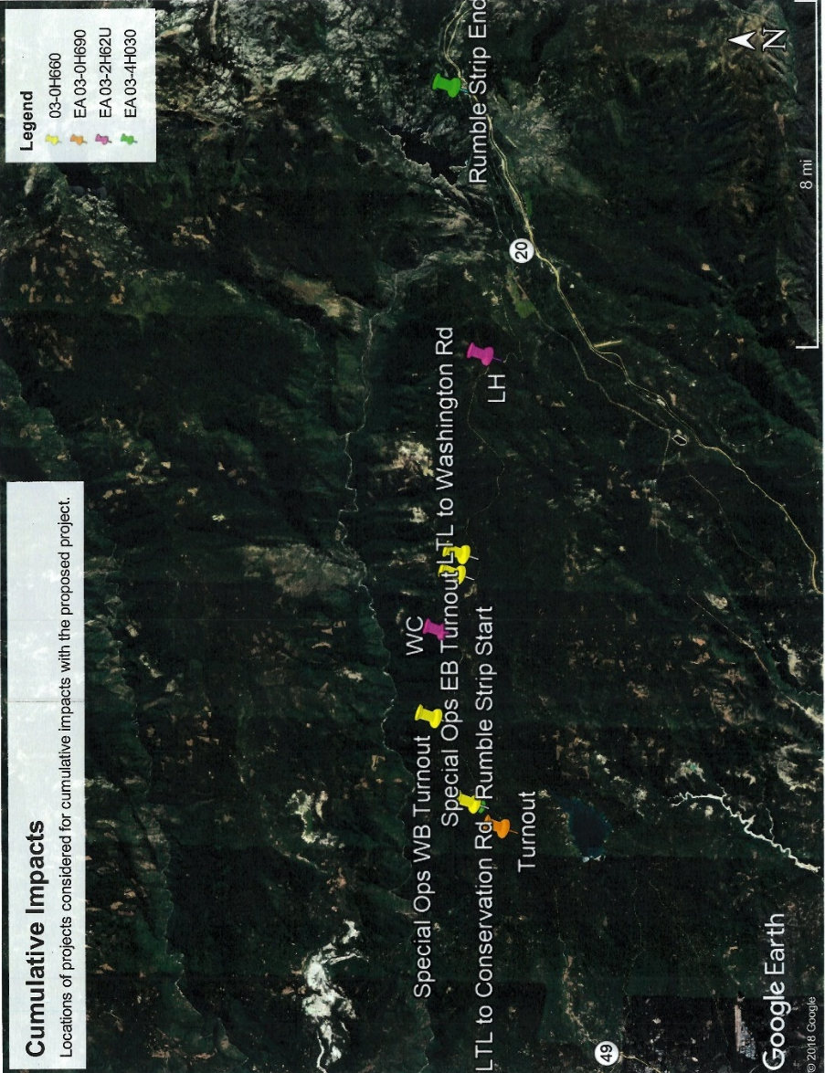
Figure 9 Cumulative Impacts Project Locations
Existing and Future Land Use
County of Nevada and USFS land use plans for the forest area surrounding the proposed project are not significantly changing from the present use. No changes to the agencies’ goals, objectives and/or management directives require modification due to the combined or individual projects. The proposed project in combination with the three foreseeable roadway construction projects would not contribute to any cumulative impacts on existing or future land use or management plan objectives.
Consistency with State, Regional, and Local Plans and Programs
The Nevada County Regional Transportation Plan identifies minimal changes for the roadway use demands over the next 20 years. The combined projects support the goals of the State and Regional transportation plans as well.
Parks and Recreational Facilities
The foreseeable planned roadway construction projects do not have a cumulative effect greater than the effects caused by the proposed project. The ground disturbance required for the Special Ops and Nevada-Placer Turnouts does not impact any park or recreational facilities. There are not any off-roadway improvements associated with Rumble Strips, so no park or recreation facilities are affected by that roadway construction project. The proposed project impacts on park and recreation facilities are discussed in section 2.1.3 and represent the total of any cumulative effects that would be considered when combined with the known foreseeable projects.
Community Character and Cohesion
The proposed project in combination with the foreseeable future projects does not divide any communities. There are no cumulative effects on community character or cohesion.
Utilities and Emergency Services
Utilities
The Rumble Strips project is being constructed on the existing roadway and will not impact any utilities. The Special Ops and Omega Curves projects both conflict with the same underground telephone transmission line. Relocation of the line is anticipated to be required for both projects.
Emergency Services
During construction, emergency service response times would be delayed during times of temporary road closures or detours. Section 2.5 addresses managing traffic related concerns including coordinating with emergency services providers during construction. Following completion of the Build Alternative, the emergency service providers would benefit from the same road improvements as the community surrounding the project. The road will have a less drastic curve, so vehicles will not have to slow as much to navigate through the area, resulting in a benefit to the community through reduced travel times. Additionally, the shoulder work and vegetation removal in new alignment areas will reduce icy road conditions over winter because the road surface will have a larger surface exposed to the sun.
The most notable emphasis is based on fire prevention, fuels reduction and efficient emergency response. County of Nevada is coordinating with CalFire to ensure its update to the draft Land Use Element of their general plan will comply with the most current directives from the California State Fire Marshall, particularly regarding State Responsibility Areas, Local Responsibility Areas and safe fire response routes. Likewise, federal directives for fuels reduction and fire breaks are being updated or actively carried out in TNF.
Traffic and Transportation/Pedestrian and Bicycle Facilities
Depending on the timing for the Turnouts project and the proposed Omega Curves project, some cumulative temporary traffic delays may occur for vehicular and bicycle traffic. Pedestrians utilizing the shoulder of the highway will need to move through construction zones with other traffic. Once the construction phases of these projects are completed, the cumulative effects of the Turnouts, Omega Curves and Special Ops are anticipated to improve traffic flow through the corridor by providing left turn refuge and enabling slower traffic more opportunities to pull over and let other travelers pass. Bicyclists and pedestrians will have more opportunity to travel out of the vehicular travel path. Rumble Strips will be added to the existing roadway and would have no effect on traffic and transportation or pedestrian and bicycle facilities.
Visual/Aesthetics
Cumulative effects from the Turnouts, Omega Curves and Special Ops projects on the visual quality of the SR-20 corridor will result in disrupted views of the forest during construction. If night work is performed, glare from lighting and construction equipment will be a temporary visual difference from the remainder of the largely unlit highway. Once construction is completed on these three projects, there will be portions along the highway with the foreground modified from overgrown forest vegetation to cuts and fills placed where the road surface is widened. Run-off preventative measures will be applied and will be the dominate feature along the disturbed earth for the 2-20 years following completion of the construction until natural succession eventually fills in the vegetation in the roadway foreground. The views of the established forest vegetation will remain however they will be set back from the travel lanes. The most extensive changes in the visual quality of the highway corridor will be due to the Omega Curves project and are discussed in section 2.1.7. Those changes represent the extent of the cumulative effects of all the projects. Rumble Strips will be added to the existing roadway and would have no effect on the visual or aesthetic value of the highway.
Cultural Resources
Turnouts is not anticipated to cumulatively impact cultural resources, as avoidance measures can be easily implemented into the designed location of the turnout on SR-20. Omega Curves and Special Ops projects both traverse similar and the same cultural resources and will not have adverse effects on the resources present in their limits. The size and extent of the resources are so large that the minor changes caused by either or both projects considered cumulatively will not decrease their value.
Water Quality and Storm Water Runoff
The cumulative effects of the projects would only marginally exceed those of the individual Omega Curves project. Projects are located in the Deer Creek Watershed and to the east, in the Upper Bear River Watershed.
Just under 2.4 acres of impervious surface will be removed from the drainages surrounding highway 20 in the cumulative project limits. The added impervious surface from widening features in Turnouts and Special Ops projects are minimal compared to the reduced impervious surface from Omega Curves project. The Rumble Strips project will not increase or decrease impervious surfaces.
None of the projects are located in a High-Risk Receiving Watershed, however throughout construction of all four proposed projects, activities may result in eroded soils or suspended solids intermittently being introduced to waterways. Short-term discharges of chemical pollutants, oil or grease may also be transported into waterways from construction machinery used. Standard methods and best management practices to minimize these potential soils, suspended solids or pollutants from entering waterways are implemented in all four projects.
Geology, Soils, Seismicity and Topography
The proposed project in combination with the foreseeable future projects results in a negligible cumulative impact on the geology, soils, seismicity or topography of the region beyond those of the Omega Curves project, which are discussed in section 2.2.2. Special Ops and the Nevada Turnouts projects result in less than 5 percent of the total excess fill of the projects combined. Rumble Strips will not result in any disturbed earth.
Hazardous Waste and Materials
Minor hazardous waste/ materials issues are present in all of the projects considered for cumulative impacts. Preliminary Site Investigations during the PS&E phase of project developments are conducted sampling of aerially deposited lead. Due to the historic land use of the region, visual characterization of potential mine waste/ tailings and discrete sampling may be performed to identify mining waste that may be present. Thermoplastic/ lead paint may be removed from the existing road surfaces prior to lane shifting, temporary detours and installation of Rumble Strips. Standard Special Provisions to address these minor hazardous waste/ materials will be developed for the projects prior to finalizing PS&E. None of the locations are Cortese listed sites. There are no cumulative effects for hazardous waste and materials.
Air Quality
The Nevada-Placer Turnouts, Special Ops, and Omega Curves projects are exempt from air quality conformity per Table 2 of 40 CFR 93.126 each, as a safety road widening project and are not considered in cumulative impacts. The Rumble Strips Project is also exempt from air quality conformity per 40 CFR 93.126 as a hazard elimination program and is not considered in cumulative impacts. Air quality conformity analysis is not required.
Natural Communities
The projects considered for cumulative analysis are all within the same region of Nevada County and Tahoe National Forest. They share natural community features of the Sierran Mixed Coniferous habitat type as detailed in section 2.3.1. Rumble Strips project in this site will only apply a centerline rumble strip, staying on paved roadway. Nevada-Placer Turnouts has implemented standard avoidance measures to have no effect on resources at the various locations of that project. The two projects will not contribute to cumulative effects.
Special Ops will require sections of the habitat to be altered, including vegetation removal and earthwork to make room for turn lanes and turnouts. The approximate area affected by the project’s four construction locations is anticipated to be just over 3, 725 cubic yards. The measurable changes to natural communities remain due to the Omega Curves project, rather than cumulative effects of the two.
Wetlands and Other Waters
There are no impacts to wetlands or other waters in either the Turnouts or Special Ops projects. There are no cumulative impacts expected beyond those caused by Omega Curves.
Animal Species
There are no impacts to animal species or their habitat in either Turnouts or Special Ops projects. There are no cumulative impacts expected beyond those caused by Omega Curves.
Threatened and Endangered Species
There are no impacts to listed species or their habitat in either Turnouts or Special Ops projects. There are no cumulative impacts expected beyond those caused by Omega Curves.
Invasive Species
There are no invasive species identified in the impacted areas of either Turnouts of Special Ops projects. There are no cumulative impacts expected beyond those caused by Omega Curves.
Avoidance, Minimization, and/or Mitigation Measures
The measures incorporated into the proposed Omega Curves project are typical for any of the cumulatively considered projects, especially since the projects are all located in TNF and similar human, physical and biological environmental conditions existing throughout the SR-20 corridor segment being considered. Reference the avoidance, minimization and mitigation measures listed in Chapter 2 of this document for further details.
Caltrans will continue to foster a relationship with the USFS, landowners and primary resource managers of TNF. Coordination with the County of Nevada Planning and Public Works Departments would likewise continue for projects on SR-20, and affecting the land use or local roads of Nevada County. Recommendations for mitigations of resources impacted by projects proposed by any of these managing agencies would be driven by compliance with NEPA and CEQA requirements.
- CEQA Evaluation
  - Determining Significance under CEQA
The proposed project is a joint project by the California Department of Transportation (Caltrans) and the Federal Highway Administration (FHWA) and is subject to state and federal environmental review requirements. Project documentation, therefore, has been prepared in compliance with both the California Environmental Quality Act (known as CEQA) and the National Environmental Policy Act (known as NEPA). The Federal Highway Administration’s responsibility for environmental review, consultation, and any other actions required by applicable federal environmental laws for this project are being, or have been, carried out by Caltrans pursuant to 23 United States Code Section 327 (23 USC 327) and the Memorandum of Understanding dated December 23, 2016 and executed by the Federal Highway Administration and Caltrans. Caltrans is the lead agency under CEQA and NEPA.
One of the main differences between NEPA and CEQA is the way significance is determined. Under NEPA, significance is used to determine whether an Environmental Impact Statement, or a lower level of documentation, will be required. NEPA requires that an Environmental Impact Statement be prepared when the proposed federal action (the project) as a whole has the potential to “significantly affect the quality of the human environment.” The determination of significance is based on context and intensity. Some impacts determined to be significant under CEQA may not be of sufficient magnitude to be determined significant under NEPA. Under NEPA, once a decision is made regarding the need for an Environmental Impact Statement, it is the magnitude of the impact that is evaluated and no judgment of its individual significance is deemed important for the text. NEPA does not require that a determination of significant impacts be stated in the environmental document.
CEQA, on the other hand, does require Caltrans to identify each “significant effect on the environment” resulting from the project and ways to mitigate each significant effect. If the project may have a significant effect on any environmental resource, then an Environmental Impact Report must be prepared. Each and every significant effect on the environment must be disclosed in the Environmental Impact Report and mitigated if feasible. In addition, the CEQA Guidelines list a number of “mandatory findings of significance,” which also require the preparation of an Environmental Impact Report. There are no types of actions under NEPA that parallel the findings of mandatory significance of CEQA. This chapter discusses the effects of this project and CEQA significance.
  - CEQA Environmental Checklist
This checklist identifies physical, biological, social, and economic factors that might be affected by the proposed project. Potential impact determinations include Significant and Unavoidable Impact, Less Than Significant With Mitigation Incorporated, Less Than Significant Impact, and No Impact. In many cases, background studies performed in connection with a project will indicate that there are no impacts to a particular resource. A No Impact answer reflects this determination. The words “significant” and “significance” used throughout the following checklist are related to CEQA, not NEPA, impacts. The questions in this checklist are intended to encourage the thoughtful assessment of impacts and do not represent thresholds of significance.
Project features, which can include both design elements of the project, and standardized measures that are applied to all or most Caltrans projects such as Best Management Practices (BMPs) and measures included in the Standard Plans and Specifications or as Standard Special Provisions, are considered to be an integral part of the project and have been considered prior to any significance determinations documented below; see Chapters 1 and 2 for a detailed discussion of these features. The annotations to this checklist are summaries of information contained in Chapter 2 to provide you with the rationale for significance determinations; for a more detailed discussion of the nature and extent of impacts, please see Chapter 2. This checklist incorporates by reference the information contained in Chapters 1 and 2.
    - Aesthetics
CEQA Significance Determinations for Aesthetics
Except as provided in Public Resources Code Section 21099, would the project:
a) Have a substantial adverse effect on a scenic vista?
No Impact. Although the project corridor is scenic, there are no Caltrans officially designated vista points or any informal vista points used by the general public within the project segment limits.
b) Substantially damage scenic resources, including, but not limited to, trees, rock outcroppings, and historic buildings within a state scenic highway?
Less Than Significant With Mitigation. There are no historic buildings in the project segments. There are no highly recognized or landmark rock outcroppings that exist within the project segments. Trees in the areas of cut and fill slopes necessary for the proposed construction will be removed. The vegetation removal and modified earthwork will be highly visible to roadway travelers. The existing, narrow and shaded highway corridor will fluctuate to an expanded corridor that is wide open and bright along both the White Cloud and Lowell Hill project segments.
Implementation of the proposed avoidance, minimization, and mitigation measures including nSSP 14-5 developed by the District Landscape Architect and consulted on with TNF, would ensure that scenic resources along SR 20 are not declassified as a County-designated scenic route or removed from the Yuba Donner National Forest Scenic Byway.
c) In non-urbanized areas, substantially degrade the existing visual character or quality of public views of the site and its surroundings? (Public views are those that are experienced from a publicly accessible vantage point.) If the project is in an urbanized area, would the project conflict with applicable zoning and other regulations governing scenic quality?
Less Than Significant With Mitigation. The project will not degrade the visual character of the surrounding Tahoe National Forest. Areas directly affected by the proposed project are limited to the smallest extent to accomplish the purpose and need of the project. Implementation of the proposed measures to screen views of the abandoned highway alignment from the traveling public, incorporate native plants in replanting efforts, and apply aesthetic treatments to the projects’ man-made components would not result in substantially degraded views of the Forest from the highway. The project is not in an urbanized area.
d) Create a new source of substantial light or glare which would adversely affect day or nighttime views in the area?
Less Than Significant. The project is not adding permanent lighting. Construction night work may introduce temporary lighting however that would be directed away from the traveling public to minimize nighttime glare for drivers. The widened corridor features through the project limits will result in roadway sections exposed to more sunlight. Replanting native vegetation and use of aesthetic treatments applied to the projects’ man-made components would reduce the light reflection to not adversely affect daytime views.
    - Agriculture and Forest Resources
CEQA Significance Determinations for Agriculture and Forest Resources
In determining whether impacts to agricultural resources are significant environmental effects, lead agencies may refer to the California Agricultural Land Evaluation and Site Assessment Model (1997) prepared by the California Department of Conservation as an optional model to use in assessing impacts on agriculture and farmland. In determining whether impacts to forest resources, including timberland, are significant environmental effects, lead agencies may refer to information compiled by the California Department of Forestry and Fire Protection regarding the state’s inventory of forest land, including the Forest and Range Assessment Project and the Forest Legacy Assessment Project; and the forest carbon measurement methodology provided in Forest Protocols adopted by the California Air Resources Board.
Would the project:
a) Convert Prime Farmland, Unique Farmland, or Farmland of Statewide Importance (Farmland), as shown on the maps prepared pursuant to the Farmland Mapping and Monitoring Program of the California Resources Agency, to non-agricultural use?
No Impact. The project is not located on any parcels that are currently farmland.
b) Conflict with existing zoning for agricultural use, or a Williamson Act contract?
No Impact. The project is not located on any parcels in a Williamson Act contract or zoned for agricultural use.
c) Conflict with existing zoning for, or cause rezoning of, forest land (as defined in Public Resources Code section 12220(g)), timberland (as defined by Public Resources Code section 4526), or timberland zoned Timberland Production (as defined by Government Code section 51104(g))?
No Impact. The project will not require or trigger rezoning of forestland, timberland or Timber Production parcels.
d) Result in the loss of forest land or conversion of forest land to non-forest use?
No Impact. The proposed project is not converting forest land to non-forest use. The abandoned highway lands will be returned to forested non-highway use over time as natural succession of plants returns to the areas of removed roadway. The proposed alignment will be shorter than the existing. Final areas of abandoned and relocated highway right of way within the forest land will be determined at later stages of the design process, however it is anticipated that the post-project result will be favorable to having more forest land than it is currently.
e) Involve other changes in the existing environment which, due to their location or nature, could result in conversion of Farmland, to non-agricultural use or conversion of forest land to non-forest use?
No Impact. The project segments are located in forest land. No conversion of Farmland will occur as a result of this project. The improved alignment of the highway will shift, however there will be no conversion of the forest land.
    - Air Quality
CEQA Significance Determinations for Air Quality
Where available, the significance criteria established by the applicable air quality management district or air pollution control district may be relied upon to make the following determinations.
Would the project:
a) Conflict with or obstruct implementation of the applicable air quality plan?
No Impact. The project does not obstruct implementation of the Northern Sierra Air Quality Management District of the Mountain Counties Air Basin.
b) Result in a cumulatively considerable net increase of any criteria pollutant for which the project region is non-attainment under an applicable federal or state ambient air quality standard?
No Impact. The project is not a capacity increasing project, and will not add to the ozone levels.
c) Expose sensitive receptors to substantial pollutant concentrations?
No Impact. There are no sensitive receptors within the project limits.
d) Result in other emissions (such as those leading to odors) adversely affecting a substantial number of people?
No Impact. There are no other emissions anticipated to result from the construction or operation of the proposed project. The project location is not close to urban or densely populated areas for people to be affected by any other emissions that may occur unexpectedly.
    - Biological Resources
CEQA Significance Determinations for Biological Resources
Would the project:
a) Have a substantial adverse effect, either directly or through habitat modifications, on any species identified as a candidate, sensitive, or special status species in local or regional plans, policies, or regulations, or by the California Department of Fish and Game or U.S. Fish and Wildlife Service?
Less Than Significant Impact. Avoidance measures implemented into the project construction will reduce any impacts to candidate, sensitive or special status species. See section 2.3.3 for information about the felt-leaved violet, a special status species listed in the Tahoe National Forest species list.
b) Have a substantial adverse effect on any riparian habitat or other sensitive natural community identified in local or regional plans, policies, regulations or by the California Department of Fish and Game or U.S. Fish and Wildlife Service?
Less Than Significant With Mitigation Incorporated. As stated in section 2.3.2, there is an indistinct and non-continuous riparian habitat present in both project segments. Due to the indistinction, the affected riparian habitat is instead calculated by area of intermittent and perennial streams associated with the sparse riparian vegetation. A maximum of 0.25 acres of habitat would be impacted permanently and temporarily by the proposed project fill. The actual acreage of riparian impacted by the project will be calculated as the project design is refined and riparian-specific vegetation being removed is identified. Compensatory mitigation to replace any riparian habitat that will be affected by the project construction efforts is proposed at 1:1.
c) Have a substantial adverse effect on state or federally protected wetlands (including, but not limited to, marsh, vernal pool, coastal, etc.) through direct removal, filling, hydrological interruption, or other means?
Less Than Significant Impact. Over 600 acres were assessed for potential impacts on natural communities within both project segments. There are 0.31 acres of Waters of the United states /Waters of the State impacted in the combined project segments. Of that area, a maximum of 0.25 acres made up by intermittent and perennial streams will have fill placed into them because of the proposed project. The remaining 0.063 acres being impacted are a roadside ditch and a seasonal wetland. Final impacted acreage will be calculated as the project design is refined. Permits will be obtained based on refined calculations from the Sacramento District of United States Army Corps of Engineers, the Central Valley Water Board and CDFW to comply with the Clean Water and Porter-Cologne Acts.
d) Interfere substantially with the movement of any native resident or migratory fish or wildlife species or with established native resident or migratory wildlife corridors, or impede the use of native wildlife nursery sites?
Less Than Significant Impact. No project features would impede the use or migration of any native or migratory fish that may be found in waterways within the project limits. Anadromous fishes are unable to reach the waterways in the project limits due to obstructions farther downstream. The existing highway, as a baseline condition, may interfere with movement of wildlife. The project includes an enhancement feature to add wildlife crossings built below the road in both segments. The completed construction will provide habitat connectivity opportunities where none currently exist. There are no wildlife nursery sites identified in the project study areas.
e) Conflict with any local policies or ordinances protecting biological resources, such as a tree preservation policy or ordinance?
No Impact. The project is in compliance with County of Nevada policies regarding biological resources and tree preservation.
f) Conflict with the provisions of an adopted Habitat Conservation Plan, Natural Community Conservation Plan, or other approved local, regional, or state habitat conservation plan?
No Impact. There are no Natural Community Conservation Plans in the project study area, however the project area is largely covered by the State Wildlife Action Plan, and the project is not in conflict with it. There is not any requirement resulting from the project to create a Habitat Conservation Plan.
    - Cultural Resources
CEQA Significance Determinations for Cultural Resources
Would the project:
a) Cause a substantial adverse change in the significance of a historical resource pursuant to §15064.5?
Less Than Significant. Five historical linear resources intersect the project impact area, and sections of them will be destroyed. The areas that will be destroyed do not retain sufficient integrity to convey the significance of the resource and/or the segments that would be lost represent a small fraction of the overall resource and would not diminish the ability of that resource to convey its importance in historical context.
b) Cause a substantial adverse change in the significance of an archaeological resource pursuant to §15064.5?
No Impact. Two prehistoric archeological sites are outside of the areas directly impacted by the project and will be further avoided through the establishment and enforcement of environmentally sensitive area fence specifications.
c) Disturb any human remains, including those interred outside of dedicated cemeteries?
No Impact. No human remains were discovered during field surveys. Procedures for actions to be taken if remains are discovered during construction will be included in the standard specifications.
    - Energy
CEQA Significance Determinations for Energy
Would the project:
a) Result in potentially significant environmental impact due to wasteful, inefficient, or unnecessary consumption of energy resources, during project construction or operation?
No Impact. The project is not a capacity increasing project. Energy demands during construction will be minimized through standard specifications.
b) Conflict with or obstruct a state or local plan for renewable energy or energy efficiency?
No Impact. The project does not conflict with or obstruct state or local plans for renewable energy measures or improving energy efficiency.
    - Geology and Soils
CEQA Significance Determinations for Geology and Soils
Would the project:
a) Directly or indirectly cause potential substantial adverse effects, including the risk of loss, injury, or death involving:
No Impact. Risk is inherent to construction work, however use of personal protection equipment, enacting safety measures and practicing situational awareness will minimize the risk.
i) Rupture of a known earthquake fault, as delineated on the most recent Alquist-Priolo Earthquake Fault Zoning Map issued by the State Geologist for the area or based on other substantial evidence of a known fault? Refer to Division of Mines and Geology Special Publication 42?
No Impact. The project is not located on or near a known fault line.
ii) Strong seismic ground shaking?
No Impact. There is earthwork associated with the proposed project, however the equipment and timing of their use will not result in seismic activity.
iii) Seismic-related ground failure, including liquefaction?
No Impact. The project is not located in an area where liquefaction is likely to occur.
iv) Landslides?
No Impact. Geological studies of the areas to be dug into inform the design process and the slope percentages that can be used to minimize overall affects of construction and prevent landslides from occurring after construction.
b) Result in substantial soil erosion or the loss of topsoil?
No Impact. Select grading of the excavated materials will be specified in the construction contract to retain as much native material on site as possible. Soil erosion standard measures will be implemented in compliance with stormwater pollution prevention plans and other best management practices.
c) Be located on a geologic unit or soil that is unstable, or that would become unstable as a result of the project, and potentially result in on- or off-site landslide, lateral spreading, subsidence, liquefaction or collapse?
No Impact. The geological units in the project area are highly stable.
d) Be located on expansive soil, as defined in Table 18-1-B of the Uniform Building Code (1994), creating substantial direct or indirect risks to life or property?
No Impact. Soils compaction or expansion coefficient will be determined in the final geotechnical study and used to determine compaction requirements set in the construction standards. No substantial risk to life or property is anticipated.
e) Have soils incapable of adequately supporting the use of septic tanks or alternative waste water disposal systems where sewers are not available for the disposal of waste water?
No Impact. The surrounding area is rural, predominantly undisturbed forest lands. No waste water treatment systems or septic systems are known, nor are anticipated to be discovered during construction.
f) Directly or indirectly destroy a unique paleontological resource or site or unique geologic feature?
No Impact. There is very low chances of discovering or destroying paleontological resources in the project areas.
    - Greenhouse Gas Emissions
CEQA Significance Determinations for Greenhouse Gas Emissions
Would the project:
a) Generate greenhouse gas emissions, either directly or indirectly, that may have a significant impact on the environment?
Less Than Significant. The operational project is not anticipated to generate additional greenhouse gas emissions. Temporary emissions will occur during construction due to construction equipment and traveling vehicles waiting for traffic control. With implementation of construction greenhouse-reduction measures, the impact would be less than significant.
b) Conflict with an applicable plan, policy or regulation adopted for the purpose of reducing the emissions of greenhouse gases?
Less Than Significant. The proposed project does not conflict with plans, policies or regulations intended to reduce greenhouse gas emissions.
    - Hazards and Hazardous Materials
CEQA Significance Determinations for Hazards and Hazardous Materials
Would the project:
a) Create a significant hazard to the public or the environment through the routine transport, use, or disposal of hazardous materials?
No Impact. The SR-20 segments being improved may make commercial transportation easier, however there are no changes to hazardous materials hauling or transport routes resulting from the proposed project.
b) Create a significant hazard to the public or the environment through reasonably foreseeable upset and accident conditions involving the release of hazardous materials into the environment?
No Impact. Standard specifications for removal and handling of known hazardous materials such as treated wood waste and aerially deposited lead will minimize the chances of accidental release into the environment.
c) Emit hazardous emissions or handle hazardous or acutely hazardous materials, substances, or waste within one-quarter mile of an existing or proposed school?
No Impact. No schools exist in within one-quarter mile of the proposed project sites.
d) Be located on a site which is included on a list of hazardous materials sites compiled pursuant to Government Code Section 65962.5 and, as a result, would it create a significant hazard to the public or the environment?
No Impact. The properties are not listed as any Cortese Sites.
e) For a project located within an airport land use plan or, where such a plan has not been adopted, within two miles of a public airport or public use airport, would the project result in a safety hazard or excessive noise for people residing or working in the project area?
No Impact. The project’s Lowell Hill segment is located within the overflight zone planning area of the Blue Canyon- Nyack Airport. The project was determined to have no effect on the airport activities.
f) Impair implementation of or physically interfere with an adopted emergency response plan or emergency evacuation plan?
No Impact. SR-20 is identified as an evacuation route. Traffic management plans finalized in later design stages of the project include provisions to allow evacuation efforts to be conducted in coordination with the California Highway Patrol and local emergency response personnel.
g) Expose people or structures, either directly or indirectly, to a significant risk of loss, injury or death involving wildland fires?
No Impact. The proposed project would not exacerbate existing risks associated with wildfire caused by highway users. Standard construction specifications for equipment idling and fuel storage during construction are intended to minimize the risk associated with their use.
    - Hydrology and Water Quality
CEQA Significance Determinations for Hydrology and Water Quality
Would the project:
a) Violate any water quality standards or waste discharge requirements or otherwise substantially degrade surface or ground water quality?
Less Than Significant Impact. Compliance with the Construction General Permit will require a risk level analysis based on the project’s potential erosion and transport to receiving waters. Analysis results will be utilized to determine standard water quality protection measures that will be implemented in order to avoid surface and ground water quality degradation. It is anticipated that BMP usage, placement, field implementation and effectiveness will be monitored, adjusted, and modified (accordingly) for the duration of the project. Compliance with all applicable NPDES Permits, in addition to coordination with the Regional Water Quality Board, is anticipated to ensure the protection of water resources in the area.
b) Substantially decrease groundwater supplies or interfere substantially with groundwater recharge such that the project may impede sustainable groundwater management of the basin?
No Impact. The proposed project does not include any activities that would result in interference with groundwater resources or existing groundwater supplies.
c) Substantially alter the existing drainage pattern of the site or area, including through the alteration of the course of a stream or river or through the addition of impervious surfaces, in a manner which would:
i) Result in substantial erosion or siltation on- or off-site;
Less Than Significant Impact. It is not anticipated that substantive alterations to drainage patterns will occur and a reduction to the overall impervious area for the project is likely. Standard construction erosion control measures and implementation strategies will be outlined in the Contractor prepared and Caltrans approved SWPPP. These will likely include temporary soil stabilization measures, linear sediment barriers (i.e. silt fence, gravel bag berms, fiber rolls), and construction site waste management (i.e. concrete washout, construction materials storage, litter/ waste management) among other approved controls.
ii) Substantially increase the rate or amount of surface runoff in a manner which would result in flooding on- or off-site;
No Impact. The impervious surface area of the cumulative project segments is anticipated to be reduced by 2.4 acres, reducing runoff in the watershed.
iii) Create or contribute runoff water which would exceed the capacity of existing or planned stormwater drainage systems or provide substantial additional sources of polluted runoff; or
No Impact. The project segments are near the headwaters of the watersheds they are located in. The activities and features are not expected to increase the capacity of the existing stormwater drainage system, which is largely limited to roadside ditches and overside drains.
iv) Impede or redirect flood flows?
No Impact. The project would not redirect flood flows. Contouring needed for the earthwork will remain in the same flows and drainages.
d) In flood hazard, tsunami, or seiche zones, risk release of pollutants due to project inundation?
No Impact. The project is not located near inundation zones.
e) Conflict with or obstruct implementation of a water quality control plan or sustainable groundwater management plan?
No Impact. The project does not affect any water quality control plans or sustainable groundwater management plans.
    - Land Use and Planning
CEQA Significance Determinations for Land Use and Planning
Would the project:
a) Physically divide an established community?
No Impact. There are no residences or established communities within the project limits.
b) Cause a significant environmental impact due to a conflict with any land use plan, policy, or regulation adopted for the purpose of avoiding or mitigating an environmental effect?
No Impact. The project is not in conflict with the County of Nevada land use plans or policies.
    - Mineral Resources
CEQA Significance Determinations for Mineral Resources
Would the project:
a) Result in the loss of availability of a known mineral resource that would be of value to the region and the residents of the state?
No Impact. Mineral resources that may be present in soils excavated will remain in the project areas as soils used for fill.
b) Result in the loss of availability of a locally important mineral resource recovery site delineated on a local general plan, specific plan or other land use plan?
No Impact. Mineral resource recovery as authorized by the County of Nevada and the Tahoe National Forest management regulations is unchanged by the proposed project.
    - Noise
CEQA Significance Determinations for Noise
Would the project result in:
a) Generation of a substantial temporary or permanent increase in ambient noise levels in the vicinity of the project in excess of standards established in the local general plan or noise ordinance, or applicable standards of other agencies?
Less Than Significant. Construction related noises are in compliance with ordinances. Specification for noise to be restricted between 9 PM and 6 AM from exceeding 86 decibels at 50 feet from the job site will be applied to the project contract to minimize potential noise-related impacts, particularly pertaining to the White Cloud project segment near the White Cloud Campground.
b) Generation of excessive groundborne vibration or groundborne noise levels?
No Impact. Noise levels and groundborne vibration resulting from construction activities are not expected to be excessive.
c) For a project located within the vicinity of a private airstrip or an airport land use plan or, where such a plan has not been adopted, within two miles of a public airport or public use airport, would the project expose people residing or working in the project area to excessive noise levels?
No Impact. Construction activities and any noises resulting from them are too far away and will not affect the people residing near or working in the Blue Canyon- Nyack Airport.
    - Population and Housing
CEQA Significance Determinations for Population and Housing
Would the project:
a) Induce substantial unplanned population growth in an area, either directly (for example, by proposing new homes and businesses) or indirectly (for example, through extension of roads or other infrastructure)?
No Impact. The project does not induce growth or extend roads or other infrastructure.
b) Displace substantial numbers of existing people or housing, necessitating the construction of replacement housing elsewhere?
No Impact. No relocations are needed to conduct the proposed project.
    - Public Services
CEQA Significance Determinations for Public Services
a) Would the project result in substantial adverse physical impacts associated with the provision of new or physically altered governmental facilities, need for new or physically altered governmental facilities, the construction of which could cause significant environmental impacts, in order to maintain acceptable service ratios, response times or other performance objectives for any of the public services:
Fire protection?
No Impact. The project does not require new or altered facilities and does not change acceptable service ratios, response times or objectives of the fire protection services near the project segments.
Police protection?
No Impact. The project does not require new or altered facilities and does not change acceptable service ratios, response times or objectives of the police protection services near the project segments.
Schools?
No Impact. No schools are located near the project segments.
Parks?
No Impact. No parks are located near the project segments.
Other public facilities?
No Impact. No other public service facilities are located near the project segments.
    - Recreation
CEQA Significance Determinations for Recreation
a) Would the project increase the use of existing neighborhood and regional parks or other recreational facilities such that substantial physical deterioration of the facility would occur or be accelerated?
Less Than Significant. The project would change how recreationists use the Pioneer Trail during times when there are temporary closures near the construction areas. The trail would become segmented into two point-to-point sections and one out-and-back section between the two highway construction limits. It is not foreseeable to guess where recreationists would go as an alternative trail. It is unlikely that any increased use of other recreational facilities in the region would become used to a point of physical deterioration.
Reduced access from SR-20 within the Lowell Hill project segment to the Steephollow Snow Trail System between markers 25 and 19 may shift trail users to access the trail system from the Omega Overlook west of the project segment. However, the turn off at marker 25 may be restricted by snow plowed over the vehicle entrance in any given non-construction year. It is unlikely that the shift to restrict access at marker 25 would increase use of the rest of the trail system to the point of physical deterioration.
b) Does the project include recreational facilities or require the construction or expansion of recreational facilities which might have an adverse physical effect on the environment?
Less Than Significant With Mitigation Incorporated. There are recreational trails affected by the construction of the proposed project. Reconstruction of trails segmented by earthwork for the proposed alignment is included in the scope of the project; provision of benches in the fill slopes will help to reconnect existing recreational trails through the project limits. Further, compensatory trail reconstruction for segments outside the fill slopes will be conducted by TNF. The trail reconstruction efforts by TNF are not expected to have adverse physical environmental effects as they would be constructed using hand tools and small equipment. Transportation
CEQA Significance Determinations for Transportation
Would the project:
a) Conflict with a program plan, ordinance or policy addressing the circulation system, including transit, roadway, bicycle and pedestrian facilities?
No Impact. The project does not conflict with plans, ordinances or policy addressing transportation alternatives.
b) Substantially increase hazards due to a geometric design feature (e.g., sharp curves or dangerous intersections) or incompatible uses (e.g., farm equipment)?
No Impact. The purpose of the project is to improve geometric design features that are too small. Increased curve radii are expected to improve safety for the highway users.
c) Result in inadequate emergency access?
No Impact. Traffic management plans will incorporate provision of emergency access. The traffic management plans are developed and finalized in later design progress, in coordination with California Highway Patrol and local agency contacts. In this project, County of Nevada Sheriff’s Department and Office of Emergency Services, as well as the U.S. Forest Service would be contributors to the final traffic management plan.
    - Tribal Cultural Resources
CEQA Significance Determinations for Tribal Cultural Resources
Would the project cause a substantial adverse change in the significance of a tribal cultural resource, defined in Public Resources Code section 21074 as either a site, feature, place, cultural landscape that is geographically defined in terms of the size and scope of the landscape, sacred place, or object with cultural value to a California Native American tribe, and that is:
a) Listed or eligible for listing in the California Register of Historical Resources, or in a local register of historical resources as defined in Public Resources Code section 5020.1(k), or
b) A resource determined by the lead agency, in its discretion and supported by substantial evidence, to be significant pursuant to criteria set forth in subdivision (c) of Public Resources Code Section 5024.1. In applying the criteria set forth in subdivision (c) of Public Resource Code Section 5024.1, the lead agency shall consider the significance of the resource to a California Native American tribe.
No Impact. No Tribal Cultural Resources were formally identified within the area of direct impacts for the proposed project that meet the criteria set forth in Public Resources Code section 5020.1(k) or the criteria set forth in subdivision (c) of Public Resource Code Section 5024.1.
    - Utilities and Service Systems
CEQA Significance Determinations for Utilities and Service Systems
Would the project:
a) Require or result in the relocation or construction of new or expanded water, wastewater treatment or storm water drainage, electric power, natural gas, or telecommunications facilities, the construction or relocation of which could cause significant environmental effects?
Less Than Significant Impact. Within the White Cloud project segment, a buried telecommunications facility has been identified. The proposed alignment will require the facility to be relocated to stay within the transportation easement. The assumed location will be disturbed through the efforts of the proposed project and no additional environmental effects are anticipated.
b) Have sufficient water supplies available to serve the project and reasonably foreseeable future development during normal, dry and multiple dry years?
No Impact. The proposed project is not affecting any water supply facilities.
c) Result in a determination by the wastewater treatment provider which serves or may serve the project that it has adequate capacity to serve the project’s projected demand in addition to the provider’s existing commitments?
No Impact. The proposed project is not affecting any wastewater treatment provider or facilities.
d) Generate solid waste in excess of state or local standards, or in excess of the capacity of local infrastructure, or otherwise impair the attainment of solid waste reduction goals?
No Impact. Any solid waste generated by the proposed project will be within the capacity of local disposal infrastructure and would not impair waste reduction goals.
e) Comply with federal, state, and local management and reduction statutes and regulations related to solid waste?
No Impact. The proposed project is in compliance with management of, and reduction statues and regulations of solid waste.
    - Wildfire
CEQA Significance Determinations for Wildfire
If located in or near state responsibility areas or lands classified as very high fire hazard severity zones, would the project:
a) Substantially impair an adopted emergency response plan or emergency evacuation plan?
No Impact. The proposed project includes a Traffic Management Plan which takes into account emergency response actions and evacuations that may be required to occur through the construction areas, including during temporary closures. Coordination with California Highway Patrol and local emergency response agencies is included in the Traffic Management Plan to avoid impairment of any response or evacuation.
b) Due to slope, prevailing winds, and other factors, exacerbate wildfire risks, and thereby expose project occupants to, pollutant concentrations from a wildfire or the uncontrolled spread of a wildfire?
No Impact. Project occupants will be construction personnel as there are no residents in the project area. Project occupants would not be required to work without effective personnel protection equipment during wildfire that may result in pollutant concentrations blown into the work area.
c) Require the installation or maintenance of associated infrastructure (such as roads, fuel breaks, emergency water sources, power lines or other utilities) that may exacerbate fire risk or that may result in temporary or ongoing impacts to the environment?
No Impact. Vegetation removal and new alignment locations being installed would not exacerbate the fire risk inherent to the area. The post-construction features will act as a fuel break within the project limits, until the time when mature vegetation has regrown on the regraded and abandoned highway areas.
d) Expose people or structures to significant risks, including downslope or downstream flooding or landslides, as a result of runoff, post-fire slope instability, or drainage changes?
No Impact. Geotechnical report results will be used to inform compaction requirements of the proposed sloped earthwork. The project will incorporate materials that provide slope stability and prevent downstream exposure to runoff. The drainage features of the proposed alignment will not change the receiving waters.
    - Mandatory Findings of Significance
CEQA Significance Determinations for Mandatory Findings of Significance
a) Does the project have the potential to substantially degrade the quality of the environment, substantially reduce the habitat of a fish or wildlife species, cause a fish or wildlife population to drop below self-sustaining levels, threaten to eliminate a plant or animal community, substantially reduce the number or restrict the range of a rare or endangered plant or animal or eliminate important examples of the major periods of California history or prehistory?
No Impact. The proposed project incorporates avoidance and minimization measures to prevent permanent degradation of the environment or impair wildlife habitat. Wildlife highway crossing features are included in the scope of the project and provide a new opportunity for habitat connectivity.
b) Does the project have impacts that are individually limited, but cumulatively considerable? (“Cumulatively considerable” means that the incremental effects of a project are considerable when viewed in connection with the effects of past projects, the effects of other current projects, and the effects of probable future projects.)
No Impact. Cumulative effects of foreseeable projects have been determined to have no greater impacts than the individual projects may have.
c) Does the project have environmental effects which will cause substantial adverse effects on human beings, either directly or indirectly?
No Impact. The proposed project is not located in any community settings and does not require any relocations.
  - Wildfire
Regulatory Setting
Senate Bill 1241 required the Office of Planning and Research, the Natural Resources Agency, and the California Department of Forestry and Fire Protection to develop amendments to the “CEQA Checklist” for the inclusion of questions related to fire hazard impacts for projects located on lands classified as very high fire hazard severity zones. The 2018 updates to the CEQA Guidelines expanded this to include projects “near” these very high fire hazard severity zones.
Affected Environment
The project segments are in a Very High Fire Hazard Severity Zone, as recommended by CalFire. The zoning is classified as being under the Federal Responsibility Area, as it is a federal property. SR-20 is an evacuation route identified by Nevada County.
Environmental Consequences
The project may impair emergency response during times of temporary road closure or one-way traffic control. The Traffic Management Plan (TMP), developed later in the project evolution, will consider how to incorporate the existing emergency response and evacuation plans into the TMP. Typical coordination occurs with representatives from the local fire response, County Sheriff’s Department, Highway Patrol and Office of Emergency Services.
The proposed alignments would not exacerbate wildfire risk. The existing highway is already located in a Very High Fire Severity Zone, and new alignments are not adding vehicles or humans to high risk areas. Direction from USFS staff have been to consider native plants for landscaping, many of which are naturally fire-resistant. Removal of vegetation within the project impact areas will reduce fire-fuels and create a fire break, at least during the construction and for a period afterwards.
There will not be infrastructure associated with wildfire risks installed within the project limits.
The project disturbs the slopes, both in areas of cut and fill earthwork. There is not any significant risk resulting from the project that would expose people or structures to downslope or downstream flooding or landslides, as a result of runoff, post-fire slope instability or drainage changes. The project’s impervious surface area is being reduced. Additional evaluations made later in the design process will determine any changes to drainage patterns, however none are anticipated at this stage of the development.
Potential benefits the project may impart to lessen the risk of wildfire includes features such as widened roadway, shoulders and a clear recovery zone, reduced vegetation adjacent to the roadside and additional turnout areas for emergency response vehicle staging. Additionally, the improved curve radii will decrease emergency response time once construction has been completed.
Avoidance, Minimization, and/or Mitigation Measures
Caltrans standard contract specifications inherently include safety measures which would indirectly result in minimization of wildfire risk from construction activities. Features of the project which contribute to resilience to wildfire include metal sign posts, cement drainage structures and cleared vegetation.
  - Climate Change
Climate change refers to long-term changes in temperature, precipitation, wind patterns, and other elements of the earth's climate system. An ever-increasing body of scientific research attributes these climatological changes to greenhouse gas (GHG) emissions, particularly those generated from the production and use of fossil fuels.
While climate change has been a concern for several decades, the establishment of the Intergovernmental Panel on Climate Change (IPCC) by the United Nations and World Meteorological Organization in 1988 led to increased efforts devoted to GHG emissions reduction and climate change research and policy. These efforts are primarily concerned with the emissions of GHGs generated by human activity, including carbon dioxide (CO2), methane (CH4), nitrous oxide (N2O), tetrafluoromethane, hexafluoroethane, sulfur hexafluoride (SF6), and various hydrofluorocarbons (HFCs). CO2 is the most abundant GHG; while it is a naturally occurring component of Earth’s atmosphere, fossil-fuel combustion is the main source of additional, human-generated CO2.
Two terms are typically used when discussing how we address the impacts of climate change: “greenhouse gas mitigation” and “adaptation.” Greenhouse gas mitigation covers the activities and policies aimed at reducing GHG emissions to limit or “mitigate” the impacts of climate change. Adaptation, on the other hand, is concerned with planning for and responding to impacts resulting from climate change (such as adjusting transportation design standards to withstand more intense storms and higher sea levels). This analysis will include a discussion of both.
Regulatory Setting
This section outlines federal and state efforts to comprehensively reduce greenhouse gas emissions from transportation sources.
Federal
To date, no national standards have been established for nationwide mobile-source GHG reduction targets, nor have any regulations or legislation been enacted specifically to address climate change and GHG emissions reduction at the project level.
The National Environmental Policy Act (NEPA) (42 United States Code [USC] Part 4332) requires federal agencies to assess the environmental effects of their proposed actions prior to making a decision on the action or project.
The Federal Highway Administration (FHWA) recognizes the threats that extreme weather, sea-level change, and other changes in environmental conditions pose to valuable transportation infrastructure and those who depend on it. FHWA therefore supports a sustainability approach that assesses vulnerability to climate risks and incorporates resilience into planning, asset management, project development and design, and operations and maintenance practices (FHWA 2019). This approach encourages planning for sustainable highways by addressing climate risks while balancing environmental, economic, and social values—“the triple bottom line of sustainability” (FHWA n.d.). Program and project elements that foster sustainability and resilience also support economic vitality and global efficiency, increase safety and mobility, enhance the environment, promote energy conservation, and improve the quality of life.
Various efforts have been promulgated at the federal level to improve fuel economy and energy efficiency to address climate change and its associated effects. The most important of these was the Energy Policy and Conservation Act of 1975 (42 USC Section 6201) and Corporate Average Fuel Economy (CAFE) Standards. This act establishes fuel economy standards for on-road motor vehicles sold in the United States. Compliance with federal fuel economy standards is determined through the CAFE program based on each manufacturer’s average fuel economy for the portion of its vehicles produced for sale in the United States.
Energy Policy Act of 2005, 109th Congress H.R.6 (2005–2006): This act sets forth an energy research and development program covering: (1) energy efficiency; (2) renewable energy; (3) oil and gas; (4) coal; (5) the establishment of the Office of Indian Energy Policy and Programs within the Department of Energy; (6) nuclear matters and security; (7) vehicles and motor fuels, including ethanol; (8) hydrogen; (9) electricity; (10) energy tax incentives; (11) hydropower and geothermal energy; and (12) climate change technology.
The U.S. EPA in conjunction with the National Highway Traffic Safety Administration (NHTSA) is responsible for setting GHG emission standards for new cars and light-duty vehicles to significantly increase the fuel economy of all new passenger cars and light trucks sold in the United States. Fuel efficiency standards directly influence GHG emissions.
State
California has been innovative and proactive in addressing GHG emissions and climate change by passing multiple Senate and Assembly bills and executive orders (EOs) including, but not limited to, the following:
EO S-3-05 (June 1, 2005): The goal of this EO is to reduce California’s GHG emissions to: (1) year 2000 levels by 2010, (2) year 1990 levels by 2020, and (3) 80 percent below year 1990 levels by 2050. This goal was further reinforced with the passage of Assembly Bill (AB) 32 in 2006 and Senate Bill (SB) 32 in 2016.
Assembly Bill (AB) 32, Chapter 488, 2006, Núñez and Pavley, The Global Warming Solutions Act of 2006: AB 32 codified the 2020 GHG emissions reduction goals outlined in EO S-3-05, while further mandating that the California Air Resources Board (ARB) create a scoping plan and implement rules to achieve “real, quantifiable, cost-effective reductions of greenhouse gases.” The Legislature also intended that the statewide GHG emissions limit continue in existence and be used to maintain and continue reductions in emissions of GHGs beyond 2020 (Health and Safety Code [H&SC] Section 38551(b)). The law requires ARB to adopt rules and regulations in an open public process to achieve the maximum technologically feasible and cost-effective GHG reductions.
EO S-01-07 (January 18, 2007): This order sets forth the low carbon fuel standard (LCFS) for California. Under this EO, the carbon intensity of California’s transportation fuels is to be reduced by at least 10 percent by the year 2020. ARB re-adopted the LCFS regulation in September 2015, and the changes went into effect on January 1, 2016. The program establishes a strong framework to promote the low-carbon fuel adoption necessary to achieve the governor's 2030 and 2050 GHG reduction goals.
Senate Bill (SB) 375, Chapter 728, 2008, Sustainable Communities and Climate Protection: This bill requires ARB to set regional emissions reduction targets for passenger vehicles. The Metropolitan Planning Organization (MPO) for each region must then develop a "Sustainable Communities Strategy" (SCS) that integrates transportation, land-use, and housing policies to plan how it will achieve the emissions target for its region.
SB 391, Chapter 585, 2009, California Transportation Plan: This bill requires the State’s long-range transportation plan to identify strategies to address California’s climate change goals under AB 32.
EO B-16-12 (March 2012) orders State entities under the direction of the Governor, including ARB, the California Energy Commission, and the Public Utilities Commission, to support the rapid commercialization of zero-emission vehicles. It directs these entities to achieve various benchmarks related to zero-emission vehicles.
EO B-30-15 (April 2015) establishes an interim statewide GHG emission reduction target of 40 percent below 1990 levels by 2030 to ensure California meets its target of reducing GHG emissions to 80 percent below 1990 levels by 2050. It further orders all state agencies with jurisdiction over sources of GHG emissions to implement measures, pursuant to statutory authority, to achieve reductions of GHG emissions to meet the 2030 and 2050 GHG emissions reductions targets. It also directs ARB to update the Climate Change Scoping Plan to express the 2030 target in terms of million metric tons of carbon dioxide equivalent (MMTCO₂e). Finally, it requires the Natural Resources Agency to update the state’s climate adaptation strategy, Safeguarding California, every 3 years, and to ensure that its provisions are fully implemented.
SB 32, Chapter 249, 2016, codifies the GHG reduction targets established in EO B-30-15 to achieve a mid-range goal of 40 percent below 1990 levels by 2030.
SB 1386, Chapter 545, 2016, declared “it to be the policy of the state that the protection and management of natural and working lands … is an important strategy in meeting the state’s greenhouse gas reduction goals, and would require all state agencies, departments, boards, and commissions to consider this policy when revising, adopting, or establishing policies, regulations, expenditures, or grant criteria relating to the protection and management of natural and working lands.”
AB 134, Chapter 254, 2017, allocates Greenhouse Gas Reduction Funds and other sources to various clean vehicle programs, demonstration/pilot projects, clean vehicle rebates and projects, and other emissions-reduction programs statewide.
SB 743, Chapter 386 (September 2013): This bill changes the metric of consideration for transportation impacts pursuant to CEQA from a focus on automobile delay to alternative methods focused on vehicle miles travelled, to promote the state’s goals of reducing greenhouse gas emissions and traffic related air pollution and promoting multimodal transportation while balancing the needs of congestion management and safety.
SB 150, Chapter 150, 2017, Regional Transportation Plans: This bill requires ARB to prepare a report that assesses progress made by each metropolitan planning organization in meeting their established regional greenhouse gas emission reduction targets.
EO B-55-18 (September 2018) sets a new statewide goal to achieve and maintain carbon neutrality no later than 2045. This goal is in addition to existing statewide targets of reducing GHG emissions.
EO N-19-19 (September 2019) advances California’s climate goals in part by directing the California State Transportation Agency to leverage annual transportation spending to reverse the trend of increased fuel consumption and reduce GHG emissions from the transportation sector. It orders a focus on transportation investments near housing, managing congestion, and encouraging alternatives to driving. This EO also directs ARB to encourage automakers to produce more clean vehicles, formulate ways to help Californians purchase them, and propose strategies to increase demand for zero-emission vehicles.
Environmental Setting
The proposed project is in a rural area. SR-20 is the only commercial transportation route between Interstate-80 (I-80) and Nevada City for both passenger and commercial vehicles. The nearest alternate route to the north is via a 127-mile detour taking SR-49 and I-80. To the south, SR-174 and I-80 would provide a 40-mile detour. Traffic counts are low and while the Level of Service is categorized as an “E” (see Section 1.5,) SR-20 is only rarely congested at the few local roads or campground turn-offs. Traffic delays are caused primarily by accidents and seasonal closures due to snow temporarily closing the highway. Limited by the topography, no railroad tracks run parallel with or intersect the project limits. The Nevada County Transportation Planning Agency guides transportation development in the area. The Nevada County General Plan Circulation element address GHG reduction goals during construction of projects.
A GHG emissions inventory estimates the amount of GHGs discharged into the atmosphere by specific sources over a period of time, such as a calendar year. Tracking annual GHG emissions allows countries, states, and smaller jurisdictions to understand how emissions are changing and what actions may be needed to attain emission reduction goals. U.S. EPA is responsible for documenting GHG emissions nationwide, and the ARB does so for the state, as required by H&SC Section 39607.4.
National GHG Inventory
The U.S. EPA prepares a national GHG inventory every year and submits it to the United Nations in accordance with the Framework Convention on Climate Change. The inventory provides a comprehensive accounting of all human-produced sources of GHGs in the United States, reporting emissions of CO₂, CH₄, N₂O, HFCs, perfluorocarbons, SF₆, and nitrogen trifluoride. It also accounts for emissions of CO₂ that are removed from the atmosphere by “sinks” such as forests, vegetation, and soils that uptake and store CO₂ (carbon sequestration). The 1990–2016 inventory found that of 6,511 MMTCO₂e GHG emissions in 2016, 81% consist of CO₂, 10% are CH₄, and 6% are N₂O; the balance consists of fluorinated gases (EPA 2018a). In 2016, GHG emissions from the transportation sector accounted for nearly 28.5% of U.S. GHG emissions as illustrated in Figure 10.
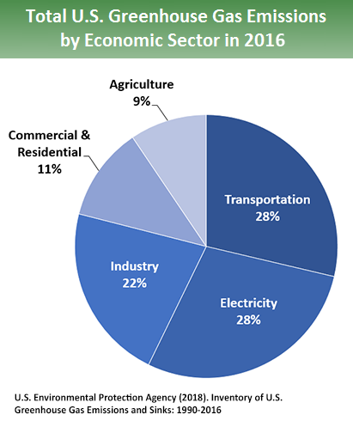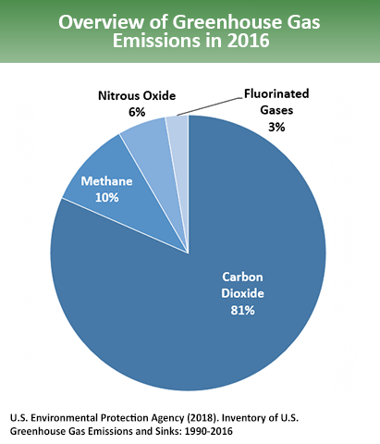
Figure 10 U. S. 2016 Greenhouse Gas Emissions
State GHG Inventory
ARB collects GHG emissions data for transportation, electricity, commercial/residential, industrial, agricultural, and waste management sectors each year. It then summarizes and highlights major annual changes and trends to demonstrate the state’s progress in meeting its GHG reduction goals. The 2019 edition of the GHG emissions inventory found total California emissions of 424.1 MMTCO₂e for 2017, with the transportation sector responsible for 41% of total GHGs. It also found that overall statewide GHG emissions declined from 2000 to 2017 despite growth in population and state economic output (ARB 2019a).
AB 32 required ARB to develop a Scoping Plan that describes the approach California will take to achieve the goal of reducing GHG emissions to 1990 levels by 2020, and to update it every 5 years. ARB adopted the first scoping plan in 2008. The second updated plan, California’s 2017 Climate Change Scoping Plan, adopted on December 14, 2017, reflects the 2030 target established in EO B-30-15 and SB 32. The AB 32 Scoping Plan and the subsequent updates contain the main strategies California will use to reduce GHG emissions.
Regional Plans
The proposed project is within the jurisdiction of the Nevada County Regional Transportation Planning Agency (RTPA) and is included in the Nevada County Regional Transportation Plan (RTP). The RTP estimates that based on current measurements, in 2030 emissions may be measured at 5,250 tons CO₂ per day and 120 tons CH₄ per day. Current trend estimates for CO₂ will increase daily emissions, while CH₄ are estimated to decrease. The 2015-2035 RTP identifies the objective 3.B to reduce regional emissions of criteria pollutants and greenhouse gases by 2.5 percent per year. Supporting policies include ensuring transportation facilities are compatible with adjacent land uses and encouraging use of native plant landscapes in shoulders and median strips to increase carbon uptake. The RTP Final Supplemental Environmental Impact Report Mitigation Measure 3.2-3 recommends promoting use of alternative fuels and efforts to recycle construction materials (including during demolition phase) in RTP projects
Project Analysis
GHG emissions from transportation projects can be divided into those produced during operation of the SHS and those produced during construction. The primary GHGs produced by the transportation sector are CO2, CH4, N2O, and HFCs. CO2 emissions are a product of the combustion of petroleum-based products, like gasoline, in internal combustion engines. Relatively small amounts of CH4 and N2O are emitted during fuel combustion. In addition, a small amount of HFC emissions are included in the transportation sector.
The CEQA Guidelines generally address greenhouse gas emissions as a cumulative impact due to the global nature of climate change (Pub. Resources Code, § 21083(b)(2)). As the California Supreme Court explained, “because of the global scale of climate change, any one project's contribution is unlikely to be significant by itself.” (Cleveland National Forest Foundation v. San Diego Assn. of Governments (2017) 3 Cal.5th 497, 512.) In assessing cumulative impacts, it must be determined if a project’s incremental effect is “cumulatively considerable” (CEQA Guidelines Sections 15064(h)(1) and 15130).
To make this determination, the incremental impacts of the project must be compared with the effects of past, current, and probable future projects. Although climate change is ultimately a cumulative impact, not every individual project that emits greenhouse gases must necessarily be found to contribute to a significant cumulative impact on the environment.
Operational Emissions
The purpose of the proposed project is to improve the curved alignment and will not increase the vehicle capacity of the roadway. This type of project generally causes minimal or no increase in operational GHG emissions. Because the project would not increase the number of travel lanes on SR-20, no increase in vehicle miles traveled (VMT) would occur as result of project implementation. While some GHG emissions during the construction period would be unavoidable, no increase in operational GHG emissions is expected.
Construction Emissions
Construction greenhouse gas emissions would result from material processing, on-site construction equipment, and traffic delays due to construction. These emissions will be produced at different levels throughout the construction phase; their frequency and occurrence can be reduced through innovations in plans and specifications and by implementing better traffic management during construction phases.
In addition, with innovations such as longer pavement lives, improved traffic management plans, and changes in materials, the greenhouse gas emissions produced during construction can be offset to some degree by longer intervals between maintenance and rehabilitation activities.
Construction greenhouse gas emissions were calculated using the Caltrans Construction Emissions Tool version 1.2 model to quantify the estimated average carbon dioxide (CO2), methane (CH4), nitrous oxide (N2O), and hydrofluorocarbons (HFCs) emissions from construction activities of the proposed project. The emissions expected to result from construction are anticipated to occur during 2021 through 2022, and the total expected greenhouse emissions are shown in Table 6 below.
Table 6 Estimates (US tons) of GHG Emissions During Construction
Construction Year | CO2 | CH4 | N2O | HFCs | CO2e*
2021 | 385 | 0.013 | 0.019 | 0.010 | 538.987
2022 | 316 | 0.009 | 0.020 | 0.017 | 573.785
Total | 700 | 0.02 | 0.04 | 0.03 | 1156.42

Implementation of the following measures will reduce greenhouse gas emissions from construction activities. Please note that although these measures are anticipated to reduce construction-related emissions, these reductions cannot be quantified at this time.
- The construction contractor must comply with the Caltrans’ Standard Specifications in Section 14-9 (2018). - Section 14-9-02 specifically requires compliance by the contractor with all applicable laws and regulations related to air quality, including air pollution control district and air quality management district regulations and local ordinances.
- Construction equipment and vehicles will be properly tuned and maintained. All construction equipment will use low sulfur fuel as required by CA Code of Regulations Title 17, Section 93114.
- To the extent feasible, construction traffic will be scheduled and routed to reduce congestion and related air quality impacts caused by idling vehicles along local roads during peak travel times.
CEQA Conclusion
While the proposed project will result in GHG emissions during construction, it is anticipated that the project will not result in any increase in operational GHG emissions. The proposed project does not conflict with any applicable plan, policy, or regulation adopted for the purpose of reducing the emissions of greenhouse gases. With implementation of construction GHG-reduction measures, the impact would be less than significant.
Caltrans is firmly committed to implementing measures to help reduce GHG emissions. These measures are outlined in the following section.
Greenhouse Gas Reduction Strategies
Statewide Efforts
Major sectors of the California economy, including transportation, will need to reduce emissions to meet the 2030 and 2050 GHG emissions targets. Former Governor Edmund G. Brown promoted GHG reduction goals that involved (1) reducing today’s petroleum use in cars and trucks by up to 50 percent; (2) increasing from one-third to 50 percent our electricity derived from renewable sources; (3) doubling the energy efficiency savings achieved at existing buildings and making heating fuels cleaner; (4) reducing the release of methane, black carbon, and other short-lived climate pollutants; (5) managing farms and rangelands, forests, and wetlands so they can store carbon; and (6) periodically updating the state's climate adaptation strategy, Safeguarding California.
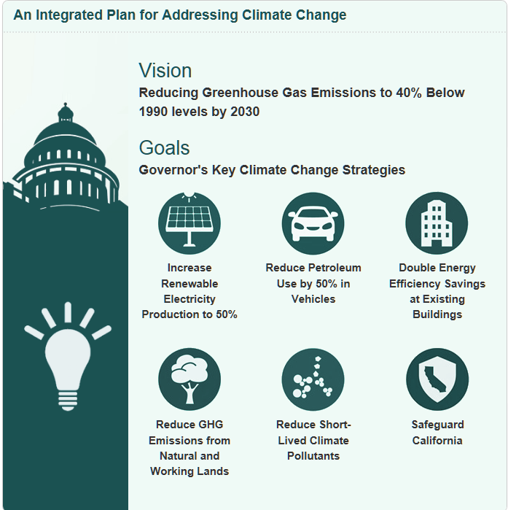
Figure 11 California Climate Strategy

The transportation sector is integral to the people and economy of California. To achieve GHG emission reduction goals, it is vital that the state build on past successes in reducing criteria and toxic air pollutants from transportation and goods movement. GHG emission reductions will come from cleaner vehicle technologies, lower-carbon fuels, and reduction of vehicle miles traveled (VMT). A key state goal for reducing GHG emissions is to reduce today's petroleum use in cars and trucks by up to 50 percent by 2030 (State of California 2019).
In addition, SB 1386 (Wolk 2016) established as state policy the protection and management of natural and working lands and requires state agencies to consider that policy in their own decision making. Trees and vegetation on forests, rangelands, farms, and wetlands remove carbon dioxide from the atmosphere through biological processes and sequester the carbon in above- and below-ground matter.
Caltrans Activities
Caltrans continues to be involved on the Governor’s Climate Action Team as the Air Resources Board works to implement Executive Orders S-3-05 and S-01-07 and help achieve the targets set forth in AB 32. Executive Order B-30-15, issued in April 2015, and SB 32 (2016), set an interim target to cut greenhouse gas emissions to 40 percent below 1990 levels by 2030. The following major initiatives are underway at Caltrans to help meet these targets.
California Transportation Plan (CTP 2040)
The California Transportation Plan (CTP) is a statewide, long-range transportation plan to meet our future mobility needs and reduce GHG emissions. In 2016, Caltrans completed the California Transportation Plan 2040, which establishes a new model for developing ground transportation systems, consistent with CO₂ reduction goals. It serves as an umbrella document for all the other statewide transportation planning documents. Over the next 25 years, California will be working to improve transit and reduce long-run repair and maintenance costs of roadways and developing a comprehensive assessment of climate-related transportation demand management and new technologies rather than continuing to expand capacity on existing roadways.
SB 391 (Liu 2009) requires the CTP to meet California’s climate change goals under AB 32. Accordingly, the CTP 2040 identifies the statewide transportation system needed to achieve maximum feasible GHG emission reductions while meeting the state’s transportation needs. While MPOs have primary responsibility for identifying land use patterns to help reduce GHG emissions, CTP 2040 identifies additional strategies in Pricing, Transportation Alternatives, Mode Shift, and Operational Efficiency.
Caltrans Strategic Management Plan
The Strategic Management Plan, released in 2015, creates a performance-based framework to preserve the environment and reduce greenhouse gas emissions, among other goals. Specific performance targets in the plan that will help to reduce greenhouse gas emissions include the following:
- Increasing percentage of non-auto mode share
- Reducing vehicle miles traveled
- Reducing Caltrans’ internal operational (buildings, facilities, and fuel) greenhouse gas emissions
Funding and Technical Assistance Programs
In addition to developing plans and performance targets to reduce GHG emissions, Caltrans also administers several sustainable transportation planning grants. These grants encourage local and regional multimodal transportation, housing, and land use planning that furthers the region’s RTP/SCS; contribute to the State’s GHG reduction targets and advance transportation-related GHG emission reduction project types/strategies; and support other climate adaptation goals (e.g., Safeguarding California).
Caltrans Policy Directives and Other Initiatives
Caltrans Director’s Policy 30 (DP-30) Climate Change (June 22, 2012) is intended to establish a Department policy that will ensure coordinated efforts to incorporate climate change into Departmental decisions and activities. Caltrans Activities to Address Climate Change (April 2013) provides a comprehensive overview of Caltrans’ statewide activities to reduce GHG emissions resulting from agency operations.
Project-Level Greenhouse Gas Reduction Strategies
The following measures will also be implemented in the project to reduce GHG emissions and potential climate change impacts from the project.
- Reduce construction waste and maximize the use of recycled materials (reduces consumption of raw materials, reduces landfill waste, and encourages cost savings). Caltrans will specify that the abandoned segments of highway being removed to be used as a percentage of the aggregate base material for the proposed alignment.
- Salvage large removed trees for lumber or similar on-site beneficial uses other than standard wood-chipping. (E.g., use in roadside landscape projects or green infrastructure components). Caltrans, in coordination with USFS, will specify on-site wood-chipping and placement of tree trunks or other woody material cut from proposed alignment earthwork areas in the abandoned, out sloped right of way.
- On-site recycling of existing project features is encouraged: (E.g., MBGR, light standards, sub-base granular material, or native material that meets Caltrans specifications for incorporation into new work). Caltrans will specify that a percentage of native material removed in early clearing and grubbing be retained for placement in the abandoned, out sloped right of way to encourage revegetation out of the native seed bank.
- Earthwork Balance: Reduce the need for transport of earthen materials by balancing cut and fill quantities. Caltrans has balanced earthwork between the two project segments to avoid importing soils or disposing of native forest soils off site. As the design phase continues to refine the project details, earthwork balance within each segment may become feasible.
- The construction contractor must comply with the Caltrans’ Standard Specifications in Section 14-9 (2018). - Section 14-9-02 specifically requires compliance by the contractor with all applicable laws and regulations related to air quality, including air pollution control district and air quality management district regulations and local ordinances.
- Construction equipment and vehicles will be properly tuned and maintained. All construction equipment will use low sulfur fuel as required by CA Code of Regulations Title 17, Section 93114.
- Construction traffic will be scheduled and routed to reduce congestion and related greenhouse gas emissions caused by idling vehicles along local roads during peak travel times.
Adaptation
Reducing GHG emissions is only one part of an approach to addressing climate change. Caltrans must plan for the effects of climate change on the state’s transportation infrastructure and strengthen or protect the facilities from damage. Climate change is expected to produce increased variability in precipitation, rising temperatures, rising sea levels, variability in storm surges and their intensity, and in the frequency and intensity of wildfires. Flooding and erosion can damage or wash out roads; longer periods of intense heat can buckle pavement and railroad tracks; storm surges combined with a rising sea level can inundate highways. Wildfire can directly burn facilities and indirectly cause damage when rain falls on denuded slopes that landslide after a fire. Effects will vary by location and may, in the most extreme cases, require that a facility be relocated or redesigned. Accordingly, Caltrans must consider these types of climate stressors in how highways are planned, designed, built, operated, and maintained.
Federal Efforts
Under NEPA assignment, Caltrans is obligated to comply with all applicable federal environmental laws and FHWA NEPA regulations, policies, and guidance.
The U.S. Global Change Research Program (USGCRP) delivers a report to Congress and the president every 4 years, in accordance with the Global Change Research Act of 1990 (15 U.S.C. ch. 56A § 2921 et seq). The Fourth National Climate Assessment, published in 2018, presents the foundational science and the “human welfare, societal, and environmental elements of climate change and variability for 10 regions and 18 national topics, with particular attention paid to observed and projected risks, impacts, consideration of risk reduction, and implications under different mitigation pathways.” Chapter 12, “Transportation,” presents a key discussion of vulnerability assessments. It notes that “asset owners and operators have increasingly conducted more focused studies of particular assets that consider multiple climate hazards and scenarios in the context of asset-specific information, such as design lifetime” (USGCRP 2018).
The U.S. DOT Policy Statement on Climate Adaptation in June 2011 committed the federal Department of Transportation to “integrate consideration of climate change impacts and adaptation into the planning, operations, policies, and programs of DOT in order to ensure that taxpayer resources are invested wisely, and that transportation infrastructure, services and operations remain effective in current and future climate conditions” (U.S. DOT 2011).
FHWA order 5520 (Transportation System Preparedness and Resilience to Climate Change and Extreme Weather Events, December 15, 2014) established FHWA policy to strive to identify the risks of climate change and extreme weather events to current and planned transportation systems. FHWA has developed guidance and tools for transportation planning that foster resilience to climate effects and sustainability at the federal, state, and local levels (FHWA 2019).
State Efforts
Climate change adaptation for transportation infrastructure involves long-term planning and risk management to address vulnerabilities in the transportation system. California’s Fourth Climate Change Assessment (2018) is the state’s effort to “translate the state of climate science into useful information for action” in a variety of sectors at both statewide and local scales. It adopts the following key terms used widely in climate change analysis and policy documents:
- Adaptation to climate change refers to adjustment in natural or human systems in response to actual or expected climatic stimuli or their effects, which moderates harm or exploits beneficial opportunities.
- Adaptive capacity is the “combination of the strengths, attributes, and resources available to an individual, community, society, or organization that can be used to prepare for and undertake actions to reduce adverse impacts, moderate harm, or exploit beneficial opportunities.”
- Exposure is the presence of people, infrastructure, natural systems, and economic, cultural, and social resources in areas that are subject to harm.
- Resilience is the “capacity of any entity – an individual, a community, an organization, or a natural system – to prepare for disruptions, to recover from shocks and stresses, and to adapt and grow from a disruptive experience”. Adaptation actions contribute to increasing resilience, which is a desired outcome or state of being.
- Sensitivity is the level to which a species, natural system, or community, government, etc., would be affected by changing climate conditions.
- Vulnerability is the “susceptibility to harm from exposure to stresses associated with environmental and social change and from the absence of capacity to adapt.” Vulnerability can increase because of physical (built and environmental), social, political, and/or economic factor(s). These factors include, but are not limited to: ethnicity, class, sexual orientation and identification, national origin, and income inequality. Vulnerability is often defined as the combination of sensitivity and adaptive capacity as affected by the level of exposure to changing climate.
Several key state policies have guided climate change adaptation efforts to date. Recent state publications produced in response to these policies draw on these definitions.
EO S-13-08, issued by then-governor Arnold Schwarzenegger in November 2008, focused on sea-level rise and resulted in the California Climate Adaptation Strategy (2009), updated in 2014 as Safeguarding California: Reducing Climate Risk (Safeguarding California Plan). The Safeguarding California Plan offers policy principles and recommendations and continues to be revised and augmented with sector-specific adaptation strategies, ongoing actions, and next steps for agencies.
EO S-13-08 also led to the publication of a series of sea-level rise assessment reports and associated guidance and policies. These reports formed the foundation of an interim State of California Sea-Level Rise Interim Guidance Document (SLR Guidance) in 2010, with instructions for how state agencies could incorporate “sea-level rise (SLR) projections into planning and decision making for projects in California” in a consistent way across agencies. The guidance was revised and augmented in 2013. Rising Seas in California – An Update on Sea-Level Rise Science was published in 2017 and its updated projections of sea-level rise and new understanding of processes and potential impacts in California were incorporated into the State of California Sea-Level Rise Guidance Update in 2018.
EO B-30-15, signed in April 2015, requires state agencies to factor climate change into all planning and investment decisions. This EO recognizes that effects of climate change other than sea-level rise also threaten California’s infrastructure. At the direction of EO B-30-15, the Office of Planning and Research published Planning and Investing for a Resilient California: A Guidebook for State Agencies in 2017, to encourage a uniform and systematic approach. Representatives of Caltrans participated in the multi-agency, multidisciplinary technical advisory group that developed this guidance on how to integrate climate change into planning and investment.
AB 2800 (Quirk 2016) created the multidisciplinary Climate-Safe Infrastructure Working Group, which in 2018 released its report, Paying it Forward: The Path Toward Climate-Safe Infrastructure in California. The report provides guidance to agencies on how to address the challenges of assessing risk in the face of inherent uncertainties still posed by the best available science on climate change. It also examines how state agencies can use infrastructure planning, design, and implementation processes to address the observed and anticipated climate change impacts.
Caltrans Adaptation Efforts
Caltrans Vulnerability Assessments
Caltrans is conducting climate change vulnerability assessments to identify segments of the State Highway System vulnerable to climate change effects including precipitation, temperature, wildfire, storm surge, and sea-level rise. The approach to the vulnerability assessments was tailored to the practices of a transportation agency, and involves the following concepts and actions:
- Exposure – Identify Caltrans assets exposed to damage or reduced service life from expected future conditions.
- Consequence – Determine what might occur to system assets in terms of loss of use or costs of repair.
- Prioritization – Develop a method for making capital programming decisions to address identified risks, including considerations of system use and/or timing of expected exposure.
The climate change data in the assessments were developed in coordination with climate change scientists and experts at federal, state, and regional organizations at the forefront of climate science. The findings of the vulnerability assessments will guide analysis of at-risk assets and development of adaptation plans to reduce the likelihood of damage to the State Highway System, allowing Caltrans to both reduce the costs of storm damage and to provide and maintain transportation that meets the needs of all Californians.
Project Adaptation Analysis
Climate change effects were addressed in the District 3 Climate Change Vulnerability Assessment (D3 CCVA) using two Global Climate Models to analyze the various global policies and economic forces that may contribute to greenhouse gas emission concentrations. Four scenarios were analyzed; peak emissions at three different time frames and a fourth representing declining emissions after 2080. The three peak time frames are in the next few years, mid-century, and end of century. The summary report of the D3 CCVA only presents results of the near-range and the long-range time frame for peak emissions.
The model results were then considered for the role of the State Highway System not merely for daily commuting or the movement of goods and services, but as the backbone of most evacuation routes. In the proposed project area, SR-20 is the only evacuation route providing access for evacuees, responding emergency personnel and equipment and acting as a potential physical barrier, in this area as a firebreak.
The resiliency of SR-20 to function amidst the variable stressors of temperature change, precipitation, wildfire, and sea-level rise and storm surge inundation were examined in the D3 CCVA. Temperature increase is projected for the project area, and overall in District 3. The average maximum temperature over seven days is expected to increase through the end of the century. These projections are averaged for three periods: 1) 2010 to 2039, represented by the year 2025, 2) 2040 to 2069, represented by the year 2055, and 3) 2070 to 2099, represented by the year 2085. In the 2025 period, the temperature increase is estimated to be between 2 and 5.9 degrees Fahrenheit, depending on location. Temperatures are projected to rise by 4 to 7.9 degrees Fahrenheit by 2055, and by 8 to 11.9 degrees Fahrenheit by 2085. Increases in the average maximum temperature will have a range of impacts for District 3, including those related to design, operations, and maintenance listed above. Some examples include more rapid deterioration of pavements, expansion and contraction of bridge joints and other materials, and potential heat stress and health impacts for Caltrans employees.
The “100-year storm event” is one useful way to examine this data—it is defined as a storm with a likelihood of occurring once every 100 years (or a one percent chance of occurring in any given year). A storm of this magnitude could cause significant damage, so it is a good design standard for infrastructure projects. Understanding how the 100-year storm may change in the future can help Caltrans to build more resilient infrastructure, designed to accommodate heavier storm events.
The depth of a 100-year precipitation event is expected to increase over time in District 3, based on the median precipitation model (HadGEM2-CC). Projections vary by location, with some of the most significant changes projected in the Sierra Nevada and parts of Sutter and Yuba counties. SR-20 winds through these areas. In the 2025 period (midpoint of the years 2010 to 2039), 100- year precipitation depths are expected to increase by 0 to 9.9% with the greatest change in the Sierra Nevada and in the western edges of Glenn and Colusa counties (5 to 9.9%). In the 2055 period (midpoint of the years 2040 to 2069), the range increases from 0 to 14.9%, and by 2085 (midpoint of the years 2070 to 2099) the range increases to 0 to 19.9%, depending on location. Generally, storms like the 100-year event are expected to become more severe with depth increasing by 11 to 12.5%. Droughts between periods of rain are anticipated to become longer and more extreme. Decadal to multi-decadal megadroughts are expected to become more likely in the west as temperatures rise, despite the increased frequency of heavy downpours.
The 100-year precipitation event depths are directly proportional to intensity so a projected increase in precipitation depth yields a 12.5% increase in intensity. Therefore, climate change is projected to increase the 100-year intensity by 11.0% – 12.5% in the project area by the year 2085. Runoff is generally a product of a runoff coefficient multiplied by intensity multiplied by the watershed area.
Watersheds within this project’s limits may change size due to the reduced impervious surface area of the proposed alignment, and runoff coefficients could result in increased, decreased, or no change in runoff from existing conditions based on the specific conditions of each watershed. The impact to the runoff coefficient and final area of each watershed would not be determined until the Final Drainage Report is completed in the later design phase of project development.
Changing precipitation patterns and higher temperatures are also expected to influence both the intensity and scale of wildfires. Higher temperatures decrease the moisture in soils and vegetation—which leads to increased wildfire risk. Wildfires can contribute to landslide and flooding exposure by burning off protective land cover and reducing the underlying soils’ capacity to absorb rainfall. California is already prone to serious wildfires, and future climate forecasts suggest that this vulnerability will get worse.
The mileage of State Highway System exposed does not change over time, but the level of wildfire risk does. For example, there are portions of the Sierra Nevada range that show medium projections of risk in the 2025 period (mean of the years 2010 to 2039) that change to high concern by the middle of the century, and very high concern by the end of the century. The projected wildfire risk for the district overall is very high, given that a large portion of the district consists of forested foothills and mountain ranges. Wildfires in District 3 could lead to road closures, and damages to State Highway System infrastructure such as signs, guardrails, culverts, and asphalt. They could also lead to indirect impacts such as landslides on steep slopes.
Modeling indicates that climate change will influence the proposed project environment, however the project itself would not exacerbate the effects of climate change. Due to the vegetation removal required for construction and the improved roadway alignment the project areas will provide a barrier to fire moving past them.
Sea-Level Rise
The proposed project is outside the coastal zone and not in an area subject to the effects of sea-level rise or storm surge inundation. Accordingly, direct impacts to transportation facilities due to projected sea-level rise or inundation are not expected.
Floodplains
The proposed project is not located in a floodplain. The proposed alignment reduces the impervious surface in the watersheds by approximately 2.4 acres, which may help reduce some seasonal flood magnitudes downstream under future climate conditions such as more precipitation falling as rain than snow. This effect of the design in addition to materials selection will build resilience into this area of SR-20.
Wildfire
The project location is currently considered a very high fire hazard severity zone as recommended by CalFire assessments. The D3 CCVA identifies that between postmiles 20.15 and 45.66, SR-20 will have a high level of concern for wildfire exposure between now and 2039. No infrastructure associated with wildfire risks will be installed within the project limits. USFS staff have directed Caltrans to consider native plants for landscaping, many of which are naturally fire-resistant. Avoidance and Minimization Measure AES 2 specifies that species native to the Tahoe National Forest will be replanted in revegetation areas. Removal of vegetation within the project impact areas will reduce fire fuels and create a fire break, at least during construction and for a period afterwards. Potential benefits the project may impart to lessen the risk of wildfire includes features such as widened roadway, shoulders and a clear recovery zone, reduced vegetation adjacent to the roadside, and additional turnout areas for emergency response vehicle staging. Refer to Section 3.3 for more information about wildfire.
- Comments and Coordination
Early and continuing coordination with the general public and public agencies is an essential part of the environmental process. It helps planners determine the necessary scope of environmental documentation and the level of analysis required, and to identify potential impacts and avoidance, minimization, and/or mitigation measures and related environmental requirements. Agency and tribal consultation and public participation for this project have been accomplished through a variety of formal and informal methods, including interagency coordination meetings, public meetings, public notices, Project Development Team (PDT) meetings and Project Development Focus meetings. This chapter summarizes the results of Caltrans efforts to fully identify, address, and resolve project-related issues through early and continuing coordination.
  - Agency Coordination
United States Forest Service, Tahoe National Forest, Yuba River District staff have been informally coordinated with during the development process of this project. Additionally, formal coordination meetings were held on October 4, 2018, March 7, 2019, April 25, 2019, and another is planned for January 2020. The Forest Supervisor, Yuba River District Ranger and his designated staff attended as well as Caltrans project development staff. Discussions were held about the purpose and need of the proposed project, future right of way processes, project development timelines, studies conducted and concerns such as wildfire fuels, the Burlington Motorcycle Trail and the Pioneer Trail.
County of Nevada Departments of Planning and Public Works staff were coordinated with on the proposed project in a formal coordination meeting on June 20, 2019 at the Caltrans District 3 offices. The purpose and need, project overview and right of way of county-maintained roadways was clarified, disclosure of the need to conform intersections with SR-20 after alignment modifications and improvements are made.
  - Tribal Consultation
The Native American Heritage Commission (NAHC) was contacted August 15, 2017 to request a search of the Sacred Land Files and request a list of Native American tribes or individuals with potential interests, concerns, and/or knowledge regarding cultural resources or Traditional Cultural Properties that may be affected by the project. Of the four tribes originally identified by the NAHC, only the United Auburn Indian Community of the Auburn Rancheria (UAIC) and the Washoe Tribe of Nevada and California responded, and also requested that the Nevada City Indian Rancheria be included in subsequent consultation.
Consultation with the United Auburn Indian Community (UAIC) has been informally conducted between Caltrans staff and UAIC liaisons throughout the project development process. A formal coordination meeting was held on April 18, 2019 at the Caltrans District 3 offices. The purpose and need, project overview, cultural importance of resources discovered during field surveys, and the requests for preservation of the culturally important resources were discussed.
Washoe Tribe members met with TNF and Department staff on May 14, 2019 to provide information regarding ethnographic uses of bedrock mortars. A second meeting on the same topic was held on May 29, 2019 and included UAIC members as well.
  - Public Coordination
The draft Initial Study/ Environmental Assessment will be available for public review at the Caltrans District 3 office in Marysville, Nevada County Government Center at 950 Maidu Avenue, Nevada City, CA 95959, the Nevada County Community Library at 980 Helling Way, Nevada City, CA 95959, and the US Forest Service Supervisor’s Office at 631 Coyote St., Nevada City, CA 95959. A digital copy can be requested from the contacts below.
A public meeting is planned for February 10, 2020 at 5:00 PM to 6:30 PM to garner input from the public who are interested in Caltrans’ project. The meeting will be held at the Eric W. Rood Administrative Center, Board of Supervisors Chambers, 950 Maidu Avenue in Nevada City.
Public comments will be accepted at the public meeting and until close of business (5:00 PM) on March 13, 2020, via e-mail at: erin.damm@dot.ca.gov and in writing at the Caltrans District 3 office at:
California Department of Transportation, District 3
Attention: Erin Damm
703 B Street
Marysville, CA 95901
All written and email comments received by the deadline will be reviewed by the Caltrans project development team and considered prior to project approval or abandonment. Comments posted on social media or other platforms will not be considered.
- List of Preparers
This document was prepared by the following:
Department Staff
Erin D. Damm, Associate Environmental Planner. Contribution: Environmental Coordination, Document Preparer, Task order manager for the Visual Impact Assessment.
Kelly McNally, District Environmental Branch Chief. Contribution: Environmental document oversight.
Connor Buitenhuys, Principal Investigator- Prehistoric and Historic Archeology. Contribution: Task order manager, cultural resources.
Ian Springer, Principal Investigator- Historic Archeology. Contribution: Task order manager, cultural resources.
Gail St. John, Senior Environmental Planner, Principal Architectural Historian. Contribution: Architectural historical resources.
Lisa Bright, District Native American Coordinator. Contribution: Native American Consultation.
Sarah-Jane Gerstman, Natural Resource Specialist, Biology. Contribution: Task order manager for the Natural Environmental Study.
Gregory Saiyo, Natural Resource Specialist, Biology. Contribution: Resource Agency Coordinator.
Youngil Cho, Air Quality Specialist. Contribution: Air, Noise, Climate Change, Energy Analysis.
Mark Melani, Hazardous Waste Coordinator. Contribution: Hazardous Waste.
Sean Cross, NPDES Coordinator. Contribution: Stormwater Permitting.
Jonathan Sampson, Landscape Associate. Contribution: Aesthetics.
ICF Jones & Stokes, Inc.
Shahira Ashkar, Project Manager. Contribution: Task order oversight.
Jennifer Ban, Task Order Manager. Contribution: Visual Impact Assessment Oversight.
Tim Messick, Senior Graphic Designer. Contribution: Visual simulations.
John Howe, Task Order Manger. Contribution: Wildlife Biology, Reviewer.
Aliana Summers, Project Coordinator. Contribution: Botany.
Pablo Herrera, Wildlife Biologist. Contribution: Natural Environmental Study.
Katherine Carpenter, Botanist/ Wetland Ecologist. Contribution: Natural Environmental Study.
Dan Schiff, Geographic Information Systems Specialist. Contribution: Natural Environmental Study.
Stephanie Monzon, Administrative Staff. Contribution: Natural Environmental Study Editor.
Pacific Legacy, Inc.
Robert Jackson, Project Manager. Contribution: Task order oversight.
Lisa Shapiro, Principal Investigator. Contribution: Prehistoric Archaeology.
Hannah Ballard, Principal Investigator. Contribution: Historical Archaeology.
Scott Baxter, Senior Archaeologist. Contribution: Historical Archaeology.
JRP Historical Consulting, LLC
David Hickman, Architectural Historian. Contribution: Architectural History.
Christopher McMorris, Principal Architectural Historian. Contribution: Architectural History
- Distribution List
The filing of the notice of availability and documents with the State Clearinghouse, the notification of cooperating and participating agencies, and the public notice published in the newspaper satisfy the requirements of Executive Order 12372 regarding intergovernmental review of federal programs.
The following agencies have been distributed notice of availability of this draft environmental document.
USFS, Tahoe National Forest- Supervisor’s Office
USFS, Tahoe National Forest- Yuba River Ranger District
County of Nevada-Director, Public Works Department
Native American Heritage Commission, CA
Natural Resources Agency, CA
Department of Parks and Recreation
Office of Emergency Services
Fish and Wildlife, Habitat Conservation Planning Branch
Fish and Wildlife, Region 2- Norther Central, Rancho Cordova
Department of Food and Agriculture
Department of Forestry and Fire Protection
CA Highway Patrol
Air Resources Board
State Water Resources Control Board, Region 2- Central Valley
- Section 4(f) Analysis
  - Introduction
This section of the document discusses de minimis impact determinations under Section 4(f). Section 6009(a) of SAFETEA-LU amended Section 4(f) legislation at 23 United States Code (USC) 138 and 49 USC 303 to simplify the processing and approval of projects that have only de minimis impacts on lands protected by Section 4(f). This amendment provides that once the U.S. Department of Transportation (USDOT) determines that a transportation use of Section 4(f) property, after consideration of any impact avoidance, minimization, and mitigation or enhancement measures, results in a de minimis impact on that property, an analysis of avoidance alternatives is not required and the Section 4(f) evaluation process is complete.
FHWA’s final rule on Section 4(f) de minimis findings is codified in 23 Code of Federal Regulations (CFR) 774.3 and CFR 774.17.
Responsibility for compliance with Section 4(f) has been assigned to the Department pursuant to 23 USC 326 and 327, including de minimis impact determinations, as well as coordination with those agencies that have jurisdiction over a Section 4(f) resource that may be affected by a project action.
  - Description of Proposed Project
Caltrans proposes to improve two non-contiguous segments of the alignment of SR-20 by modifying the existing horizontal and vertical curves of the roadway and adding turnouts. This project will update the roadway to current standards by increasing the curve radii, widening shoulders to 8 feet, adding turnouts for both directions, and improving the vertical profile grade. Additionally, this project will improve the clear recovery zone (CRZ) by removing obstacles and flattening slopes close to the travelled way. Two main project segments occur between PM 29.7-30.9 and 36.8-30.9 are referred to as White Cloud and Lowell Hill segments respectively.
There are two alternatives considered for the project; a build alternative and a no-build alternative. Additional details are found in Chapter 1 of this document.
  - Section 4(f) Properties
    - Study Areas
Two study areas were used for the identification and determinations of Section 4(f) properties. The first area corresponds with the environmental study area for other resources discussed in this document, plus a half mile radius outside each segment’s study area. Within this study area, existing park and recreation areas as well as any wildlife refuges were identified. The second study area is termed the Area of Potential Effects (APE) as defined by Section 106 of the National Historic Preservation Act. Historic or archeological sites on or eligible for listing on the National Register of Historic Places that exist in this APE are considered Section 4(f) properties. The APE limit is a boundary to identify historic resources and the environmental study limit is a boundary that includes all environmental resources, including historic resources, within the project area. Sometimes these two study areas do not exactly coincide.
There are four Section 4(f) resources identified within the environmental study limits and one Section 4(f) resources outside the environmental study limits, but adjacent to the proposed project. Skillman Campground is not within the environmental study limits, but within close proximity to the study area. The following Section 4(f) resources are within the project limits: Pioneer Trail, Steephollow Snow Trail, Burlington Motorcycle Trail System, White Cloud Campground. These resources are shown in Figure 12 and Figure 12.
Tahoe National Forest
The following four Section 4(f) resources are located on Tahoe National Forest land managed by the U.S. Forest Service: Pioneer Trail, Steephollow Snow Trail System, Burlington Motorcycle Trail System and White Cloud Campground. These recreational facilities are located on land that is publicly owned, the land is formally designed to serve as a primary function or major purpose to recreation (USFS Management Plan, 1999), and is generally accessible to the public with certain restrictions. Recreation opportunities for walking, hiking, running, mountain cycling and equestrian riding exist on the Pioneer Trail. Off-highway vehicle riding, and camping are available on the Burlington Motorcycle Trail System. There are eight trails in the overall Burlington Trail System, however only Excelsior and Last Chance Trail are located within the Environmental Study Limit at the Lowell Hill project segment. There is a winter recreation Nordic ski trail system also in the Lowell Hill project segment, partially overlapping with the Last Chance motorcycle trail. Also within the study areas is the White Cloud Campground. Skillman Horse Camp is approximately 2 miles east of the White Cloud project segment and accessible via the Pioneer Trail as well as from SR-20. Figure 12 illustrates the extent of the trails in relation to the project segments.
Pioneer Trail – de minimis determination
The Pioneer Trail in relation to the project location is shown on the project maps in Chapter 1. The Trail is 24.4 miles long, roughly running adjacent to SR-20 for most of its length from west to east, until near Zeibright Road when the trail runs northeast to Bowman Lake Road, crossing at Lang’s Crossing and meeting at the Spalding Lake trail. The Trail was built primarily by volunteer efforts through coordination with the USFS.

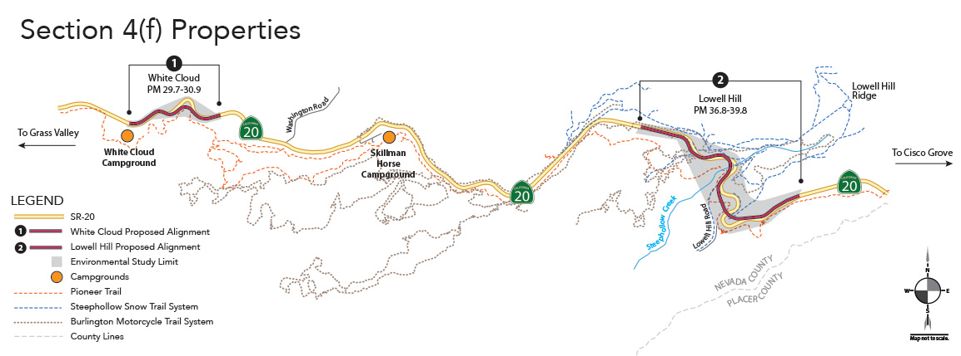
Figure 12 Project Segments in Relation to Section 4(f) Properties
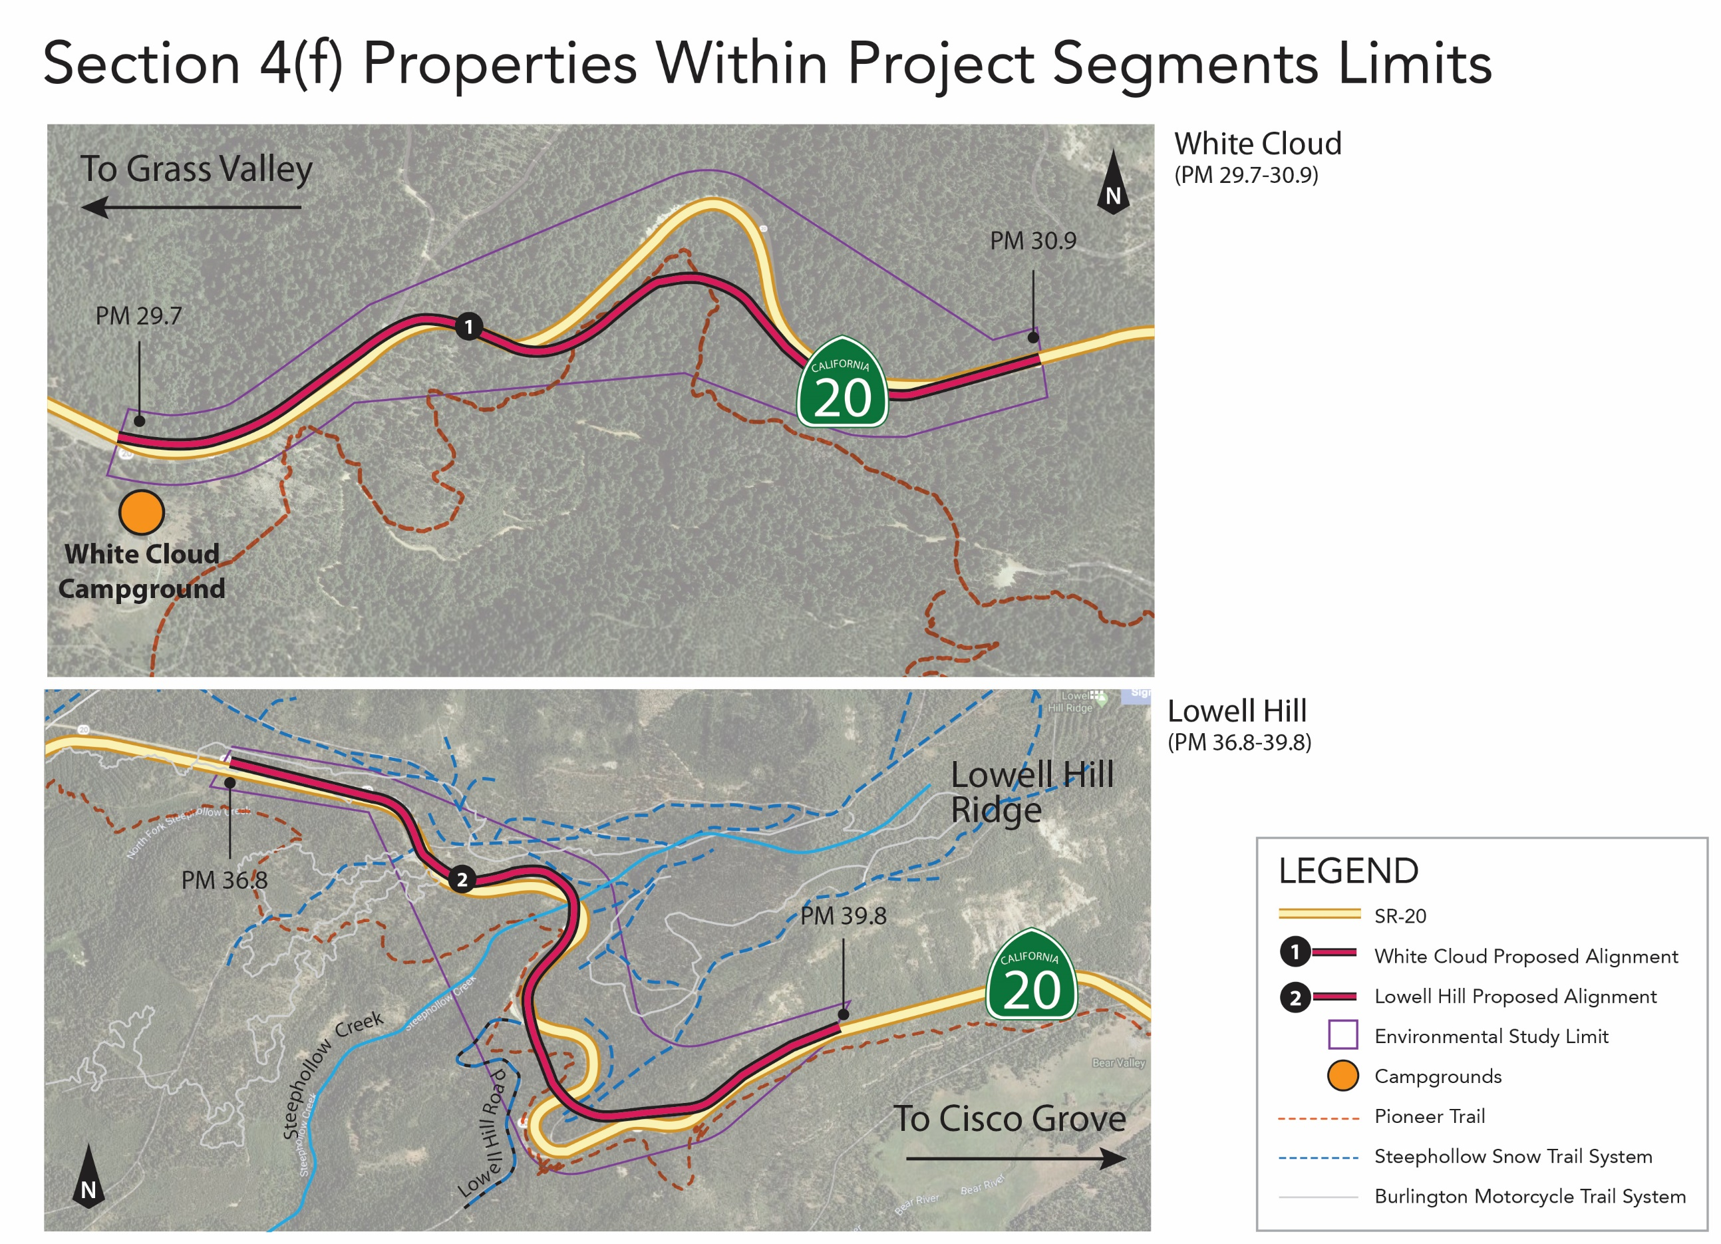
Figure 13 Section 4(f) Resources at Project Segments

The Trail is in Nevada County and TNF. The Pioneer Trail functions as a locally significant, beginner-to-intermediate level recreational trail to the mountain cycling and equestrian communities. The Trail is easily accessible from multiple locations along the nearly 25-mile point-to-point course. Trail access points include Five Mile House, White Cloud campground, a forest spur road across SR-20 from the Jefferson Creek Scenic Overlook, Skillman Campground, Chalk Bluff staging area, off Excelsior Point Road, off Lowell Hill Road, off Zeibright Road, and from multiple locations on Bowman Lake Road before terminating in the Spalding Lake Trail. Forest roads and other trails provide additional connectivity between Pioneer Trail and other recreation opportunities in the forest.
Under the provisions of Section 4(f), it was determined there will be a use of portions of the recreational Pioneer Trail because the land is permanently incorporated into a Department of Transportation Easement (DOTE). The following information explains the effects to the portions of the Pioneer Trail. The cut and fill earthwork slopes of the highway will be engineered to provide a shelf (or other similar provision) in the slopes as the Trail meanders at a relatively static elevation. While there will not be a deeded description for the location of the Trail itself, incorporation of a shelf for the Trail in the transportation facility will be included in construction plans. Reconstructed portions of the Pioneer Trail due to Caltrans’ project will be different from its existing physical location and there will be a visual difference between existing segments and those that will traverse the slope shelf. However, once the construction is finished the gentle slope and continuous mileage features of the Trail will be intact.
Caltrans is utilizing USFS trail standards and is designing the fill earthwork to include a flattened area, or bench, to hold the reconstructed trail at consistent elevations as the existing trail. The shelf will enable connectivity with other portions of the Trail outside of the DOTE to provide a complete point-to-point trail following construction, as exists prior to the project construction. Activities, such as hiking, mountain cycling, and equestrian riding will be temporarily affected for approximately 24 months as the trail will, intermittently, be closed to recreational users for safety reasons during construction. Although this section of trail (1,000-feet) will be closed with no detour, the rest of the remaining 24-miles of the Pioneer trail will remain open and accessible. Once the new section of trail is reconstructed, the features of the trail, such as the width of the trail, incline elevation, and base materials (dirt trail) will remain the same.
It is anticipated that reconstructed segments of trail within the DOTE would be available for use before the overall project is completed. The location of the Trail would meander in and out of the DOTE without a specifically described location, built into earthwork of the road project where it is practical for the overall Trail recreational activities. The portions of the Trail that would need to be reconstructed outside of the project limits will be funded by Caltrans and coordinated through USFS. As part of the circulation for the draft environmental document, Caltrans is also soliciting comments from the public in regards to the Section 4(f) de minimis determination. Following the public comment period, any comments received on the de minimis determination for the Pioneer Trail will be addressed in the Final Environmental Document. Written concurrence from USFS will be requested after all public comments on the de minimis determination have been considered and addressed..
Steephollow Snow Trail System – de minimis determination
Steephollow Snow Trail System (SSTS) is the westerly most Nordic-only winter trail system located on Tahoe National Forest land managed by the USFS. The other Nordic-only winter trails are on SR-49 near the Yuba Pass Sno-Park, on SR-89 approximately 8 and 15 miles north of Truckee and 6 miles south of Truckee, and on I-80 approximately 10 miles west of Truckee. Mixed use trails for Nordic-ski and snowmobiling recreation occur throughout TNF. The SSTS has approximately 8 miles of easy to moderate difficulty trail segments with zero vehicle (including no snowmobile) use during winter season designated months. Some of the SSTS trail segments are open with non-winter seasonal use designations to vehicles or motorcycles only, as described in the USFS Motor Vehicle Use Map.
The trail segments meander on the north side of SR-20 near the Steephollow Creek headwaters, extending as far east-northeast as the Lake Spaulding Overlook at approximately 5,760 feet elevation. The main parking for the trail system is at the Alpha-Omega rest stop on SR-20, approximately 2 miles west of the Lowell Hill project segment. There are two other turn-offs from SR-20 that provide parking and trailhead access to the trail system; via Last Chance Mine Road at trail junction marker 7, and from a turn East off SR-20 at trail junction marker 25. Passenger vehicle access to the two trailhead parking areas may be difficult in the winter if highway plowing has heaped snow over their intersections with SR-20.
The segment of SSTS that is being affected by the proposed project is part of a trail commonly referred to as Ridge Run Nordic. The first mile of Ridge Run Nordic between the trailhead at junction marker 25 and junction marker 19 is not a segment of the trail system that authorizes vehicular use, either seasonally or year-round. The trail segment can be used during non-snow conditions for hiking, mountain biking or equestrian riding. Because the trail segment does not share use with a transportation facility, it meets a key designation to apply Section 4(f), unlike access at Last Chance Mine Road. After construction is complete, access to parking at the junction 25 trailhead from SR-20 would be reconnected to the proposed highway alignment directly across from the intersection at Lowell Hill Road. This reconnection would be constructed by Caltrans as part of the proposed project. Additional information about Last Chance Mine Road is discussed in the next chapter sub-section below.
In early coordination with USFS staff, it was clarified that trail junction markers are attached to trees or permanent posts to indicate safe routes when the dirt trail is obscured by snow. It was further clarified that forest service staff and/or authorized trail volunteers may vary the marked trail locations when conditions preclude safe Nordic ski use of segments of the trail. During construction, the segment of the Ridge Run Nordic trail being affected would be temporarily closed from the trailhead parking off SR-20 at junction marker 25. Signage at junction marker 19 would indicate to trail users coming from alternate access points that the trail to junction marker 25 would be temporarily closed.
Temporary closure of the Steephollow Snow Trail segment from the parking and trailhead at trail junction marker 7 to trail junction marker 9 may be required if construction affects the intersection of SR-20 and Last Chance Mine Road over winter.
The proposed project will permanently affect the Ridge Run Nordic trail segment between markers 25 and 19. Approximately 1,000 feet of the existing trail would be bisected by earthwork where the proposed alignment will be located. One possible route to reconnect the segment would be a cut-off route, set back approximately 200 feet from the earthwork edge. The cut-off route would have a 15% slope. The cut-off route would reconnect the segment between junction markers 19 and 25, and the trail segment will then be outside of the transportation easement. Figure 5 Lowell Hill Segment Existing and Proposed Trail LocationsFigure 5 shows the proposed location of the cut-off route.
Work to reconnect the trail would be conducted through USFS coordination using hand tools and small equipment to construct the cut-off route and retain the feature of year-round non-vehicular access in this segment of the overall trail system. Caltrans would compensate the USFS for their construction efforts of the cut-off route.
The five criteria of a temporary use exemption under 23 CFR 774.13(d) do not apply because there will be temporary trail interference due to the segment closure during highway construction and trail reconstruction. Therefore, a Temporary Occupancy Use of a portion of the SSTS as defined by Section 4(f) will occur. The duration of the trail reconstruction will be temporary, and the ownership of the trail land is not changing. The reconstructed portion of the SSTS segment would retain the medium difficulty slope as currently exists in the system. The location of the reconstructed segment will be outside the direct impact of the proposed alignment and the native vegetation adjacent to it will remain so the changes apparent to the recreational user will be minimal. Following the public comment period, any comments received on the de minimis impact determination for the SSTS will be addressed in the Final Environmental Document. Written concurrence on Caltrans determination can only be requested from USFS after the public notice period and after the public has had a chance to comment on the de minimis impact determination.
    - Resources Evaluated Relative to the Requirements of Section 4(f): No Use Determinations
Section 4(f) of the Department of Transportation Act of 1966, codified in federal law at 49 United States Code (USC) 303, declares that “it is the policy of the United States Government that special effort should be made to preserve the natural beauty of the countryside and public park and recreation lands, wildlife and waterfowl refuges, and historic sites.”
This section of the document discusses parks, recreational facilities, wildlife refuges, and historic properties found within or next to the project area that do not trigger Section 4(f) protection because: 1) they are not publicly owned, 2) they are not open to the public, 3) they are not eligible historic properties, or 4) the project does not permanently use the property and does not hinder the preservation of the property.
Within the project segment study limits, plus a half mile buffer, there are no properties that are not protected by Section 4(f). The properties are located on Tahoe National Forest land managed by the USFS, with fostering recreation as a core management objection. The properties are publicly owned and are generally accessible to the public with certain restrictions. However, protection for the following properties in relation to the proposed project, has been determined to not meet the 3rd or 4th requirement for application of Section 4(f) protections per regulations at 23 CFR 774.
Last Chance Mine Road
Last Chance Mine Road is included in the Steephollow Snow Trail System, designated with parking near the trailhead at trail junction marker 7. The USFS 2013 motor vehicle use map also designates the road as route number 0020-016, a road “open to all motor vehicles, including smaller off-highway vehicles that may not be licensed for highway use (but not to oversize or overweight vehicles under State traffic law).” Additionally, a seasonal use designation is applied, restricting vehicular use of the road between November 2 and April 30.
Guidance from the Federal Highway Administration Section 4(f) Policy Paper clarifies when application of Section 4(f) protection to trails having a shared use with a transportation facility is appropriate. Because there is a motor vehicle use designation of Last Chance Mine Road, albeit with seasonal use designations, the primary purpose is as part of the local transportation system, transporting forest users into the forest, not for recreation. Accordingly, there will be no use of a Section 4(f) property and the provisions of Section 4(f) do not apply.
Regardless, Caltrans is making reasonable efforts to maintain the continuity of existing access to the forest and to the various trails that intersect or may overlay portions of Last Chance Mine Road. During construction, temporary closures may be required to realign the intersection of Last Chance Mine Road with the highway after highway elevation improvements have been made. The intersection realignment will be constructed to current design standards.
Burlington Motorcycle Trail System
The Burlington Motorcycle Trail System (BMTS) provides approximately 50 miles of variable experience-level trails for off-highway motor vehicle recreation along the Burlington Ridge in TNF. The trail was developed in partnership with Tahoe National Forest, Nevada County Woods Riders and the State of California OHMVR Division, and offers trails with beginner and intermediate degrees of difficulty. A portion of the trail system is only open to motorcycle riders while others are open to all off-highway vehicles (OHV). Access to the BMTS, as cited in the TNF trail guide, can be found from Omega Overlook Trail head, Chalk Bluff Staging Area and Burlington Ridge and Upper Burlington Ridge roads. There are also other locations where the BMTS can be accessed from intersecting forest roads.
Within the White Cloud project segment, Jefferson Creek Road intersects with SR-20. This road is designated as an unmaintained transportation, unpaved, dirt road open to all vehicles on the BMTS trail guide. There is not an OHV or motorcycle-only BMTS trail intersecting with Jefferson Creek Road. The requirements of Section 4(f) do not apply to this portion of the BMTS because the motorcycle trail overlaps onto Jefferson Creek Road, which is an integral part of the local transportation system and serves the primary purpose for transportation. This determination follows FHWA’s long standing guidance found in FHWA’s Section 4(f) Policy Paper (July 2012).
Within the Lowell Hill project segment, two motorcycle-only trail segments, the Last Chance Motorcycle Trail and the Excelsior Trail traverse on the north and south sides of SR-20 from post miles 36.90 to 37.25, approximately. This portion of the highway will experience vertical alignment changes and shoulder widening but will not directly impact the motorcycle trails. The SR-20 intersection with Last Chance Mine Road will also be improved and brought to conform to the proposed new highway vertical elevation. The intersection may experience temporary detours or closures during the construction work. Even though this road is authorized for OHV use, and ties to the Last Chance Motorcycle Trail segment, the requirements of Section 4(f) do not apply because the road is an integral part of the local transportation system and serves the primary purpose for transportation.
Similarly, south of SR-20 Excelsior Point Road intersection will be brought to conform with the improved vertical alignment of the highway on its existing alignment. The intersection will have temporary detours or closures during construction work. Excelsior Point Road is also designated as an unmaintained road open to all vehicles and intersects with the Excelsior Motorcycle Trail. Section 4(f) does not apply to Excelsior Point Road because the road is an integral part of the local transportation system and serves the primary purpose for transportation. No direct impacts to the Excelsior Motorcycle Trail will occur.
The BMTS will not have any portions permanently incorporated into the project construction areas, nor will there be any temporary occupancy, adverse or otherwise. Forest road access improvements are not being considered part of the Section 4(f) property because they are open to all vehicles and enable access to other forest uses such as fuel wood gathering. While the proposed project construction activity is in proximity to portions of the BMTS, there is not a constructive use of the trail system, as defined by the Section 4(f) guidelines. Inherently, OHV’s and motorcycles are relatively noisy and dusty recreational activities. The construction activities will not impair the purpose or recreational features of the BMTS. Access to portions of the forest roads intersecting with the BMTS will experience delays or temporary closures during construction.
White Cloud Campground
White Cloud Campground is immediately west of the proposed project’s westerly limits on SR-20. It’s ease of access from the highway and proximity to Nevada City are reasons for its heavy use. There are 46 single-family campsites, one of which is a double site. Sites are for RV and tent camping but there are no hookups for RV amenities. Within the campsite, features include an amphitheater, trailheads, drinking water, water spigots, flush toilets, picnic tables and campfire rings. There is a camp host, but the sites not reserved in advance are paid for at the self-pay station. The campground is shaded by fir, cedar and pine trees.
Recreational activities accessed directly from the campground include horseback riding, hiking, mountain biking and Nordic-skiing on the Pioneer Trail. To the west, recreationists can follow the Trail approximately 5 miles to Scotts Flat Lake. Other nearby recreation opportunities campers may be visiting are the South Yuba River, Washington Scenic Overlook, Alpha and Omega Scenic Overlook and Interpretive Trail, Rock Creek Nature Trail, Burlington motorcycle and OHV trails, and Grouse Ridge Non-Motorized Area. Except as mentioned previously in this appendix, these recreation opportunities are outside of the proposed project segments and will not be directly impacted.
The campground itself will not be impacted directly by the proposed project. Most of the features or attributes of the campground will not experience interference from the proposed project. Indirect interference from the project may result from delayed travel times to the campground due to temporary construction road closures or detours. There are specifications to limit night-work noise to be restricted between 9 PM and 6 AM from exceeding 86 decibels at 50 feet from the job site, so campers will not experience sleep interrupting construction-related sounds or lighting during the overnight hours. During the day however, campers may have views of construction equipment in the distance from their campgrounds. Daytime construction activities and sounds may be viewed and heard by campers.
While White Cloud Campground is a Section 4(f) property, no “use” will occur. Therefore, the provisions of Section 4(f) do not apply.
Historical Resources
For the purposes of Section 4(f), a historic resource is subject to Section 4(f) only if it is on or eligible for the National Register of Historic Places. Section 4(f) applies to archeological sites that are on or eligible for the National Register and that warrant preservation in place.
Within the Area of Potential Effects (APE), there are seven historic resources that have been determined eligible for inclusion to the National Register of Historic Places (NRHP). Two of the historic properties are prehistoric archaeological sites and the other five are historical built structures, also called linear resources.
The first prehistoric archaeological sites will be completely avoided by a redesigned alignment that will not intersect the site, and the second prehistoric archeological site will be protected by using an ESA fenced area to restrict construction activities from any accidental encroachment. Thus, under Section 106 of the National Historic Preservation Act, the project has a “no adverse effect” finding for the two prehistoric archaeological sites. Under Section 4(f), the provisions of “use” are not triggered for these two prehistoric archaeological sites.
The five linear resources include features which extend beyond the project study area, in some cases across state lines. These historic linear resources extend far outside the APE; therefore, it is beyond the scope of the proposed project to fully evaluate and record these historical built structures. Because of this limitation to fully evaluate the eligibility of these five linear resources, assumption of eligibility was made for listing on the National Register. The five linear resources were determined to be non-contributing elements to the overall eligibility of the linear resource that was assumed to be eligible. Each of the five linear resources have been found to have “no adverse effect” under Section 106 of the National Historic Preservation Act. In addition, the project as a whole has “no adverse effect”.
It is FHWA’s long-standing policy that there would not be a Section 4(f) use if, after consultation with the State Historic Preservation Officer, Caltrans determines that the project would use only a part of the linear resource which is considered a non-contributing element. In other words, Section 4(f) requirements do not apply to non-contributing properties when the Section 106 consultation results in a determination of no historic properties affected or no adverse effect, and the impact to the non-contributing element would not substantially impair the historic attributes of the resource. The appropriate steps, including consultation with the State Historic Preservation Officer (SHPO) and the Tribal Historic Preservation Officer (THPO) were conducted during environmental studies and current efforts are underway for concurrence with Caltrans’ finding of effects. Please refer to Cultural Resources Section 2.1.8 for additional information.
Properties eligible for protection under the Department of Transportation Act of 1966, Section 4(f) include the five linear resources. The proposed project would not result in a “use” of those properties as defined by Section 4(f). The two prehistoric archaeological sites were evaluated but are not considered for Section 4(f) protections.
Following the 30-day public comment period, any comments received on the Section 4(f) analysis will be addressed in the Final Environmental Document.
  - Section 6(f)
The Land and Water Conservation Fund (LWCF) Act was established by Congress in 1964 to fulfill a bipartisan commitment to safeguard natural areas, water resources and cultural heritage, and to provide recreation opportunities to all Americans. The LWCF program provides matching grants to States and local governments for the acquisition and development of public outdoor recreation areas and facilities. Section 6(f) of this Act prohibits the conversion of property acquired or developed with these grants to a non-recreational purpose without the approval of the Department of Interior’s (DOI) National Park Service.
There are no properties within the project study limits which have been converted to or acquired or developed for public outdoor recreation areas or facilities using section 6(f) grant funds.

- Title VI Policy Statement

- Avoidance, Minimization and/or Mitigation Summary
To ensure that all of the environmental measures identified in this document are executed at the appropriate times, the following measures as articulated on the proposed Environmental Commitments Record [ECR] that follows, would be implemented. During project design, avoidance, minimization, and/or mitigation measures will be incorporated into the project’s final plans, specifications, and cost estimates, as appropriate. All permits will be obtained prior to implementation of the project. During construction, environmental and construction/engineering staff will ensure that the commitments contained in the Environmental Commitments Record are fulfilled. Following construction and appropriate phases of project delivery, long-term mitigation maintenance and monitoring will take place, as applicable. Because the following Environmental Commitments Record is a draft, some fields have not been completed; they will be filled out as each of the measures is implemented.

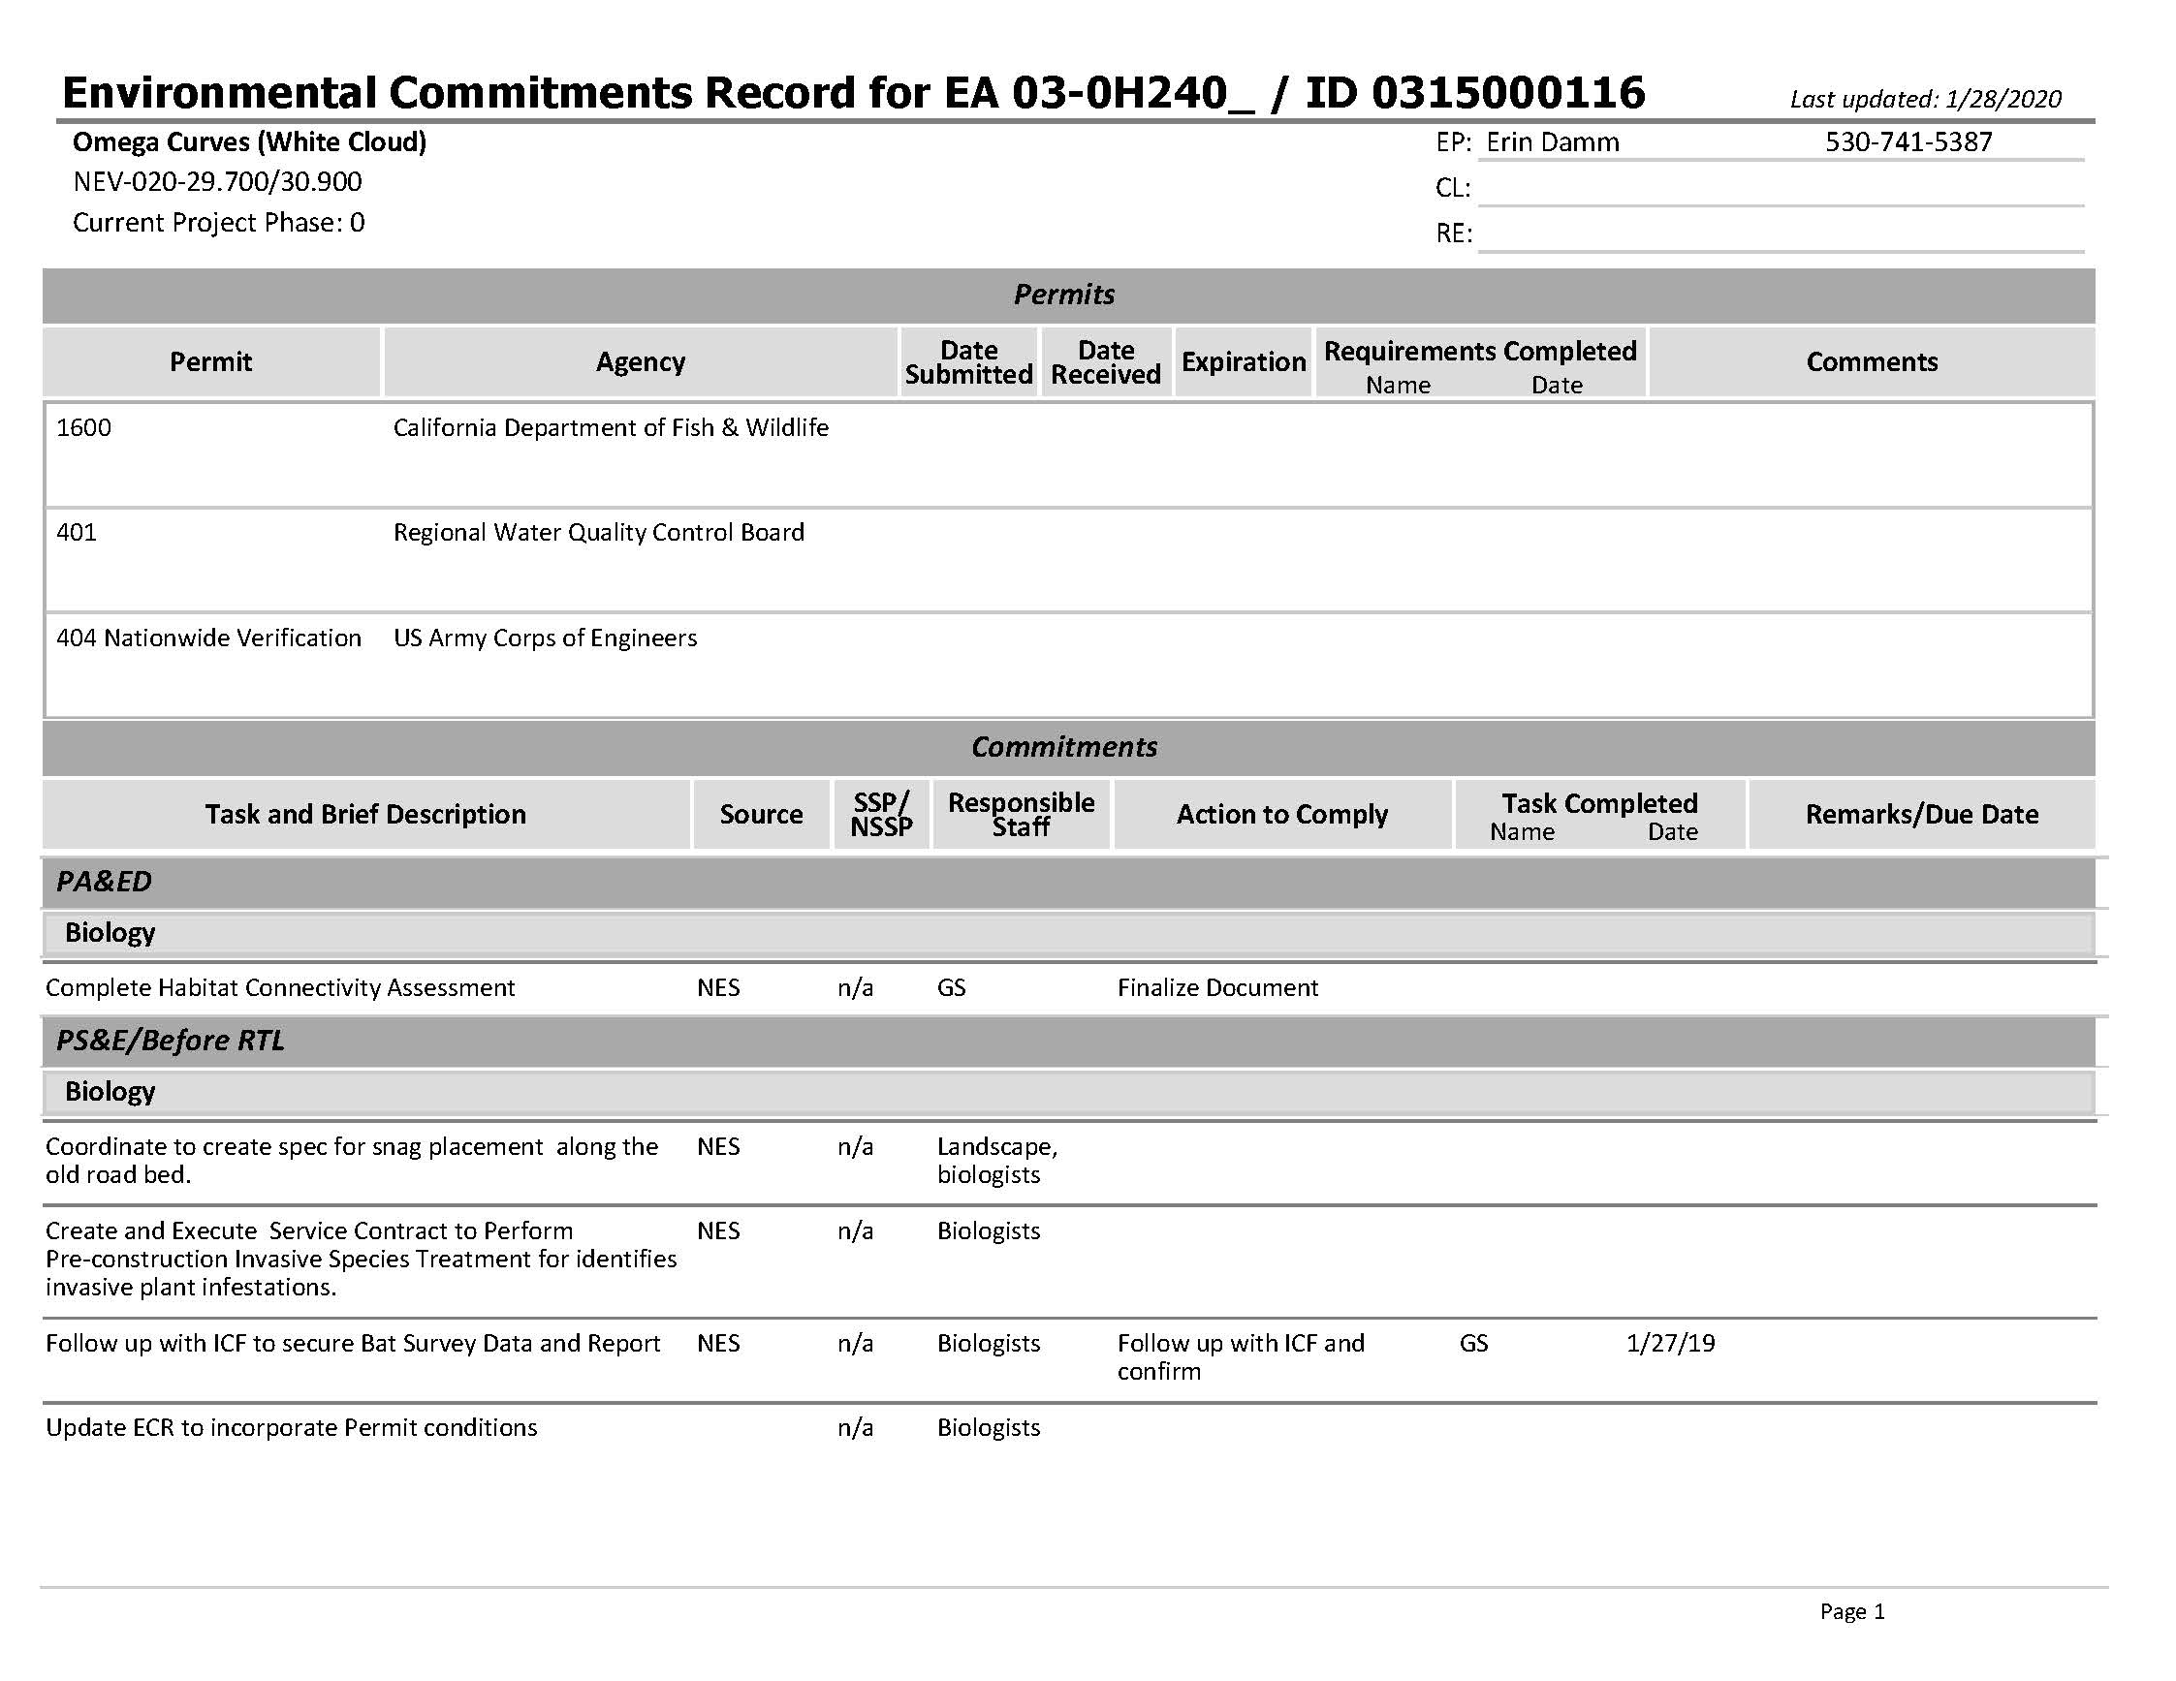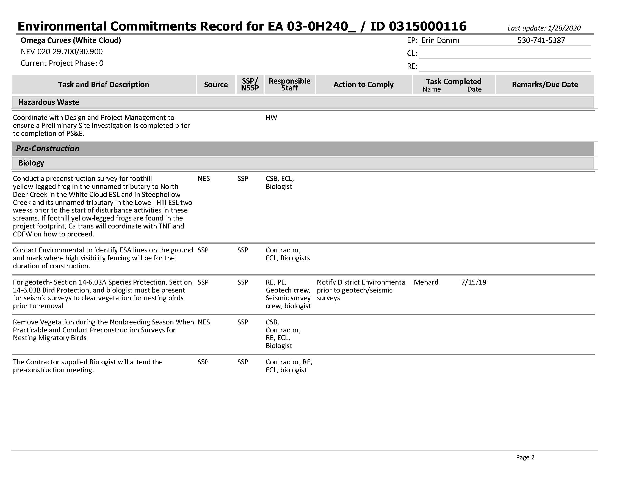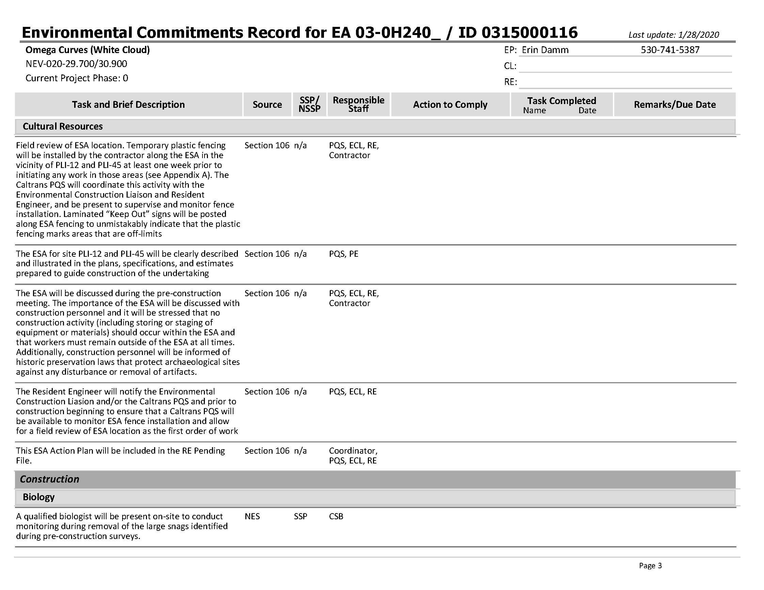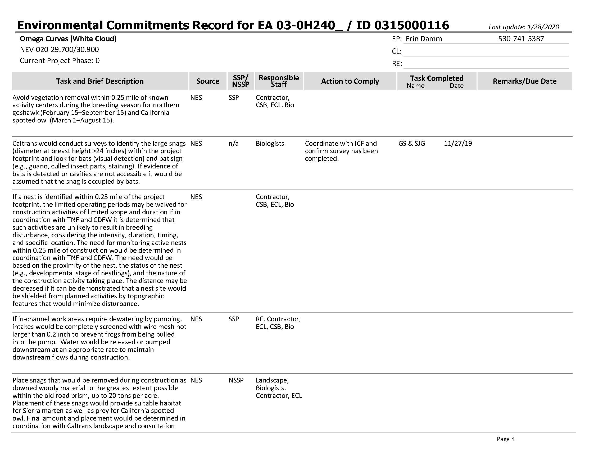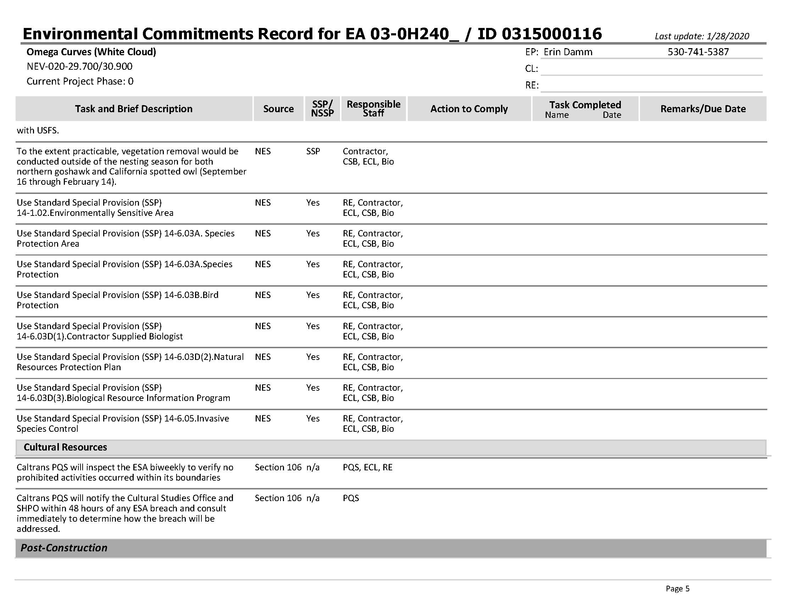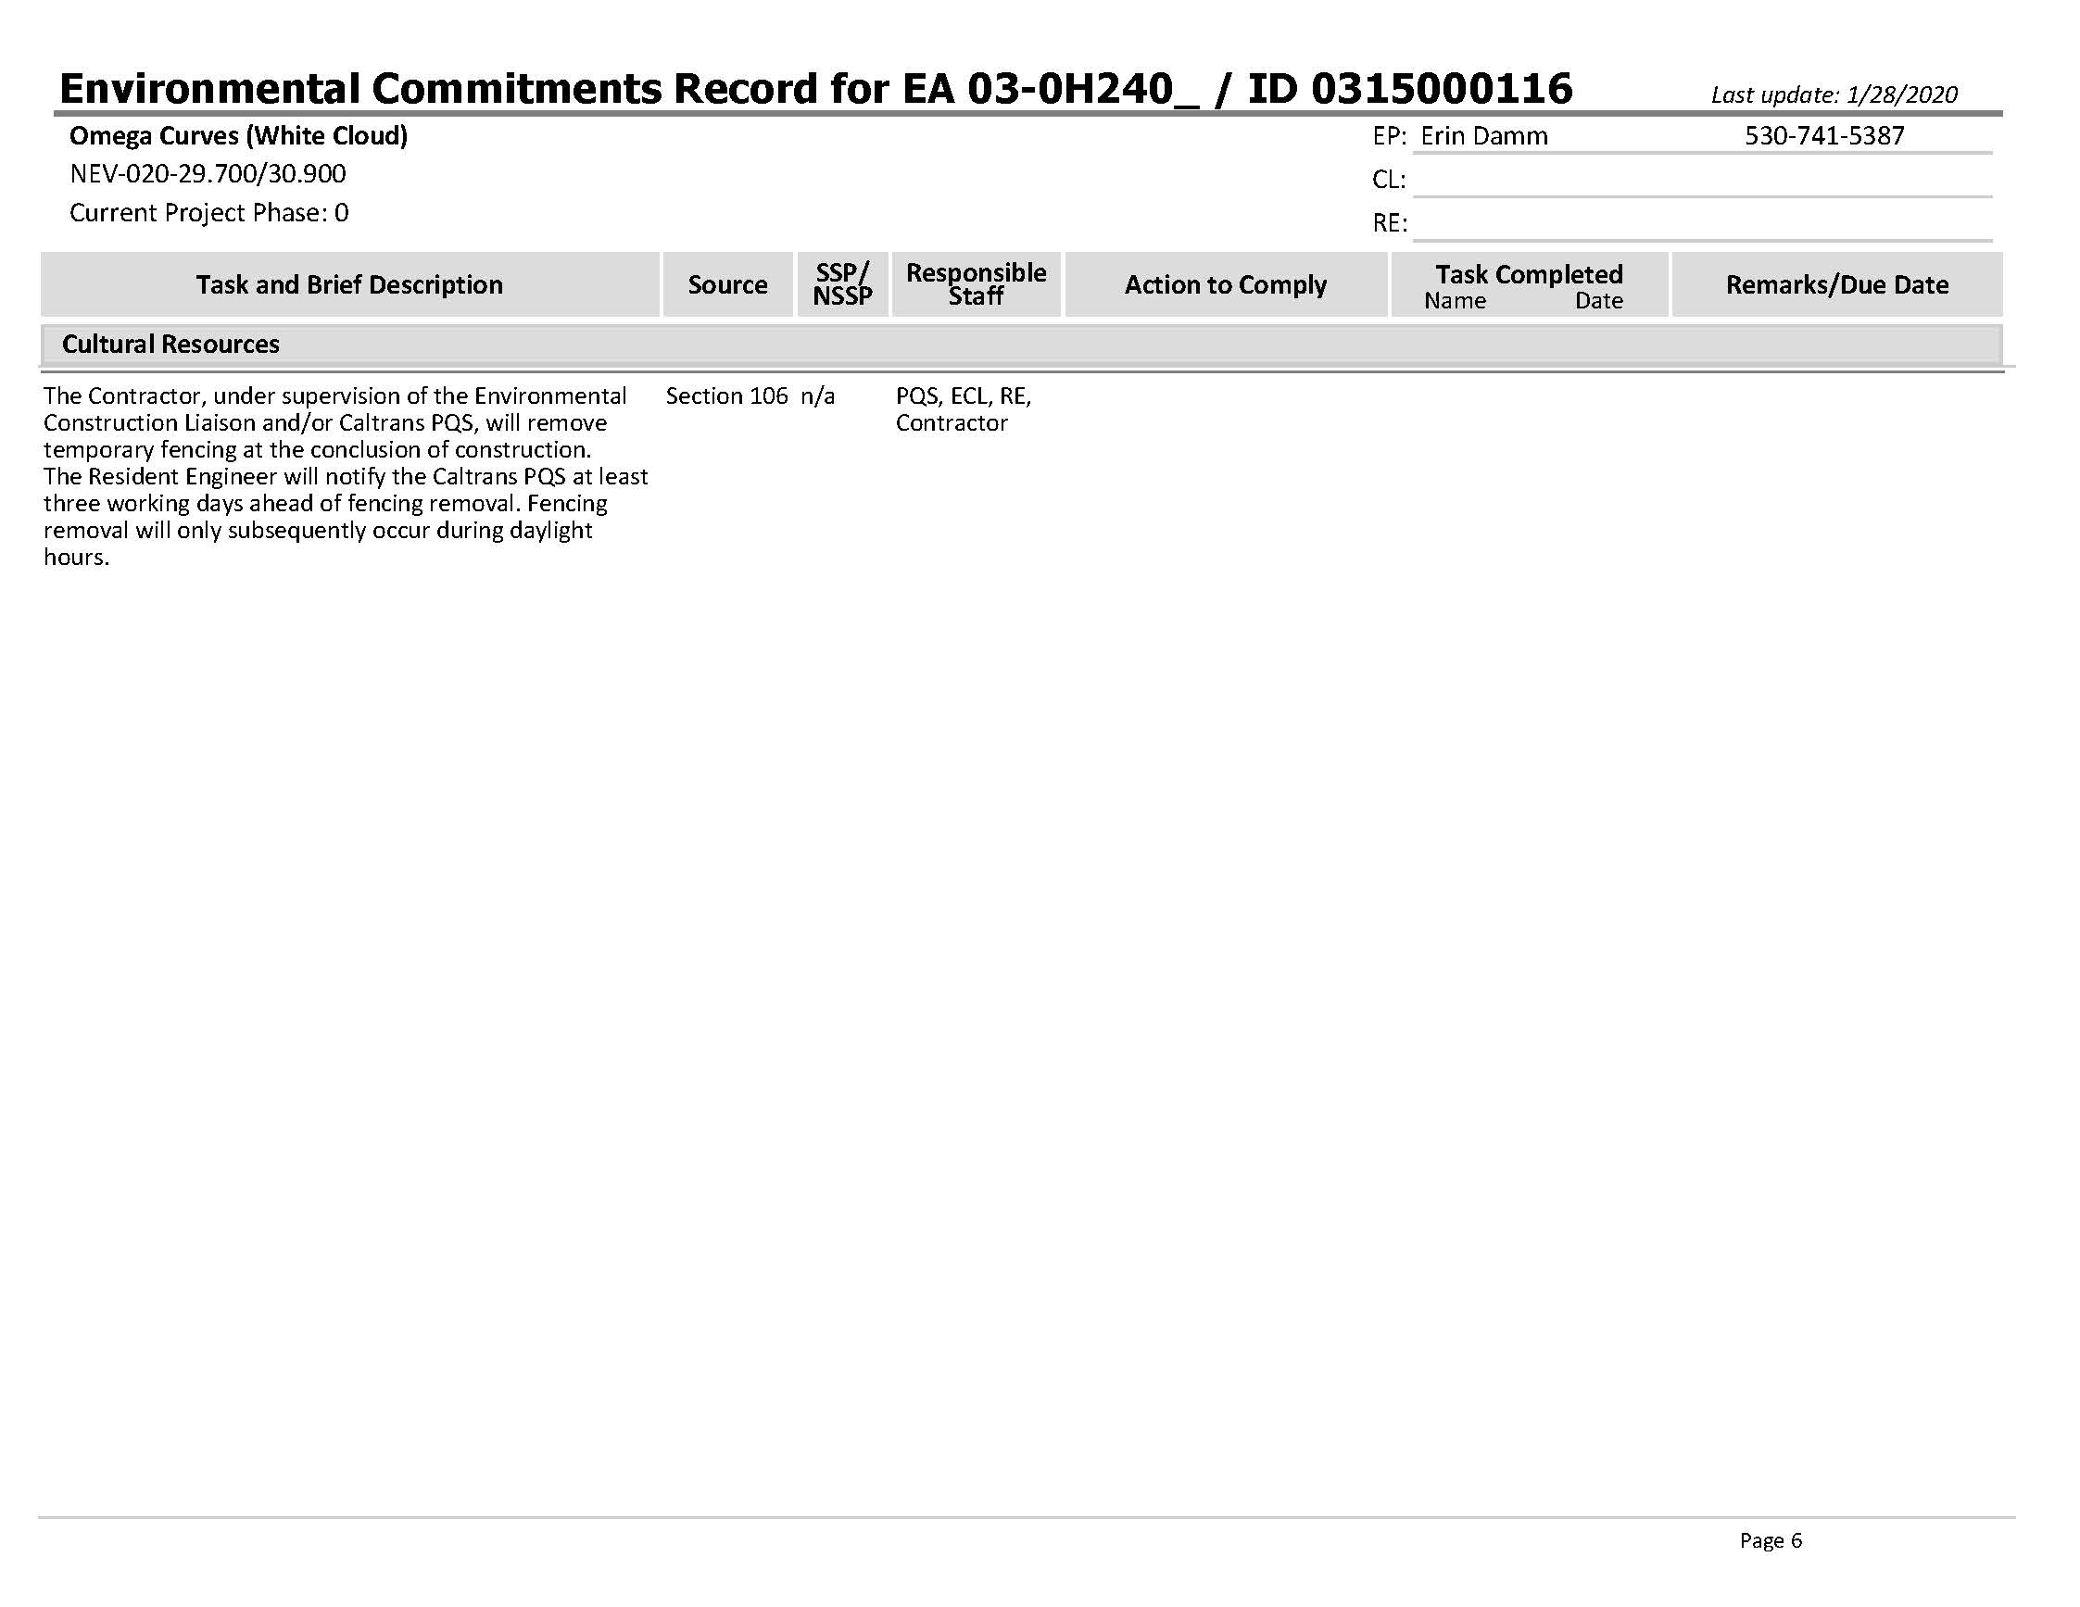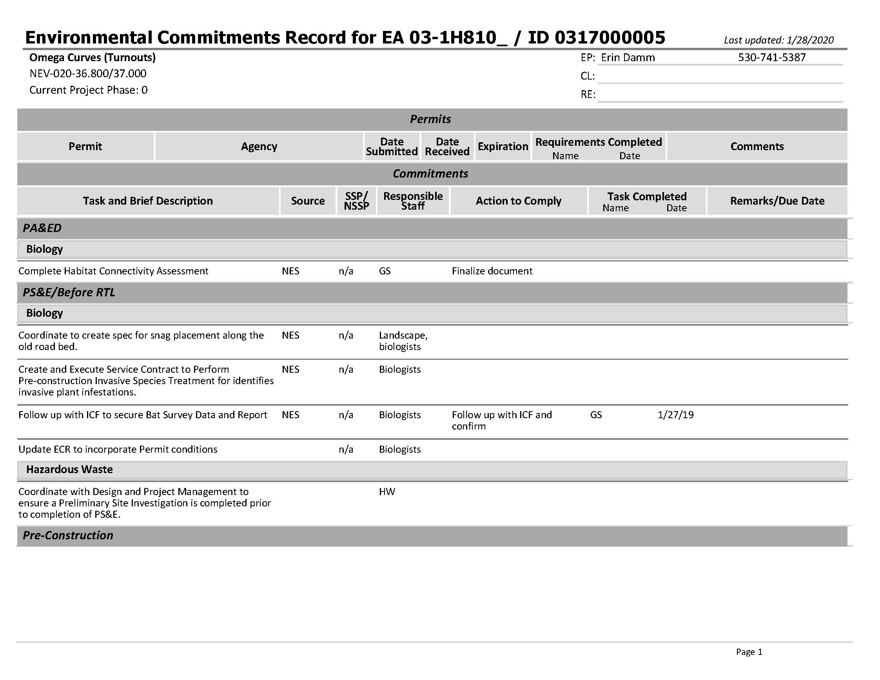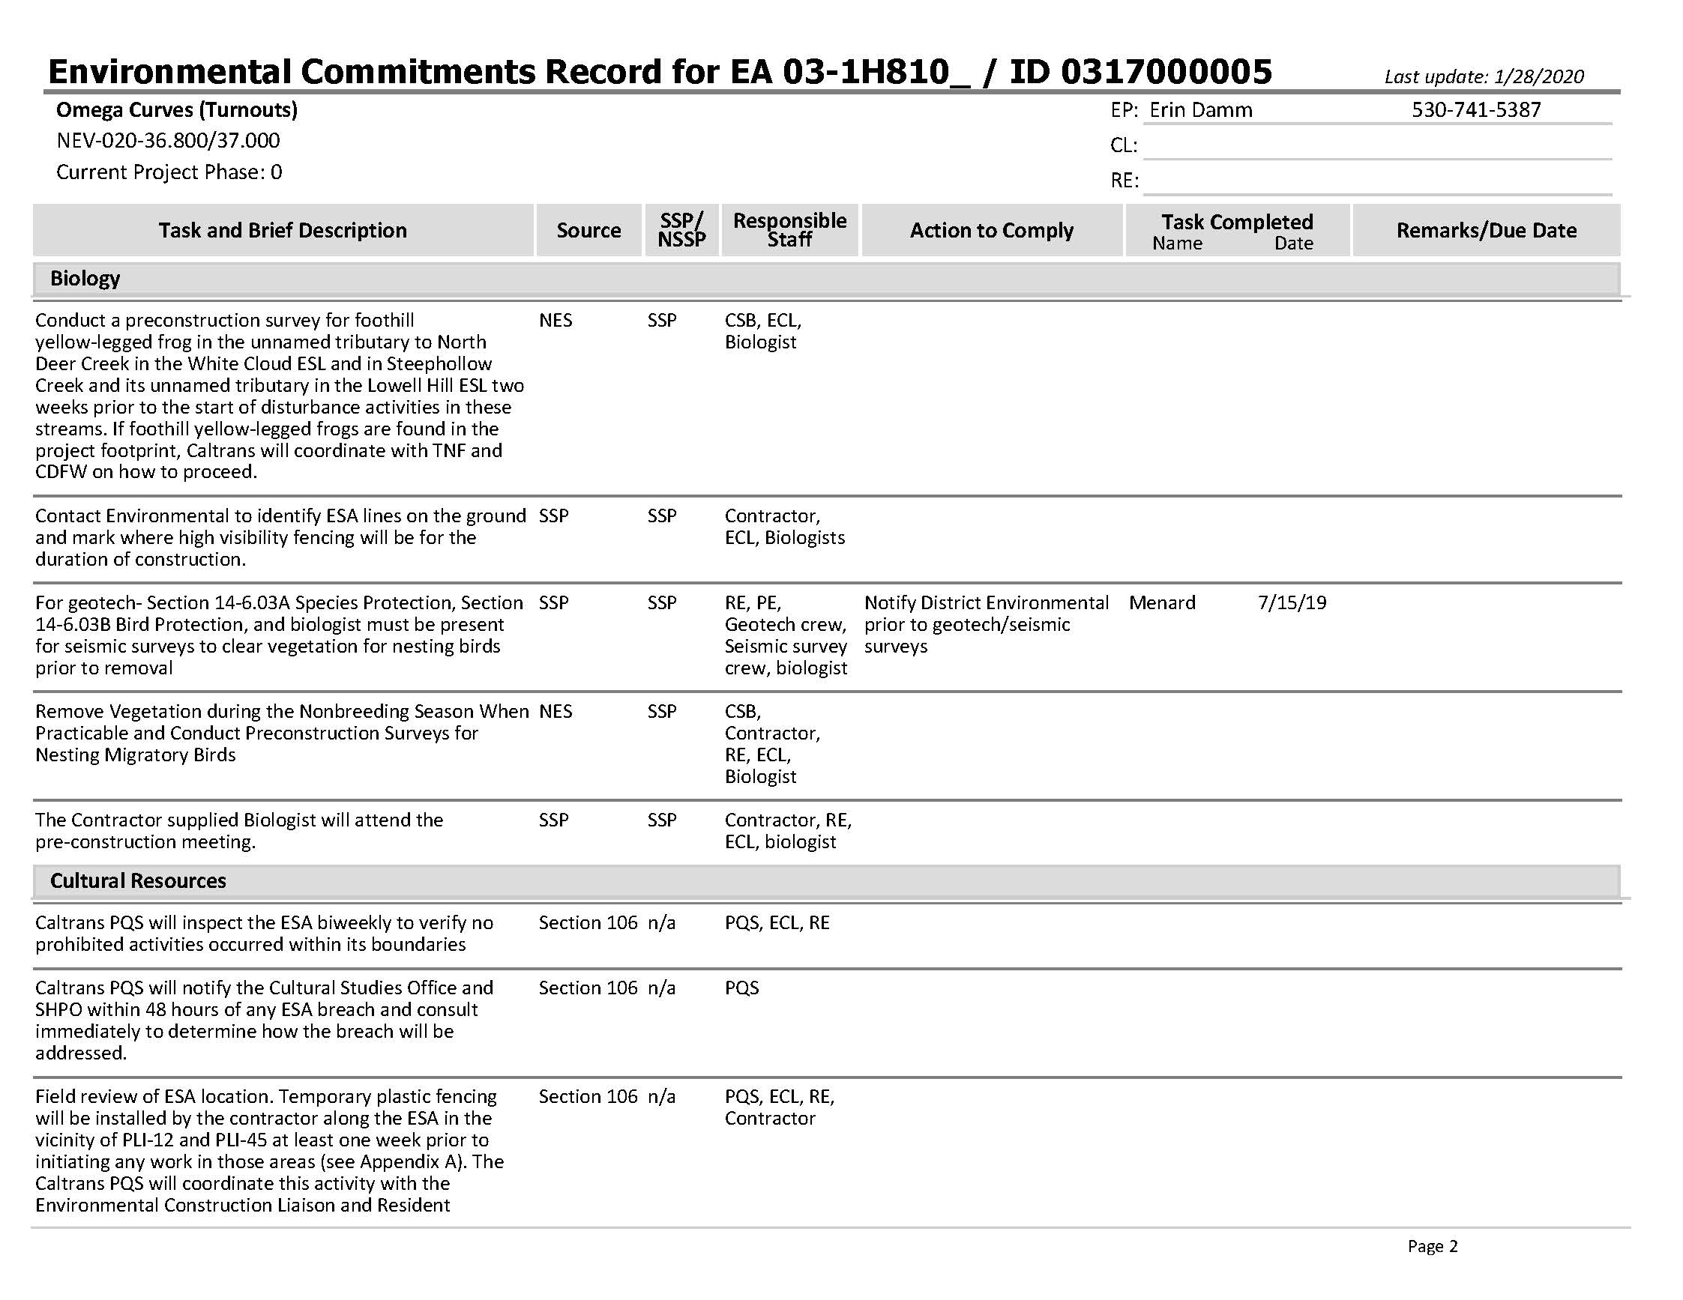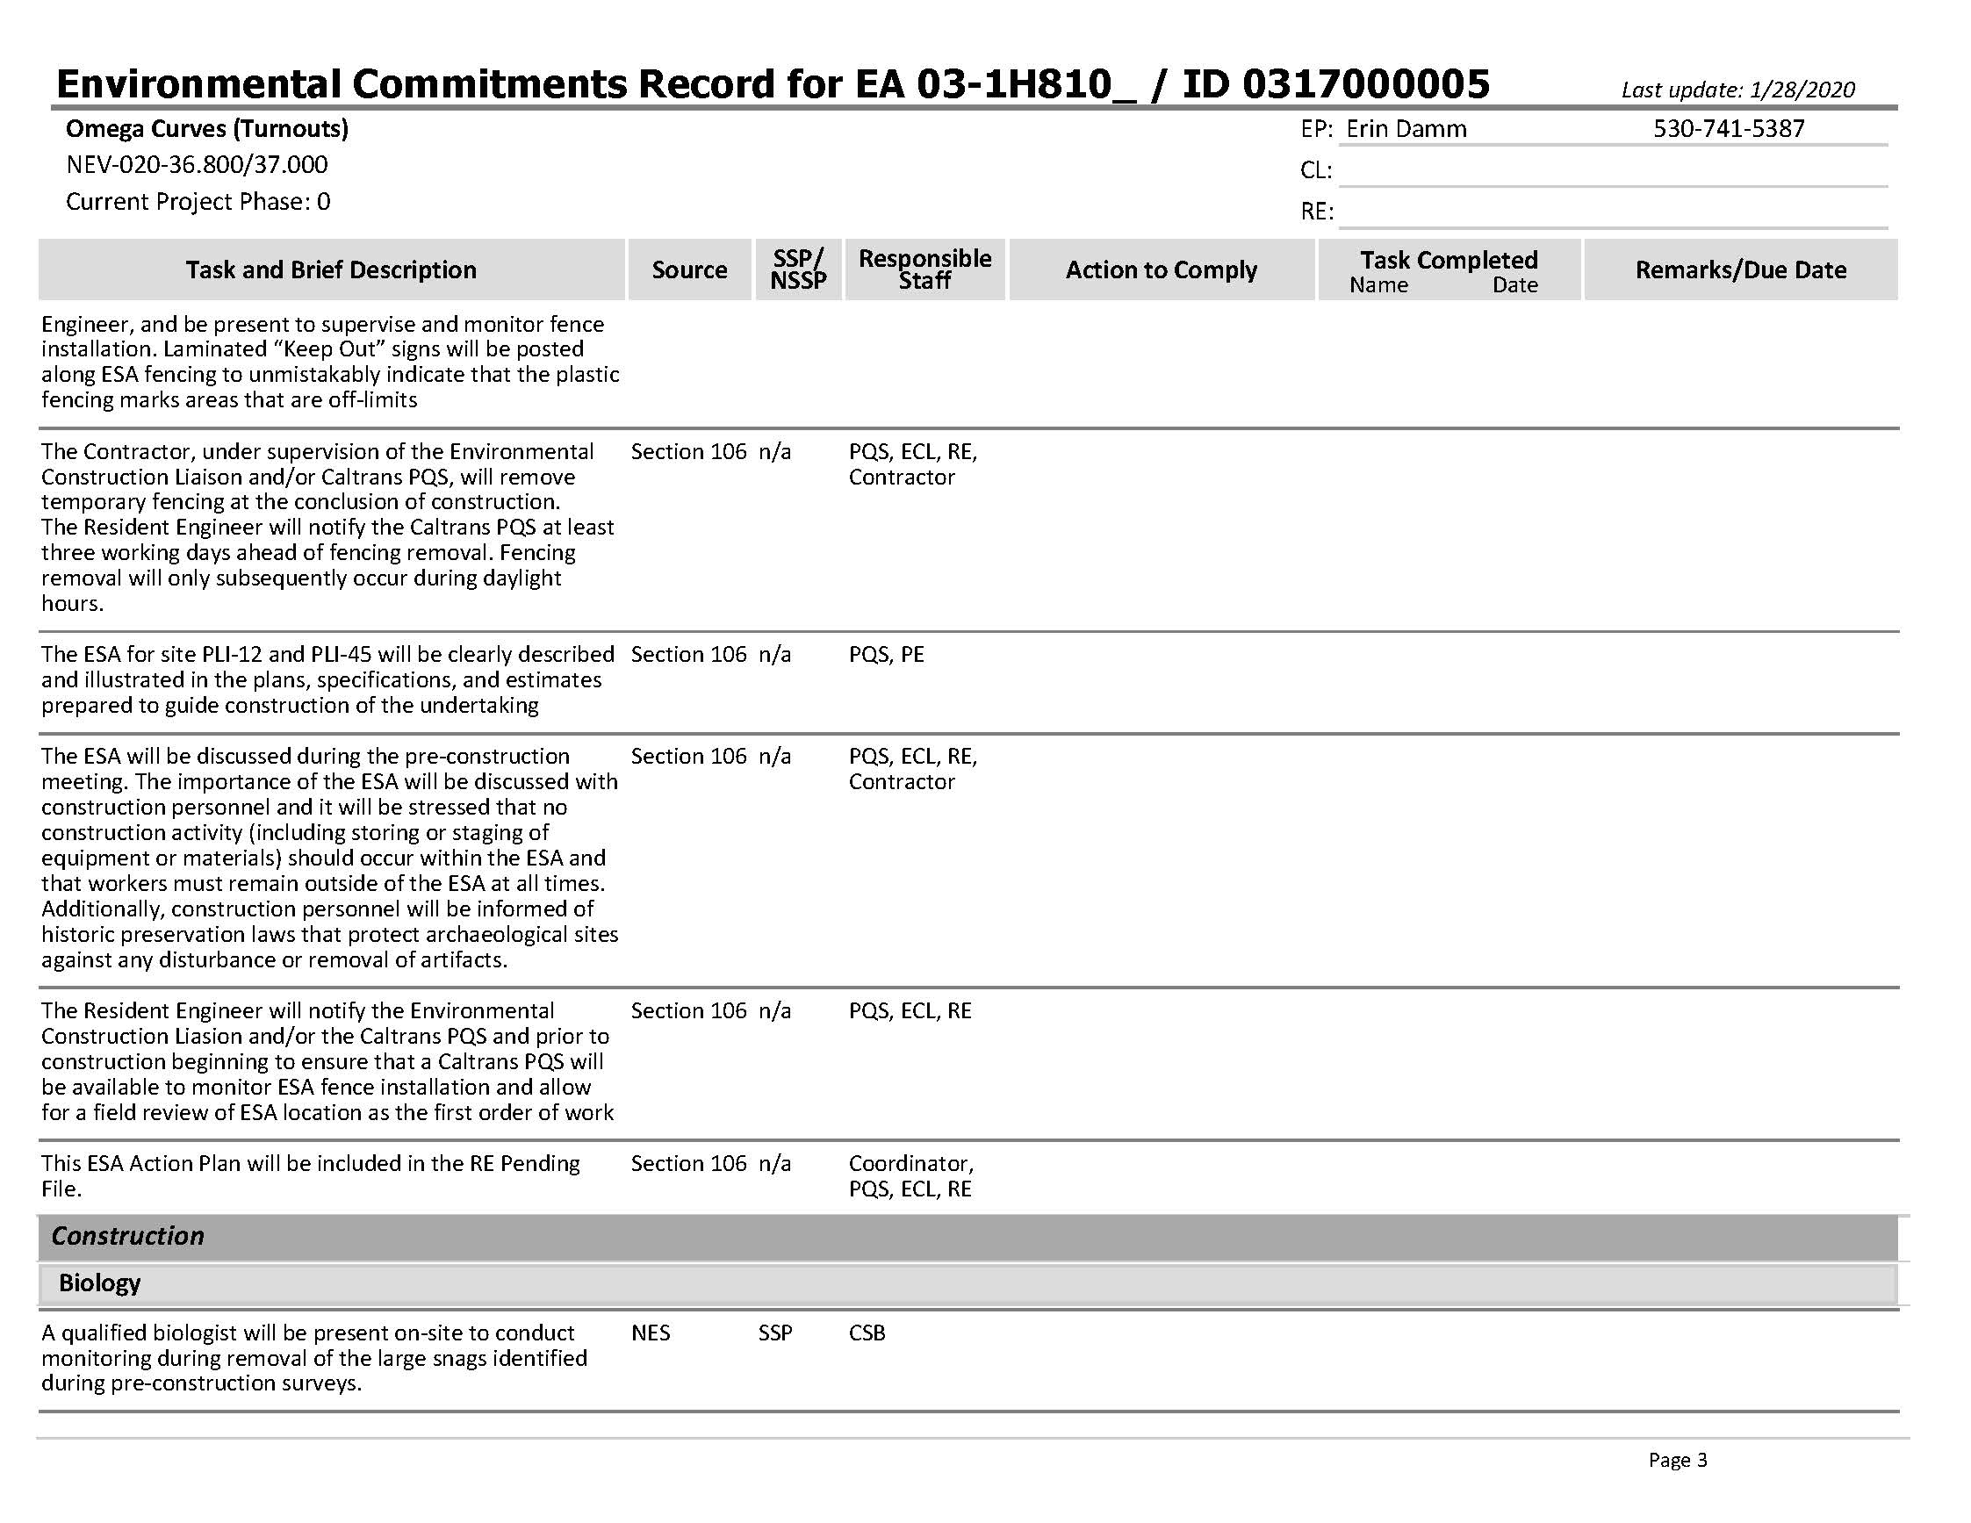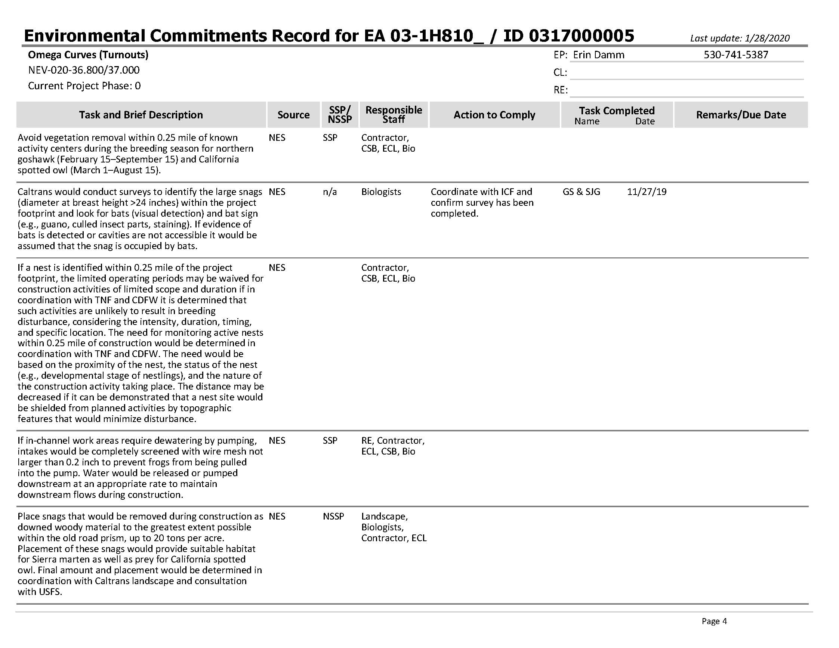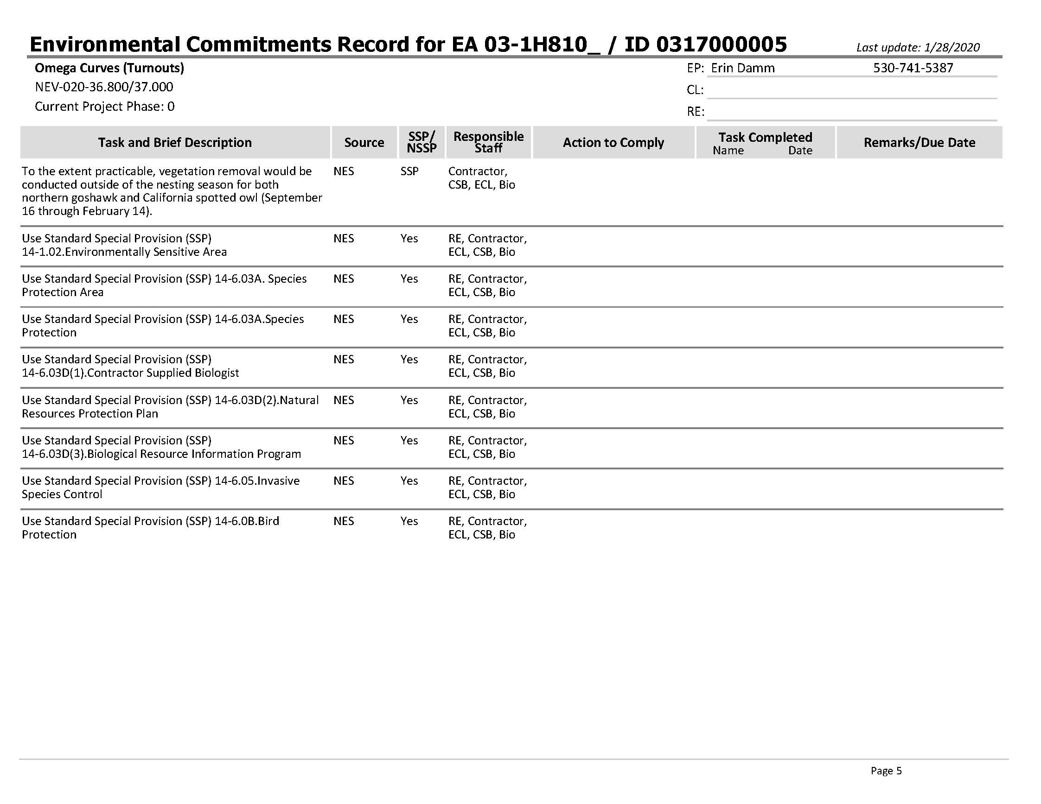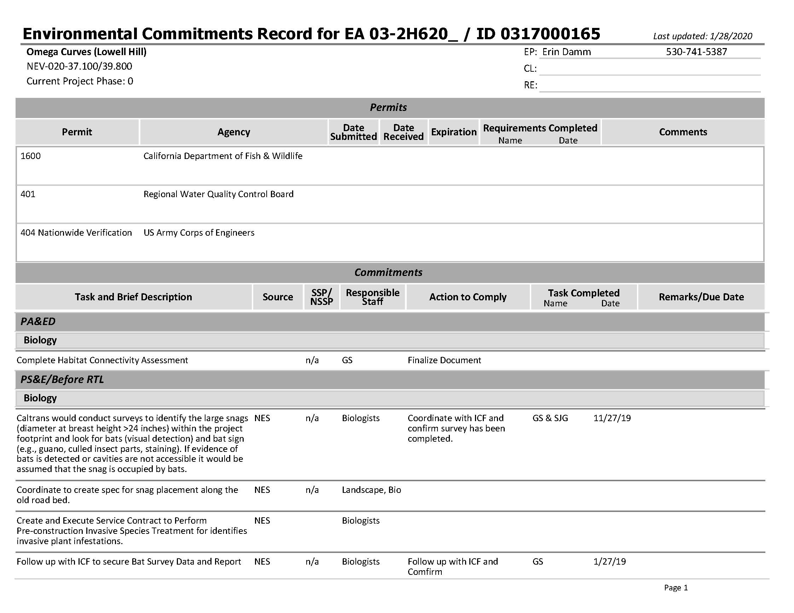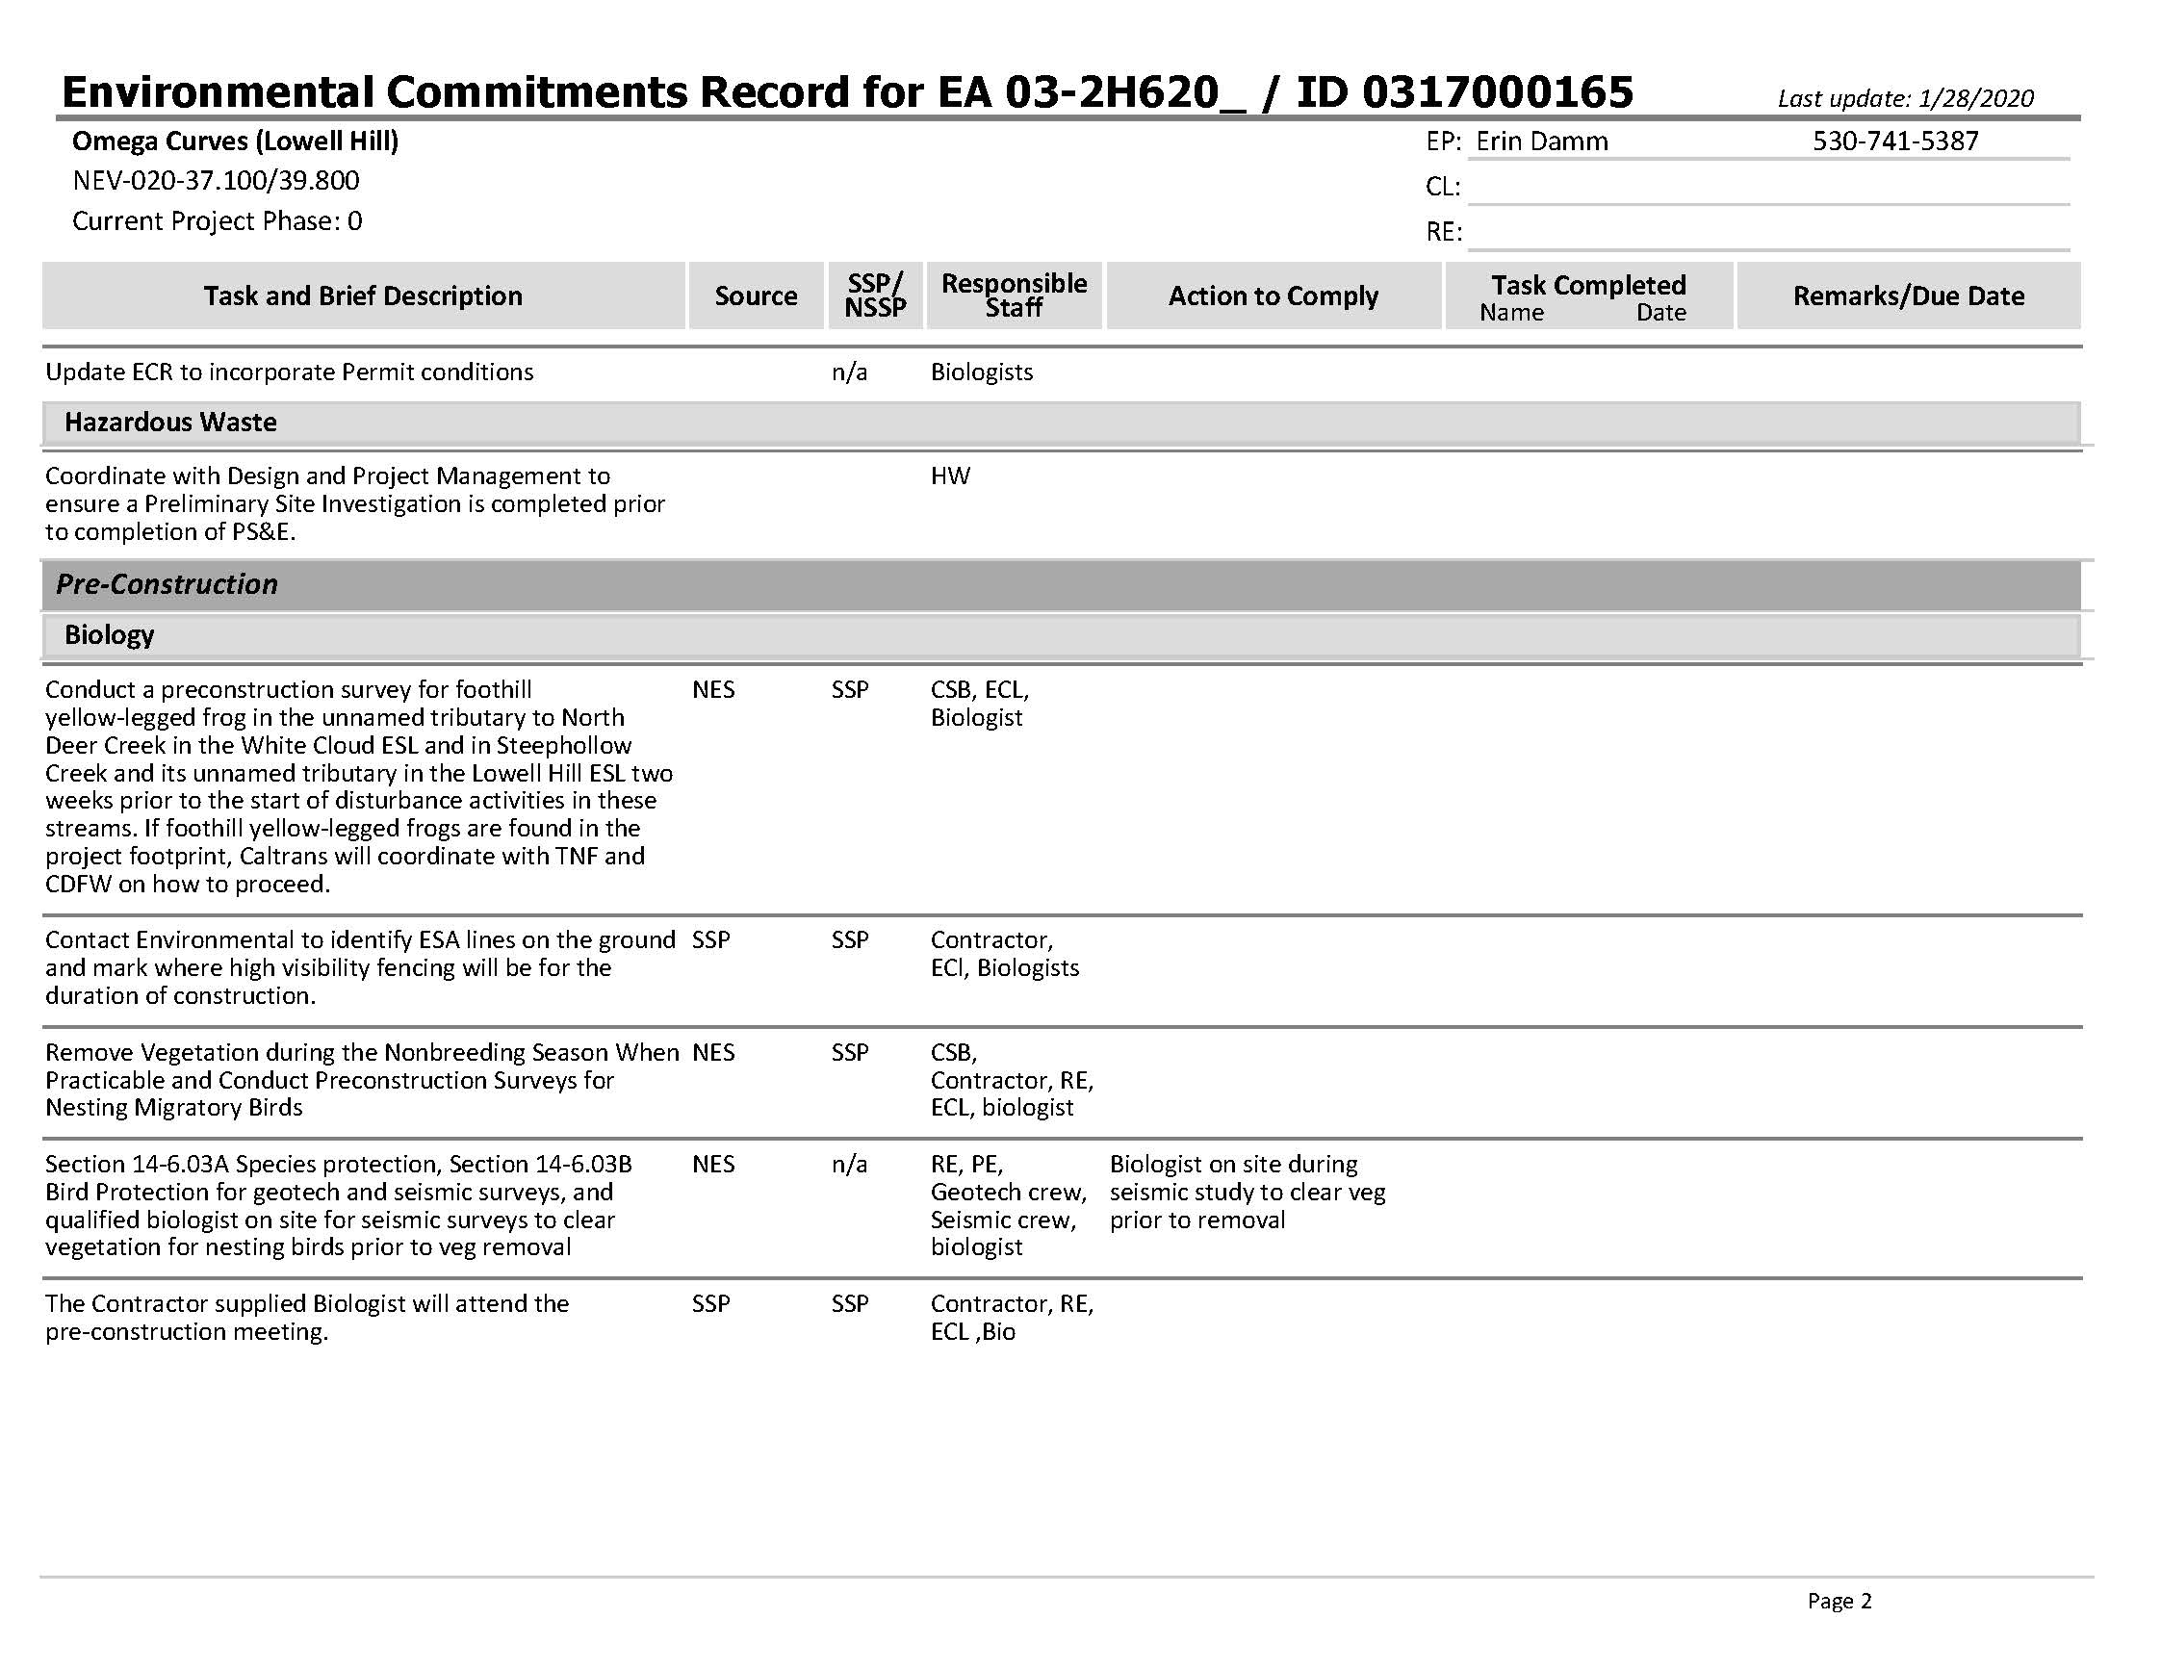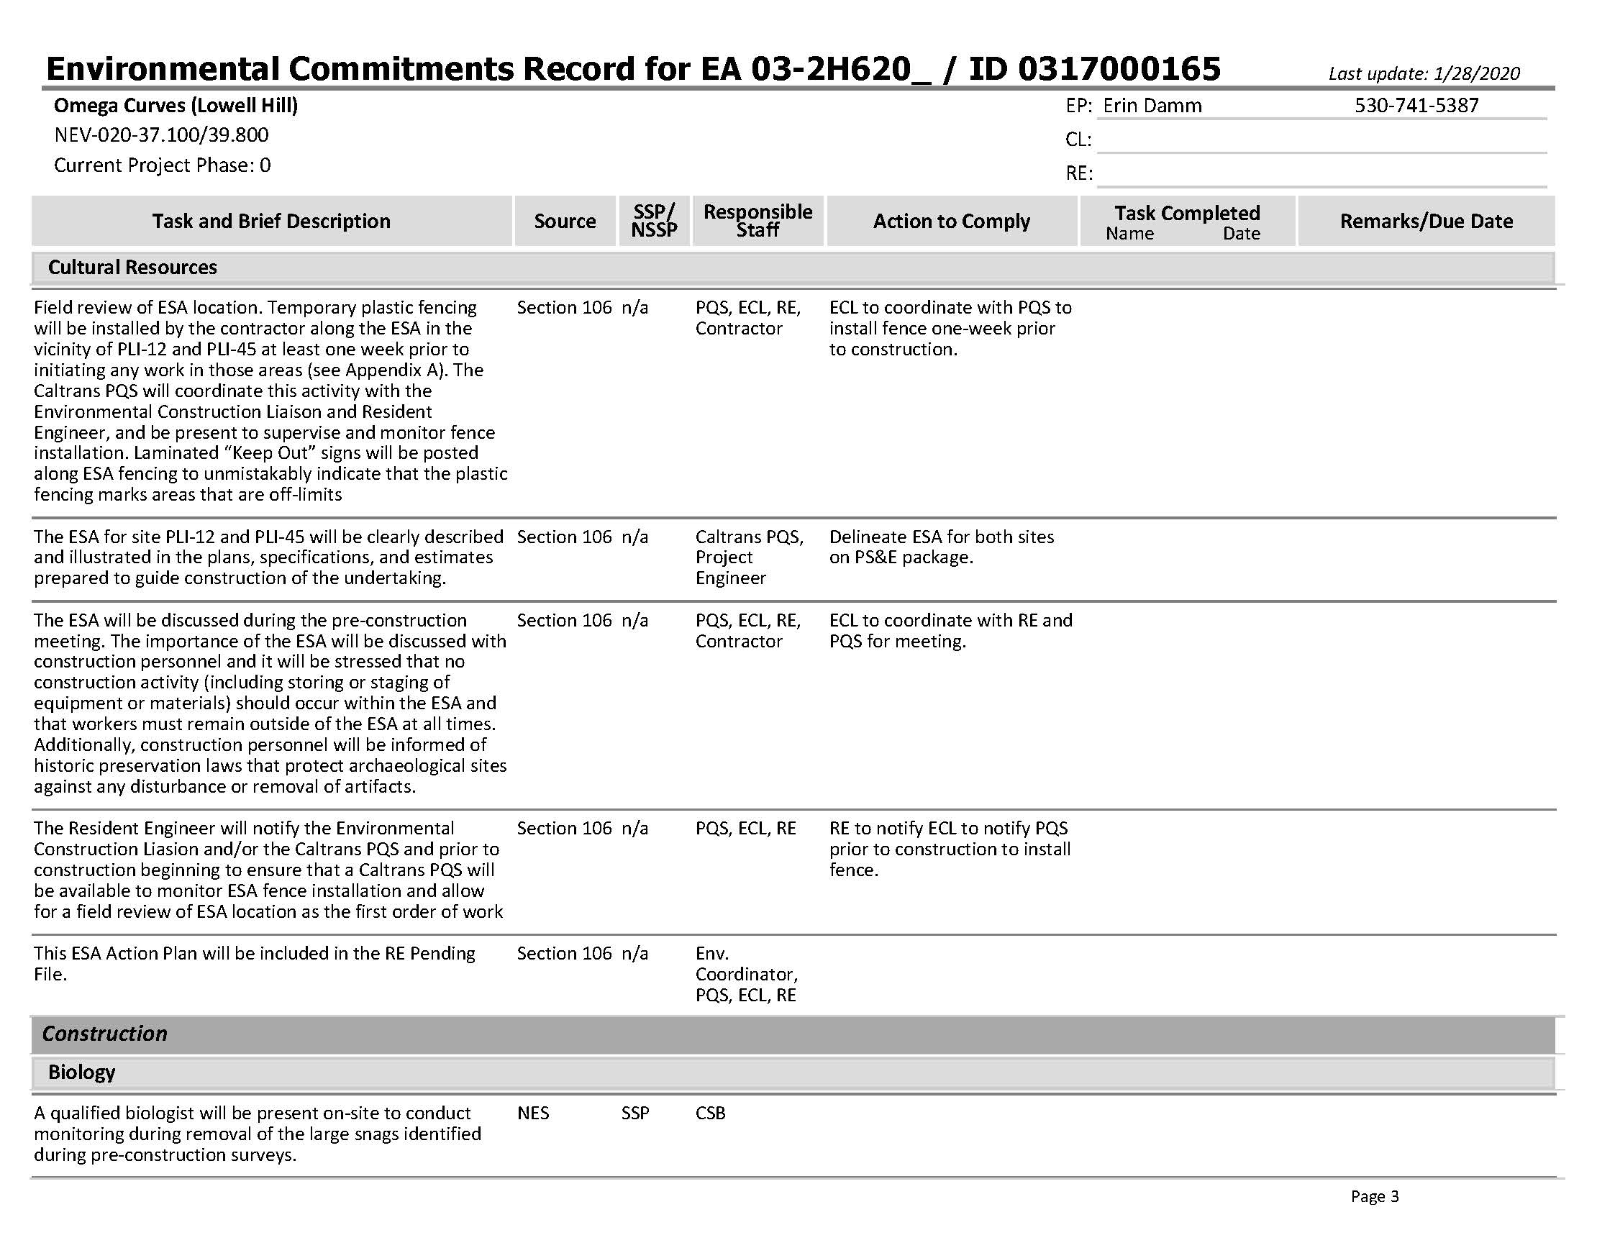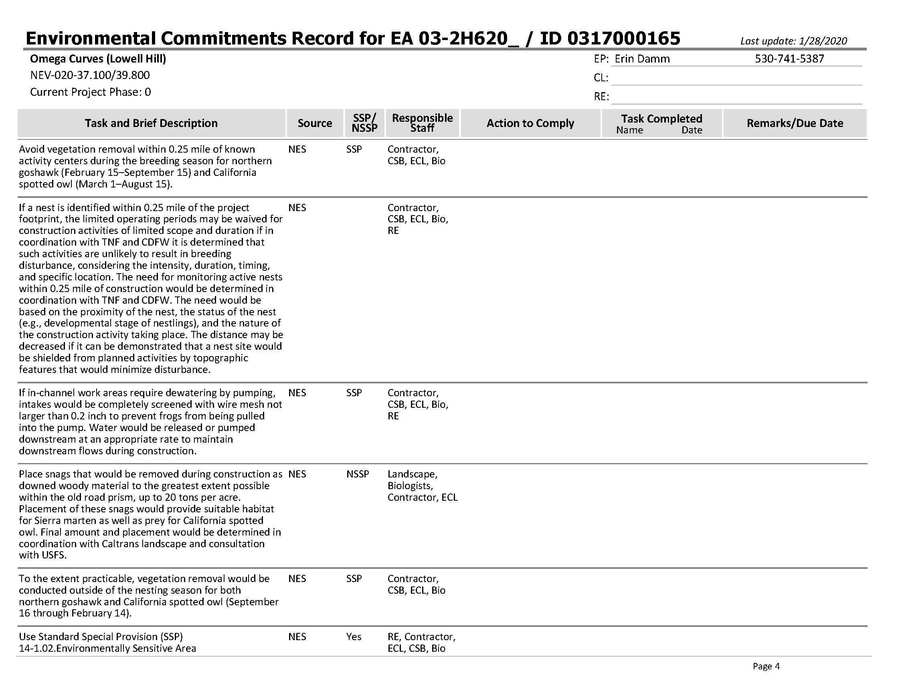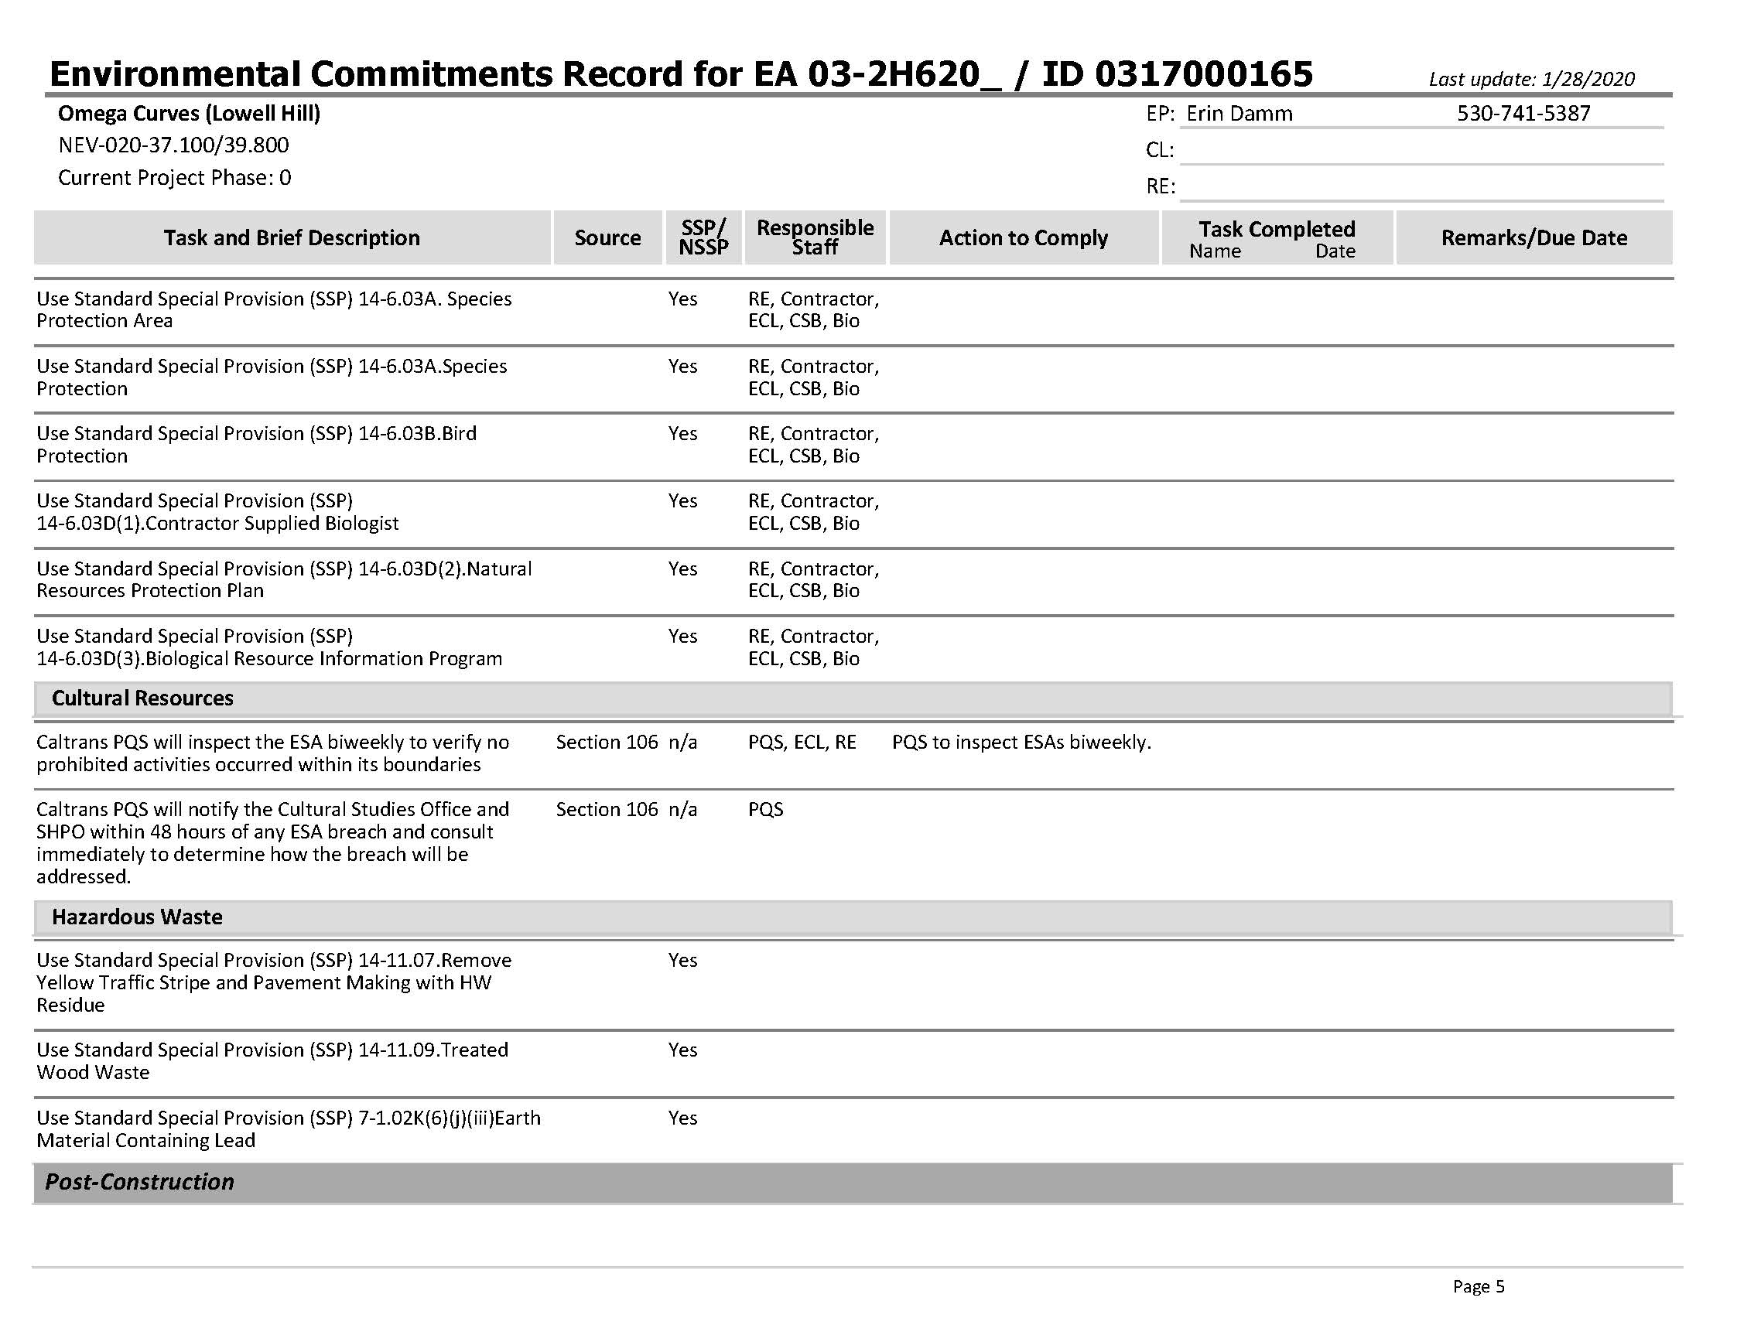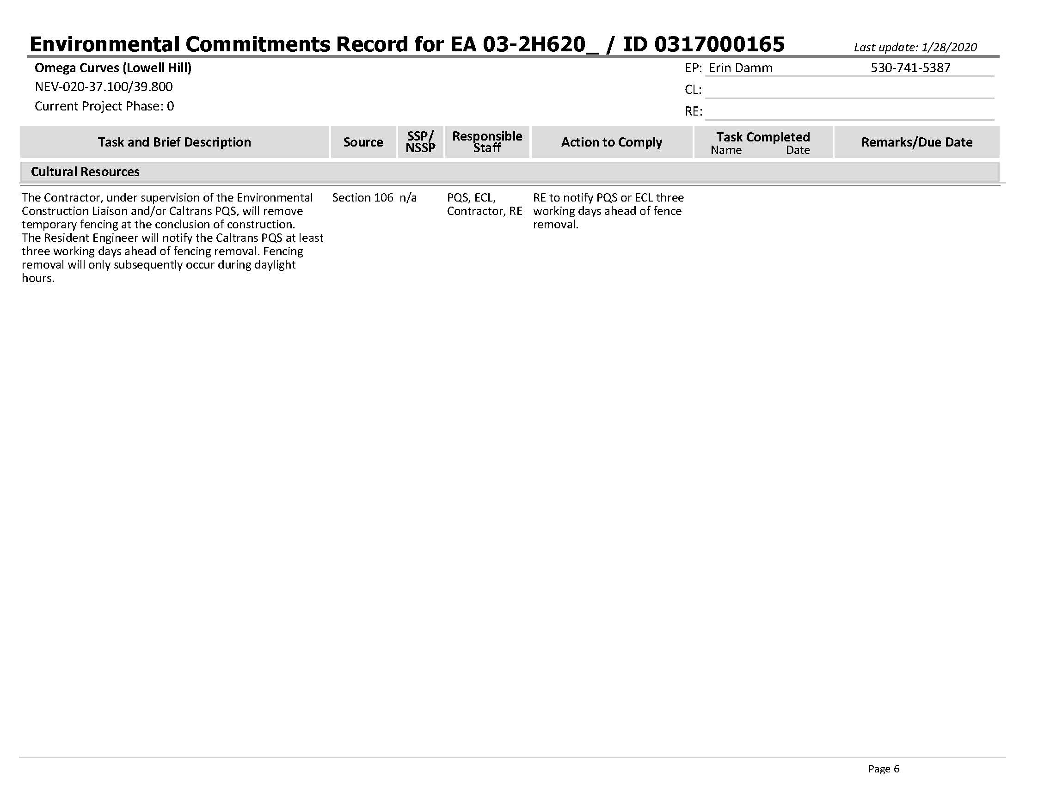
- Species List by Resource Agency
Species listed in this appendix are taken from documents produced by the individual resource agency and the originals may be reviewed upon request. Originals may not be ADA compliant.
California Native Plant Society
Rare and Endangered Plant Inventory, as taken January 3, 2020 for quadrangles Washington and Blue Canyon.

Scientific Name | Common Name | Rare Plant Rank | CESA | FESA
Allium sanbornii var. congdonii | Congdon's onion | 4.3 | None | None
Allium sanbornii var. sanbornii | Sanborn's onion | 4.2 | None | None
Antennaria flagellaris | stoloniferous pussy‐toes | 4.2 | None | None
Carex lasiocarpa | woolly‐fruited sedge | 2B.3 | None | None
Cypripedium fasciculatum | clustered lady's‐slipper | 4.2 | None | None
Darlingtonia californica | California pitcherplant | 4.2 | None | None
Fritillaria eastwoodiae | Butte County fritillary | 3.2 | None | None
Lewisia cantelovii | Cantelow's lewisia | 1B.2 | None | None
Lycopus uniflorus | northern bugleweed | 4.3 | None | None
Mielichhoferia elongate | elongate copper moss | 4.3 | None | None
Phacelia stebbinsii | Stebbins' phacelia | 1B.2 | None | None
Poa sierra | Sierra blue grass | 1B.3 | None | None
Pseudostellaria sierra | Sierra starwort | 4.2 | None | None
Schoenoplectus subterminalis | water bulrush | 2B.3 | None | None
Silene occidentalis ssp. Occidentalis | Western campion | 4.3 | None | None
Stellaria obtuse | obtuse starwort | 4.3 | None | None
Viola tomentosa | felt‐leaved violet | 4.2 | None | None

California Department of Fish and Wildlife

Selected Elements by Scientific Name from the California Natural Diversity Database, as queried on January 3, 2020 for quadrangles Washington and Blue Canyon. A record count of 17 species resulted.

Species Name | Common Name | Element Code | Federal Status | State Status | Global Rank | State Rank | Rare Plant/ Rank/CDFW SSC or FP
Ambystoma macrodactylum sigillatum | southern long-toed salamander | AAAAA01085 | None | None | G5T4 | S3 | SSC
Aplodontia rufa californica | Sierra Nevada mountain beaver | AMAFA01013 | None | None | G5T3T4 | S2S3 | SSC
Carex lasiocarpa | woolly-fruited sedge | PMCYP03720 | None | None | G5 | S2 | 2B.3
Erethizon dorsatum | North American porcupine | AMAFJ01010 | None | None | G5 | S3
Fen | Fen | CTT51200CA | None | None | G2 | S1.2
Fritillaria eastwoodiae | Butte County fritillary | PMLIL0V060 | None | None | G3Q | S3 | 3.2
Lewisia cantelovii | Cantelow's lewisia | PDPOR04020 | None | None | G3 | S3 | 1B.2
Martes caurina sierra | Sierra marten | AMAJF01014 | None | None | G5T3 | S3
Mielichhoferia elongate | elongate copper moss | NBMUS4Q022 | None | None | G5 | S3S4 | 4.3
Monadenia mormonum buttoni | Button's Sierra sideband | IMGASC7071 | None | None | G2T1 | S1S2
Phacelia stebbinsii | Stebbins' phacelia | PDHYD0C4D0 | None | None | G3 | S3 | 1B.2
Poa sierra | Sierra blue grass | PMPOA4Z310 | None | None | G3 | S3 | 1B.3
Rana boylii | foothill yellow-legged frog | AAABH01050 | None | Candidate Threatened | G3 | S3 | SSC
Rana sierra | Sierra Nevada yellow-legged frog | AAABH01340 | Endangered | Threatened | G1 | S1 | WL
Schoenoplectus subterminalis | water bulrush | PMCYP0Q1G0 | None | None | G4G5 | S3 | 2B.3
Viola tomentosa | felt-leaved violet | PDVIO04280 | None | None | G3 | S3 | 4.2
Vulpes vulpes necator | Sierra Nevada red fox | AMAJA03012 | Candidate Threatened | G5T1T2 | S1

United States Department of the Interior, Fish And Wildlife Service
This Official Species List is provided pursuant to Section 7 of the Endangered Species Act, and fulfills the requirement for Federal agencies to "request of the Secretary of the Interior information whether any species which is listed or proposed to be listed may be present in the area of a proposed action".
This species list was provided under event code 08ESMF00-2020-E-02156 on January 3, 2020 by:
Sacramento Fish And Wildlife Office
Federal Building
2800 Cottage Way, Room W-2605
Sacramento, CA 95825-1846
(916) 414-6600
Amphibians
California red-legged frog, Rana draytonii
There is final critical habitat for this species. Your location is outside the critical habitat.
Species profile: https://ecos.fws.gov/ecp/species/2891
Species survey guidelines:
https://ecos.fws.gov/ipac/guideline/survey/population/205/office/11420.pdf
Status: Threatened
Sierra Nevada yellow-legged frog, Rana sierrae
There is final critical habitat for this species. Your location is outside the critical habitat.
Species profile: https://ecos.fws.gov/ecp/species/9529
Status: Endangered
Fishes
Delta smelt Hypomesus transpacificus
There is final critical habitat for this species. Your location is outside the critical habitat.
Species profile: https://ecos.fws.gov/ecp/species/321
Status: Threatened
Critical habitats
There are no critical habitats within your project area under this office's jurisdiction.

National Oceanic and Atmospheric Administration, National Marine Fisheries Service

Species or species habitat listed under the Endangered Species Act which are present in quadrangles Washington, number 391020-C7 and Blue Canyon number 39120‐C6 on January 3, 2020 include:
Essential Fish Habitat for Chinook Salmon.

List of Technical Studies
Air Quality Report
Noise Study Report
Water Quality Report
Natural Environment Study
Location Hydraulic Study
Historical Property Survey Report
- Historic Resource Evaluation Report
- Historic Architectural Survey Report
- Archaeological Survey Report
Hazardous Waste Reports
- Initial Site Assessment
Scenic Resource Evaluation/Visual Impact Assessment
Initial Paleontology Study

Actual rates are calculated by collisions per million vehicle miles occurring within the location post miles. Statewide average rates are calculated by collisions per million vehicles miles across the state in similar roadways.
A point source is any discrete conveyance such as a pipe or a man-made ditch.
The U.S. EPA defines “effluent” as “wastewater, treated or untreated, that flows out of a treatment plant, sewer, or industrial outfall.”
Land cover type is considered a natural community of special concern.
GHGs differ in how much heat each trap in the atmosphere (global warming potential, or GWP). CO₂ is the most important GHG, so amounts of other gases are expressed relative to CO₂, using a metric called “carbon dioxide equivalent” (CO₂e). The global warming potential of CO₂ is assigned a value of 1, and the GWP of other gases is assessed as multiples of CO₂.

