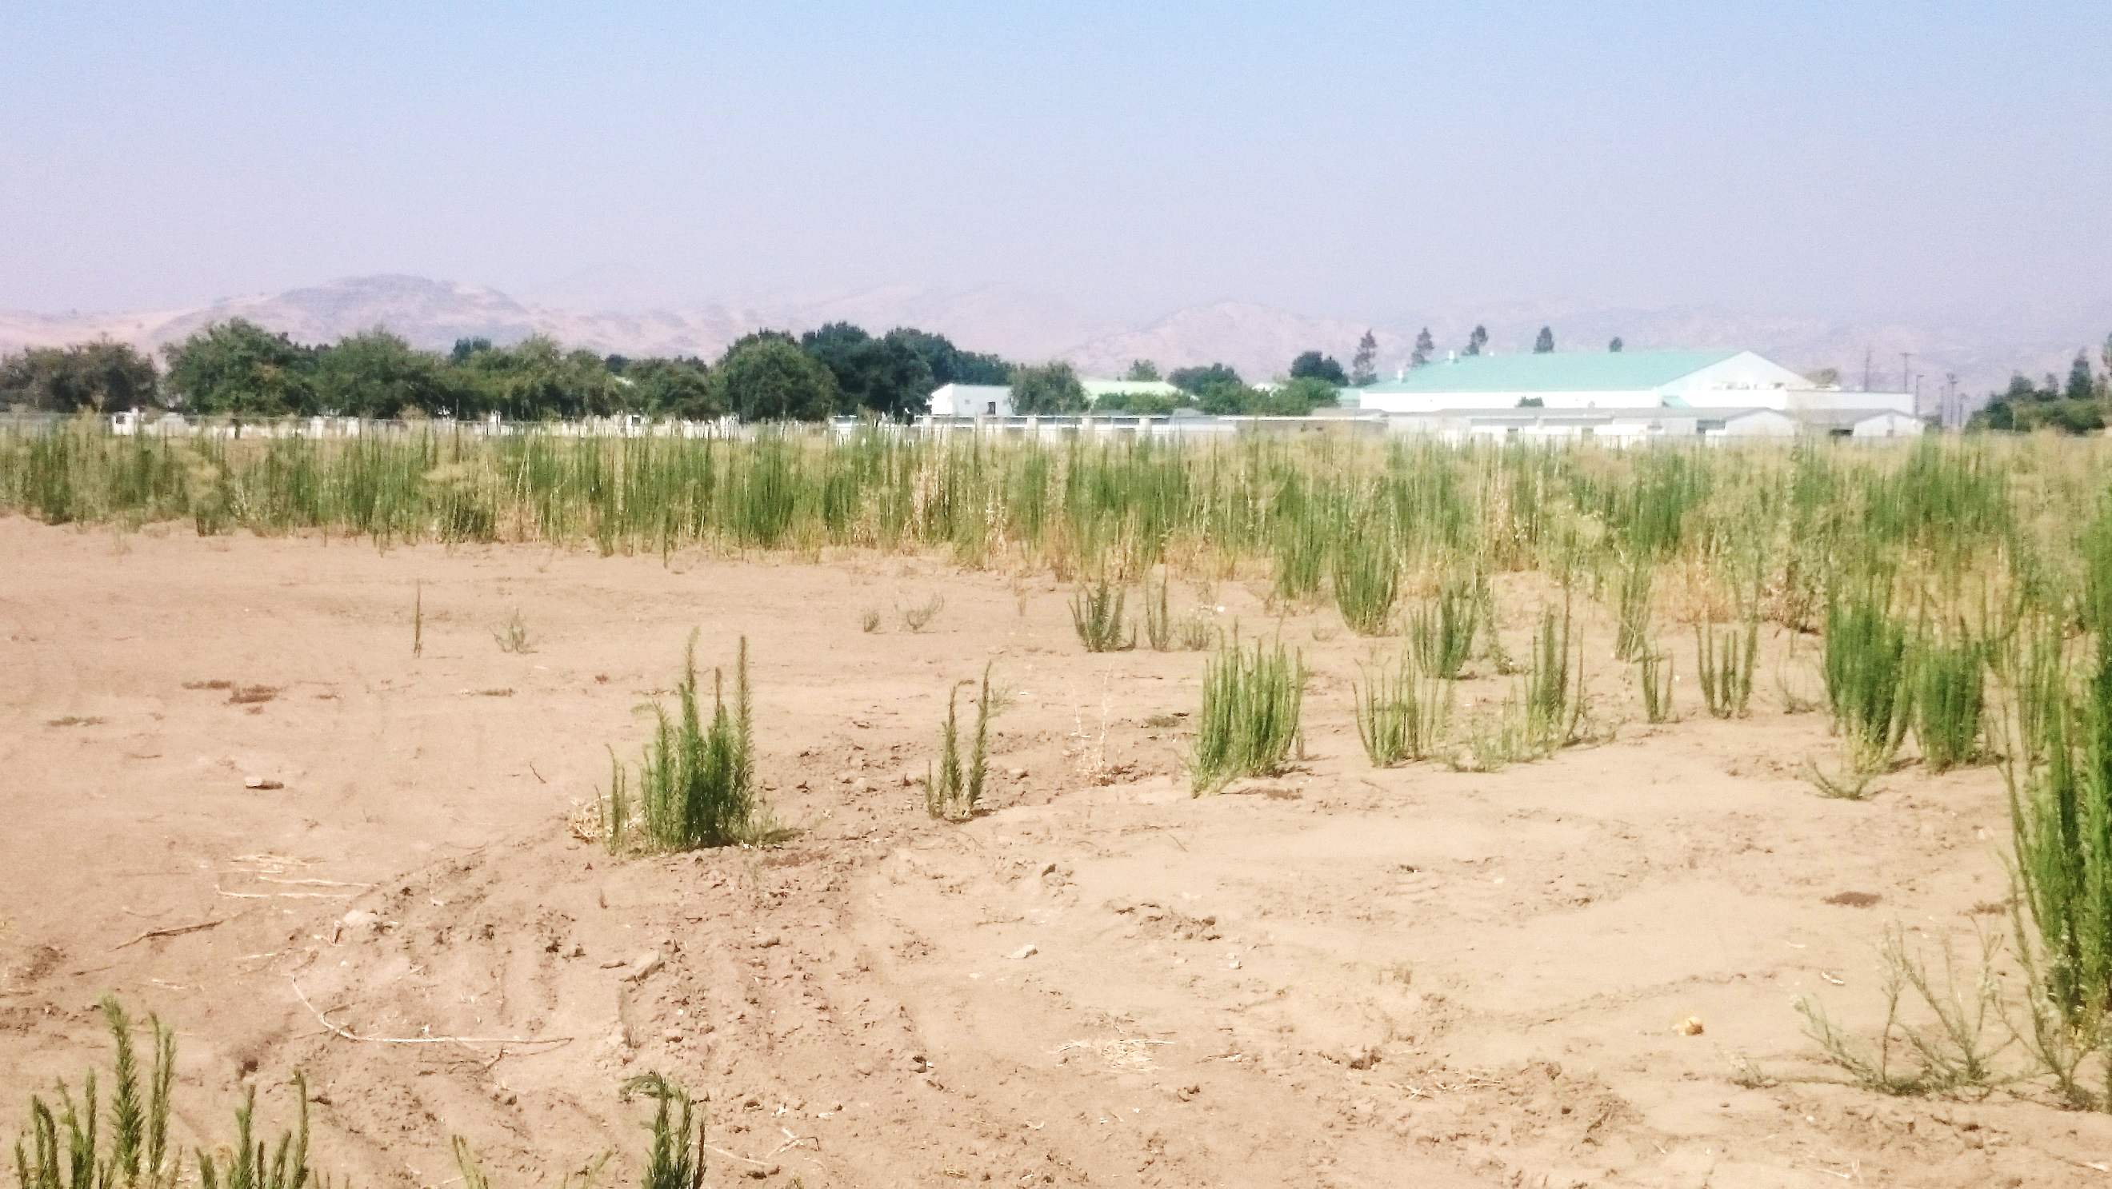

draft

initial study/
mitigated negative declaration

Orosi High School Recreation Complex Phase 2
41815 Road 128
Orosi, CA 93647


School Site Solutions, Inc.
October 2019
This page intentionally left blank

draft

initial study/
mitigated negative declaration

Orosi High School Recreation Complex Phase 2
41815 Road 128
Orosi, CA 93647

Submitted to:

Cutler-Orosi Joint Unified School District
12623 Avenue 416
Orosi, CA 93647

Prepared by:

School Site Solutions, Inc.
2015 H Street
Sacramento, CA 95811
916-930-0736

This page intentionally left blank
TABLE OF CONTENTS
Table of Contents i
FIGURES AND TABLES ii
List of Abbreviations and acronyms iii
1.0 PROJECT INFORMATION 1-1
2.0 ENVIRONMENTAL FACTORS POTENTIALLY AFFECTED 2-1
2.1 Determination 2-1
3.0 CEQA ENVIRONMENTAL CHECKLIST 3-1
3.1 Aesthetics 3-1
3.2 Agriculture and Forestry Resources 3-4
3.3 Air Quality 3-6
3.4 Biological Resources 3-10
3.5 Cultural Resources 3-12
3.6 Energy 3-14
3.7 Geology and Soils 3-15
3.8 Greenhouse Gas Emissions 3-18
3.9 Hazards and Hazardous Materials 3-21
3.10 Hydrology and Water Quality 3-24
3.11 Land Use and Planning 3-27
3.12 Mineral Resources 3-28
3.13 Noise 3-29
3.14 Population and Housing 3-32
3.15 Public Services 3-33
3.16 Recreation 3-35
3.17 Transportation 3-36
3.18 Tribal Cultural Resources 3-38
3.19 Utilities and Service Systems 3-40
3.20 Wildfire 3-42
3.21 Mandatory Findings of Significance 3-44
4.0 References 1

FIGURES AND TABLES
Figures

Figure 1: Project Location and Vicinity 1-3
Figure 2: Proposed Project 1-4

APPENDICES

- Musco Light Design Layout
- Musco Control System Summary
- Site Photos
- Letter to the Native American Heritage Commission
- Sacred Lands File Search Request
- Letter to the Tule River Tribal Council

Tables
Table 3.13-1. Construction Equipment Noise Characteristics 3-30

LIST OF abbreviations and ACRONYMS
AE-20 | Exclusive Agriculture Zone
BMP | Best Management Practice
CALFIRE | California Department of Forestry and Fire Protection
CAPCOA | California Air Pollution Control Officers Association
CARB | California Air Resources Board
CEQA | California Environmental Quality Act
CERCLA | Comprehensive Environmental Response, Compensation, and Liability Act
CNDDB | California Natural Diversity Database
DOE | Department of Energy
DPM | Diesel particulate matter
FHSZ | Fire hazard severity zones
GAMAQI | Guidelines Assessing and Mitigating Air Quality Impacts
GHG | Greenhouse gas
kWh | Kilowatt-hour
LOS | Level of service
LRA | Local Responsibility Areas
MT CO₂e | Metric tons carbon dioxide equivalent
NAHC | Native American Heritage Commission
O₃ | Ozone
OPUD | Orosi Public Utility District
OSHA | Occupational Safety and Health Administration
PM₁₀ | Particulate matter diameter 10 millimeters
PM_{2.5} | Particulate matter diameter 2.5 millimeters
PPV | Peak particle velocity
PRC | Public Resources Code
R-1 | Residential Zone
RCRA | Resource Conservation and Recovery Act
SJVAB | San Joaquin Valley Air Basin
SJVAPCD | San Joaquin Valley Air Pollution Control District
SPAL | Small Project Analysis Level
SRA | State Responsibility Areas
TAC | Toxic air contaminant
VHFHSZ | Very High Fire Hazard Severity Zone
VMT | Vehicle miles traveled
This page intentionally left blank

PROJECT INFORMATION
- Project Title:
  - Orosi High School Recreation Complex Phase 2
- Lead Agency Name and Address:
  - Cutler-Orosi Joint Unified School District
- Contact Person and Phone Number:
Raffi Soghomonian 559-528-4763
- Project Location:
  - 41815 Road 128, Orosi, CA 93647
- Project Sponsor’s Name and Address:
  - N/A
- General Plan Designation:
  - Quasi Public/High Density Residential
- Zoning:
  - Residential and AE-20 Exclusive Ag Zone
- Description of Project:
  - The proposed project would include the installation of 19 light standards within the previously developed recreational complex area in Orosi, California (see Figure 1). Eight 70-foot light standards would be installed around the existing football field and junior varsity soccer field, six 60- to 80-foot light standards would be installed around the existing baseball field, and five 60- to 70-foot light standards would be installed around the existing softball field.
  - The proposed project also includes the installation of three 960-square foot buildings that would house restrooms and concessions. The existing facilities and proposed facilities are shown on Figure 2.
- Surrounding Land Uses and Setting:
  - El Monte Middle School is located to the north of the proposed project area; Avenue 419 and Orosi High School are located to the south of the proposed project area; Road 126 and residential uses are located to the west of the proposed project area; and Road 128 and residential uses are located to the east of the proposed project area.

- Other Public Agencies Whose Approval is Required (e.g., permits, financial approval, or participation agreements):

- California Department of Education, School Facilities and Transportation Unit
- Department of Toxic Substance Control
- Division of the State Architect
- California State Clearing House
- Native American Heritage Commission

- Have California Native American tribes traditionally and culturally affiliated with the project area requested consultation pursuant to Public Resource Code section 21080.3.1? If so, is there a plan for consultation that includes, for example, the determination of significance of impacts to tribal cultural resources, procedures regarding confidentiality, etc.?
  - The District requested a Sacred Lands File search from the Native American Heritage Commission on October 1, 2019. Pursuant to AB 52, the District contacted the tribal representatives on the list on October 2, 2019. To date, the District has received no responses from tribal representatives. In the event that the tribal representatives express interest in the project and/or the project area, the District will coordinate with the tribes to address any concerns.
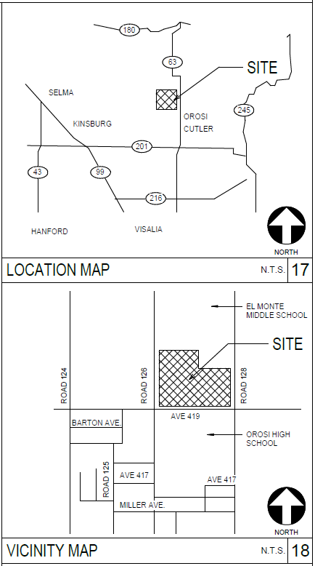
- Project Location and Vicinity
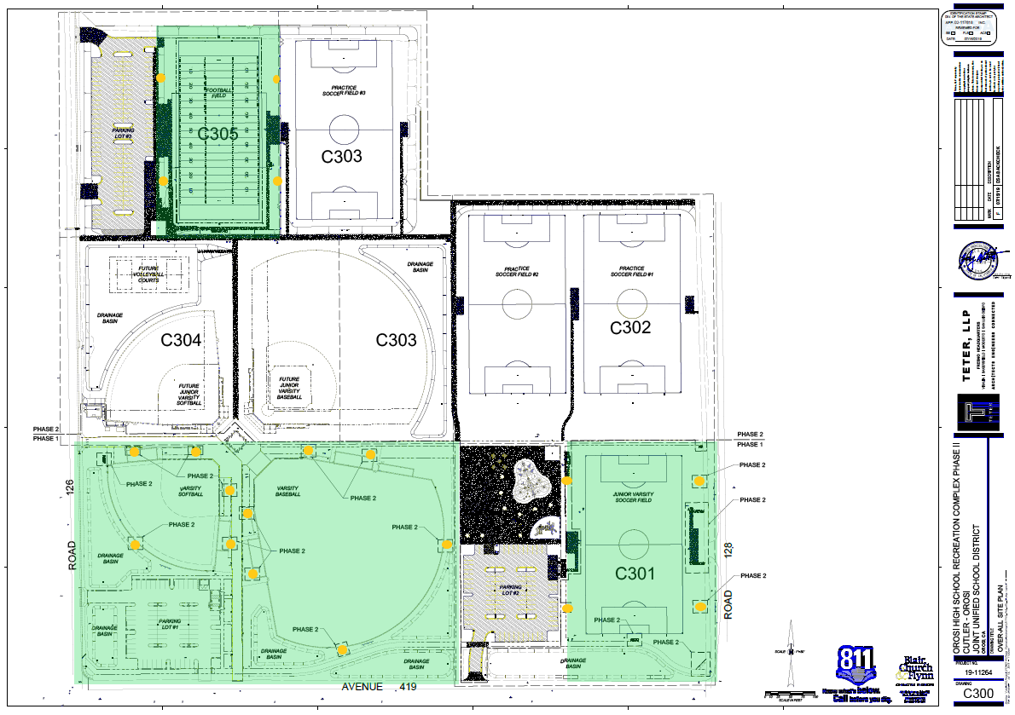
- Proposed Project

ENVIRONMENTAL FACTORS POTENTIALLY AFFECTED
The environmental factors checked below would be potentially affected by this project, involving at least one impact that is a “Potentially Significant Impact” as indicated by the checklist in Chapter 3.0.
Aesthetics | Agriculture and Forestry Resources | Air Quality
Biological Resources | Cultural Resources | Energy
Geology/Soils | Greenhouse Gas Emissions | Hazards & Hazardous Materials
Hydrology/Water Quality | Land Use/Planning | Mineral Resources
Noise | Population/Housing | Public Services
Recreation | Transportation | Tribal Cultural Resources
Utilities/Service Systems | Wildfire | Mandatory Findings of Significance

Determination
On the basis of this initial evaluation:
I find that the proposed project COULD NOT have a significant effect on the environment, and a NEGATIVE DECLARATION will be prepared.
I find that although the proposed project could have a significant effect on the environment, there will not be a significant effect in this case because revisions in the project have been made by or agreed to by the project proponent. A MITIGATED NEGATIVE DECLARATION will be prepared.
I find that the proposed project MAY have a significant effect on the environment, and an ENVIRONMENTAL IMPACT REPORT is required.
I find that the proposed project MAY have a “Potentially Significant Impact” or “Potentially Significant Unless Mitigated” impact on the environment, but at least one effect (1) has been adequately analyzed in an earlier document pursuant to applicable legal standards, and (2) has been addressed by mitigation measures based on the earlier analysis as described on attached sheets. An ENVIRONMENTAL IMPACT REPORT is required, but it must analyze only the effects that remain to be addressed.
I find that although the proposed project could have a significant effect on the environment, because all potentially significant effects (a) have been analyzed adequately in an earlier ENVIRONMENTAL IMPACT REPORT or NEGATIVE DECLARATION pursuant to applicable standards, and (b) have been avoided or mitigated pursuant to that earlier ENVIRONMENTAL IMPACT REPORT or NEGATIVE DECLARATION, including revisions or mitigation measures that are imposed upon the proposed project, nothing further is required.
Signature |  | Date
This page intentionally left blank

CEQA ENVIRONMENTAL CHECKLIST

Aesthetics
 | Potentially Significant Impact | Less Than Significant with Mitigation Incorporated | Less Than Significant Impact | No  Impact
Except as provided in Public Resources Code Section 21099, would the project:
- Have a substantial adverse effect on a scenic vista?
- Substantially damage scenic resources, including, but not limited to, trees, rock outcroppings, and historic buildings within a state scenic highway
- In non-urbanized areas, substantially degrade the existing visual character or quality of public views of the site and its surroundings? (Public views are those that are experienced from a publicly accessible vantage point.) If the project is in an urbanized area, would the project conflict with applicable zoning and other regulations governing scenic quality?
- Create a new source of substantial light or glare which would adversely affect day or nighttime views in the area?

Impact Analysis
- Would the project have a substantial effect on a scenic vista?
The proposed project area is located in a rural and residential area characterized by views of El Monte Middle School, Orosi High School, roads, curbs, gutters, sidewalks, utility poles, and surrounding residential uses. According to the Tulare County General Plan there are no designated scenic vistas within the planning area (see Figure 11-2). Development of the proposed project would have no impact on a scenic vista.

b. Would the project substantially damage scenic resources, including, but not limited to, trees, rock outcroppings, and historic buildings within a state scenic highway?
According to the California Department of Transportation, there are no officially designated or eligible state scenic highways located within the community of Orosi. The project site has been developed as a recreational complex and is devoid of trees, rock outcroppings, or historic structures. The nearest Eligible State Scenic Highway is State Route 180 in Kings County, which is approximately 12.0 miles north of the proposed project (Esri 2017). Therefore, project construction and operation would have no impact on scenic resources within a state scenic highway.

c. In non-urbanized areas, would the project substantially degrade the existing visual character or quality of public views of the site and its surroundings? (Public views are those that are experienced from a publicly accessible vantage point.) If the project is in an urbanized area, would the project conflict with applicable zoning and other regulations governing scenic quality?
Views of the project area from publicly accessible vantage points (i.e., Roads 126 and 128 and Avenue 419) currently include a football field, soccer field, baseball field, and softball field. Views of the surrounding areas contain residences and schools in the foreground, trees in the middle ground, and mountain peaks in the background. The proposed project includes the installation of 19 light standards (ranging in height from 50-80 feet) and three 960-sqaure foot buildings (approximately 15 feet high). Although the proposed project would introduce new features that would be visible from publicly accessible vantage points, construction and operation of the proposed project would be consistent with the visual character of the Orosi High School campus and the recreational complex and would not degrade the visual quality of the site or surroundings. Impacts would be less than significant.

- Would the project create a new source of substantial light or glare which would adversely affect day or nighttime views in the area?
Existing sources of nighttime lighting near the project site includes lighting from residences to the east of the project site, streetlights installed along Road 128, and lighting from the Orosi High School campus. Existing sources of glare are relatively limited and would consist of headlights striking residential or school windows.
Construction of the project would take approximately two months to complete and would occur Monday through Friday 7:00 a.m. to 3:00 p.m. Because construction activities would cease at 3:00 p.m., the use of temporary lighting sources during construction would not be required.
Once installed, new lighting would facilitate nighttime use of the football, soccer, baseball, and softball fields. Nighttime use of fields would occur five days per week, and hours of operation would be until 10:00 p.m. Monday through Friday. District-controlled timers would be installed and programmed to shut off the lights at 10:00 p.m. on weekdays (when seasonally needed).
Musco Lighting conducted a photometric study for the project to determine projected light levels emanating from the project area. The purpose of the study was to determine potential nighttime lighting impacts associated with project lighting and spillover to nearby residential properties and public roads. According to the study, proposed light fixtures would generate a maximum 64 maintained horizontal foot-candles of light in the infields and approximately 50 maintained horizontal foot-candles of light in the outfields of the baseball and softball fields and a maximum of 38 and 43 maintained horizontal foot-candles of light in the football and soccer fields, respectively. Along the west side of the project area, the maximum vertical foot-candles of light at the property line would be 0.73 (Musco 2019). The average light levels along the perimeter of the athletic fields would be relatively low, and the use of the field lights would be controlled by timers and lights would be shut off at 10:00 p.m. In addition, the lights would be fully shielded and downward directed to minimize light spillover onto adjacent properties for focus lighting onto athletic fields. Use of timers and downward directing of lighting would also reduce opportunities for sky glow and unnecessary illumination of nighttime skies. Therefore, project lighting and glare impacts would be less than significant and would not adversely affect existing nighttime and daytime views in the area.

Agriculture and Forestry Resources
In determining whether impacts to agricultural resources are significant environmental effects, lead agencies may refer to the California Agricultural Land Evaluation and Site Assessment Model (1997) prepared by the California Department of Conservation as an optional model to use in assessing impacts on agriculture and farmland. In determining whether impacts to forest resources, including timberland, are significant environmental effects, lead agencies may refer to information compiled by the California Department of Forestry and Fire Protection regarding the State’s inventory of forest land, including the Forest and Range Assessment Project and the Forest Legacy Assessment Project; and the forest carbon measurement methodology provided in Forest Protocols adopted by the California Air Resources Board.
 | Potentially Significant Impact | Less Than Significant with Mitigation Incorporated | Less Than Significant Impact | No  Impact
Would the project:
- Convert Prime Farmland, Unique Farmland, or Farmland of Statewide Importance (Farmland), as shown on the maps prepared pursuant to the Farmland Mapping and Monitoring Program of the California Resources Agency, to non-agricultural use?
- Conflict with existing zoning for agricultural use, or a Williamson Act contract?
- Conflict with existing zoning for, or cause rezoning of, forest land (as defined in Public Resources Code Section 12220(g)), timberland (as defined by Public Resources Code Section 4526), or timberland zoned Timberland Production (as defined by Government Code Section 51104(g))?
- Result in the loss of forest land or conversion of forest land to non-forest use?
- Involve other changes in the existing environment which, due to their location or nature, could result in conversion of Farmland, to non-agricultural use or conversion of forest land to non-forest use?

Impact Analysis
- Would the project convert Prime Farmland, Unique Farmland, or Farmland of Statewide Importance (Farmland) as shown on the maps prepared pursuant to the Farmland Mapping and Monitoring Program of the California Resources Agency, to non-agricultural use?
The project area has been developed as a football field, soccer field, baseball field, and softball field with a concession building. The proposed project would not convert Important Farmland to non-agricultural use.
b. Would the project conflict with existing zoning for agricultural use, or a Williamson Act contract?
Although the eastern portion of the project site is zoned AE-20 (exclusive agriculture zone), a soccer field was developed in this area as part of the first phase of development. The site is not actively used for agricultural use. Likewise, the project area is not under a Williamson Act Contract. This impact would be less than significant.
c. Would the project conflict with existing zoning for, or cause rezoning of, forest land (as defined in Public Resources Code Section 12220(g)), timberland (as defined by Public Resources Code Section 4526), or timberland zoned Timberland Production (as defined by Government Code Section 51104(g))?
The project site is surrounded by agricultural, residential, and school-related uses. The site’s existing zoning “R-1 Residential” and “AE-20 Exclusive Agriculture” does not support the definitions provided by Public Resources Code (PRC) Section 42526 for timberland, PRC Section 12220(g) for forestland, or Government Code Section 51104(g) for timberland zoned for production. Therefore, no impacts related to the conversion of timberlands or forest land would occur.

d. Would the project result in the loss of forest land or conversion of forestland to non-forest use?
As discussed in the response 3.2.1(c), the project site is surrounded by agricultural, residential, and school-related uses. Implementation of the project would not result in the loss of forest land or conversion of forest land to non-forest use. No impact would occur.

- Would the project involve other changes in the existing environment which, due to their location or nature, could result in conversion of Farmland, to non-agricultural use or conversion of forest land to non-forest use?
As discussed in responses 3.2.1(a) and (c), the project site was developed with recreational uses in the spring/summer of 2019 as the first phase of the recreational complex project. No forest land is located within the project site or the vicinity of the project site. Implementation of the proposed project would not result in changes to the environment that, due to its location or nature, could result in the conversion of farmland to non-agricultural use or converting forest land to non-forest use. Therefore, no impact would occur.

Air Quality
Where available, the significance criteria established by the applicable air quality management district or air pollution control district may be relied upon to make the following determinations.
 | Potentially Significant Impact | Less Than Significant with Mitigation Incorporated | Less Than Significant Impact | No  Impact
Would the project:
- Conflict with or obstruct implementation of the applicable air quality plan?
- Result in a cumulatively considerable net increase of any criteria pollutant for which the project region is non- attainment under an applicable federal or state ambient air quality standard?
- Expose sensitive receptors to substantial pollutant concentrations?
- Result in other emissions (such as those leading to odors) adversely affecting a substantial number of people?

Impact Analysis
- Would the project conflict with or obstruct implementation of the applicable air quality plan?
The project site is located within the San Joaquin Valley Air Basin (SJVAB), which includes Fresno, Kern, Kings, Madera, Merced, San Joaquin, Stanislaus, and Tulare Counties, and is within the jurisdictional boundaries of the San Joaquin Valley Air Pollution Control District (SJVAPCD). A project is nonconforming with an air quality plan if it conflicts with or delays implementation of any applicable attainment or maintenance plan. A project is conforming if it complies with all applicable SJVAPCD rules and regulations, complies with all proposed control measures that are not yet adopted from the applicable plan(s), and is consistent with the growth forecasts in the applicable plan(s) (or is directly included in the applicable plan). Zoning changes, specific plans, general plan amendments and similar land use plan changes which do not increase dwelling unit density, do not increase vehicle trips, and do not increase vehicle miles traveled are also deemed to comply with the applicable air quality plan (SJVAPCD 2017).

For construction impacts, the pollutant of greatest concern to the SJVAPCD is respirable particulate matter (PM₁₀). To aid in evaluating potentially significant construction and/or operational impacts of a project, SJVAPCD has prepared an advisory document, the Guide for Assessing and Mitigating Air Quality Impacts (GAMAQI), which contains standard procedures for addressing air quality in CEQA documents (SJVAPCD, 2002), which was updated in March of 2017. The SJVAPCD recommends that significance be based on a consideration of the control measures to be implemented during project construction. Compliance with Regulation VIII (Fugitive PM₁₀ Prohibitions) and implementation of appropriate mitigation measures to control PM₁₀ emissions are considered by the Air District to be sufficient to render a project’s construction-related impacts less than significant. All control measures listed in the GAMAQI Table 2 (Regulation VIII Control Measures) are required for all construction sites by regulation. Therefore, implementation of Mitigation Measure AQ-1, as required by the SJVAPCD would reduce construction-related impacts to less than significant.

GAMAQI presents a three-tiered approach to operational air quality analysis. The Small Project Analysis Level (SPAL) is first used to screen the project for potentially significant impacts. A project that meets the screening criteria at this level requires no further analysis and air quality impacts of the project may be deemed less than significant. If a project does not meet all the criteria at this screening level, additional screening is recommended at the Cursory Analysis Level and, if warranted, the Full Analysis Level.

GAMAQI 5-3(b) (Table 2), which SJVAPCD recommends using as part of the initial screening process, shows the maximum trips per day to be considered a SPAL project. The District projects that the proposed project would not generate additional trips in exceedance of the institutional land use category type project; therefore, the project meets the SPAL criterion for project type and is excluded from quantifying criteria pollutant emissions for CEQA purposes.

Therefore, the project’s emissions would not exceed the construction significance thresholds with the implementation of Mitigation Measure AQ-1 and is not expected to generate activities that could cause exceedance of the operational thresholds or violate any SJVAPCD rule or regulation. The project would not conflict with or delay the implementation of the SJVAPCD Attainment Plans. Therefore, project impacts would be less than significant with the implementation of Mitigation Measure AQ-1.

b. Would the project result in a cumulatively considerable net increase of any criteria pollutant for which the project region is non-attainment under an applicable federal or state ambient air quality standard?
The SJVAB is designated as a nonattainment area for federal ozone (O₃) and particulate matter 2.5 microns or less in diameter (PM_{2.5}) standards and for state O₃, PM₁₀ standards, and PM_{2.5} standards. Movement of soil and pollutant emissions associated with entrained dust (earth movement) and internal combustion engines used by on-site construction equipment and from off-site worker vehicles and truck trips during project construction have the potential to release short-term criteria air pollutants. However, due to the short duration of construction activities and the implementation of Mitigation Measure AQ-1, the project would not result in a cumulatively considerable net increase of any criteria pollutant for which the project region is nonattainment. The project would not change the land use of the project site or produce criteria pollutant emissions during project operation. Therefore, impacts would be less than significant with implementation of Mitigation Measure AQ-1.

c. Would the project expose sensitive receptors to substantial pollutant concentrations?
During construction, diesel equipment would be operating. Diesel particulate matter (DPM) is known to the State of California as a toxic air contaminant (TAC). The risks associated with exposure to substances with carcinogenic effects are typically evaluated based on a lifetime of chronic exposure, which is defined in the California Air Pollution Control Officers’ Association (CAPCOA’s) Air Toxics “Hot Spots” Program Risk Assessment Guidelines as 24 hours per day, seven days per week, 365 days per year, for 70 years. DPM would be emitted during the short term of construction assumed for the proposed project from heavy equipment used in the construction process. Because diesel exhaust particulate matter is considered carcinogenic, long-term exposure to diesel exhaust emissions has the potential to result in adverse health impacts. Due to the short-term nature of project construction, impacts from exposure to diesel exhaust emissions during construction would be less than significant.

- Would the project result in other emissions (such as those leading to odors) adversely affecting a substantial number of people?
The CEQA guidelines indicate that a significant impact would occur if the proposed project would create objectionable odors affecting a substantial number of people. Construction of the proposed project would emit diesel exhaust and volatile organic compounds, which are objectionable to some; however, emissions will disperse rapidly from the project site and the activity would be temporary. Impacts due to objectionable odors would be less than significant.

Mitigation Measures

Mitigation Measure AQ-1: The following measures shall be implemented by the construction contractor during construction activities:

- All disturbed areas, including storage piles, which are not being actively utilized for construction purposes, shall be effectively stabilized of dust emissions using water, chemical stabilizer/suppressant, covered with a tarp or other suitable cover or vegetative ground cover.
- All on-site unpaved roads and off-site unpaved access roads shall be effectively stabilized of dust emissions using water or chemical stabilizer/suppressant.
- All land clearing, grubbing, scraping, excavation, land leveling, grading, cut and fill, and demolition activities shall be effectively controlled of fugitive dust emissions utilizing application of water or by presoaking.
- With the demolition of buildings up to six stories in height, all exterior surfaces of the building shall be wetted during demolition.
- When materials are transported off-site, all material shall be covered, or effectively wetted to limit visible dust emissions, and at least six inches of freeboard space from the top of the container shall be maintained.
- All operations shall limit or expeditiously remove the accumulation of mud or dirt from adjacent public streets at the end of each workday. (The use of dry rotary brushes is expressly prohibited except where preceded or accompanied by sufficient wetting to limit the visible dust emissions.) (Use of blower devices is expressly forbidden.)
- Following the addition of materials to, or the removal of materials from, the surface of outdoor storage piles, said piles shall be effectively stabilized of fugitive dust emissions utilizing sufficient water or chemical stabilizer/suppressant.
- Within urban areas, track-out shall be immediately removed when it extends 50 or more feet from the site and at the end of each workday.
- An owner/operator of any site with 150 or more vehicle trips per day, or 20 or more vehicle trips per day by vehicles with three or more axles shall implement measures to prevent carryout and track-out.

Biological Resources
 | Potentially Significant Impact | Less Than Significant with Mitigation Incorporated | Less Than Significant Impact | No  Impact
Would the project:
- Have a substantial adverse effect, either directly or through habitat modifications, on any species identified as a candidate, sensitive, or special-status species in local or regional plans, policies, or regulations, or by the California Department of Fish and Game or U.S. Fish and Wildlife Service?
- Have a substantial adverse effect on any riparian habitat or other sensitive natural community identified in local or regional plans, policies, regulations or by the California Department of Fish and Game or U.S. Fish and Wildlife Service?
- Have a substantial adverse effect on state or federally protected wetlands (including, but not limited to, marsh, vernal pool, coastal, etc.) through direct removal, filling, hydrological interruption, or other means?
- Interfere substantially with the movement of any native resident or migratory fish or wildlife species or with established native resident or migratory wildlife corridors, or impede the use of native wildlife nursery sites?
- Conflict with any local policies or ordinances protecting biological resources, such as a tree preservation policy or ordinance?
- Conflict with the provisions of an adopted Habitat Conservation Plan, Natural Community Conservation Plan, or other approved local, regional, or state habitat conservation plan?

Impact Analysis
- Would the project have a substantial adverse effect, either directly or through habitat modifications, on any species identified as a candidate, sensitive, or special-status species in local or regional plans, policies, or regulations, or by the California Department of Fish and Game or U.S. Fish and Wildlife Service?
The project site has been developed for recreational use as a football field, soccer field, baseball field, and softball field. A search of the California Department of Wildlife’s California Natural Diversity Database (CNDDB) Orange Cove South 7.5-minute quadrangle identified 16 occurrences of special-status plant and animal species. However, no suitable habitat is present within the proposed project area to support the special-status species. No native habitat is present on or adjacent to the project site. Because of the surrounding built environment, no mammals other than raccoons, domestic dogs and cats occur in the area, nor do any reptilian species. Common native and non-native bird species may find shelter and nesting opportunities within the mature street trees located in the area; however, no trees are located on the project site. Construction and operation of the proposed project would not impact species identified as candidate, sensitive, or special-status in local or regional plans, policies, and regulations.
b. Would the project have a substantial adverse effect on any riparian habitat or other sensitive natural community identified in local or regional plans, policies, regulations, or by the California Department of Fish and Game or U.S. Fish and Wildlife Service?
Review of the National Wetlands Inventory indicates there are no surface waters within 0.5 mile of the project site. Therefore, no direct or indirect impacts to riparian habitat or other sensitive natural communities are anticipated as a result of project activities.

c. Would the project have a substantial adverse effect on state or federally protected wetlands (including, but not limited to, marsh, vernal pool, coastal, etc.) through direct removal, filling, hydrological interruption, or other means?
Review of the National Wetlands Inventory indicates no wetlands are mapped on the project site. Therefore, no direct or indirect impacts to federally protected wetlands as defined by Section 404 of the Clean Water Act through direct removal, filling, hydrological interruption, or other means are anticipated as a result of project activities.

d. Would the project interfere substantially with the movement of any native resident or migratory fish or wildlife species or with established native resident or migratory wildlife corridors, or impede the use of native wildlife nursery sites?
The project site has been developed for recreational use as a football field, soccer field, baseball field, and softball field and is surrounded by fencing of varying types. The project site does not contain wildlife travel routes, such as a riparian strip, ridgeline, drainage, or wildlife crossings, such as a tunnel, culvert, or underpass.

The project site and adjacent areas do not support resident or migratory fish species or wildlife nursery sites. No established resident or migratory wildlife corridors occur within the project site. Therefore, the project would not interfere substantially with or impede: (1) the movement of any resident or migratory fish or wildlife species, (2) established resident or migratory wildlife corridors, or (3) the use of wildlife nursery sites.

e. Would the project conflict with any local policies or ordinances protecting biological resources, such as a tree preservation policy or ordinance?
No native trees or shrubs and no sensitive habitats are present on the project site. The proposed project would not impact trees of biological resources. Therefore, the project would not conflict with local policies or ordinances protecting biological resources.

- Would the project conflict with the provisions of an adopted Habitat Conservation Plan, Natural Community Conservation Plan, or other approved local, regional, or state habitat conservation plan?
The project site is located in a rural and residential area that is not part of an adopted habitat conservation plan, natural communities conservation plan, or other conservation plan. Therefore, construction and operation of the proposed project would have no impact to an approved habitat conservation plan.

Cultural Resources
 | Potentially Significant Impact | Less Than Significant with Mitigation Incorporated | Less Than Significant Impact | No  Impact
Would the project:
- Cause a substantial adverse change in the significance of a historical resource pursuant to §15064.5?
- Cause a substantial adverse change in the significance of an archaeological resource pursuant to §15064.5?
- Disturb any human remains, including those interred outside of formal cemeteries?

Impact Analysis
- Would the project cause a substantial adverse change in the significance of a historical resource pursuant to §15064.5?
The existing football, soccer, baseball, and softball fields were constructed in spring/summer of 2019. Given that the stadium is less than 50 years old, the existing recreational fields do not have the potential to be a historic resource. Therefore, no impact related to historic built resources would result with implementation of the proposed project.

b. Would the project cause a substantial adverse change in the significance of an archaeological resource pursuant to §15064.5?
The project site and surrounding lands have been heavily disturbed by previous grading activity and are underlain by a variable thickness of artificial fill or disturbed soil typical of a developed area. Therefore, the potential for the site to contain archaeological resources is considered to be low.

However, unknown or unrecorded resources may potentially be revealed during construction activities associated with the light standard installation and the installation of the pre-fabricated buildings. This may occur if ground disturbance activities penetrate deeper than previous work performed. California PRC protects archaeological, paleontological, and historical sites with a wide variety of state policies and regulations in conjunction with the CEQA. Furthermore, all construction activities must comply with PRC Section 21083.2-21084.1 and CEQA Guidelines Section 15064.5 and 15126.4(b) which address the protection of archaeological and historical resources. This impact would be less than significant.

- Would the project disturb any humans remains, including those interred outside of formal cemeteries?
The project site and surrounding area has been mass graded. During previous ground disturbance activities, no human remains were identified or recorded onsite. In the unlikely event that human remains are discovered, during precise grading or construction activities, the project would be subject to California Health and Safety Code Section 7050.5 and PRC Section 5097.98. California Health and Safety Code Section 7050.5 identify the required procedures to follow in the unlikely discovery of human remains. PRC Section 5097.98 stipulates the notification process during the discovery of Native American human remains, descendants, disposition of human remains, and associated artifacts. Therefore, adherence to all applicable codes and regulations would result in a less-than-significant impact.

Energy
 | Potentially Significant Impact | Less Than Significant with Mitigation Incorporated | Less Than Significant Impact | No  Impact
Would the project:
- Result in a potentially significant environmental impact due to wasteful, inefficient, or unnecessary consumption of energy resources during project construction or operation?
- Conflict with or obstruct a state or local plan for renewable energy or energy efficiency?

Impact Analysis
- Would the project result in a potentially significant environmental impact due to wasteful, inefficient, or unnecessary consumption of energy resources during project construction or operation?
The proposed project would not have a direct or cumulative impact, or create wasteful, inefficient, or unnecessary consumption of energy resources during construction or operation of the proposed project. Also, the proposed project would not conflict with or obstruct a state or local plan for renewable energy or energy efficiency. The only energy consumed would be through fossil fuels (gasoline and diesel operated equipment) during construction-related activities and operation of the light standards and electricity in the three 960-square foot pre-fabricated buildings. The proposed lighting and lighting control systems would be in compliance with requirements of the current California Energy Commission efficiency standards for non-residential buildings. Therefore, the proposed project would result in a less-than-significant impact related to wasteful, inefficient, or unnecessary consumption of energy resources.

- Conflict with or obstruct a state or local plan for renewable energy or energy efficiency?
Title 24 is designed to provide certainty and uniformity throughout California while ensuring that the efficient and non‐wasteful consumption of energy is carried out through design features. Adherence to Title 24 is deemed necessary to ensure that no significant impacts occur from the inefficient, wasteful, and unnecessary consumption of energy. The proposed lighting and lighting control systems would be in compliance with requirements of the current California Energy Commission efficiency standards for non-residential buildings. Additionally, the 3 proposed buildings would be compliant with Title 24; therefore, the proposed project would not conflict with or obstruct a state or local plan for renewable energy or energy efficiency. This impact would be less than significant.

Geology and Soils
 | Potentially Significant Impact | Less Than Significant with Mitigation Incorporated | Less Than Significant Impact | No  Impact
Would the project:
- Directly or indirectly cause potential substantial adverse effects, including the risk of loss, injury, or death involving:
- Rupture of a known earthquake fault, as delineated on the most recent Alquist-Priolo Earthquake Fault Zoning Map issued by the State Geologist for the area or based on other substantial evidence of a known fault? Refer to Division of Mines and Geology Special Publication 42.
- Strong seismic ground shaking?
- Seismic-related ground failure, including liquefaction?
- Landslides?
- Result in substantial soil erosion or the loss of topsoil?
- Be located on a geologic unit or soil that is unstable, or that would become unstable as a result of the project, and potentially result in on- or off-site landslide, lateral spreading, subsidence, liquefaction or collapse?
- Be located on expansive soil, as defined in Table 18-1-B of the Uniform Building Code (1994), creating substantial direct or indirect risks to life or property?
- Have soils incapable of adequately supporting the use of septic tanks or alternative waste water disposal systems where sewers are not available for the disposal of waste water?
- Directly or indirectly destroy a unique paleontological resource or site or unique geologic feature?

Impact Analysis
a. Would the project directly or indirectly cause potential substantial adverse effects, including the risk of loss, injury, or death involving:
i. Rupture of a known earthquake fault, as delineated on the most recent Alquist-Priolo Earthquake Fault Zoning Map issued by the State Geologist for the area or based on other substantial evidence of a known fault? Refer to Division of Mines and Geology Special Publication 42.

The project site is not within a designated State of California Alquist-Priolo Earthquake Fault Zone, or within an area designated as geologically hazardous in the Safety Element of the Tulare County General Plan. The nearest fault is in the Independence Fault, which is located 60 miles east of the project area. Therefore, impacts to the project area from rupture of a known earthquake fault would be less than significant.

ii. Strong seismic ground shaking?
The project area is located in a seismic zone which is sufficiently far from known faults and consists primarily of a stable geological formation. The nearest fault is in the Independence Fault, which is located 60 miles east of the project area. Therefore, the impact due to ground shaking would be less than significant.
iii. Seismic-related ground failure, including liquefaction?
According to the Tulare County General Plan Recirculated Draft EIR, the probability of soil liquefaction occurring in the County is considered to be a low to moderate hazard. The California Office of Emergency Services MyHazards web viewer indicates that the project area is not located in an area requiring liquefaction investigation. This impact would be less than significant.
- Landslides?
The proposed project is located on the Valley Floor and is situated on relatively flat topography. There are no geologic landforms on or near the site that could result in a landslide event. Therefore, there is no risk of landslides within or near the project area.
b. Would the project result in substantial soil erosion or the loss of topsoil?
The proposed project involves the installation of 19 light standards and 3 960-square foot pre-fabricated buildings. The project would require minimal ground disturbance; and therefore, the potential for soil erosion or loss of topsoil would be less than significant.
c. Would the project be located on a geologic unit or soil that is unstable, or that would become unstable as a result of the project, and potentially result in on- or off-site landslide, lateral spreading, subsidence, liquefaction or collapse?
According to the U.S. Department of Agriculture Web Soil Survey, the project area is entirely underlain by Greenfield sandy loam, 0 to 2 percent slope. The soils within the project area are well-drained, non-hydric soils with a low shrink-swell potential. Project features (i.e., light standards and concession/restroom buildings) would be installed/constructed on relatively level, stable soils and would not result in on- or off-site landslide, lateral spreading, subsidence, liquefaction, or collapse. This impact would be less than significant.
d. Would the project be located on expansive soil, as defined in Table 18-1-B of the Uniform Building Code (1994), creating substantial direct or indirect risks to life or property?
According to the U.S. Department of Agriculture Web Soil Survey, the project area is entirely underlain by Greenfield sandy loam, 0 to 2 percent slope. The soils within the project area are well-drained, non-hydric soils with a low shrink-swell potential (i.e., low expansion potential). This impact would be less than significant.
e. Would the project have soils incapable of adequately supporting the use of septic tanks or alternative waste water disposal systems where sewers are not available for the disposal of waste water?
The project would not include installation of septic tanks, as the proposed project facilities would connect to Orosi Public Utility District (OPUD) sewer services. Therefore, the capability of the soils to support the operation of such tanks does not need to be evaluated. No impact would occur in association with construction and operation of the project.

- Directly or indirectly destroy a unique paleontological resource or site or unique geologic feature?
According to the Tulare County General Plan Draft EIR, paleontological resources have been recorded in the valley; therefore, the potential exists that paleontological resources are discovered during construction activities. Implementation of Mitigation Measure GEO-1 would reduce potential impacts to paleontological resources to a less-than-significant level.

Mitigation Measures
Mitigation Measure GEO-1: During construction, if paleontological resources are encountered, all ground-disturbing activities shall be redirected within 50 feet of the find until a qualified paleontologist can be contacted to evaluate the find and make recommendations. If found to be significant and proposed project activities cannot avoid the paleontological resources, a paleontological evaluation and monitoring plan, shall be implemented. Adverse impacts to paleontological resources shall be mitigated, which may include monitoring, data recovery and analysis, a final report, and the accession of all fossil material to a paleontological repository. Upon completion of project ground-disturbing activities, a report documenting methods, findings, and recommendations shall be prepared and submitted to the paleontological repository.2

Greenhouse Gas Emissions
 | Potentially Significant Impact | Less Than Significant with Mitigation Incorporated | Less Than Significant Impact | No  Impact
Would the project:
- Generate greenhouse gas emissions, either directly or indirectly, that may have a significant impact on the environment?
- Conflict with an applicable plan, policy or regulation adopted for the purpose of reducing the emissions of greenhouse gases?

Impact Analysis
- Would the project generate greenhouse gas emissions, either directly or indirectly, that may have a significant impact on the environment?
The California Air Pollution Control Officers Association (CAPCOA) has published guidance on determining the significance of impacts from project greenhouse gas (GHG) emissions under CEQA in its white paper “CEQA and Climate Change” (CAPCOA 2008). The CAPCOA white paper includes screening thresholds that can be used to determine whether additional analysis and mitigation are required regarding GHG impacts. The County uses the annual 900 metric tons of carbon dioxide equivalent (MT CO₂e) screening threshold proposed by the CAPCOA white paper to determine if project impacts are significant.
The proposed project would install LED fixtures atop new steel poles near the Orosi Recreation Complex football field, soccer field, and baseball/softball fields. The project site does not contain existing lighting. Therefore, the project would generate GHG emissions associated with short-term construction activities and long-term operational activities. GHG emissions generated by project construction would be temporary in nature and would cease upon completion of the construction phase.
GHG emissions during project construction would primarily result from operation of diesel and gasoline-fueled construction equipment and vehicles. Project construction would take approximately 2 months to complete. Equipment to be used during construction would include a trencher, small excavator, small truck, drill rig, forklift, and small crane. Due to the short duration of construction and limited amount of construction equipment required of the project, project construction is anticipated to produce less than the 900 MT CO₂e per year threshold.
During project operation, GHG-generating activities are primarily associated with generation of electricity to power the proposed LED light fixtures. According to the U.S. Department of Energy (DOE), LED lighting is a highly energy-efficient form of lighting and consumes considerably less energy than incandescent bulbs (DOE 2019). Musco Lighting estimates that project lighting would have a total energy load of 150.28 kilowatts. Once installed, new lighting is expected to be on during nighttime hours until 10:00 p.m. Monday through Friday. Sunset times vary throughout the year between 5:00 p.m. and 8:00 p.m. at the project site. Therefore, project lighting would be used between 2.0 and 5.0 hours per day on average during the week. Assuming that project lighting is used for 5.0 hours every day Monday through Friday, the project would use approximately 195,364 kilowatt-hours (kWh) in one year. Energy generation associated with these light fixtures would be approximately 138 MT CO₂e per year (EPA 2018). Therefore, project GHG emissions would be considerably less than the CAPCOA GHG emissions threshold of 900 MT CO₂e per year, and impacts would be less than significant.
- Would the project conflict with an applicable plan, policy or regulation adopted for the purpose of reducing the emissions of greenhouse gases?
The Scoping Plan, approved by CARB in 2008 (CARB 2008) and updated in 2014 and 2017, provides a framework for actions to reduce California’s GHG emissions and requires CARB and other state agencies to adopt regulations and other initiatives to reduce GHGs. The Scoping Plan is not directly applicable to specific projects, nor is it intended to be used for project-level evaluations. Relatedly, in the Final Statement of Reasons for the Amendments to the CEQA Guidelines, the California Natural Resources Agency observed that “the [Scoping Plan] may not be appropriate for use in determining the significance of individual projects because it is conceptual at this stage and relies on the future development of regulations to implement the strategies identified in the Scoping Plan” (CARB 2008). However, under the Scoping Plan there are several state regulatory measures aimed at the identification and reduction of GHG emissions. CARB and other state agencies have adopted many of the measures identified in the Scoping Plan. Most of these measures focus on area source emissions (e.g., energy usage, high Global Warming Potential GHGs in consumer products) and changes to the vehicle fleet (i.e., hybrid, electric, and more fuel-efficient vehicles) and associated fuels (e.g., low-carbon fuel standard), among others. The project would comply with all applicable regulations adopted in furtherance of the Scoping Plan to the extent required by law.
Regarding consistency with post-2020 statewide targets, specifically Senate Bill 32 (goal of reducing GHG emissions to 40% below 1990 levels by 2030) and Executive Order S-3-05 (goal of reducing GHG emissions to 80% below 1990 levels by 2050), there are no established protocols or thresholds of significance for that future-year analysis. However, CARB forecasts that compliance with the current Scoping Plan puts the state on a trajectory of meeting these long-term GHG goals, although the specific path to compliance is unknown. The Scoping Plan Second Update reaffirms that the state is on the path toward achieving the 2050 objective of reducing GHG emissions to 80% below 1990 after the adoption of Senate Bill 32 and Assembly Bill 197 in 2016.
As discussed previously, the project would generate minimal short-term GHG emissions and long-term operational GHG emissions. Operational GHG emissions would be considerably less than the CAPCOA GHG emissions threshold of 900 MT CO₂e per year and as such, construction and operation of the project would not conflict with the state’s trajectory toward future GHG reductions. With respect to future GHG targets under Senate Bill 32 and Executive Order S-3-05, CARB has also made clear its legal interpretation that it has the requisite authority to adopt whatever regulations are necessary, beyond the AB 32 horizon year of 2020, to meet the reduction targets in 2030 and in 2050. This legal interpretation by an expert agency provides evidence that future regulations will be adopted to continue the state on its trajectory toward meeting these future GHG targets. Based on the preceding considerations, the project would not conflict with an applicable plan, policy, or regulation adopted to reduce the emissions of GHGs, and impacts would be less than significant.

Hazards and Hazardous Materials
 | Potentially Significant Impact | Less Than Significant with Mitigation Incorporated | Less Than Significant Impact | No  Impact
Would the project:
- Create a significant hazard to the public or the environment through the routine transport, use, or disposal of hazardous materials?
- Create a significant hazard to the public or the environment through reasonably foreseeable upset and accident conditions involving the release of hazardous materials into the environment?
- Emit hazardous emissions or handle hazardous or acutely hazardous materials, substances, or waste within one-quarter mile of an existing or proposed school?
- Be located on a site which is included on a list of hazardous materials sites compiled pursuant to Government Code Section 65962.5 and, as a result, would it create a significant hazard to the public or the environment?
- For a project located within an airport land use plan or, where such a plan has not been adopted, within 2 miles of a public airport or public use airport, would the project result in a safety hazard or excessive noise for people residing or working in the project area?
- Impair implementation of or physically interfere with an adopted emergency response plan or emergency evacuation plan?
- Expose people or structures, either directly or indirectly, to a significant risk of loss, injury or death involving wildland fires?

Impact Analysis
- Would the project create a significant hazard to the public or the environment through the routine transport, use, or disposal of hazardous materials?
Construction of the proposed project would require the transport and use of small quantities of hazardous materials in the form of gasoline, diesel, and oil. There is the potential for small leaks due to refueling of construction equipment; however, implementation of Best Management Practices (BMPs) identified in construction specification plans would reduce the potential for accidental release of construction-related fuels and other hazardous materials. These BMPs would prevent, minimize, or remedy storm water contamination from spills or leaks, control the amount of runoff from the site, and require proper disposal and handling of hazardous materials.

Any on-site storage, transport, or use of hazardous materials during the operation of the proposed project would comply with local, state, and federal regulatory requirements.

Therefore, impacts associated with a potential hazard to the public or the environment through the routine transport, use, or disposal of hazardous materials would be less than significant.

b. Would the project create a significant hazard to the public or the environment through reasonably foreseeable upset and accident conditions involving the release of hazardous materials into the environment?
Construction of the proposed project would require the transport and use of small quantities of hazardous materials in the form of gasoline, diesel, and oil. There is the potential for accidental release of hazardous materials; however, implementation of Best Management Practices (BMPs) identified in construction specification plans would reduce the potential for accidental release of construction-related fuels and other hazardous materials. These BMPs would prevent, minimize, or remedy storm water contamination from spills or leaks, control the amount of runoff from the site, and require proper disposal and handling of hazardous materials.

Any on-site storage, transport, or use of hazardous materials during the operation of the proposed project would comply with local, state, and federal regulatory requirements.

Therefore, impacts associated with a potential hazard to the public or the environment due to accidental release of hazardous materials would be less than significant.

c. Would the project emit hazardous emissions or handle hazardous or acutely hazardous materials, substances, or waste within one-quarter mile of an existing or proposed school?
The proposed project would include the storage, transport, and use of fuels and other hazardous materials commonly associated with construction activities. All chemical transport, storage, and use would comply with Resource Conservation and Recovery Act (RCRA); Comprehensive Environmental Response, Compensation, and Liability Act (CERCLA); California hazardous waste control law; Occupational Safety and Health Administration (OSHA); and the Tulare County Environmental Health Services requirements. With the required regulation compliance, potential impacts from the storage, transport, and use of fuels and other hazardous materials to the public or the environment would be less than significant.

d. Would the project be located on a site which is included on a list of hazardous materials sites compiled pursuant to Government Code Section 65962.5 and, as a result, would it create a significant hazard to the public or the environment?
According to the Department of Toxic Substances Envirostor website, the proposed project is not located on a site which is included on a list of hazardous materials sites. The nearest listing is at El Monte Middle School approximately 300 feet north of the project area and requires no further action. There is no impact associated hazardous materials listings.
e. Would the project be located within an airport land use plan or, where such a plan has not been adopted, within 2 miles of a public airport or public use airport, would the project result in a safety hazard or excessive noise for people residing or working in the project area?
The nearest airport to the project area is Sequoia Field Airport, which is more than seven miles south of the project area. There would be no impact associated with proximity to a public airport and/or exposure of people residing or working in the area to noise from the airport.
f. Would the project impair implementation of or physically interfere with an adopted emergency response plan or emergency evacuation plan?
The proposed project is not located in the vicinity of a principal route of assistance, as described by the Safety Element of the Tulare County General Plan. The proposed project would not interfere with implementation of an emergency response plan or evacuation. There would be no impact.

- Would the project expose people or structures, either directly or indirectly, to a significant risk of loss, injury or death involving wildland fires?
The California Department of Forestry and Fire Protection (CALFIRE) developed Fire Hazard Severity Zones (FHSZ) for State Responsibility Areas (SRA) and Local Responsibility Areas (LRA). The project site is located in an LRA area with a non-fire hazard designation. Therefore, the project would not result in exposure of people or structures to significant risk of loss injury or death as a result of wildland fire hazards.

Hydrology and Water Quality
 | Potentially Significant Impact | Less Than Significant with Mitigation Incorporated | Less Than Significant Impact | No  Impact
Would the project:
- Violate any water quality standards or waste discharge requirements or otherwise substantially degrade surface or groundwater quality?
- Substantially decrease groundwater supplies or interfere substantially with groundwater recharge such that the project may impede sustainable groundwater management of the basin?
- Substantially alter the existing drainage pattern of the site or area, including through the alteration of the course of a stream or river or through the addition of impervious surfaces, in a manner which would:
- Result in substantial erosion or siltation on- or off-site;
- Substantially increase the rate or amount of surface runoff in a manner which would result in flooding on- or offsite;
- Create or contribute runoff water which would exceed the capacity of existing or planned stormwater drainage systems or provide substantial additional sources of polluted runoff; or
- Impede or redirect flood flows?
- In flood hazard, tsunami, or seiche zones, risk release of pollutants due to project inundation?
- Conflict with or obstruct implementation of a water quality control plan or sustainable groundwater management plan?

Impact Analysis
- Would the project violate any water quality standards or waste discharge requirements or otherwise substantially degrade surface or groundwater quality?
Development of a property may result in two types of water quality impacts: (1) short-term impacts due to construction related discharges; and (2) long-term impacts from operation or changes in site runoff characteristics. Runoff may carry on-site surface pollutants to water bodies such as lakes, streams, and rivers that ultimately drain to the ocean. Projects that increase urban runoff may indirectly increase local and regional flooding intensity and erosion.

Construction activities may require a small amount of ground disturbance for installation of the 19 light standards and placement of the three pre-fabricated, modular buildings. Implementation of BMPs identified in construction specification plans would reduce the potential for violations of water quality standards that could degrade surface or groundwater quality. Therefore, potential violations of water quality standards or waste discharge requirements would be less than significant during project construction.

The project is proposed on a developed recreational complex property and would not increase the intensity of use from that presently found on-site. Project operation would not alter the runoff presently leaving the site. Therefore, potential violations of water quality standards or waste discharge requirements would be less than significant during project operation.

b. Would the project substantially decrease groundwater supplies or interfere substantially with groundwater recharge such that the project may impede sustainable groundwater management of the basin?
The proposed project does not propose the installation of any water wells that would directly extract groundwater but would rely on existing wells operated by OPUD. OPUD would supply water to the proposed pre-fabricated buildings on the project site. Additionally, the increase in impervious surface cover that would occur with the proposed project would be negligible and would not reduce the amount of water percolating down into the ground. Therefore, impacts to groundwater supplies or recharge would be less than significant.

c. Would the project substantially alter the existing drainage pattern of the site or area, including through the alteration of the course of a stream or river or through the addition of impervious surfaces, in a manner which would:
i. Result in substantial erosion or siltation on- or off-site;
The proposed project is located on the Valley Floor and is situated on relatively flat topography. Construction of the proposed project would require minimal ground disturbance associated with installation of the light standards and the 3 pre-fabricated buildings. Impacts associated with erosion or siltation would be less than significant.
ii. Substantially increase the rate or amount of surface runoff in a manner which would result in flooding on- or offsite;
The proposed project would increase the impervious surface at the project site at the bases of the proposed light standards. The increase in impervious surface would not substantially increase the rate or amount of surface runoff in a manner which would result in flooding on- or offsite. No impact would occur.
iii. Create or contribute runoff water which would exceed the capacity of existing or planned stormwater drainage systems or provide substantial additional sources of polluted runoff; or
The project site is located on the grounds of the existing recreational complex that is served by a developed stormwater drainage system. Flood control in the vicinity is provided by a network of box culverts, underground storm drainpipes, and open channels. No substantial changes to the existing drainage pattern of the area are proposed, and no streams, rivers, or drainage channels that contribute runoff to the local drainage network would be impacted by the project. No impact would occur.

iv. Impede or redirect flood flows?
The project is located in an area of minimal flood hazard. The project would not place structures within a 100-year flood hazard area that would impede or redirect flood flows; therefore, no impact would occur.
d. In flood hazard, tsunami, or seiche zones, would the project risk release of pollutants due to project inundation?
A seiche is an oscillating wave in a closed or partially closed water body such as a river, lake, reservoir, pond, and other large inland water body caused by wind, tidal forces, earthquakes, landslides and other phenomena. Tsunamis are long wave-length, earthquake-generated ocean waves. Mudflows are fast-moving landslides composed of mud and debris, typically caused by heavy rainfall or melting snow on steep hillsides.

According to the California Office of Emergency Services, the project site is not within a Tsunami Emergency Response Planning Zone. Because there are no existing large water storage reservoirs or other inland water bodies in the vicinity of the project site, hazards from a seiche are considered negligible. The potential for seismically induced landslides or mud debris flows within or near the proposed project site is considered negligible given the flat topography of the area. For these reasons, no impacts from inundation by a seiche, tsunami, or mudflow are anticipated.

- Would the project conflict with or obstruct implementation of a water quality control plan or sustainable groundwater management plan?
Construction activities associated with the installation of light standards would include utility trenching to extend electrical to light pole locations, excavation of pole locations, installation of pre-cast concrete bases with integrated grounding at pole location, assembly of luminaires and installation of luminaires on poles, and installation of poles on pre-cast concrete basins with the use of a crane. Soil excavation associated with utility trenching and pole installation could expose disturbed areas to rainfall and stormwater runoff. In addition, accidental/incidental spills of construction-related contaminants (e.g., fuels and oils) could also occur during project construction, thereby degrading water quality. During site operations, surface runoff conditions would be similar to existing conditions.
The County’s Storm Water Quality and Regulation Ordinance sets forth requirements to protect water resources within the County through the use of BMPs to reduce polluted runoff. The ordinance prohibits polluted non-stormwater discharges to the stormwater conveyance system and requires BMPs that reduce stormwater pollutants to be implemented. Furthermore, the County’s Storm Water Quality Regulations require projects to establish erosion prevention, sediment control, and phased grading measures to reduce potential erosion, sedimentation, and water pollution impacts. The project would comply with all applicable local, state, and federal regulations and policies related to the protection of water quality. As a result, impacts to water quality would be less than significant.

Land Use and Planning
 | Potentially Significant Impact | Less Than Significant with Mitigation Incorporated | Less Than Significant Impact | No  Impact
Would the project:
- Physically divide an established community?
- Cause a significant environmental impact due to a conflict with any land use plan, policy, or regulation adopted for the purpose of avoiding or mitigating an environmental effect?

Impact Analysis
- Would the project physically divide an established community?
The project would be located on a developed recreational site that currently supports the Orosi Recreation Complex football, soccer, baseball, and softball fields. The project would install LED light fixtures atop 60- to 80-foot-tall steel poles around the perimeter of the athletic fields. Connectivity between the project site and surrounding areas would be maintained, and no division of an established community would occur. Therefore, no impact would occur.
- Would the project cause a significant environmental impact due to a conflict with any land use plan, policy, or regulation adopted for the purpose of avoiding or mitigating an environmental effect?
The project site is located on the grounds of the Orosi Recreation Complex, which is zoned as R-1 – Residential and AE-20 – Exclusive Agriculture and designated as Quasi Public and High Density Residential in the Tulare County General Plan. The project does not propose to change the site’s existing zoning or land use designation. The proposed construction and installation of lighting equipment would comply with applicable land use requirements, policies, zoning, and development standards as required by California law for school districts, and adhere to other applicable state codes and regulations.

The project site is not subject to a specific plan or local coastal program. For these reasons, the project would not conflict with any existing state, regional, county, or local laws, policies, regulations, plans or guidelines. Therefore, this impact would be less than significant.

Mineral Resources
 | Potentially Significant Impact | Less Than Significant with Mitigation Incorporated | Less Than Significant Impact | No  Impact
Would the project:
- Result in the loss of availability of a known mineral resource that would be of value to the region and the residents of the state?
- Result in the loss of availability of a locally important mineral resource recovery site delineated on a local general plan, specific plan or other land use plan?

Impact Analysis
- Would the project result in the loss of availability of a known mineral resource that would be of value to the region and the residents of the state?
Mineral resources located within Tulare County are predominantly sand and gravel resources primarily provided by four streams: Kaweah River, Lewis Creek, Deer Creek, and the Tule River. According to the USGS Mineral Resources On-Line Spatial Data, the project site is 4.25 miles west of the Kaweah River Rock sand and gravel mine. The California Department of Conservation indicates that the nearest, active mining operation (Orosi Rock, LLC, mining sand and gravel) is located approximately 2.25 miles east of the project site. Because of the distance to the mining operations, the project would not result in the loss of availability of a known mineral resource that would be of value to the region and the residents of the state.
- Would the project result in the loss of availability of a locally important mineral resource recovery site delineated on a local general plan, specific plan or other land use plan?
The proposed project site is not delineated on a local land use plan as a locally important mineral resource recovery site. Therefore, the project would not result in the loss of availability of a locally important mineral resource recovery site delineated on a local general plan, specific plan, or other land use plan.

Noise
 | Potentially Significant Impact | Less Than Significant with Mitigation Incorporated | Less Than Significant Impact | No  Impact
Would the project result in:
- Generation of a substantial temporary or permanent increase in ambient noise levels in the vicinity of the project in excess of standards established in the local general plan or noise ordinance, or applicable standards of other agencies?
- Generation of excessive ground borne vibration or ground borne noise levels?
- For a project located within the vicinity of a private airstrip or an airport land use plan or, where such a plan has not been adopted, within 2 miles of a public airport or public use airport, would the project expose people residing or working in the project area to excessive noise levels?

Impact Analysis
- Would the project result in generation of a substantial temporary or permanent increase in ambient noise levels in the vicinity of the project in excess of standards established in the local general plan or noise ordinance, or applicable standards of other agencies?
Noise impacts from construction activities are a function of the noise generated by the operation of construction equipment and on-road delivery and worker commuter vehicles, the location of equipment, and the timing and duration of the noise-generating activities. For the purpose of this analysis, it was estimated that the construction of the proposed project would begin in Fall 2019 and be completed in two months.

The Tulare County General Plan 2030 Update: Chapter 10 – Health and Safety contains the policies that relate to noise and which have potential relevance to the project’s CEQA review: HS-8.11 Peak Noise Generators wherein the County shall limit noise generating activities, such as construction, to the hours of normal business operation (7 a.m. to 7 p.m.). No peak noise generating activities shall be allowed to occur outside of normal business hours without County approval; HS-8.18 Construction Noise wherein the County shall seek to limit the potential noise impacts of construction activities by limited construction activities to the hours of 7 a.m. and 7 p.m., Monday through Saturday when construction activities are located near sensitive receptors. No construction shall occur on Sundays or national holidays without a permit from the County to minimize noise impacts associated with development near sensitive receptors; HS-8.19 Construction Noise Control wherein the County shall ensure that construction contractors implement best practices guidelines (i.e., berms, screens, etc.) as appropriate and feasible to reduce construction-related noise impacts on surrounding land uses.

The following analysis relies on construction equipment data and usage of a project of similar scope and size (the Hillsdale Middle School Field Lighting Project [Cajon Valley Union School District 2018]). Table 3.13-1 lists the equipment expected to be used during construction (i.e., installation of light standards and pre-fabricated buildings). For each equipment type, the table shows an average noise emission level (in A-weighted decibels at 50 feet, unless otherwise specified) and a “usage factor,” which is an estimated percentage of operating time that the equipment would be producing noise at the stated level.

Table 3.13-1. Construction Equipment Noise Characteristics

Equipment Type | Maximum Sound Level (Dba at 50 feet) | Usage Factor (%)
Bore/Drill Rigs | 84 | 20
Cement and Mortar Mixer | 79 | 45
Crane | 83 | 29
Forklift | 65 | 50
Generator Set | 82 | 74
Pickup Truck with Small Crane | 55 | 40
Tractor/Loader/Backhoe | 85 | 37
Note: Knauer, H. et al., 2006. FHWA Highway Construction Noise Handbook. U.S. Department of Transportation, Research and Innovative Technology, Administration, Cambridge, Massachusetts, FHWA-HEP-06-015 (August 2006)

The project would generate short-term noise during construction and long-term noise during operation. Sources of construction and operational noise, and typical noise levels, are described below.

Construction of the project would generate noise that could expose nearby receptors to elevated noise levels that may disrupt communication and routine activities. The magnitude of the impact would depend on the type of construction activity, equipment, duration of the construction, distance between the noise source and receiver, and intervening structures. Equipment that would be in operation during construction would include trencher, excavators, drill rig, carpentry tools, hand tools, lifts, and cranes. None of the equipment would produce high levels of impact-type noise (such as pile driving, for example). Typically, construction equipment operates in alternating cycles of full power and low power, producing average noise levels less than the maximum noise level. The average sound level of construction activity also depends on the amount of time that the equipment operates and the intensity of the construction activities during that time. The typical noise levels for various pieces of construction equipment at a distance of 50 feet are presented in Table 3.13-1. For example, the measured maximum sound level from a backhoe is 85 Dba at a distance of 50 feet.

Average noise levels from construction activities would be higher than the ambient noise levels in the site vicinity for the two-month construction window. These levels are unlikely to be sustained over the workday and would fluctuate as activities start and stop and as workers and equipment move around the site. However, given the temporary nature of the construction activities, the noise levels anticipated during construction, and compliance with the County’s Noise Ordinance (construction activities limited between 7:00 a.m. and 7:00 p.m., Monday through Saturday), this impact would be less than significant. Further, the District would require the contractor to implement measures and methods that would ensure compliance with the County Noise Ordinance’s average sound level limits. As such, temporary construction noise levels would not exceed levels established by the County’s Noise Ordinance and noise impacts during the daytime would be less than significant.

b. Would the project result in generation of excessive ground borne vibration or ground borne noise levels?
Construction activities that might expose persons to excessive ground borne vibration or ground borne noise have the potential to cause a significant impact. Ground borne vibration information related to construction/heavy equipment activities has been collected by the California Department of Transportation (Caltrans). The Caltrans data indicates that transient vibrations (such as from demolition activity) with a peak particle velocity (PPV) of approximately 0.035 inches per second may be characterized as barely perceptible, and vibration levels up to 0.25 inches per second may be characterized as distinctly perceptible (Caltrans 2013). Caltrans (2013) uses a damage threshold of 0.2 inches per second PPV for conventional buildings.
Ground borne vibration is typically attenuated over relatively short distances. With the anticipated construction equipment, construction-related vibration levels would be approximately 0.127 inches per second PPV at 25 feet from the construction area (assuming simultaneous operation of a caisson drill, a jackhammer, and a small bulldozer). At 25 feet, this vibration would be above the threshold of “barely perceptible” level of 0.035 inches per second PPV; however, the nearest residence is approximately 120 feet from the nearest construction area. Additionally, this vibration level (at 25 feet) is well below the distinctly perceptible level of 0.25 inches per second PPV (DOT 2013). The expected vibration level at the residential buildings is also expected to be below the Caltrans damage threshold for conventional buildings. Therefore, impacts related to ground borne vibration would be less than significant.
- For a project located within the vicinity of a private airstrip or an airport land use plan or, where such a plan has not been adopted, within 2 miles of a public airport or public use airport, would the project expose people residing or working in the project area to excessive noise levels?
The nearest airport to the project area is Sequoia Field Airport, which is more than seven miles south of the project area. There would be no impact associated with proximity to a public airport and/or exposure of people residing or working in the area to noise from the airport.

Population and Housing
 | Potentially Significant Impact | Less Than Significant with Mitigation Incorporated | Less Than Significant Impact | No  Impact
Would the project:
- Induce substantial unplanned population growth in an area, either directly (for example, by proposing new homes and businesses) or indirectly (for example, through extension of roads or other infrastructure)?
- Displace substantial numbers of existing people or housing, necessitating the construction of replacement housing elsewhere?

Impact Analysis
- Would the project induce substantial unplanned population growth in an area, either directly (for example, by proposing new homes and businesses) or indirectly (for example, through extension of roads or other infrastructure)?
The installation of field lighting and three pre-fabricated buildings that would support concessions and restrooms at the project site would serve the existing school and surrounding community population and would not induce population growth. Furthermore, the proposed project would not increase the capacity at the surrounding schools; therefore, there would be no impact related to unplanned population growth.
- Would the project displace substantial numbers of existing people or housing, necessitating the construction of replacement housing elsewhere?
The project site contains existing athletics fields and parking at the Orosi High School Recreation Complex and does not contain housing. Therefore, no housing would be displaced, and there would be no impact to existing housing.

Public Services
 | Potentially Significant Impact | Less Than Significant with Mitigation Incorporated | Less Than Significant Impact | No  Impact
Would the project:
- Result in substantial adverse physical impacts associated with the provision of new or physically altered governmental facilities, need for new or physically altered governmental facilities, the construction of which could cause significant environmental impacts, in order to maintain acceptable service ratios, response times or other performance objectives for any of the public services:
- Fire protection?
- Police protection?
- Schools?
- Parks?
- Other public facilities?

Impact Analysis
a. Would the project result in substantial adverse physical impacts associated with the provision of new or physically altered governmental facilities, need for new or physically altered governmental facilities, the construction of which could cause significant environmental impacts, in order to maintain acceptable service ratios, response times or other performance objectives for any of the public services:
i. Fire protection?
Fire protection for the proposed project site is provided by the Tulare County Fire Department. The nearest Fire Station is the Cutler-Orosi Fire Station 4, located approximately 1.5 miles south of the proposed project area. The proposed project would not generate population growth or add people to the area. Thus, the proposed project would not generate the need for additional fire services that would require new or physically altered facilities. No impact to fire services would occur.
ii. Police protection?
Police protection for the proposed project site is provided by the Tulare County Sheriff’s Department. The nearest Sheriff’s Substation is the Cutler-Orosi Substation, located approximately 1.5 miles south of the proposed project area. The proposed project would not generate population growth or add people to the area. Thus, the proposed project would not generate the need for additional police services that would require new or physically altered facilities. No impact to police services would occur.
iii. Schools?
The proposed project would install light standards and pre-fabricated buildings at the existing Orosi High School Recreation Complex. The proposed project would serve the existing population and would not induce population growth. Therefore, the proposed project would not increase demand for schools or necessitate construction of new school facilities. No impact would occur.
iv. Parks?
The proposed project would install light standards and pre-fabricated buildings at the existing Orosi High School Recreation Complex. The proposed project would serve the existing population and would not induce population growth. Therefore, the proposed project would not increase demand for parks. No impact would occur.
- Other public facilities?
The proposed project would install light standards and pre-fabricated buildings at the existing Orosi High School Recreation Complex. The proposed project would serve the existing population and would not induce population growth. Therefore, the proposed project would not increase demand for public facilities or services. No impact would occur.

Recreation
 | Potentially Significant Impact | Less Than Significant with Mitigation Incorporated | Less Than Significant Impact | No  Impact
- Would the project increase the use of existing neighborhood and regional parks or other recreational facilities such that substantial physical deterioration of the facility would occur or be accelerated?
- Does the project include recreational facilities or require the construction or expansion of recreational facilities which might have an adverse physical effect on the environment?

Impact Analysis
- Would the project increase the use of existing neighborhood and regional parks or other recreational facilities such that substantial physical deterioration of the facility would occur or be accelerated?
The proposed project would install light standards and three pre-fabricated buildings at the Orosi High School Recreation Complex. The project would serve the region’s existing population and would not induce population growth. However, new lighting installed at the football, soccer, baseball, and softball fields would facilitate nighttime use of the athletic fields. Nighttime use of fields would occur five days per week, and hours of operation would be until 10:00 p.m. during weekdays. While the proposed project would extend the hours of operation/use of the athletic fields throughout the week, regular and continued maintenance of the fields by District field maintenance staff would ensure that substantial deterioration of the fields would not occur or be accelerated. Therefore, impacts would be less than significant.
- Does the project include recreational facilities or require the construction or expansion of recreational facilities which might have an adverse physical effect on the environment?
The proposed project would not demolish existing recreational facilities and would not construct new or expand current recreational facilities. The proposed project would install light standards and three pre-fabricated buildings on the existing Orosi High School Recreation Complex. The proposed project does not include new recreational facilities and would not require the construction or expansion of recreational facilities. Therefore, no impact would occur.

Transportation
 | Potentially Significant Impact | Less Than Significant with Mitigation Incorporated | Less Than Significant Impact | No  Impact
Would the project:
- Conflict with a program, plan, ordinance or policy addressing the circulation system, including transit, roadway, bicycle and pedestrian facilities?
- Conflict or be inconsistent with CEQA Guidelines §15064.3, subdivision (b)?
- Substantially increase hazards due to a geometric design feature (e.g., sharp curves or dangerous intersections) or incompatible uses (e.g., farm equipment)?
- Result in inadequate emergency access?

Impact Analysis
- Would the project conflict with a program plan, ordinance or policy addressing the circulation system, including transit, roadway, bicycle and pedestrian facilities?
The proposed project area is located at the intersection of Road 128 and Avenue 419. According to the Draft Cutler/Orosi Community Plan 2019 Update, Avenue 419 (in the project vicinity) is a major collector and Road 128 is a major arterial.
Project construction activities associated with the installation of light standards and the three pre-fabricated buildings would occur over a two-month period. During project construction, the proposed project would not require closure of any streets or interfere with vehicle, pedestrian, bicycle, or mass transit access. During project construction, vehicles would access work areas directly and would not be staged on the street. Due to the low number of workers required during construction (approximately 18 workers would be required during the two-month construction period) and the hours of construction (7:00 a.m. to 7:00 p.m.), construction traffic would not substantially change the number vehicle trips on the surrounding roadway network. Therefore, project construction would not cause changes to delay at any intersection, or operation of a roadway segment or freeway segment.
During operations, the extended hours of field use enabled by the proposed field lighting could result in additional trips in the local area to the athletics fields. However, because use of the fields is limited to school team competitions, the District anticipates the project would not change the existing land use and would not cause a substantial change in trip generation compared to existing conditions.
Because the proposed project would not result in a substantial increase in traffic on local streets, impacts related to conflicts with an applicable plan, ordinance, or policy establishing measures of effectiveness for the performance of the circulation system would be less than significant.
b. Would the project conflict or be inconsistent with CEQA Guidelines §15064.3, subdivision (b)?
On September 27, 2013, Governor Jerry Brown signed SB 743 into law and started a process that changes the methodology of a transportation impact analysis as part of CEQA requirements. SB 743 directed the California Office of Planning and Research to establish new CEQA guidance for jurisdictions that removes the level of service (LOS) method, which focuses on automobile vehicle delay and other similar measures of vehicular capacity or traffic congestion, from CEQA transportation analysis.
Rather, vehicle miles traveled (VMT), or other measures that promote “the reduction of greenhouse gas emissions, the development of multimodal transportation networks, and a diversity of land uses,” are now be used as the basis for determining significant transportation impacts in the State.
As the proposed project would only include installation of light standards and pre-fabricated buildings, operation of the proposed project would not result in a substantial increase in traffic on local streets. The addition of project traffic is not anticipated to exceed the County’s level of significance threshold of LOS (LOS D or better). In addition, implementation of the proposed project would not disrupt or otherwise prevent roadway improvements, including the addition of bike paths or sidewalks in the vicinity of the project site. The project would also not disrupt existing transit services. As such, implementation of the proposed project is not anticipated to generate a substantial increase in VMT and would not conflict with goals related to the reduction of VMT and compliance with SB 743. Therefore, the project would be consistent with State CEQA Guidelines Section 15064.3. Implementation of the proposed project would result in less-than-significant VMT impacts, and no mitigation would be required.
c. Would the project substantially increase hazards due to a geometric design feature (e.g., sharp curves or dangerous intersections) or incompatible uses (e.g., farm equipment)?
The proposed project would install light standards and pre-fabricated buildings at the existing Orosi High School Recreation Complex. The proposed project would not result in changes to or interfere with the County’s vehicular, bicycle, or pedestrian transportation system or increase hazards or incompatible uses. Therefore, there would be no impact regarding hazards due to a design feature or incompatible use.
- Would the project result in inadequate emergency access?
Access to the proposed project site is from Avenue 419 (a major collector) and Road 128 (a major arterial). The proposed project would not require closure of any streets and would not interfere with emergency access to the proposed project site or surrounding area. During project construction, vehicles would access the work areas directly and would not be staged on the surrounding streets. Therefore, no impact related to interference with an adopted emergency response plan or emergency evacuation plan would occur.

Tribal Cultural Resources
 | Potentially Significant Impact | Less Than Significant with Mitigation Incorporated | Less Than Significant Impact | No  Impact
Would the project:
- Cause a substantial adverse change in the significance of a tribal cultural resource, defined in Public Resources Code Section 21074 as either a site, feature, place, cultural landscape that is geographically defined in terms of the size and scope of the landscape, sacred place, or object with cultural value to a California Native American tribe, and that is:
- Listed or eligible for listing in the California Register of Historical Resources, or in a local register of historical resources as defined in Public Resources Code Section 5020.1(k)? Or
- A resource determined by the lead agency, in its discretion and supported by substantial evidence, to be significant pursuant to criteria set forth in subdivision I of Public Resources Code Section 5024.1? In applying the criteria set forth in subdivision I of Public Resource Code Section 5024.1, the lead agency shall consider the significance of the resource to a California Native American tribe.

Impact Analysis
a. Would the project cause a substantial adverse change in the significance of a tribal cultural resource, defined in Public Resources Code Section 21074 as either a site, feature, place, cultural landscape that is geographically defined in terms of the size and scope of the landscape, sacred place, or object with cultural value to a California Native American tribe, and that is:
i. Listed or eligible for listing in the California Register of Historical Resources, or in a local register of historical resources as defined in Public Resources Code Section 5020.1(k)? Or
The District requested a Sacred Lands Inventory on file with the Native American Heritage Commission (NAHC), which concluded negative results (i.e., no sacred lands were identified in the project site). Based on the list provided by the NAHC, on October 1, 2019, the District notified one Native American Tribe (Tule River Tribal Council) consistent with AB 52 requirements; no responses have been received. However, in the unlikely event that unrecorded resources are discovered during construction activities, compliance with the California Public Resources Code would reduce this potential impact to less than significant.

- A resource determined by the lead agency, in its discretion and supported by substantial evidence, to be significant pursuant to criteria set forth in subdivision I of Public Resources Code Section 5024.1? In applying the criteria set forth in subdivision I of Public Resource Code Section 5024.1, the lead agency shall consider the significance of the resource to a California Native American tribe.
The District requested a Sacred Lands Inventory on file with the Native American Heritage Commission (NAHC), which concluded negative results (i.e., no sacred lands were identified in the project site). Based on the list provided by the NAHC, on October 1, 2019, the District notified one Native American Tribe (Tule River Tribal Council) consistent with AB 52 requirements; no responses have been received. However, in the unlikely event that unrecorded resources are discovered during construction activities, compliance with the California Public Resources Code would reduce this potential impact to less than significant.

Utilities and Service Systems
 | Potentially Significant Impact | Less Than Significant with Mitigation Incorporated | Less Than Significant Impact | No  Impact
Would the project:
- Require or result in the relocation or construction of new or expanded water, wastewater treatment or stormwater drainage, electric power, natural gas, or telecommunications facilities, the construction or relocation of which could cause significant environmental effects?
- Have sufficient water supplies available to serve the project and reasonably foreseeable future development during normal, dry and multiple dry years?
- Result in a determination by the wastewater treatment provider which serves or may serve the project that it has adequate capacity to serve the project’s projected demand in addition to the provider’s existing commitments?
- Generate solid waste in excess of State or local standards, or in excess of the capacity of local infrastructure, or otherwise impair the attainment of solid waste reduction goals?
- Comply with federal, state, and local management and reduction statutes and regulations related to solid waste?

Impact Analysis
- Would the project require or result in the relocation or construction of new or expanded water, wastewater treatment or stormwater drainage, electric power, natural gas, or telecommunications facilities, the construction or relocation of which could cause significant environmental effects?
The proposed project would install light standards and pre-fabricated buildings at the Orosi High School Recreation Complex. The proposed project would require the use of water and wastewater systems associated with the proposed buildings. The utility services required of the proposed project would not necessitate the relocation or construction of new or expanded facilities. This impact would be less than significant.
b. Would the project have sufficient water supplies available to serve the project and reasonably foreseeable future development during normal, dry and multiple dry years?
The OPUD provides potable water to the proposed project area. OPUD has sufficient water supplies to serve the proposed project. This impact would be less than significant.
c. Would the project result in a determination by the wastewater treatment provider which serves or may serve the project that it has adequate capacity to serve the project’s projected demand in addition to the provider’s existing commitments?
The OPUD would collect and treat wastewater generated by the proposed project. OPUD has adequate capacity to serve the project’s projected demand. This impact would be less than significant.
d. Would the project generate solid waste in excess of State or local standards, or in excess of the capacity of local infrastructure, or otherwise impair the attainment of solid waste reduction goals?
Construction of the proposed project would produce minimal quantities of solid waste during project construction. Operation of the proposed project would not result in an increase in solid waste generation from the project site above what is currently generated onsite. Therefore, the amount of solid waste generated by the proposed project would be consistent with the amount of solid waste currently generated by the project site and would not contribute substantial quantities of solid waste to a landfill. Therefore, solid waste impacts resulting from construction and operation of the proposed project would be less than significant.
- Would the project comply with federal, state, and local management and reduction statutes and regulations related to solid waste?
The proposed project would install light standards and pre-fabricated buildings and would produce minimal quantities of solid waste during project construction. The proposed project would comply with federal, state, and local statutes and regulations related to solid waste and solid waste reduction during project construction and operation. Therefore, the proposed project would result in than-significant impacts related to solid waste regulations.

Wildfire
 | Potentially Significant Impact | Less Than Significant with Mitigation Incorporated | Less Than Significant Impact | No  Impact
If located in or near state responsibility areas or lands classified as very high fire hazard severity zones, would the project:
- Substantially impair an adopted emergency response plan or emergency evacuation plan?
- Due to slope, prevailing winds, and other factors, exacerbate wildfire risks, and thereby expose project occupants to pollutant concentrations from a wildfire or the uncontrolled spread of a wildfire?
- Require the installation or maintenance of associated infrastructure (such as roads, fuel breaks, emergency water sources, power lines or other utilities) that may exacerbate fire risk or that may result in temporary or ongoing impacts to the environment?
- Expose people or structures to significant risks, including downslope or downstream flooding or landslides, as a result of runoff, post-fire slope instability, or drainage changes?

Impact Analysis
- Would the project substantially impair an adopted emergency response plan or emergency evacuation plan?
The proposed project is not located in the vicinity of a principal route of assistance, as described by the Safety Element of the Tulare County General Plan. The proposed project would not interfere with implementation of an emergency response plan or evacuation. There would be no impact.

b. Would the project, due to slope, prevailing winds, and other factors, exacerbate wildfire risks, and thereby expose project occupants to pollutant concentrations from a wildfire or the uncontrolled spread of a wildfire?
The California Department of Forestry and Fire Protection (CALFIRE) developed Fire Hazard Severity Zones (FHSZ) for State Responsibility Areas (SRA) and Local Responsibility Areas (LRA). The proposed project site is located in an LRA area with a non-fire hazard designation. The proposed project site is not located in or near a Very High Fire Hazard Severity Zone (VHFHSZ) nor is it located in or near a SRA. Therefore, the proposed project would not exacerbate wildfire risks due to slope and prevailing winds, thereby exposing project occupants to pollutant concentrations from a wildfire or the uncontrolled spread of a wildfire. As a result, a less-than-significant impact would occur, and no mitigation would be required.

c. Would the project require the installation or maintenance of associated infrastructure (such as roads, fuel breaks, emergency water sources, power lines or other utilities) that may exacerbate fire risk or that may result in temporary or ongoing impacts to the environment?
The proposed project would not require the installation or maintenance of infrastructure that may exacerbate fire risk. No impact would occur.
- Would the project expose people or structures to significant risks, including downslope or downstream flooding or landslides, as a result of runoff, post-fire slope instability, or drainage changes?
Landslides and other forms of mass wasting, including mud flows, debris flows, and soil slips, occur as soil moves downslope under the influence of gravity. Landslides are frequently triggered by intense rainfall or seismic shaking but can also occur as a result of erosion and downslope runoff caused by rain following a fire. Because the proposed project site is level, the proposed project would not expose people or structures to potential substantial adverse effects associated with landslides. Further, the proposed project site is not located in or near a VHFHSZ nor is it located in or near a SRA. Therefore, the proposed project would not expose people or structures to significant risks, including downslope or downstream flooding or landslides, as a result of runoff, post-fire slope instability, or drainage changes. As a result, a less-than-significant impact would occur, and no mitigation would be required.

Mandatory Findings of Significance
 | Potentially Significant Impact | Less Than Significant with Mitigation Incorporated | Less Than Significant Impact | No  Impact
- Does the project have the potential to substantially degrade the quality of the environment, substantially reduce the habitat of a fish or wildlife species, cause a fish or wildlife population to drop below self-sustaining levels, threaten to eliminate a plant or animal community, substantially reduce the number or restrict the range of a rare or endangered plant or animal or eliminate important examples of the major periods of California history or prehistory?
- Does the project have impacts that are individually limited, but cumulatively considerable? (“Cumulatively considerable” means that the incremental effects of a project are considerable when viewed in connection with the effects of past projects, the effects of other current projects, and the effects of probable future projects.)
- Does the project have environmental effects which will cause substantial adverse effects on human beings, either directly or indirectly?

Impact Analysis
- Does the project have the potential to substantially degrade the quality of the environment, substantially reduce the habitat of a fish or wildlife species, cause a fish or wildlife population to drop below self-sustaining levels, threaten to eliminate a plant or animal community, substantially reduce the number or restrict the range of a rare or endangered plant or animal or eliminate important examples of the major periods of California history or prehistory?
Implementation of the mitigation measures recommended in this Initial Study would ensure that construction and operation of the proposed project would not substantially degrade the quality of the environment; reduce the habitat, population, or range of a plant or animal species; or eliminate important examples of California history or prehistory.
b. Does the project have impacts that are individually limited, but cumulatively considerable? (“Cumulatively considerable” means that the incremental effects of a project are considerable when viewed in connection with the effects of past projects, the effects of other current projects, and the effects of probable future projects)?
The potential impacts of the proposed project are individually limited and are not cumulatively considerable. Implementation of mitigation measures recommended in this report would reduce potentially significant impacts that could become cumulatively considerable.
- Does the project have environmental effects which will cause substantial adverse effects on human beings, either directly or indirectly?
The proposed project would be constructed and operated in accordance with all applicable regulations governing hazardous materials, noise, and geotechnical considerations. Because all potentially significant impacts of the proposed project are expected to be mitigated to less-than-significant levels, it is unlikely that implementation of the proposed project would cause substantial adverse effects on human beings. As a result, less-than-significant impacts would occur with implementation of the recommended mitigation measures.

References
Cajon Valley Union School District. 2018. Draft Initial Study/Mitigated Negative Declaration Hillsdale Middle School Field Lighting Project. June 2018.
California Air Pollution Control Officers Association (CAPCOA). 2008. CEQA and Climate Change. January 2008.
California Air Resources Board. 2017. California’s 2017 Climate Change Scoping Plan. November 2017.
California Department of Conservation. 2016a. Tulare County Important Farmland Map.
___________. 2016b. Mines Online. Available: https://maps.conservation.ca.gov/mol/index.html. Accessed August 2019.
California Office of Emergency Services. 2015. MyHazards. Available: http://myhazards.caloes.ca.gov/. Accessed August 2019.
California Department of Forestry and Fire Protection (CALFIRE). 2019. Fire Hazard Severity Zone Maps. Available: https://osfm.fire.ca.gov/divisions/wildfire-prevention-planning-engineering/wildland-hazards-building-codes/fire-hazard-severity-zones-maps/. Accessed August 2019.
California Department of Toxic Substances. 2019. EnviroStor website. Available: https://www.envirostor.dtsc.ca.gov/public/map/?global_id=54880002. Accessed August 2019.
Caltrans (California Department of Transportation). 2013. Transportation- and Construction-Induced Vibration Guidance Manual. Sacramento, California: Caltrans Noise, Vibration and Hazardous Waste Management Office. September 2013.
Department of Energy. 2019. LED Lighting. Available: https://www.energy.gov/energysaver/save-electricity-and-fuel/lighting-choices-save-you-money/led-lighting. Accessed September 2019.
Esri. 2017. California Scenic Highways. https://www.arcgis.com/home/webmap/viewer.html?useExisting=1&layers=f0259b1ad0fe4093a5604c9b838a486a. Accessed August 2019.
Musco Lighting. 2019. Orosi Sports Complex. File #197229A, April 5, 2019.
ResearchGate. 2019. Equipment and Associated Peak Particle Velocity. Available: https://www.researchgate.net/figure/Vibration-Source-Levels-for-Construction-Equipment_tbl2_270341774. Accessed August 2019.
San Joaquin Valley Air Pollution Control District. 2012. Small Project Analysis Level. Available: https://www.valleyair.org/transportation/CEQA%20Rules/SPALTables61912.pdf. Accessed August 2019.
____________. 2017. Guide for Assessing and Mitigating Air Quality Impacts. March 2017.
Tulare County. 2010. Tulare County General Plan Recirculated Draft EIR. February 2010.
___________. 2012. 2030 Update Tulare County General Plan. August 2012.
___________. 2019. Draft Cutler/Orosi Community Plan 2019 Update.
U.S. Department of Agriculture. 2019. Web Soil Survey. Available: https://websoilsurvey.sc.egov.usda.gov/App/WebSoilSurvey.aspx. Accessed August 2019.
U.S. Geologic Survey. 2017. Mineral Resources On-Line Spatial Data. Available: https://mrdata.usgs.gov/mineral-resources/active-mines.html. Accessed August 2019.

Appendix A

Musco Lighting Design Layout

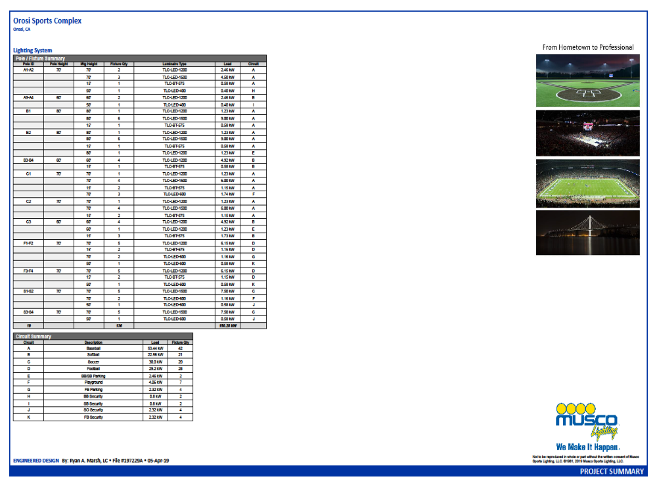

Appendix B

Musco Control System Summary

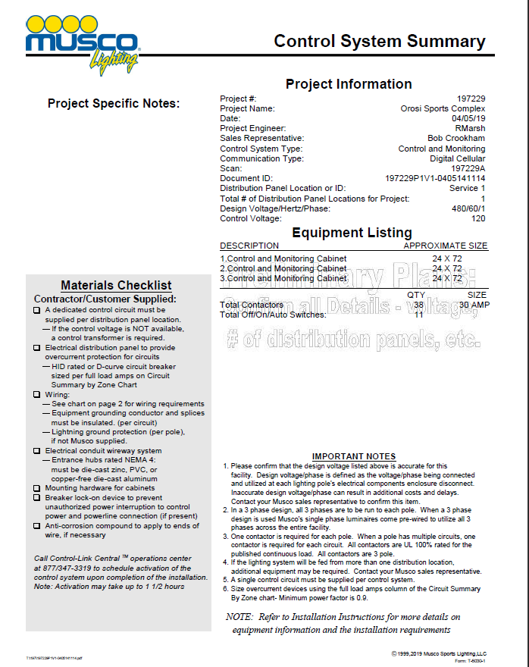

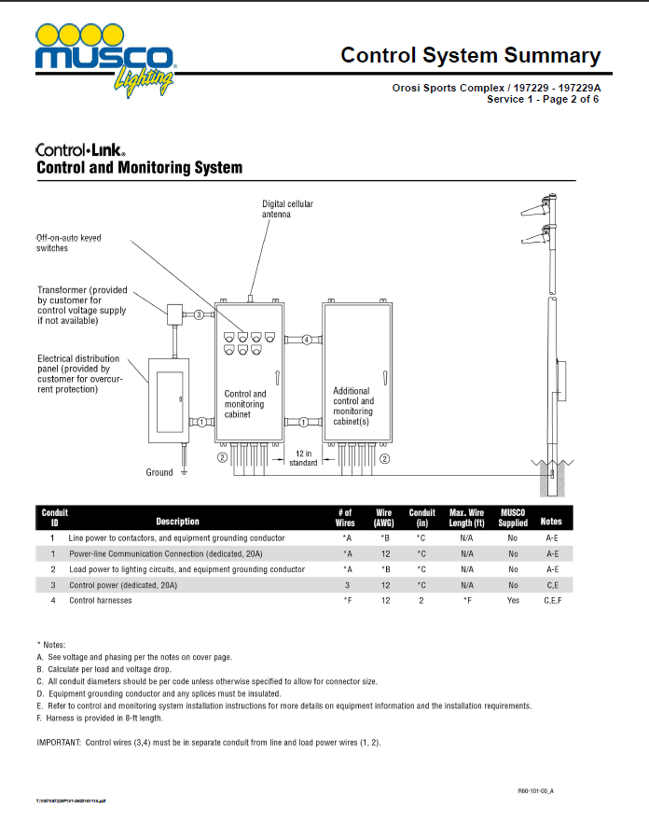

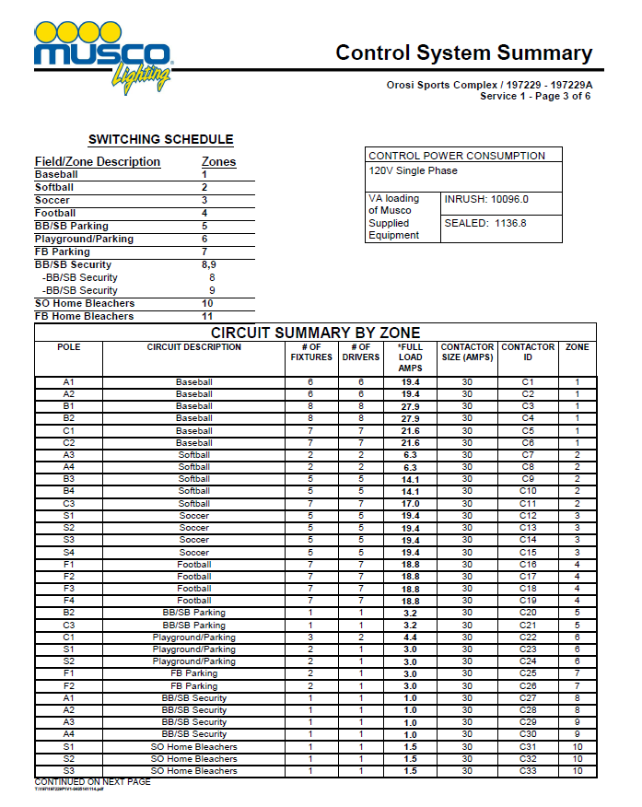

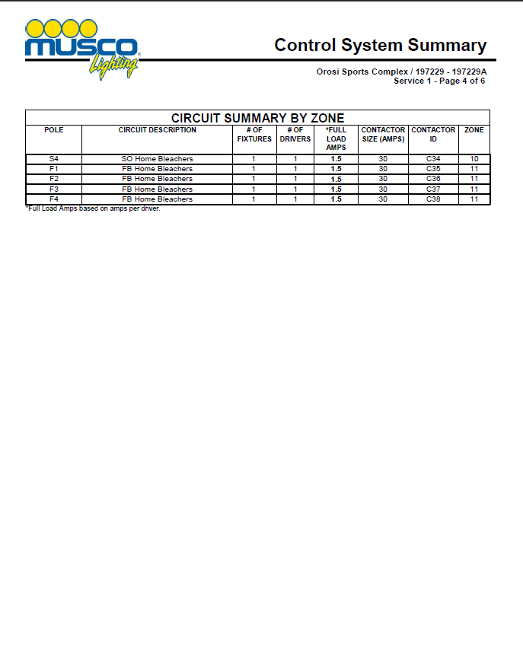

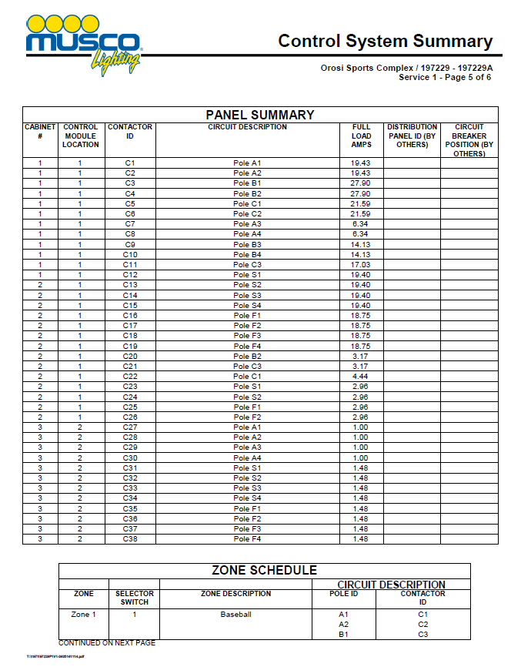

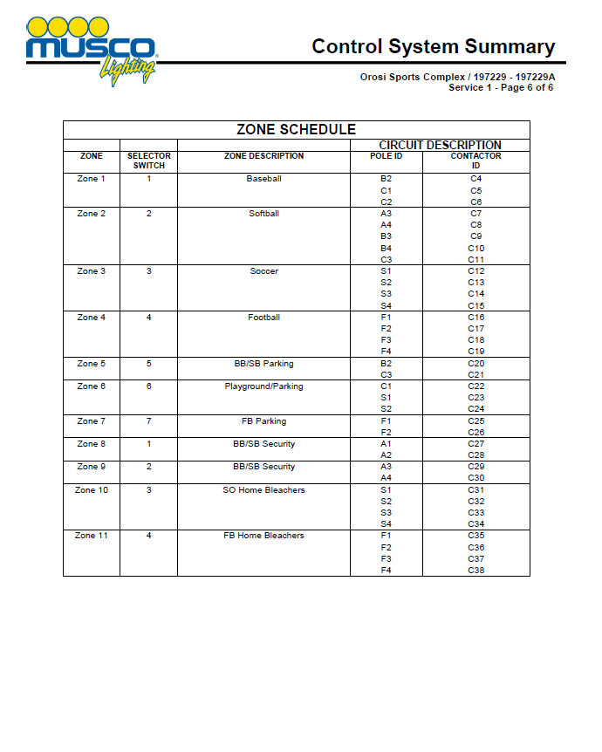

Appendix C

Site Photos

Figure 1 – Proposed Playfield and Lighting Project Aerial View: Corner of Road 128 and Avenue 419
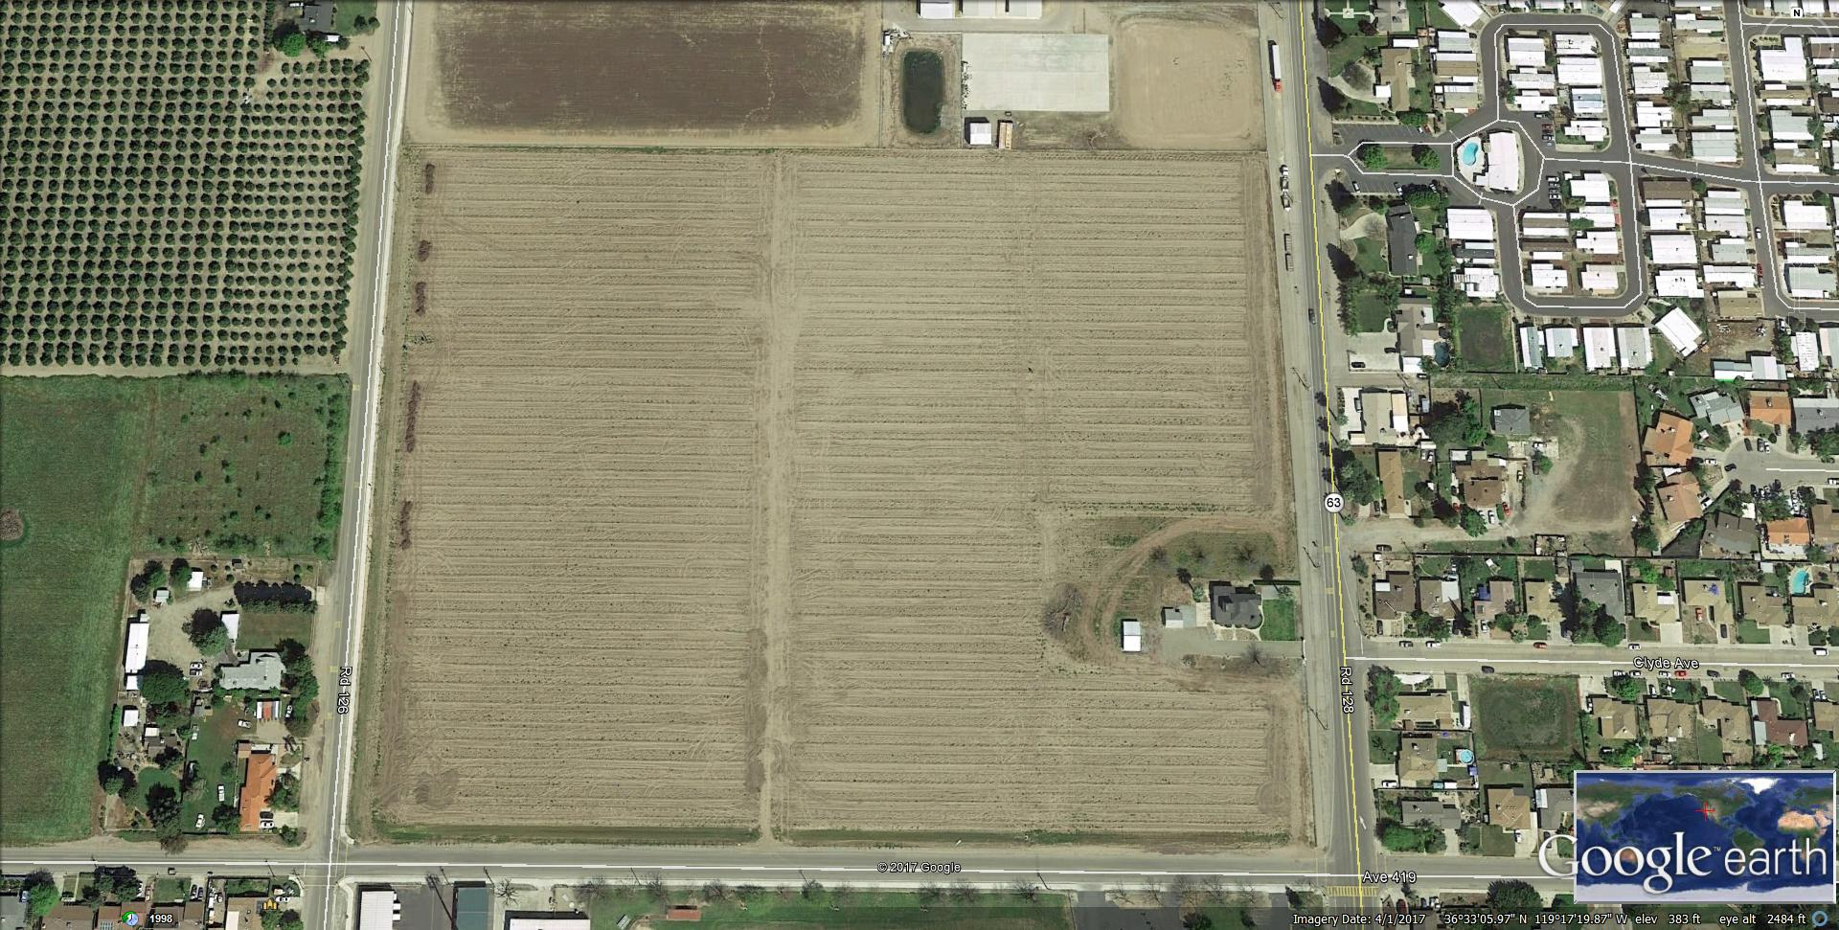

Figure 2 – Proposed Playfield and Lighting Project: Cutler Orosi Unified School District
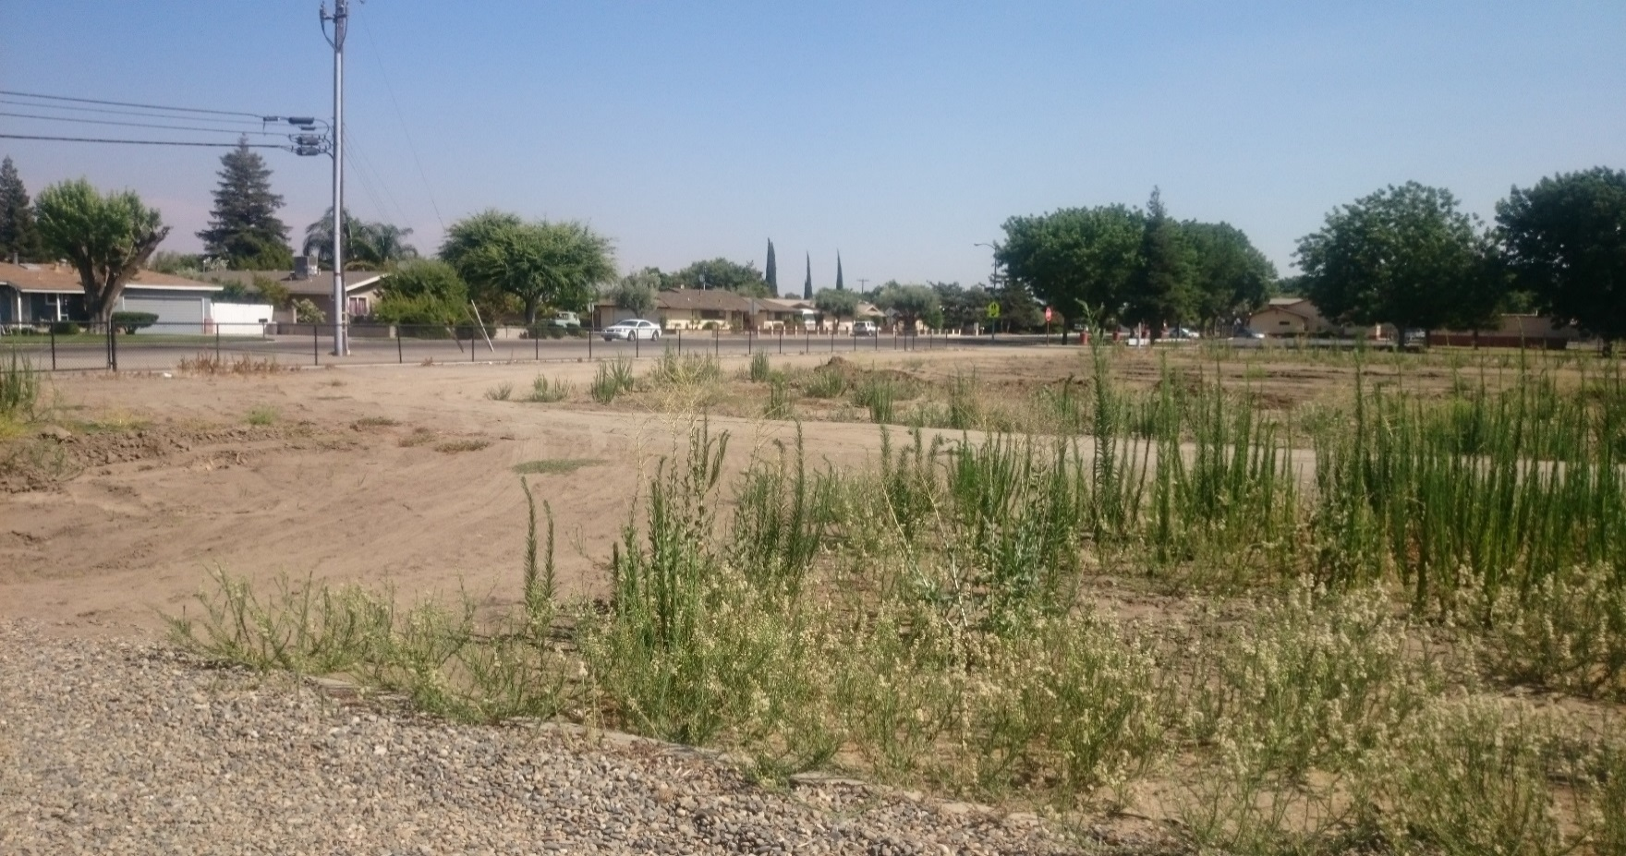

Figure 3 – Proposed Playfield and Lighting Project: Cutler Orosi Unified School District
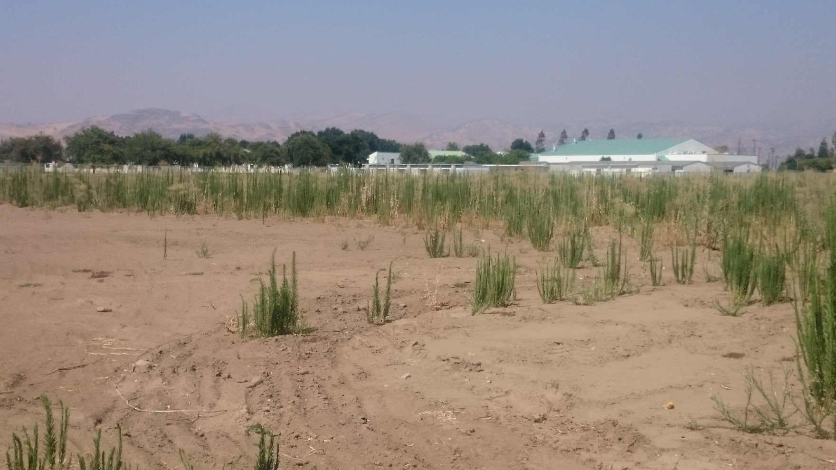

Figure 4 – Proposed Playfield and Lighting Project Location: Cutler Orosi Unified School District
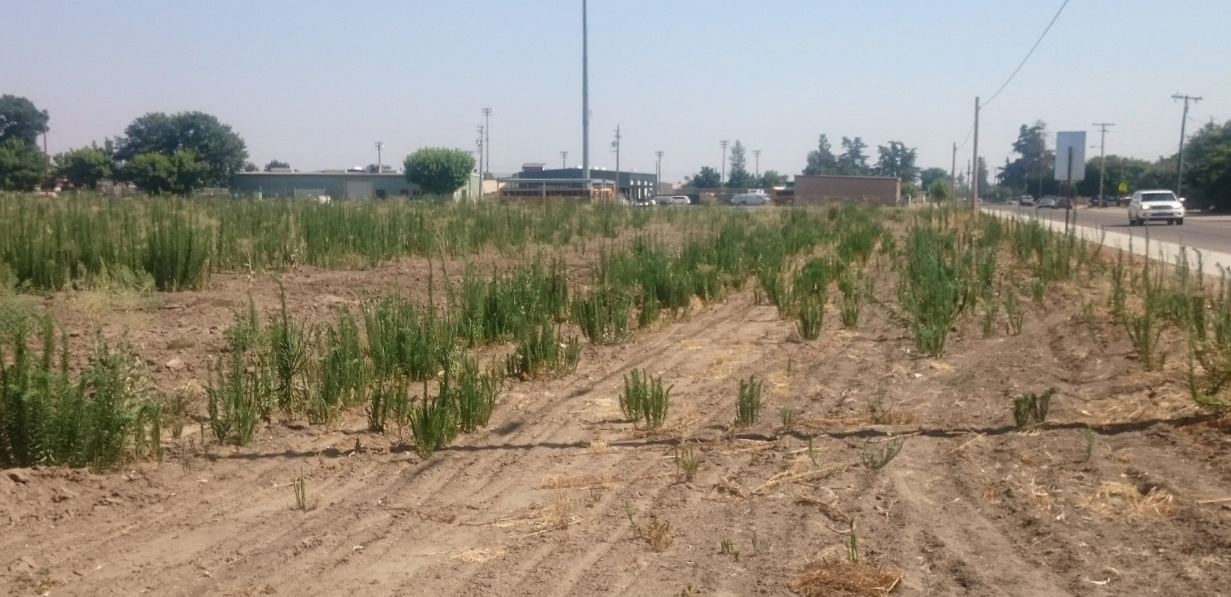

Figure 5 - Proposed Playfield and Football Field Lighting Project Location: Cutler Orosi Unified School District
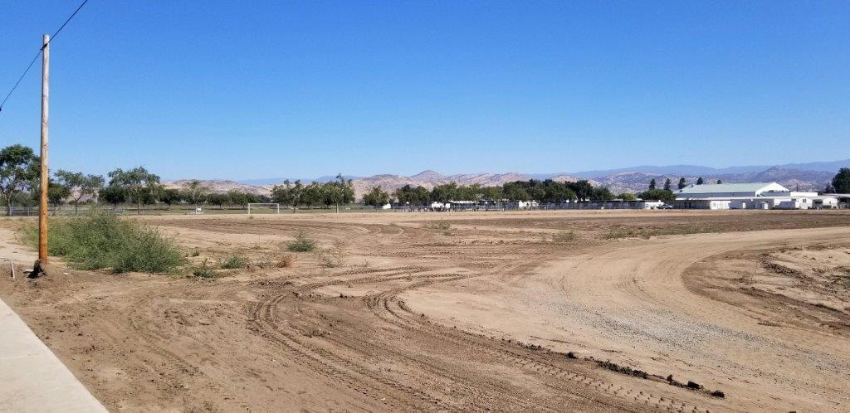

Appendix D

Letter to the Native American Heritage Commission

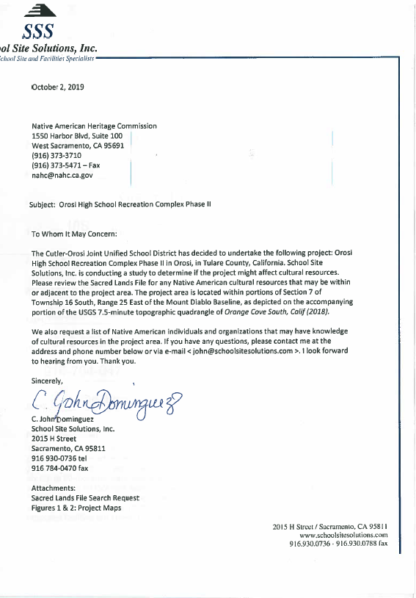

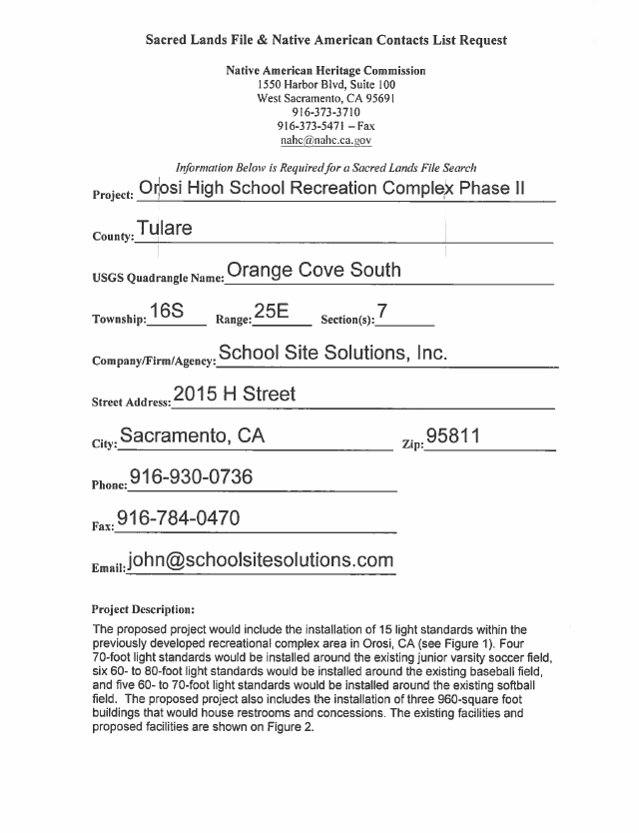

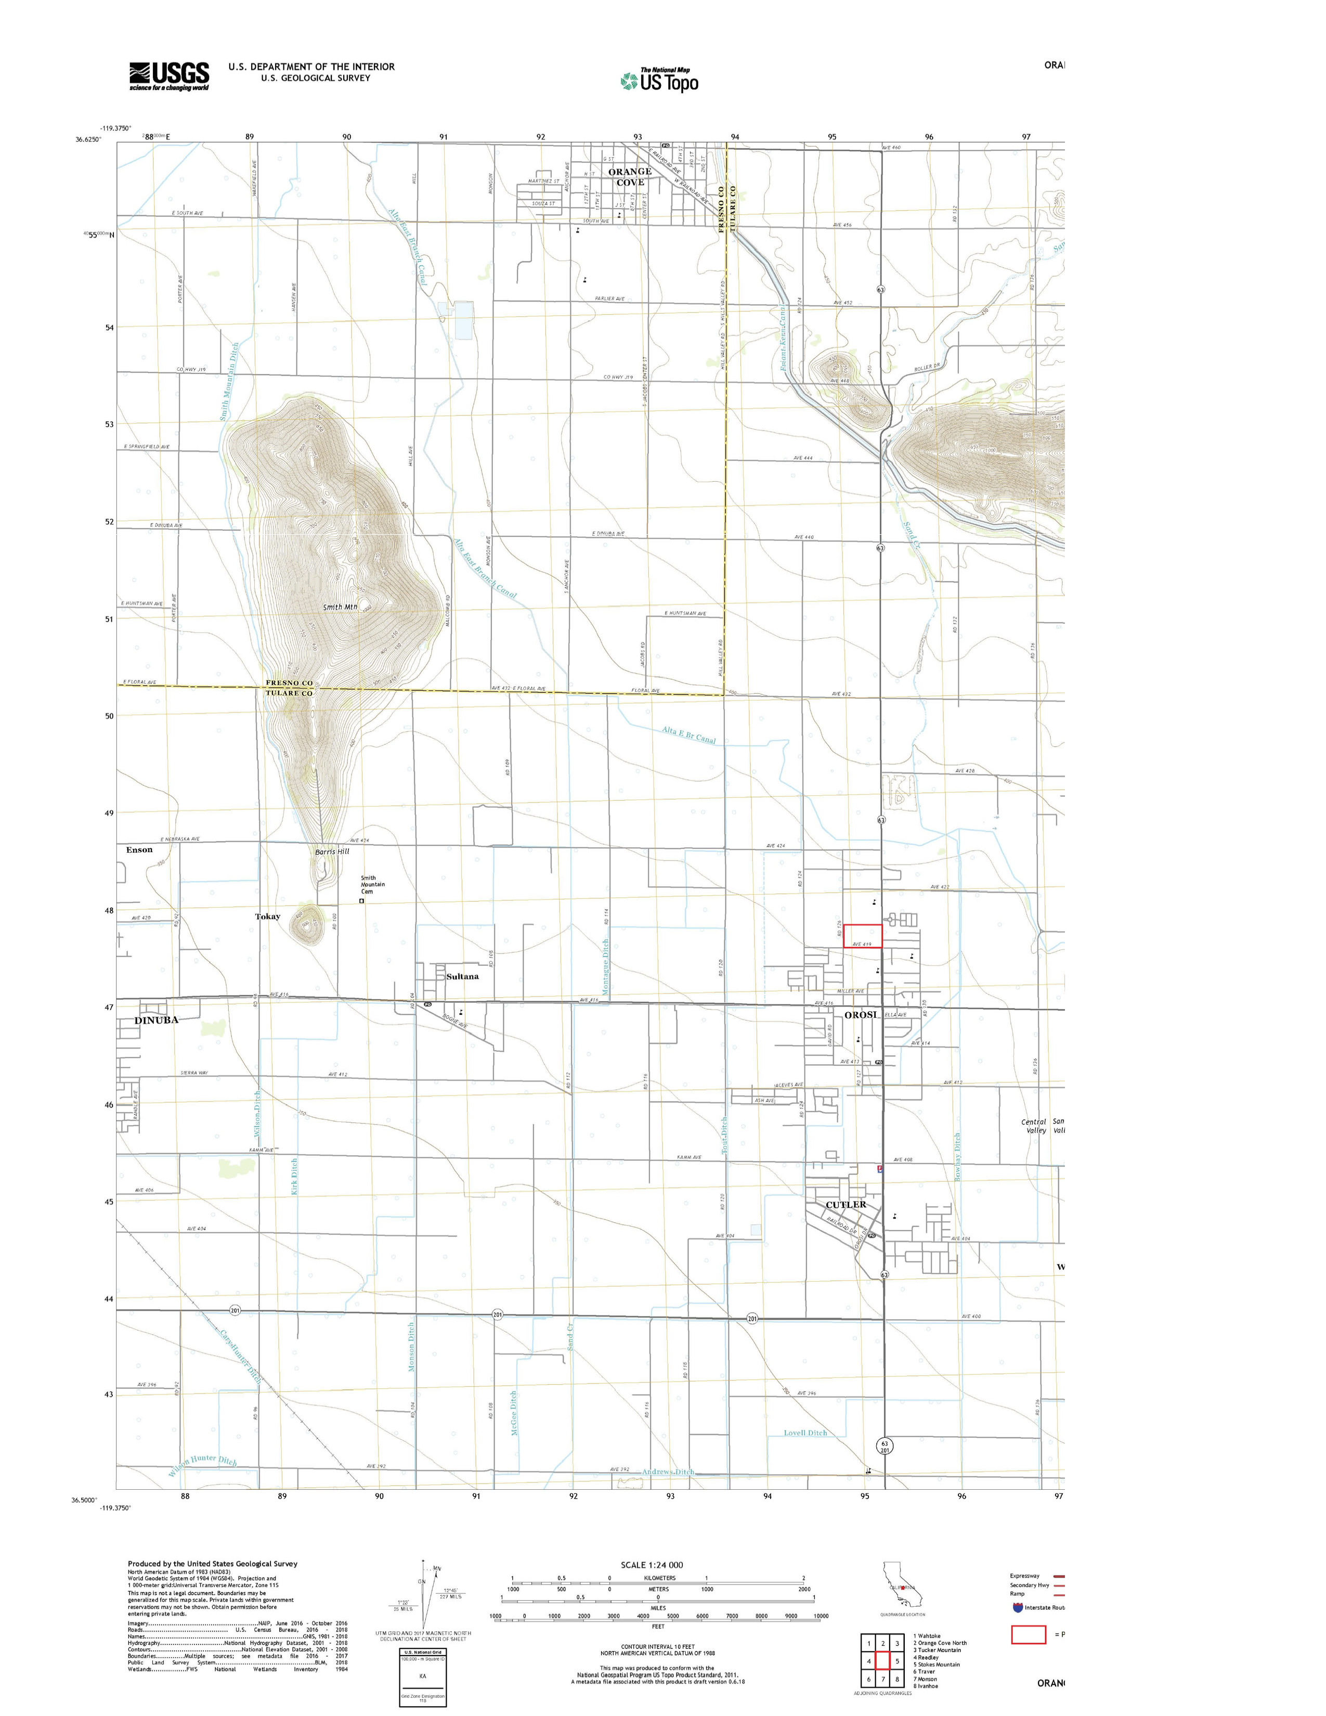

Appendix E

Sacred Lands File Search Request

Appendix F

Letter to the Tule River Tribal Council

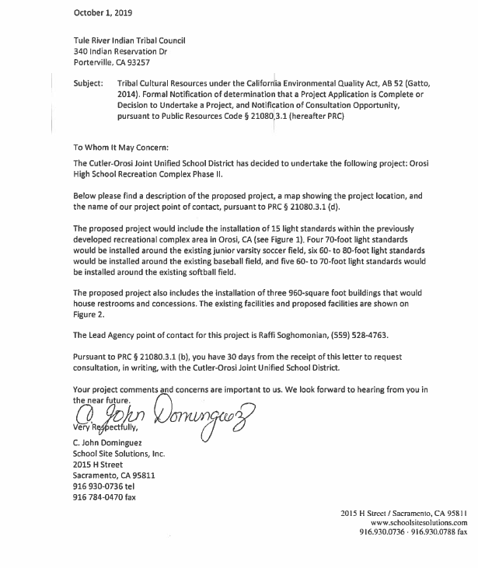

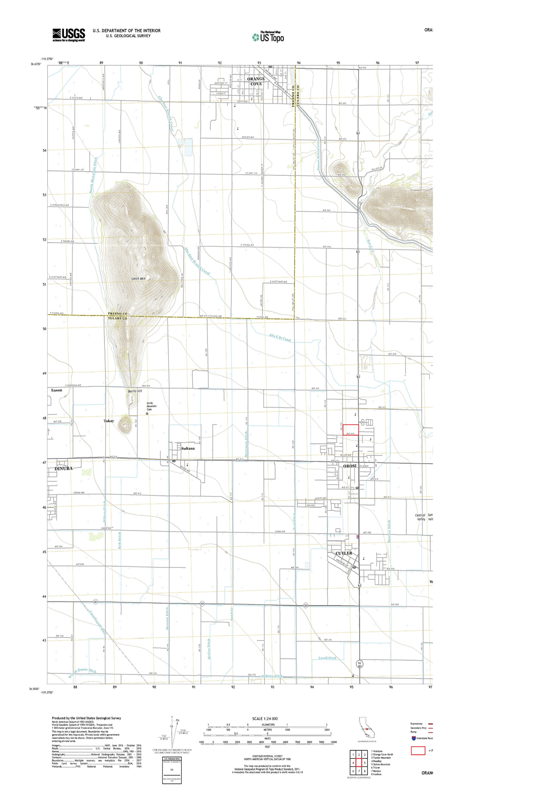

(END OF DOCUMENT)

