NOTICE OF DETERMINATION
TO: | ☐ Clerk of the Board of Supervisors  or  ☒ [County Name] County Clerk  Address: 20801 Krameria Avenue Riverside, CA 92518 | FROM: | Public Agency/Lead Agency:  March Joint Powers Authority
TO: |  | FROM: | Address:  14205 Meridian Parkway, Suite 140 Riverside, CA 92518
TO: |  | FROM: | Contact: | Lauren Sotelo
TO: |  | FROM: | Phone: | 951-656-7000

TO: | ☒ Office of Planning and Research  1400 Tenth Street, Rm. 113  Sacramento, CA 95814 | Lead Agency (if different from above)  Click to enter Agency
TO: |  | Address:  Click enter address
TO: |  | Contact: | Click to enter contact
TO: |  | Phone: | Click to enter phone no.
SUBJECT: Filing of Notice of Determination in compliance with Section 21108 or 21152 of the Public Resources Code.
State Clearinghouse Number
(If submitted to SCH):
March Business Center Specific Plan (SP-1) Final Environmental Impact Report (SCH# 2002071089)
Project Title: Plot Plan 21-01: UPS Onsite Refueling Facility
Project Applicant (include address and telephone number):
BT OH, LLC.
55 Glenlake Parkway N.E.
Atlanta, GA 30328
(323) 833-8542
Specific Project Location – Identify street address and cross street or attach a map showing project site (preferably a USGS 15’ or 7 ½’ topographical map identified by quadrangle name):
Street Address: 20801 Krameria Avenue, Riverside, CA 92518
Nearest Cross street: Coyote Bush Road/Krameria Avenue
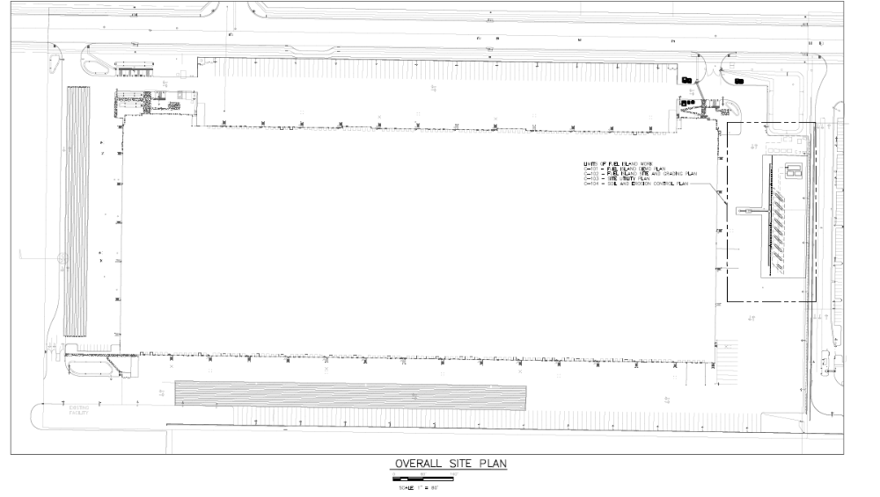
Project Site
Krameria Avenue
General Project Location (City and/or County): Unincorporated Riverside County
Project Description: Plot Plan 21-01 was approved for the construction of a 41,000 square foot refueling facility to the east of the existing UPS Parcel Delivery Terminal site. The project improvements include the installation of unleaded and diesel refueling dispensers/islands, a dispenser canopy, one (1) 20,000-gallon diesel above ground storage tank, two (2) 10,000 gallons unleaded above ground storage tanks and 9 light poles. The supporting infrastructure would include piping and electrical work. The refueling dispensers and above ground storage tanks are to be located adjacent to the existing CNG station constructed as part of the previous entitlements.
Identify the person or entity undertaking the project, including any private applicant, any other person undertaking an activity that receives financial assistance from the Public Agency as part of the project, and any person receiving a lease, permit, license, certificate, or other entitlement of use from the Public Agency as part of the project.

BT OH, LLC.
55 Glenlake Parkway N.E.
Atlanta, GA 30328
(323) 833-8542
This is to advise that the (☒ Lead Agency or ☐ Responsible Agency) has approved the above described project on September 8, 2021 and has made the following determinations regarding the above described project:
 |  | The project [ ☐ will ☒ will not] have a significant effect on the environment beyond that already identified in the previously certified EIR (March Business Center Specific Plan (SP-1) Final Environmental Impact Report (SCH# 2002071089)).
 | ☒ | An Addendum to a previously certified Environmental Impact Report (SCH #2002071089) was prepared and certified for this project pursuant to the provisions of CEQA and reflects the independent judgment of the Lead Agency.
 | ☐ | A Negative Declaration was prepared for this project pursuant to the provisions of CEQA and reflects the independent judgment of the Lead Agency.
 | ☐ | A Mitigated Negative Declaration was prepared for this project pursuant to the provisions of CEQA and reflects the independent judgment of the Lead Agency.
 |  | Mitigation measures [ ☒were ☐ were not ] made a condition of the approval of the project.
A Mitigation Monitoring or Reporting Plan [ ☒ was ☐ was not] adopted for this project.
Specifically, this project relies upon and is subject to the Mitigation Monitoring and Reporting Program adopted in connection with the previously certified March Business Center Specific Plan (SP-1) Final Environmental Impact Report (SCH #2002071089).
 |  | A Statement of Overriding Considerations [ ☒ was ☐ was not] previously adopted for the March Business Center Specific Plan and applies to this project.
 |  | Findings [ ☒ were ☐ were not] made pursuant to the provisions of CEQA.
 |  | This is to certify that the Final EIR with comments and responses and record of project approval, or the Negative Declaration, is available to General Public at:
 |  | Custodian:  Lauren Sotelo/Senior Planner  March Joint Powers Authority | Location:  March Joint Powers Authority  14205 Meridian Parkway, Suite 140  Riverside, CA 92518

Date: Click or tap to enter a date. | 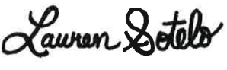___________________________________  Signature
Date: Click or tap to enter a date. | Name: Lauren Sotelo
Date: Click or tap to enter a date. | Title: Senior Planner
Date Received for Filing: Click or tap to enter a date.
Authority cited: Sections 21083, Public Resources Code.
Reference Section 21000-21174, Public Resources Code.

